Homework #2

**XML Exercise:**

1. Review the following XML document

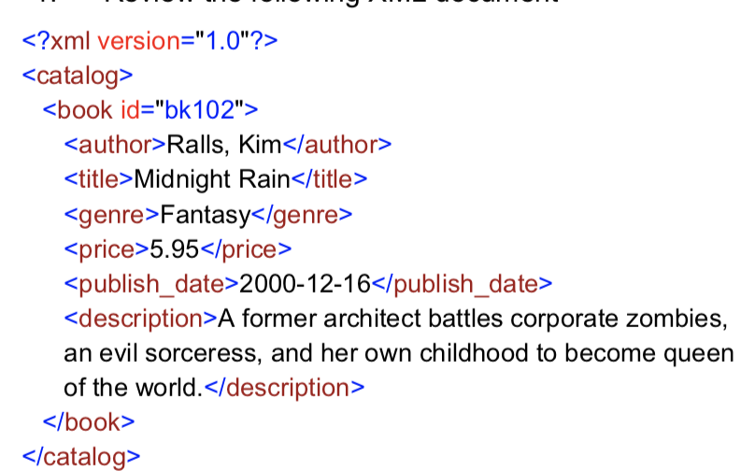

1. Create an XML Schema for the given XML

<xs:schema attributeFormDefault="unqualified" elementFormDefault="qualified" xmlns:xs="http://www.w3.org/2001/XMLSchema"> <xs:element name="catalog"> <xs:complexType> <xs:sequence> <xs:element name="book"> <xs:complexType> <xs:sequence> <xs:element type="xs:string" name="author"/> <xs:element type="xs:string" name="title"/> <xs:element type="xs:string" name="genre"/> <xs:element type="xs:float" name="price"/> <xs:element type="xs:date" name="publish_date"/> <xs:element type="xs:string" name="description"/> </xs:sequence> <xs:attribute type="xs:string" name="id"/> </xs:complexType> </xs:element> </xs:sequence> </xs:complexType> </xs:element> </xs:schema>

1. Write a Python program to retrieve price from the XML

**JSON Exercise:**

1. Explore the online API to understand the ***posts*** JSON data representation:

https://jsonplaceholder.typicode.com/posts

2. Connect to the online API to receive ***500 posts*** (use JSON library)

3. Parse the ***posts*** JSON data and load into the MySQL relational database