UML Class Diagram
Figure 2 presents the UML class diagram for CLIUniApp. The diagram illustrates the classes required to fulfill the requirements backlog, along with their fields, methods, member visibility, and the relationships and multiplicities between them. Member visibility follows standard UML notation: a plus sign (+) marks public members, a minus sign (–) marks private members, and a hash (#) marks protected members. Every field is shown with its data type and every method with its parameter types and return type, and each method name corresponds directly to a function in the backlog so that the design remains traceable to the requirements. The classes are also grouped into two layers: the CLIUniApp control layer, which holds the controller that drives the command-line interaction, and the model, persistence and utility layer, which holds the domain classes, the file-backed store and the validation helper. The two containers group the classes by responsibility and are not UML elements.
The diagram uses five UML relationship types. Generalisation (a solid line with a hollow triangle) shows that one class is a kind of another. Composition (a solid line with a filled diamond) shows a strong whole–part ownership in which the part cannot exist without its whole. Aggregation (a solid line with a hollow diamond) shows a weaker whole–part relationship in which the part can exist independently. An association (a plain solid line) shows that one class holds a reference to another and works through it. A dependency (a dashed arrow) shows that one class uses the operations of another without owning an instance of it. The numbers at each end of an association state its multiplicity.
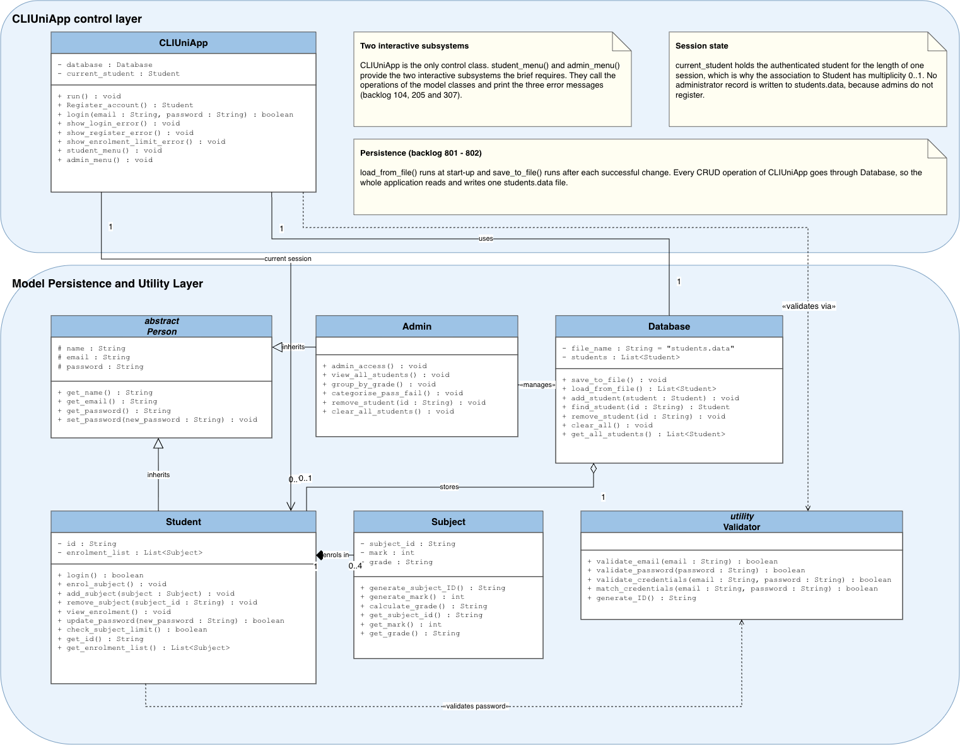
Figure 2. UML class diagram for CLIUniApp
Classes
Person (abstract). Person is an abstract superclass that captures the attributes shared by every human actor in the system: name, email and password. These fields are declared protected (#) so that the Student and Admin subclasses can reuse them while they stay hidden from unrelated classes. Person is abstract because the system never instantiates a bare person — only concrete students and admins exist. It exposes public accessors get_name(), get_email() and get_password(), and a set_password() mutator used when a password is changed.
Student (extends Person). Student represents a registered student. It adds a private id — the zero-padded six-digit identifier assigned at registration (000001–999999) — and a private enrolment_list holding the student’s Subject objects. Its public methods realise the student-facing backlog: login() (101), enrol_subject() (301), add_subject() (306), remove_subject() (401), view_enrolment() (501), update_password() (602) and check_subject_limit() (304), together with the accessors get_id() and get_enrolment_list(). Because a student may hold at most four subjects, the composition to Subject is bounded 0..4 and check_subject_limit() enforces the rule before a new subject is added.
Admin (extends Person). Admin represents existing university staff, who do not register and therefore add no persistent fields of their own; the identity fields are inherited from Person. Its public methods realise the admin backlog: admin_access() (701), view_all_students() (502), group_by_grade() (702), categorise_pass_fail() (703), remove_student() (704) and clear_all_students() (705). Because these operations act on the entire student collection rather than on the admin’s own state, Admin depends on Database.
Subject. Subject describes a single enrolment. It holds a private subject_id (the unique three-digit ID, 001–999), a private mark (a random integer from 25 to 100) and a private grade (Z, P, C, D or HD on the UTS scale). It owns the logic that populates these fields — generate_subject_ID() (305), generate_mark() (302) and calculate_grade() (303) — with the accessors get_subject_id(), get_mark() and get_grade(). A Subject has no meaning independent of the student who enrolled in it, which is why the relationship is modelled as composition.
Validator (utility). Validator is a stateless helper class that concentrates the pattern-checking rules so they are defined once and reused across registration, login and password changes. Its public methods are validate_email() (202), validate_password() (203, 601), validate_credentials() (103), match_credentials() (102) and generate_ID() (204). It holds no fields; the «utility» stereotype signals that its operations are used without holding an object of the class. Both CLIUniApp and Student depend on it.
Database. Database encapsulates all persistence to the students.data file and owns the in-memory collection of Student objects. It holds a private file_name constant ("students.data") and a private students list. Its public methods provide the file-I/O backlog and the CRUD operations both subsystems need: save_to_file() (801), load_from_file() (802), add_student(), find_student(), remove_student(), clear_all() and get_all_students(). Because the stored student records exist independently of any single run of the application, Database’s relationship to Student is modelled as aggregation rather than composition.
CLIUniApp. CLIUniApp is the application controller and entry point that coordinates the other classes. It owns a Database (composition — the file-backed store is created and managed by the application) and keeps a reference to the current_student for the active session. Its methods drive the command-line flow: run() is the main loop; Register_account() (201) creates a new student after validation; login() (101) authenticates a returning student; show_login_error() (104), show_register_error() (205) and show_enrolment_limit_error() (307) present the three required error messages; and student_menu() and admin_menu() route the user into the correct subsystem.
Fields and visibility
Table 2 lists each class’s fields with their data types and visibility. All fields are private (–) or protected (#) so that state is encapsulated — read or changed only through the classes’ public methods. The final column justifies the visibility chosen for each group of fields.
Class | Field | Type | Visibility | Justification for visibility
Person | name | String | # protected | Protected (#) rather than private so the Student and Admin subclasses inherit these shared identity fields, while classes outside the hierarchy cannot reach them.
Person | email | String | # protected
Person | password | String | # protected
Student | id | String | – private | Private (–) to protect state the class must keep valid: id is generated once and must never be reassigned from outside, and enrolment_list is guarded by check_subject_limit() so it never exceeds four subjects.
Student | enrolment_list | List<Subject> | – private
Admin | (inherits name, email, password from Person) | — | — | No fields of its own; the identity fields are inherited from Person (protected).
Subject | subject_id | String | – private | Private (–) so the values stay consistent — mark must remain 25–100 and determines grade — and are set only by the class’s own generate_ and calculate_ methods.
Subject | mark | int | – private
Subject | grade | String | – private
Validator | (no fields — utility class) | — | — | No fields — a stateless «utility» class whose operations are used without holding an object.
Database | file_name = "students.data" | String | – private | Private (–) to encapsulate persistence: file_name is fixed and the student collection is changed only through the class’s CRUD and file-I/O methods.
Database | students | List<Student> | – private
CLIUniApp | database | Database | – private | Private (–) so the controller alone owns its data store and current-session state, exposed only through its public flow and menu methods.
CLIUniApp | current_student | Student | – private
Table 2. Class fields, types, visibility, and justification for each visibility choice
Methods and visibility
Table 3 lists the methods of each class with their parameter types, return types and visibility, and maps each to its backlog item to confirm that every required function is implemented by exactly one class. All methods are public (+); the final column justifies that choice for each class’s group of methods.
Class | Method (signature) | Return | Vis. | Backlog ID | Justification for visibility
Person | get_name() | String | + | — | Public (+) so subclasses and collaborators can read the identity data and change a password only through these accessors and mutator — never by touching the protected fields directly.
Person | get_email() | String | + | —
Person | get_password() | String | + | —
Person | set_password(new_password : String) | void | + | —
Student | login() | boolean | + | 101 | Public (+) because these are the student subsystem’s operations that CLIUniApp invokes after login; the accessors give controlled read access to the private id and enrolment_list.
Student | enrol_subject() | void | + | 301
Student | add_subject(subject : Subject) | void | + | 306
Student | remove_subject(subject_id : String) | void | + | 401
Student | view_enrolment() | void | + | 501
Student | update_password(new_password : String) | boolean | + | 602
Student | check_subject_limit() | boolean | + | 304
Student | get_id() | String | + | —
Student | get_enrolment_list() | List<Subject> | + | —
Admin | admin_access() | void | + | 701 | Public (+) as they are the admin subsystem’s operations, called by CLIUniApp when an admin is using the system.
Admin | view_all_students() | void | + | 502
Admin | group_by_grade() | void | + | 702
Admin | categorise_pass_fail() | void | + | 703
Admin | remove_student(id : String) | void | + | 704
Admin | clear_all_students() | void | + | 705
Subject | generate_subject_ID() | String | + | 305 | Public (+) so the owning Student and the controller can build and read a subject; the generate_ and calculate_ methods set the private fields internally, and the accessors expose them read-only.
Subject | generate_mark() | int | + | 302
Subject | calculate_grade() | String | + | 303
Subject | get_subject_id() | String | + | —
Subject | get_mark() | int | + | —
Subject | get_grade() | String | + | —
Validator | validate_email(email : String) | boolean | + | 202 | Public (+) so any class can reuse the shared validation and ID-generation rules; being a «utility», the methods are called without instantiating the class.
Validator | validate_password(password : String) | boolean | + | 203, 601
Validator | validate_credentials(email : String, password : String) | boolean | + | 103
Validator | match_credentials(email : String, password : String) | boolean | + | 102
Validator | generate_ID() | String | + | 204
Database | save_to_file() | void | + | 801 | Public (+) because they are the only sanctioned way to read or modify persisted data — all file access and CRUD passes through this interface, keeping the file_name and students collection private.
Database | load_from_file() | List<Student> | + | 802
Database | add_student(student : Student) | void | + | —
Database | find_student(id : String) | Student | + | —
Database | remove_student(id : String) | void | + | 704
Database | clear_all() | void | + | 705
Database | get_all_students() | List<Student> | + | —
CLIUniApp | run() | void | + | — | Public (+) as the application’s entry points and menu flow — invoked to run the program, register or authenticate a user, display errors, and route to the correct subsystem.
CLIUniApp | Register_account() | Student | + | 201
CLIUniApp | login(email : String, password : String) | boolean | + | 101
CLIUniApp | show_login_error() | void | + | 104
CLIUniApp | show_register_error() | void | + | 205
CLIUniApp | show_enrolment_limit_error() | void | + | 307
CLIUniApp | student_menu() | void | + | —
CLIUniApp | admin_menu() | void | + | —
Table 3. Class methods, return types, visibility, backlog mapping, and justification for each visibility choice
Relationships and multiplicity
Table 4 lists every relationship in the diagram with its type and multiplicity. The multiplicity column reads from the source class to the target class.
From | To | Relationship | Multiplicity | Description
Student | Person | Generalisation | — | A student is a kind of person and inherits its identity fields.
Admin | Person | Generalisation | — | An admin is a kind of person and inherits its identity fields.
Student | Subject | Composition | 1 → 0..4 | A student owns up to four subjects; each subject belongs to exactly one student and is removed with it.
CLIUniApp | Database | Composition | 1 → 1 | The application creates and owns a single file-backed data store.
Database | Student | Aggregation | 1 → 0..* | The store holds any number of student records that persist independently of a session.
CLIUniApp | Student | Association | 1 → 0..1 | At most one student is logged in during a session (the current student).
CLIUniApp | Validator | Dependency | — | Uses the validation and ID-generation operations during register and login.
Student | Validator | Dependency | — | Uses password validation when updating a password.
Admin | Database | Dependency | — | Operates on the whole student collection to view, categorise and remove records.
Table 4. Class relationships and multiplicities

