Agentic Healthcare AI System

This consolidates the complete architecture, research strategy, model design, RAG system, training roadmap, safety layer, humanintheloop mechanisms, datasets, deployment pipeline, commercialization strategy, and everything discussed.

SECTION 1 — PROBLEM CONTEXT & VISION
Healthcare users struggle with symptom interpretation, medication clarity, decisionmaking, and booking medical services. Traditional systems are fragmented and outdated. The goal is to build a proprietary Agentic AI healthcare assistant powered by your OWN fine-tuned model, not dependent on ChatGPT/Claude APIs.

Your system will:
• Interpret symptoms safely
• Provide medically grounded guidance
• Retrieve verified medical information (FDA, PubMed, NHS, CDC)
• Help with medications & interactions
• Book appointments through tools/agents
• Escalate to human clinicians when needed
• Be commercially deployable as your OWN model

SECTION 2 — HIGHLEVEL SYSTEM ARCHITECTURE
Components:
1. Custom finetuned LLM (Mistral/Llama/Qwen) running on your cloud/GPU
2. Agentic execution framework (LangChain/Agno/LangGraph)
3. RAG system with vector DB and embeddings
4. Medical knowledge sources:
• FDA (drug labels, adverse events)
• PubMed abstracts
• NHS symptom/treatment pages
• CDC guidelines
5. Safety layer (rules, emergency detection, model output monitoring)
6. Humanintheloop workflow (clinician review)
7. Tool ecosystem:
• Symptom analyzer
• Drug info retriever
• Appointment scheduling API
• Followup planner
• PDF extractor for report analysis

8. Frontend UI + Backend API layer for your product

SECTION 3 — DATA SOURCES (DETAILED)
will use FREE, highquality public datasets:

FDA:
• Drug labeling
• FDA adverse event reporting system
• Medicine usage guidelines

PubMed:
• Free abstracts (not paywalled)
• Biomedical literature metadata
• PubMed Central openaccess full articles

NHS:
• Condition → symptoms
• Causes, treatments, self-care guidance
• Triage escalation rules

CDC:
• Infectious diseases
• Prevention guidelines
• Emergency symptoms and red flags

Kaggle / HuggingFace:
• MedQuAD
• MedMCQA
• Symptomdiagnosis datasets
• Clinical QA datasets

SECTION 4 — MODEL DEVELOPMENT PIPELINE

1. Choose base model:
• Mistral 7B
• Llama 3 8B
• Qwen 7B

2. Dataset creation:
• Clean FDA + NHS + PubMed data
• Convert into instructionformat JSONL
• Include:
Medical Q&A
Symptom reasoning
Medication explanations
Safety + refusal examples
Emergency escalation
Triage reasoning

3. Finetuning:
• Use LoRA / QLoRA for lowcost training
• Train on your dataset so model becomes YOURS
• Integrate refusal behavior
• Train model to rely on RAG context

4. Evaluation:
• Triage accuracy
• Safety checks
• Hallucination tests
• Citation accuracy

SECTION 5 — RAG SYSTEM ARCHITECTURE

Pipeline:
1. Collect documents (FDA, NHS, PubMed abstracts)
2. Clean and chunk text (500–800 tokens)
3. Generate embeddings (opensource or commercial)
4. Insert into vector DB (Qdrant/Pinecone/LanceDB)
5. Retrieval logic:
• top_k retrieval
• metadata filtering (disease category, drug class)
6. Final answer:
• Model uses ONLY retrieved context
• Must cite context sources

Benefits:
• Prevents hallucination
• Makes system medically trustworthy
• Allows continuous updates

SECTION 6 — AGENTIC AI WORKFLOW

1. User sends message
2. Safety layer checks emergency cues
3. Planner agent decides next steps:
• Retrieve documents?
• Call symptomanalysis tool?
• Ask clarification questions?
• Call drug info tool?
• Schedule appointment?
4. RAG retrieves relevant paragraphs
5. Your model generates grounded response
6. If risk detected → escalate to human reviewer
7. Final answer delivered to user
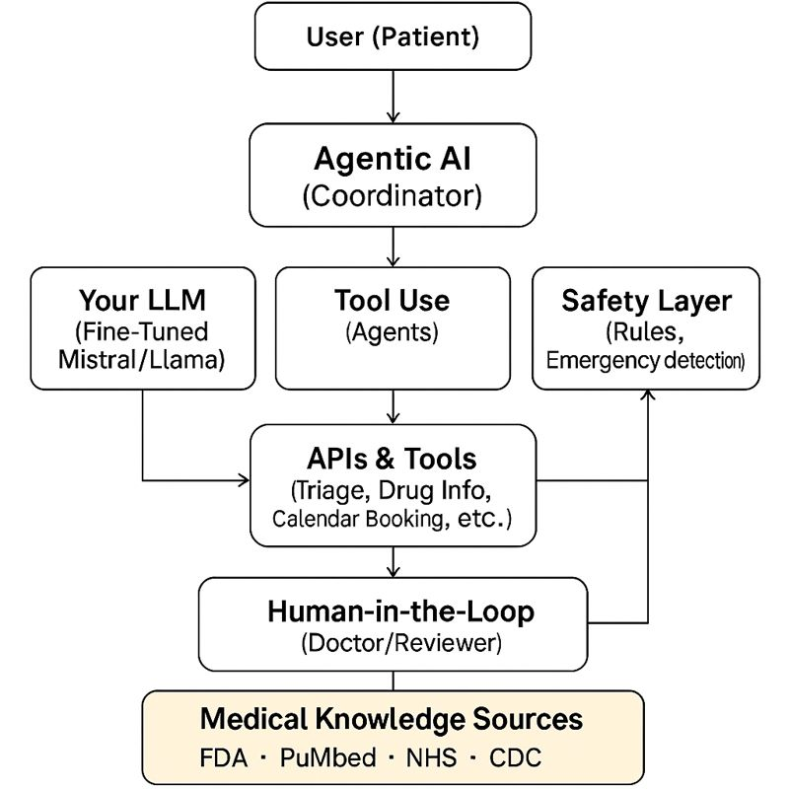

DETAILED FLOW DIAGRAM (STEP-BY-STEP)
[USER QUERY]
|
v
---------------------------------------------------------
1. INPUT PROCESSING (Intent Detection)
---------------------------------------------------------
|
v
---------------------------------------------------------
2. SAFETY CHECK (Emergency? High-risk?)
---------------------------------------------------------
- If emergency → immediate alert + instructions
- If unclear → ask clarifying questions
|
v
---------------------------------------------------------
3. AGENTIC DECISION MAKER (Planner)
---------------------------------------------------------
- Decides:
• Should I look up symptoms?
• Should I retrieve medical knowledge?
• Should I call a tool (triage API, search)?
• Should I ask user more questions?
|
v
---------------------------------------------------------
4. RAG KNOWLEDGE RETRIEVAL
---------------------------------------------------------
- Embeddings → Vector DB → Retrieves:
• FDA drug labels
• PubMed abstracts
• NHS guidelines
• CDC safety rules
|
v
---------------------------------------------------------
5. YOUR CUSTOM LLM (Fine-Tuned Model)
---------------------------------------------------------
- Uses retrieved context
- Follows safety rules
- Applies your training data
- Generates grounded, explainable answer
|
v
---------------------------------------------------------
6. TOOL-EXECUTION AGENTS
---------------------------------------------------------
- Appointment booking API
- Drug Info API
- Symptom-checker API
- Follow-up Scheduling
|
v
---------------------------------------------------------
7. HUMAN-IN-THE-LOOP (Only When Needed)
---------------------------------------------------------
- Low-confidence cases
- High-risk symptoms
- Ambiguous medication conflicts
Doctor reviews → modifies → approves
|
v
---------------------------------------------------------
8. FINAL RESPONSE TO USER
---------------------------------------------------------
- Safe, grounded answer
- With citations
- With next steps
- With booking options

S

SECTION 7 — SAFETY & HUMAN IN THELOOP SYSTEM

Safety Components:
• Emergency keyword scanner
• Symptomrisk classifier
• Confidence scoring from model
• RAG citation enforcement
• Refusal behavior when unsure

Humaninloop:
• Low confidence cases routed to clinician
• Medication conflicts flagged
• Audit logs for legal compliance

SECTION 8 — TRAINING: HOW TO MAKE THE MODEL YOURS

Training steps:
1. Dataset formulation (JSON format)
2. LoRA/QLoRA finetuning
3. Persona and tone embedding
4. Safety behaviors baked in
5. Medical precision via RAG dependence

This ensures:
• It does NOT feel like ChatGPT
• It has your product’s unique voice
• It behaves medically safe

SECTION 9— TEAM EXECUTION PLAN

• Dataset team: collects, cleans, formats medical text
• Model team: finetunes, evaluates, deploys model
• Agent/Backend team: builds agent graph, RAG, APIs
• Safety team: defines rules, emergency flows
• Product team: UI, UX, packaging, sales narrative

Reference Links:

1. FDA (Food & Drug Administration) — Drug & Device Data
OpenFDA Homepage:
https://open.fda.gov/
OpenFDA Drug APIs:
https://open.fda.gov/apis/drug/
Drug Label Dataset (download):
https://open.fda.gov/apis/drug/label/download/
Drug Event / Adverse Events API:
https://open.fda.gov/apis/drug/event/
Drug Enforcement Reports:
https://open.fda.gov/apis/drug/enforcement/

2. PubMed / NCBI — Biomedical Research
PubMed Search Portal:
https://pubmed.ncbi.nlm.nih.gov/
PubMed API (E-utilities):
https://www.ncbi.nlm.nih.gov/home/develop/api/
PubMed Bulk Download:
https://pubmed.ncbi.nlm.nih.gov/download/
PubMed Central (open-access full articles):
https://www.ncbi.nlm.nih.gov/pmc/

3. DailyMed (NIH Drug Label Data)
DailyMed Official Site:
https://dailymed.nlm.nih.gov/

4. MedlinePlus (Patient-Friendly Medical Knowledge)
MedlinePlus Homepage:
https://medlineplus.gov/

5. NHS (UK National Health Service) — Symptoms & Conditions
NHS Conditions A-Z:
https://www.nhs.uk/conditions/
NHS Medicines A-Z:
https://www.nhs.uk/medicines/

6. CDC (Centers for Disease Control, USA)
CDC Diseases & Conditions:
https://www.cdc.gov/diseases-conditions/
CDC Emergency Symptoms Guidance:
https://www.cdc.gov/

7. Kaggle — Medical NLP / QA Datasets
MedQuAD (Medical Q&A dataset):
https://www.kaggle.com/datasets/pythonafroz/medquad-medical-question-answer-for-ai-research
Kaggle Medical NLP Search:
https://www.kaggle.com/datasets?search=medical&tags=13204-NLP

8. Hugging Face — Medical Datasets
Medical LLM Fine-Tuning Collections:
https://huggingface.co/collections/Mahadih534/medical-llms-finetuning-datasets
Medical QA Dataset Collection:
https://huggingface.co/collections/lavita/medical-qa-datasets
Medical Datasets for LLMs:
https://huggingface.co/collections/mfmezger/medical-datasets-for-llms
MedMCQA (Medical Exam QA Dataset):
https://huggingface.co/datasets/openlifescienceai/medmcqa

9. Fine-Tuning LLM Guides (LoRA / QLoRA / SFT)
HuggingFace Transformers Training docs:
https://huggingface.co/docs/transformers/en/training
Fine-tuning LLMs with HuggingFace (blog):
https://huggingface.co/blog/dvgodoy/fine-tuning-llm-hugging-face
Practical Guide to Fine-Tune LLMs with LoRA:
https://medium.com/@manindersingh120996/practical-guide-to-fine-tune-llms-with-lora-c835a99d7593
How to Fine-Tune LLMs in 2024/2025:
https://www.philschmid.de/fine-tune-llms-in-2025
Google Gemma QLoRA Fine-Tuning Tutorial:
https://ai.google.dev/gemma/docs/core/huggingface_text_finetune_qlora

10. LLM Education / Foundation
Hugging Face LLM Course:
https://huggingface.co/learn/llm-course/en/chapter1/1
Fine-tuning Deep Learning (Wikipedia):
https://en.wikipedia.org/wiki/Fine-tuning_(deep_learning)

11. Models You Can Use (Open Weights)
Llama (Meta):
https://huggingface.co/meta-llama
Mistral Models:
https://huggingface.co/mistralai
Falcon Models:
https://huggingface.co/tiiuae
Qwen Models:
https://huggingface.co/Qwen

12. Tools for Hosting & Serving Your Model
vLLM (fast inference engine):
https://github.com/vllm-project/vllm
Text Generation Inference (TGI):
https://github.com/huggingface/text-generation-inference
RunPod GPU Cloud:
https://www.runpod.io/
Lambda Labs GPU Cloud:
https://lambdalabs.com/

