ERCOFTAC
Seminar and Workshop on Turbomachinery Flow Prediction VII

4th-7th January 1999
Aussois

Test Case U3 : Centrifugal Pump with a Vaned Diffuser (Univ. Genova, Italy)

Presentation : J.F. Combes, EDF-DER France

Test case

A simplified model of centrifugal pump has been tested in the University of Genova (Italy) in order to investigate the aerodynamic influence of the vaned diffuser on the impeller flow. It consists of a 420 mm diameter unshrouded centrifugal impeller and a rotatable 664 mm diameter radial vaned diffuser. The geometry of the machine is shown in figure 1 ; the co-ordinates of the impeller blade and diffuser vane profiles are given in tables 1 and 2. The impeller has seven untwisted constant thickness backswept blades. The diffuser used has 12 vanes and a 6 percent vaneless radial gap. The tip clearance is set at a value of 0.4 mm, 1 percent of the blade span.

The model operates in an open circuit with air directly discharged into the atmosphere from the radial diffuser. The inlet air temperature was 298 K and the air density 1.2 kg/m³. The results were obtained at the nominal operating conditions, at a constant rotational speed of 2000 rpm.

Phase locked ensemble averaged velocity components have been measured with hot wire probes at the impeller outlet for 30 different relative positions of the probe with respect to the diffuser vanes, and 17 axial positions in the span wise direction. The data also include the distribution of the ensemble averaged static pressure at the impeller front end at 10 radial positions, taken by means of miniature fast response tranducers mounted at the impeller stationary casing. LDV measurements were also performed in the impeller and the diffuser.

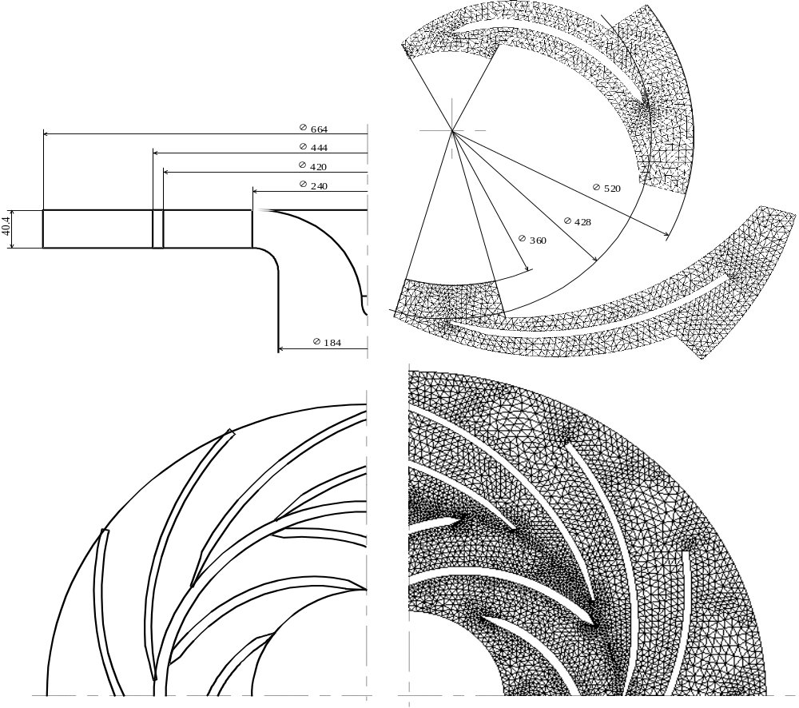

Figure 1 : Centrifugal Pump Geometry

Impeller
Inlet blade diameter | D₁ = 240 mm
Outlet diameter | D₂ = 420 mm
Blade span | b = 40 mm
Clearance between blade and shroud | g = 0.4 mm
Number of blades | z_{i} = 7
Inlet blade angle | β’₁ = - 65 °
Outlet blade angle | β’2 = - 70 °
Diffuser
Inlet vane diameter | D₃ = 444 mm
Outlet vane diameter | D₄ = 664 mm
Vane span | b = 40 mm
Number of vanes | z_{d} = 12
Inlet vane angle | α’₃ = - 74 °
Outlet vane angle | α’₄ = - 68 °
Operating conditions
Rotational speed | n = 2000 rpm
Flowrate coefficient φ = 4 Q / (U₂πD₂²) | φ = 0.0475
Total pressure rise coefficient ψ = 2 (Pt₄ - Pt₀)/ρU₂² | ψ = 0.65
Reynolds number Re = U₂ l / ν | Re = 6.5 10⁵
Inlet air reference temperature | Τ = 298 Κ
Air density | ρ = 1.2 kg/m³

Table 1 : Geometric data and operating conditions

Impeller blade coordinates |  |  |  | Diffuser vane coordinates
R (mm) | θ (deg.) | R (mm) | θ (deg.) | R (mm) | θ (deg.) | R (mm) | θ (deg.)
120.00 | 0.00 | 120.00 | 0.00 | 220.07 | 0.00 | 223.94 | 0.26
120.48 | 1.61 | 122.76 | 1.16 | 221.65 | -1.53 | 225.74 | -1.21
121.06 | 3.21 | 124.91 | 2.79 | 223.29 | -3.05 | 227.72 | -2.67
121.74 | 4.79 | 126.76 | 4.10 | 224.96 | -4.55 | 229.87 | -4.13
122.50 | 6.36 | 128.71 | 5.40 | 226.69 | -6.04 | 232.19 | -5.57
123.36 | 7.91 | 130.77 | 6.69 | 228.45 | -7.52 | 234.69 | -7.01
124.31 | 9.43 | 132.95 | 7.96 | 230.25 | -8.98 | 237.37 | -8.42
128.31 | 13.62 | 137.43 | 11.86 | 232.10 | -10.42 | 239.73 | -9.84
132.58 | 17.67 | 141.73 | 15.98 | 233.98 | -11.85 | 241.60 | -11.26
136.86 | 21.65 | 146.03 | 20.04 | 237.85 | -14.67 | 245.43 | -14.07
141.13 | 25.60 | 150.33 | 24.05 | 241.85 | -17.43 | 249.41 | -16.82
145.40 | 29.50 | 154.63 | 28.03 | 245.97 | -20.14 | 253.50 | -19.52
149.67 | 33.37 | 158.92 | 31.96 | 250.20 | -22.79 | 257.71 | -22.17
153.94 | 37.21 | 163.22 | 35.86 | 254.52 | -25.39 | 262.01 | -24.76
158.22 | 41.01 | 167.52 | 39.72 | 258.94 | -27.93 | 266.41 | -27.31
162.49 | 44.79 | 171.81 | 43.54 | 263.43 | -30.43 | 270.88 | -29.80
166.77 | 48.52 | 176.11 | 47.33 | 267.99 | -32.88 | 275.42 | -32.25
171.05 | 52.22 | 180.40 | 51.06 | 272.60 | -35.28 | 280.02 | -34.66
175.33 | 55.87 | 184.69 | 54.75 | 277.26 | -37.63 | 284.67 | -37.02
179.61 | 59.47 | 188.98 | 58.39 | 281.96 | -39.95 | 289.36 | -39.34
183.89 | 63.02 | 193.27 | 61.97 | 286.69 | -42.22 | 294.08 | -41.62
188.17 | 66.52 | 197.56 | 65.49 | 291.45 | -44.45 | 298.83 | -43.86
192.45 | 69.95 | 201.85 | 68.95 | 296.22 | -46.65 | 303.60 | -46.06
196.74 | 73.31 | 206.13 | 72.34 | 300.99 | -48.81 | 308.37 | -48.23
201.02 | 76.61 | 210.42 | 75.66 | 305.77 | -50.94 | 313.15 | -50.37
203.83 | 77.59 | 210.34 | 77.00 | 310.55 | -53.03 | 317.93 | -52.47
206.67 | 78.52 | 210.36 | 78.23 | 315.31 | -55.09 | 322.70 | -54.54
209.53 | 79.42 | 210.47 | 79.33 | 320.06 | -57.13 | 327.45 | -56.59
 |  |  |  | 324.78 | -59.13 | 332.17 | -58.60
 |  |  |  | 328.30 | -60.62 | 335.70 | -60.10

Table 2 : Impeller blade and diffuser vane profile coordinates

Data for Comparison

The following experimental results are provided on a diskette or sent by e-mail :

1- Instantaneous distributions of the ensemble averaged radial and tangential relative velocity at the impeller outlet (R/R2 = 1.02), for 17 axial positions, from z/b = 0.05 (near hub) to z/b = 0.95 (near shroud), as a function of the circumferential coordinate, for 2 blade passages Yi/Gi and for 4 different relative positions :
file crcu0.dat : t/Ti = 0.126 where Ti is the impeller blade passing period,
file crcu1.dat : t/Ti = 0.226,
file crcu2.dat : t/Ti = 0.326,
file crcu3.dat : t/Ti = 0.426.

2- Instantaneous distributions of the ensemble averaged static pressure coefficient at the shroud for 10 radial positions, from R/R2 = 0.533 to R/R2 = 1.019, as a function of the circumferential coordinate, for 2 blade passages and for 4 different relative positions :
file cp0.dat : t/Ti = 0. where Ti is the impeller blade passing period,
file cp1.dat : t/Ti = 0.1,
file cp2.dat : t/Ti = 0.2, and
file cp3.dat : t/Ti = 0.3,
file cp.dat : Circumferential ensemble averaged static pressure coefficient and stator generated unsteady pressure coefficient.

Requirements

- Description of the numerical method, rotor-stator interaction handling, turbulence modelling and boundary conditions
- Calculation details :
mesh generation, computer used, CPU time, memory requirements, concergence, accuracy, post-processing
- General description of the flow
- Averaged and instantaneous velocity fields at the impeller exit (R/R2 = 1.02),
- Averaged and instantaneous pressure distribution at the shroud.

References

Ubaldi M., Zunino P., Barigozzi G., Cattanei, A., "An Experimental Investigation of Stator Induced Unsteadiness on Centrifugal Impeller Outflow", ASME Journal of Turbomachinery, vol.118,pp.41-54,1996.

Ubaldi M., Zunino P., Barigozzi G., Ghiglione A., "LDV investigation of the rotor-stator aerodynamic interaction in a centrifugal turbomachine", 8th Int. Symposium on Applications of Laser Techniques to Fluid Mechanics, Lisbon, 1996.

