System/Software Requirements Specification

for

**Multi Clock**

**Version 1**

**Prepared by Group 4**

**Nguyễn Mạnh Hùng**

**Nguyễn Thành Luân**

**Hồ Minh Huy**

**FPT University**

**March, 20, 2020**

**Table of Contents**

**Table of Contents**

**Revision History**

**1.** **Introduction**

1.1 Purpose

1.2 System Purpose

1.3 Definitions, Acronyms and Abbreviations

1.4 Document Conventions

1.5 Intended Audience and Reading Suggestions

1.6 References

**2.** **Overall Description**

2.1 Product/System Perspective

2.2 System/Product Features

2.3 User requirements

2.4 User Classes and Characteristics

2.5 Operating Environment

2.6 Design and Implementation Constraints

2.7 User Documentation

**3.** **Specific Requirements**

3.1 Functional Requirements Specification

3.1.1 Function1 /Use-case 1

3.1.2 UC01-Login<Sample>

3.1.3 Function2 /Use-case 2

3.2 Non-Functional Requirements Specification

3.2.1 External Interface Requirements

3.2.2 Other Nonfunctional Requirements

**Appendix A: Glossary**

**Appendix B: Analysis Models**

**Appendix C: Issues List**

**Revision History**

|  |  |  |  |
| --- | --- | --- | --- |
| **Name** | **Date** | **Reason For Changes** | **Version** |
|  |  |  |  |
|  |  |  |  |

# Introduction

## Purpose

*It will awake you up until you get up and leave your bed .Every morning, you dont have to worry about get up late, go to work or go to school late anymore.Count time with stopwatch*

## System Purpose

“Multi Clock” is the Mobile Android application about alarm.The user can:

+ update alarm time

+delete and save old alarm time

+set different alarm tone for different alarms

+count time  with stopwatch

Definitions, Acronyms, and Abbreviations

|  |  |
| --- | --- |
| **Acronym** | **Definition** |
| **N/A** | Not Available |
| **OS** | Operating System |
| **UC** | Use Case |

## Document Conventions

* Font family: Times New Roman,
* Font weight: Regular.
* Font size: 11.
* Font weight heading 1: bold.
* Font size heading 1: 18.
* Font weight heading 2: bold.
* Font size heading 2: 14.

## Project Scope

## This application is for all people have an android smartphone when you need some help. The application will  can set up alarm easier,remind you about time,count time when you take part in all activities that you need to calculate time. The application is very suitable for all peoples and all ages

## References

## Software requirement specification form

## SRS of Cafeteria Ordering System (by Karl Wiegers)

## Software engineering – Ninth Edition (by Ian Sommerville)

# Overall Description

## Product/System Perspective

This software product is eventually intended for everybody who wants to have tools for get up on time and stopwatch, a good one. However, there is only one app for all tools tip alarm clock.

The product will release a product app free, open-source. Users can easily view Application by smartphone

## System/Product Features

The application can run on smartphone using Android OS, upper android 8.1/API27

Users can get up on time and stopwatch.

## User requirements

There are no requirements comes from end users.

## User Classes and Characteristics

|  |  |
| --- | --- |
| **Object** | **Description** |
| User |  |

Open application for everyone

Characteristics: Software doesn’t require any special characteristics of the user. Every user can become a member of the system.

## Operating Environment

* Operating System: Android System
* Database: SQLite
* Platform: Android
* Library: N/A

## Design and Implementation Constraints

Developers should also be careful about the privacy of users.

## Assumptions and Dependencies

Assump users have an android smartphone >=A.ver 8.1, API 27, and the user also have knowledge about using it at the minimum level (access, fill in the field).

# Specific Requirements

## Functional Requirements Specification

**Business Rules**

|  |  |
| --- | --- |
| **ID** | **Descriptions** |
| B01 | User needs using the App Store to download the app. |

### Function1 /Use-case 1

3.1.1.1 Design Home Screen

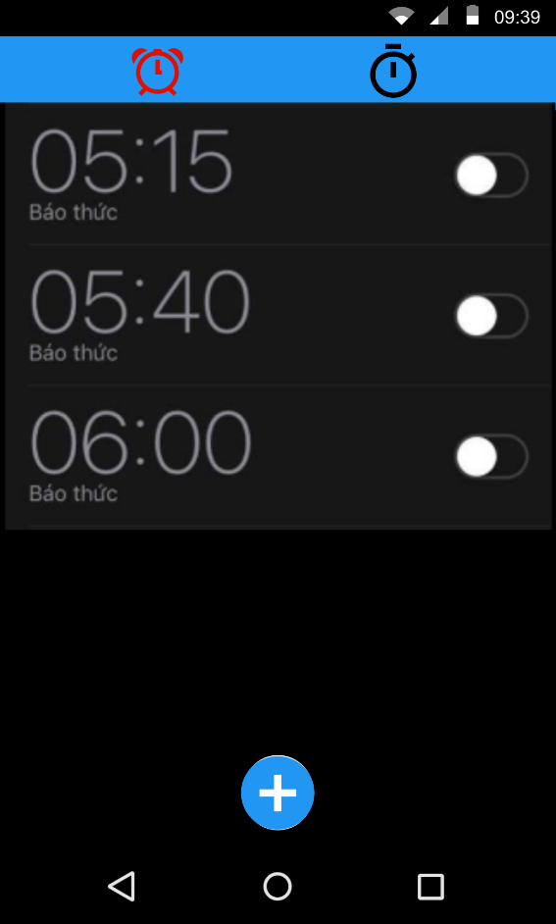

SCR-01: Home screen

Use case Diagram

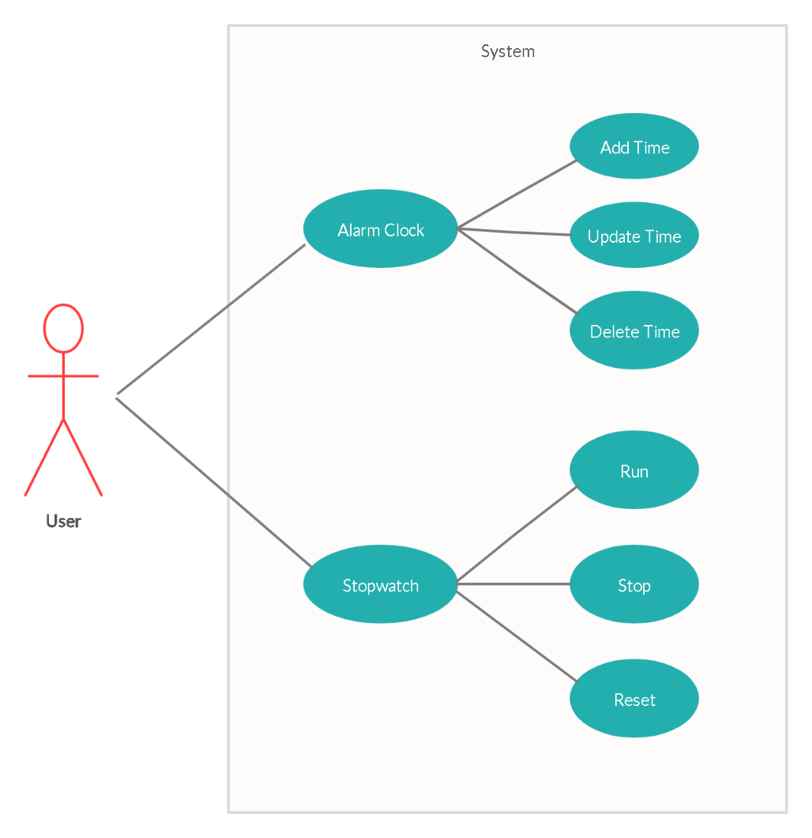

|  |  |  |
| --- | --- | --- |
| **ID** | **Actor** | **Name** |
| UC01 | User | Alarm Clock |
| UC02 | User | Stopwatch |

### UC01 - Checklist Screen

#### Screen Design

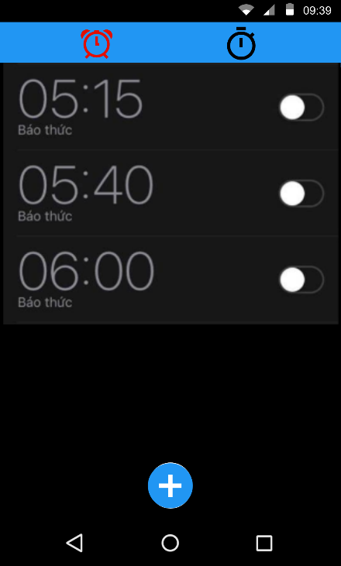

SCR-02: Alarm Clock Screen

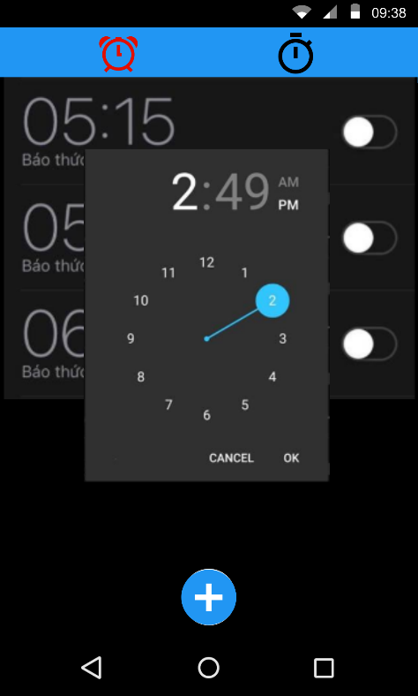

SCR-03:ADD Alarm Clock Screen

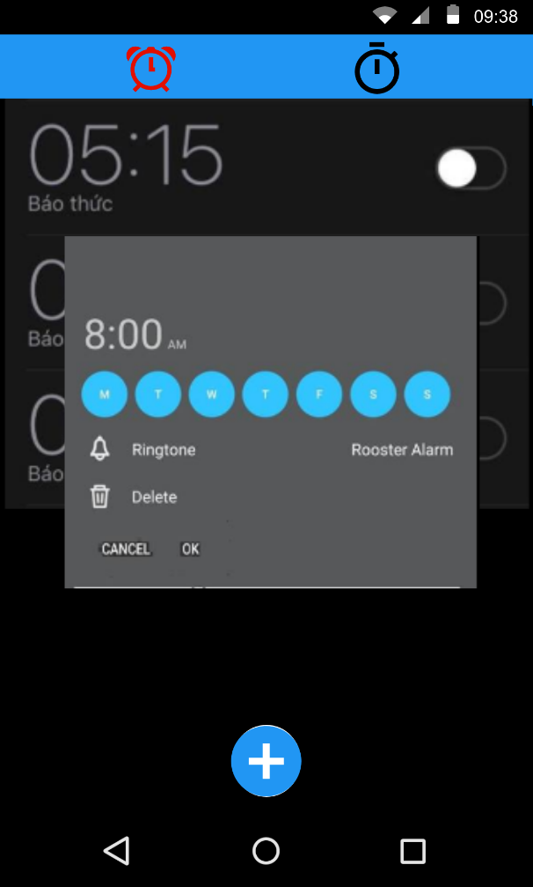

SCR-04:Edit Alarm Clock Screen

**Table 3-1: Screen Definition**

|  |  |  |  |  |  |
| --- | --- | --- | --- | --- | --- |
| **#** | **Field Name** | **Type** | **Mandatory** | **Max Length** | **Description** |
| 1 | Alram Clock | Tablayout | No |  | Function |
| 2 | StopWatch | Tablayout | No |  | Function |
| 3 | List Alarm | List | No |  | Display time |
| 4 | Toggle | Toggle | No |  | On/OFF Alarm |
| 5 | Add | Button | No |  | Add time |

**Figure 3-1**: Screen Design of Register

#### Use Case Specification

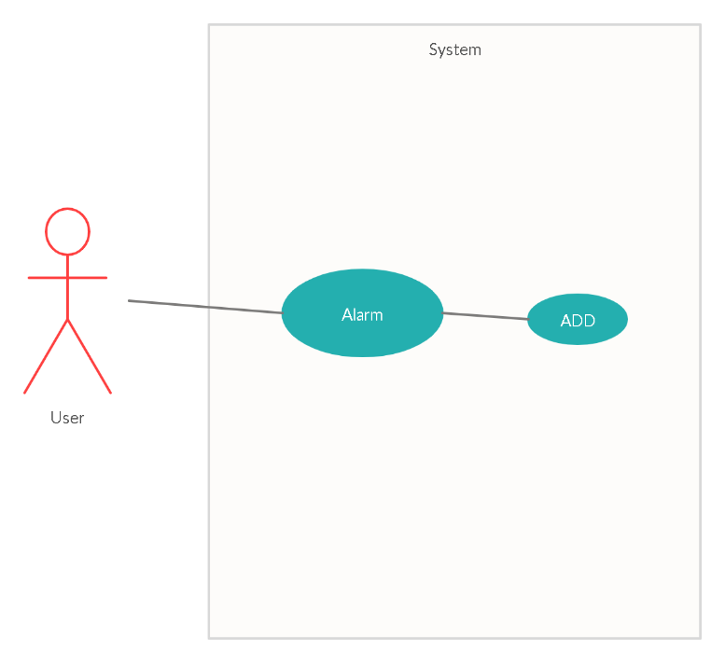

**Figure 3-2:** Add time Use-Case Diagram

|  |  |
| --- | --- |
| **Use Case ID** | **UC-01** |
| **Use Name** | **Add time** |
| **Actor** | User |
| **Description** | Add time for alarm |
| **Precondition** |  |
| **Trigger** |  |
| **Post-Condition** |  |
| **Normal Flow** | **1.0 Go in ADD**   1. User Open app 2. System display Alarm Screen. (SCR-01) 3. User clicks floating action button. (SCR-02). 4. The system displays navigate add screen (SCR-03).   **1.1 Back to Alarm screen**   1. **OK** 2. **Cancel** |
| **Alternative flows** | N/A |
| **Exceptions** | **1.0-E1 – Input data false** |
| **Priority** | Medium |
| **Frequency of Use** | Medium |
| **Business Rules** | B01 |
| **Other Information** | N/A |
| **Assumptions** | N/A |

#### 3.1.2.3 Use Case Specification

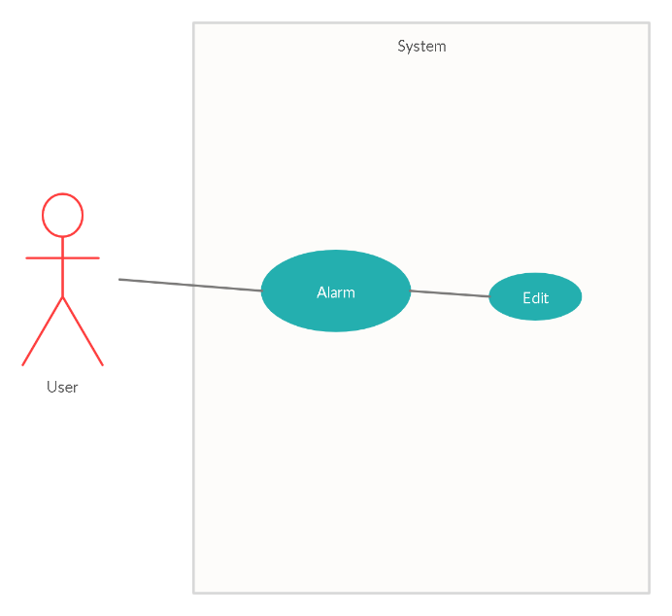

**Figure 3-3:** Edit time Use-Case Diagram

|  |  |
| --- | --- |
| **Use Case ID** | **UC-02** |
| **Use Name** | **Edit Alarm** |
| **Actor** | User |
| **Description** | Edit alarm |
| **Precondition** |  |
| **Trigger** |  |
| **Post-Condition** |  |
| **Normal Flow** | **1.0 Go in Edit**   1. User Open app 2. System display Alarm Screen. (SCR-01) 3. User clicks Alarm on list Alarm. (SCR-02). 4. The system displays edit screen (SCR-04).   **1.1 Back to Alarm screen**   1. **Delete** 2. **OK** 3. **Cancel** |
| **Alternative flows** | N/A |
| **Exceptions** | **1.0-E1 – Input data false** |
| **Priority** | Medium |
| **Frequency of Use** | Medium |
| **Business Rules** | B01 |
| **Other Information** | N/A |
| **Assumptions** | N/A |

### UC02 - StopWatch Screen

#### Screen Design

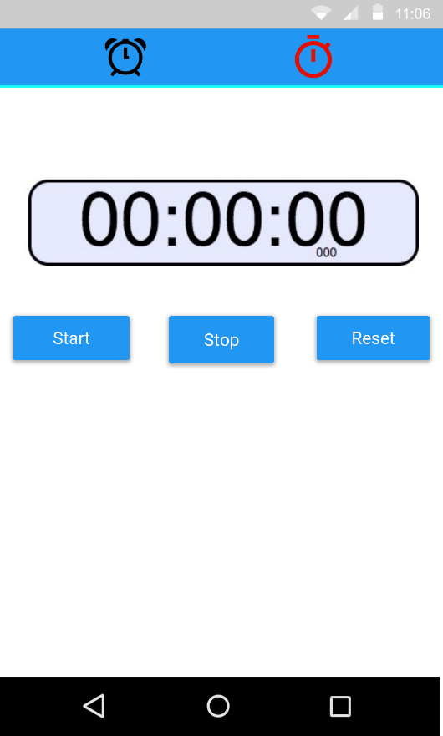

**SRC-02**: Screen design of StopWatch

**Table 3-1: Screen Definition**

|  |  |  |  |  |  |
| --- | --- | --- | --- | --- | --- |
| **#** | **Field Name** | **Type** | **Mandatory** | **Max Length** | **Description** |
| 1 | Alarm Clock | TabLayout | No |  | Alarm |
| 2 | StopWatch | TabLayout | No |  | Time count |
| 3 | Time count | Chronometer |  |  | Number Time count |
| 4 | Start | Button | No |  | Start time count |
| 5 | Stop | Button | No |  | Stop time count |
| 6 | Reset | Button | No |  | Reset number time count |

#### Use Case Specification

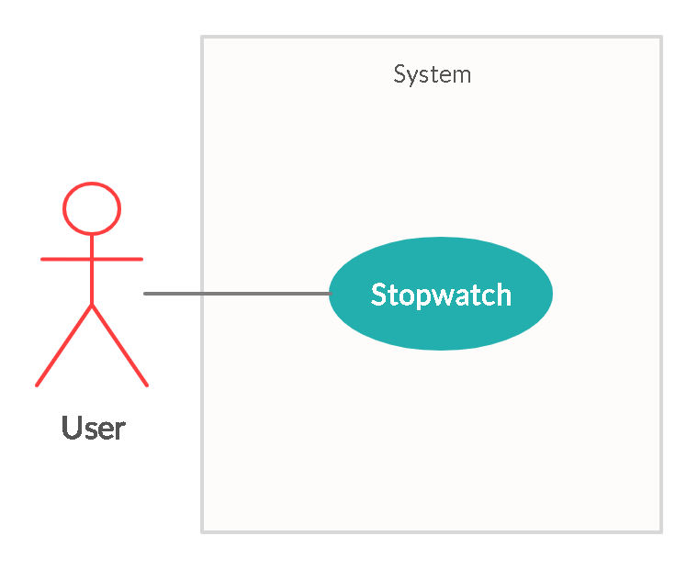

**Figure 3-14:** Stopwatch Use-Case Diagram

|  |  |
| --- | --- |
| **Use Case ID** | **UC-02** |
| **Use Name** | **StopWatch** |
| **Actor** | User |
| **Description** | Screen Show stopwatch |
| **Precondition** | N/A |
| **Trigger** | N/A |
| **Post-Condition** | N/A |
| **Normal Flow** | **1.0 Select icon Stopwatch**   1. User Open app 2. System display Alarm clock Screen. (SCR-01) 3. Select icon Stopwatch on Alarm clock screen. 4. The system displays navigate to Stopwatch Screen(SRC-02). |
| **Alternative flows** | N/A |
| **Exceptions** | N/A |
| **Priority** | Medium |
| **Frequency of Use** | Medium |
| **Business Rules** | B01 |
| **Other Information** | N/A |
| **Assumptions** | N/A |

## 3.2 Non-Functional Requirements Specification

### 3.2.1 External Interface Requirements

#### 3.2.1.1 Hardware Interface

* Android >= ver 8.1/API 27 Environment
* Internet

#### 3.2.1.2 Software Interface

|  |  |  |
| --- | --- | --- |
| **ID** | **Software Used** | **Description** |
| 1 | OS | Android OS |
| 2 | XML | Build front-end |
| 3 | Java | Build backend |

### 3.2.2 Other Nonfunctional Requirements

#### 3.2.2.1 Safety Requirements

If there is extensive damage to a wide portion of the database due to catastrophic failure, such as a disk crash, the recovery method restores a past copy of the database that was backed up to archival storage (typically tape) and reconstructs a more current state by reapplying or redoing the operations of committed transactions from the backed up log, up to the time of failure.

#### 3.2.2.2 Performance Requirements

Any response must be within 2 seconds or less

After press any button, there’re always respond within 1 seconds (loading process, save success, etc)