HealthConnect Final Model & Data Science Package
Final model decision, evaluation, documentation and cross-track contribution
HealthConnect Clinic Experience Lab · AnalystLab Africa Experience Lab, Week 8 · Data Science track · Final Integration, Presentation & Showcase
Final verdict. The final model is the unchanged Week 6 logistic regression, kept as a tested integration fixture. It is not approved for patient-level decisions: hold-out AUC 0.53 (95% CI 0.47–0.59), 0 of 6 acceptance criteria met. The useful, validated outputs are the rule-based outreach list, the flat visit forecast, the collections findings, and a testing harness ready for an attendance model.

1. Week 7 → Week 8 transition
Item | Summary
Main Week 7 output | A tested and refined model package: a six-criterion test of the Week 6 admission model, seven refinements, and a hardened scoring interface (V2) with a model card and hand-off note.
Most important testing result | The model has no usable predictive skill: hold-out AUC 0.53 (95% CI 0.47–0.59), 0 of 6 acceptance criteria met. Planted-signal tests proved the method would have found real signal.
Major issue found | The data has no attendance/no-show field, so the project target (missed appointments) cannot be modelled; the interface also failed 10 of 18 tests, and PatientVisits looks ahead.
What was refined | Seven feature/model refinements (none accepted) and the scoring interface: validated inputs, clear errors, risk bands, caution flag, versioning. Interface tests 8/18 → 18/18.
Component ready for integration | The V2 scoring interface, input/output contract, model card and testing harness (as an integration fixture). Not the model's predictions.
Still to integrate | Validated attendance KPIs from Data Analytics; ML Engineering pipeline confirmation; GenAI scope; PM risk/readiness log. The attendance target cannot be added without an attendance dataset.
Tracks involved | Data Analytics, Data Science (me), ML Engineering, GenAI, Project Management.
What to demonstrate | Baseline versus final comparison, honest error analysis, the can/cannot-use matrix, and the rule-based outreach list and forecast as the usable outputs.

2. Part 1 — Integration readiness
Field | Entry
Final component | Final Model & Data Science Package: Week 6 admission model (unchanged logistic regression) kept as a tested integration fixture, plus testing harness, scoring interface V2, rule-based risk list and forecasts.
Problem addressed | How HealthConnect can use data and AI to reduce missed appointments; what a model can and cannot responsibly support given the available data.
Current status | Complete and documented. Model status: NOT approved for patient-level decisions (0/6 criteria). Interface and harness: ready.
What improved in Week 7 | Systematic testing; refinement trials; interface hardening (8/18 → 18/18 tests); model card; issue log.
Tracks it depends on | Data Analytics (validated KPIs and data-quality findings); Project Management (scope and priorities); a future attendance dataset.
Tracks that depend on it | ML Engineering (scorer, contract, requirements); GenAI (only the plain-language model limits); Project Management (risks, readiness).
Output provided | Scorer V2 (joblib), input/output contract, model card, FINAL_MODEL_REQUIREMENTS.md, test harness, risk list rule, 2027 forecasts, this package.
Output needed from other tracks | DA: validated attendance/no-show KPIs and data dictionary; MLE: pipeline run confirmation; PM: sign-off on scope and risk log. (Not yet received unless confirmed below.)
Evidence of readiness | Interface tests 18/18; 6 pre-registered criteria evaluated; negative control and planted-signal tests; notebooks, tables and figures in the GitHub repository.
Limitations | No predictive skill; wrong target (admission, not no-show); one year of data; PatientVisits look-ahead; no external validation; teammate integration evidence still to be attached.

3. Review of the Week 7 results
Week 7 result | Value | Meaning
Hold-out ROC-AUC (95% CI) | 0.529 (0.47–0.59) | Includes chance (0.50); required ≥ 0.65 with lower bound > 0.50
Time-based test AUC (Oct–Dec) | 0.480 (CI 0.43–0.53) | No demonstrable skill on future data
Share of 30 random splits with AUC > 0.5 | 40% | About what chance gives
Calibration slope (ideal 1.0) | 0.18 | Predicted risks are not informative
Top-20% rule: precision vs prevalence | 0.167 vs 0.117 (lift 1.42×) | No enrichment of admissions
Acceptance criteria met | 0 of 6 (candidate); 0 of 6 (best refinement) | Not suitable for patient-level use
Best refinement (development CV) | R1 Clinical-core features: ΔAUC +0.019, p = 0.13 | Below the +0.02 gain required; not accepted
Method validity (planted signals) | Detected from true AUC ≈ 0.57; shuffled-label AUC 0.501 | 'No signal' reflects the data, not a weak test
Scoring-interface tests (Week 6 → refined) | 8/18 → 18/18 | Interface hardened for ML Engineering

4. Final candidate confirmation
Decision rule: choose an option that meets the acceptance criteria set in Week 7; if none does, keep the simplest, best-documented model only as an integration fixture and say so.
Option | Criteria met | Hold-out AUC | Reason | Decision
Week 6 candidate (logistic regression, 18 booking-time features) | 0/6 | 0.529 | Simplest, reproducible, already wrapped by the validated scorer | SELECTED as fixture
Best refinement (R1 Clinical-core features) | 0/6 | 0.537 | Not a meaningful gain (ΔAUC +0.008, CI spans 0); fewer features but no better | Not selected
Random forest / gradient boosting (Week 6) | not run (CV AUC 0.50) | ≈0.50 | Memorises noise (unconstrained forest train AUC 1.00, CV 0.50) | Rejected
Rule-based risk score (RiskScore, no fitting) | see comparison below | see comparison below | Transparent, needs no training data; matches Week 6 recommendation | Recommended operational tool

5. Baseline versus final comparison

Figure 1. Final model versus baseline
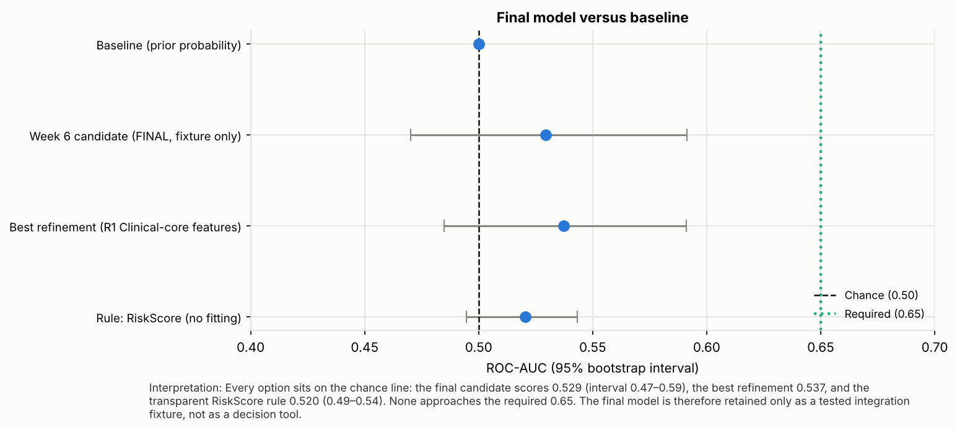
Model | AUC | Lower 95% | Upper 95% | Evaluated on
Baseline (prior probability) | 0.500 | 0.500 | 0.500 | Hold-out, Week 7
Week 6 candidate (FINAL, fixture only) | 0.529 | 0.470 | 0.591 | Hold-out, Week 7
Best refinement (R1 Clinical-core features) | 0.537 | 0.485 | 0.591 | Hold-out, Week 7
Rule: RiskScore (no fitting) | 0.520 | 0.495 | 0.543 | All 5,000 appointments, descriptive

The transparent RiskScore rule is a weak signal, not a strong one: on all 5,000 appointments the high-risk flag (33.9% of appointments) has an admission rate of 13.2% against 11.0% for the rest (chi-square p = 0.022), but its AUC of 0.52 has an interval (0.49–0.54) that touches chance. It is therefore justified for outreach on clinical and equity grounds (older, chronic or underweight/obese patients), not as a predictor.

6. Error analysis summary
Item | Finding | Note
Flagging rule | Top 20% by score (capacity rule), out-of-fold on all 5,000
True / false positives | 127 / 873 | Precision 12.7% vs prevalence 11.7%
False / true negatives | 459 / 3,541 | 78% of admissions missed
Admission rate: flagged vs unflagged | 12.7% vs 11.5% | chi-square p = 0.31: flags do not enrich for admissions
Error pattern | Flags driven by department, weekday, province categories | Selection effect; no outcome-related pattern to correct
Segments | 34 assessed; 0 significant after Holm | No segment where the model works
Overfitting | Train 0.60 vs CV 0.52 | Mild; learning curve flat at 0.5

7. Strengths and weaknesses
 | Assessment
Strengths | Fully reproducible; transparent (logistic); uses only booking-time fields; validated input/output contract; negative-control and power-tested; model card and caution flag
Weaknesses | No discrimination (AUC ≈ 0.53); uninformative probabilities; flags driven by noise categories; PatientVisits look-ahead; one year of data; wrong target for the project objective (admission, not no-show)

8. Feature and model decision log
ID | Week | Decision | Reason | Outcome
D1 | Week 6 | Target = hospital admission (no attendance field exists) | Only outcome available that is recorded per appointment | Wrong target for no-show; flagged as open issue I-02
D2 | Week 6 | Exclude diagnosis, severity, labs, prescriptions, referral from the candidate | Post-visit information: would be leakage at booking time | Feature set A only
D3 | Week 6 | Logistic regression as the candidate; compare with RF and boosting against baselines | Transparent, strong baseline for weak-signal data | Flexible models memorised noise
D4 | Week 7 | Fix six acceptance criteria before testing | Prevent the verdict being tuned to the results | 0 of 6 met
D5 | Week 7 | Select refinements on development CV only; open hold-out once | Avoid optimistic bias | No refinement accepted (needed ΔAUC ≥ 0.02, p < 0.05)
D6 | Week 7 | Plant known signals and shuffle labels to test the method | A 'no signal' verdict needs proof that signal would be seen | Detected from true AUC ≈ 0.57 upward
D7 | Week 7 | Rebuild the scoring interface with a validated contract (V2) | Interface tests failed 10 of 18 for the Week 6 behaviour | 18/18 pass
D8 | Week 8 | Retain the Week 6 candidate unchanged as the FINAL model, as an integration fixture with a caution flag | No variant met the criteria; simplest documented model | Not approved for patient-level decisions
D9 | Week 8 | Recommend the rule-based risk list and forecasts for operational use | They need no predictive claim; validated in Week 6 | Used for outreach and slot planning

9. Business interpretation and suitability
What the model can and cannot be used for:
Possible use | Allowed? | Evidence
Rank patients by admission risk for clinical decisions | NO | AUC 0.53, CI includes chance; 0/6 criteria
Show a risk percentage to staff or patients | NO | Calibration slope 0.18; probabilities uninformative
Predict missed appointments / no-shows | NO | No attendance field in the data; different target
Rank facilities, departments or doctors | NO | Segments and facilities show no reliable differences; keys inconsistent
Test the ML pipeline end to end (inputs, outputs, errors, persistence) | YES | Validated scorer, 18/18 interface tests, model card, contract
Reuse the testing harness on an attendance model | YES | Target-independent: criteria, stability, calibration, error and power tests
Targeted outreach by a transparent rule (65+/50–64 with chronic disease, obesity or underweight) | YES (rule, not model) | 6,662 high-risk patients; 5,164 (78%) had no 2026 appointment
Plan appointment slots with the 2027 visit forecast | YES (as a flat baseline) | ≈4,975 visits/month; MAPE 14.0% vs 15.3% for the mean; no trend

How validated findings shape the interpretation:
Validated finding | How it changed model interpretation
0 of 26 candidate admission factors significant after Holm correction | Explains why no model finds signal; the candidate's features carry no information
Admission rate does not differ by age, gender, diagnosis, visit type or department | Confirms that department/weekday/province weights in the model are noise
High-risk rule flags 33.3% of patients; only 22% of them had a 2026 appointment | The actionable gap is access/outreach, not prediction; supports the rule-based list
Visits are stable at ≈4,975/month with no detectable trend | Supports using a flat forecast for slot planning rather than a model
Satisfaction not related to any recorded driver | Warns against using ratings as model features
Bill 'Status' unreliable; 5,000 of 60,000 bills have an appointment record | Limits any join-based feature; justifies the data-integrity recommendation

Data Analytics teammate: add their validated attendance/no-show KPIs here when received. [TO COMPLETE with teammate]

10. Limitations and risks
Risk | Detail | Severity | Mitigation
Wrong target | Admission modelled, not no-show; the dataset has no attendance field | High | Obtain appointment-status data; retrain with the same tests
No predictive skill | AUC 0.53; probabilities uninformative (calibration slope 0.18) | High | Do not show scores to staff or patients; caution flag in every output
Look-ahead feature | PatientVisits counts the full year | Medium | Recompute as visits before each appointment
Single year, no external validation | One year of one clinic network | Medium | Re-test on a later period before any use
Weak rule enrichment | Lift 1.13×; AUC interval touches chance | Medium | Use rule for outreach only; monitor results
Data quality | Inconsistent keys, unreliable bill status | Medium | Fix at source (Analytics recommendation)
Privacy | Patient-level data and names | High | Names/phones excluded; patient-level data not pushed to GitHub

11. Requirements for ML Engineering
- Use scorer V2 with the input/output contract (18 fields, ranges, categories); reject invalid input with the field-named errors.
- Read CSVs with keep_default_na=False, na_values=[''] — the value 'None' (no chronic disease) is real data, not missing.
- Recompute PatientVisits as visits before the appointment date before any production use.
- Return risk_band, model_version and use_caution with every score; never show a bare probability.
- Do not deploy for patient-level decisions. Retrain on an attendance target once available and rerun all six criteria.
- Full detail: FINAL_MODEL_REQUIREMENTS.md and week7/outputs/model_card.md.

12. Final cross-track integration (HC-POD records)
Each link below has the nine fields required. Entries marked [TO COMPLETE] must be filled by the intern with the real details and evidence from the teammate; I have not claimed any collaboration that was not recorded.

Data Analytics → Data Science
Field | Entry
Dependency | Validated KPIs, data-quality findings, attendance patterns
Output received | [TO COMPLETE with teammate] — expected: Cleaned feature definitions; confirm which patterns are real before modelling
Output provided | [TO COMPLETE with teammate]
Final integration activity | Findings → model interpretation (T_FIND table); fixed inconsistent keys
What changed | [TO COMPLETE with teammate] (record the real change)
How it improved the solution | Model interpretation now cites validated findings; explains why no factor predicts admission
Evidence | [TO COMPLETE with teammate] (message, screenshot, shared file, meeting note)
Contribution to final presentation | Model section: baseline vs final, limits, can/cannot-use

Data Science → ML Engineering
Field | Entry
Dependency | Scorer V2, contract, requirements, model card
Output received | Feedback on scorer/requirements [TO COMPLETE with teammate]
Output provided | Scorer V2, contract, requirements, model card, limits statement
Final integration activity | Requirements file; retraining and look-ahead rules
What changed | [TO COMPLETE with teammate] (record the real change)
How it improved the solution | ML pipeline receives a validated interface and a clear 'not for patient decisions' flag
Evidence | [TO COMPLETE with teammate] (message, screenshot, shared file, meeting note)
Contribution to final presentation | Model section: baseline vs final, limits, can/cannot-use

ML Engineering → Data Science
Field | Entry
Dependency | Pipeline feedback, input errors found in testing
Output received | [TO COMPLETE with teammate] — expected: Fixes to the contract after pipeline run
Output provided | [TO COMPLETE with teammate]
Final integration activity | Contract updates, if any
What changed | [TO COMPLETE with teammate] (record the real change)
How it improved the solution | Contract based on real pipeline behaviour
Evidence | [TO COMPLETE with teammate] (message, screenshot, shared file, meeting note)
Contribution to final presentation | Model section: baseline vs final, limits, can/cannot-use

Data Analytics → Project Management
Field | Entry
Dependency | Validated findings and KPI definitions
Output received | [TO COMPLETE with teammate] — expected: Priority list of insights for the final presentation
Output provided | [TO COMPLETE with teammate]
Final integration activity | Status of each finding
What changed | [TO COMPLETE with teammate] (record the real change)
How it improved the solution | PM plan uses validated, not provisional, insights
Evidence | [TO COMPLETE with teammate] (message, screenshot, shared file, meeting note)
Contribution to final presentation | [TO COMPLETE with teammate]

GenAI → Project Management
Field | Entry
Dependency | Assistant scope, Knowledge Base coverage, tested questions
Output received | [TO COMPLETE with teammate] — expected: Risk log for AI answers
Output provided | [TO COMPLETE with teammate]
Final integration activity | Scope statement
What changed | [TO COMPLETE with teammate] (record the real change)
How it improved the solution | PM records GenAI limits and escalation rules
Evidence | [TO COMPLETE with teammate] (message, screenshot, shared file, meeting note)
Contribution to final presentation | [TO COMPLETE with teammate]

Project Management → All tracks
Field | Entry
Dependency | Priorities, risks, decisions, readiness status
Output received | [TO COMPLETE with teammate] — expected: Common integration timeline
Output provided | [TO COMPLETE with teammate]
Final integration activity | Final status matrix
What changed | [TO COMPLETE with teammate] (record the real change)
How it improved the solution | One consistent story across all tracks
Evidence | [TO COMPLETE with teammate] (message, screenshot, shared file, meeting note)
Contribution to final presentation | [TO COMPLETE with teammate]

Figure 2. Data Science in the integrated solution
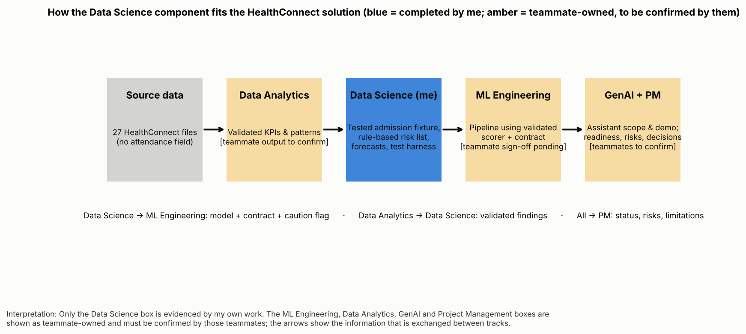

13. End-to-end solution walkthrough
Step | Explanation
1. Problem | HealthConnect Clinic loses capacity and patient trust when appointments are missed; it needs data and AI to reduce this and improve patient support.
2. Data | 27 files; 20,000 patients, 5,000 encounters, 60,000 bills. No attendance field, so missed appointments cannot be measured or modelled directly.
3. Analytics | Stable ≈4,975 visits/month; 6,662 high-risk patients (33.3%), only 1,498 with a 2026 appointment; weak billing and claims control (≈0.92 bn RWF unpaid, 21,028 pending claims). 0 of 26 admission factors significant.
4. Predictive component (Data Science) | Tested admission model: AUC 0.53, no gain over baseline. Rule-based list and flat forecast are the usable outputs.
5. ML Engineering component | Validated scorer V2 with contract, error handling and versioning, ready to be wrapped in a pipeline/API. [Teammate to confirm how it was run.]
6. GenAI component | Assistant answers only from the approved Knowledge Base, and may explain model limits in plain language but must not give risk predictions. [Teammate to confirm.]
7. PM layer | Priorities, risks, decisions and readiness tracking across tracks; the model's 'not approved' status is a recorded risk decision. [Teammate to confirm.]
8. Final solution | A decision-support package: outreach list for high-risk patients without a visit, slot planning from the forecast, collections follow-up, and a ready test harness for an attendance model.
9. Business value | Targets the 5,164 high-risk patients with no 2026 visit; avoids deploying a model that would mislead; protects revenue follow-up; sets up a defensible attendance model.
10. Limitations | Model has no skill; attendance data missing; look-ahead feature; single year; rule enrichment is weak. Next step: obtain appointment-status data and retrain with the same tests.

14. Contribution to the final presentation
The model section of the final presentation has five points: the baseline vs final result (AUC 0.53, 0/6 criteria); the error analysis; the can/cannot-use matrix; the rule-based outreach list (5,164 high-risk patients without a 2026 visit); and the requirements passed to ML Engineering.

15. Reflection
- A failed model test is a finding, not a failure of the work: proving that the data holds no usable signal prevented a misleading deployment.
- Testing the testing (planted signals, shuffled labels) made the negative result defensible.
- Target mismatch should be checked on day one: the project asked about missed appointments, the data could only support admissions.
- The most valuable outputs were simple: a transparent rule, a flat forecast, and a clear can/cannot-use statement.

