Exploratory Data Analysis Report
Patient, clinical, operational, financial and patient-experience analysis
HealthConnect Rwanda · AnalystLab Africa Experience Lab, Week 6 · Track 2: Healthcare Predictive Analytics and Population Health Intelligence

1. Summary
- 20,000 patients; mean age 45.0; 10,090 male and 9,910 female; 74.6% have a chronic condition; 33.3% meet the high-risk rule.
- Patients are spread evenly over the five provinces (Western 4,091; Northern 3,923) and every patient has insurance.
- Clinical: five diagnoses are almost equally common (about 12,000 each) and severity is split evenly across Mild/Moderate/Severe. Admission rate 11.7% (586 of 5,000), mean length of stay 5.5 days, referral rate 8.3%.
- Financial: 9.31 bn RWF billed, 8.39 bn paid, 0.92 bn outstanding (0.1%). Claim approval is 50%; payment methods are evenly split.
- Experience: mean rating 2.99/5 with ratings spread evenly from 1 to 5; 40% rate 1–2. Feedback exists for 35% of bills.
- A recurring theme: categories are almost uniformly distributed, so the data behave as if generated at random. Differences between groups, facilities and departments are small and mostly within chance variation.

2. Patient analysis (demographics, geography, insurance, growth)

Figure 01. Who are HealthConnect's patients?
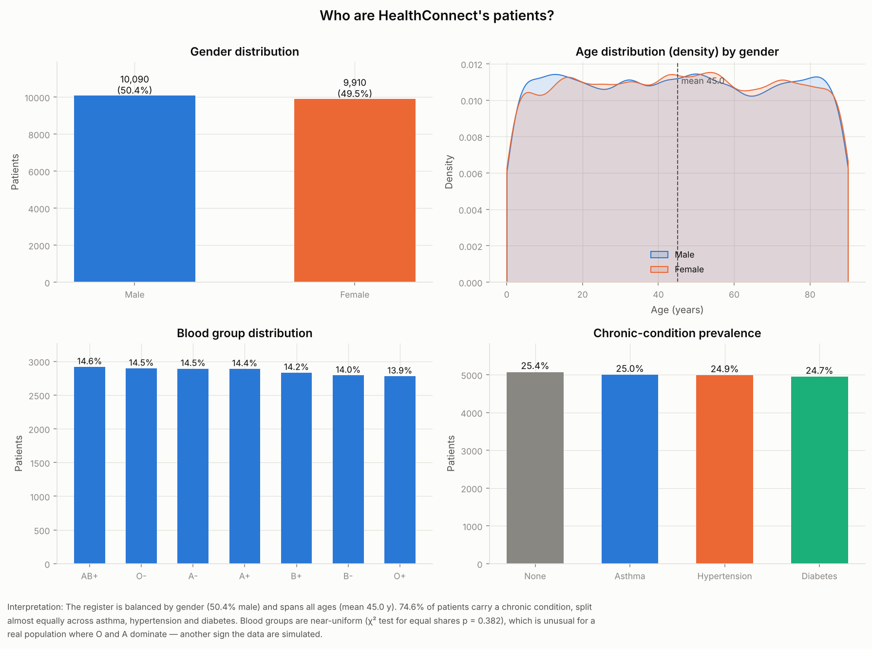

Figure 02. Age pyramid of registered patients
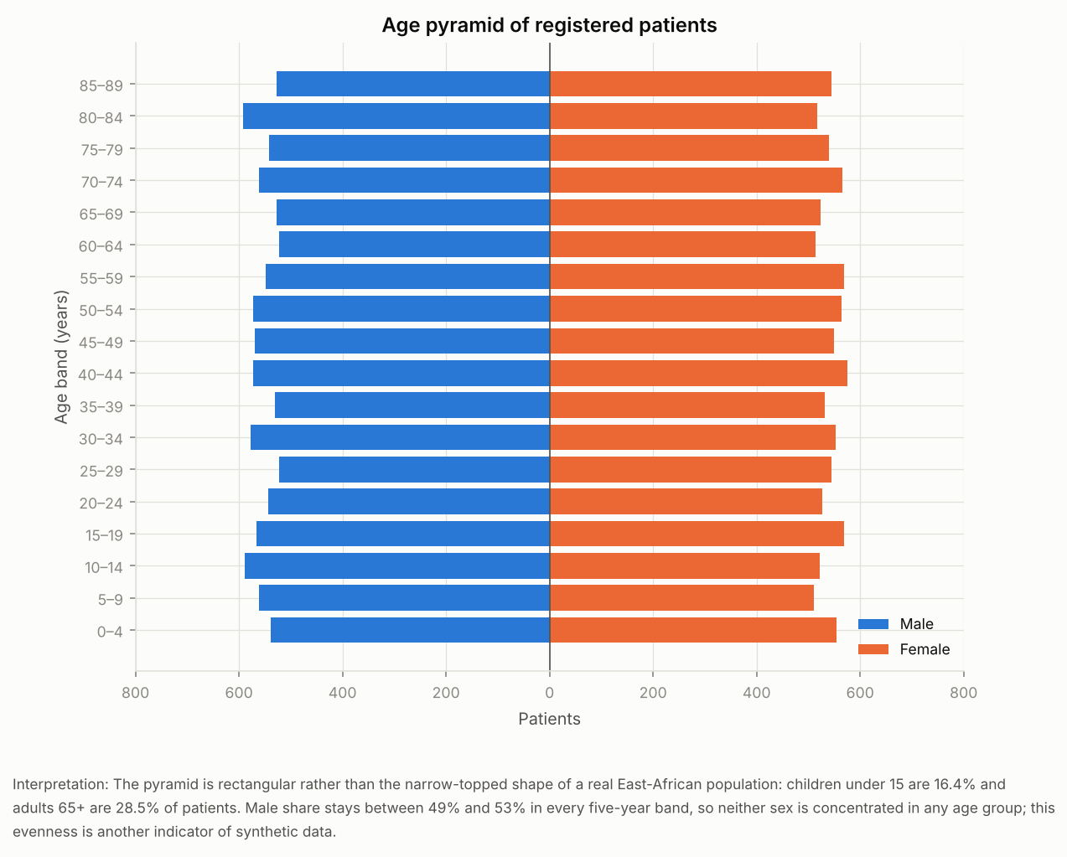

Figure 03. Chronic-disease prevalence by age group
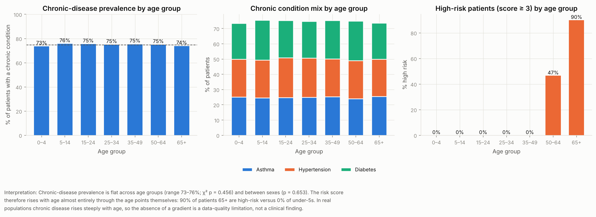

Figure 04. Patients by insurance code (INS001–INS015)
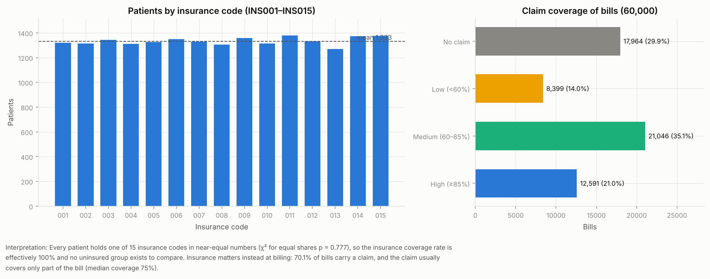

Figure 05. Patients by province
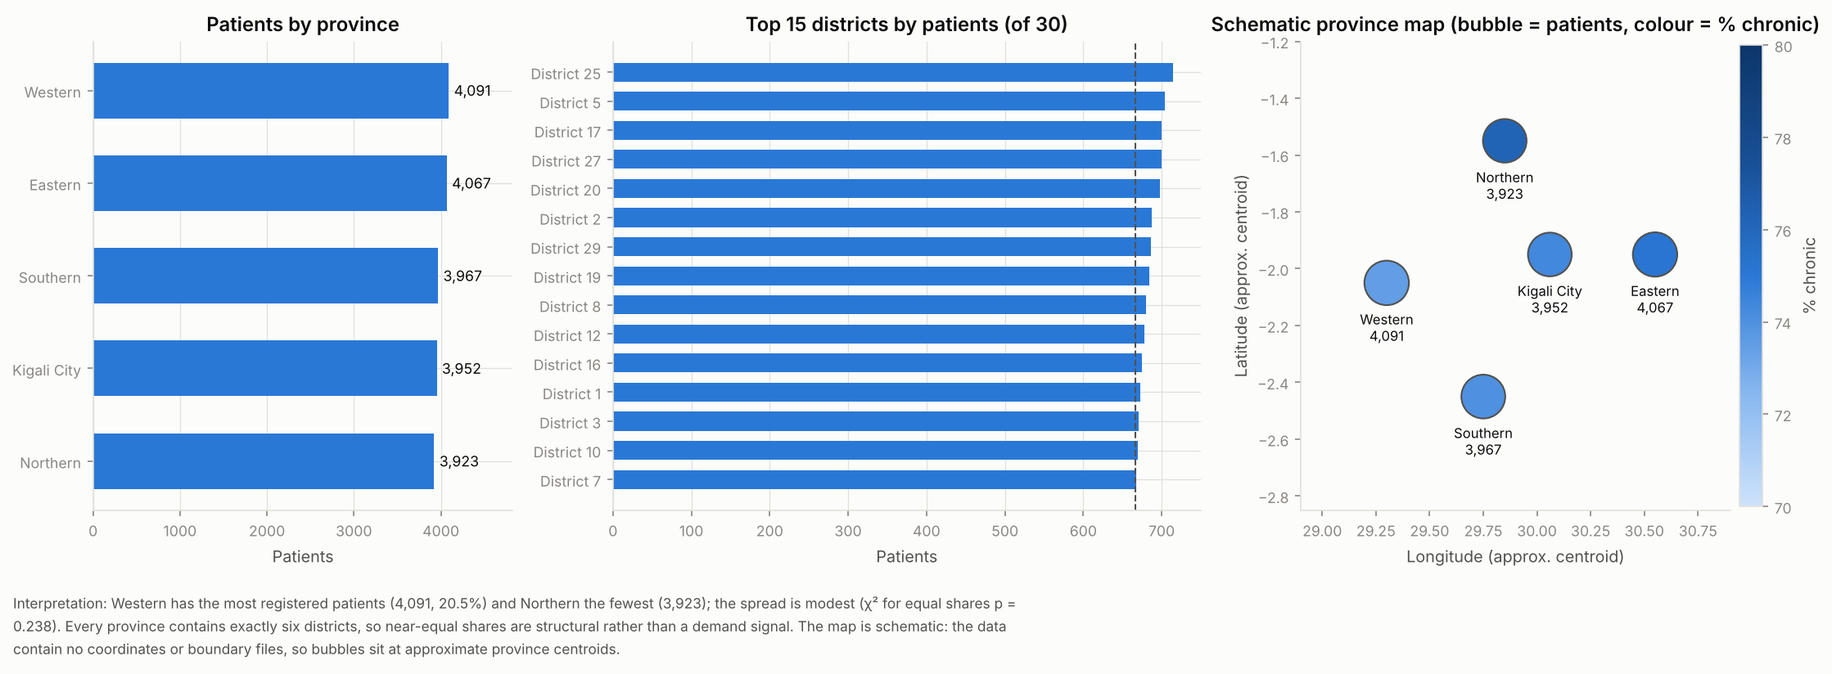

Figure 06. Cumulative unique patients seen (growth proxy)
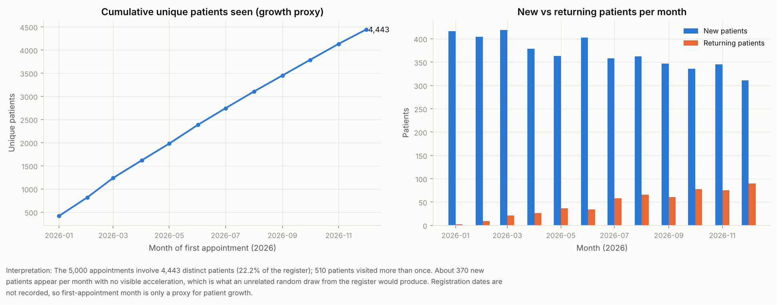

3. Clinical analysis (diagnoses, labs, prescriptions, admissions, referrals)

Figure 07. Diagnosis frequency (60,000 diagnoses)
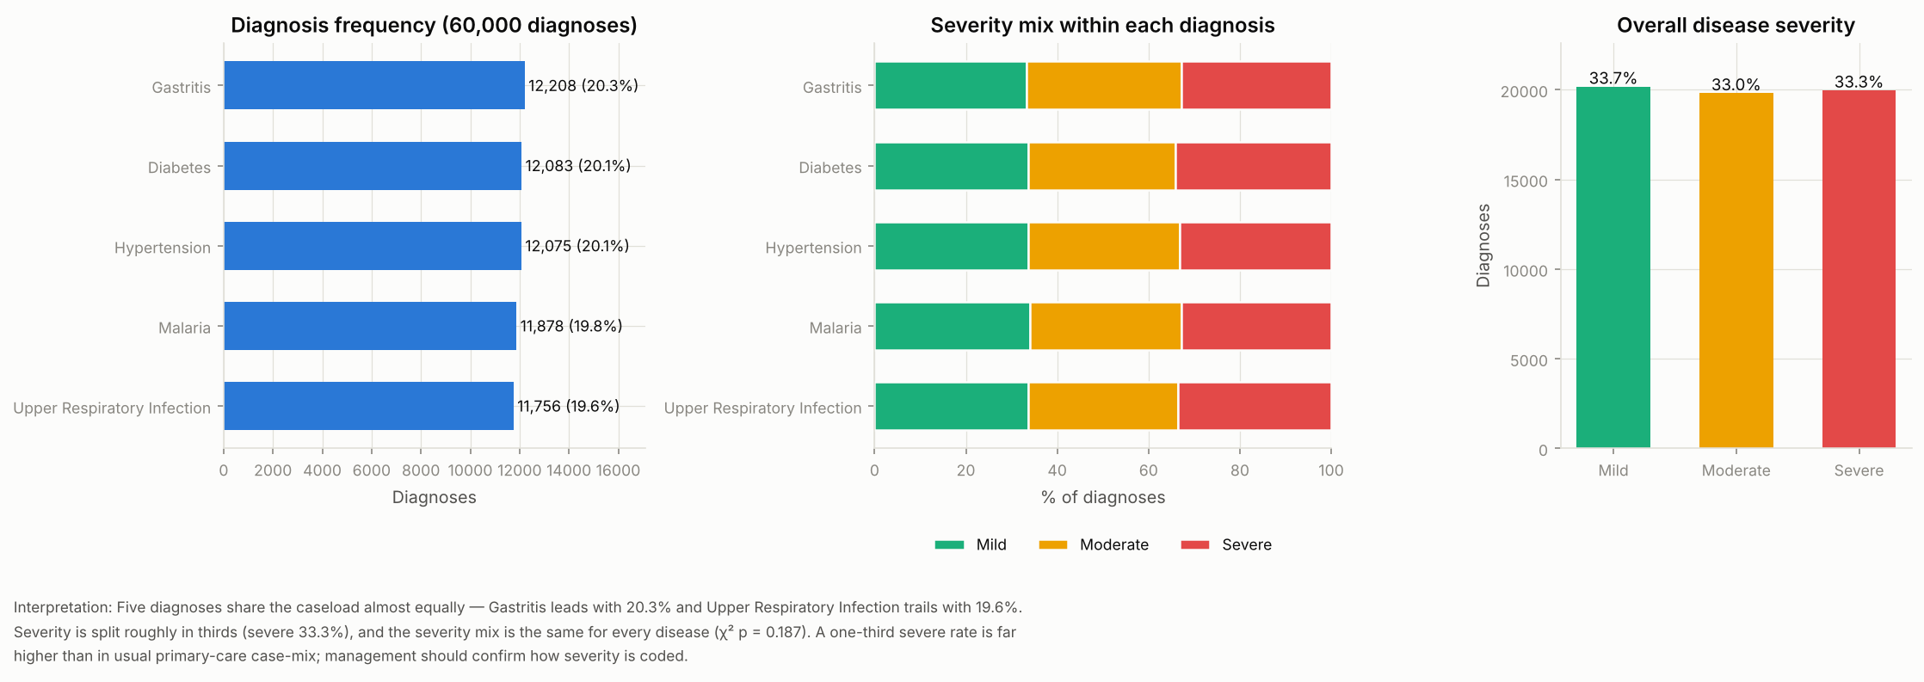

Figure 08. Laboratory test volume
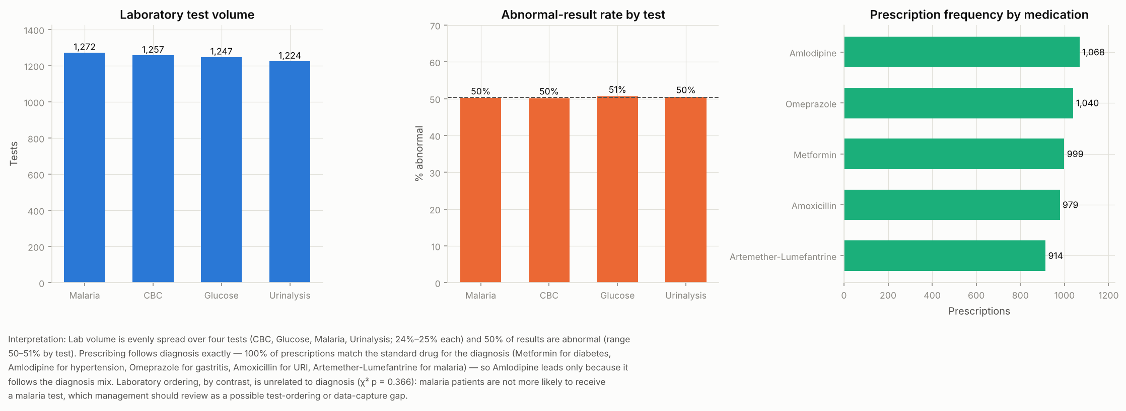

Figure 09. Monthly admission and referral rate
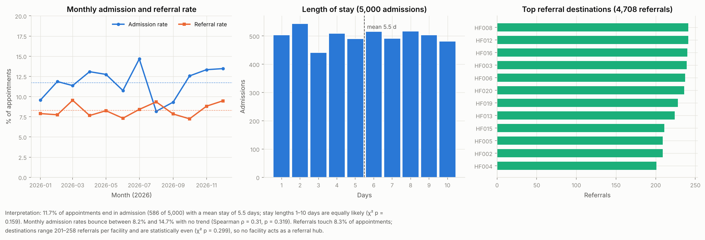

4. Operational analysis (staff workload, facility utilisation, capacity)

Figure 10. Appointments per doctor (350 doctors)
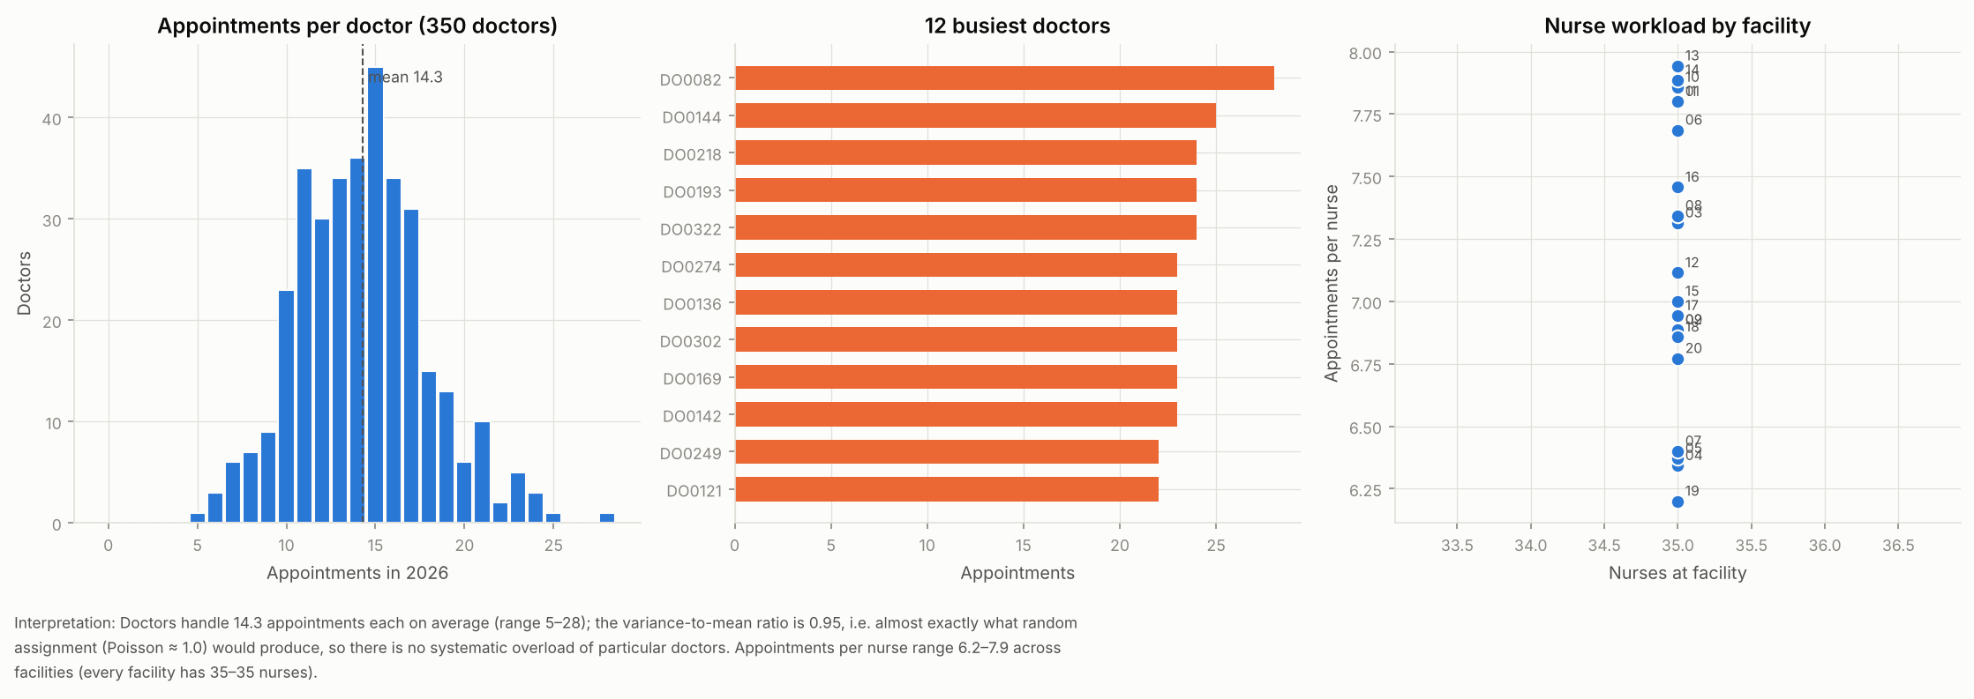

Figure 11. Facility utilisation: appointments by facility
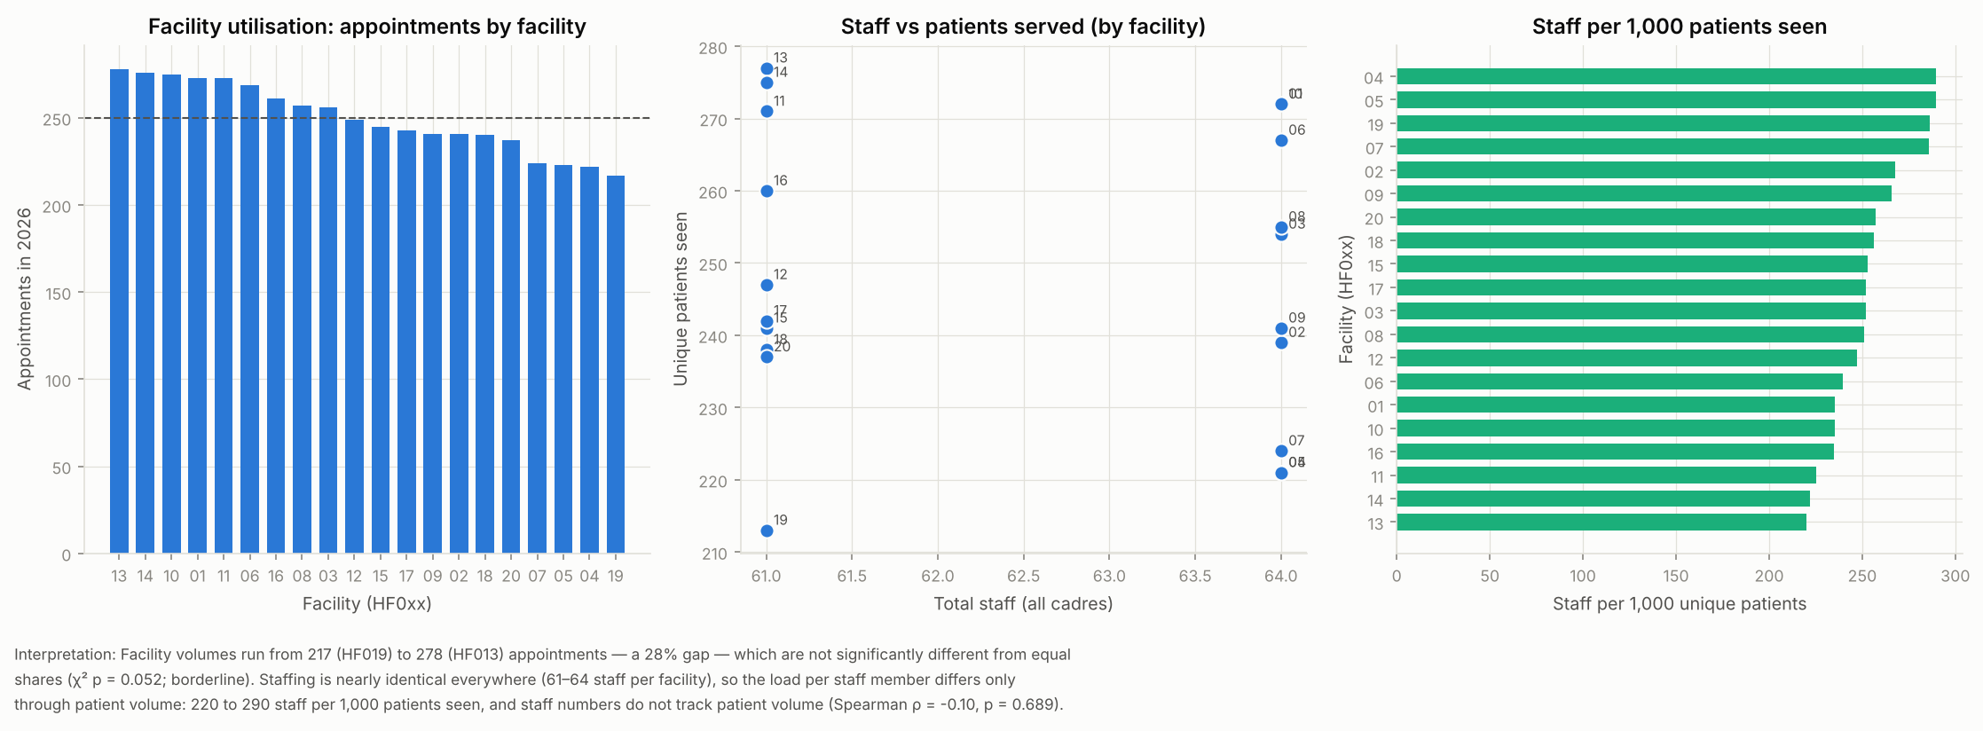

Figure 12. Bed occupancy – lower-bound estimate
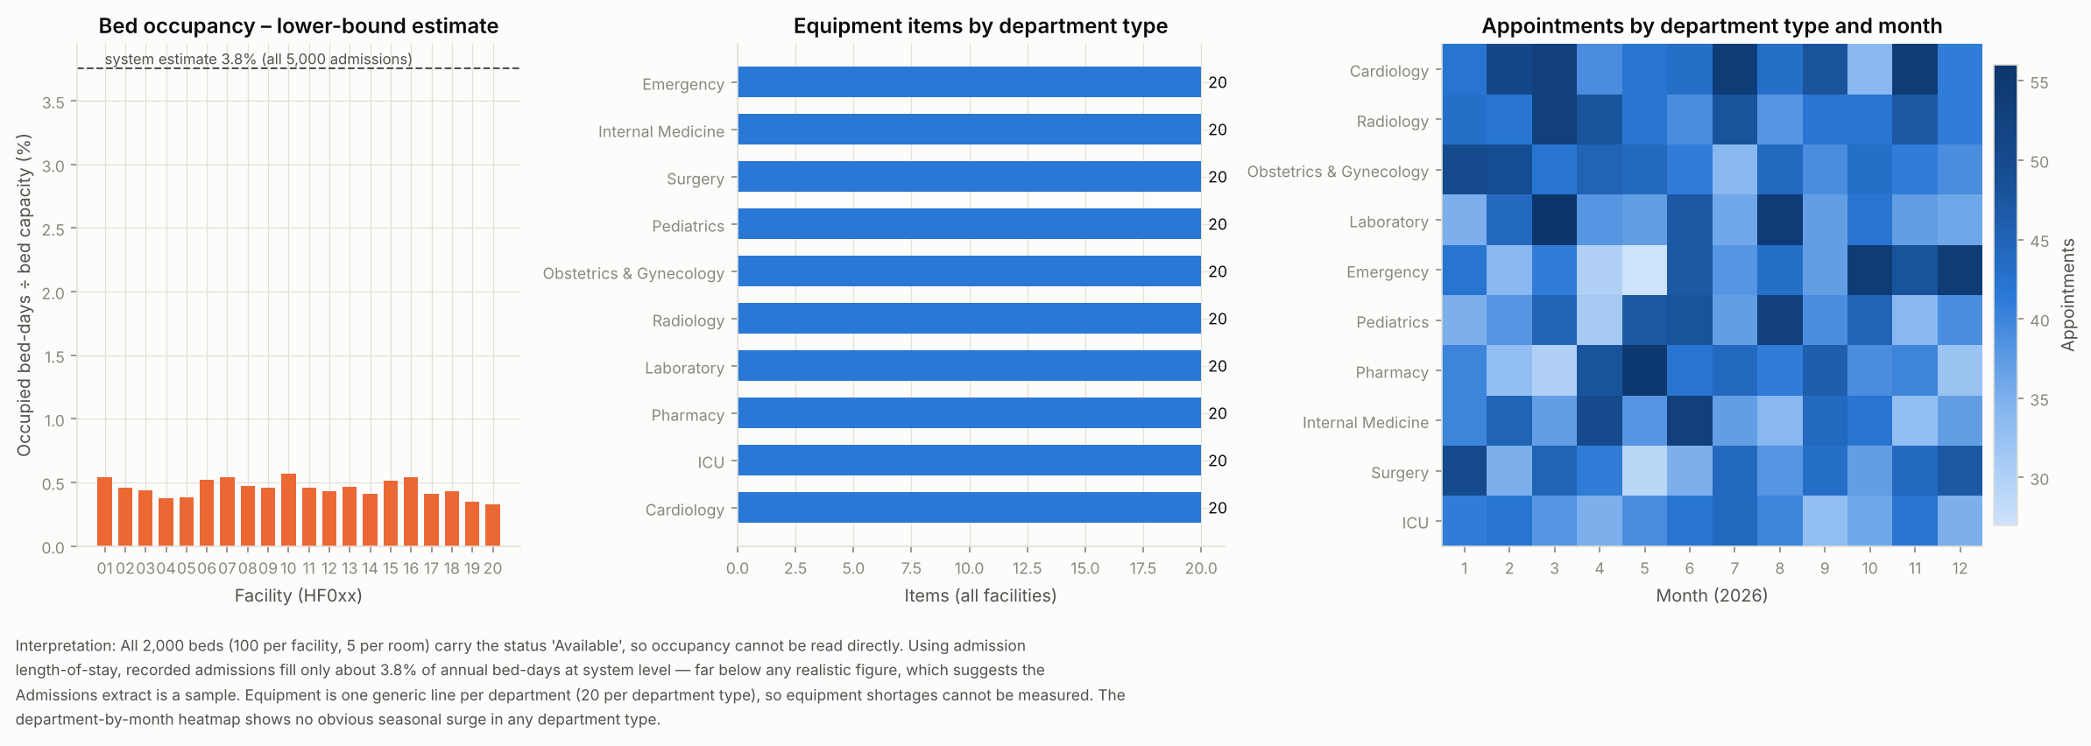

5. Financial analysis (revenue, billing, claims, payments)

Figure 13. Monthly revenue (Revenue_Summary)
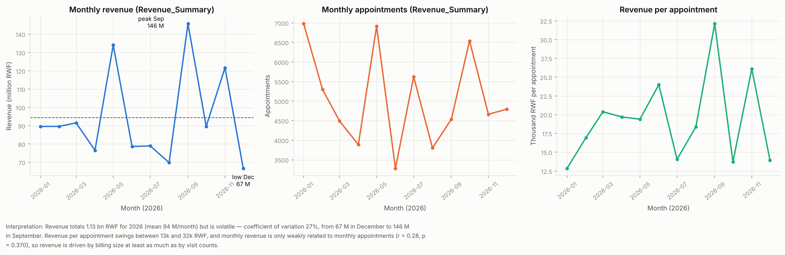

Figure 14. Billing amount distribution (60,000 bills)
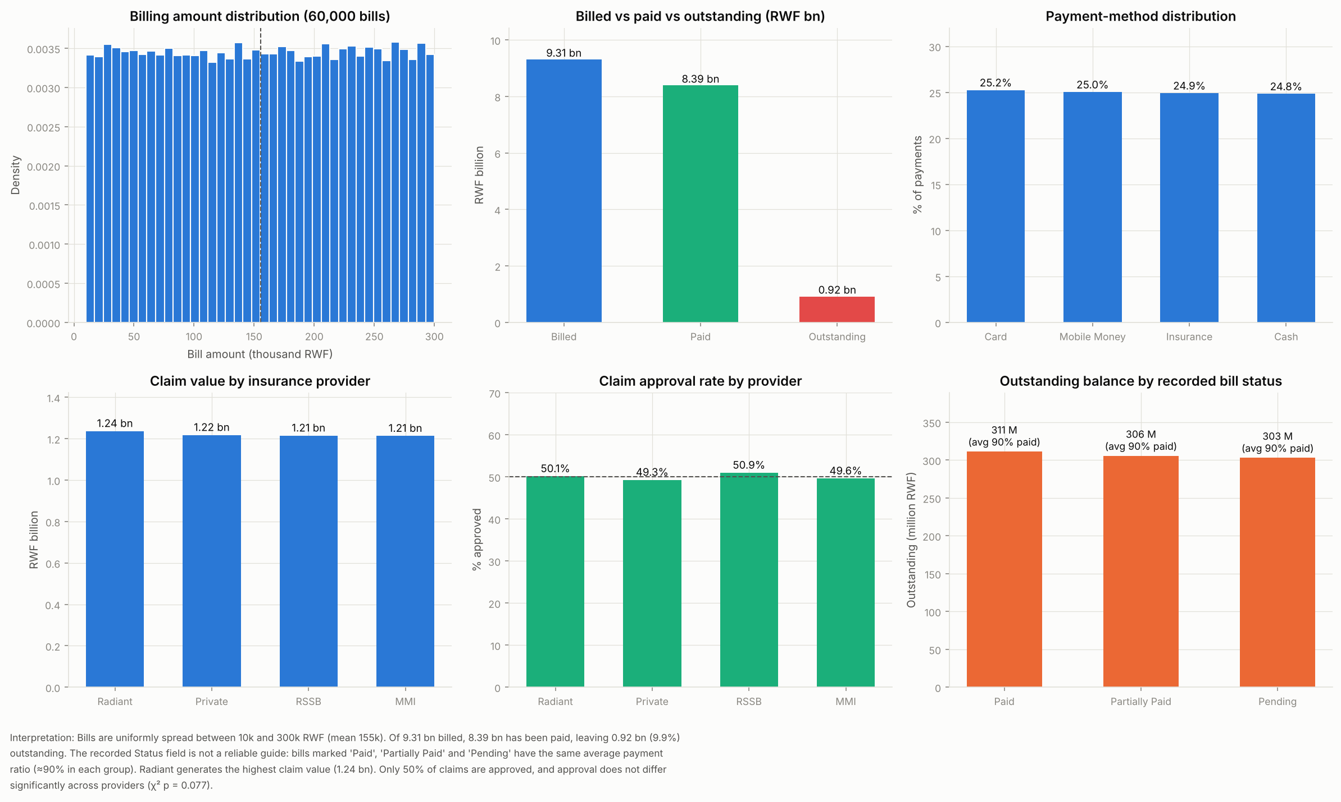

Figure 15. Billed revenue by department type (5,000-appointment cohort)
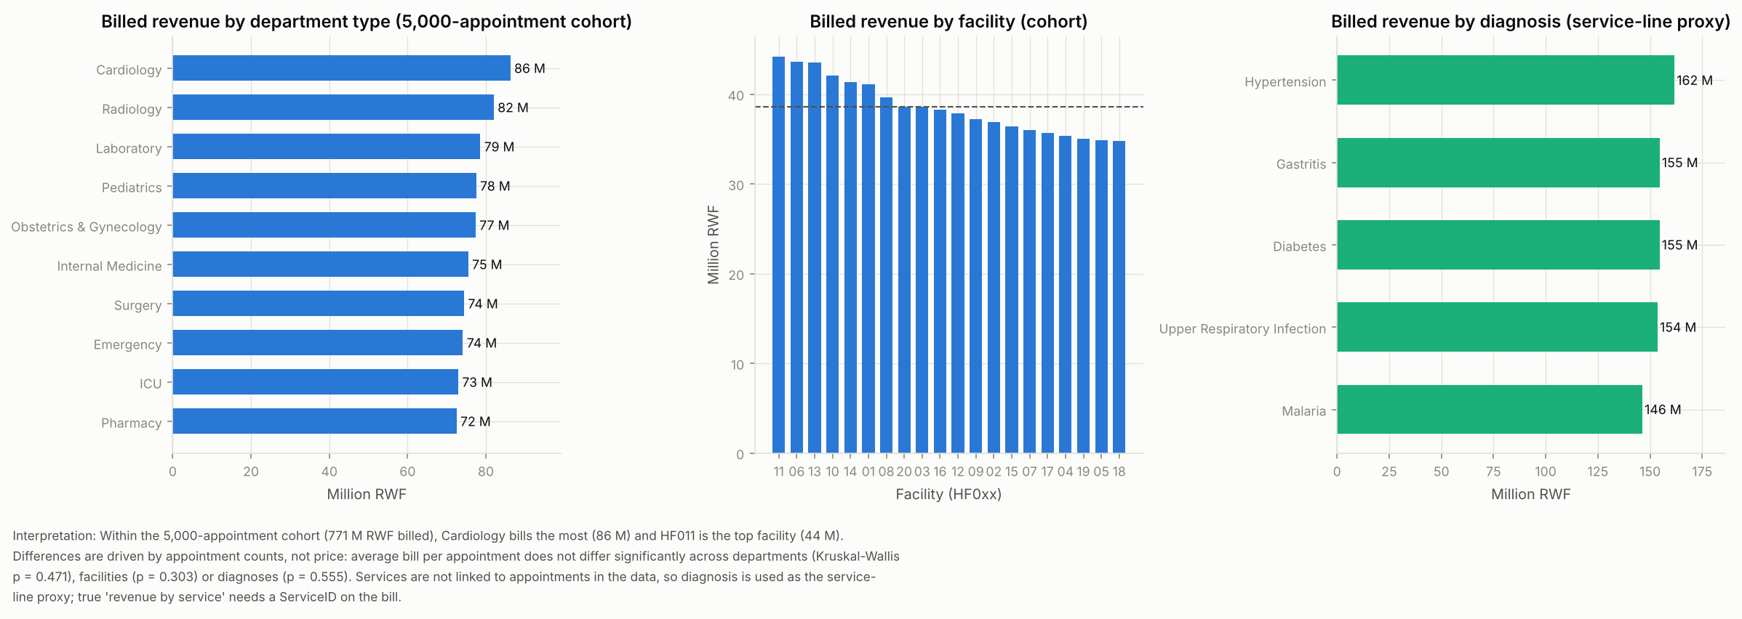

6. Patient experience analysis (satisfaction)

Figure 16. Satisfaction rating distribution (21,064)
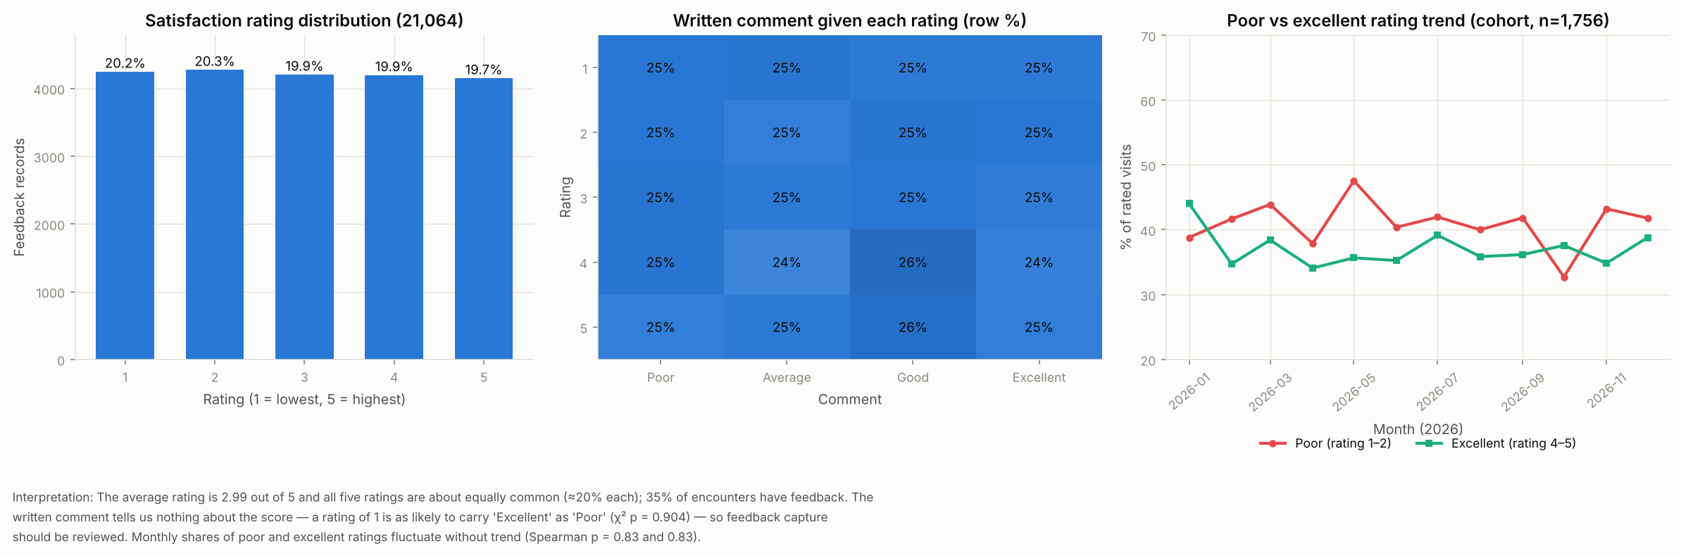

Figure 17. Mean satisfaction by facility (95% CI)
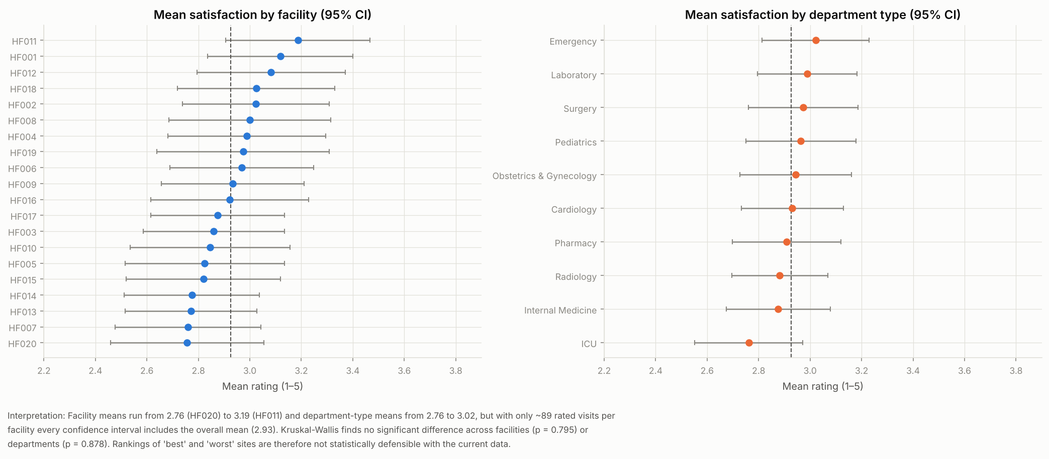

7. Engineered features
Ten features were created and saved in the integrated datasets:
- Age group (7 bands) and BMI category
- Chronic-disease flag and number of conditions
- Clinical risk score and high-risk flag (65+/50–64 with chronic disease, obesity or underweight)
- Visit frequency and recency (days since last appointment)
- Length of stay and admission flag
- Bill amount per visit, payment ratio and outstanding balance
- Claim coverage ratio (claim amount ÷ bill)
- Doctor workload (appointments per clinician) and department workload index
- Facility performance score (0–100: 35% satisfaction, 30% collection rate, 15% claim approval, 20% load per clinician)
- Satisfaction group (poor 1–2, neutral 3, good 4–5)

