Statistical Analysis Report
Descriptive statistics, correlations and hypothesis tests
HealthConnect Rwanda · AnalystLab Africa Experience Lab, Week 6 · Track 2: Healthcare Predictive Analytics and Population Health Intelligence

1. Summary
- 15 hypothesis tests were run at α = 0.05; 0 rejected the null hypothesis, also after Holm correction for multiple testing.
- Of 26 candidate admission factors screened, 0 remained significant after correction.
- Eleven correlation pairs were examined. The only strong, significant association is facility billed revenue ↔ appointment count (r = 0.90), which is arithmetic: more visits means more bills.
- Interpretation: apart from mechanical links (BMI from height and weight, revenue from volume), recorded variables are statistically independent. This is a data finding as much as a statistical one.

2. Descriptive statistics
Variable | Source | n | Mean | Median | Mode | Std Dev | Variance | Min | P5 | P10 | Q1 (P25) | Q3 (P75) | P90 | P95 | P99 | Max | IQR | Skewness | Excess kurtosis | CV %
Patient age (years) | Patients (20,000) | 20000 | 45.03 | 45.00 | 90.00 | 26.26 | 689.64 | 0 | 4.00 | 9.00 | 22.00 | 68.00 | 82.00 | 86.00 | 90.00 | 90.00 | 46.00 | 0.00531 | -1.19 | 58.31
BMI (kg/m²) | Patients (20,000) | 20000 | 30.04 | 29.20 | 32.00 | 10.43 | 108.70 | 11.10 | 15.00 | 17.10 | 21.70 | 36.90 | 44.60 | 49.30 | 56.10 | 61.20 | 15.20 | 0.458 | -0.39 | 34.70
Height (cm) | Patients (20,000) | 20000 | 164.90 | 165.00 | 152.00 | 14.79 | 218.75 | 140.00 | 142.00 | 145.00 | 152.00 | 178.00 | 185.00 | 188.00 | 190.00 | 190.00 | 26.00 | 0.0164 | -1.22 | 8.97
Weight (kg) | Patients (20,000) | 20000 | 79.76 | 80.00 | 78.00 | 23.38 | 546.62 | 40.00 | 44.00 | 47.00 | 60.00 | 100.00 | 112.00 | 116.00 | 120.00 | 120.00 | 40.00 | 0.0145 | -1.20 | 29.31
Length of stay (days) | Admissions (5,000) | 5000 | 5.49 | 6.00 | 2.00 | 2.87 | 8.26 | 1.00 | 1.00 | 1.00 | 3.00 | 8.00 | 9.00 | 10.00 | 10.00 | 10.00 | 5.00 | -0.00885 | -1.23 | 52.38
Bill amount (RWF) | Billing (60,000) | 60000 | 155,157 | 155,247 | 36,833 | 83,840 | 7,029,207,257 | 10,002 | 24,718 | 38,804 | 82,275 | 227,908 | 271,134 | 285,652 | 296,837 | 299,998 | 145,632 | -0.00309 | -1.21 | 54.04
Amount paid (RWF) | Payments (60,000) | 60000 | 139,824 | 129,822 | 129,528 | 83,370 | 6,950,588,556 | 5,002 | 20,556 | 32,341 | 68,694 | 210,240 | 264,199 | 282,129 | 296,143 | 299,998 | 141,546 | 0.255 | -1.11 | 59.62
Outstanding balance (RWF) | Billing − Payments (60,000) | 60000 | 15,332 | 0 | 0 | 36,038 | 1,298,742,598 | 0 | 0 | 0 | 0 | 0 | 76,387 | 113,261 | 142,715 | 149,991 | 0 | 2.33 | 4.19 | 235.04
Claim amount (RWF) | Insurance claims (42,036) | 42036 | 116,135 | 111,422 | 42,625 | 67,812 | 4,598,533,237 | 5,173 | 17,900 | 28,056 | 59,154 | 165,175 | 211,879 | 236,447 | 270,767 | 298,533 | 106,021 | 0.329 | -0.76 | 58.39
Claim ÷ bill | Insurance claims (42,036) | 42036 | 0.75 | 0.749 | 1.00 | 0.144 | 0.0209 | 0.5 | 0.524 | 0.549 | 0.625 | 0.875 | 0.951 | 0.976 | 0.995 | 1 | 0.249 | 0.00343 | -1.19 | 19.26
Satisfaction rating (1–5) | Feedback (21,064) | 21064 | 2.99 | 3.00 | 2.00 | 1.41 | 2.00 | 1.00 | 1.00 | 1.00 | 2.00 | 4.00 | 5.00 | 5.00 | 5.00 | 5.00 | 2.00 | 0.013 | -1.30 | 47.29
Staff experience (years) | All staff (1,250) | 1250 | 12.93 | 13.00 | 3.00 | 7.17 | 51.45 | 1.00 | 2.00 | 3.00 | 6.00 | 19.00 | 23.00 | 24.00 | 25.00 | 25.00 | 13.00 | 0.017 | -1.20 | 55.48
Appointments per doctor | Appointments × doctors (350) | 350 | 14.29 | 14.00 | 15.00 | 3.68 | 13.56 | 5.00 | 9.00 | 10.00 | 12.00 | 16.00 | 19.00 | 21.00 | 24.00 | 28.00 | 4.00 | 0.373 | 0.411 | 25.78
Monthly revenue (M RWF) | Revenue summary (12) | 12 | 94.39 | 89.60 | 66.69 | 25.60 | 655.26 | 66.69 | 68.42 | 70.51 | 78.17 | 99.08 | 132.85 | 139.34 | 144.48 | 145.76 | 20.91 | 0.956 | -0.419 | 27.12
Monthly appointments | Revenue summary (12) | 12 | 5,067 | 4,728 | 3,280 | 1,230 | 1,511,955 | 3,280 | 3,567 | 3,810 | 4,340 | 5,852 | 6,876 | 6,943 | 6,972 | 6,979 | 1,512 | 0.349 | -1.06 | 24.27

3. Distributions

Figure 18. Distributions of key numeric variables (dashed = median, dotted = quartiles)
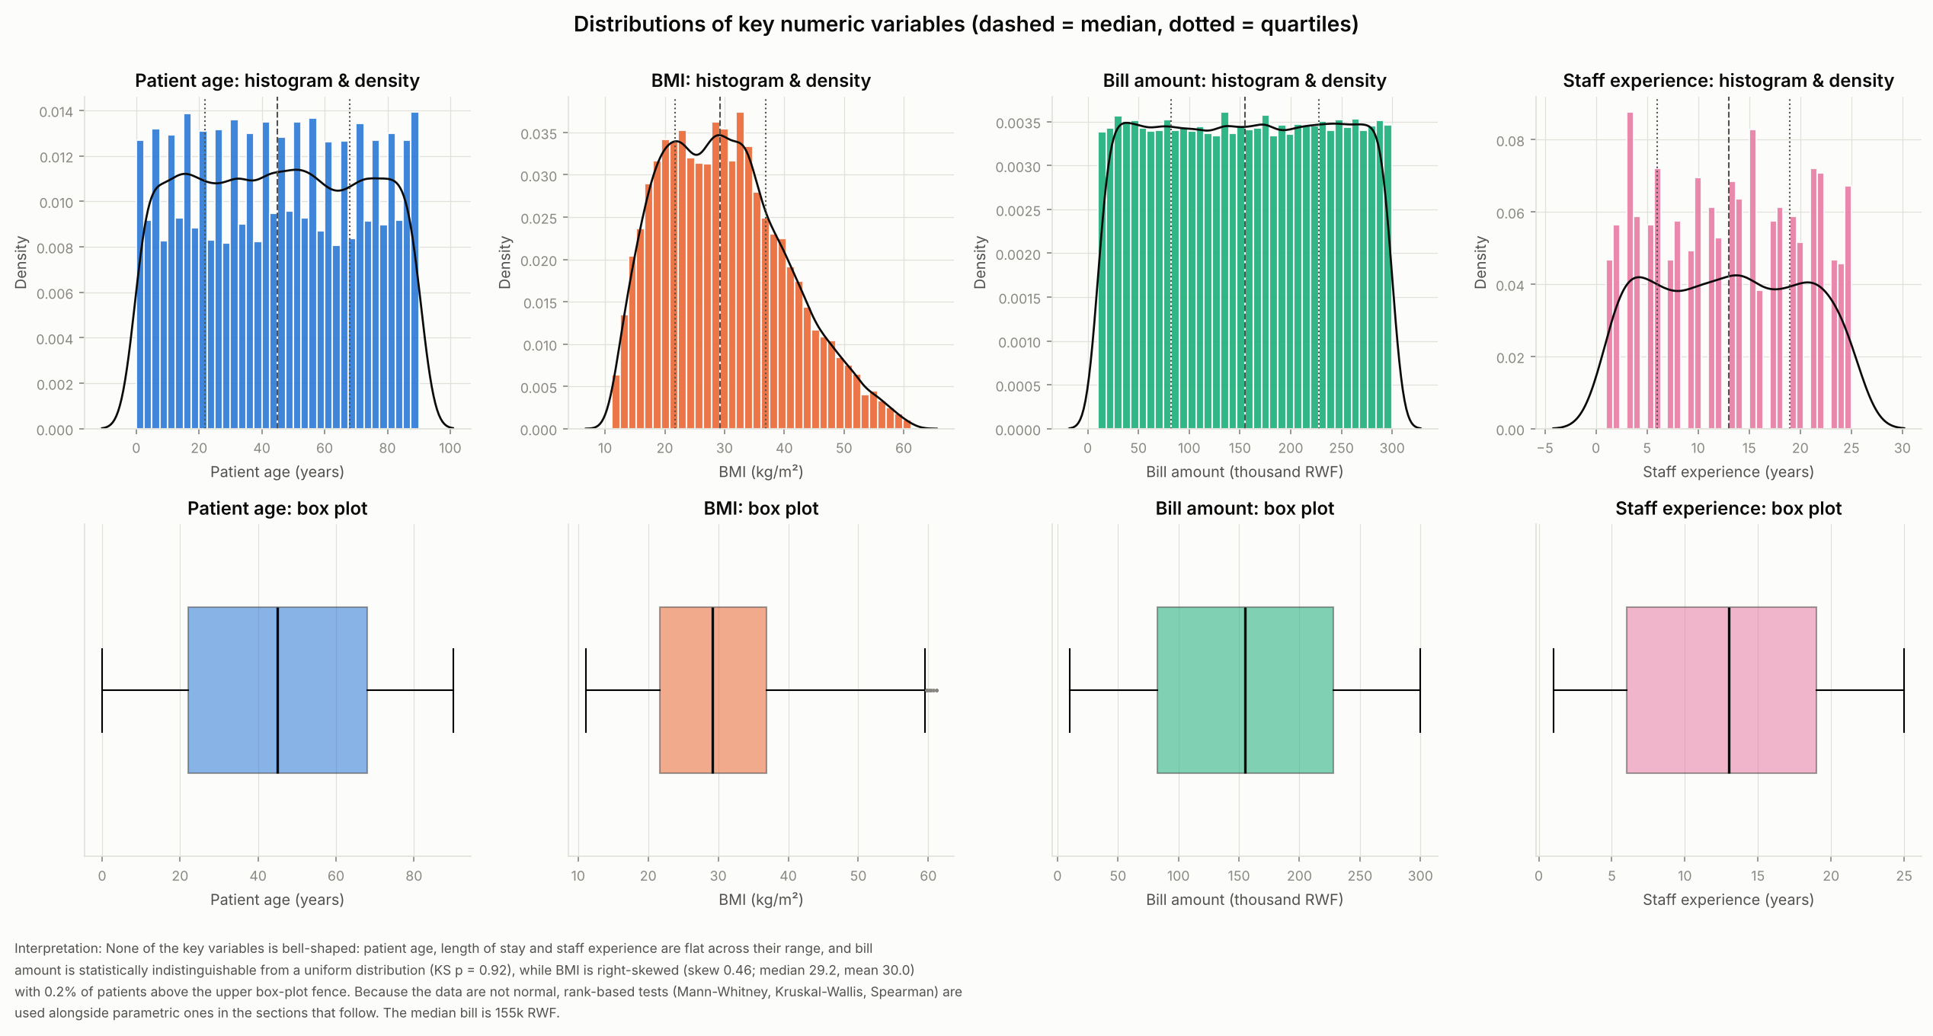

Figure 19. Bill amount by disease severity
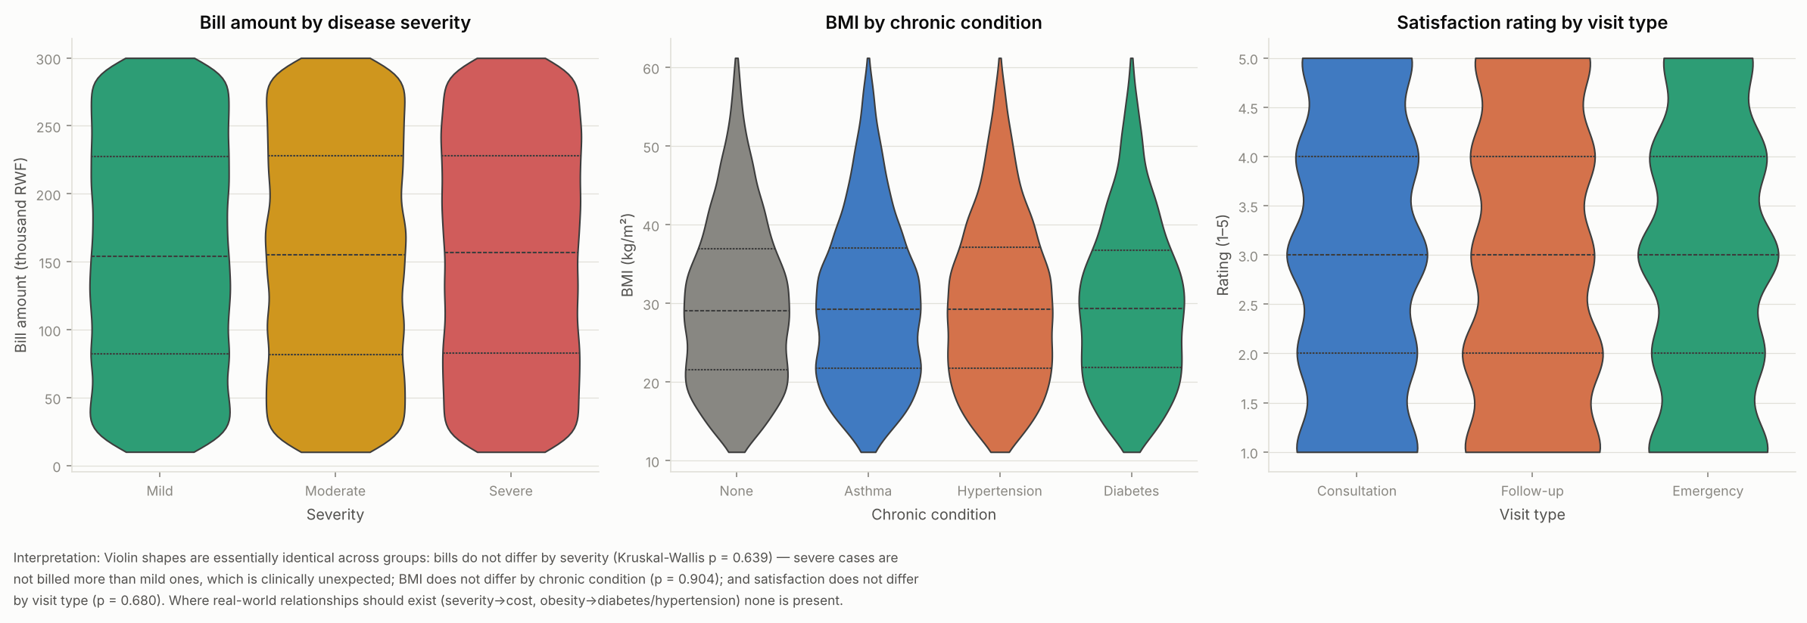

4. Correlation analysis
Pair | Data | n | Method | Coefficient | p_value | Strength | Sig.
Age ↔ hospital admission (0/1) | Appointment cohort | 5000 | Point-biserial (Spearman ρ = 0.021) | 0.021 | 0.129 | negligible | No
Age ↔ billing amount | Appointment cohort | 5000 | Pearson (Spearman ρ = -0.003) | -0.003 | 0.859 | negligible | No
Diagnosis ↔ length of stay | Admitted cohort | 586 | Kruskal-Wallis; η = 0.073 (ANOVA p = 0.544) | 0.073 | 0.538 | negligible | No
Department workload index ↔ mean satisfaction | 200 departments (IDs) | 200 | Spearman | -0.024 | 0.731 | negligible | No
… same, 10 department types | 10 department types | 10 | Spearman | 0.225 | 0.532 | weak | No
… same, 20 facilities (appts per clinician) | 20 facilities | 20 | Spearman | 0.019 | 0.937 | negligible | No
Monthly revenue ↔ monthly appointments | Revenue summary, 12 months | 12 | Pearson (Spearman ρ = 0.329) | 0.285 | 0.37 | weak | No
… facility billed revenue ↔ appointments | 20 facilities (cohort) | 20 | Pearson | 0.896 | 8.95e-08 | strong | Yes
Insurance code (15) ↔ healthcare utilisation (visited yes/no) | 20,000 patients | 20000 | χ²; Cramér's V = 0.006 | 0.006 | 0.693 | negligible | No
Claim coverage ratio ↔ bill amount | 42,036 bills with claims | 42036 | Spearman | 0.001 | 0.862 | negligible | No
Claim filed (0/1) ↔ bill amount | 60,000 bills | 60000 | Point-biserial | -0.006 | 0.155 | negligible | No

Figure 20. Spearman correlation heatmap — encounter master (pairwise complete observations)
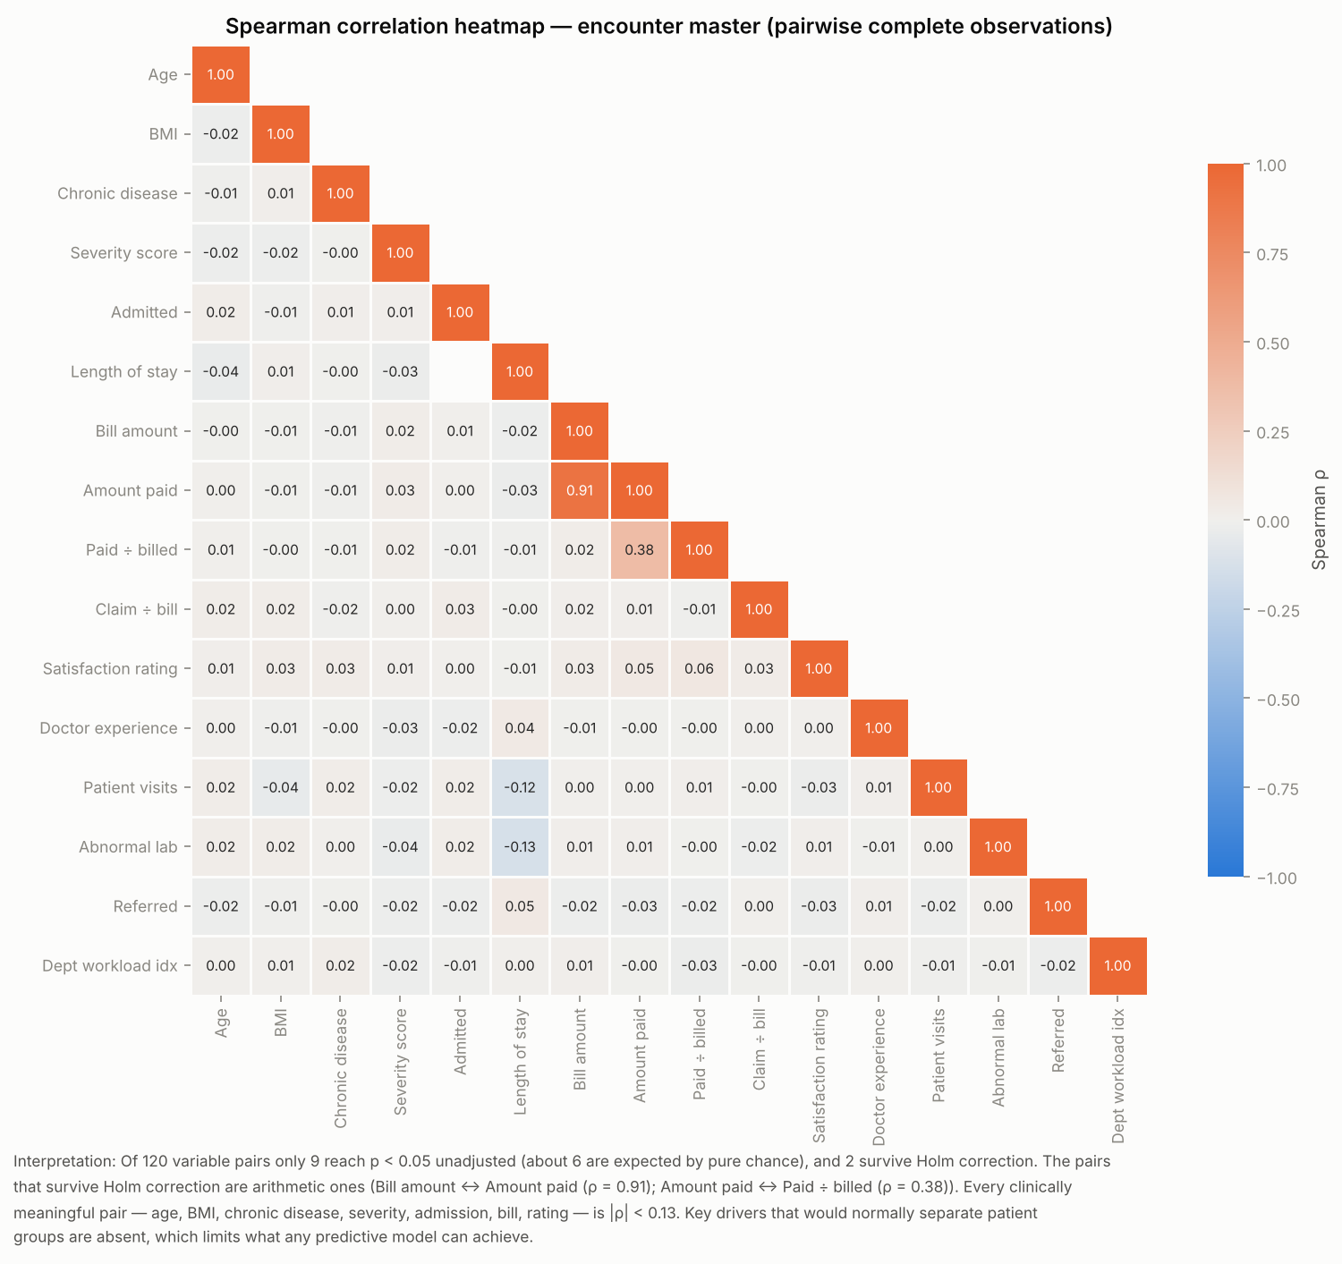

Figure 21. Pair plot — age, BMI, bill amount, doctor experience by severity
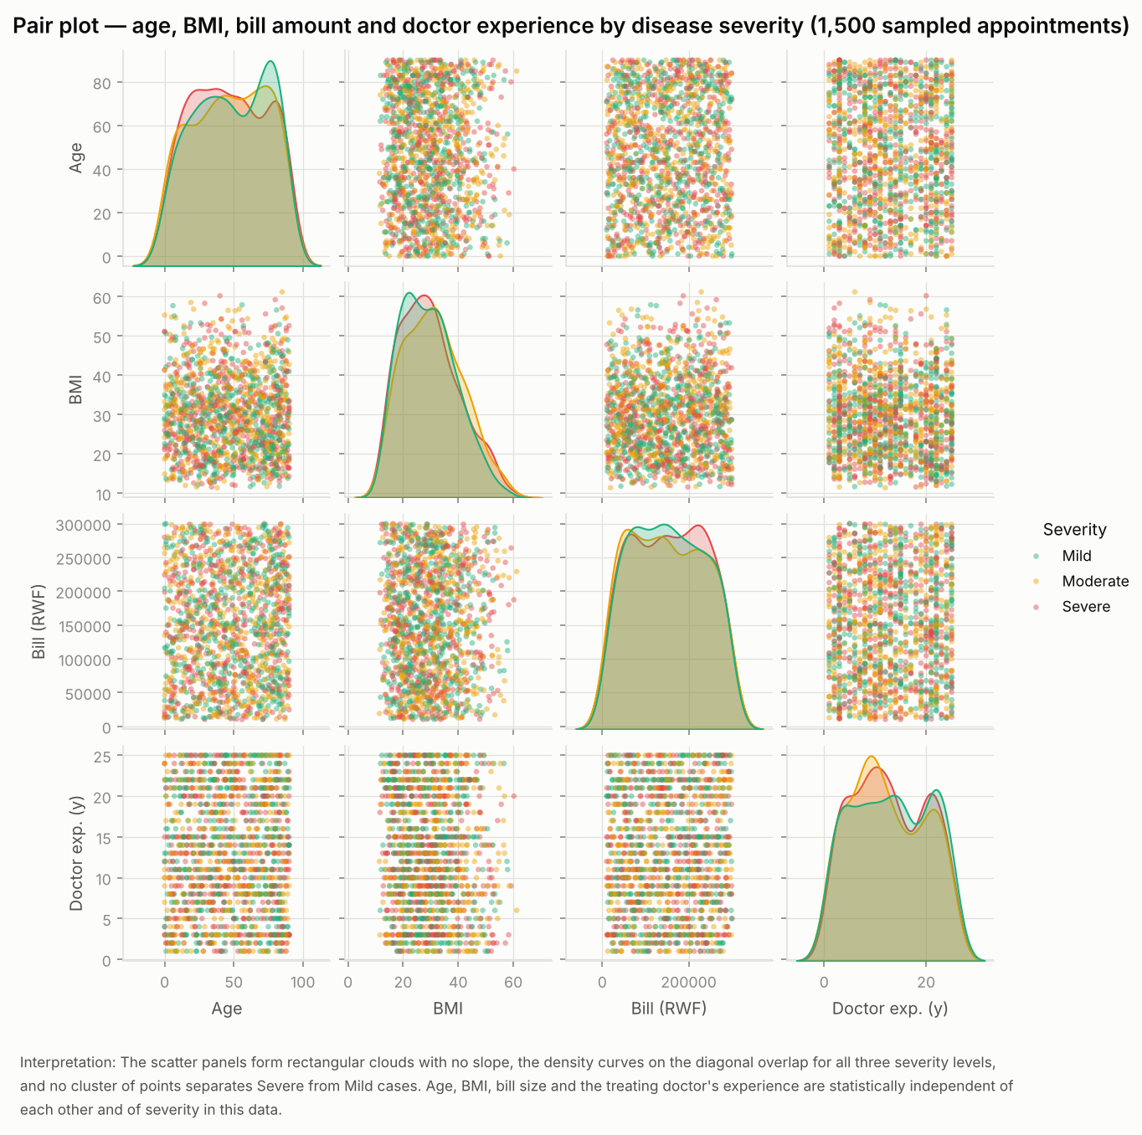

Figure 22. Admission rate by age group (95% CI)
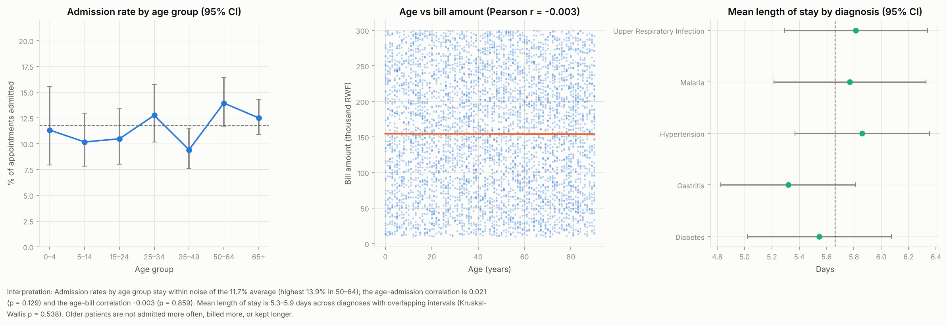

5. Admission and chronic-disease risk factors

Figure 23. Association of each factor with admission
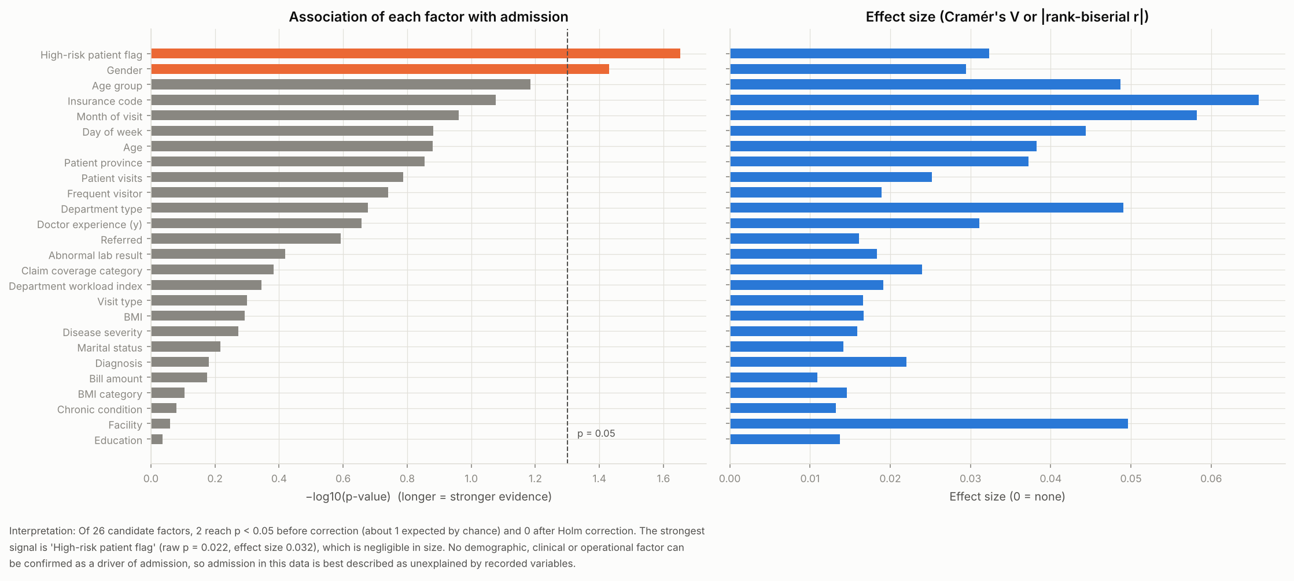

Figure 24. Chronic-disease prevalence by patient group with 95% Wilson CI (red = interval excludes overall 74.6%)
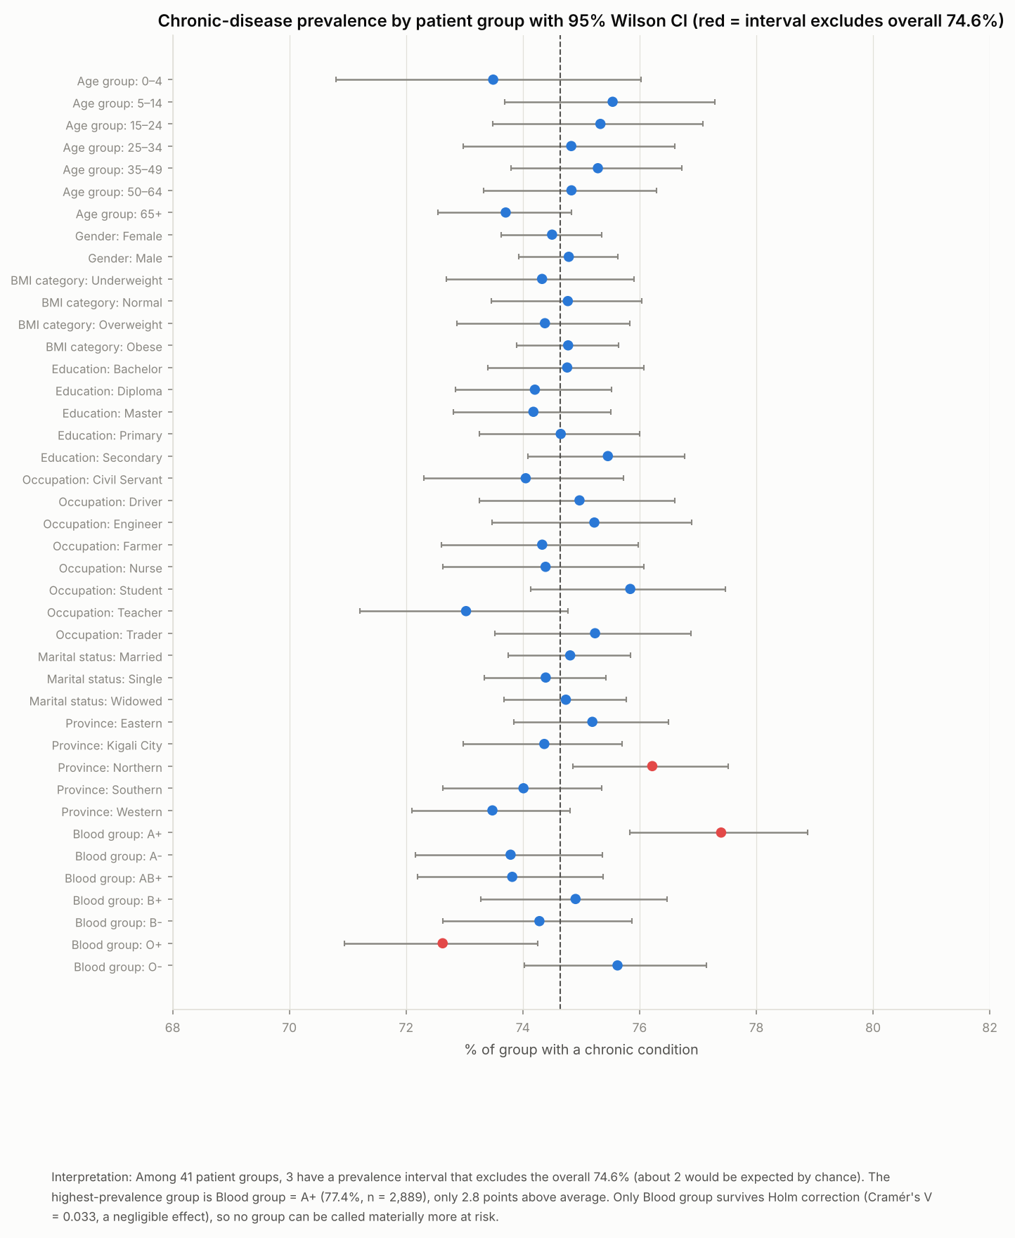

Figure 25. Logistic regression: odds ratios for any chronic disease (95% bootstrap CI)
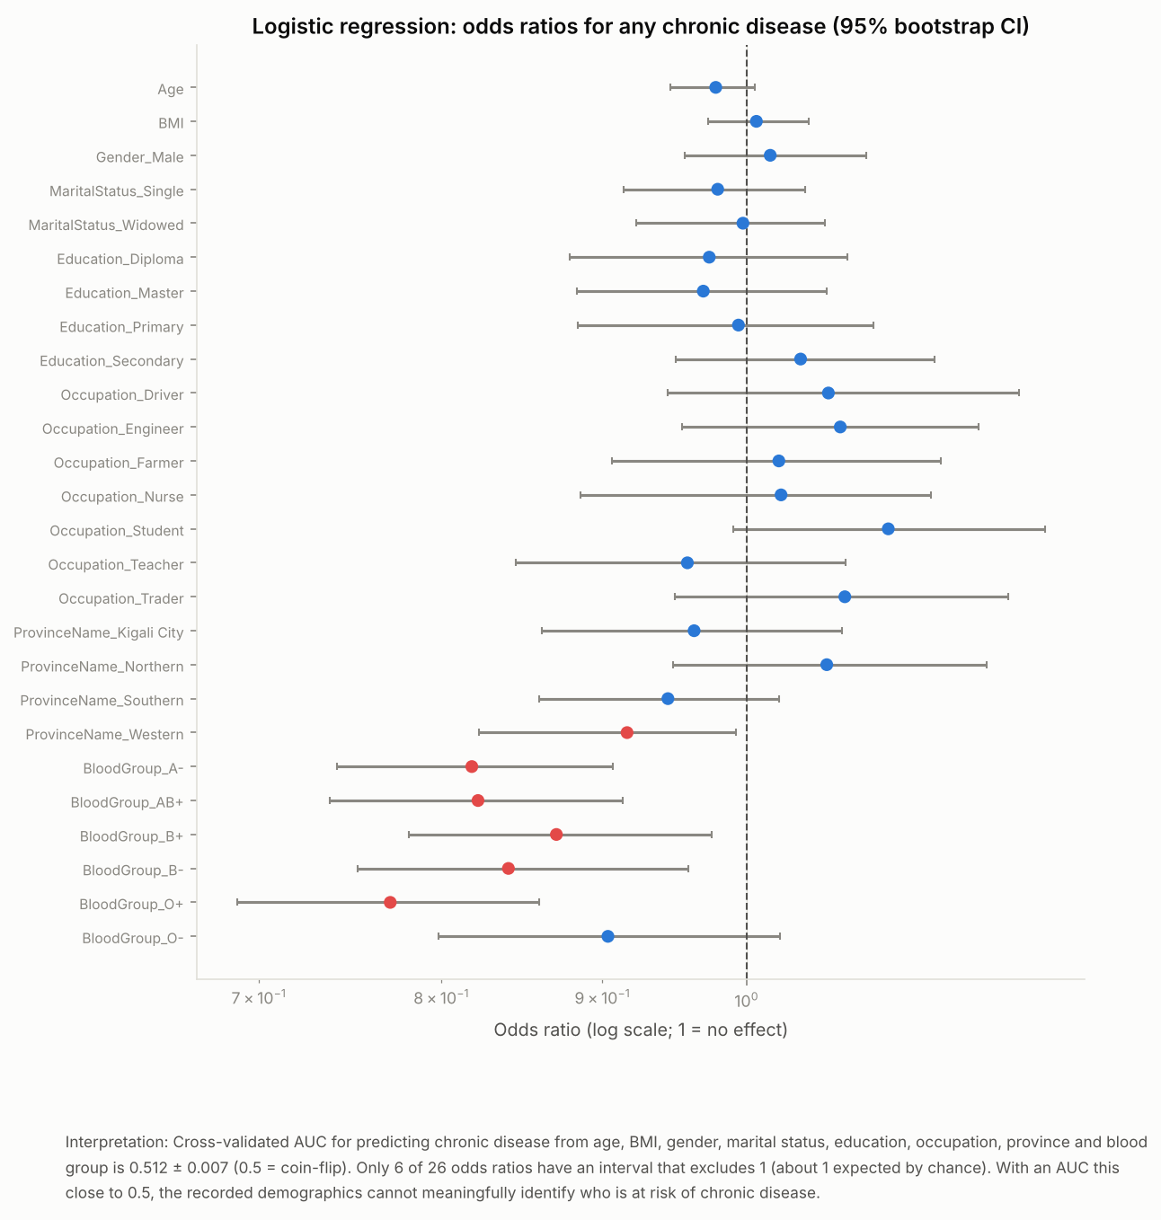

6. Hypothesis tests
Each test states H0 and H1, the test used, α, sample size, test statistic, p-value, effect size and decision. Holm-adjusted p-values control the family-wise error rate across all tests.

H1. Do average bills differ between bills with an insurance claim and bills without? (100% of patients are insured, so 'uninsured' cannot be tested)
Item | Detail
H0 | Mean bill (claim) = mean bill (no claim)
H1 | Mean bills differ
Test | Welch two-sample t-test (Mann-Whitney U agrees: p = 0.155)
α / n | 0.05 / 60,000
Statistic | -1.42
p-value (Holm) | 0.154 (1)
Effect size | -0.0127 (Cohen's d)
Decision | Fail to reject H0
Conclusion | No significant difference (p = 0.154); effect size -0.013 is negligible. Mean bill 154,838 RWF with claim vs 155,903 RWF without (-1,065).

H1b. Do bills paid via the 'Insurance' method differ from other payment methods?
Item | Detail
H0 | Mean bill equal
H1 | Mean bill differs
Test | Welch t-test
α / n | 0.05 / 60,000
Statistic | 0.439
p-value (Holm) | 0.661 (1)
Effect size | 0.00414 (Cohen's d)
Decision | Fail to reject H0
Conclusion | No significant difference (p = 0.661); effect size 0.004 is negligible. 155,417 vs 155,070 RWF.

H2. Does patient satisfaction differ across the 20 facilities?
Item | Detail
H0 | Median rating identical in all facilities
H1 | At least one facility differs
Test | Kruskal-Wallis H (one-way ANOVA agrees: p = 0.785)
α / n | 0.05 / 1,756
Statistic | 13.8
p-value (Holm) | 0.795 (1)
Effect size | 0.00786 (ε² (rank))
Decision | Fail to reject H0
Conclusion | No significant difference (p = 0.795); effect size 0.008 is negligible. Facility means 2.76–3.19.

H2b. Does satisfaction differ across the 10 department types?
Item | Detail
H0 | Median rating identical
H1 | At least one differs
Test | Kruskal-Wallis H
α / n | 0.05 / 1,756
Statistic | 4.47
p-value (Holm) | 0.878 (1)
Effect size | 0.00255 (ε² (rank))
Decision | Fail to reject H0
Conclusion | No significant difference (p = 0.878); effect size 0.003 is negligible.

H3. Do admission rates differ between age groups?
Item | Detail
H0 | Admission rate equal across the 7 age groups
H1 | At least one age group differs
Test | χ² test of independence (df = 6)
α / n | 0.05 / 5,000
Statistic | 11.9
p-value (Holm) | 0.0653 (0.98)
Effect size | 0.0487 (Cramér's V)
Decision | Fail to reject H0
Conclusion | No significant difference (p = 0.065); effect size 0.049 is negligible. Rates 9.4%–13.9%.

H4. Does satisfaction depend on disease severity?
Item | Detail
H0 | Rating distribution identical across Mild/Moderate/Severe
H1 | Differs
Test | Kruskal-Wallis H
α / n | 0.05 / 21,064
Statistic | 0.36
p-value (Holm) | 0.835 (1)
Effect size | 1.71e-05 (ε² (rank))
Decision | Fail to reject H0
Conclusion | No significant difference (p = 0.835); effect size 0.000 is negligible.

H5. Does length of stay differ by diagnosis?
Item | Detail
H0 | Median LOS equal across diagnoses
H1 | At least one differs
Test | Kruskal-Wallis H
α / n | 0.05 / 586
Statistic | 3.12
p-value (Holm) | 0.538 (1)
Effect size | 0.00533 (ε² (rank))
Decision | Fail to reject H0
Conclusion | No significant difference (p = 0.538); effect size 0.005 is negligible. Mean LOS 5.3–5.9 d.

H6. Is satisfaction related to billing outcome (recorded bill status)?
Item | Detail
H0 | Rating equal across Paid / Partially Paid / Pending
H1 | Differs
Test | Kruskal-Wallis H (Spearman ρ rating vs paid ratio = -0.001, p = 0.893)
α / n | 0.05 / 21,064
Statistic | 0.669
p-value (Holm) | 0.716 (1)
Effect size | 3.18e-05 (ε² (rank))
Decision | Fail to reject H0
Conclusion | No significant difference (p = 0.716); effect size 0.000 is negligible.

H7. Are emergency visits admitted more often than other visits?
Item | Detail
H0 | Admission proportion equal
H1 | Proportions differ
Test | χ² test (2×2, Yates)
α / n | 0.05 / 5,000
Statistic | 0.689
p-value (Holm) | 0.406 (1)
Effect size | 0.0117 (φ)
Decision | Fail to reject H0
Conclusion | No significant difference (p = 0.406); effect size 0.012 is negligible. Emergency 11.2% vs other 12.0%.

H8. Are severe cases admitted more often than mild cases?
Item | Detail
H0 | Admission rate equal across severity levels
H1 | Differs
Test | χ² test (df = 2)
α / n | 0.05 / 5,000
Statistic | 1.26
p-value (Holm) | 0.533 (1)
Effect size | 0.0159 (Cramér's V)
Decision | Fail to reject H0
Conclusion | No significant difference (p = 0.533); effect size 0.016 is negligible. Rates: Mild 11.7%, Moderate 11.1%, Severe 12.4%

H9. Does chronic-disease prevalence differ by gender?
Item | Detail
H0 | Prevalence equal for men and women
H1 | Differs
Test | χ² test (2×2, Yates)
α / n | 0.05 / 20,000
Statistic | 0.202
p-value (Holm) | 0.653 (1)
Effect size | 0.00318 (φ)
Decision | Fail to reject H0
Conclusion | No significant difference (p = 0.653); effect size 0.003 is negligible.

H10. Does chronic-disease prevalence differ by age group?
Item | Detail
H0 | Prevalence equal across age groups
H1 | Differs
Test | χ² test (df = 6)
α / n | 0.05 / 20,000
Statistic | 5.71
p-value (Holm) | 0.456 (1)
Effect size | 0.0169 (Cramér's V)
Decision | Fail to reject H0
Conclusion | No significant difference (p = 0.456); effect size 0.017 is negligible.

H11. Is the written comment related to the numeric rating?
Item | Detail
H0 | Comment independent of rating
H1 | Associated
Test | χ² test of independence
α / n | 0.05 / 21,064
Statistic | 6.24
p-value (Holm) | 0.904 (1)
Effect size | 0.00993 (Cramér's V)
Decision | Fail to reject H0
Conclusion | No significant difference (p = 0.904); effect size 0.010 is negligible. A valid feedback instrument should show strong association.

H12. Does the claim approval rate differ between insurance providers?
Item | Detail
H0 | Approval rate equal
H1 | Differs
Test | χ² test (df = 3)
α / n | 0.05 / 42,036
Statistic | 6.86
p-value (Holm) | 0.0766 (1)
Effect size | 0.0128 (Cramér's V)
Decision | Fail to reject H0
Conclusion | No significant difference (p = 0.077); effect size 0.013 is negligible.

H13. Does the share of the bill actually paid differ by payment method?
Item | Detail
H0 | Payment ratio equal across methods
H1 | Differs
Test | Kruskal-Wallis H
α / n | 0.05 / 60,000
Statistic | 2.87
p-value (Holm) | 0.412 (1)
Effect size | 4.79e-05 (ε² (rank))
Decision | Fail to reject H0
Conclusion | No significant difference (p = 0.412); effect size 0.000 is negligible.

Figure 26. Hypothesis tests at a glance (red = significant at α = 0.05)
