Predictive Analytics Report
Forecasting, classification, regression, clustering and PCA
HealthConnect Rwanda · AnalystLab Africa Experience Lab, Week 6 · Track 2: Healthcare Predictive Analytics and Population Health Intelligence

1. Summary
Task | Result | Validation | Verdict
Visit forecast (12 months) | Simple exponential smoothing ≈ 4,975 visits/month (≈59,700 in 2027) | MAPE 14.0% vs 15.3% for the historical mean | Useful only as a flat baseline; no trend
Revenue forecast (12 months) | ≈ 1.10 bn RWF for 2027 (≈92 M/month) | MAPE 26% vs 27% for the mean | High uncertainty (95% band ±68%)
Admission prediction | Best CV AUC 0.514 | Permutation p = 0.32; hold-out AUC 0.529 (0.47–0.59) | No predictive signal (chance = 0.50)
Satisfaction prediction | Best real-model R² -0.001 | Permutation p = 0.44; hold-out R² -0.007 | No predictive signal
Department workload forecast | Cardiology and Radiology highest (load index 109 and 105) | Monte-Carlo overload probability 26%–38% | Differences not significant
Clustering | Patients: 3 chronic-condition groups + none; Facilities: 2 volume-based groups; Departments: continuous | Silhouette 0.28 / 0.19 / 0.14 | Weak structure; for peer grouping only

Method principle: every model is compared with a naive baseline and with a label-permutation null, using cross-validation and (for classification) a held-out test set. A model is only reported as useful if it beats those benchmarks. Statsmodels and Jupyter could not be installed in the analysis sandbox, so exponential-smoothing models were implemented directly in NumPy and the notebook was executed with a custom runner; the notebook file is a standard .ipynb with all outputs saved.

2. Forecasting (visits, revenue, department workload)
With only 12 monthly observations, models were chosen by rolling-origin back-testing (minimum 6 months training, horizons 1–3). The Mean, Naïve, Linear trend, Simple Exponential Smoothing and damped Holt models were compared; 95% bands come from back-test RMSE.

Visit forecast back-test
Model | MAE | RMSE | MAPE
Simple exp. smoothing | 736.67 | 978.51 | 14.04
Mean | 758.79 | 903.47 | 15.28
Holt damped trend | 1,112 | 1,427 | 21.17
Linear trend | 1,167 | 1,491 | 21.65
Naïve (last value) | 1,228 | 1,464 | 24.24

Revenue forecast back-test
Model | MAE | RMSE | MAPE
Simple exp. smoothing | 26,183,534 | 31,781,845 | 25.56
Mean | 26,980,202 | 31,897,882 | 27.00
Holt damped trend | 27,143,406 | 32,295,130 | 27.16
Linear trend | 31,476,605 | 36,232,057 | 33.37
Naïve (last value) | 38,636,863 | 46,648,548 | 39.38

Figure 27. Monthly patient visits — 12-month forecast (Simple exp. smoothing)
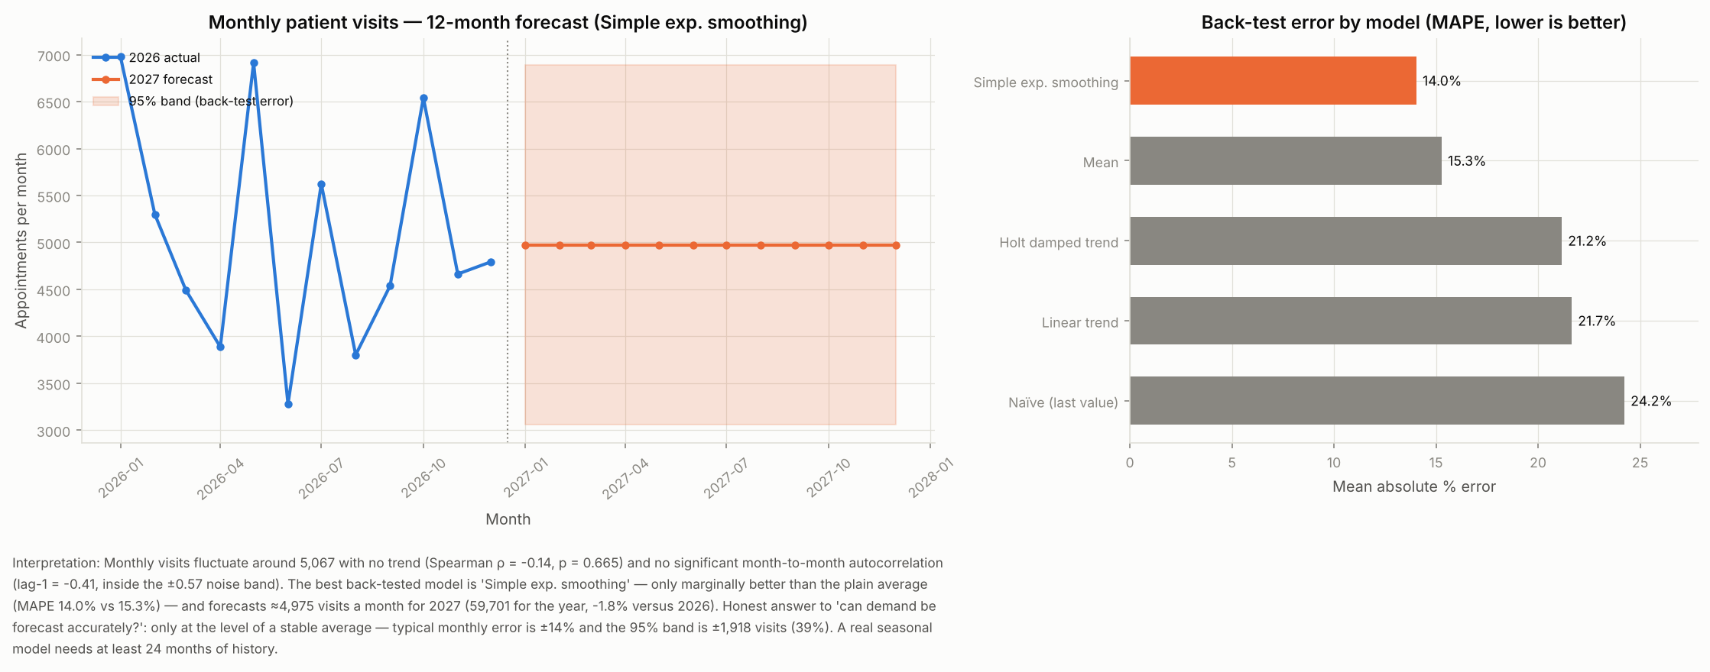

Figure 28. Monthly revenue — 12-month forecast (Simple exp. smoothing)
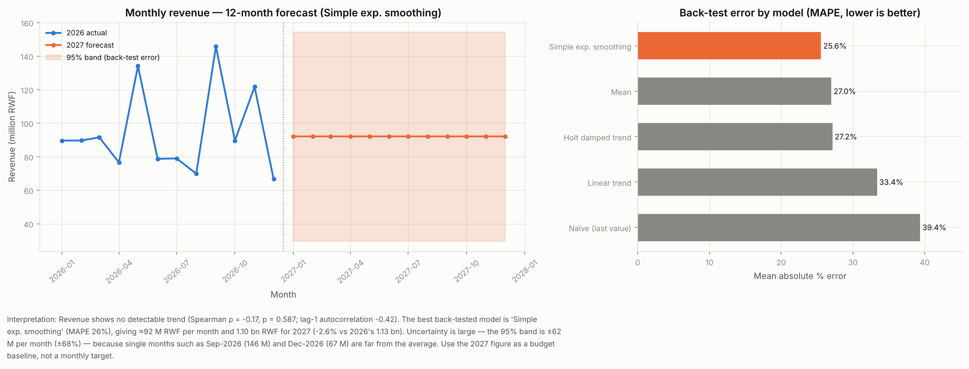

Figure 29. Forecast 2027 visits per month by department type
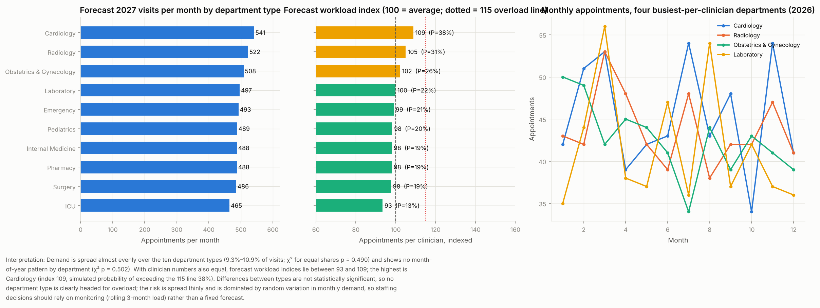

Department workload forecast
DepartmentName | Share_of_visits | Clinicians | Fcst_visits_per_month | Fcst_per_clinician | P_overload | Hist_WorkloadIndex | Fcst_WorkloadIndex
Cardiology | 0.11 | 105 | 541.29 | 5.16 | 0.38 | 108.80 | 108.80
Radiology | 0.1 | 105 | 522.38 | 4.98 | 0.31 | 105.00 | 105.00
Obstetrics & Gynecology | 0.1 | 105 | 508.45 | 4.84 | 0.26 | 102.20 | 102.20
Laboratory | 0.1 | 105 | 496.51 | 4.73 | 0.22 | 99.80 | 99.80
Emergency | 0.1 | 105 | 492.53 | 4.69 | 0.21 | 99.00 | 99.00
Pediatrics | 0.1 | 105 | 488.55 | 4.65 | 0.2 | 98.20 | 98.20
Pharmacy | 0.1 | 105 | 487.55 | 4.64 | 0.19 | 98.00 | 98.00
Internal Medicine | 0.1 | 105 | 487.55 | 4.64 | 0.19 | 98.00 | 98.00
Surgery | 0.1 | 105 | 485.56 | 4.62 | 0.19 | 97.60 | 97.60
ICU | 0.09 | 105 | 464.67 | 4.43 | 0.13 | 93.40 | 93.40

3. Hospital admission prediction (classification)
Three feature sets were tested: A booking-time information only; B adding diagnosis and severity; C adding labs, prescriptions and referral. Models: logistic regression, random forest, gradient boosting, against a prior-probability baseline (repeated stratified CV).
FeatureSet | Model | AUC | AUC_sd | PR_AUC | Brier | Brier_baseline
A Booking-time | Baseline (prior) | 0.5 | 0 | 0.117 | 0.103 | 0.103
A Booking-time | Logistic regression | 0.514 | 0.024 | 0.129 | 0.104 | 0.103
A Booking-time | Random forest | 0.504 | 0.022 | 0.126 | 0.104 | 0.103
A Booking-time | Gradient boosting | 0.502 | 0.031 | 0.125 | 0.104 | 0.103
B + Diagnosis & severity | Baseline (prior) | 0.5 | 0 | 0.117 | 0.103 | 0.103
B + Diagnosis & severity | Logistic regression | 0.509 | 0.025 | 0.127 | 0.105 | 0.103
B + Diagnosis & severity | Random forest | 0.501 | 0.025 | 0.126 | 0.104 | 0.103
B + Diagnosis & severity | Gradient boosting | 0.496 | 0.031 | 0.123 | 0.105 | 0.103
C + Labs, Rx, referral | Baseline (prior) | 0.5 | 0 | 0.117 | 0.103 | 0.103
C + Labs, Rx, referral | Logistic regression | 0.51 | 0.023 | 0.126 | 0.105 | 0.103
C + Labs, Rx, referral | Random forest | 0.5 | 0.025 | 0.123 | 0.104 | 0.103
C + Labs, Rx, referral | Gradient boosting | 0.496 | 0.032 | 0.123 | 0.105 | 0.103

Figure 30. Cross-validated AUC by model and feature set
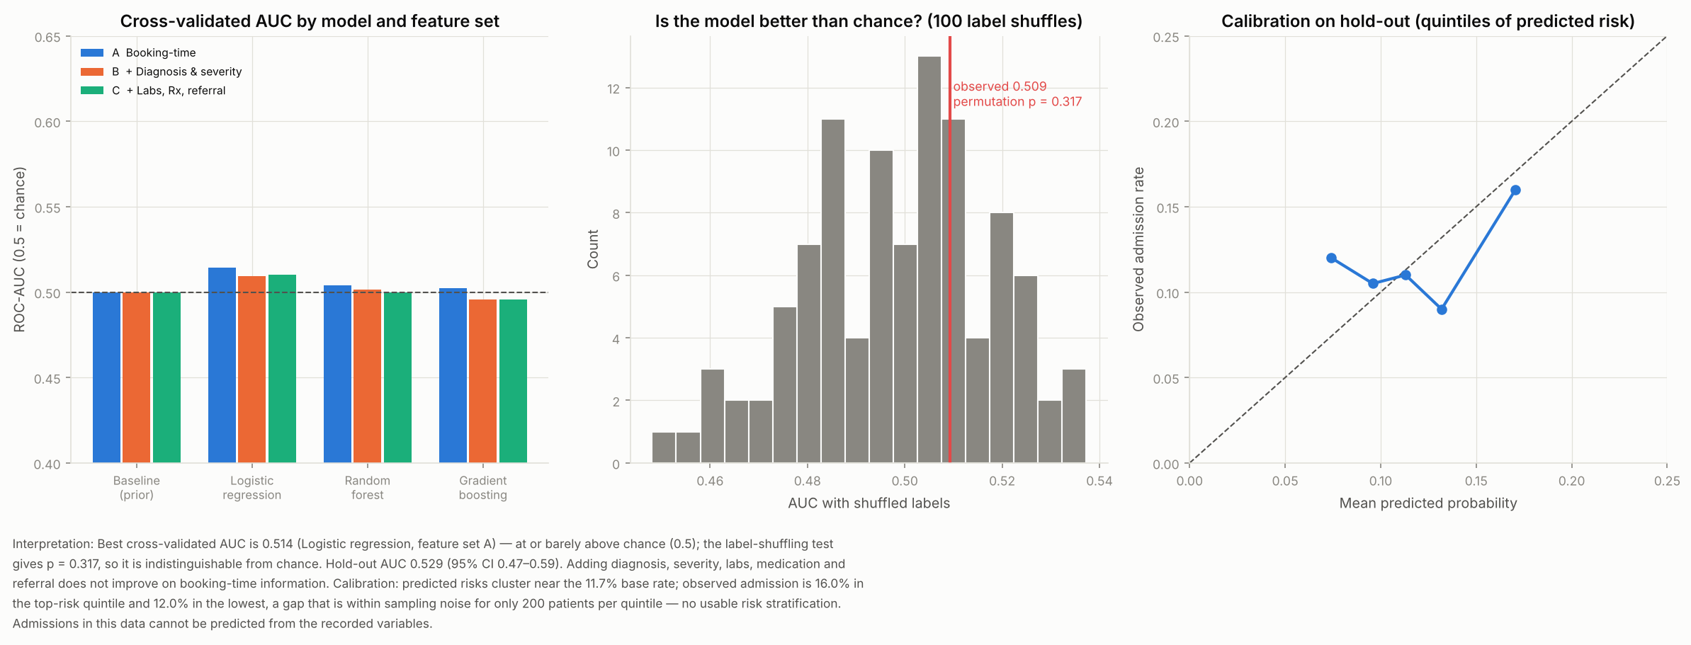

Figure 31. Permutation importance — admission model (drop in hold-out AUC when feature is shuffled)
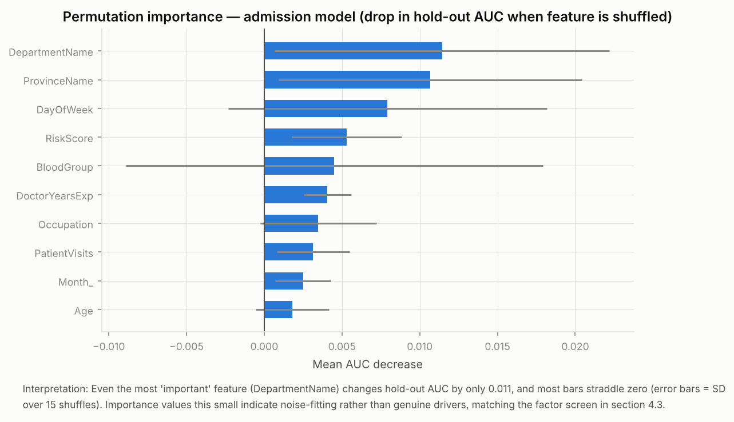

4. Patient satisfaction prediction
Scope | Model | R2 | R2_sd | MAE | AUC | AUC_sd
Scope 1 – all feedback (n=21,064) | Baseline (mean) | -0 | 0 | 1.20
Scope 1 – all feedback (n=21,064) | Ridge | -0.001 | 0.001 | 1.21
Scope 1 – all feedback (n=21,064) | Random forest | -0.005 | 0.002 | 1.21
Scope 1 – all feedback (n=21,064) | Gradient boosting | -0.001 | 0.001 | 1.20
Scope 1 – all feedback (n=21,064) | Logistic regression → P(rating ≥ 4) |  |  |  | 0.498 | 0.008
Scope 1 – all feedback (n=21,064) | Gradient boosting → P(rating ≥ 4) |  |  |  | 0.5 | 0.005
Scope 2 – cohort + operational (n=1,756) | Baseline (mean) | -0.003 | 0.003 | 1.18
Scope 2 – cohort + operational (n=1,756) | Ridge | -0.029 | 0.019 | 1.20
Scope 2 – cohort + operational (n=1,756) | Random forest | -0.009 | 0.01 | 1.18
Scope 2 – cohort + operational (n=1,756) | Gradient boosting | -0.025 | 0.011 | 1.20
Scope 2 – cohort + operational (n=1,756) | Logistic regression → P(rating ≥ 4) |  |  |  | 0.509 | 0.022
Scope 2 – cohort + operational (n=1,756) | Gradient boosting → P(rating ≥ 4) |  |  |  | 0.496 | 0.027

Figure 32. Cross-validated R² for predicting rating
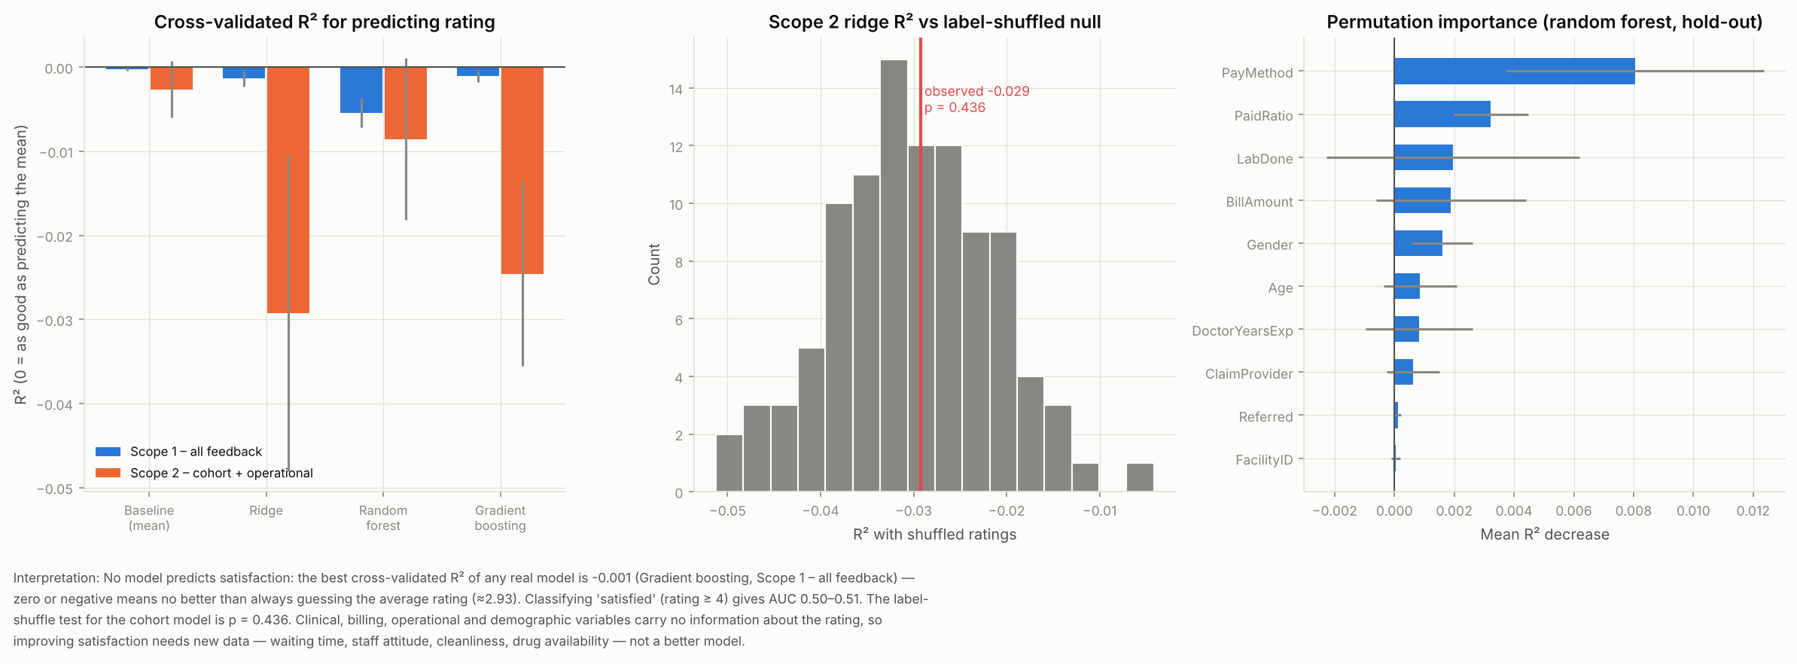

5. Clustering and segmentation
Patients: silhouette peaks at 0.28 (k = 8) against 0.21 for shuffled data. The 4-segment solution simply reproduces the chronic-condition indicators. High-risk shares are 38–39% in each condition group and 18% in the no-chronic-disease group.

Patient segments (k = 4)
Label | Patients | MeanAge | MeanBMI | Female | MeanVisits | HighRisk | AdmitRate | Description
S1 | 4996 | 45.25 | 30.10 | 0.495 | 0.252 | 0.389 | 0.129 | high asthma, low hypertension
S2 | 4988 | 44.72 | 30.12 | 0.492 | 0.253 | 0.384 | 0.136 | high hypertension, low asthma
S3 | 4945 | 44.66 | 29.98 | 0.496 | 0.246 | 0.38 | 0.135 | high diabetes, low asthma
S4 | 5071 | 45.50 | 29.98 | 0.498 | 0.249 | 0.183 | 0.121 | low asthma, low hypertension

Facility clusters
Cluster | Facilities | Appointments | ApptPerClinician | StaffPer1000Pts | MeanRating | CollectionRate | PerformanceScore | Members
0 | 9 | 267.89 | 5.11 | 234.44 | 2.96 | 0.91 | 71.29 | 01, 06, 08, 10, 11, 12, 13, 14, 16
1 | 11 | 235.36 | 4.48 | 268.68 | 2.89 | 0.9 | 35.90 | 02, 03, 04, 05, 07, 09, 15, 17, 18, 19, 20

Figure 33. Patients: silhouette vs null, by number of clusters
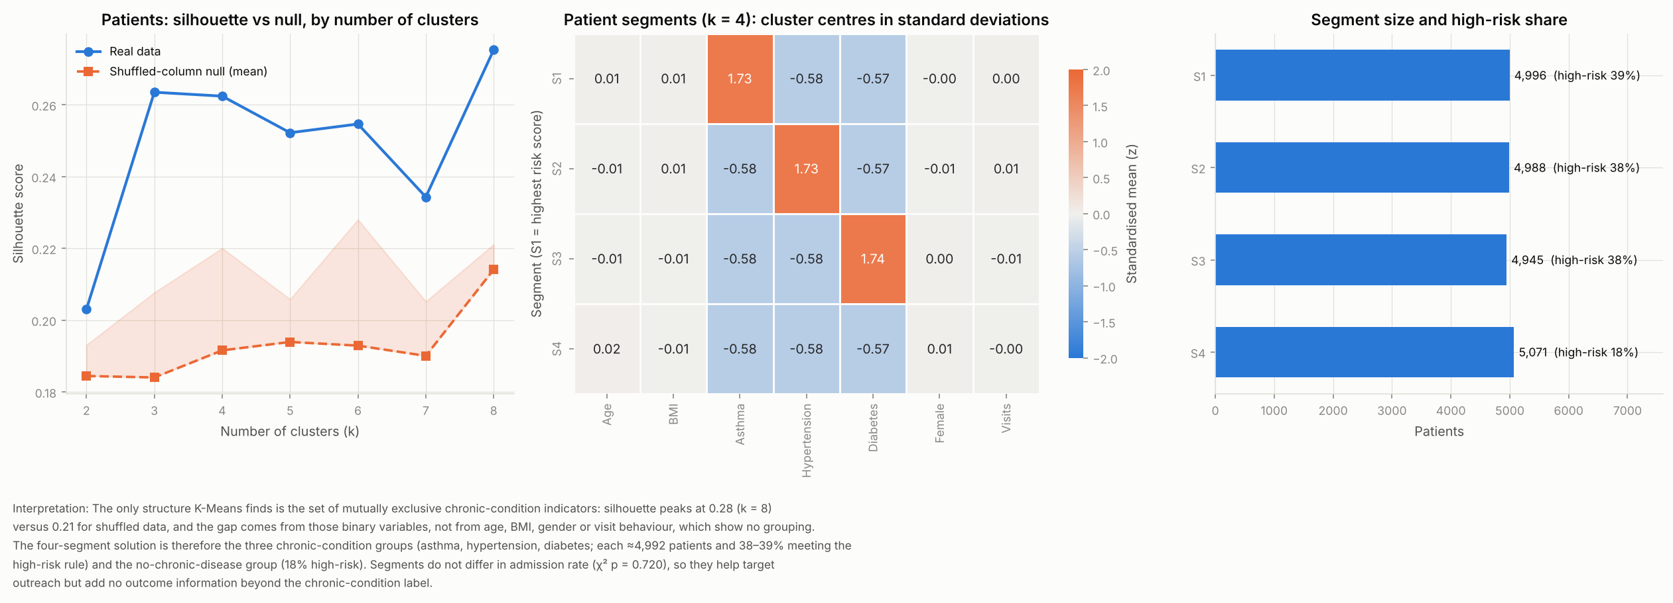

Figure 34. Ward hierarchical clustering of facilities
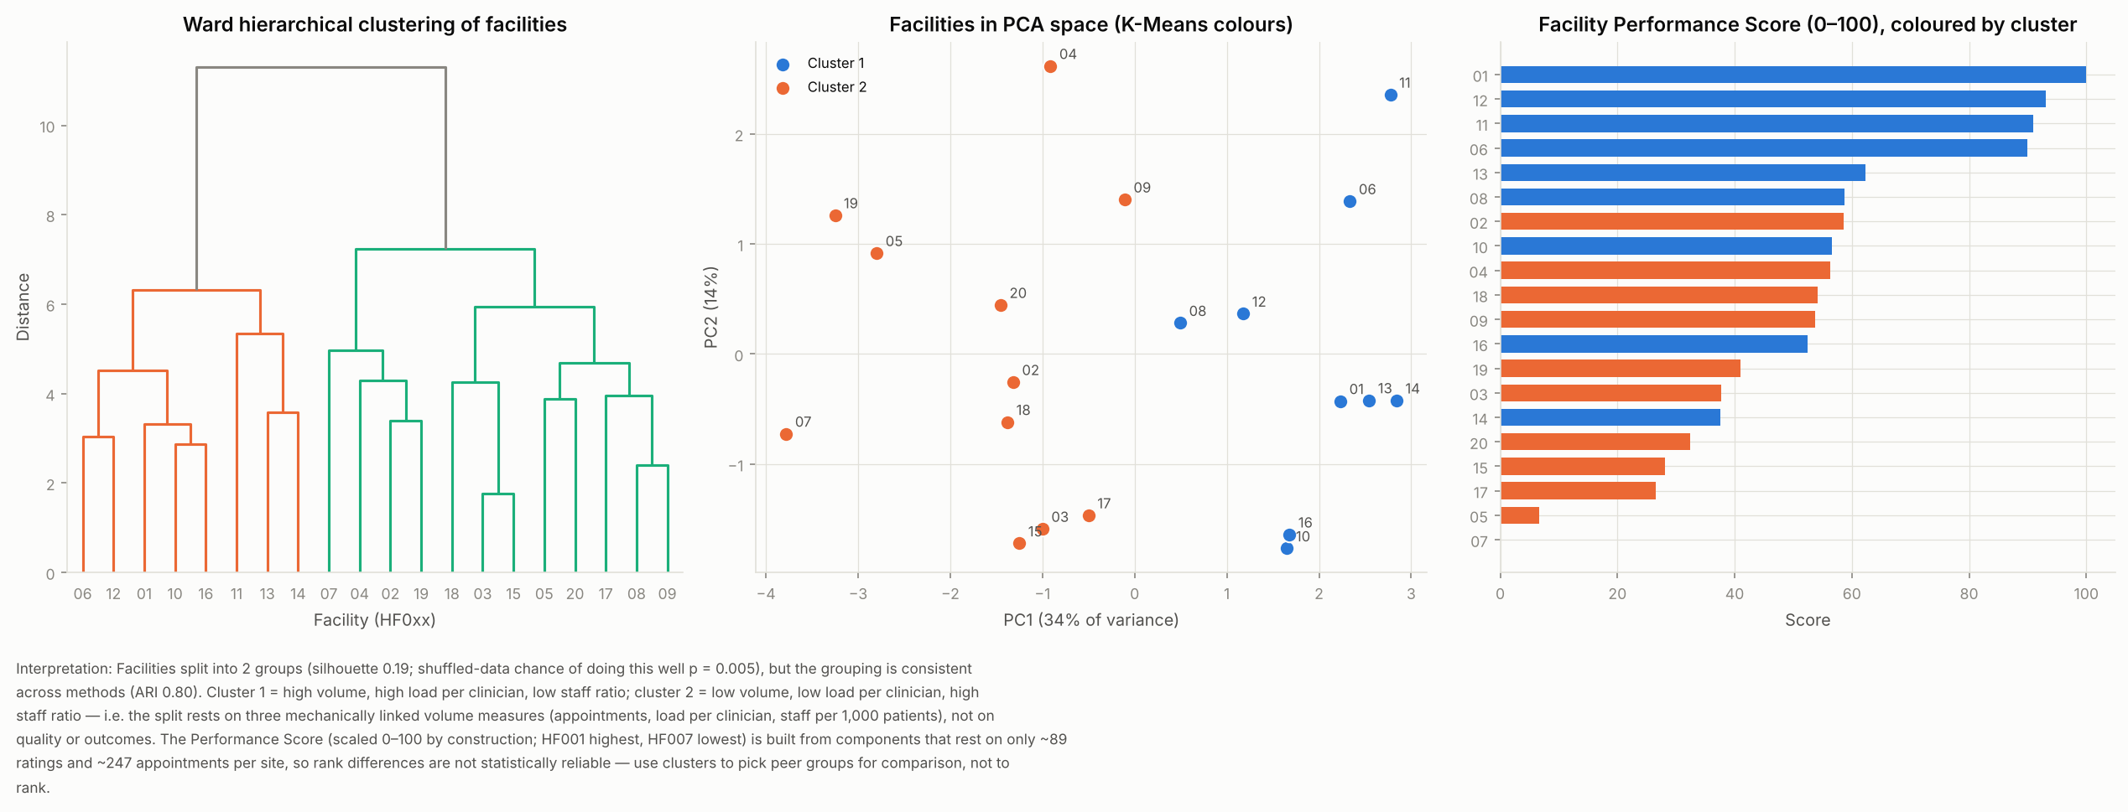

Figure 35. Departments: silhouette vs null
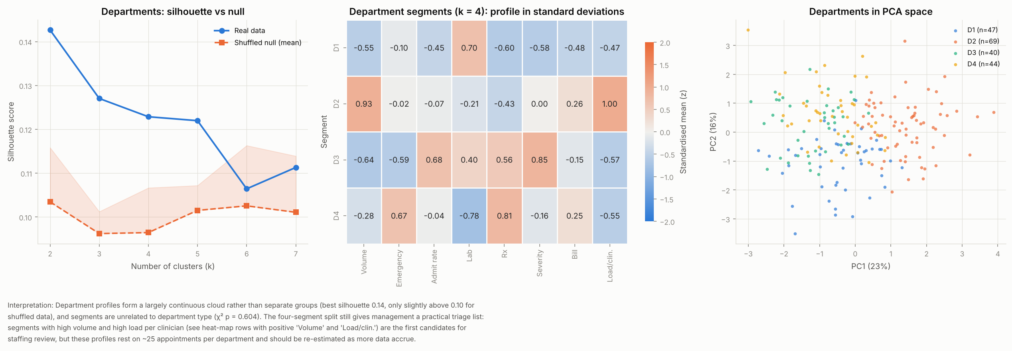

6. Principal Component Analysis (optional)

Figure 36. Patients: scree plot and cumulative variance
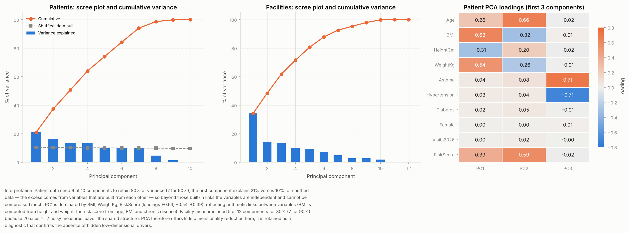

7. Limitations and what would make the models work
- Outcomes are statistically independent of all recorded drivers, so no algorithm can predict them; the models were run to prove this rigorously, not to force a result.
- Only 12 months of aggregate history: seasonality and trend cannot be assessed; forecasts are flat baselines with wide bands.
- Only 5,000 of 60,000 visits have an appointment record, and facility/department/doctor links are inconsistent.
- To enable genuine prediction: collect longitudinal patient histories, wait times, readmission and discharge outcomes, richer feedback items, and 24+ months of data.

