Model Testing & Refinement Report
Week 7 — testing, error analysis and refinement of the Week 6 candidate model
HealthConnect Clinic Experience Lab · AnalystLab Africa Experience Lab, Week 7 · Data Science track · Testing, Refinement & End-to-End Validation

Verdict at a glance
Conclusion. The Week 6 candidate model does not meet any of the 6 pre-registered acceptance criteria and is not suitable for patient-level use. Seven evidence-based refinements did not change that (best: R1 Clinical-core features, ΔAUC +0.019, p = 0.13). Testing the method itself showed it would have detected a real effect (planted signals recovered from a true AUC of about 0.57), so the result reflects the data, not a weak test. The most useful improvement was to the model's scoring interface: Week 6 behaviour passed 8 of 18 interface tests and the refined scorer passes 18 of 18. The data also contain no attendance field, so a missed-appointment model — the project's real objective — cannot yet be built; this is the main item to resolve before Week 8.

Measure | Week 6 candidate | Refined (R1 Clinical-core features)
Hold-out AUC (untouched 1,000 appointments) | 0.529 (95% CI 0.47–0.59) | 0.537 (95% CI 0.48–0.59)
Time-based test AUC (train Jan–Sep, test Oct–Dec) | 0.480 (CI 0.43–0.53) | 0.488 (CI 0.44–0.53)
Share of 30 random splits with AUC > 0.5 | 40% | 63%
Calibration slope (ideal 1.0) | 0.18 | 0.24
Acceptance criteria met | 0 of 6 | 0 of 6
Interface tests passed | 8 of 18 (Week 6 behaviour) | 18 of 18 (refined scorer)

1. Week 6 → Week 7 transition
Item | Answer
1. Main Week 6 output | Healthcare predictive-analytics package: integrated data (20,000 patients, 5,000 encounters, 60,000 bills), 36 charts, 15 hypothesis tests, forecasts, admission and satisfaction models, clustering, reports, 8-script GitHub pipeline.
2. Most important component | The candidate classification model: logistic regression predicting hospital admission from booking-time information (Week 6 CV AUC 0.514, hold-out AUC 0.529).
3. Main issue / limitation / dependency | No predictive signal found in Week 6 (permutation p = 0.32); model tested on one split and one threshold only; inconsistent keys across source tables; no attendance field.
4. Component requiring testing | The candidate model and the way it will be called by the ML pipeline (scoring interface).
5. Relevant tracks | Data Science (owner), ML Engineering (interface/pipeline), Data Analytics (which findings should drive features), Project Management (issue log, readiness).
6. What I intend to test | Stability, metrics at deployable thresholds, calibration, errors (false positives/negatives), segments, overfitting, feature validity, whether the test method can detect a real signal, and the scoring interface.
7. What I expect to improve / validate | Decide whether the model is fit for use, refine only on evidence, harden the interface for ML Engineering, and define what Week 8 needs.

Important context. The Week 7 brief describes a missed-appointment (no-show) classifier on HealthConnect_Appointment_Data.csv. That file is not part of the project data used since Week 4 (the 27 HealthConnect hospital files), and those data have no attendance, no-show or cancellation field. As instructed ("do not select a new dataset"), this report tests the Week 6 candidate — hospital admission — and states in section 9 what that means for the missed-appointment objective.

2. Week 6 candidate model summary
Item | Detail
Task | Binary classification: will the appointment end in a hospital admission? (586 of 5,000 = 11.7%)
Features (18) | Age, BMI, RiskScore, ChronicFlag, DoctorYearsExp, PatientVisits, Month; gender, marital status, education, occupation, province, blood group, chronic condition, visit type, department, facility, weekday
Algorithm | Logistic regression (L2, C = 0.1), standardised numerics, one-hot categories (rare levels grouped)
Week 6 evidence | Repeated 5×3 CV AUC 0.514; hold-out AUC 0.529; permutation p = 0.32; richer feature sets and random forest / gradient boosting did no better
Baselines | Prior-probability model (AUC 0.50) and a single-rule score (RiskScore only). No Week 5 model exists in this project line, so naive baselines — the strictest available — are used.
Intended purpose | Rank appointments by admission risk to target outreach and plan capacity

3. Testing approach
Acceptance criteria were fixed before any testing, so the verdict cannot be tuned to the results. The model is suitable for patient-level use only if all six hold on untouched data.
Criterion | Rule
C1 Discrimination | Hold-out ROC-AUC ≥ 0.65
C2 Significance | Lower 95% bootstrap bound of hold-out AUC > 0.50
C3 Precision value | PR-AUC ≥ 1.5 × prevalence
C4 Stability | AUC > 0.5 in ≥ 90% of 30 random splits and in the time-based split (CI lower bound > 0.5)
C5 Calibration | Calibration slope between 0.8 and 1.2
C6 Beats baseline | Corrected paired CV gain over the naive baseline with a 95% interval excluding 0

- Data splits. Development set 4,000 appointments (selection and tuning, repeated 5×3 CV with identical folds for all models) and an untouched hold-out of 1,000 (same split as Week 6), opened once at the end. A separate time-based split (train Jan–Sep, test Oct–Dec) mimics deployment.
- Test battery. 33 recorded tests: 15 model tests (T01–T15) and 18 scoring-interface tests (X01–X18). Each is recorded with expected result, actual result, pass/fail, issue, action and retest (Appendix A and the Excel record).
- Reading the results. A FAIL on a model test (T-series) is a finding about the model, not a defect in the testing; failures are reported, not hidden. Where no issue exists the test is marked PASS (reproducibility, negative control, planted-signal detection).

4. Test results and performance metrics

4.1 Reproducibility, stability and time-based validation (T01–T03)
The Week 6 result reproduced exactly (CV AUC 0.514, hold-out AUC 0.529). It is not stable: across 30 random 80/20 splits the AUC averages 0.495 (sd 0.021, range 0.46–0.53) and only 40% of splits exceed 0.50 — about what chance alone would give. On future appointments (Oct–Dec) the AUC is 0.480 (95% CI 0.43–0.53).

Figure W01. Stability of the candidate model
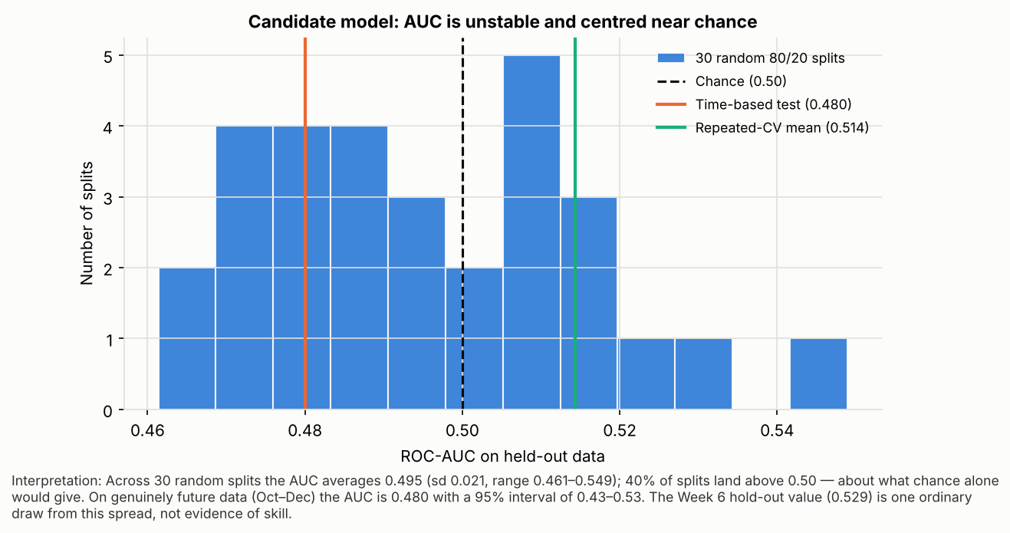

4.2 Classification metrics at deployable thresholds (T04)
Thresholds were chosen on the development set only and applied once to the hold-out. A 0.5 threshold flags 0 patients (predicted probabilities never reach it). The F1-optimal threshold (0.060) flags 985 of 1,000 patients — essentially everyone, equivalent to the 'flag everyone' baseline. A realistic capacity rule (flag the top 20%) has precision 16.7% against a prevalence of 11.7% (lift 1.42×, precision 95% CI 11.2%–22.1%) while random selection gives 15.5%.
Rule | Flagged | TP | FP | FN | TN | Precision | Recall | F1 | Balanced_Acc | MCC
Model, F1-optimal threshold | 985 | 115 | 870 | 2 | 13 | 0.117 | 0.983 | 0.209 | 0.499 | -0.006
Model, threshold 0.5 | 0 | 0 | 0 | 117 | 883 | 0.000 | 0.000 | 0.000 | 0.500 | 0.000
Model, flag top 20% (capacity rule) | 180 | 30 | 150 | 87 | 733 | 0.167 | 0.256 | 0.202 | 0.543 | 0.072
Baseline: flag everyone | 1000 | 117 | 883 | 0 | 0 | 0.117 | 1.000 | 0.209 | 0.500 | 0.000
Baseline: flag no one | 0 | 0 | 0 | 117 | 883 | 0.000 | 0.000 | 0.000 | 0.500 | 0.000
Baseline: random 20% | 200 | 31 | 169 | 86 | 714 | 0.155 | 0.265 | 0.196 | 0.537 | 0.059

Figure W02. ROC and cumulative-gains curves, hold-out set
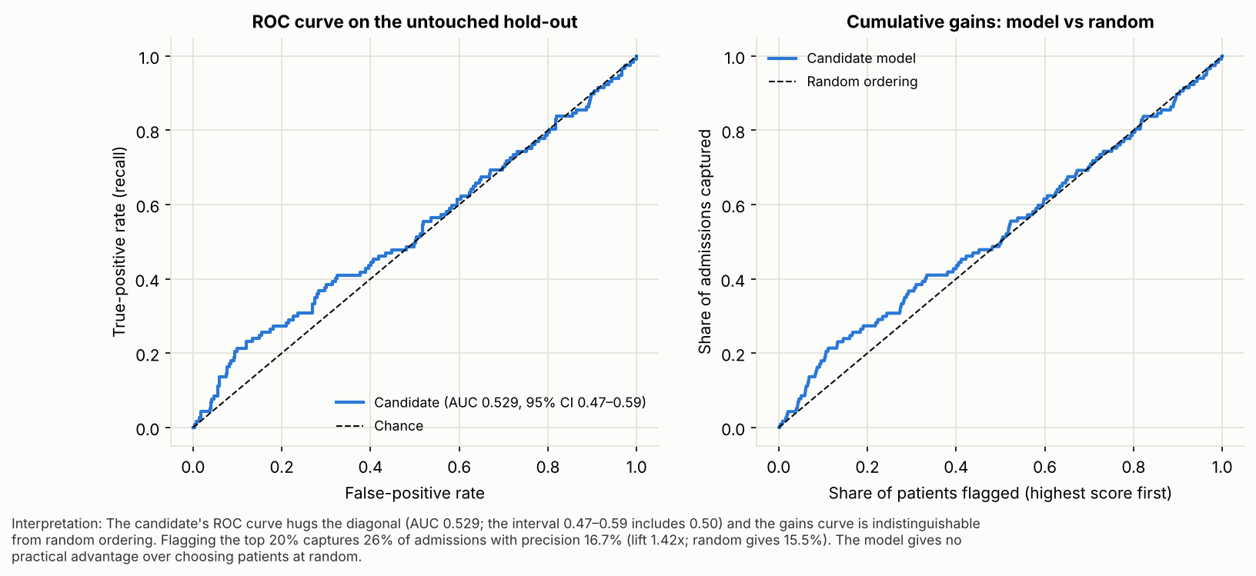

4.3 Calibration (T05)
The calibration slope is 0.18 (95% CI -0.06–0.41; ideal 1.0): observed admission rates barely change across risk deciles. The Brier score (0.1043) is no better than predicting the average (0.1035). Predicted risks therefore should not be shown to staff as percentages.

Figure W03. Calibration of the candidate model
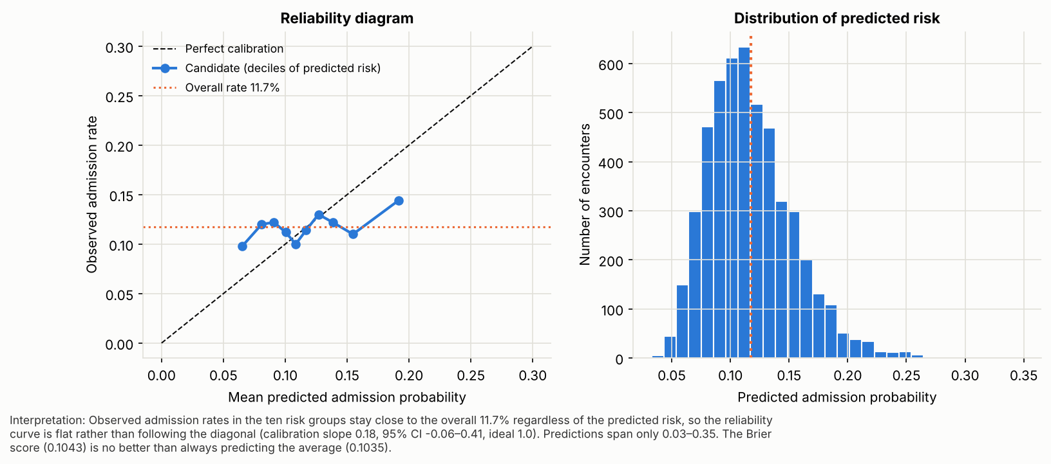

5. Error analysis

5.1 False positives and false negatives (T06)
Using the capacity rule on out-of-fold predictions for all 5,000 appointments: 127 true positives, 873 false positives, 459 false negatives and 3,541 true negatives. 78% of admissions are missed and 87% of flags are false alarms. Flagged patients are admitted at 12.7% versus 11.5% for unflagged patients (chi-square p = 0.31): the flags do not enrich for admissions.
Patterns in the errors: missed-versus-caught admissions differ on 9 of 16 variables and wrongly-flagged versus unflagged non-admitted patients on 13 of 16 (Holm-adjusted), led by department, weekday and province. This is a selection effect rather than an insight: patients are flagged because of the values of the very variables the score uses, and those variables (department, weekday, province) had no demonstrated link to admission in Week 6. There is therefore no outcome-related error pattern that a feature fix could remove.

5.2 Performance across segments (T07)
AUC was assessed in 34 segments (gender, age band, province, department, visit type, severity, chronic status; ≥ 30 admissions each). Values range 0.37–0.59; 3 intervals lie wholly above 0.50 and 1 wholly below (about 1.7 expected by chance); 0 remain significant after Holm correction. The model is not reliable in any segment, and no segment is systematically worse.

Figure W04. Model performance by segment
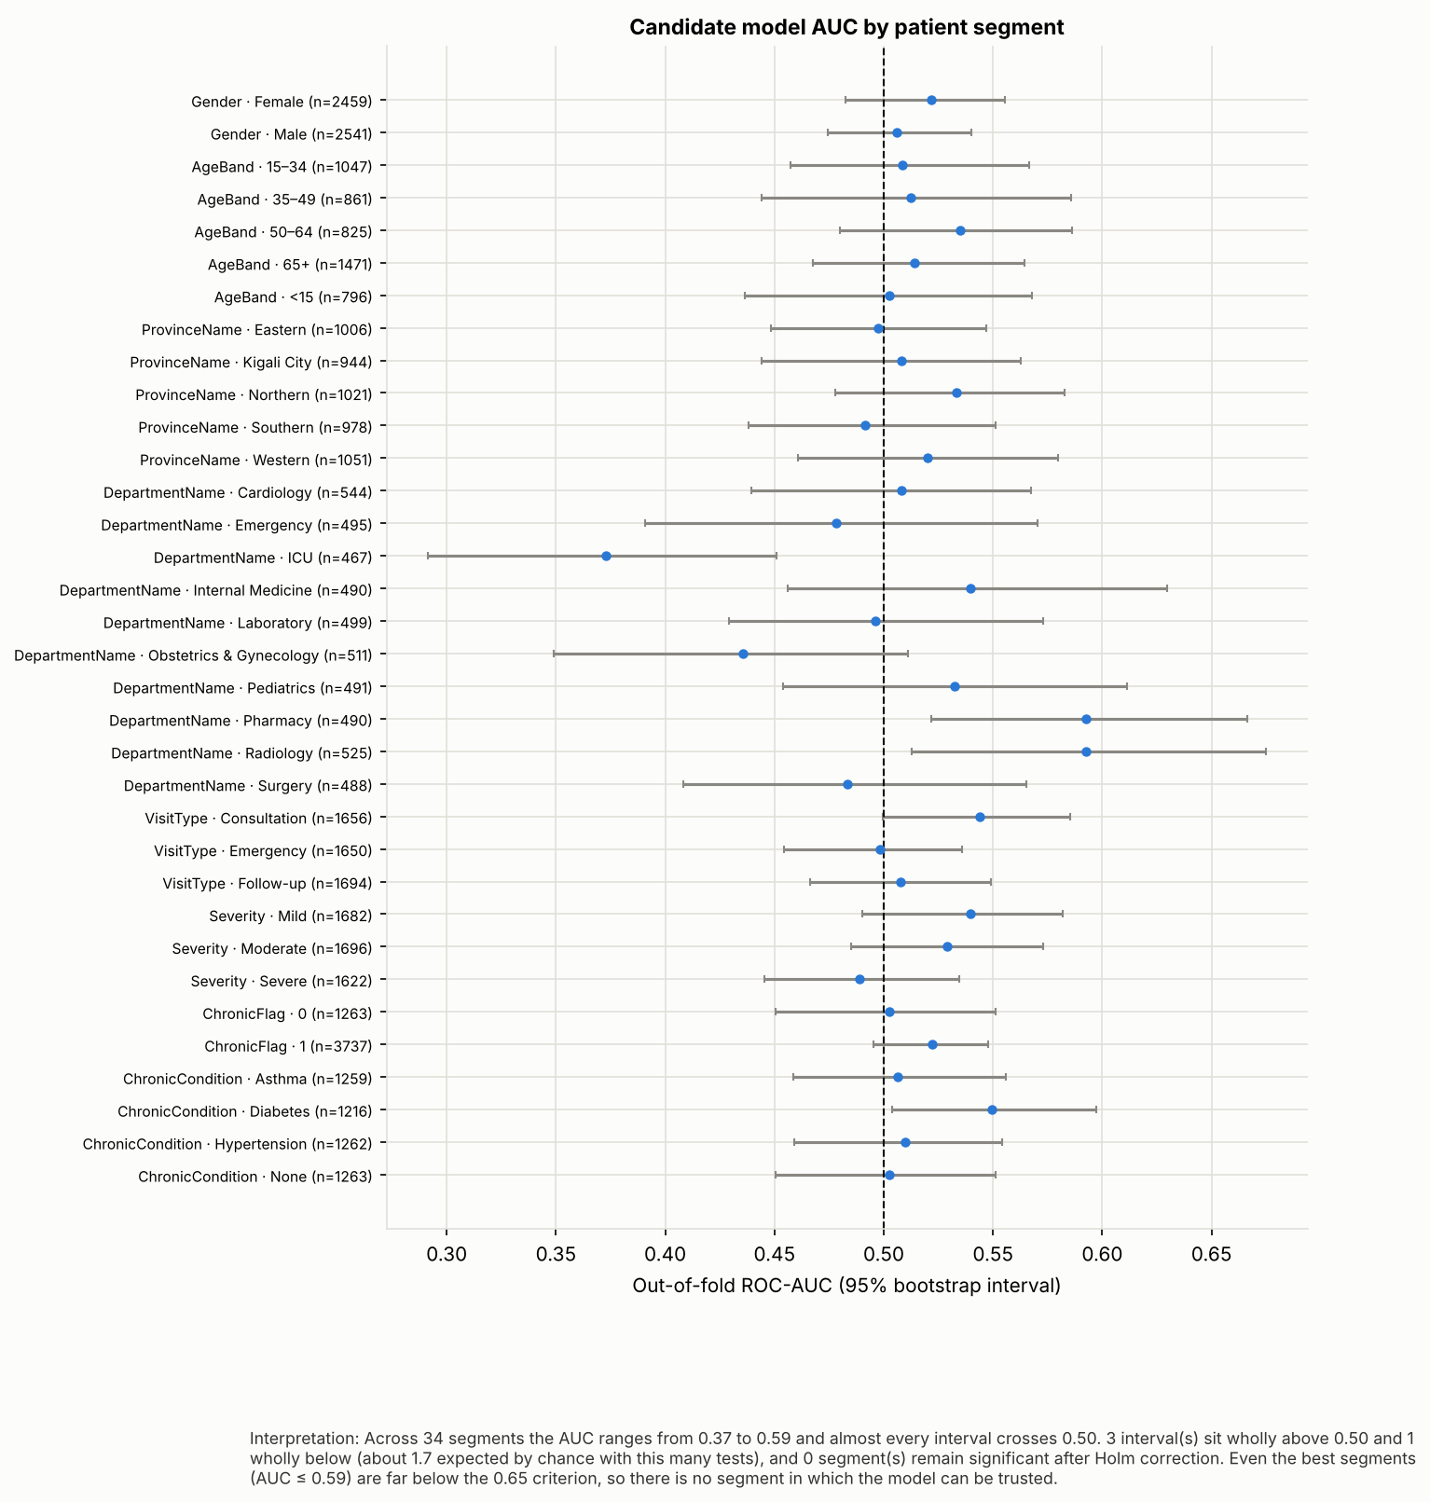

6. Robustness and validity tests

6.1 Overfitting (T08)
Model | Training AUC | CV AUC | Gap
Logistic regression (candidate) | 0.601 | 0.520 | 0.081
Random forest (Week 6 setting) | 0.943 | 0.502 | 0.441
Gradient boosting (Week 6 setting) | 0.757 | 0.497 | 0.260
Random forest, unconstrained (deliberately overfit) | 1.000 | 0.499 | 0.501

The candidate overfits mildly and, as data grows, its training AUC falls while its cross-validated AUC stays at about 0.5: it fits noise, not signal. Flexible models make this worse (the unconstrained forest memorises the training data and still scores 0.50 in cross-validation).

Figure W05. Overfitting and learning-curve check
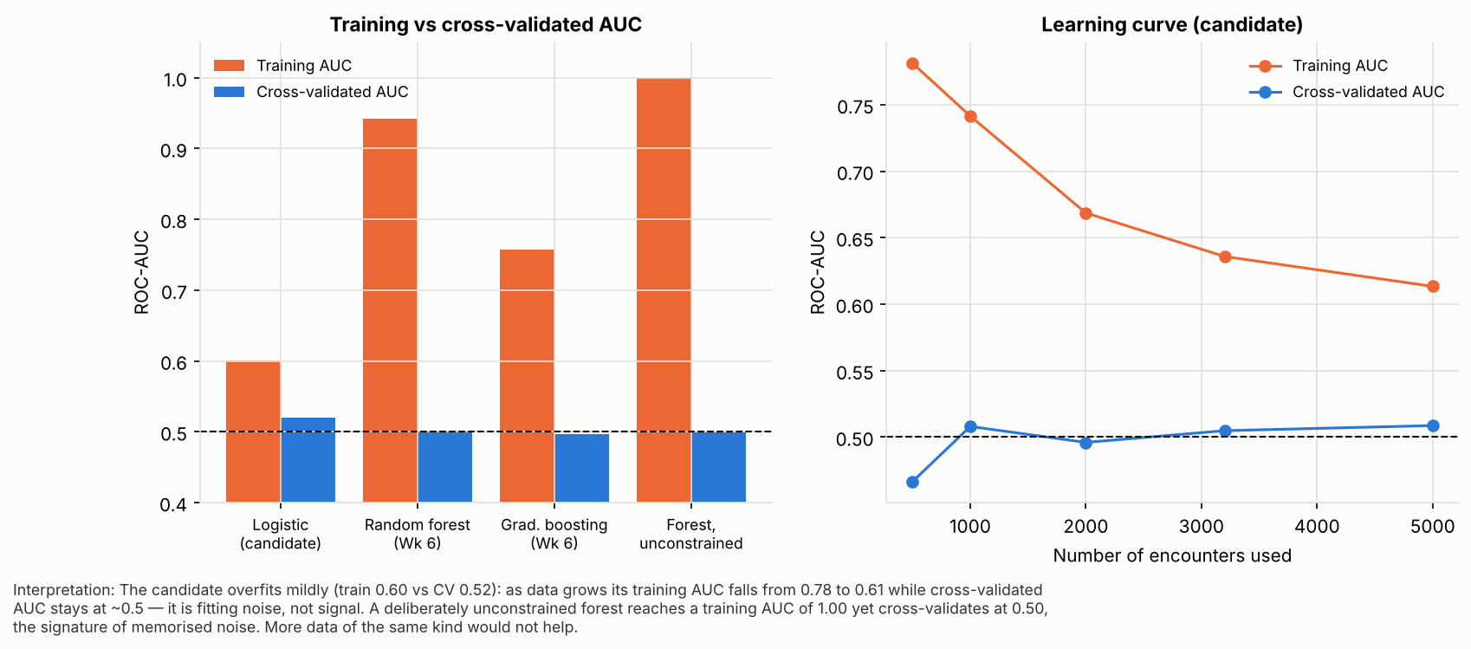

6.2 Do the features support the objective? (T09)
Permutation importance on five held-out folds: the largest mean importance is 0.0051 AUC points and 1 of 18 features are positive in every fold (about 0.6 expected by luck). The Week 6 univariate screen agrees (2 of 26 factors significant before correction, 0 after). A prediction-time audit found one mild look-ahead feature (PatientVisits counts the whole year) and confirmed that diagnosis, severity, labs, prescriptions and referral are post-visit information that must not be used at booking time.
Features | Known when predicting? | In candidate? | Note
Age, BMI, RiskScore, ChronicFlag, ChronicCondition, demographics, geography, BloodGroup | Yes | Yes (feature set A) | Known at registration
VisitType, DepartmentName, FacilityID, DayOfWeek, Month_, DoctorYearsExp | Yes | Yes (feature set A) | Known when the appointment is booked
PatientVisits (appointments on record) | Partly | Yes (feature set A) | Counted over the whole year, so it includes visits after the one being scored — mild look-ahead; recompute as 'visits before this date' in production
Diagnosis, Severity | No — recorded at the visit | No (feature set B only) | Not available when predicting; excluded from deployment
LabDone, LabAbnormal, Prescription, Referred | No — recorded during/after the visit | No (feature set C only) | Post-visit information (possible leakage); excluded from deployment
LengthOfStayDays, BillAmount, Rating | No — outcome-linked | Never used | Would leak the outcome

6.3 Can this testing method detect a real signal? (T10, T11)
A 'no signal' conclusion is only trustworthy if the same pipeline would have found a signal had one existed. Shuffled labels give a mean AUC of 0.501 (sd 0.018), confirming the pipeline is unbiased. When genuine Age effects of known strength are planted, they are recovered and flagged significant from a true AUC of about 0.57 upward, and no effect is detected when none is planted. With about 586 admissions, effects of AUC ≥ 0.57 in the booking-time data would therefore have been found.
Planted effect | True AUC of signal | AUC recovered (CV) | Permutation p | Detected
0.000 | 0.516 | 0.512 | 0.194 | False
0.200 | 0.567 | 0.542 | 0.032 | True
0.400 | 0.617 | 0.590 | 0.032 | True
0.600 | 0.676 | 0.658 | 0.032 | True
0.900 | 0.746 | 0.731 | 0.032 | True

Figure W06. Feature importance and planted-signal power check
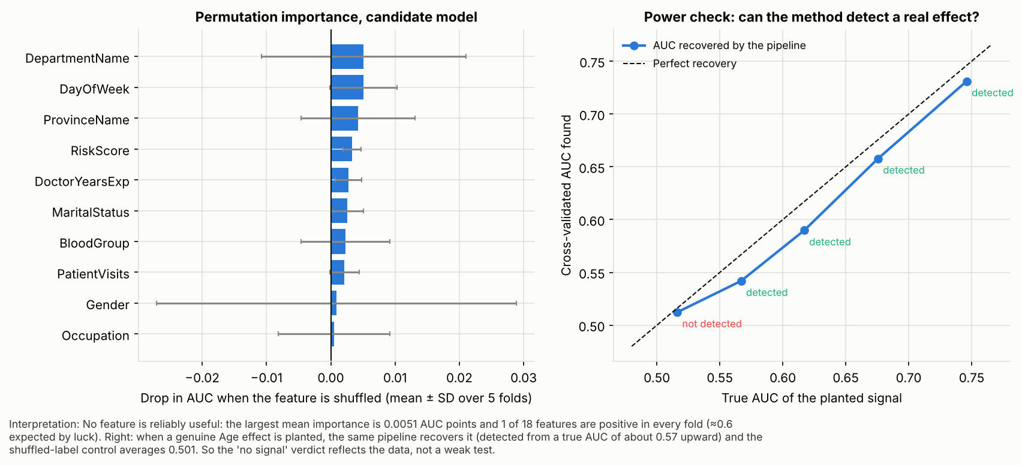

7. Baseline versus candidate versus refined model

7.1 Refinement activities (T12)
Each refinement addresses a finding from testing; selection used only the development set and required a gain of at least 0.02 AUC with a significant corrected resampled t-test.
- R1 Clinical-core features — removes the noisy department/weekday/province/occupation categories that drove the flags.
- R2a/R2b Stronger L2 and L1 selection — addresses mild overfitting.
- R3 Balanced class weights — addresses the model never flagging anyone at 0.5.
- R4 Shallow gradient boosting — tests whether non-linear structure exists.
- R5 Isotonic calibration — addresses uninformative probabilities.
- Rule only (RiskScore) — the simplest possible benchmark.
Model | CV AUC | SD | PR-AUC | Brier | ΔAUC vs candidate | Corrected-t p
Baseline (prior probability) | 0.500 | 0.000 | 0.117 | 0.103 | 0.018 | 0.149
Rule only (RiskScore) | 0.517 | 0.025 | 0.123 | 0.103 | 0.035 | 0.101
Candidate (Week 6) | 0.481 | 0.021 | 0.118 | 0.105 | 0.000
R1 Clinical-core features | 0.501 | 0.018 | 0.126 | 0.104 | 0.019 | 0.128
R2a Stronger L2 (C=0.01) | 0.485 | 0.021 | 0.117 | 0.104 | 0.003 | 0.628
R2b L1 feature selection | 0.491 | 0.024 | 0.119 | 0.104 | 0.010 | 0.530
R3 Balanced class weights | 0.479 | 0.021 | 0.117 | 0.249 | -0.002 | 0.557
R4 Shallow gradient boosting | 0.475 | 0.027 | 0.112 | 0.104 | -0.007 | 0.638
R5 Candidate + isotonic calibration | 0.484 | 0.026 | 0.120 | 0.104 | 0.003 | 0.671

On the development set every variant scores between 0.475 and 0.517. The best refinement (R1 Clinical-core features) gains +0.019 AUC (p = 0.13) — below the +0.02 threshold and not significant — and the single-rule RiskScore benchmark is as good as any model, which supports the Week 6 recommendation to use a rule rather than a model for outreach. No refinement was accepted.

Figure W07. Before/after: candidate vs refinements
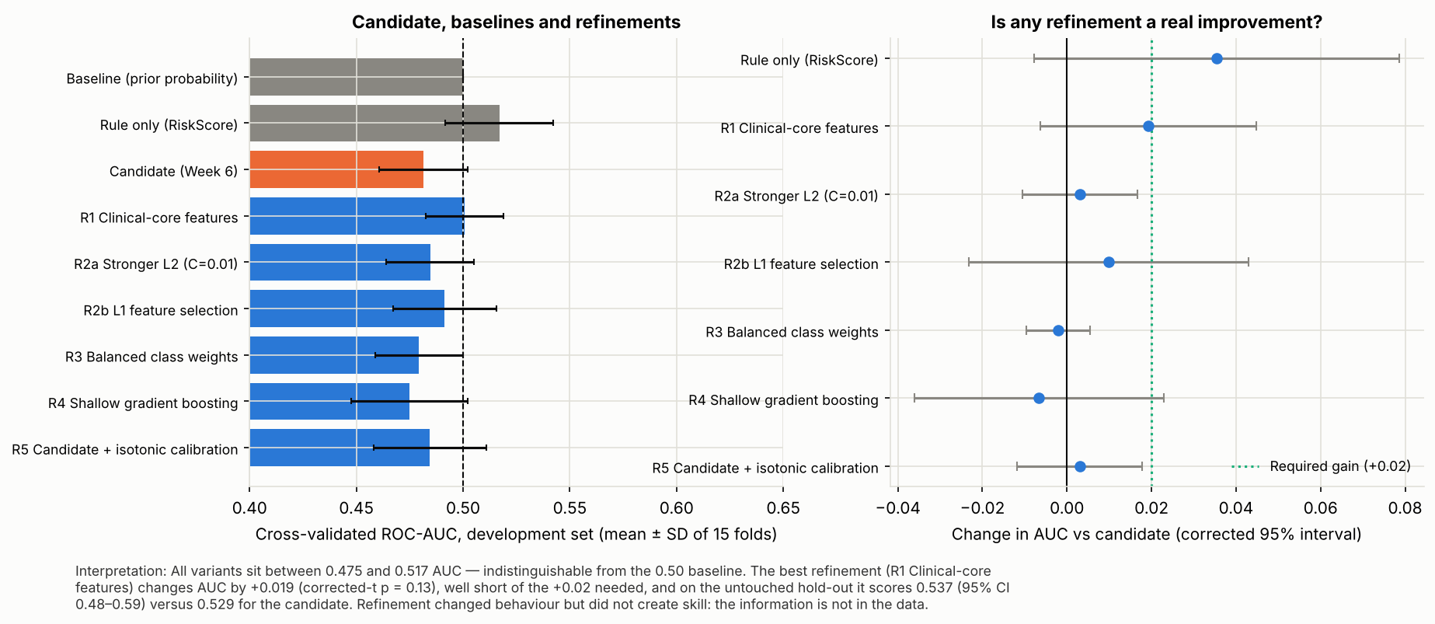

7.2 Re-test on untouched data (T13–T15)
Measure | Baseline | Candidate (Week 6) | Refined (R1 Clinical-core features)
Hold-out AUC (95% CI) | 0.500 | 0.529 (0.47–0.59) | 0.537 (0.48–0.59)
Hold-out PR-AUC (prevalence 0.117) | 0.117 | 0.145 | 0.145
Top-20% precision / recall | 0.117 (random) | 0.167 / 0.256 | 0.130 / 0.222
Time-based AUC | 0.500 | 0.480 | 0.488
Calibration slope | n/a | 0.18 | 0.24

Paired on the same hold-out patients, the refined model differs from the candidate by +0.008 AUC (95% CI -0.040 to +0.060) — no meaningful improvement. Isotonic recalibration moves the candidate's Brier score from 0.1043 to 0.1037 (baseline 0.1035), which is simply the average rate.

7.3 Acceptance criteria — final verdict
Criterion | Candidate (Week 6) | Refined (R1 Clinical-core features)
C1 AUC ≥ 0.65 | 0.529 [FAIL] | 0.537 [FAIL]
C2 CI lower > 0.5 | 0.470 [FAIL] | 0.485 [FAIL]
C3 PR-AUC ≥ 1.5×prevalence | 0.145 vs 0.176 [FAIL] | 0.145 vs 0.176 [FAIL]
C4 stable (≥90% splits >0.5 and time-split CI lower >0.5) | 40% / 0.43 [FAIL] | 63% / 0.44 [FAIL]
C5 slope 0.8–1.2 | 0.18 [FAIL] | 0.24 [FAIL]
C6 beats baseline (corrected CI of AUC−0.5 excludes 0) | -0.044 to +0.007 [FAIL] | -0.022 to +0.024 [FAIL]

Result: the candidate meets 0 of 6 criteria and the refined model 0 of 6. Neither is suitable for patient-level use.

8. Interpretation and model suitability
- What the results mean. Within these data, hospital admission cannot be predicted from booking-time information better than chance. The tests also explain why: the outcome is statistically independent of the recorded patient, doctor, department and calendar variables, the candidate fits noise, and added flexibility only memorises it.
- Is the improvement meaningful? No. Refinements moved AUC by at most +0.02 (not significant); the hold-out difference is +0.008 with an interval spanning zero.
- Remaining weaknesses. No discrimination, uninformative probabilities, flags driven by noise categories, mild look-ahead in PatientVisits, small time-based test set.
- Suitable for the intended HealthConnect use case? Not for patient-level decisions. It is suitable only as a test fixture for pipeline integration, with the 'use caution' flag attached to every score.

End-to-end validation questions
Question | Answer
1. What component did I test? | The Week 6 candidate admission classifier and its scoring interface.
2. What did I expect to happen? | Meet the six pre-registered criteria; handle valid and invalid inputs as per the contract.
3. What actually happened? | 0 of 6 criteria met (hold-out AUC 0.529, CI 0.47–0.59); interface passed 8/18 tests.
4. What issue or weakness did I identify? | No predictive skill; noise-driven flags; uninformative probabilities; silent acceptance of invalid input; CSV 'None'→NaN pitfall; look-ahead feature.
5. What did I change or improve? | Tried seven refinements (none accepted); built a validated scoring interface with an input/output contract, model card and caution flag.
6. What happened when I tested it again? | Model: no improvement (hold-out Δ +0.008). Interface: 18/18 pass.
7. Which other track was involved? | ML Engineering (interface hand-off; teammate sign-off pending), with Data Analytics findings reused and Project Management issue log.
8. How does the validated component contribute to HealthConnect? | It gives the pipeline a tested, documented scoring component and an evidence-based 'no' on patient-level admission prediction, avoiding a misleading model in the final solution.
9. What still needs to be completed before Week 8? | See section 11.

9. Business relevance and the missed-appointment objective
The project question is how HealthConnect can use data and AI to reduce missed appointments. Three conclusions follow from the testing:
- A no-show model cannot be built from the current data. There is no attendance, cancellation or no-show field, and no booking lead time, reminder or contact history. The admission classifier is a different target and does not answer the project question.
- The tested harness transfers directly. Pre-registered criteria, stability and time-based splits, calibration, error and segment analysis, planted-signal power test and the interface contract are target-independent; once an attendance field is available they can be re-run in minutes.
- Where the validated Week 6 findings help now. Rule-based outreach to high-risk patients (33.3% meet the rule; only 1,498 of 6,662 had a 2026 appointment), the 2027 visit forecast (≈4,975 a month, ±14%) for slot planning, and the collections findings (0.92 bn RWF unpaid) remain valid and do not depend on this model.

10. Cross-track testing and integration evidence

10.1 Data Science → ML Engineering: model hand-off and scoring-interface test
Matrix connection: 'test whether the integrated pipeline correctly handles model requirements and expected inputs/outputs.' The Week 6 scoring behaviour (V1, a bare model call) was tested against an explicit input/output contract with 18 cases. V1 failed 10: impossible values (Age = -5, province = Mars) were scored without complaint, a missing ChronicCondition was silently scored as a category (the CSV 'None'→NaN pitfall, which also affected my own re-load of the Week 6 export), extra columns such as a patient name were accepted unreported, empty input crashed, error messages did not name the field, and the output was a bare array with no version or caution flag. After the refinement (V2: contract, validation, warnings, documented output schema, caution flag) all 18 tests pass. Test → Finding → Action → Retest → Validated improvement.
ID | Scenario | Expected | V1 (Week 6) | V2 (refined)
X01 | Valid single record | Returns one probability in [0, 1] | PASS | PASS
X02 | Valid batch of 200 | 200 finite probabilities | PASS | PASS
X03 | Columns in a different order | Identical scores (columns matched by name) | PASS | PASS
X04 | Unexpected extra column (e.g. PatientName) | Scored; ignored column reported (identifier safety) | FAIL | PASS
X05 | Required column missing (Age) | Clear error naming 'Age' | PASS | PASS
X06 | Unseen category in an open field (Occupation = Astronaut) | Scored, and the unseen value is reported | FAIL | PASS
X07 | Impossible value in a closed list (ProvinceName = Mars) | Rejected with an error naming ProvinceName | FAIL | PASS
X08 | Out-of-range numbers (Age = -5, BMI = 500) | Rejected with an error naming the column | FAIL | PASS
X09 | Missing numeric value (Age = NaN) | Clear error naming 'Age' | FAIL | PASS
X10 | Wrong data type (Age = 'forty') | Clear error naming 'Age' | FAIL | PASS
X11 | Empty input (0 rows) | Empty result, no crash | FAIL | PASS
X12 | Determinism (same input twice) | Identical output | PASS | PASS
X13 | Persistence (save and reload the scorer) | Identical output after reload | PASS | PASS
X14 | ChronicCondition = 'None' (valid: no chronic disease) | Accepted as a normal value | PASS | PASS
X15 | ChronicCondition missing — the CSV 'None'→NaN pitfall | Rejected with a clear error naming ChronicCondition | FAIL | PASS
X16 | Output schema | risk_score, risk_band, warnings, model_version, use_caution | FAIL | PASS
X17 | Input is not a DataFrame | Clear error saying a DataFrame is required | FAIL | PASS
X18 | Speed: 10,000 rows | Under 5 seconds | PASS | PASS

Figure W08. Scoring-interface tests, before and after refinement
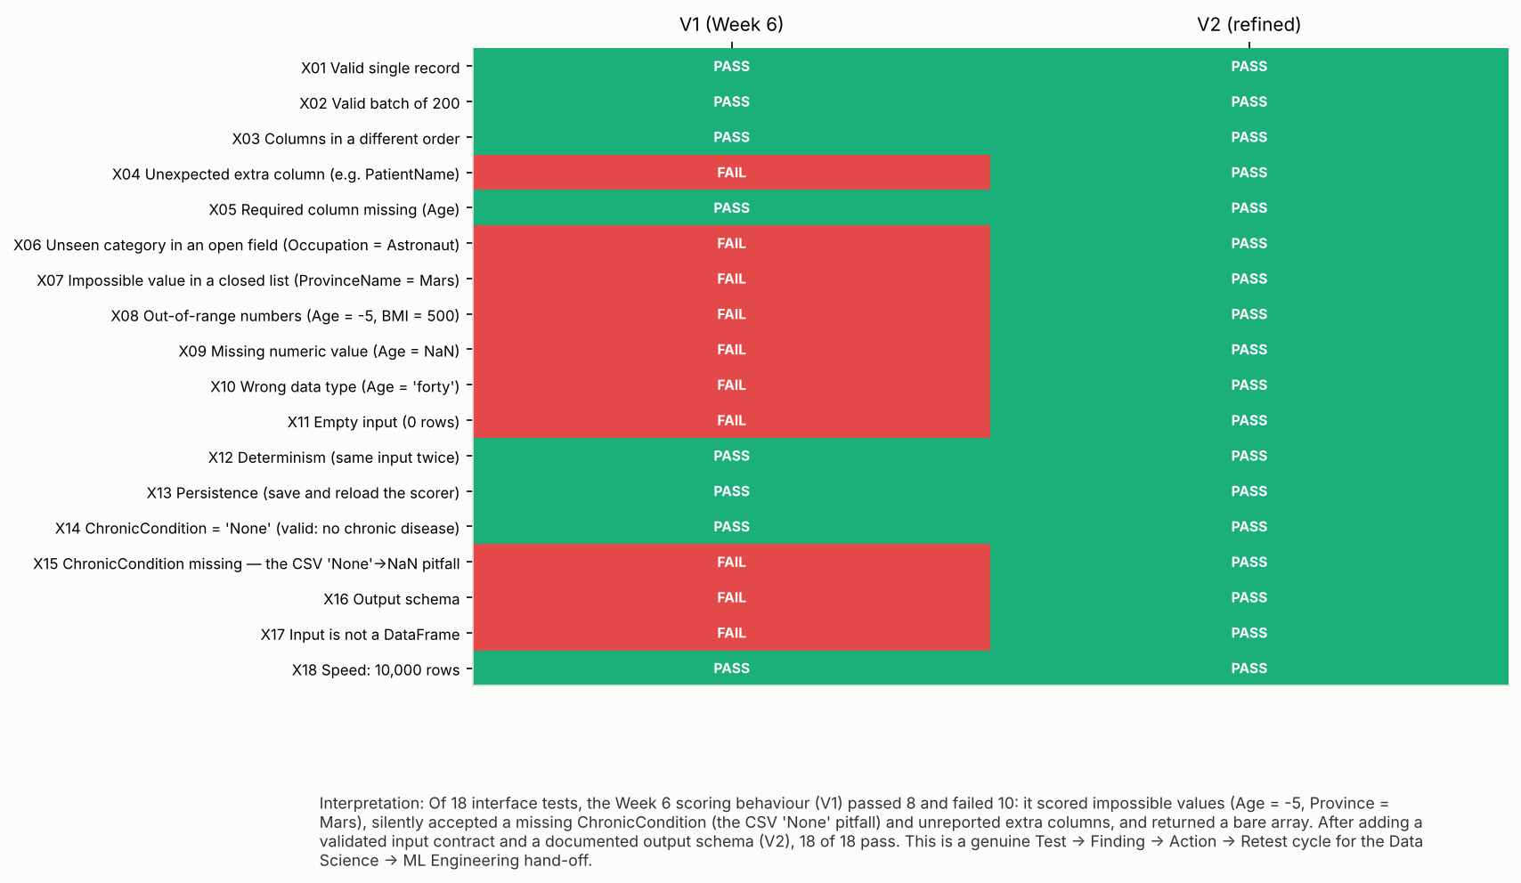

10.2 Cross-track record
Field | Record
1. Track collaborated with | ML Engineering (hand-off prepared by Data Science; teammate review pending). Supporting inputs: Data Analytics (Week 6 EDA/statistical findings reused in feature review); Project Management (issue log).
2. Project dependency | ML Engineering depends on a model with documented inputs, outputs and limits; Data Science depends on ML Engineering to confirm the pipeline preserves them.
3. Component/output being tested | Scoring interface around the Week 6 candidate model: input contract, validation, output schema, persistence, speed.
4. Information/output received | [To complete with ML Engineering teammate: pipeline/preprocessing details, their input format, their run results]
5. Information/output provided | Model card, input/output contract (JSON), validated scorer (admission_risk_scorer.py), saved model, 18-case interface test suite, accepted/rejected-input rules, caution that the model has no predictive skill.
6. Testing activity completed | 18 interface test cases run on the Week 6 behaviour (V1) and the refined scorer (V2): V1 8/18, V2 18/18. [Teammate run: to be completed]
7. Issue/finding identified | 10 failures in V1: impossible/missing values scored silently, 'None'→NaN pitfall, unreported extra columns (possible identifiers), bare-array output, empty input crash, unclear error messages.
8. Refinement/action taken | Input contract with ranges and closed lists; validation with field-named errors; unseen-category warnings; documented output schema with version and 'use caution' field; empty-input handling.
9. Retest result | V2 passes 18/18 (src/admission_risk_scorer.py; outputs/tables/t_scoring_interface_tests.csv).
10. What changed as a result | Scores can no longer be produced from invalid input without a clear error or warning; the pipeline owner now has an explicit contract and a caution flag.
11. Evidence | Notebook section F; Figure W08; model_card.md; input_output_contract.json; models/admission_scorer_v2.joblib; [teammate confirmation/screenshot: to be added]
12. How it improved HealthConnect | Prevents silent bad scores and identifier leakage into the model pipeline, and makes the model's lack of skill visible to downstream users before Week 8 integration.

To complete: The brief states that communication alone is not sufficient and that the activity must produce Test → Finding → Action → Retest. Items 4 and 6 contain a bracketed placeholder for the ML Engineering teammate's own run of the hand-off tests and sign-off (instructions: week7/HANDOFF_TO_ML_ENGINEERING.md). Complete them with the teammate's real result before submission; do not submit them as complete until that has happened.

10.3 Other track connections
- Data Analytics → Data Science. The Week 6 univariate/statistical findings (0 of 26 admission factors significant after correction; admission rate not related to age, diagnosis or visit type) were used to check feature validity in the model tests; the model results agree. These were my own Week 6 analytical findings; a teammate's validated KPI findings can be added in the same table when available.
- Data Science → Project Management. The integration & issue log (Appendix B) lists 11 issues with severity, owner, status and retest for the PM track to maintain.

11. Assumptions, limitations, risks and dependencies
Category | Detail
Issues resolved | Interface validation (I-03); CSV 'None' guard (I-04); post-visit features excluded (I-06).
Issues unresolved | No predictive skill (I-01); no attendance field (I-02); uninformative probabilities (I-07); inconsistent source keys (I-08); look-ahead in PatientVisits (I-05); teammate sign-off pending (I-10).
New issues discovered | Silent acceptance of invalid input; CSV 'None'→NaN pitfall in exported data; noise categories driving flags; look-ahead feature.
New cross-track dependencies | ML Engineering must adopt the contract and the 'use caution' flag; Project Management must resolve the data-source question (I-02) before Week 8.
Technical limitations | Scikit-learn only; Jupyter/statsmodels could not be installed in the working environment, so the notebook is executed by a custom runner (standard .ipynb with saved outputs); scoring tested on 10,000 rows, not production loads.
Data limitations | Single year (2026); 586 admissions; inconsistent facility/department/doctor keys; no attendance field.
Analytical limitations | Time-based test has only 1,235 appointments (117 admissions in the Week 6 hold-out); segment tests have wide intervals.
Modelling limitations | No signal means no model can be validated; refinement search was limited to seven pre-specified variants.
AI safety/reliability | A model with no skill could mislead staff if shown as risk percentages; hence the caution flag and the recommendation not to display scores.
Integration challenges / testing limitations | Interface tests were designed and run by Data Science; teammate verification outstanding. Contract ranges are based on the 2026 data.
Potential project impact / mitigation | Building on this model in Week 8 would produce a misleading demo; mitigate by treating it as a fixture and re-targeting to attendance once data exist.

12. Week 8 recommendations and outstanding actions
- Resolve the data-source question: obtain the missed-appointment dataset (HealthConnect_Appointment_Data.csv with attendance, lead time, reminders) or agree in writing that the admission model is the proxy.
- Re-run the full test harness (notebook sections B–F) on the attendance target; apply the same pre-registered criteria.
- Complete the ML Engineering teammate run of the hand-off tests and record the result in the cross-track record.
- In the final integration, show only the rule-based high-risk list and aggregate forecasts to users; do not display model risk percentages.
- Recompute PatientVisits as 'visits before the appointment date'; read all exported CSVs with keep_default_na=False.
- Add the validated findings from Data Analytics (attendance KPIs) as candidate features; collect 24+ months of data and re-test the time-based split.
- Update the README, commit Week 7 and present the testing evidence in the final presentation.

Appendix A. Testing record
Abbreviated record (all 11 fields are in HC_Week7_Testing_Validation_Record.xlsx). Result = outcome of the test as originally run; Retest = result after refinement.
ID | Scenario | Expected | Actual | Result | Issue / action | Retest
T01 | Reproduce Week 6 candidate (CV and hold-out) | CV AUC 0.514 and hold-out AUC 0.529 (±0.002) | CV AUC 0.514; hold-out AUC 0.529 | PASS
T02 | Stability across 30 random splits | AUC > 0.5 in ≥ 90% of splits (C4) | 40% above 0.5; mean 0.495 (range 0.461–0.549) | FAIL | Skill is not consistently above chance
T03 | Time-based split (train Jan–Sep, test Oct–Dec) | AUC > 0.5 with CI above 0.5 (C4, C2) | AUC 0.480 (95% CI 0.433–0.528) | FAIL | CI includes 0.5: no demonstrable skill on future data
T04 | Metrics at deployable thresholds on untouched hold-out | Top-20% rule has lift ≥ 1.5 over prevalence (C3) | Lift 1.42x (precision 0.167 vs prevalence 0.117); 0.5 threshold flags 0 patients; F1-optimal threshold flags 985 of 1000 | FAIL | At 0.5 the model never flags anyone; the F1-optimal threshold flags nearly everyone — the model has no useful operating point
T05 | Calibration (out-of-fold, all encounters) | Calibration slope within 0.8–1.2 (C5) and Brier below baseline | Slope 0.18 (95% CI -0.06–0.41); Brier 0.1043 vs baseline 0.1035 | FAIL | Predicted risks are not informative about actual risk (slope far below 1; Brier no better than baseline)
T06 | Error analysis: FN vs TP and FP vs TN profiles; do flags enrich for admissions? | Errors show outcome-related, correctable patterns, and flagged patients are admitted more often than unflagged | Flagged patients are admitted at 12.7% vs 11.5% unflagged (p = 0.31); 78% of admissions missed, 87% of flags false alarms. Profile differences (9 of 16 and 13 of 16 variables after Holm) mirror the features the score is built from (selection effect), led by DepartmentName/DayOfWeek/ProvinceName - categories with no demonstrated link to admission | FAIL | Flags are driven by noise categories, not by outcome-related patterns; there is no error pattern that feature fixes could remove
T07 | Performance across segments (gender, age band, province, department, visit type, severity, chronic status) | AUC consistently > 0.5 across segments; no segment where the model fails | 34 segments: AUC 0.37–0.59; 3 intervals above and 1 below 0.5 (≈1.7 expected by chance); 0 significant after Holm correction | FAIL | No segment where the model works reliably once multiple testing is accounted for; results scatter around 0.5
T08 | Overfitting: train vs CV AUC; learning curve | Small train–CV gap and CV AUC rising with more data | Candidate gap 0.081 (train 0.601, CV 0.520); learning-curve train AUC falls 0.78→0.61 while CV stays ~0.5; unconstrained forest train 1.000 vs CV 0.499 | FAIL | Mild overfitting (train above CV) and no learning: CV AUC stays at ~0.5 as data grows while training AUC falls — the model fits noise. Flexible models only memorise it
T09 | Feature validity: per-fold permutation importance and prediction-time availability | Some features contribute consistently; all features available at prediction time | 1 of 18 features consistent across folds (≈0.6 by chance); max importance 0.0051; one mild look-ahead feature found (PatientVisits) | FAIL | No feature contributes reliably; PatientVisits uses the full-year count (look-ahead) — must be 'visits before this appointment' in production Documented in feature-timing audit and the input contract
T10 | Negative control (shuffled labels) | Mean AUC ≈ 0.50 (pipeline free of leakage/bias) | Shuffled mean 0.501 (sd 0.018); observed 0.520, permutation p = 0.19 | PASS
T11 | Planted-signal detection (can the method find a real effect?) | Pipeline recovers a planted Age effect and flags it significant | Detected from true AUC ≈ 0.57 upward; with no planted effect, no detection | PASS
T12 | Refinement comparison on development CV (7 variants vs candidate) | At least one refinement beats the candidate by ≥ 0.02 AUC (corrected-t p < 0.05) | Best: R1 Clinical-core features, ΔAUC +0.019 (p = 0.13); R5 calibration changes Brier -0.0013 | FAIL | No refinement produced a meaningful improvement Refinements tried: clinical-core features, L2/L1 regularisation, class weights, shallow boosting, isotonic calibration
T13 | Re-test of refined model on untouched hold-out | Refined AUC ≥ 0.65 with lower CI bound > 0.5 (C1, C2) | R1 Clinical-core features: AUC 0.537 (95% CI 0.48–0.59); candidate 0.529; paired Δ +0.008 (95% CI -0.040 to +0.060) | FAIL | Refinement does not create skill
T14 | Re-test: stability and time-based split of refined model | AUC > 0.5 in ≥ 90% of splits and in the time split (C4) | 63% of splits above 0.5 (mean 0.514); time split 0.488 (CI 0.44–0.53) | FAIL
T15 | Re-test: calibration after refinement (slope; isotonic recalibration) | Slope within 0.8–1.2 and Brier below baseline (C5) | Refined slope 0.24, Brier 0.1037; isotonic-calibrated candidate Brier 0.1037 vs baseline 0.1035 | FAIL | Recalibration can only push predictions toward the average rate (Brier ≈ baseline); it cannot add information
X01 | Interface: Valid single record | Returns one probability in [0, 1] | V1: scored, p=0.089 | PASS |  | V2: PASS - scored, p=0.089
X02 | Interface: Valid batch of 200 | 200 finite probabilities | V1: 200 finite scores | PASS |  | V2: PASS - 200 finite scores
X03 | Interface: Columns in a different order | Identical scores (columns matched by name) | V1: identical scores | PASS |  | V2: PASS - identical scores
X04 | Interface: Unexpected extra column (e.g. PatientName) | Scored; ignored column reported (identifier safety) | V1: scored silently; extra column (possible identifier) not reported | FAIL | Week 6 scoring behaviour does not meet the interface contract Report extra columns (possible identifiers) in the output warnings | V2: PASS - scored and extra column reported
X05 | Interface: Required column missing (Age) | Clear error naming 'Age' | V1: ValueError: columns are missing: {'Age'} | PASS |  | V2: PASS - ScoringError: Missing required column(s): ['Age']
X06 | Interface: Unseen category in an open field (Occupation = Astronaut) | Scored, and the unseen value is reported | V1: scored silently; unseen category not reported | FAIL | Week 6 scoring behaviour does not meet the interface contract Flag categories never seen in training instead of scoring silently | V2: PASS - scored with warning
X07 | Interface: Impossible value in a closed list (ProvinceName = Mars) | Rejected with an error naming ProvinceName | V1: scored an impossible province without complaint | FAIL | Week 6 scoring behaviour does not meet the interface contract Closed lists (province, gender, chronic condition) enforced | V2: PASS - ScoringError: Column 'ProvinceName' has value(s) outside the allowed list ['Eastern', 'Kigali City', 'Northern
X08 | Interface: Out-of-range numbers (Age = -5, BMI = 500) | Rejected with an error naming the column | V1: scored Age=-5, BMI=500 without complaint | FAIL | Week 6 scoring behaviour does not meet the interface contract Numeric range checks from the contract | V2: PASS - ScoringError: Column 'Age' out of allowed range [0, 110] at row(s) [0]
X09 | Interface: Missing numeric value (Age = NaN) | Clear error naming 'Age' | V1: ValueError: Input X contains NaN.  LogisticRegression does not accept missing values encoded as NaN natively. F | FAIL | Week 6 scoring behaviour does not meet the interface contract Missing values rejected with the field name | V2: PASS - ScoringError: Column 'Age' has missing value(s) at row(s) [0]; missing values are not imputed
X10 | Interface: Wrong data type (Age = 'forty') | Clear error naming 'Age' | V1: ValueError: could not convert string to float: 'forty' | FAIL | Week 6 scoring behaviour does not meet the interface contract Type checks with the field name | V2: PASS - ScoringError: Column 'Age' must be numeric; non-numeric value(s) at row(s) [0]
X11 | Interface: Empty input (0 rows) | Empty result, no crash | V1: ValueError: Found array with 0 sample(s) (shape=(0, 7)) while a minimum of 1 is required by StandardScaler. | FAIL | Week 6 scoring behaviour does not meet the interface contract Empty input returns an empty, correctly-typed result | V2: PASS - empty result
X12 | Interface: Determinism (same input twice) | Identical output | V1: identical on repeat | PASS |  | V2: PASS - identical on repeat
X13 | Interface: Persistence (save and reload the scorer) | Identical output after reload | V1: identical after save/load | PASS |  | V2: PASS - identical after save/load
X14 | Interface: ChronicCondition = 'None' (valid: no chronic disease) | Accepted as a normal value | V1: 'None' accepted as a value | PASS |  | V2: PASS - 'None' accepted as a value
X15 | Interface: ChronicCondition missing — the CSV 'None'→NaN pitfall | Rejected with a clear error naming ChronicCondition | V1: TypeError: ufunc 'isnan' not supported for the input types, and the inputs could not be safely coerced to any supported | FAIL | Week 6 scoring behaviour does not meet the interface contract Missing ChronicCondition rejected with a hint about the CSV 'None' pitfall | V2: PASS - ScoringError: Column 'ChronicCondition' has missing value(s) at row(s) [0] - if the data came from a CSV, the text 'None
X16 | Interface: Output schema | risk_score, risk_band, warnings, model_version, use_caution | V1: bare array: no band, warnings, version or caution flag | FAIL | Week 6 scoring behaviour does not meet the interface contract Documented output schema incl. risk band, version and 'use caution' field | V2: PASS - output schema as documented
X17 | Interface: Input is not a DataFrame | Clear error saying a DataFrame is required | V1: ValueError: Expected 2D array, got scalar array instead:  array={'Age': 12, 'BMI': 43.3, 'RiskScore': 2, 'Docto | FAIL | Week 6 scoring behaviour does not meet the interface contract Explicit DataFrame requirement | V2: PASS - ScoringError: Input must be a pandas DataFrame with one row per appointment.
X18 | Interface: Speed: 10,000 rows | Under 5 seconds | V1: 10,000 rows in 0.02s | PASS |  | V2: PASS - 10,000 rows in 0.02s

Appendix B. Integration & issue log
ID | Issue | Severity | Found in | Status | Owner | Action / mitigation | Retest
I-01 | Candidate admission model has no predictive skill (hold-out AUC 0.529, CI includes 0.50; 0 of 6 acceptance criteria met) | Critical | Testing T02–T15 | Open — cannot be fixed with this data | Data Science | Do not use for patient-level decisions; keep rule-based risk list; revisit after Week 8 data additions | Re-tested after 7 refinements: no improvement (T12–T15)
I-02 | Brief assumes a missed-appointment (no-show) model on HealthConnect_Appointment_Data.csv; project data contain no attendance field | Critical (dependency) | Week 6→7 transition | Open — needs decision | Project Management / Data owner | Obtain the appointment/attendance extract or confirm the admission model as the agreed proxy; re-use this test harness on the new target | n/a
I-03 | Week 6 scoring interface (V1) accepted impossible values, missing fields and unreported extra columns; returned a bare array (10 of 18 interface tests failed) | High | Interface tests X01–X18 | Resolved | Data Science → ML Engineering | Input/output contract, validation layer, documented output schema (V2) | V2 passes 18/18
I-04 | CSV 'None' (no chronic disease) is read as missing by default; V1 silently scored it as a category | Medium | X14, X15 | Resolved (guard in V2); recurring risk | Data Science / ML Engineering | V2 rejects missing ChronicCondition with a hint; read CSVs with keep_default_na=False | X15 PASS in V2
I-05 | PatientVisits counts the whole year, so it includes visits after the one being scored (mild look-ahead) | Medium | T09 / feature-timing audit | Open | Data Science / ML Engineering | Recompute as 'visits before this appointment date' in the production pipeline | Not re-tested (no signal either way)
I-06 | Diagnosis, severity, labs, prescriptions and referral are only known after the visit (leakage if used at booking time) | Medium | Feature-timing audit | Resolved | Data Science | Excluded from the deployed feature set; documented in model card | n/a
I-07 | Predicted probabilities are uninformative (calibration slope 0.18; Brier 0.1043 vs baseline 0.1035) | High | T05, T15 | Open — cannot be fixed with this data | Data Science | Do not display risk percentages; recalibration cannot add information | Isotonic calibration: Brier 0.1037 (baseline 0.1035)
I-08 | Facility, department and doctor keys are inconsistent in the source data (carried from Week 6); only 5,000 of 60,000 billed visits have an appointment record | High | Week 6 data-quality report | Open | Project Management / Data owner | Re-extract appointments with enforced foreign keys before any facility-level modelling | n/a
I-09 | Only 12 months of data; the time-based test has 1235 appointments and 162 admissions | Medium | T03 | Open | Data Science | Collect 24+ months; repeat the time-based test | n/a
I-10 | ML Engineering teammate has not yet run the hand-off tests or signed off the contract | Medium | Cross-track record | Open | Intern + ML Engineering teammate | Share the hand-off package (model card, contract, scorer, tests) and record their result in the cross-track record | Pending
I-11 | No Week 5 baseline model exists in this project line, so the baseline is naive (prior probability, single-rule score) | Low | Model comparison | Documented | Data Science | Naive baselines are the strictest available comparison | n/a

Appendix C. Reproducing this work
- Repository folder week7/: src/week7_model_testing.py (analysis notebook source), src/admission_risk_scorer.py (scoring wrapper, V1 and V2), src/build_week7_docs.py (this report).
- Run order: Week 6 scripts 01–06 (creates outputs/data/HC_Integrated_Encounters_5000.csv), then python week7/src/_nb_runner.py week7/src/week7_model_testing.py week7/outputs/HC_Week7_Model_Testing_Notebook.ipynb, then python week7/src/build_week7_docs.py.
- Hand-off files: outputs/model_card.md, outputs/input_output_contract.json, outputs/models/admission_scorer_v2.joblib, outputs/tables/t_scoring_interface_tests.csv.

