ProgramTest (Shooting)

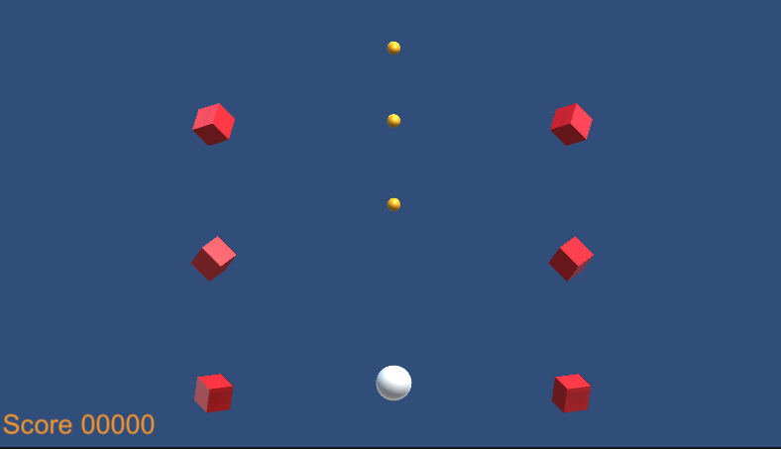

Please improve the attached Unity project "ProgramTestShooting".

This project was created with Unity 2023.3.9.

There is only one scene included in the project, SampleScene.

# 

# ■ Description of SampleScene

This section describes the main objects placed in SampleScene.

|  |  |
| --- | --- |
| ◇MainCamera There is only one camera. In this project, the camera is set to "Orthographic". ◇GameFlow This is where the main code of this project is located.  Two transitions, "Title screen" and "Stage screen" are set up here. ◇UI All the UI displayed in this project is placed under this object.  The UI is set to "ScreenSpace-Camera”. ◇StageObject This is used as a location for temporary objects created during the stage. |  |

# ■ Explanation of the game flow

* When you launch this project, it will start with the title screen (TitleLoop.cs).
* Press the "Space" key on the title screen to start the stage (StageLoop.cs)
* During the stage, you control your ship (Player.cs) to defeat the enemies (Enemy.cs) coming at you from the top of the stage.
* You can fire bullets (PlayerBullet.cs) by pressing the "Z" key.
* If you hit an enemy with a bullet, you will defeat the enemy and get a point.
* Enemies will appear periodically from Spawners (EnemySpawner.cs) placed throughout the stage.
* Press the "ESC" key to exit the stage and return to the title screen.

# 

# ■ Test Content

This project is "less than a game" at the moment, but we want you to improve some aspects of it to make it more interesting.

There are many ways to do this, but here are some basic fixes that we want you to consider for the test.

1. The way the enemies appear is monotonous and uninteresting. Improve the enemy's movement, actions and spawning so they are more dynamic, fun and pleasing to look at and play against.
2. The current movement and behavior of the player is simple and uninteresting. Please improve it. You may add some new features for this purpose.
3. Please add some visual and audio effects for bullets, enemy collisions, etc.
4. Please add a playable end condition to this stage. In other words, you will need to add a rule that the game ends when the player fails in some way, or when the game ends based on a time limit.