DESIGN DOCUMENT

Resolution used – 1920 x 1080

**Color palettes**

Standard formal color pallete. White and black contrasts for easy recognition. Important or notable options can be in blue. Red for alerts.

Useful for log in pages

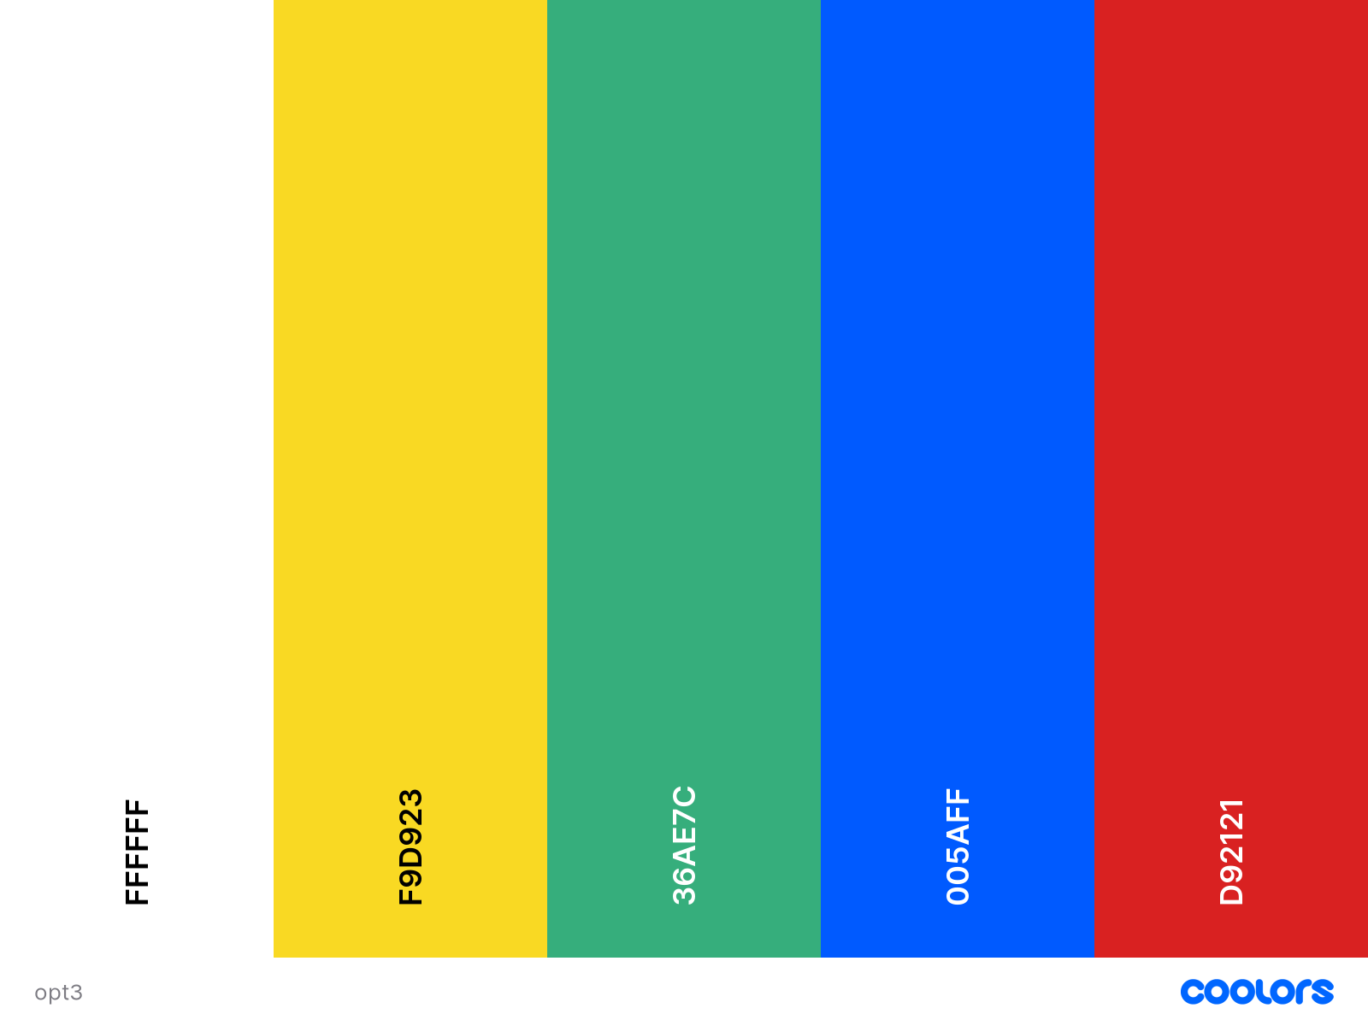

A colorful take on the original palette. White backgrounds or highlights. Yellow and green are complimentary can be used along side. Blue can be used for important fields and red for alerts.

Useful for chat rooms and user profiles

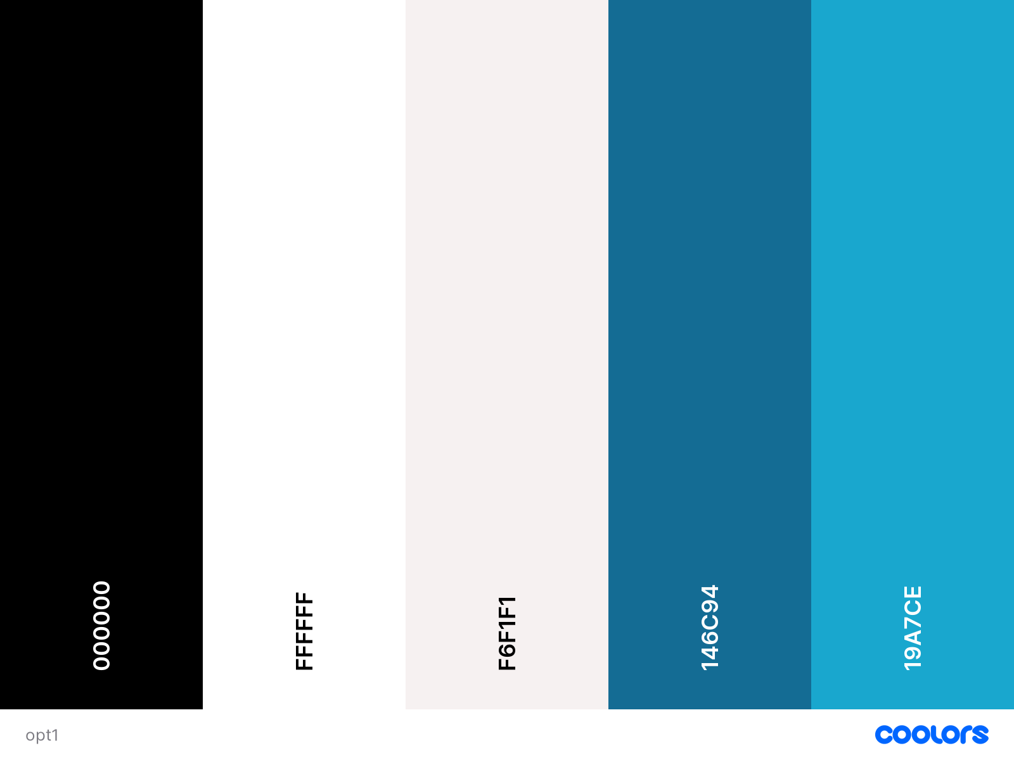

Simple and straight to the point. Black and white contrast, varying shades of blue to work with.

Useful for home pages, strict and straight to the point

WIREFRAMES

**Home page wireframes**

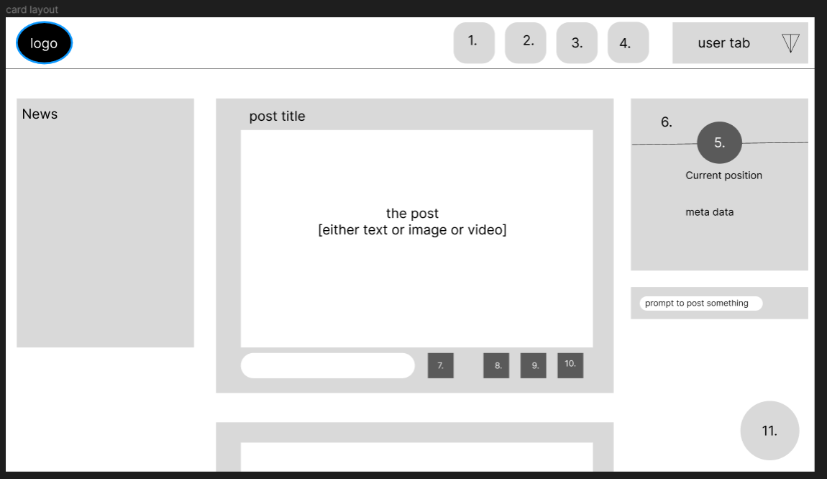

Legend –

1. Home
2. Contacts
3. Jobs
4. Messaging
5. profile picture
6. banner image
7. comments
8. share
9. save
10. options
11. chat bot(tentative)

clicking on profile will lead to profile page

basic home page layout with variable card and compact layout to suit the user’s needs

**Profile page wireframe**

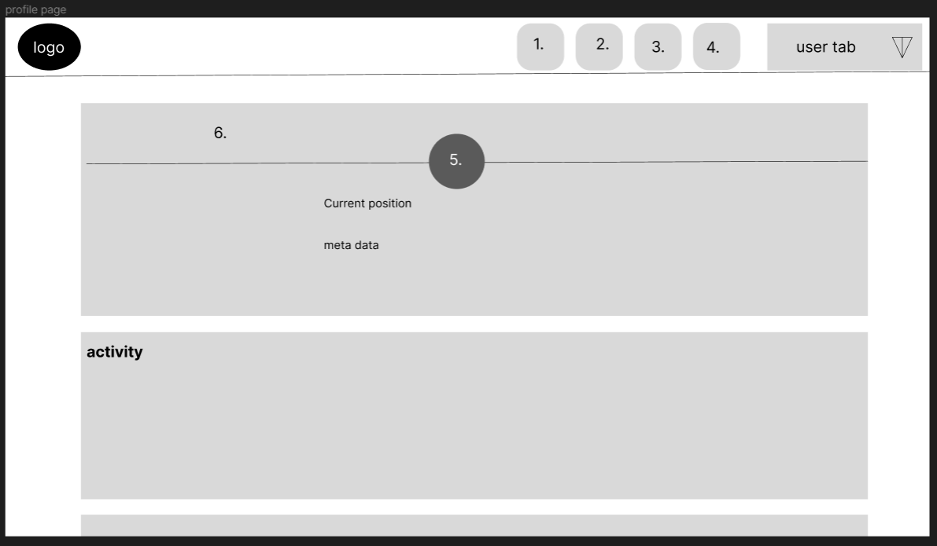

activity is where the user’s posts, comments and

saved data is found

other cards below

**chatroom wireframe**

5. options to add images, videos, links etc

6. will show up when the other person is typing someting

possibility - could shorten the text bubbles to make more

space in the field

**Log in portal**

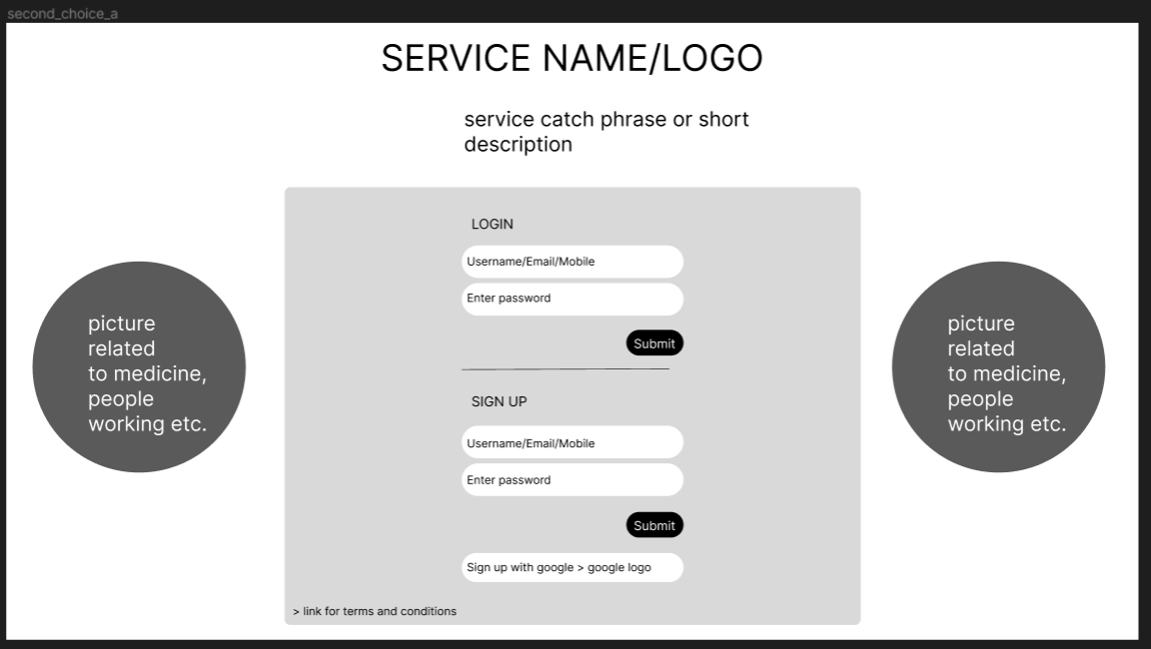

Three alternate design ideas.

**Job page**

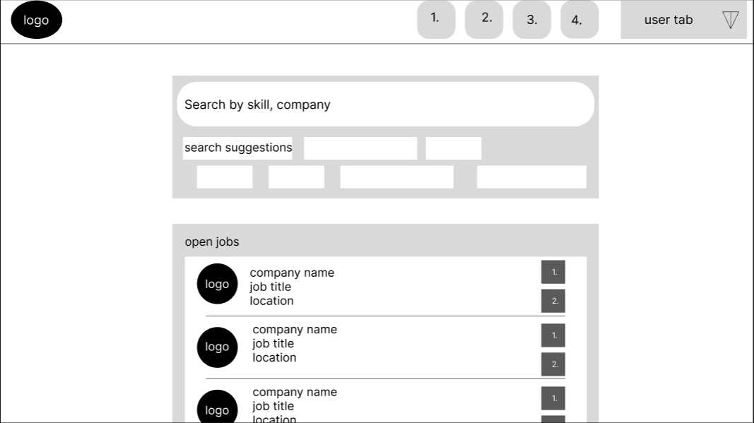

Here one will first notice the big search panel with suggestions. If the user is not sure as to what he wants to search, he may use one of the suggestions or he may simply check the relevant open jobs listed below.

**Research page**

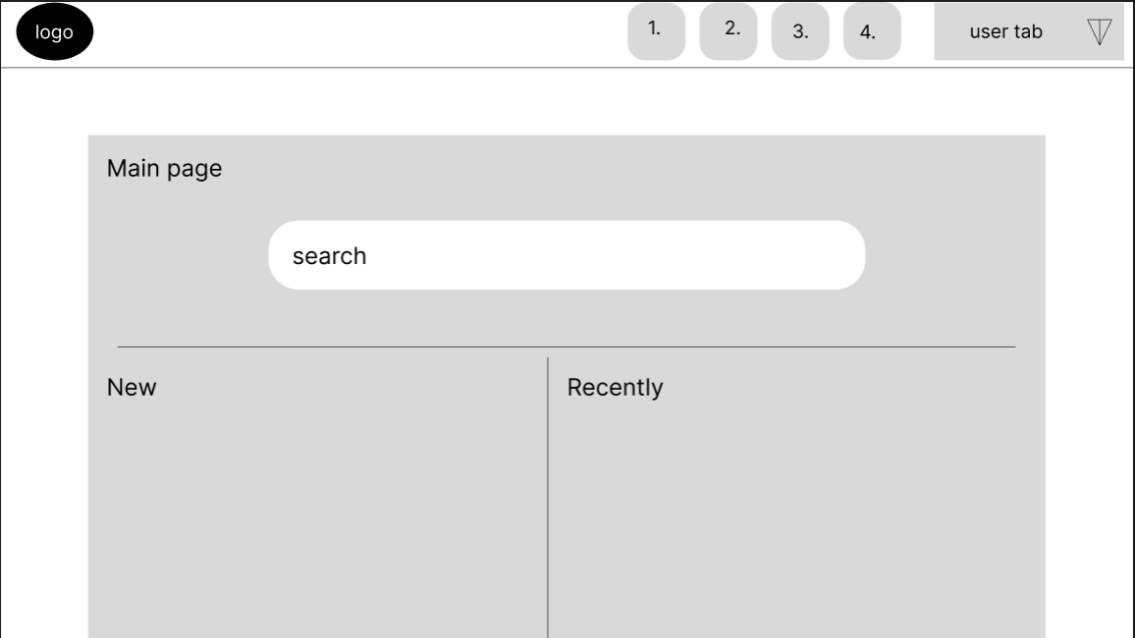

Research home page

Specific research documentation page

**Logo**



After several rounds of ideation and brainstorming this is the logo we came up with. It shows the medical field and how we are bringing people together for the betterment of doctors and the medical field as a whole.