Paper 1 draft: do corrections to draft metabolic models transfer?
Draft for comment, 6 October 2026

Title and abstract
Working titles:
- Do corrections to draft metabolic models transfer to new organisms? A pre-specified test on twelve bacteria
- Blind curation of automatically reconstructed metabolic models, tested on held-out bacteria against genome-wide mutant screens
Abstract. Most bacteria have only automatically built metabolic models, and corrections to these models are usually judged on the same data that inspired them. We asked whether corrections developed on four bacteria also improve the models of other bacteria.
As the yardstick we used published genome-wide mutant screens (RB-TnSeq), which show which genes a bacterium needs to grow on a given carbon source. We compared them with the genes that automatically built models (2017 CarveMe drafts from the EMBL GEMs collection) predict to be needed. On the four development bacteria we wrote five automatic correction rules that use only the genome annotation, and a procedure in which an AI model corrects gene–reaction links without seeing any screening data. We locked both methods, with a time-stamped record, before downloading the screens of twelve new bacteria: all remaining bacteria in the screening database that met criteria set in advance. We tested them in two rounds of six, holding the second round back until the first had been analysed.
Ten of the twelve could be tested. Before correction, the models agreed with the screens only moderately (Matthews correlation coefficient 0.33 to 0.52 in the eight bacteria whose experiments they could represent; 0 is chance and 1 is perfect). The automatic rules raised it by 0.037 on average (95% interval 0.025 to 0.048). The gain was the same in both rounds and in development, nine bacteria improved and none got worse, and 94% of the predictions the rules changed now agree with the screens. AI curation added 0.028 (eight improved, two worse; 0.029 on the held-back round alone), almost entirely by removing genes the drafts wrongly listed as backup enzymes. Four bacteria exposed limits of the locked pipeline. For two, the locked rules could not set up a model to test. Two others had experiments the models cannot represent: one grows by photosynthesis, and one "carbon-free" medium contains organic carbon. All four are reported.
In a comparison added after the study, we scored hand-curated models from the literature with the same protocol; one of them, iAH991, had to be rebuilt from its published tables. None approached the agreement between replicate screens (MCC 0.85 to 0.94); the extensively curated E. coli model iML1515 scored 0.59. In the three study bacteria whose curated models could be compared gene by gene (P. putida, S. oneidensis and B. thetaiotaomicron), we found no clear difference between the corrected drafts and the curated models on the genes and conditions both cover: the curated minus the corrected draft was −0.006, +0.051 and +0.014, and every 95% interval included zero, though the upper limits allow the curated model to be better by up to 0.10 to 0.13. Between 60% and 67% of the corrected drafts' wrong calls were also made by the curated models. The curated models grew in at least as many of the screened conditions as the drafts (36 against 28 of 43, 9 against 9 of 12, and 24 against 14 of 25), the B. thetaiotaomicron model only once given vitamin B12: as published it requires B12, which the screening medium lacks, and grew in none.
Simple annotation-based corrections carry over to new bacteria. Their gain is small. On the genes both contain, corrected drafts and hand-curated models score about the same and share most of their errors, and neither comes close to the limit set by the screens' reproducibility. Much of what limits these predictions is therefore common to automatic and hand-curated models rather than specific to drafts. The drafts' clearer deficit is coverage: they cannot grow on many of the carbon sources the bacteria use.

Introduction
Corrections to automatically built metabolic models are rarely tested on organisms they were not developed on. This study runs that test.
Genome-scale metabolic models link genes to reactions and predict which genes an organism needs to grow in a given environment. Automated pipelines such as CarveMe [1], gapseq [2] and ModelSEED [3] now build most available models. The EMBL GEMs collection alone holds 5,587 CarveMe drafts [1]. Drafts from different tools disagree with each other [4,5] and with measured phenotypes [2], and curation is what turns a draft into a useful model [6,7].
How do we know that a correction helps? Usually by scoring it against phenotype data, often the same data that suggested it. A correction chosen because it fixes a disagreement will look good on the data that revealed that disagreement, whether or not it generalizes. Structural quality scores do not settle the question either, because they measure a model's structure rather than its predictions [8].
Randomly barcoded transposon sequencing (RB-TnSeq) measures the fitness of mutants in nearly every gene, for dozens of bacteria across many carbon sources [9,10]. Bernstein et al. showed how to use such data to evaluate Escherichia coli models [11]. Because the data cover many organisms, they allow a stronger test: develop corrections on some organisms, then score them on organisms that played no part.
AI models are entering curation as well. For Human2 (Human-GEM 2.0), GPT-4 assessed all 26,246 gene–reaction pairs; the pairs it flagged were reviewed by hand, and the updated model was evaluated against CRISPR gene essentiality [12]. Machine-learning gap-filling has also been shown to improve phenotype predictions of draft models [15]. To our knowledge, no fully automated correction procedure has been locked before any outcome was accessed, tested on several held-out organisms with an isolated, paired effect estimate, and then repeated on a held-back set.
Here we developed five annotation-based correction rules and a written AI curation procedure on four bacteria, and locked both: every file they use was fingerprinted and recorded with a timestamp, so any later change would show. We then scored them once on six new bacteria whose fitness data were downloaded only after the lock, and repeated the test unchanged on six more that had been held back. We report what transferred, what did not, and where the locked pipeline itself limited the test, and we compare the drafts with hand-curated models scored the same way.

Results

Study design: develop on four bacteria, test on twelve
We developed the corrections on four bacteria, locked them, and tested them on twelve new bacteria in two rounds (Figure 1).
Panel. Eligibility was declared before anything was downloaded:
- Fitness Browser bacteria not used before in this project;
- an exact-strain draft in the EMBL GEMs collection;
- at least eight carbon-source experiments;
- at most three base media.
Twelve organisms qualified: every remaining bacterium in the Fitness Browser that met these criteria. A seeded random split assigned six to panel A, tested first, and six to panel B, held back until panel A had been analysed. Until each panel's inputs were locked, only non-outcome data were downloaded: gene and experiment metadata, protein sequences and the draft models.
Arms. Three models were built per organism:
- B0: the draft with a minimal gap-fill for growth on one reference condition, chosen by a written rule;
- U′: B0 plus five automatic, annotation-based rules;
- M: U′ plus gene-rule decisions made blind by an AI curator.
Primary metric. The paired difference in MCC between two arms, on the union of their scored genes. Per organism it carries a gene-bootstrap 95% interval. Across organisms it is the mean of the per-organism differences, with an organism-bootstrap 95% interval. The pre-declared reading: supported if the mean is positive and its interval excludes zero, not supported if the mean is zero or negative, and inconclusive otherwise.
Locking. The method, and then each panel's inputs including every AI curation decision, were locked before that panel's fitness data were downloaded. Locking means that every file was fingerprinted (hashed), committed to git and recorded with an external timestamp, so any later change would show. The full time order and its independent check are in Methods.
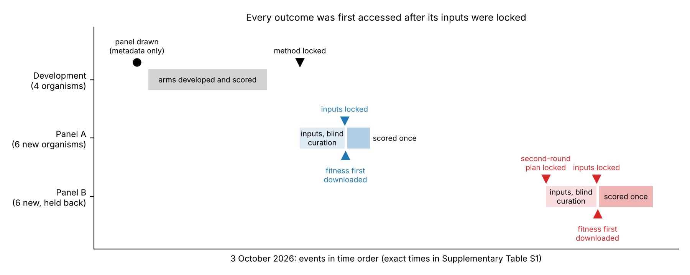
Figure 1. Design and order of events of the transfer study, 3 October 2026. The panel was drawn from metadata only. The organism-specific corrections behind the development arms were made in September. Their annotation-triggered form, and the arms shown here, were written and run on 3 October, after the panel was drawn and before any panel outcome was downloaded. Times of the locks and downloads are in Supplementary Table S1.

The drafts agree only moderately with mutant fitness
Before any correction, the drafts predict gene importance with MCC 0.33–0.52 in eight of the ten evaluable new organisms (Table 1).
- The outliers. R. palustris (0.145) and M. tuberculosis (−0.016) are well below that range; their models misrepresent the experiments.
- Gap-fill. Most drafts needed a small gap-fill to grow on their reference condition: 0 to 7 reactions.
- Coverage. Most models grew in only part of the mapped conditions, in as few as 7 of 21 (D. shibae) or 3 of 7 (R. palustris). M. tuberculosis grew in all 19.
- Corrections and coverage. The corrections changed the number of conditions with growth by at most one, and only in three new organisms.
Table 1. Organisms of the transfer study. Conditions mapped: compound × medium conditions whose carbon source maps to a BiGG metabolite; some lack an exchange reaction in the model and cannot support growth. Grows: conditions in which the model grows, for B0 and U′. MCC: union-gene MCC of B0 and U′ on the H1 comparison and of M on the H2 comparison, each on its own paired observations.
Phase | Organism | Gap-fill reactions | Conditions mapped | Grows B0 / U′ | Union genes | MCC B0 / U′ / M | Status
Development | Bacteroides thetaiotaomicron VPI-5482 | 5 | 25 | 14 / 14 | 507 | 0.497 / 0.510 / 0.551 | evaluable
Development | Pseudomonas putida KT2440 | 2 | 43 | 28 / 28 | 1,038 | 0.496 / 0.553 / 0.590 | evaluable
Development | Shewanella oneidensis MR-1 | 3 | 12 | 8 / 9 | 713 | 0.470 / 0.492 / 0.479 | evaluable
Development | Sinorhizobium meliloti 1021 | 1 | 33 | 21 / 22 | 979 | 0.565 / 0.617 / 0.639 | evaluable
Panel A | Echinicola vietnamensis DSM 17526 | 0 | 14 | 7 / 7 | 497 | 0.440 / 0.476 / 0.533 | evaluable
Panel A | Dinoroseobacter shibae DFL 12 | 7 | 21 | 7 / 7 | 584 | 0.422 / 0.472 / 0.530 | evaluable
Panel A | Dyella japonica UNC79MFTsu3.2 | 3 | 9 | 6 / 6 | 542 | 0.502 / 0.568 / 0.597 | evaluable
Panel A | Mycobacterium tuberculosis H37Rv | 0 | 19 | 19 / 19 | 463 | −0.016 / −0.016 / −0.018 | evaluable
Panel A | Rhodopseudomonas palustris CGA009 | 5 | 7 | 3 / 3 | 679 | 0.145 / 0.176 / 0.145 | evaluable
Panel A | Dechlorosoma suillum PS | — | — | — | — | — | not evaluable: gap-fill failed
Panel B | Caulobacter crescentus NA1000 | 4 | 13 | 5 / 5 | 547 | 0.431 / 0.448 / 0.475 | evaluable
Panel B | Cupriavidus basilensis 4G11 | 1 | 36 | 15 / 16 | 958 | 0.373 / 0.435 / 0.486 | evaluable
Panel B | Marinobacter adhaerens HP15 | 4 | 29 | 16 / 16 | 615 | 0.329 / 0.373 / 0.424 | evaluable
Panel B | Shewanella loihica PV-4 | 3 | 12 | 9 / 10 | 645 | 0.483 / 0.511 / 0.515 | evaluable
Panel B | Shewanella amazonensis SB2B | 1 | 20 | 14 / 15 | 648 | 0.518 / 0.549 / 0.560 | evaluable
Panel B | Desulfovibrio vulgaris Miyazaki F | — | — | — | — | — | not evaluable: no reference condition

Hand-curated models score about the same as the corrected drafts on shared genes
This comparison was added after the study, to put the size of the gains in context. It is descriptive, not a held-out test: every organism involved was used in development, and its fitness data had been seen. iJN1463 was also consulted during development: it was the first curated model scored on this benchmark, and development audits of the menaquinone pathway drew on its biomass composition and pathway. One of U′'s reaction patches (carbamate kinase) also fixes an error that iJN1463 shares.
We scored hand-curated models with the study's protocol, without gap-filling them: iML1515 for E. coli [17], and for each development organism the curated model that our data-provenance record had named before any was scored: iJN1463 for P. putida [18], iSO783 for S. oneidensis [19], iAH991 for B. thetaiotaomicron [20] and iGD1575 for S. meliloti [21]. For the three models outside BiGG, the choice of models and the analyses were written down and committed before scoring; decisions taken later are listed as deviations in Methods. Newer curated models of S. oneidensis and S. meliloti exist [22–24] and were not scored. Models outside BiGG were given BiGG identifiers by relabelling only. We found no public model file of iAH991, so we rebuilt it from the paper's supplementary tables. The rebuild reproduces the printed network, but it reproduces most, not all, of the paper's published predictions, so it did not pass every check we had set in advance (Methods).
Two of the curated models could not be compared gene by gene under the study's protocol:
- iGD1575 (S. meliloti), as distributed, makes ATP from nothing through at least four cycles of reversible reactions, a fault common among models built from the ModelSEED reaction database [27], which iGD1575 uses. It fails the energy check that every draft passed, so, as planned, it was not scored.
- iAH991 (B. thetaiotaomicron) grows in none of the 25 mappable conditions. Its biomass requires vitamin B12, which it cannot make and which the screening medium does not contain; the bacterium grew without it. With B12 added at the trace rate the protocol uses for vitamins, an exploratory deviation, it grows in 24 of the 25. Its gene-level results below come from that run; giving the drafts the same addition changes none of their calls.
- No model comes close to the screens' own reproducibility. Calls from replicate screens of the same condition agree with each other at MCC 0.90 to 0.94 (0.85 to 0.88 between replicates from different experiment sets). iML1515 grows in all 32 E. coli conditions but scores 0.59, and the curated models of the study organisms score 0.44 to 0.55 on their own genes and conditions (iAH991 in its exploratory run). The limit lies in the models and the binary growth call, not in noise in the screens.
- On shared genes, the corrected drafts score about the same as the curated models. On the genes both models contain and the conditions in which both grow (MCC):
Organism (curated model) | Shared genes × conditions | Draft (B0) | + automatic rules (U′) | + AI curation (M) | Hand-curated | Curated − U′ [95% interval]
P. putida KT2440 (iJN1463) | 764 × 28 | 0.53 | 0.57 | 0.61 | 0.56 | −0.006 [−0.108, 0.103]
S. oneidensis MR-1 (iSO783) | 440 × 8 | 0.48 | 0.50 | 0.48 | 0.55 | +0.051 [−0.028, 0.125]
B. thetaiotaomicron VPI-5482 (iAH991, exploratory, with B12) | 369 × 14 | 0.49 | 0.50 | 0.54 | 0.52 | +0.014 [−0.073, 0.102]
Each draft arm is compared with the curated model on the genes and conditions that pair shares, so the B0 and M pairs differ slightly from the U′ pair (for S. oneidensis, B0 grows in 7 of the 8 conditions; M adds 1 to 4 genes). Curated − B0: +0.035 [−0.063, 0.140], +0.070 [−0.013, 0.149] and +0.026 [−0.060, 0.117]; curated − M: −0.042 [−0.139, 0.054], +0.064 [−0.010, 0.143] and −0.013 [−0.095, 0.067], in the order of the table (gene bootstrap). Shared genes × conditions is the U′ pair's.
- No clear difference, and largely shared errors. Every interval above includes zero, though the upper limits would allow the curated model to be better by up to 0.10 to 0.13. The corrected draft and the curated model agree on 90% to 94% of calls (Cohen's κ 0.57 to 0.66), but of the calls either model makes as "important", only 43% to 56% are made by both. Of the corrected draft's wrong calls, 60% in P. putida (710 of 1,190), 66% in S. oneidensis (383 of 580) and 67% in B. thetaiotaomicron (478 of 711) are also wrong in the curated model, four to eight times what independent errors would give. Most of the shared errors (416, 359 and 303) are genes the screens show to be important that both models predict to be dispensable.
- The curated models' extra genes mostly add wrong "important" calls. In the conditions where both models grow, the screens confirm 52 of the 1,287 "important" calls on the 383 genes only iJN1463 contains, 16 of 43 on iSO783's 127 such genes, and 30 of 568 on iAH991's 447. In iAH991, 266 of these calls, none confirmed, come from one curation choice: a capsular polysaccharide in the biomass whose synthesis requires 21 genes at once. Counting every gene of either model, as the study's primary analysis does, the curated model scores 0.45 against 0.49 to 0.58 for the draft arms in P. putida, 0.45 against 0.49 to 0.56 in B. thetaiotaomicron and 0.53 against 0.47 to 0.49 in S. oneidensis. Only the differences from M, in P. putida (−0.130 [−0.227, −0.039]) and B. thetaiotaomicron (−0.112 [−0.187, −0.040]), exclude zero.
- The curated models grow in at least as many conditions, iAH991 once given B12. Of the conditions the pipeline can map, iJN1463 grows in 36 of 43 and the P. putida drafts in 28. iSO783 and the corrected S. oneidensis drafts each grow in 9 of 12, though not the same nine (iSO783 grows on N-acetylglucosamine, the drafts on adenosine), and iSO783 also grows on two dipeptides the carbon-source table leaves unmapped. iAH991 grows in none of 25 as published and in 24 with B12, against 14 for the drafts. In 10 of the P. putida draft's 15 gaps and all 7 of iJN1463's, the model has no exchange reaction for the carbon source.
Coverage across the study. In the twelve organisms whose drafts represent the experiments, the drafts grow in 33% to 75% of the screened conditions the pipeline can map (median 60%; 150 of 267 in total, or 47% of all 321 screened carbon-source conditions), and the corrections raise this only to 155 of 267. The gene-level scores in this paper cover only the conditions in which a model grows (Table 1).

The automatic rules transfer, and the transfer replicates
The five automatic rules improved agreement on new organisms by the same amount as in development: +0.036 in development, +0.037 on panel A and +0.036 on panel B (Figure 2, left).
Set | Mean MCC difference, U′ − B0 [organism bootstrap 95%] | Up / down / unchanged | Sign test p | Reading
Development, 4 organisms (retrospective) | +0.036 [0.017, 0.054] | 4 / 0 / 0 | — | —
Panel A, 5 evaluable | +0.037 [0.017, 0.054] | 4 / 0 / 1 | 0.125 | supported
Panel B, 5 evaluable | +0.036 [0.024, 0.051] | 5 / 0 / 0 | 0.063 | supported: replicated
Panels A and B, 10 evaluable | +0.037 [0.025, 0.048] | 9 / 0 / 1 | 0.004 | supported
- No organism got worse. The one unchanged organism is M. tuberculosis, whose model carries no signal in any arm (Results, last section).
- Same on common genes. Restricted to genes present in both models, the pooled estimate is identical (+0.037 [0.025, 0.048]).
- Same with t-intervals. With five organisms per panel the percentile bootstrap is coarse. t-based 95% intervals give the same readings: panel A [0.007, 0.067], panel B [0.015, 0.057], pooled [0.022, 0.051].
- What changed. Across the ten new organisms the gain rests on 53 genes whose predictions changed (2 to 10 per organism). Of 274 gene × condition calls that switched from important to unimportant, 273 agree with the data; of 117 that switched the other way, 94 do.
Which rules carried it (Figure 3).
- Menaquinone rule. This rule removes menaquinone from the biomass when the annotation shows fewer than two of the eight steps of its pathway. It contributed the most on both new panels: +0.020 each (panel A [0.003, 0.041]; panel B [0.003, 0.040]), against +0.010 in development. It fired in six of the ten new organisms and never lowered MCC. All 200 calls it changed went from important to unimportant, and 199 agree with the data. They involve 24 genes, mostly not menaquinone enzymes: thioesterases, β-oxidation and 2-methylcitrate-cycle enzymes and 4-hydroxybenzoyl-CoA reductase subunits, which the drafts had drawn into a route to menaquinone.
- Universal reaction patches. +0.005 on panel A and +0.012 on panel B, against +0.014 in development.
- Smaller contributions. Rule normalisation added +0.004 and +0.003, and the ATP synthase rule +0.003 and +0.001.
Stable total, shifting parts. The total gain was the same in all three phases, but its make-up shifted: the reaction patches and rule normalisation contributed less on the new panels than in development, and the menaquinone rule more. The gain is consistent but modest. After correction, MCC stays between 0.37 and 0.57 in the eight organisms with a working model.
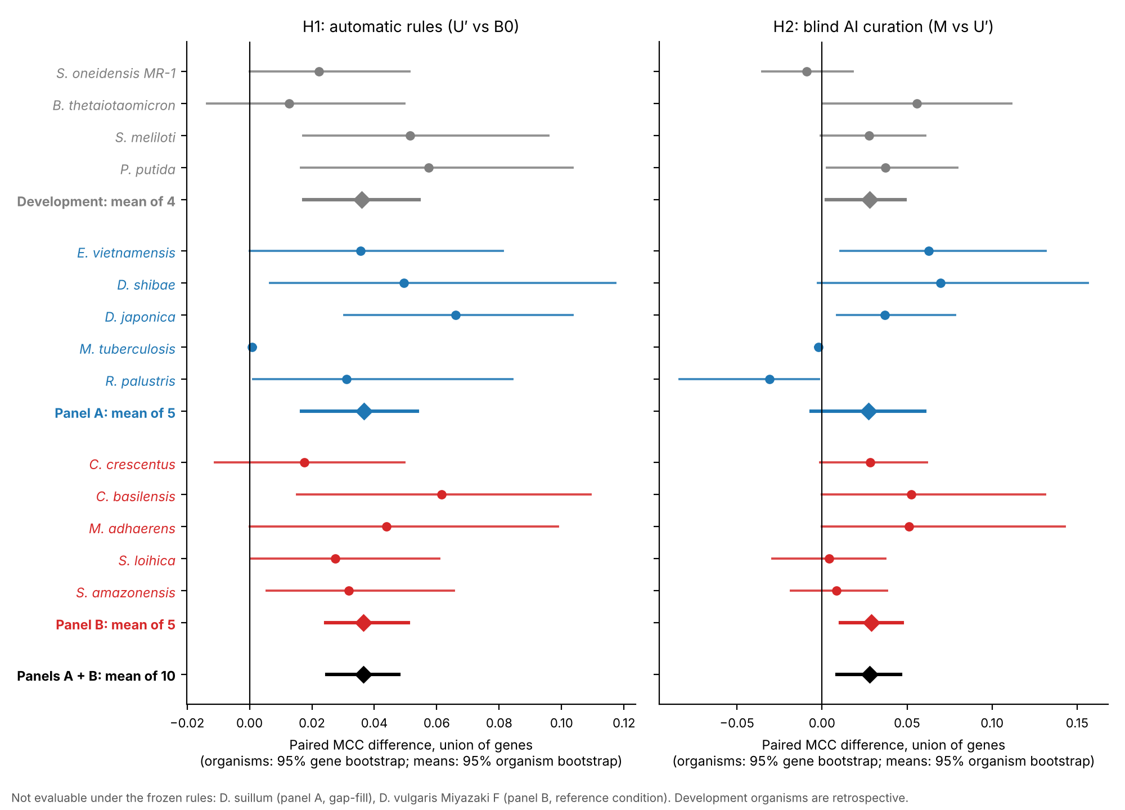
Figure 2. Paired MCC differences per organism, union of genes. Left: automatic rules (U′ vs B0, H1). Right: blind AI curation (M vs U′, H2); the two panels have different x-axis ranges. Circles: organisms, with 95% gene-bootstrap intervals. Diamonds: means over organisms, with 95% organism-bootstrap intervals. Grey: development organisms (retrospective). Blue: panel A. Red: panel B. Black: pooled new organisms. D. suillum and D. vulgaris Miyazaki F were not evaluable under the locked rules.
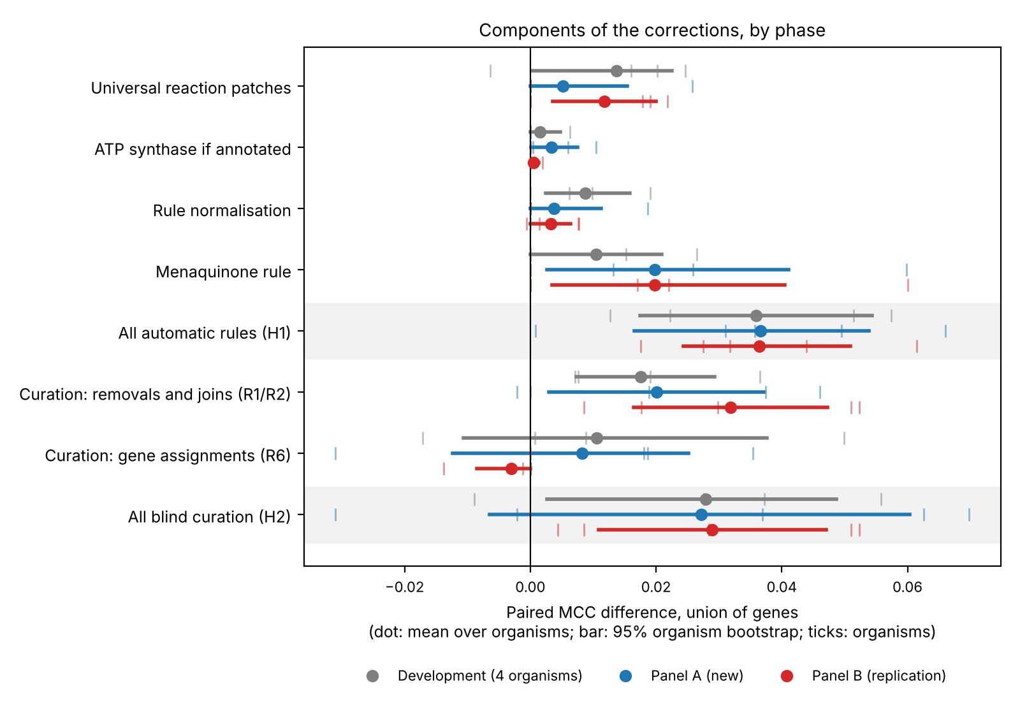
Figure 3. Contribution of each component, by phase. Each row compares an arm with the arm it extends, on the union of genes. Dots: mean over organisms. Bars: 95% organism-bootstrap interval. Ticks: individual organisms.

Blind AI curation helps, through one kind of decision
Blind AI curation of gene rules added +0.028 MCC pooled over the ten new organisms (Figure 2, right). Almost all of the gain came from removing gene alternatives that are not catalysts.
How the curator worked. It never saw fitness data. For each organism, a fresh AI subagent received a packet built from the U′ model and gene annotations only. The packet listed the gene-less reactions and the alternative-gene (OR) rules of reactions essential in at least one condition. Every gene came with its Fitness Browser description, RefSeq definition and genomic neighbourhood. The subagent was the same Claude model as the study session and made one attempt, under a fixed written procedure. It was instructed to open only its packet and not to use the web; its tools were not technically restricted. Four outcomes were allowed:
- removal (R1): remove an alternative that is not a catalyst;
- join (R2): join subunits into a complex;
- assignment (R6): assign genes to a gene-less reaction;
- abstain.
Set | Candidates | R1 | R2 | R6 | Abstained
Development (4 organisms) | 296 | 62 | 2 (with R1) | 18 | 214
Panel A (5 organisms) | 265 | 76 | 2 | 25 | 162
Panel B (5 organisms) | 297 | 74 | 0 | 12 | 211
Results by panel.
- Panel A: inconclusive. +0.027 [−0.007, 0.060], three organisms up and two down. The two losses were M. tuberculosis (−0.002) and R. palustris (−0.031), the two organisms whose models misrepresent the experiments. Without M. tuberculosis (a pre-declared sensitivity analysis, because its phenotypes are widely published), the estimate was +0.035 [−0.008, 0.066].
- Panel B: supported. +0.029 [0.011, 0.047], five of five up. This is the clean replication: the pooled analysis below was declared after the panel A results were known.
- Pooled: supported. +0.028 [0.009, 0.046], eight up and two down (sign test p = 0.11). On common genes: +0.026 [0.013, 0.040].
- t-intervals. Panel A [−0.026, 0.081], panel B [0.001, 0.057], pooled [0.005, 0.051]: the same readings, with panel B and the pooled estimate close to zero at their lower end.
Which decisions helped.
- Removals carried the gain: removals and joins together gave pooled +0.026 [0.014, 0.038], eight up, one down, one unchanged. On the new panels the curator joined subunits only twice, both in M. tuberculosis, so the effect of joins is untested.
- Assignments gave nothing on balance: pooled +0.003 [−0.008, 0.013], three up, three down, four unchanged.
Precision of the new calls. Curation only adds "important gene" calls: it never turned an important call into an unimportant one. So the question is how many of the new calls the fitness data confirm (Figure 4). The counts are gene × condition calls, so one gene can count many times: the 328 calls from removals and joins involve 29 genes.
- R1/R2. On the new panels, these decisions created 328 new calls (gene × condition) and the data confirm 174. Of the 154 misses, 95 are in M. tuberculosis, whose model has no signal. Without it, 174 of 233 are confirmed (75%).
- R6. Assignments created 85 new calls, of which 34 are confirmed; on panel B only 3 of 32.
- For comparison. Between 0.6% and 16% of gene × condition cells are important in the data. U′'s own important calls are 44–80% precise in the organisms whose models carry signal.
Ion transporters. Two thirds of the unconfirmed assignment calls (34 of 51) involve ion transporters: a zinc ABC transporter in R. palustris, chloride channels in C. crescentus and S. loihica, and a manganese transporter in S. loihica. These genes became important in every condition with growth, and none is. The other 17 involve dihydropyrimidinase, the glycine-cleavage T and H proteins, dihydroorotate dehydrogenase and a lactate permease. A secondary hypothesis added before panel B (H3), after a look at three organisms already scored, dropped assignments to inorganic-ion transport reactions. It pointed the right way (+0.003 [0.000, 0.008]) but was inconclusive, because the filter changed only two organisms.
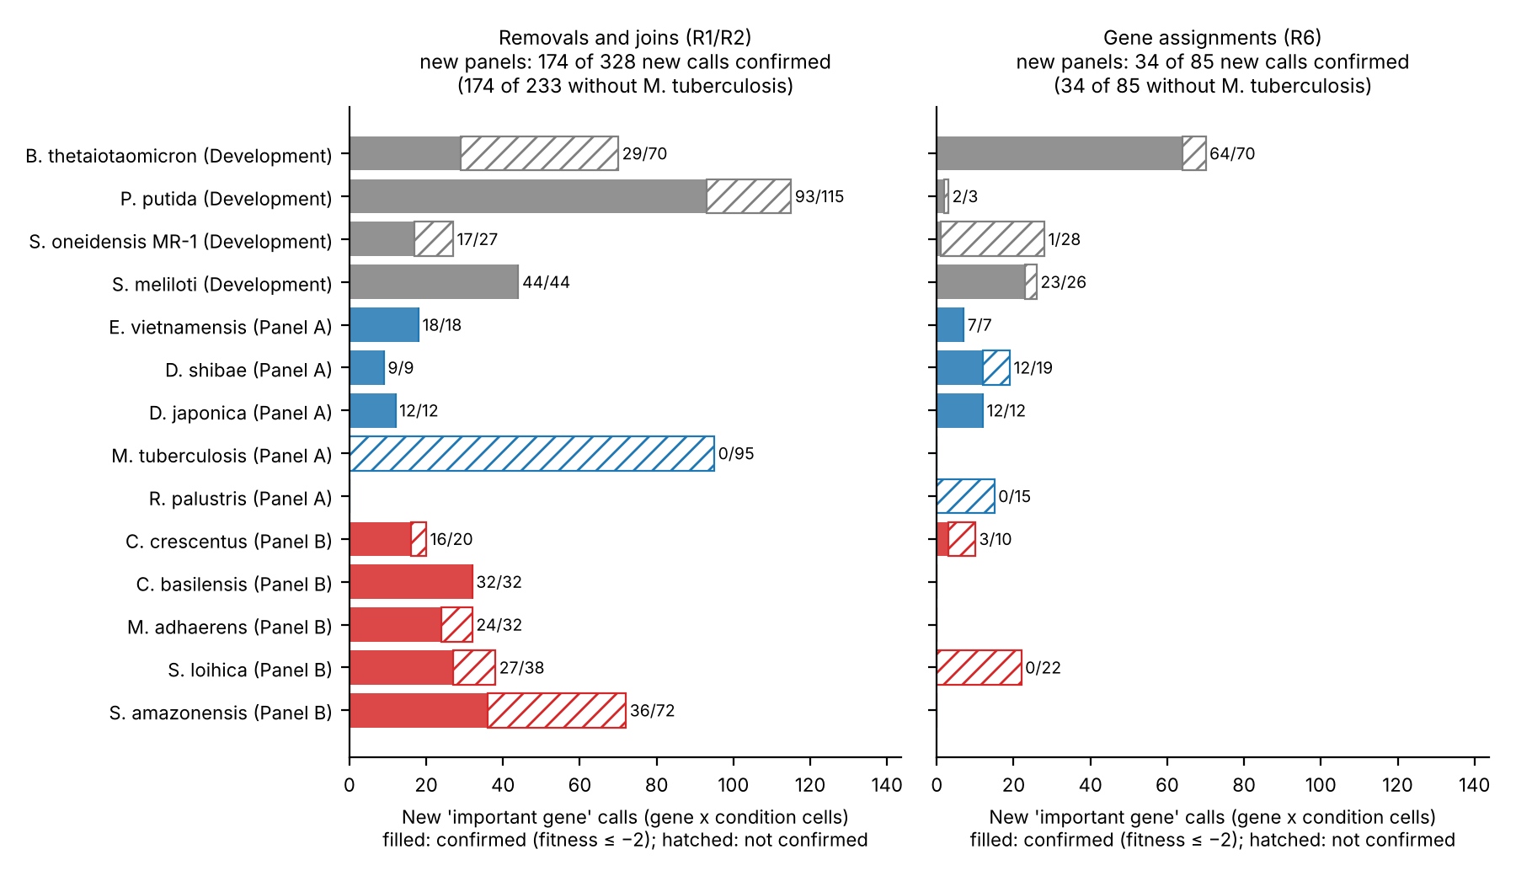
Figure 4. New "important gene" calls made by blind curation, by decision kind and organism. Filled: confirmed by the fitness data (fitness ≤ −2). Hatched: not confirmed. Counts are gene × condition cells on the union of genes.

The locked pipeline set its own limits
Applied as locked, the pipeline could not set up a model for two organisms and misrepresented the experiments of two more. None was replaced or dropped after the outcomes were seen.
Organism | What happened | Rule responsible
D. suillum PS (panel A) | All six gap-fill solutions found within the six-round limit created an energy-generating cycle, so no base model could be built. Its fitness table was never downloaded. | gap-fill with an energy-cycle gate
D. vulgaris Miyazaki F (panel B) | The carbon-source experiments of its main medium name no compound, so no reference condition could be chosen. Its fitness table was never downloaded. | reference-condition rule
M. tuberculosis H37Rv (panel A) | The "no carbon" Sauton's medium still contains asparagine, citrate (as ferric ammonium citrate) and 0.2% ethanol. As defined organics these are unlimited, so the model grows at implausible rates (5–9 per hour) in every condition and its predictions carry no signal (MCC about 0 in every arm). | media rule
R. palustris CGA009 (panel A) | The experiments are phototrophic and anaerobic, but the CarveMe universe has no photosystem. The gap-fill made the model respire the trace nitrate of the medium's cobalt nitrate, so it grows in 3 of 7 conditions with the wrong energy metabolism (MCC 0.14–0.18). | media rule; no light input
Each problem suggests a fix:
- limit counter-ions that come only from trace-element salts;
- flag organic carbon in "no carbon" media;
- handle phototrophs;
- add more gap-fill cut rounds;
- use a reference rule that skips media without named carbon sources.
Testing such fixes needs new organisms, because every eligible organism has now been used.

Discussion
Corrections derived from four bacteria improved predictions for nine of ten held-out bacteria and left the tenth unchanged, by the same amount in development and in both rounds (+0.036, +0.037 and +0.036). This holds within one assay platform and one 2017 draft collection.
How large is the gain? In absolute terms it is small: 0.037 on a scale where the drafts start at 0.33 to 0.52. For comparison, no model we scored comes close to the agreement between replicate screens (0.85 to 0.94), and the extensively curated E. coli model scores 0.59. In the three study bacteria whose curated models we could compare gene by gene, we found no clear difference between the corrected drafts and the curated models on the genes both contain, and 60% to 67% of the corrected drafts' wrong calls are also the curated models'. Much of the remaining disagreement is therefore not specific to automatic drafts, and since replicate screens agree closely, it lies in what the models represent rather than in noise in the data. Against that background the gain is modest but real: no new organism got worse, the total was the same in all three phases, and 94% of the changed predictions moved toward the data. A set of rules tuned to the quirks of its development organisms would shrink on new ones; this set did not, although its parts shifted between phases (Figure 3).
What hand curation buys. On this test, no clear gain on the genes both kinds of model contain, although the intervals cannot exclude one of about 0.1. The curated models contain more genes, but the screens confirm few of the extra genes' predicted requirements; and they grow in at least as many conditions, the B. thetaiotaomicron model once given a vitamin it requires. Curated and automatic models fail on largely the same calls, four to eight times more often together than independent errors would, and most shared errors are genes the screens show to matter that both models predict to be dispensable. We can only suggest reasons, untested here: both kinds of model predict growth or no growth rather than the graded fitness the screens measure; neither represents the regulation that decides which of two backup enzymes a cell actually uses; and some gene functions are wrong or unknown in both. This reading rests on three development organisms scored after the study, one with a rebuilt model, and it should be tested on held-out organisms with curated models.
A second gap is coverage. The drafts grow in only about half to two thirds of the screened conditions the pipeline can map, and the corrections barely change that. Here curation helped: the curated models grow in at least as many of these conditions, the B. thetaiotaomicron model once given a vitamin it requires as published. Filling the drafts' gaps would use condition-level growth, as the base gap-fill already does for one condition, but no gene-level outcome data. In P. putida, 10 of the draft's 15 gaps lack an exchange reaction for the carbon source altogether, and 14 of the 57 screened carbon sources cannot be mapped at all. A locked test of such a fix on new organisms is the natural next study.
What transferred is unglamorous. On the new organisms the largest single contribution came from a biomass rule: dropping menaquinone where the annotation shows fewer than two of the eight steps of its pathway. The calls it corrected were mostly not about menaquinone enzymes. They concerned enzymes that the drafts had drawn into a route to menaquinone to satisfy the biomass demand. A universal biomass that demands what an organism cannot make distorts which genes look essential. The rule's annotation trigger has not yet been checked against measured quinone types, which differ systematically between bacterial groups [16].
AI curation works within limits. Without seeing outcomes, an AI curator improved predictions on eight of ten new organisms; the clean replication on panel B gave +0.029. The gain came from one kind of decision: removing gene alternatives that are not catalysts. Assigning genes to gene-less reactions did not help on balance, and two thirds of its wrong calls involved ion transporters. That suggests a practical policy: let AI curators remove alternatives, and hold their gene assignments, especially to ion transporters, to a stricter standard. Joins of subunits were too rare here to judge.
Pre-specification is cheap. It took hours, not months, to do four things: lock a method, record the lock, download outcomes only afterwards and have an independent agent recompute every number. The same design suits other claims that a model change helps. Here it has three weaknesses:
- Self-custody. The same model family designed, prepared and scored the test, and checked it.
- A private record. The external time record is a private project document. A public registration would be stronger.
- One manifest changed. The replication plan's manifest no longer verifies at the current head, because one input file gained panel B entries before the panel B inputs were locked.
An external custodian of the outcome data, or a community challenge on newly measured organisms, would remove the first weakness.
Limits.
- One assay platform and one draft collection. RB-TnSeq fitness and the 2017 EMBL GEMs drafts; current CarveMe output and other reconstruction tools are untested.
- Fitness is not growth. Pooled competitive fitness is not single-mutant growth. Only genes with fitness values are scored, which excludes genes essential in the library's growth medium, so the benchmark measures carbon-source-specific importance. The threshold of −2 was used without a t-score filter.
- The metric. MCC on binary calls was pre-specified. Bernstein et al. recommend the area under the precision–recall curve [11], which we have not analysed on matched observations.
- Small panels. Ten evaluable organisms, two of them Shewanella species related to the development organism S. oneidensis.
- Development exposure. The curated E. coli model helped flag one reaction patch, so E. coli counts as a fifth exposed organism.
- Blinding of the curator. It rests on instructions. The packets' gene descriptions came from the Fitness Browser gene table. Whether any of them reflect the Browser's fitness-based re-annotations remains to be checked.
- Unknown training exposure. The AI curator's training may include published phenotypes; the pre-declared sensitivity analysis without M. tuberculosis did not change the reading.
- Locked pipeline choices. These excluded or misrepresented four of twelve organisms.
- Few curated comparisons. Three organisms, all used in development and compared after the study. iJN1463 was consulted during development. iAH991 is a rebuild from published tables that did not pass every check we had set in advance, and its gene-level comparison needed vitamin B12 added to its medium. The S. meliloti model could not be scored.
- Gaps in the locked tables. The carbon-source table maps D-tagatose to an identifier that is not BiGG's (tagat__D for tag__D), so one S. meliloti condition can never grow, and it leaves two dipeptides unmapped although BiGG names them; iSO783 grows on both, and the drafts have no exchange for either. The media rule limits reductants such as cysteine to trace uptake so that they cannot serve as carbon sources; a model that cannot make cysteine from sulfate or methionine, such as iAH991, is then left with a trace of sulfur.
Next tests.
- Growth on every screened carbon source that maps to BiGG: fill the coverage gaps from condition-level growth alone, lock the fix, and test gene predictions on new organisms.
- Hand-curated models of held-out organisms, and the original iAH991 file, scored the same way.
- Current CarveMe drafts of the same organisms (a robustness check, since these organisms are now exposed).
- A random-removal control for the curator's removals.
- Other phenotype types, such as growth profiles.
- Organisms whose fitness data are published after a method is locked.

Methods
Data.
- Fitness. Fitness Browser RB-TnSeq gene fitness and experiment metadata [9,10]. Carbon-source experiments with no second condition other than DMSO were grouped by compound and base medium, and fitness was averaged over replicate experiments.
- Models. EMBL GEMs drafts [1] pinned at collection commit 260d0f1, and the CarveMe bacterial universe.
- Media recipes. FEBA medium recipes (bitbucket commit 803273865ea9).
Panel selection. Eligibility criteria were declared before any candidate's data were downloaded:
- in the Fitness Browser on the selection date;
- not among the nine organisms with archived downloads in the project;
- a bacterium;
- an exact-strain EMBL GEMs model, after normalising punctuation and known taxonomic renamings;
- at least eight carbon-source experiments;
- at most three base media.
Eligible organisms were ordered by identifier and shuffled with a fixed seed (20261003): the first half became panel A and the rest panel B. No organism was replaced after assignment.
Gene mapping. Model genes were matched to Fitness Browser loci by protein sequence:
- exact identity;
- or containment covering at least 90% of the longer sequence;
- or equal length with at least 97% identical positions.
Ambiguous matches were left unmapped. Between 91.4% and 100% of model proteins mapped (panel A at least 95.6%).
Media and carbon sources. Each base medium was mapped from its FEBA recipe to BiGG metabolites [13]:
- inorganic salts to their ions;
- vitamins, cofactors, nucleobases and reductants to trace uptake;
- other defined organics unlimited;
- buffers and chelators dropped;
- complex ingredients made a medium undefined, and its experiments were excluded.
Water, protons, CO2 and trace metals (capped at 0.1 mmol/gDW/h) were always available. O2 was available when the experiments were aerobic. Carbon sources were mapped to the BiGG metabolite of exactly the named compound. Applied to the development media, the rule reproduced the hand-curated media component by component, except for two trace limits (cysteine in MOPS rich medium, methionine in Varel–Bryant medium).
Base model (B0). Each draft received a minimal gap-fill from the CarveMe universe (minimum growth 0.05 per hour), with a gate that rejects solutions creating energy-generating cycles. The gap-fill targeted one reference condition chosen by a written rule: in the base medium with most carbon-source experiments, the first tested substrate in a fixed order (D-glucose, D-fructose, glycerol, L-lactate, pyruvate, succinate, …). The rule reproduced the hand-chosen references of all four development organisms.
Automatic rules (U′). Applied in order:
- three universal reaction patches: carbamate kinase in its catabolic direction, subunit conjunctions for carbamoyl-phosphate synthase, and an irreversible MECDPDH4E;
- normalisation of conjunction rules;
- diffusion and exchange of glycolaldehyde;
- an F0F1 ATP synthase when the draft has none and the annotation names at least six of its eight subunit types;
- removal of menaquinone from the biomass when the annotation shows fewer than two steps of its pathway.
The rules generalise organism-specific corrections made in September. One reaction patch was found partly with the curated E. coli model iML1515. Their annotation-triggered form was written on 3 October, after the panel had been drawn from metadata and before any panel outcome was downloaded. U′ was chosen after all development arms had been run, as the arm with the highest development MCC.
Blind adjudication (M). For each organism, a packet was built from the U′ model and metadata only. It listed the gene-less reactions and the alternative-gene rules of reactions essential in at least one mapped condition where U′ grows. Each came with its equation, annotations and current rule. Every gene came with its description from the Fitness Browser gene table, its RefSeq definition and its genomic neighbourhood. One fresh subagent per organism wrote its decisions in one attempt. It was instructed to read only its packet and the written procedure and not to use the web. The procedure was not revised after development. All decisions were locked with the inputs before any outcome was downloaded.
Scoring.
- Simulation. Carbon uptake was set to −10 mmol/gDW/h and growth counted above 0.001 per hour. Medium components that the model could not take up received an uptake-only transporter (medium completion), and the energy-generating-cycle gate applied. The solver was GLPK through COBRApy 0.32.1 (Python 3.11).
- Calls. A gene was predicted important when its deletion stops growth in a condition where the wild-type model grows. It was observed important when its fitness is −2 or lower, with no t-score filter. Only genes with fitness values are scored.
- Metric. MCC [14] on all gene × condition pairs where both arms grow. The primary gene set was the union of both arms' genes: a gene absent from a model counts as predicted unimportant there.
- Uncertainty and reading. Per-organism intervals: 1,000 gene-bootstrap resamples. Means: 10,000 organism-bootstrap resamples, with t-based intervals as a sensitivity analysis. Organisms changing by less than 0.001 counted as unchanged. Sign tests were exact and two-sided. The pre-declared reading is given in Results.
Locking, time order and verification. Each lock is a manifest of file hashes with a content fingerprint, committed to git and recorded in a private project document whose server timestamp follows the commit by less than half a minute. Outcome files were downloaded only after the corresponding lock, and their hashes and download times were recorded. All locks, downloads and runs took place on 3 October 2026. The method was locked first, and each panel's inputs were locked before that panel's fitness tables were first downloaded; each arm was then run once. Supplementary Table S1 lists the times.
All four manifests verify at their own commits. At the current head the replication plan's manifest differs in one file, filter_report.json, which gained panel B entries before the panel B inputs were locked; its earlier entries are unchanged.
On 3 October a separate agent, using its own code, recomputed the primary and secondary results from the run matrices, with exact agreement. It checked the fitness values of every arm against the downloaded tables (376,620 arm × gene × condition cells on panel A and 881,911 on panel B), and confirmed the time order from git history, the manifests, the download records and the external timestamps. A second agent checked this paper's derived tables, figures and counts against the result files on 5 October.
Hand-curated reference models (added after the study). iML1515 [17], from the validation repository of Bernstein et al. [11], and iJN1463 from BiGG (BiGG's version of the iJN1462 model of Nogales et al. [18]) were scored with the study's media and carbon-source tables, parameters, medium completion, energy-cycle gate and solver, without gap-filling. Their gene identifiers are locus tags that match the Fitness Browser's. iML1515 was scored on the E. coli BW25113 screens; the strain's deletions (araBAD, rhaBAD, lacZ) were not applied, because the protocol has no strain adjustment, and the three of these genes that are scored show no fitness defect. The runs used Python 3.13 with the study's versions of COBRApy and optlang (the study ran under Python 3.11).
For the other development organisms we took the curated model that the project's data-provenance record of 5 September 2026 names: iSO783 (BioModels MODEL1507180036) [19,25], iGD1575 (Supplementary Data 6 of [21]) and iAH991 [20]. The plan (docs/studies/transfer-v1-curated-references-plan.md) was committed before any of them was scored. By then the identifier translation of iSO783 and iGD1575 had listed which exchange reactions each lacks, but no fitness outcome had been computed. Each model was given BiGG identifiers by relabelling only: identifiers that are already BiGG's were kept, older BiGG identifiers and ModelSEED compounds were mapped through the ModelSEED database's aliases [26], and the four cases the aliases could not settle (ubiquinone-8 and ubiquinol-8 in iSO783 and iGD1575) were decided by name and recorded with their evidence. iGD1575's two-step exchanges were collapsed to single exchanges, and one of its gene rules, unparseable because of a missing parenthesis, was restored. An independent check found stoichiometry, bounds, gene rules and objectives unchanged, reaction by reaction, for all three models. Models without a periplasm were also checked for proton import from nothing, which the gate does not test; there was none in iSO783 or iAH991.
Deviations from the plan. Each was decided before the gene-level results it affects were computed, except the two gene-map corrections, which independent checks found afterwards.
- Gene maps. The plan mapped iSO783's genes by identity and iAH991's by removing the underscore. The Fitness Browser lists 13 S. oneidensis and 5 B. thetaiotaomicron loci in the other form (SO_0419, BT_0823), so each model was mapped by its rule first and then by the other form, as the drafts' mapping does. This changed iSO783's own MCC from 0.547 to 0.546 and iAH991's from 0.4485 to 0.4487.
- iAH991 was scored although the rebuild did not pass every check set in advance (next paragraph).
- iAH991's medium. The exploratory run added vitamin B12 at the trace rate the protocol uses for vitamins (0.001 mmol/gDW/h).
- Arabinan. The screen's sugar-beet arabinan, which the table maps to BiGG's three-sugar araban__L for the drafts, was mapped to iAH991's arabinan, a polymer of about 101 sugars. At the protocol's fixed uptake rate iAH991 therefore receives about 34 times more carbon in this condition. Without it, curated − U′ is +0.013 [−0.074, 0.100].
We found no public model file of iAH991, so we rebuilt it from Supplementary Tables S10a and S10b of [20] (scripts/rebuild_iAH991_from_pdf.py), without access to fitness data. The rebuild matches the published counts (1,488 reactions, 1,152 metabolites, 991 genes); an independent re-reading of the PDF found no difference in stoichiometry or gene rules, and the rebuild agrees with the paper's second printing of the network (its Table S12) apart from 11 gene rules that S12 prints malformed. Three entries cut off or garbled in S10a (the biomass reaction and two bounds) were taken from S12. The plan required the rebuild to reproduce the paper's published predictions, and it reproduces most but not all of them: 42 of 45 growth rates (two of the misses come from rates that break the paper's own dosing rule, one from an ambiguous substrate), 62 of 63 carbon-source calls, 15 of 17 knockout predictions, and the count of essential genes on rich medium (61) but not on glucose (205 against 204) or on tryptone–yeast extract–glucose medium (127 against 116, unexplained). We scored it anyway, as a judged deviation: the printed network is reproduced exactly, most mismatches trace to the paper's simulation conditions, and the rest suggest that the authors simulated a network differing from the printed one in a few reactions or gene rules. In the exploratory run iAH991's growth is limited by sulfur, because it cannot make cysteine from sulfate or methionine and the protocol caps the medium's cysteine at a trace rate; adding sulfide raises its growth but changes none of its calls. L-fucose and L-rhamnose support growth of only 0.0012 per hour; without them curated − U′ is +0.023 [−0.063, 0.111]. iGD1575's failure is recorded in results/transfer_v1/reference_models/Smeli/iGD1575/GATE_FAILURE.md.
Shared-gene comparisons use the genes both models contain and the conditions in which both grow, as in the study's common-gene analysis; union comparisons use every gene of either model; intervals come from 1,000 gene bootstraps. Coverage is the number of mapped conditions in which a model grows. Replicate agreement compares the calls (fitness ≤ −2) of pairs of replicate experiments of the same compound and medium, on the same genes and conditions; single replicates give a lower bound on the reliability of the averaged calls the benchmark scores.

Data and code availability
All code, inputs, lock manifests, run matrices and curation decisions are in the project repository (github.com/Unsaif/metabolic_modelling_advancements, branch claude/opus-continuation). It should be archived with a DOI before submission.
What | Where in the repository
Method, replication plan and adjudication procedure (with the verbatim prompt) | docs/studies/transfer-method-v1.md, transfer-v1-replication-plan.md, transfer-adjudication-procedure-v1.md, transfer-adjudication-prompt-v1.txt
Lock manifests | results/study_freezes/transfer_v1_method.json, transfer_v1_inputs_panel_A.json, transfer_v1_replication_plan.json, transfer_v1_inputs_panel_B.json
Every curation decision | data/studies/transfer_v1/decisions/<organism>.json
Run matrices, paired comparisons and aggregates | results/transfer_v1/development/, evaluation_panel_A/, evaluation_panel_B/, pooled_panels_A_B_*.json
Fitness download records (hashes and times) | data/fitness_browser_panel/
Hand-curated reference models and comparison | scripts/score_reference_model.py, compare_reference_models.py; results/transfer_v1/reference_models/, with the independent checks in independent_check/ and independent_check_curated/ (iML1515 itself from github.com/dbernste/E_coli_GEM_validation, not redistributed)
Curated models outside BiGG: plan, sources, identifier translation, iAH991 rebuild | docs/studies/transfer-v1-curated-references-plan.md; models/curated/ (sources and checksums in its README; the iAH991 supplement PDF is not redistributed); scripts/translate_curated_model.py, rebuild_iAH991_from_pdf.py; data/reference/namespace/
Figures and Table 1 | scripts/plot_transfer_timeline.py, plot_transfer_paired.py, plot_transfer_attribution.py, plot_curation_precision.py, make_transfer_table1.py
Fitness data come from the Fitness Browser (fit.genomics.lbl.gov) and draft models from the EMBL GEMs collection.

References
A reviewing agent checked entries 1–14 against publisher or repository records on 5 October 2026 (Chicco and Bernstein from search records only). Entries 15 and 16 were added on its advice, 17 and 18 with the hand-curated comparison, and 19 to 27 when the comparison was extended to curated models outside BiGG.
- Machado D, Andrejev S, Tramontano M, Patil KR. Fast automated reconstruction of genome-scale metabolic models for microbial species and communities. Nucleic Acids Res. 2018;46(15):7542–7553. doi:10.1093/nar/gky537
- Zimmermann J, Kaleta C, Waschina S. gapseq: informed prediction of bacterial metabolic pathways and reconstruction of accurate metabolic models. Genome Biol. 2021;22:81. doi:10.1186/s13059-021-02295-1
- Henry CS, DeJongh M, Best AA, Frybarger PM, Linsay B, Stevens RL. High-throughput generation, optimization and analysis of genome-scale metabolic models. Nat Biotechnol. 2010;28:977–982. doi:10.1038/nbt.1672
- Mendoza SN, Olivier BG, Molenaar D, Teusink B. A systematic assessment of current genome-scale metabolic reconstruction tools. Genome Biol. 2019;20:158. doi:10.1186/s13059-019-1769-1
- Hsieh YE, Tandon K, Verbruggen H, Nikoloski Z. Comparative analysis of metabolic models of microbial communities reconstructed from automated tools and consensus approaches. npj Syst Biol Appl. 2024;10:54. doi:10.1038/s41540-024-00384-y
- Thiele I, Palsson BØ. A protocol for generating a high-quality genome-scale metabolic reconstruction. Nat Protoc. 2010;5:93–121. doi:10.1038/nprot.2009.203
- Heinken A, et al. Genome-scale metabolic reconstruction of 7,302 human microorganisms for personalized medicine. Nat Biotechnol. 2023;41:1320–1331. doi:10.1038/s41587-022-01628-0
- Lieven C, et al. MEMOTE for standardized genome-scale metabolic model testing. Nat Biotechnol. 2020;38:272–276. doi:10.1038/s41587-020-0446-y
- Wetmore KM, et al. Rapid quantification of mutant fitness in diverse bacteria by sequencing randomly bar-coded transposons. mBio. 2015;6:e00306-15. doi:10.1128/mBio.00306-15
- Price MN, et al. Mutant phenotypes for thousands of bacterial genes of unknown function. Nature. 2018;557:503–509. doi:10.1038/s41586-018-0124-0
- Bernstein DB, Akkas B, Price MN, Arkin AP. Evaluating E. coli genome-scale metabolic model accuracy with high-throughput mutant fitness data. Mol Syst Biol. 2023;19:e11566. doi:10.15252/msb.202311566
- Luo J, Wang H, Moyer D, Guo Z, Robinson JL, Gustafsson J, Anton M, Chen Y, Kerkhoven EJ, Nielsen J, Li F. Reconstruction of human metabolic models with large language models. Proc Natl Acad Sci USA. 2026;123(15):e2516511123. doi:10.1073/pnas.2516511123
- King ZA, et al. BiGG Models: a platform for integrating, standardizing and sharing genome-scale models. Nucleic Acids Res. 2016;44:D515–D522. doi:10.1093/nar/gkv1049
- Chicco D, Jurman G. The advantages of the Matthews correlation coefficient (MCC) over F1 score and accuracy in binary classification evaluation. BMC Genomics. 2020;21:6. doi:10.1186/s12864-019-6413-7
- Chen C, Liao C, Liu YY. Teasing out missing reactions in genome-scale metabolic networks through hypergraph learning. Nat Commun. 2023;14:2375. doi:10.1038/s41467-023-38110-7
- Collins MD, Jones D. Distribution of isoprenoid quinone structural types in bacteria and their taxonomic implication. Microbiol Rev. 1981;45(2):316–354. doi:10.1128/mr.45.2.316-354.1981
- Monk JM, Lloyd CJ, Brunk E, et al. iML1515, a knowledgebase that computes Escherichia coli traits. Nat Biotechnol. 2017;35:904–908. doi:10.1038/nbt.3956
- Nogales J, Mueller J, Gudmundsson S, et al. High-quality genome-scale metabolic modelling of Pseudomonas putida highlights its broad metabolic capabilities. Environ Microbiol. 2020;22(1):255–269. doi:10.1111/1462-2920.14843
- Pinchuk GE, Hill EA, Geydebrekht OV, et al. Constraint-based model of Shewanella oneidensis MR-1 metabolism: a tool for data analysis and hypothesis generation. PLoS Comput Biol. 2010;6(6):e1000822. doi:10.1371/journal.pcbi.1000822
- Heinken A, Sahoo S, Fleming RMT, Thiele I. Systems-level characterization of a host-microbe metabolic symbiosis in the mammalian gut. Gut Microbes. 2013;4(1):28–40. doi:10.4161/gmic.22370
- diCenzo GC, Checcucci A, Bazzicalupo M, et al. Metabolic modelling reveals the specialization of secondary replicons for niche adaptation in Sinorhizobium meliloti. Nat Commun. 2016;7:12219. doi:10.1038/ncomms12219
- Ong WK, Vu TT, Lovendahl KN, et al. Comparisons of Shewanella strains based on genome annotations, modeling, and experiments. BMC Syst Biol. 2014;8:31. doi:10.1186/1752-0509-8-31
- Luo J, et al. Reconstruction of a genome-scale metabolic network for Shewanella oneidensis MR-1 and analysis of its metabolic potential for bioelectrochemical systems. Front Bioeng Biotechnol. 2022;10:913077. doi:10.3389/fbioe.2022.913077
- diCenzo GC, Tesi M, Pfau T, Mengoni A, Fondi M. Genome-scale metabolic reconstruction of the symbiosis between a leguminous plant and a nitrogen-fixing bacterium. Nat Commun. 2020;11:2574. doi:10.1038/s41467-020-16484-2
- Malik-Sheriff RS, Glont M, Nguyen TVN, et al. BioModels—15 years of sharing computational models in life science. Nucleic Acids Res. 2020;48(D1):D407–D415. doi:10.1093/nar/gkz1055
- Seaver SMD, Liu F, Zhang Q, et al. The ModelSEED Biochemistry Database for the integration of metabolic annotations and the reconstruction, comparison and analysis of metabolic models for plants, fungi and microbes. Nucleic Acids Res. 2021;49(D1):D575–D588. doi:10.1093/nar/gkaa746
- Fritzemeier CJ, Hartleb D, Szappanos B, Papp B, Lercher MJ. Erroneous energy-generating cycles in published genome scale metabolic networks: identification and removal. PLoS Comput Biol. 2017;13(4):e1005494. doi:10.1371/journal.pcbi.1005494

Supplementary information
Supplementary Table S1. Time order of the transfer study, 3 October 2026 (UTC). The external record is the server timestamp of the private project document made for each lock. Times are truncated to the second.
Step | Event | Time | External record
1 | Method locked | 09:40:45 | 09:41:01
2 | Panel A inputs locked (media, carbon sources, base models, curation decisions) | 10:11:43 | 10:11:50
3 | Panel A fitness tables first downloaded; every arm then run once | 10:12:18 to 10:12:40 | —
4 | H3 arm explored on three organisms already scored (one development, two panel A) | 12:28:54 to 12:29:25 | —
5 | Replication plan for panel B locked | 12:31:09 | 12:31:17
6 | Panel B inputs locked | 13:06:21 | 13:06:45
7 | Panel B fitness tables first downloaded; every arm then run once | 13:07:00 to 13:07:19 | —

