# CS 305 Module Two Coding Assignment Template

## Instructions

Replace the bracketed text with the relevant information in your own words. If you choose to include images or supporting materials, make certain to insert them in all the relevant locations in the document.

## Run Dependency Check

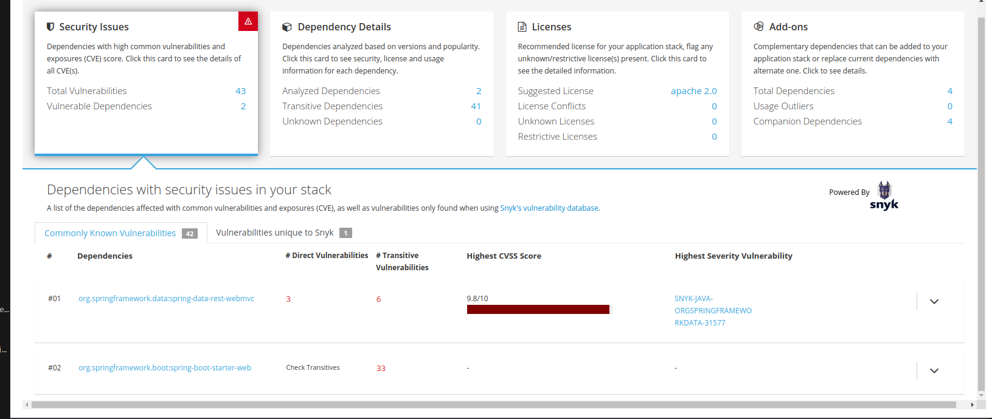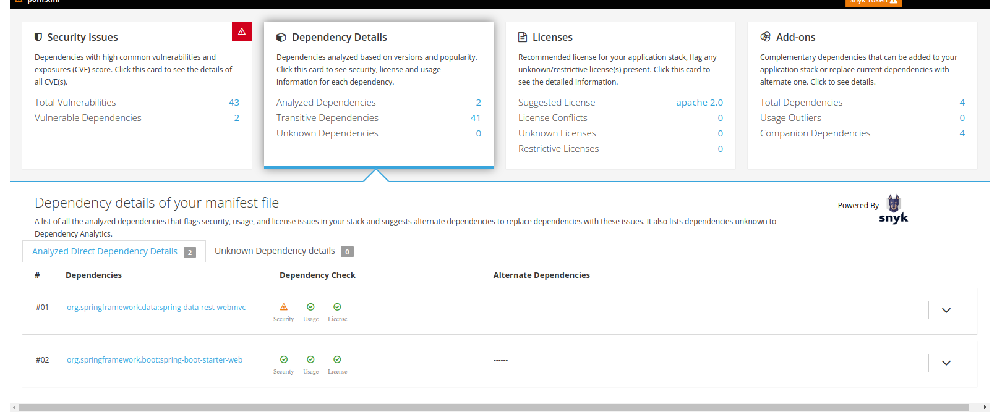[Insert text.]

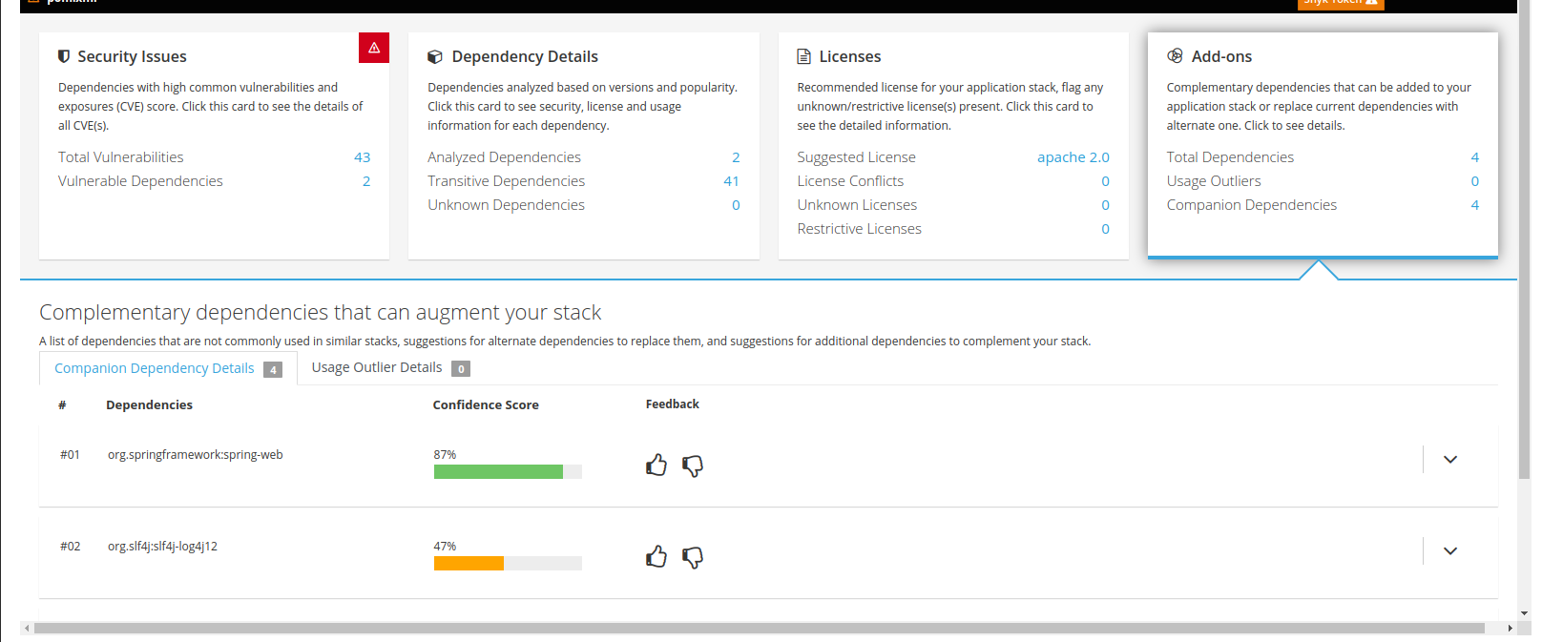

## Document Results

# Dependency Update Documentation

## Library Update: Spring Data REST WebMVC

Updateing the webmvc and boot start web to current versions should do the trick the log4j stuff and others are from that.

### 1. Introduction

This document outlines the update of the Spring Data REST WebMVC library from version 2.6.5.RELEASE to version 4.1.3. It provides information about the reasons for the update, any breaking changes, and steps taken to fix known vulnerabilities.

### 2. Update Overview

* Previous Version: 2.6.5.RELEASE
* New Version: 4.1.3

### 3. Reasons for the Update

The decision to update the Spring Data REST WebMVC library was primarily driven by the need to address security vulnerabilities and to benefit from improvements and bug fixes introduced in the newer version.

### 4. Security Considerations

#### Vulnerability Assessment

The previous version (2.6.5.RELEASE) of Spring Data REST WebMVC was found to have known security vulnerabilities that could potentially pose risks to the application's security.

#### Vulnerability Mitigation

To mitigate these vulnerabilities, it was necessary to update to a newer version (4.1.3) of the library, which includes security patches and enhancements.

### 5. Impact Analysis

#### Breaking Changes

A review of the release notes for version 4.1.3 did not reveal any significant breaking changes that would impact the existing application functionality. However, it's essential to perform thorough testing to ensure compatibility.

### 6. Update Procedure

To update the Spring Data REST WebMVC library, follow these steps:

1. Update the library version in the Maven pom.xml file as follows:

xml <dependency> <groupId>org.springframework.data</groupId> <artifactId>spring-data-rest-webmvc</artifactId> <version>4.1.3</version> </dependency>

1. Save the pom.xml file.
2. Trigger a Maven build (mvn clean install) to download and install the updated library.
3. Review and update any application code that might be affected by the library update. In most cases, this should not be necessary due to the absence of significant breaking changes.
4. Perform thorough testing to ensure that the application functions as expected with the updated library.

### 7. Rollback Plan

In the event that issues arise after the library update, a rollback plan should be in place. This involves reverting the library version back to the previous release (2.6.5.RELEASE) and restoring the previous state of the application.

### 8. Conclusion

The update of the Spring Data REST WebMVC library to version 4.1.3 was performed to address security vulnerabilities and improve the overall security posture of the application. It is crucial to monitor the application's behavior and performance after the update and be prepared to respond to any issues promptly.

## Analyze Results

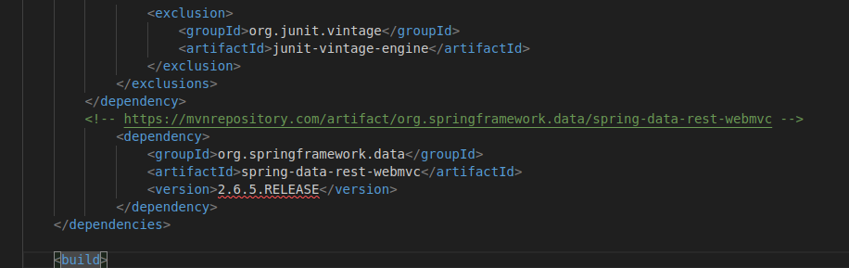

[Ins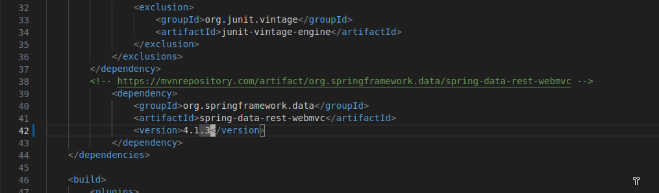ert text.]