

# Artemis Financial Vulnerability Assessment Report

Table of Contents

Document Revision History 3

Client 3

Instructions 3

Developer 4

1. Interpreting Client Needs 4

2. Areas of Security 4

3. Manual Review 4

4. Static Testing 4

5. Mitigation Plan 4

## Document Revision History

| **Version** | **Date** | **Author** | **Comments** |
| --- | --- | --- | --- |
| **1.0** | **[Date]** | **[Your name]** |  |

## Client



## Instructions

Submit this completed vulnerability assessment report. Replace the bracketed text with the relevant information. In the report, identify your findings of security vulnerabilities and provide recommendations for the next steps to remedy the issues you have found.

Respond to the five steps outlined below and include your findings.

Respond using your own words. You may also choose to include images or supporting materials. If you include them, make certain to insert them in all the relevant locations in the document.

Refer to the Project One Guidelines and Rubric for more detailed instructions about each section of the template.

## Developer

Francis Cottrell-Eshaghi

## Interpreting Client Needs

* 1. Data Confidentiality, Artemis Financial deals with sensitive financial information of their customers, including savings, retirement plans, investments, and insurance details. Breaches of confidentiality can result in financial losses, legal issues, and damage to the company's reputation.
  2. Customer Trust, clients trust Artemis Financial to handle their financial information with the utmost care and security.
  3. Compliance, financial organizations are subject to various regulatory requirements, such as GDPR, HIPAA, or industry-specific standards.
  4. Protection Against Attacks, eavesdropping, man-in-the-middle attacks, and data breaches, and most important probably, ransomware.
  5. Up-time, security breaches can disrupt business operations, leading to downtime and financial losses.
  6. Legal Liability, in the event of a security breach, legal liability can be significant.

## Areas of Security

## Encryption Standards: Governments may mandate specific encryption standards that must be followed for securing communications. These standards ensure that data transmitted over networks remains confidential and cannot be easily intercepted or decrypted by unauthorized parties.

## Data Privacy Laws: Many countries have data privacy laws and regulations that require organizations to protect the personal and financial information of individuals. Compliance with these laws is crucial for handling customer data securely.

## Financial Regulations: In the financial sector, there are often strict regulations related to secure communications. For example, financial institutions may need to comply with regulations like the Gramm-Leach-Bliley Act (GLBA) in the United States or the Markets in Financial Instruments Directive (MiFID II) in the European Union, which have specific requirements for data protection and secure communications.

## Anti-Money Laundering (AML) and Know Your Customer (KYC) Regulations: Financial institutions are required to have robust AML and KYC procedures in place, which may involve secure communication channels for verifying the identity of customers and detecting suspicious transactions.

## Export Control Laws: Some governments impose restrictions on the export of cryptographic technology and software. Organizations need to ensure compliance with these laws when using encryption technologies that may fall under export control regulations.

## Data Retention and Access: Certain governments may require organizations to retain communication data for a specified period and provide lawful access to law enforcement agencies or government authorities when necessary for security or investigative purposes.

## Cybersecurity Standards: Governments and industry regulators often establish cybersecurity standards that organizations must adhere to. These standards may include requirements for secure communications as part of broader cybersecurity frameworks.

## National Security Interests: In some cases, national security interests may lead governments to impose restrictions on secure communications, especially if they believe that certain encryption methods hinder their ability to monitor or investigate threats.

## External

## Cyberattacks, the financial industry is a prime target for cyberattacks, including phishing, ransomware, and distributed denial-of-service (DDoS) attacks.

## Data Breaches, hackers may attempt to breach Artemis Financial's systems to access sensitive customer financial information.

## Social Engineering, pretexting, baiting, tailgating, etc..

## Third-Party Risk, if Artemis Financial relies on third-party vendors or partners for services or software, vulnerabilities or breaches in those third-party systems can also impact their security.

## Regulatory Changes, changes in financial regulations and compliance requirements can create security challenges.

## Emerging Technologies, as new technologies such as blockchain, cryptocurrencies, and fintech solutions continue to evolve, they bring both opportunities and threats.

## Supply Chain Attacks, cybercriminals may target the supply chain to compromise software or hardware components before they reach Artemis Financial.

## Nation-State Actors, state-sponsored hacking groups may target financial institutions for espionage or disruption.

## Mobile Device Vulnerabilities, as employees use mobile devices for work, vulnerabilities in mobile applications or operating systems can be exploited.

## Cloud Security, if Artemis Financial uses cloud services, they must consider the security of their data and applications in the cloud.

## Environmental Disasters, natural disasters and other environmental factors can disrupt operations and data centers, affecting business continuity and data security

## Phishing and Social Engineering, cybercriminals continually refine phishing and social engineering tactics to deceive employees and gain unauthorized access to systems and data.

## AI and Automation in Cyberattacks, threat actors are using artificial intelligence and automation to carry out attacks more efficiently and at scale.

## Zero-Day Vulnerabilities, unknown vulnerabilities in software or hardware (zero-days) can be exploited by attackers before they are discovered and patched by vendors.

## Manual Review

try {

Connection con=DriverManager.getConnection(

"jdbc:mysql://localhost:3306/test","root","root");

con is not used and null and why root? Tell the person who wrote this to fix.

## Static Testing

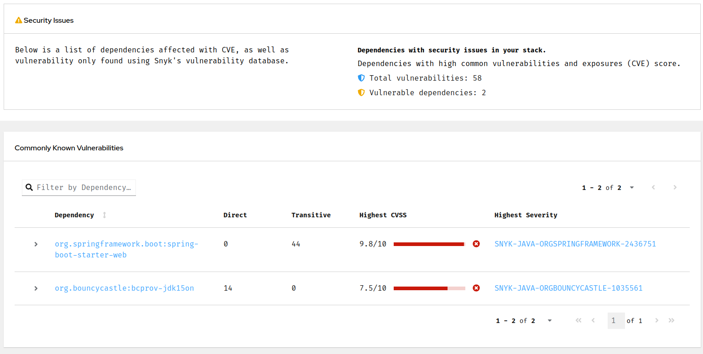

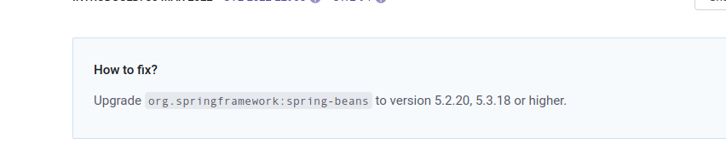

## Mitigation Plan

## Review the Manual Review and Static Testing Report.Carefully review the findings from both the manual review and static testing of the web application. Ensure you understand the nature and severity of each vulnerability.

## Prioritize Vulnerabilities, prioritize the vulnerabilities based on their severity, potential impact, and ease of exploitation. This will help you allocate resources efficiently.

## Create an Action List. For each identified vulnerability, create an action item that includes the following information

## Vulnerability Description. Clearly describe the vulnerability, including how it was discovered and its potential impact.

## Severity Level: Assign a severity level to the vulnerability (e.g., low, medium, high, critical).

## Affected Component: Specify which part of the application or system is affected.

## Recommendation: Provide a detailed recommendation on how to mitigate the vulnerability.

## Mitigation Steps: Break down the recommended actions into specific steps that developers and IT personnel can follow.

## Timeline: Define a realistic timeline for addressing the vulnerability, considering its severity and complexity.

## Responsible Party: Assign responsibility to the individual or team responsible for implementing the mitigation measures.

## Verification: Outline how the effectiveness of the mitigation will be verified, such as through testing or validation.

* 1. Mitigation Strategies
     1. Based on the type of vulnerability, consider common mitigation strategies, such as:
        1. Code fixes and patches
        2. Configuration changes
        3. Security updates for libraries and dependencies
        4. Implementation of security controls (e.g., input validation, access controls)
        5. Removal or replacement of vulnerable components
        6. Improved authentication and authorization mechanisms
        7. Encryption and secure communication protocols

1. Assign Tasks
   1. Assign specific tasks to development, operations, and security teams or individuals responsible for implementing the fixes and improvements
   2. Implement and Test Mitigations, execute the mitigation steps outlined in the action list, following best practices and security guidelines. Be sure to thoroughly test each fix to confirm that it effectively mitigates the vulnerability.
2. Review and Validation After implementing the mitigations, conduct a review to ensure that all actions were completed as planned. Verify that the vulnerabilities are indeed mitigated by retesting the application or system.
3. Documentation Document all actions taken, including the implementation of fixes, testing results, and any changes to the application's configuration or code.
4. Monitoring and Maintenance. Establish ongoing monitoring and maintenance processes to ensure that vulnerabilities do not reappear and that the application remains secure over time. Implement regular security assessments and updates as needed.
5. Reporting and Communicate the progress of vulnerability mitigation to relevant stakeholders, including management and clients. Provide updates on the status of remediation efforts.
6. Post-Incident Review If the vulnerabilities were discovered as a result of a security incident, conduct a post-incident review to identify lessons learned and improve incident response processes.