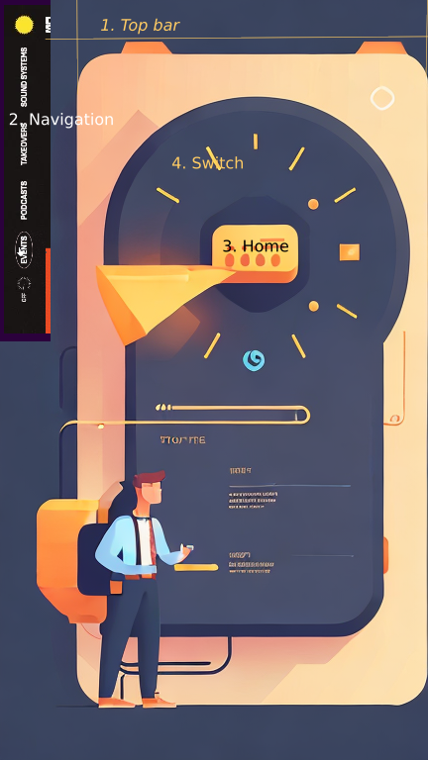

Main Screen:

1. Top Bar: A simple top bar at the top with the Kiva logo and user account information.
2. Navigation Menu: A vertical navigation menu on the left side with options like "Home," "Borrow," "Lend," "Payments," and "Settings."
3. Home Section: The central part of the screen will show the "Home" section.
4. Borrower/Lender Switch: At the top of the Home section, there will be a toggle switch to switch between "Borrower" and "Lender" views.

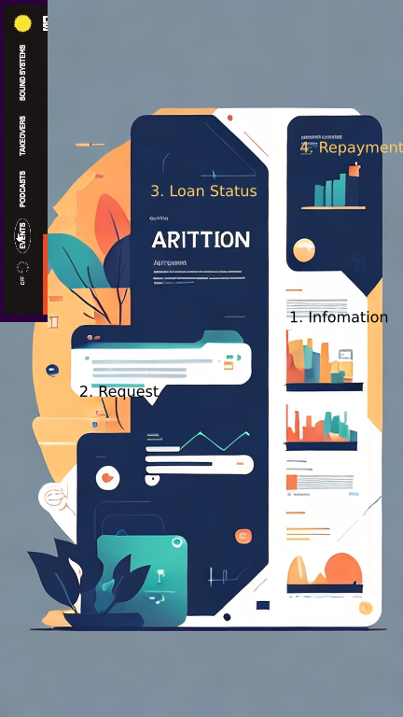

Borrower View:

1. Information: A section displaying information about Kiva and the borrowing process. It will include details like "How Kiva Works," "Borrowing Steps," and "Repayment Information."
2. Loan Request: A "Request Loan" button will allow borrowers to initiate the loan application process.
3. Loan Status: Borrowers can view the status of their current loan application or active loan (if any).
4. Repayment Tracker: A section showing the progress of their loan payback process, including remaining amount, due dates, and payment history.

Home Section:

The main screen will open with the "Home" section, where borrowers will find essential information about Kiva and the borrowing process. They can access details like "How Kiva Works," "Borrowing Steps," and "Repayment Information" here.

Loan Request:

Borrowers can click on the "Request Loan" button to initiate the loan application process. This will take them to a separate page or modal where they can enter their loan details and submit the application.

Loan Status:

Borrowers can view the status of their current loan application or active loan (if any). The application will provide them with information on whether their loan request is under review, approved, or disbursed.

Repayment Tracker: A section will display the progress of their loan payback process. Borrowers can see the remaining loan amount, upcoming due dates, and their payment history.

Cloud Sync:

Borrowers can use the clickable "Cloud Sync" button to synchronize their data with the cloud application, ensuring their loan information is updated and secure.

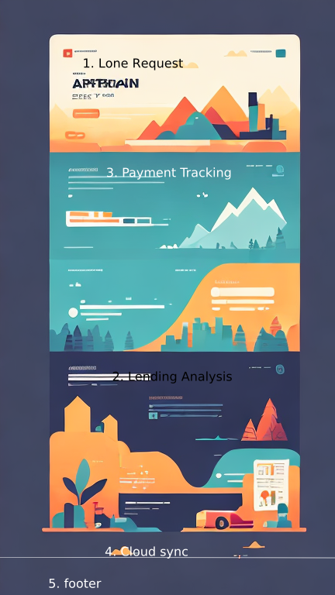

Lender View:

1. Loan Requests: A section displaying borrower loan requests with essential details like loan amount, purpose, and repayment term.
2. Lending Analysis: A subsection displaying the lender's lending data, including total lent funds, number of loans, and average repayment rate.
3. Payment Tracking: A section showing the lender's active loans, repayment history, and upcoming payments.
4. Cloud Sync Button: A clickable button to sync data with the cloud application for both borrower and lender views.
5. Footer: A footer section with links to "About Kiva," "Privacy Policy," and "Contact."

Home Section and Borrower/Lender Switch:

The main screen will open with the "Home" section displaying two toggles. The user can switch to the "Lender" view using the toggle switch.

Loan Requests:

In the "Lender" view, a section will display borrower loan requests. Lenders can click on individual requests to view more details, such as loan purpose, loan amount, and repayment term.

Lending Analysis:

The application will have a subsection displaying the lender's lending data, including total lent funds, the number of loans, and average repayment rate.

Payment Tracking:

A section will show the lender's active loans, repayment history, and upcoming payments. This data will help lenders keep track of their lending activity and plan for the recycling of previously paid funds.

Cloud Sync:

Similar to the borrower view, lenders can use the clickable "Cloud Sync" button to synchronize their lending data with the cloud application, ensuring accurate and up-to-date information.

User Interaction:

1. Users can click on the navigation menu items to switch between different sections (Home, Borrow, Lend, Payments, Settings).
2. In the Borrower View, users can click on the "Request Loan" button to initiate the loan application process.
3. In the Lender View, users can click on individual loan requests to view more details and choose to fund them.
4. Users can toggle the Borrower/Lender switch to switch between the two views.

Design Guidelines:

1. Use a clean and simple design with a clear visual hierarchy to highlight essential information.
2. Utilize easy-to-read fonts and appropriate font sizes to ensure readability on a small flip-phone screen.
3. Maintain a consistent color scheme to make the UI visually appealing and intuitive.
4. Ensure the clickable buttons are visually distinct and follow conventional button design guidelines (e.g., raised appearance, changing color when clicked).
5. Consider mobile-friendly design principles, such as touch-friendly button sizes and adequate spacing between elements.

1. Design Guidelines:

Kiva's code of conduct may include specific design guidelines to maintain consistency and branding. While being creative, it's important to respect and adhere to these guidelines. Ensure that the UI/UX design aligns with the established branding, color schemes, and typography.

2. Ethical Representation:

Creativity should not compromise the ethical representation of borrowers and lenders. Avoid using stereotypes or culturally insensitive imagery. Instead, opt for inclusive and respectful visual elements that celebrate diversity.

3. Data Privacy and Security:

Kiva's code of conduct likely emphasizes the importance of data privacy and security. Creative solutions should never compromise the protection of user data. Implement robust security measures and adhere to best practices for data handling.

4. Accessibility:

Ensure that your creative design considers accessibility for all users, including those with disabilities. Follow accessibility guidelines to make the application usable by individuals with visual, auditory, motor, or cognitive impairments.

5. Transparency and Honesty:

Kiva's code of conduct may require transparency and honesty in all interactions. Creativity should not mislead users or obscure important information. Provide clear and accurate information to borrowers and lenders, so they can make informed decisions.

6. Empathy and User-Centric Design:

While being creative, always keep the end-users in mind. Empathize with their needs and pain points, and design the interface to address these effectively. User-centric design ensures that creativity enhances the user experience rather than complicating it.

7. Regulatory Compliance:

Kiva's code of conduct may include regulations related to financial transactions and lending practices. The application's creative design should align with these regulations to ensure legal compliance.

8. Testing and Feedback:

Before implementing any creative design, conduct usability testing and gather feedback from real users. This feedback loop will help identify potential issues and ensure that the final product meets Kiva's code of conduct.

9. Continuous Improvement:

Embrace a mindset of continuous improvement. After launching the application, monitor user feedback, identify areas of improvement, and iteratively enhance the design while staying within the bounds of the code of conduct.