18. Design and implement a queue-based appointment management system for a clinic that handles patients in the order of their arrival. The system should maintain a First-Come, First- Served (FCFS) queue for patients and provide options to add new patients, view the next patient to be treated, serve (remove) a patient once treated, and display the list of all waiting patients.

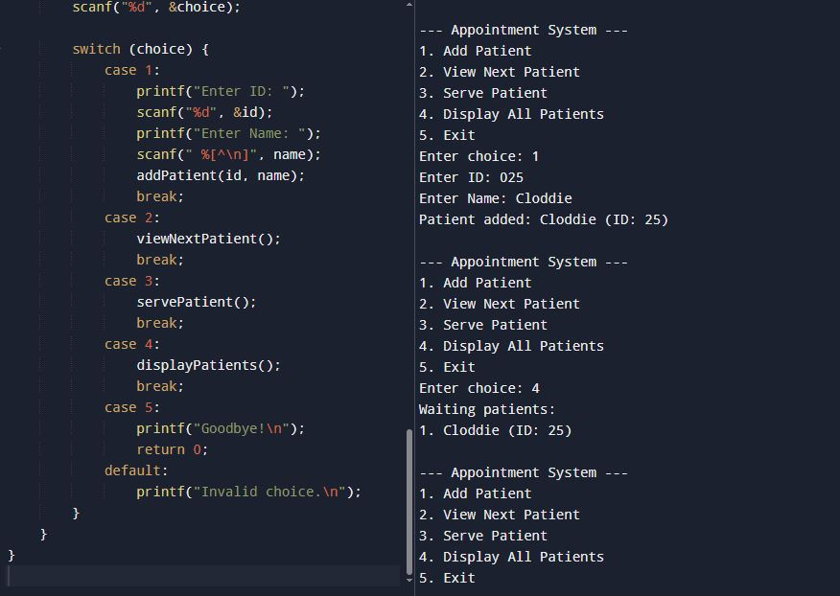
#include <stdio.h>
#include <stdlib.h>
#include <string.h>

#define MAX 50

typedef struct {
int id;
char name[50];
} Patient;

Patient queue[MAX];
int front = -1, rear = -1;

int isEmpty() {
return (front == -1 || front > rear);
}

int isFull() {
return (rear == MAX - 1);
}

void addPatient(int id, char name[]) {
if (isFull()) {
printf("Queue is full!\n");
return;
}
if (front == -1) front = 0;
rear++;
queue[rear].id = id;
strcpy(queue[rear].name, name);
printf("Patient added: %s (ID: %d)\n", name, id);
}

void viewNextPatient() {
if (isEmpty()) {
printf("No patients in queue.\n");
} else {
printf("Next patient: %s (ID: %d)\n", queue[front].name, queue[front].id);
}
}

void servePatient() {
if (isEmpty()) {
printf("No patients to serve.\n");
} else {
printf("Serving patient: %s (ID: %d)\n", queue[front].name, queue[front].id);
front++;
}
}

void displayPatients() {
if (isEmpty()) {
printf("No patients waiting.\n");
} else {
printf("Waiting patients:\n");
for (int i = front; i <= rear; i++) {
printf("%d. %s (ID: %d)\n", i - front + 1, queue[i].name, queue[i].id);
}
}
}

int main() {
int choice, id;
char name[50];

while (1) {
printf("\n--- Appointment System ---\n");
printf("1. Add Patient\n");
printf("2. View Next Patient\n");
printf("3. Serve Patient\n");
printf("4. Display All Patients\n");
printf("5. Exit\n");
printf("Enter choice: ");
scanf("%d", &choice);

switch (choice) {
case 1:
printf("Enter ID: ");
scanf("%d", &id);
printf("Enter Name: ");
scanf(" %[^\n]", name);
addPatient(id, name);
break;
case 2:
viewNextPatient();
break;
case 3:
servePatient();
break;
case 4:
displayPatients();
break;
case 5:
printf("Goodbye!\n");
return 0;
default:
printf("Invalid choice.\n");
}
}
}

