8. Write a program to perform the operations of the linked list:
- Insertion
- Deletion
- Display

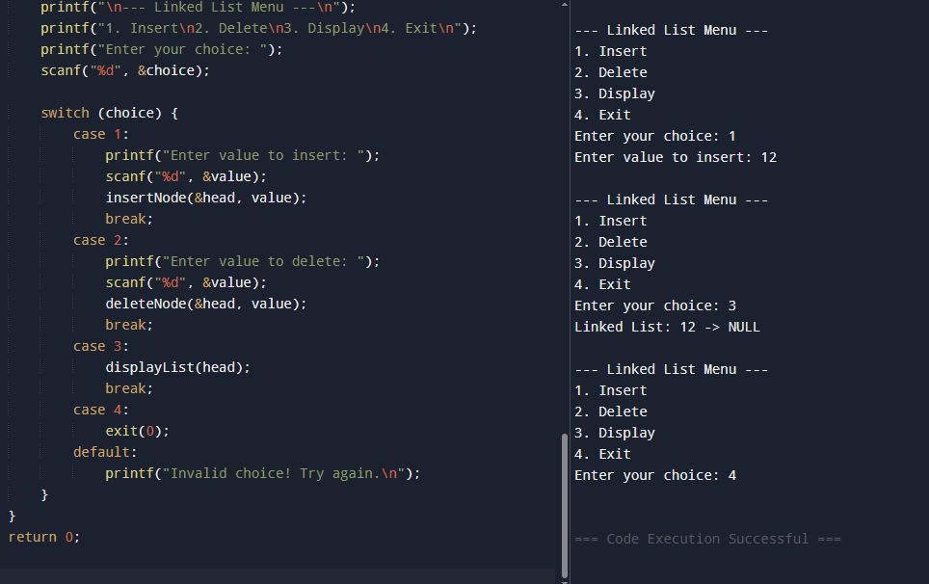

#include <stdio.h>
#include <stdlib.h>

// Define node structure
struct Node {
int data;
struct Node* next;
};

// Function to create a new node
struct Node* createNode(int value) {
struct Node* newNode = (struct Node*)malloc(sizeof(struct Node));
newNode->data = value;
newNode->next = NULL;
return newNode;
}

// Insert at end
void insertNode(struct Node** head, int value) {
struct Node* newNode = createNode(value);
if (*head == NULL) {
*head = newNode;
return;
}
struct Node* temp = *head;
while (temp->next != NULL) {
temp = temp->next;
}
temp->next = newNode;
}

// Delete a node by value
void deleteNode(struct Node** head, int value) {
struct Node* temp = *head;
struct Node* prev = NULL;

// If head node itself holds the value
if (temp != NULL && temp->data == value) {
*head = temp->next;
free(temp);
printf("Deleted %d from the list.\n", value);
return;
}

// Search for the value
while (temp != NULL && temp->data != value) {
prev = temp;
temp = temp->next;
}

// If value not found
if (temp == NULL) {
printf("Value %d not found in the list.\n", value);
return;
}

// Unlink node
prev->next = temp->next;
free(temp);
printf("Deleted %d from the list.\n", value);
}

// Display the linked list
void displayList(struct Node* head) {
if (head == NULL) {
printf("List is empty.\n");
return;
}
printf("Linked List: ");
while (head != NULL) {
printf("%d -> ", head->data);
head = head->next;
}
printf("NULL\n");
}

// Main function
int main() {
struct Node* head = NULL;
int choice, value;

while (1) {
printf("\n--- Linked List Menu ---\n");
printf("1. Insert\n2. Delete\n3. Display\n4. Exit\n");
printf("Enter your choice: ");
scanf("%d", &choice);

switch (choice) {
case 1:
printf("Enter value to insert: ");
scanf("%d", &value);
insertNode(&head, value);
break;
case 2:
printf("Enter value to delete: ");
scanf("%d", &value);
deleteNode(&head, value);
break;
case 3:
displayList(head);
break;
case 4:
exit(0);
default:
printf("Invalid choice! Try again.\n");
}
}
return 0;
}

9. Write a program to perform the operations of the Circular linked list:
- Insertion
- Deletion
- Display
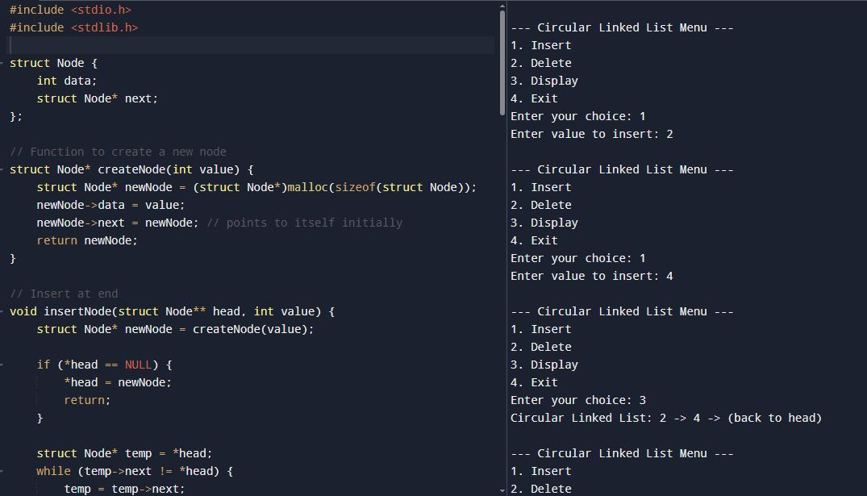
#include <stdio.h>
#include <stdlib.h>

struct Node {
int data;
struct Node* next;
};

struct Node* createNode(int value) {
struct Node* newNode = (struct Node*)malloc(sizeof(struct Node));
newNode->data = value;
newNode->next = newNode; // points to itself initially
return newNode;
}

// Insert at end
void insertNode(struct Node** head, int value) {
struct Node* newNode = createNode(value);

if (*head == NULL) {
*head = newNode;
return;
}

struct Node* temp = *head;
while (temp->next != *head) {
temp = temp->next;
}
temp->next = newNode;
newNode->next = *head;
}

// Delete a node by value
void deleteNode(struct Node** head, int value) {
if (*head == NULL) {
printf("List is empty.\n");
return;
}

struct Node* current = *head;
struct Node* prev = NULL;

// Case: deleting head node
if (current->data == value) {
if (current->next == *head) { // only one node
free(current);
*head = NULL;
printf("Deleted %d from the list.\n", value);
return;
}
// find last node
struct Node* last = *head;
while (last->next != *head) {
last = last->next;
}
last->next = current->next;
*head = current->next;
free(current);
printf("Deleted %d from the list.\n", value);
return;
}

// Case: deleting non-head node
do {
prev = current;
current = current->next;
if (current->data == value) {
prev->next = current->next;
free(current);
printf("Deleted %d from the list.\n", value);
return;
}
} while (current != *head);

printf("Value %d not found in the list.\n", value);
}

// Display the circular linked list
void displayList(struct Node* head) {
if (head == NULL) {
printf("List is empty.\n");
return;
}
struct Node* temp = head;
printf("Circular Linked List: ");
do {
printf("%d -> ", temp->data);
temp = temp->next;
} while (temp != head);
printf("(back to head)\n");
}

// Main function
int main() {
struct Node* head = NULL;
int choice, value;

while (1) {
printf("\n--- Circular Linked List Menu ---\n");
printf("1. Insert\n2. Delete\n3. Display\n4. Exit\n");
printf("Enter your choice: ");
scanf("%d", &choice);

switch (choice) {
case 1:
printf("Enter value to insert: ");
scanf("%d", &value);
insertNode(&head, value);
break;
case 2:
printf("Enter value to delete: ");
scanf("%d", &value);
deleteNode(&head, value);
break;
case 3:
displayList(head);
break;
case 4:
exit(0);
default:
printf("Invalid choice! Try again.\n");
}
}
return 0;
}

10. Write a program to perform all operations:
- For Stack using Linked List.
- For Queue using Linked List
- For Circular Queue using Linked List

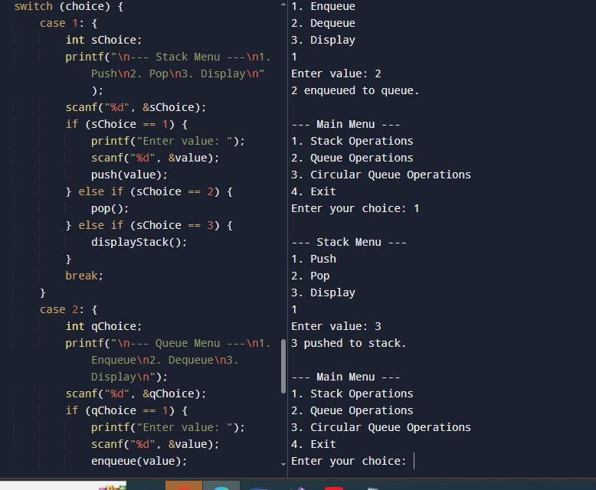
#include <stdio.h>
#include <stdlib.h>

// STACK USING LINKED LIST
struct StackNode {
int data;
struct StackNode* next;
};

struct StackNode* stackTop = NULL;

void push(int value) {
struct StackNode* newNode = (struct StackNode*)malloc(sizeof(struct StackNode));
newNode->data = value;
newNode->next = stackTop;
stackTop = newNode;
printf("%d pushed to stack.\n", value);
}

void pop() {
if (stackTop == NULL) {
printf("Stack is empty.\n");
return;
}
struct StackNode* temp = stackTop;
printf("%d popped from stack.\n", temp->data);
stackTop = stackTop->next;
free(temp);
}

void displayStack() {
if (stackTop == NULL) {
printf("Stack is empty.\n");
return;
}
struct StackNode* temp = stackTop;
printf("Stack: ");
while (temp != NULL) {
printf("%d -> ", temp->data);
temp = temp->next;
}
printf("NULL\n");
}

// QUEUE USING LINKED LIST
struct QueueNode {
int data;
struct QueueNode* next;
};

struct QueueNode* front = NULL;
struct QueueNode* rear = NULL;

void enqueue(int value) {
struct QueueNode* newNode = (struct QueueNode*)malloc(sizeof(struct QueueNode));
newNode->data = value;
newNode->next = NULL;
if (rear == NULL) {
front = rear = newNode;
} else {
rear->next = newNode;
rear = newNode;
}
printf("%d enqueued to queue.\n", value);
}

void dequeue() {
if (front == NULL) {
printf("Queue is empty.\n");
return;
}
struct QueueNode* temp = front;
printf("%d dequeued from queue.\n", temp->data);
front = front->next;
if (front == NULL) rear = NULL;
free(temp);
}

void displayQueue() {
if (front == NULL) {
printf("Queue is empty.\n");
return;
}
struct QueueNode* temp = front;
printf("Queue: ");
while (temp != NULL) {
printf("%d -> ", temp->data);
temp = temp->next;
}
printf("NULL\n");
}

// CIRCULAR QUEUE USING LINKED LIST
struct CQueueNode {
int data;
struct CQueueNode* next;
};

struct CQueueNode* cfront = NULL;
struct CQueueNode* crear = NULL;

void cenqueue(int value) {
struct CQueueNode* newNode = (struct CQueueNode*)malloc(sizeof(struct CQueueNode));
newNode->data = value;
if (cfront == NULL) {
cfront = crear = newNode;
newNode->next = cfront;
} else {
crear->next = newNode;
crear = newNode;
crear->next = cfront;
}
printf("%d enqueued to circular queue.\n", value);
}

void cdequeue() {
if (cfront == NULL) {
printf("Circular Queue is empty.\n");
return;
}
struct CQueueNode* temp = cfront;
if (cfront == crear) { // only one node
printf("%d dequeued from circular queue.\n", temp->data);
cfront = crear = NULL;
} else {
printf("%d dequeued from circular queue.\n", temp->data);
cfront = cfront->next;
crear->next = cfront;
}
free(temp);
}

void displayCQueue() {
if (cfront == NULL) {
printf("Circular Queue is empty.\n");
return;
}
struct CQueueNode* temp = cfront;
printf("Circular Queue: ");
do {
printf("%d -> ", temp->data);
temp = temp->next;
} while (temp != cfront);
printf("(back to front)\n");
}

// ---------------- MAIN MENU ----------------
int main() {
int choice, value;

while (1) {
printf("\n--- Main Menu ---\n");
printf("1. Stack Operations\n2. Queue Operations\n3. Circular Queue Operations\n4. Exit\n");
printf("Enter your choice: ");
scanf("%d", &choice);

switch (choice) {
case 1: {
int sChoice;
printf("\n--- Stack Menu ---\n1. Push\n2. Pop\n3. Display\n");
scanf("%d", &sChoice);
if (sChoice == 1) {
printf("Enter value: ");
scanf("%d", &value);
push(value);
} else if (sChoice == 2) {
pop();
} else if (sChoice == 3) {
displayStack();
}
break;
}
case 2: {
int qChoice;
printf("\n--- Queue Menu ---\n1. Enqueue\n2. Dequeue\n3. Display\n");
scanf("%d", &qChoice);
if (qChoice == 1) {
printf("Enter value: ");
scanf("%d", &value);
enqueue(value);
} else if (qChoice == 2) {
dequeue();
} else if (qChoice == 3) {
displayQueue();
}
break;
}
case 3: {
int cqChoice;
printf("\n--- Circular Queue Menu ---\n1. Enqueue\n2. Dequeue\n3. Display\n");
scanf("%d", &cqChoice);
if (cqChoice == 1) {
printf("Enter value: ");
scanf("%d", &value);
cenqueue(value);
} else if (cqChoice == 2) {
cdequeue();
} else if (cqChoice == 3) {
displayCQueue();
}
break;
}
case 4:
exit(0);
default:
printf("Invalid choice! Try again.\n");
}
}
return 0;
}

