E1CSA377 – Assignment 01
COMPUTER GRAPHICS (E1CSA377) – MicroProject-1
Name: Diksha Baranwal
Reg no: 2411021060080
Date: 23/08/2026
Sec: CSE General A
Comparative Visualization of Raster Graphics and Vector Graphics

1. About the Project
This project, Comparative Visualization of Raster Graphics and Vector Graphics, is a graphical application developed using Python, Pillow, NumPy, and Matplotlib. It demonstrates the fundamental difference between raster and vector graphics by creating the same sample object in both representations and comparing their visual quality at different zoom levels.
Raster graphics represent images using a fixed grid of pixels, while vector graphics represent objects using mathematical shapes such as lines, rectangles, and polygons. The project visually demonstrates that raster images are resolution-dependent and can become pixelated when enlarged, whereas vector graphics can be scaled while retaining smooth edges.
A simple house is used as the demonstration object because it contains easily identifiable geometric shapes. The same house is created first as a raster image and then as a vector drawing. The two versions are displayed normally and under heavy zoom so that the difference in scalability and quality can be observed directly.
The project builds an intuitive understanding of why raster graphics are widely used for photographs and detailed pixel-based images, while vector graphics are preferred for logos, icons, diagrams, illustrations, and other designs that need to remain sharp at different sizes.

2. Technologies Used
Technology | Purpose
Python | Main programming language
Pillow | Creating and manipulating raster images
Matplotlib | Displaying graphics and creating vector-style geometric drawings
NumPy | Basic numerical and image-data operations

3. Raster and Vector Graphics

3.1 Raster Graphics
Raster graphics are images made up of individual pixels arranged in rows and columns. Each pixel stores color information. Common raster formats include PNG, JPEG, BMP, and GIF. Raster images are resolution-dependent, meaning their quality depends on the number of available pixels.

3.2 Vector Graphics
Vector graphics are created using mathematical descriptions of geometric objects such as points, lines, curves, rectangles, and polygons. Because the objects are represented mathematically, they can be enlarged or reduced without losing their basic sharpness.

3.3 Zoom Comparison
When a raster image is enlarged beyond its original resolution, the individual pixels become visible and the image may appear blocky or blurred. A vector drawing is redrawn from its mathematical geometry at the new size, so its edges remain smooth.

4. Working Principle
The project uses the same simple house as the common test object. In the raster implementation, the house is drawn directly onto a fixed pixel canvas and saved as a PNG image. In the vector implementation, the house is constructed from geometric primitives such as rectangles and a polygon.
The program then displays the two representations and enlarges them for comparison. The raster image is intentionally examined at a high zoom level so that pixelation can be observed clearly. The vector representation is displayed at the same conceptual scale, demonstrating its ability to retain smooth geometric boundaries.

5. Flowchart of the Problem Statement
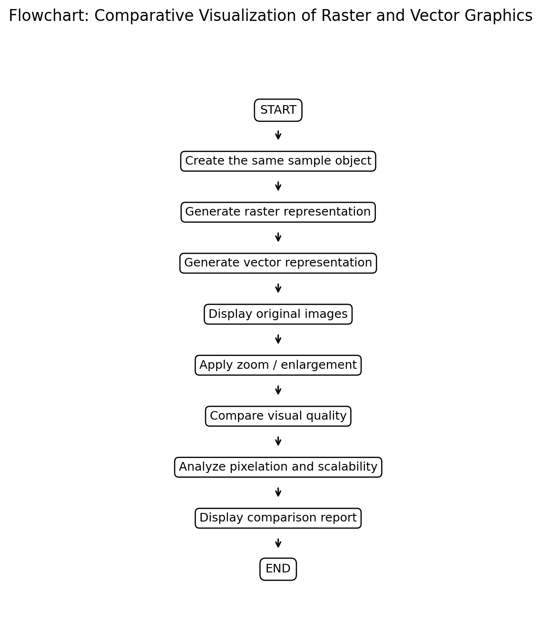

6. Output of the Problem Statement
The following figures show the two representations of the same house. The raster version is stored as a pixel-based PNG image, while the vector version is constructed from mathematical shapes.

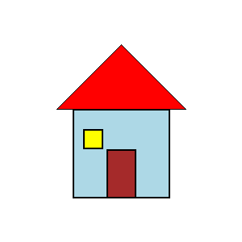
Fig: Raster representation of the sample house.

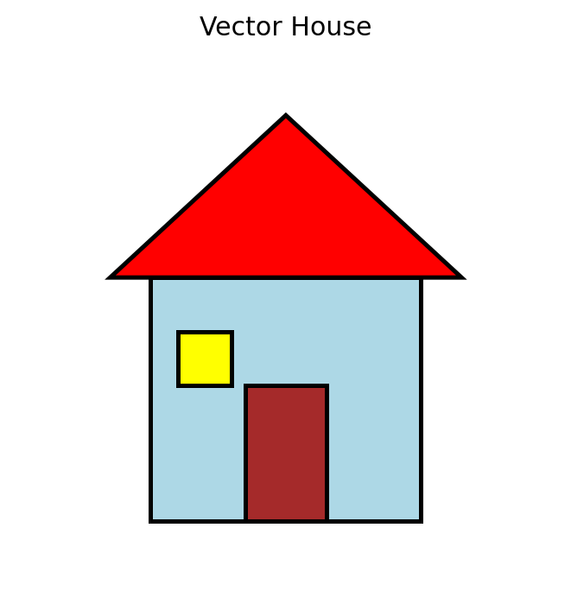
Fig: Vector representation of the sample house.

7. Zoom Comparison
The main demonstration of the project is the zoom comparison. At normal size, the raster and vector houses look similar because both represent the same visual object. Under heavy enlargement, the raster version reveals its pixel structure, whereas the vector version continues to display clean geometric boundaries.
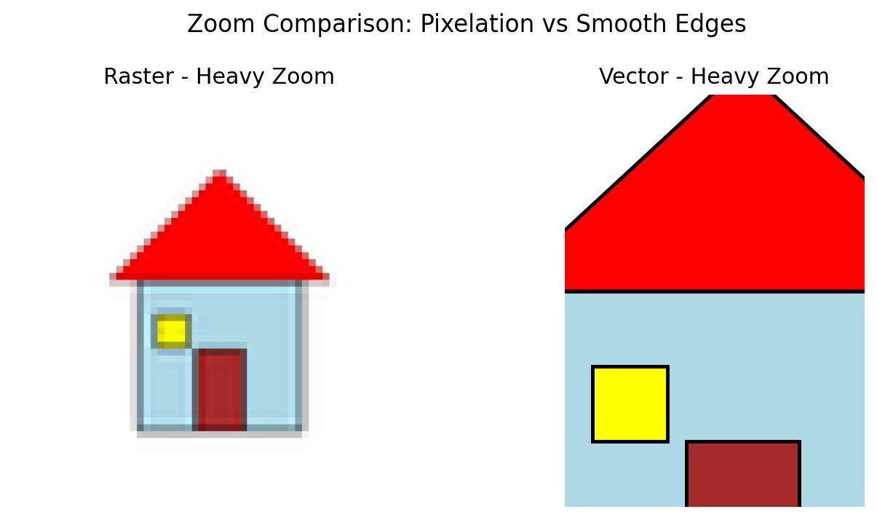
Fig: Heavy zoom comparison of raster and vector representations.

8. Methodology

Step 1: Define the Sample Object
A simple house is selected as the common graphical object. It consists of a rectangle for the body, a triangle/polygon for the roof, a rectangle for the door, and a smaller rectangle for the window.

Step 2: Create the Raster Representation
A fixed 500 × 500 pixel canvas is created using Pillow. The geometric components are drawn directly onto the pixel canvas and saved as a PNG image.

Step 3: Create the Vector Representation
The same components are represented using Matplotlib geometric patches such as Rectangle and Polygon. Their coordinates define the shape mathematically rather than storing every visible pixel.

Step 4: Display the Original Images
The raster and vector versions are displayed at their normal scale so that their visual similarity can be observed.

Step 5: Apply Enlargement
The raster image is enlarged to make pixelation visible. The vector drawing is displayed at a larger scale using the same geometric definitions.

Step 6: Compare Quality
The enlarged versions are visually compared with respect to edge smoothness, pixelation, scalability, and resolution dependence.

9. Comparison of Raster and Vector Graphics
Feature | Raster Graphics | Vector Graphics
Basic representation | Pixels | Mathematical shapes
Scaling | Quality can decrease | Remains scalable
Zooming | Can become pixelated | Edges remain smooth
Resolution dependency | Yes | No for geometric scaling
Typical formats | PNG, JPG, BMP, GIF | SVG, EPS, PDF
Best suited for | Photos and detailed pixel images | Logos, icons, diagrams, illustrations
Editing | Pixel-level editing | Object/shape-level editing
Storage behavior | Can become large for high-resolution images | Often efficient for simple geometric artwork

10. Analysis
The demonstration confirms the basic difference between the two graphics models. A raster image has a fixed number of pixels, so enlarging it does not create additional original detail. Instead, existing pixels must be interpolated or repeated, which can reveal pixelation and reduce perceived sharpness.
A vector graphic stores the geometry of objects rather than a fixed pixel grid. When its display size changes, the shapes are rendered again according to their mathematical definitions. Therefore, straight edges and geometric boundaries remain visually smooth at different sizes.
The comparison also shows why the choice between raster and vector depends on the application. Photographs contain complex color and texture information and are naturally suited to raster representation. Logos, icons, diagrams, and technical illustrations often benefit from vector representation because they may need to be displayed at many different sizes.

11. Applications
Raster graphics are commonly used in photography, digital painting, screenshots, textures, scanned documents, and other pixel-based images.
Vector graphics are commonly used in logos, icons, fonts, diagrams, maps, technical drawings, UI elements, and scalable illustrations.

12. Result
The Python application successfully creates and compares raster and vector versions of the same graphical object. The normal-size views show that both representations can produce a similar visual appearance. The zoom test demonstrates the important difference: the raster representation exposes its pixel structure when enlarged, while the vector representation maintains smooth geometric edges.

13. Advantages of the Project
- Simple visual demonstration of an important Computer Graphics concept.
- Uses beginner-friendly Python libraries.
- Shows the difference between pixels and mathematical shapes.
- Demonstrates the effect of zooming and scalability.
- Provides a practical basis for understanding image formats and graphics applications.

14. Limitations
The demonstration uses a simple geometric house rather than complex photographs or advanced illustrations. The vector comparison focuses on geometric scalability and does not represent every feature of production vector formats such as SVG. The project is intended as an educational visualization rather than a full graphics editor.

15. Conclusion
This project successfully visualizes and compares raster and vector graphics using Python. By creating the same object in two different representations and examining the result under zoom, the project makes the difference between pixel-based and geometry-based graphics directly observable. Raster graphics are resolution-dependent and may become pixelated when enlarged, whereas vector graphics remain scalable and retain smooth geometric boundaries. The project strengthens the understanding of a fundamental Computer Graphics concept and its practical applications in digital images, design, visualization, and user interfaces.

16. References
1. Python Documentation – Python programming language and standard libraries.
2. Pillow Documentation – Python Imaging Library for raster image processing.
3. Matplotlib Documentation – Plotting, visualization, and geometric graphics.
4. NumPy Documentation – Numerical computing and array operations.

