**Austin Guzzetti-Ouellette**

**Project Proposal Idea:** Everything Basketball Website **10%**

For my senior year project, I will be developing a website based entirely around the game of Basketball. This will include the history of the sport, the teams, the history of each franchise, past and current players that are a part of each franchise, and more. Since there is a ton of information to go over with basketball, I will organize the website in a manner where it is displayed like a table of contents. That way, users can easily find information on the website. I’ve already begun planning on what the website will look like and how it will function. Using multiple resources like w3schools will help me to complete this project on time.

What each group member will do (contribute) to the project:

* Kyle Stewart:

- Organize Basketball Stats (September 26th - March 13th)

- Design Format for the website (September 12th - September 16th)

- Coding (October 10th - March 13th)

* Eduardo Carey:

- Contribute ideas for page layouts and website themes (September 12th - March 13th)

- Coding (October 10th - March 13th)

* Austin Guzzetti-Ouellette:

- Coding (October 10th - March 13th)

- Help Kyle Stewart to organize/interpret Basketball Stats (September 26th - March 13th)

- Review ideas for page layouts and design format for the website (September 12th - April 10th)

**Requirements**: **40%**

Using the **swReqTemplate.docx** template file, give a complete description of ***what*** your project is proposing to do/be.

Everything Basketball is a website project that aims to provide users with in-depth knowledge of the sport. From the game's birth, to the founding of the NBA, and all the way to the modern day, this website will provide it all to the user using videos, articles, and in-depth descriptions to do so. The website also aims to provide its users with this information in an organized way through the use of grids and templates. That way, the information won’t seem overwhelming to the user and they will be able to follow it clearly. Users will also be able to interact with the site through the use of light theme/dark theme, video and article interaction, and more.

**Schedule: 20%**

Using Microsoft Project prepare a Gantt chart for all the tasks necessary in your project including what you have already completed;

<https://trello.com/b/uJGYnF0F/senior-project>

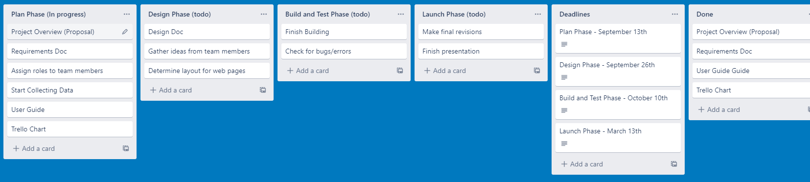

**What new skills are to be gained in the process: 20%**

The skills that I will gain/add experience to during this project will include HTML and CSS programming and I will gain some more JavaScript programming experience as well. I will also be expanding my skills with layout and template designs. I will also be expanding my skills in organizing web pages and information, and how to manage a team on a big project.

**What is your net gain from the project: 10%**

After high school, I plan on going into a job centered around the game of basketball. This project could be used as an asset and an example to future employers on how much I know about the game, while also blending in skills and knowledge that I gained from Assabet in CPWD.

NOTE: For team projects each individual will need to fill out a proposal document showing what they contributed to the proposal and what they will contribute to the project. They will need to be scheduled for their tasks.