|  |  |
| --- | --- |
|  | “Everything Basketball” Website |
|  | [Version 1.0]  Austin Guzzetti-Ouellette, Kyle Stewart, Eduardo Carey |

|  |
| --- |
|  |
|  |

“Everything Basketball” Website User Manual

### Revision History

|  |  |  |  |
| --- | --- | --- | --- |
| Version | Date | Revision Description | |
| 1.0 | 9/13/22 |  |
|  |  |  |
|  |  |  |

# Table of Contents

# Introduction

## Purpose

## Related Documents

## Problem Reporting Instructions

# Overview

## Functional Description

# References Section

## Error messages and causes

## Cross references to other operations

## Appendix A - Glossary

# Introduction

Everything Basketball is a website that provides information on everything that you could possibly know about the game of basketball. Each page of the website is designed to present information to the user in an easy to understand fashion. This user guide is for users who want to understand how the website works. This website was created using a software called “Visual Studio Code”.

## Purpose

The purpose of this document is to provide users with information about how the site will function. The content in the following pages will include information like how to navigate through the site, how the pages of the site will be structured, and how the information will be displayed on the website. This document will also include updates on what changes were made to the site. That way the user can see what was changed and when it was changed.

## Related Documents

[Austin_SrProjProposal.docx](https://docs.google.com/document/d/15CJ0qwMkK-MEpPavLUWpnR4NeIavOoY9/edit)

[Austin_swReqTemplate.docx](https://docs.google.com/document/d/1iWaVuqH6x8KjkDSzIFOfzGkiIdZw-3I-/edit)

[Austin_swDesTemplate.docx](https://docs.google.com/document/d/11sIhpqoaipMYXH0eS_5dfsNjWPXOIcDc/edit)

## Problem Reporting Instructions

If a user runs into an issue with the website, they shall contact me by using my personal email address to describe the problem.

# Functional Description

## Functional Description

Light theme and dark theme: Users will be able to select a light theme or dark theme for the website. Light theme will be the default theme that is selected, however users will be able to change the theme if they so wish.

Videos & Articles: Users will be able to interact with videos and articles displayed on the website. The users will be able to pause, play, and toggle captions on the videos that are included in the site. Users will also be able to interact with any articles or other sources of information by opening up the article on the site.

Navigation: Users will be able to have easier access to all of the pages on the website that are located on the homepage. The homepage will give users a “map” or “guide” to all of the pages on the website. If a user wants to look for something specific, they can go to the homepage and they will be able to find all the pages organized. The homepage will have a drop down menu of each decade of the sport and within those selections will be headlines that will provide the user with an understanding of what to expect from that page.

How users will use the site:

* Dropdown Menu (Navigation): Drag cursor to hover over any decade. When the cursor hovers over a decade, the cursor will change to a pointer. When the user clicks on the decade, it will trigger a dropdown menu. The dropdown menu will display key points. Each key point is linked to a specific page. Click on a key point to view specific pages about a decade.

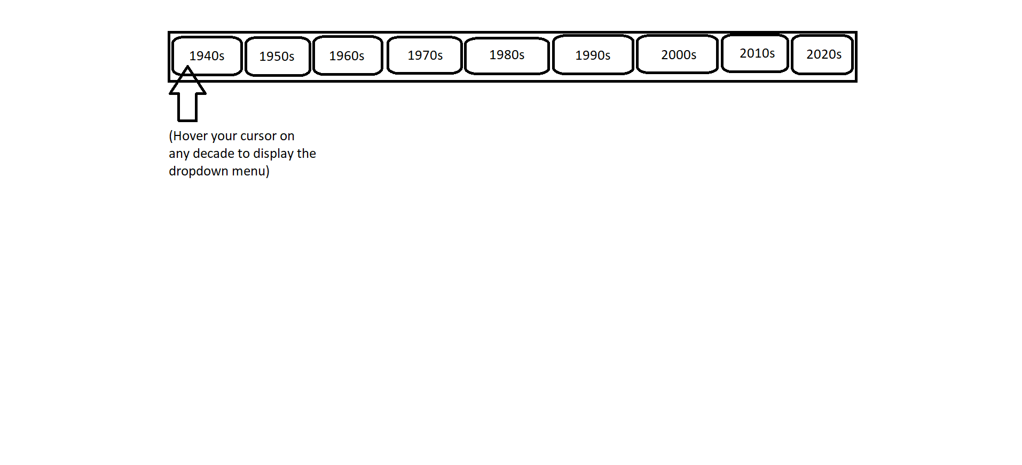

* Videos: To play a video, click on the play button. To pause the video, either click on the video or press the spacebar. To turn on or turn off captions, look under the timestamp to the right to find the captions button and click on it.

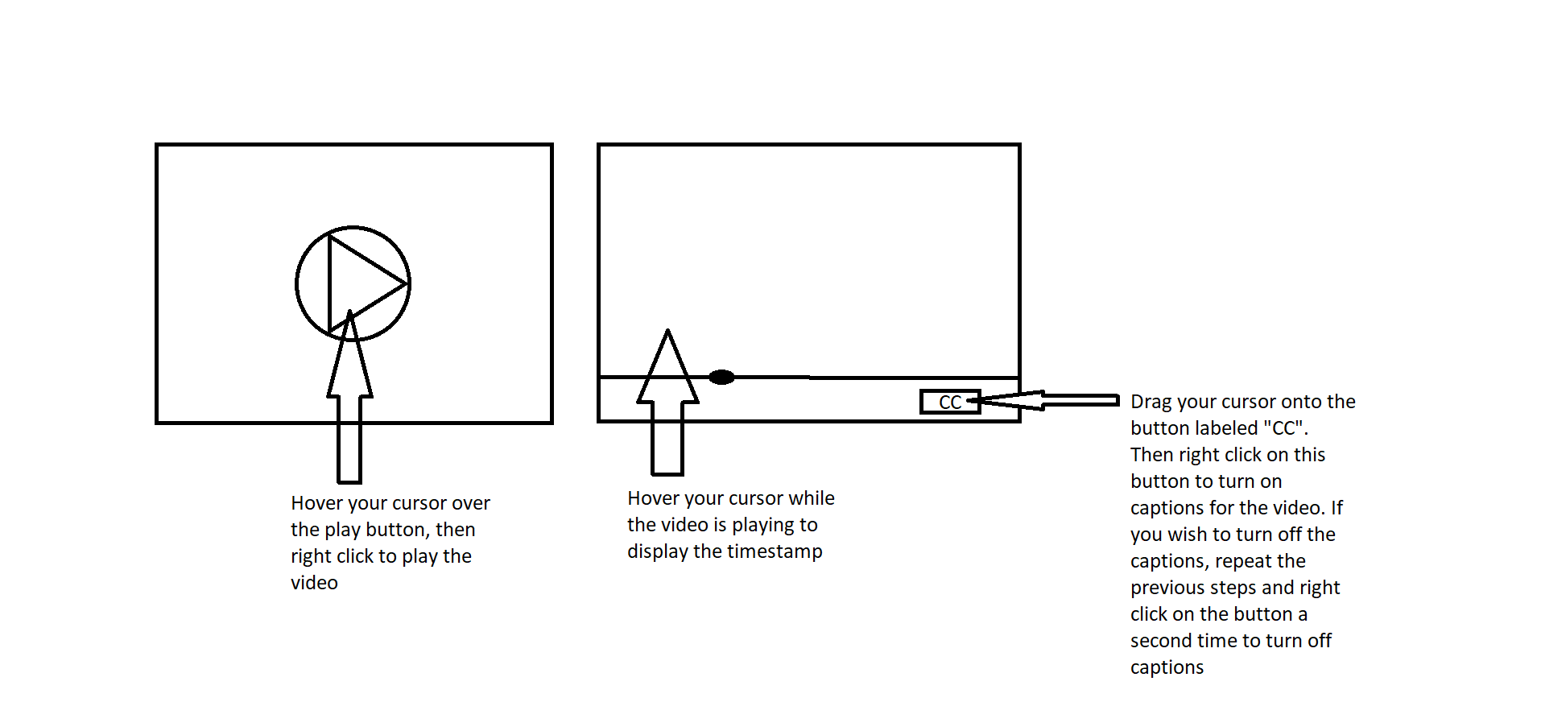

* Articles: To view the contents of an article, drag the cursor over to the article link and click on it. Once the article link is clicked, it will open a separate tab to view the contents of the article.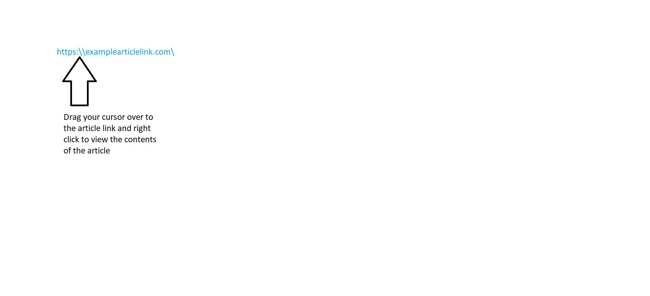
* Light & Dark Theme modes: At the top of the website homepage, there will be two option buttons. One for light mode, and one for dark mode. To select the theme that you want for the website, drag the cursor and click on the light mode or dark mode option.

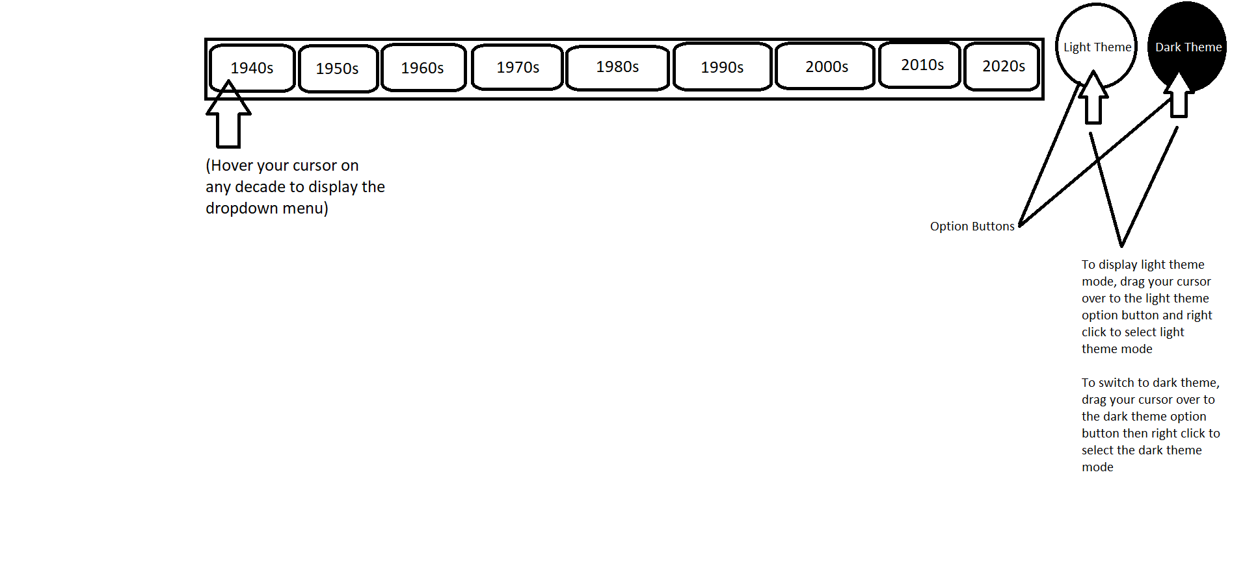

# References

## Error messages and causes

List all errors you plan to trap, their causes, and their possible solutions.

## Cross references to other operations

Design Document - See how the website was designed

## Appendix A - Glossary

|  |  |
| --- | --- |
| Title | Title |
|  |  |
|  |  |
|  |  |
|  |  |
|  |  |
|  |  |
|  |  |