**Austin Guzzetti-Ouellette, Kyle Stewart, Eduardo Carey**

Assabet Valley Regional Technical High School

Computer Programming and Web Development

# 1 Introduction

For my senior project I plSan on working to build a website about basketball. I will use visual studio code in order to program the website. This project is a website based around basketball where users will have the opportunity to learn about the game of basketball on a deeper level. Each page of the website will have a blend of images and information to appeal to the user. Each page will cover key points of each decade. I might need to incorporate subsections for certain eras as there might be more information that can’t be covered in the main key points of the page. I will also be incorporating statistical categories into each page. However, there will be certain statistical categories (such as steals, blocks, etc) that will not be able to be included in certain eras as those stats were not counted during certain periods of time. If there is speculation on a certain game that didn’t include stats, I will include resources like videos or articles that cover those games so the user can formulate their own opinion on the matter. I will try to limit how many of these controversial games I include on the website as I want the website to have more of an informational approach and not an opinionated take on basketball. As previously mentioned, each decade will have key sections that will go over important information regarding the decade. I will have to organize these key points with specific dates (I could use a number line in order to organize the information by date).

Configuring the layout for the pages will take time as there is a lot of information to cover across each of the decades. I will need to find layouts or templates that can present the information in the best possible way. This can help minimize the amount of information that could come off as overwhelming to the user. I will have my group partners help me to find and or create layouts to organize the information in the best way possible. One way I could do this is by using grids and columns in order to organize the page and the text. Text font, background color, etc will also be discussed in my group as we will determine what colors and text fonts go well together and that are appealing to the eyes of the user. To go along with that, I could incorporate a dark mode theme, but I am currently unsure whether or not to do that at the current moment.

I do have a few ideas of how to start the website. I was thinking that the best way to start the webpage would be to build a table of contents so that users can easily access information, without going through each page in order to find what they are looking for. The table of contents would consist of each decade, spanning from the birth of the game, to the founding of the NBA, to the modern era of basketball. In the table of contents, underneath each decade will include a subsection that will list the key points of that page so that the user can be aware of what to expect when they select that page.

This document’s layout will provide in-depth (detailed) information on how me and my group will organize and implement each aspect of the website. This document will also include all of the references that me and my group members will be using during the construction of the website. The following sections that this document will cover will be data design, functional design, non-functional design, and user interface design. Each of these sections will provide specified information of how we will implement them into the website.

# 2 Design Specification

## 2.1 Data Design

How the main data design; constants, variables, etc., of the system ***(your system)*** shall be implemented***.***

1. Grids shall be implemented by providing structure for the pages of the website. The Grids will also be implemented by storing the content displayed on the page in specific places in order to provide organization for the content on the page.
2. Tables shall be implemented by organizing statistical categories into separate slots. The tables will organize the statistical categories of points, rebounds, assists, steals, blocks, and more advanced analytics.
3. Columns shall be implemented by storing statistical information in specific slots in the table. The columns will break the table up by separating each statistical category to avoid cluttering of information. The Columns will also provide users with a description of each statistical category to help users interpret the statistics they will see.

## 2.2 Functional Design

How the main functional requirements of the system ***(your system)*** shall be implemented:

1. Animations
2. Hover effects shall be implemented within a cascading style sheet that will be linked to each html file of the website. When the user hovers their cursor over each NBA decade, their cursor will change to a clicker, indicating that the user can click on the decade to display more information.
3. Transition effects shall also be implemented within a cascading style sheet (either within the same stylesheet as the hover effects or a completely separate stylesheet). Transition effects are how pages will load when a user selects it.
4. Sport History (descriptions and layouts)
   1. Sport Birth will be implemented on the homepage of the website. Once users open up the homepage, it will display information based on who invented the sport, all of the original rules that were made, the first ever basketball game (pre-NBA), basketball infancy (late 1800s to 1950s, the foundation of the NBA and the very first NBA game. These topics will be split up by using grids to organize the content of the page to avoid cluttering of information.

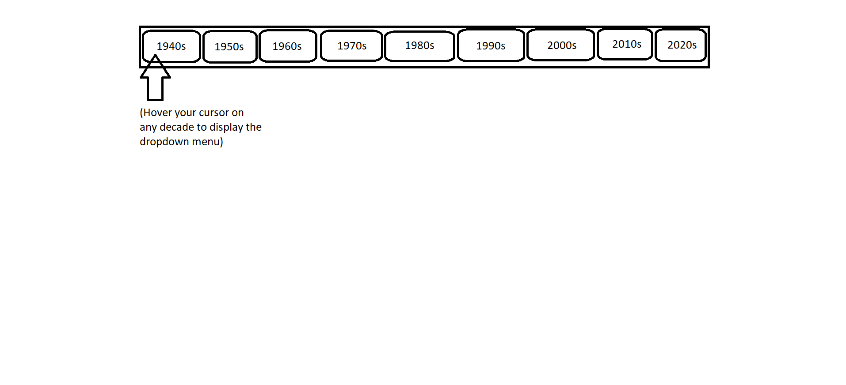

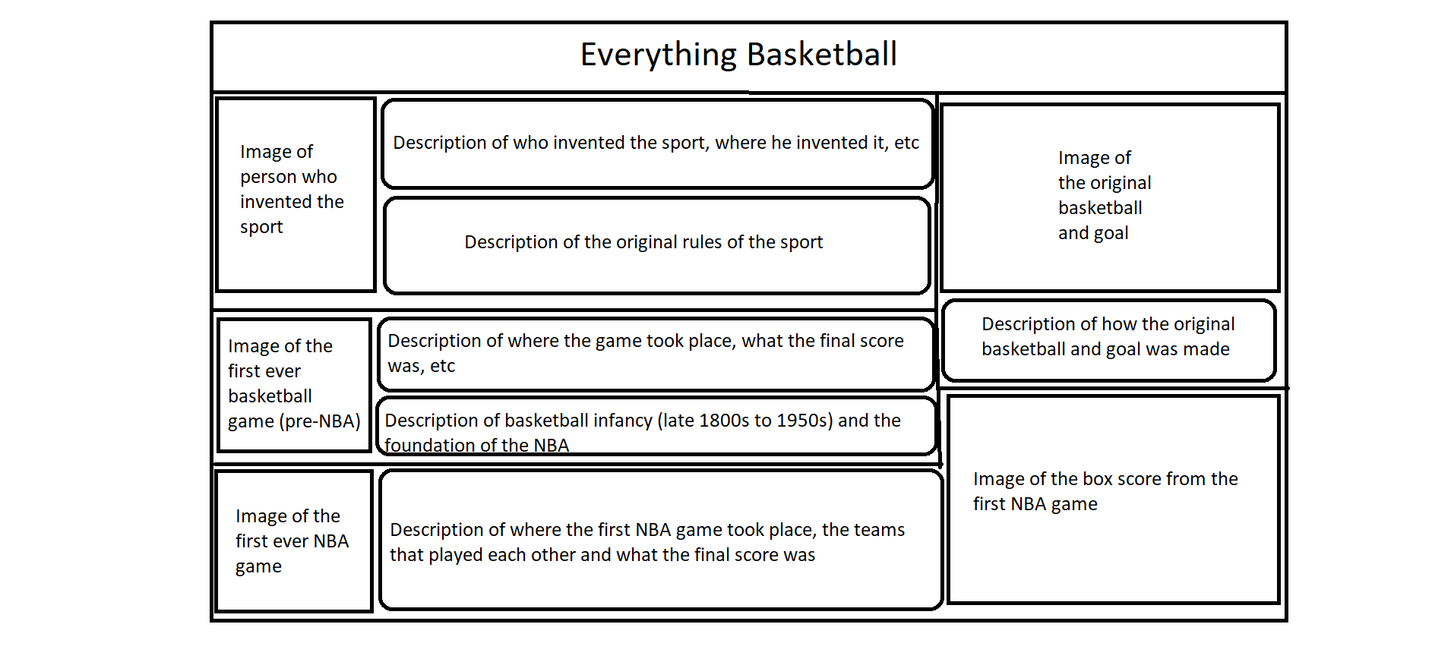

* 1. The NBA’s first superstar (George Mikan) – 1947, page will be implemented within the 1940s decade portion of the site. When users hover over the 1940s decade on the homepage, a dropdown menu will display and a key point titled “The NBA’s first superstar (George Mikan) – 1947” to which users will be able to click on the key point, which will bring them to that page. Information about George Mikan’s career will be the content displayed on this page.

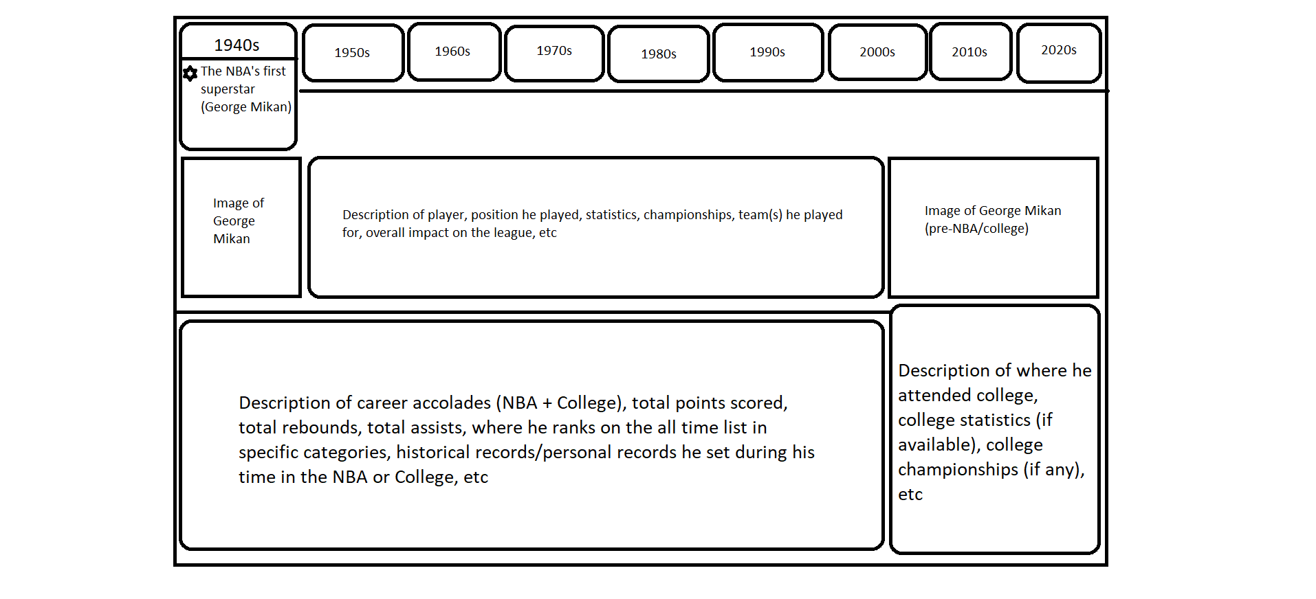

* 1. Located within the 1950s decade portion will be a key point labeled “The Houdini of The Hardwood comes to the NBA (Bob Cousy) – 1950”. When the user hovers their cursor over the 1950s decade, a dropdown menu will be displayed and the users will be able to click on the key point which will bring them to that page. When the user clicks on this key point, they will be taken to a page that goes over Bob Cousy and his career in the sport.

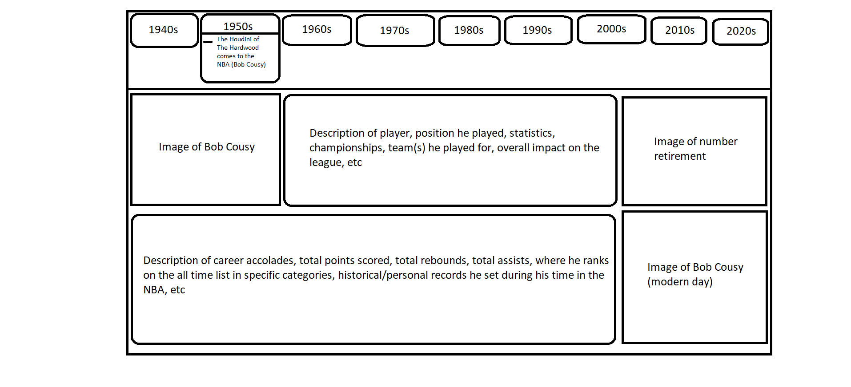

* 1. Within the 1960s decade portion will be a key point labeled “The Battle of the Giants”. When users hover their cursor over the 1960s decade, a dropdown menu will be displayed with this key point to which the users will be able to click on it. After clicking on the key point, a page will be displayed to the user that covers all of the information regarding the 1960s and how two specific players popularized that decade.

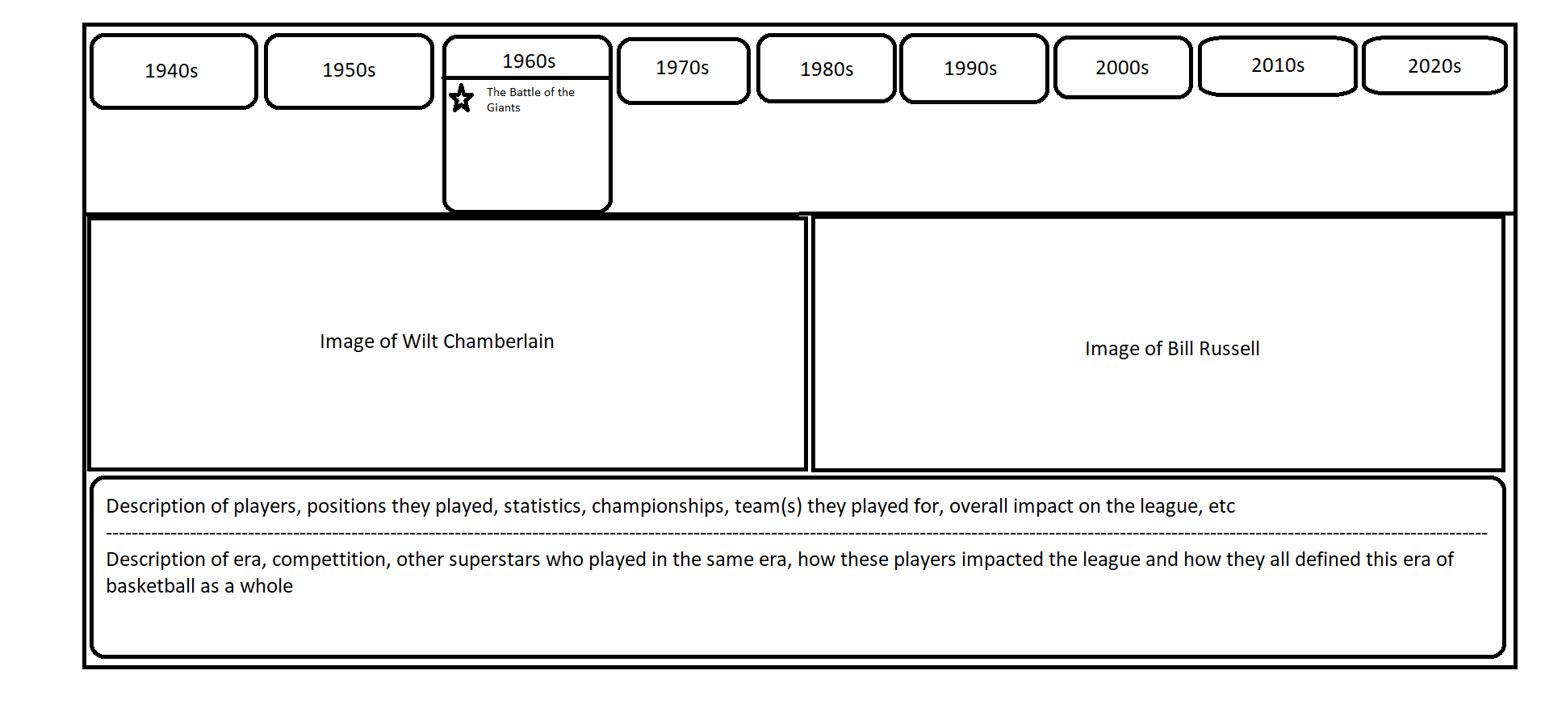

* 1. Moving into the 1970s decade portion, there will be a key point labeled “The Dark Days of the NBA”. When the user hovers their cursor over the 1970s decade, the dropdown menu for that decade will display this key point to which users will be able to click on it and it will take them to the page that will inform the user about the decade that caused a lot of worry for the NBA and its future.

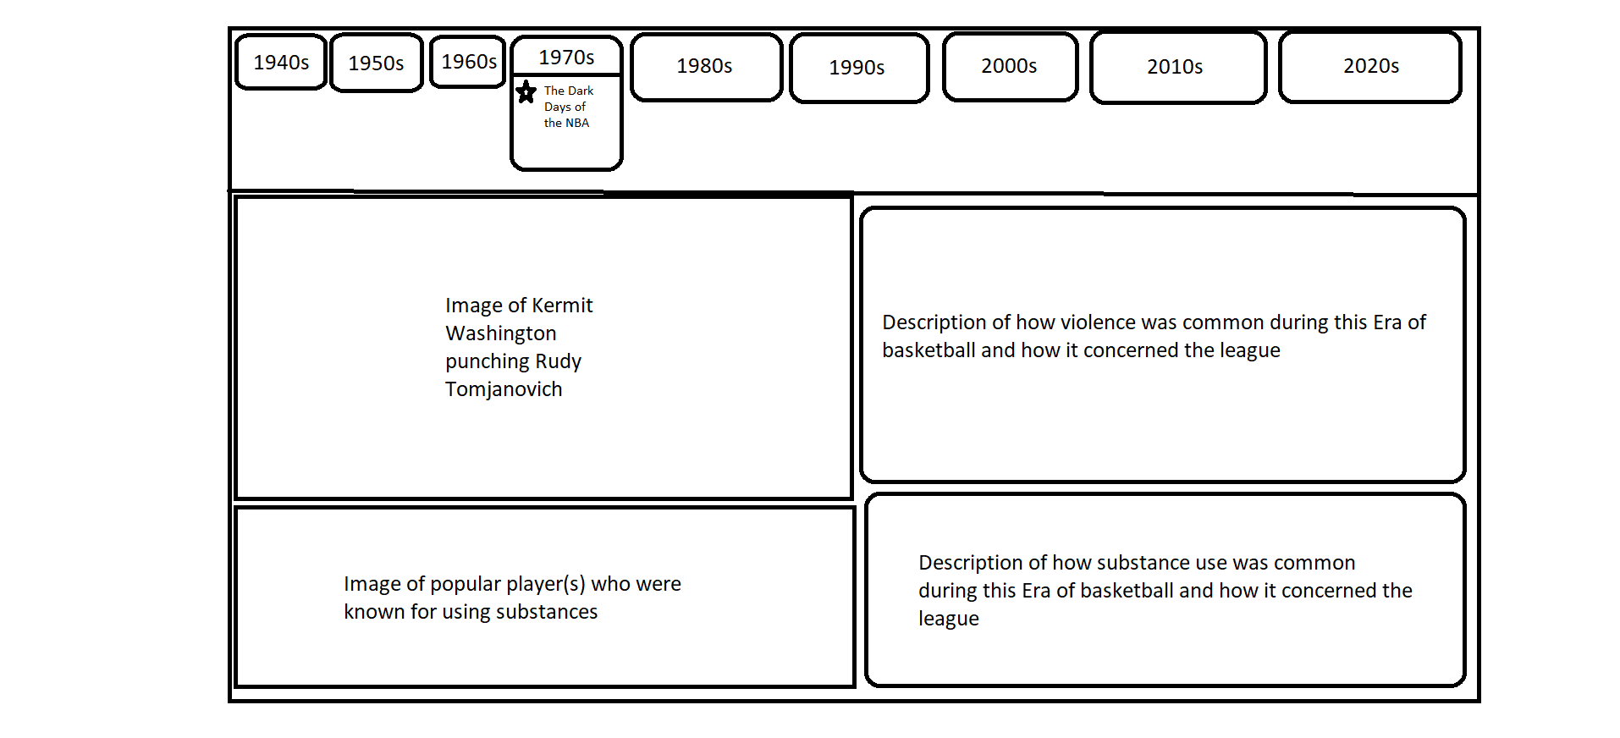

* 1. Entering into the 1980s decade portion, there will be a key point labeled “The Two that saved the NBA”. When the user hovers their cursor over the 1980s decade, a dropdown menu will be displayed and within that dropdown menu, this key point will also be displayed. Users will be able to click on this key point and it will take them to a page that will share the story about how two specific players saved the NBA from going out of business, due to the events occurring in the 1970s.

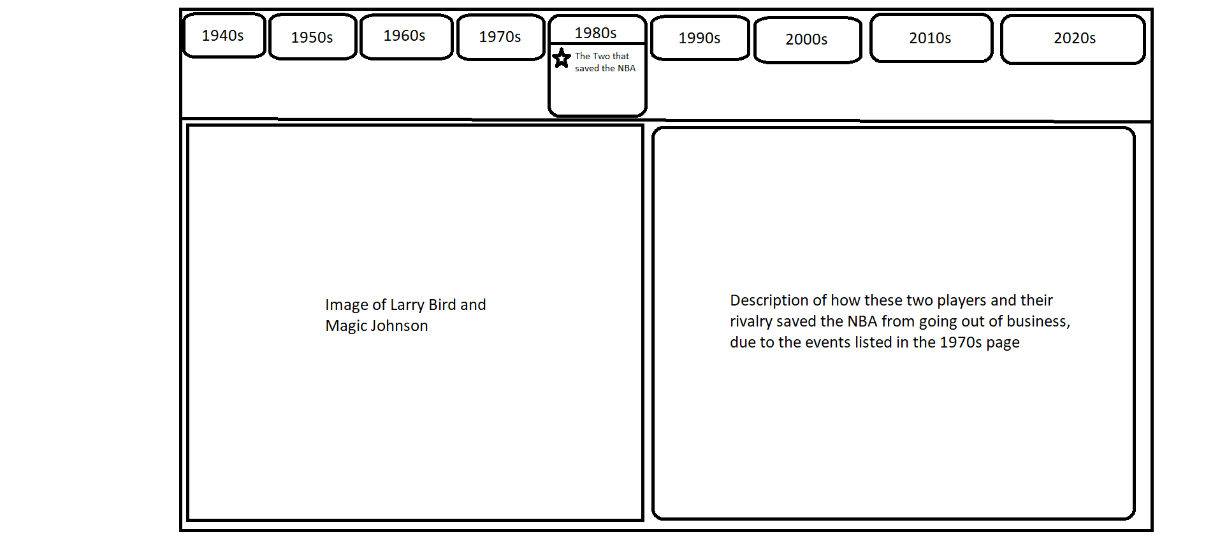

* 1. Heading into the 1990s decade portion, there will be a key point labeled “The MJ Era”. When users hover their cursor over the 1990s decade, a dropdown menu with this key point will be displayed. Once users click on this key point, they will be taken to a page that goes over how MJ defined that era of the sport. There will also be another key point displayed within the dropdown menu of this decade which will be titled “The 50 greatest players of all-time list (1996)”. When the user clicks on this key point, it will take them to a page that goes over all of the NBA players who the NBA selected to be in the 50 greatest players of all-time list to celebrate the league’s 50th anniversary of its foundation.

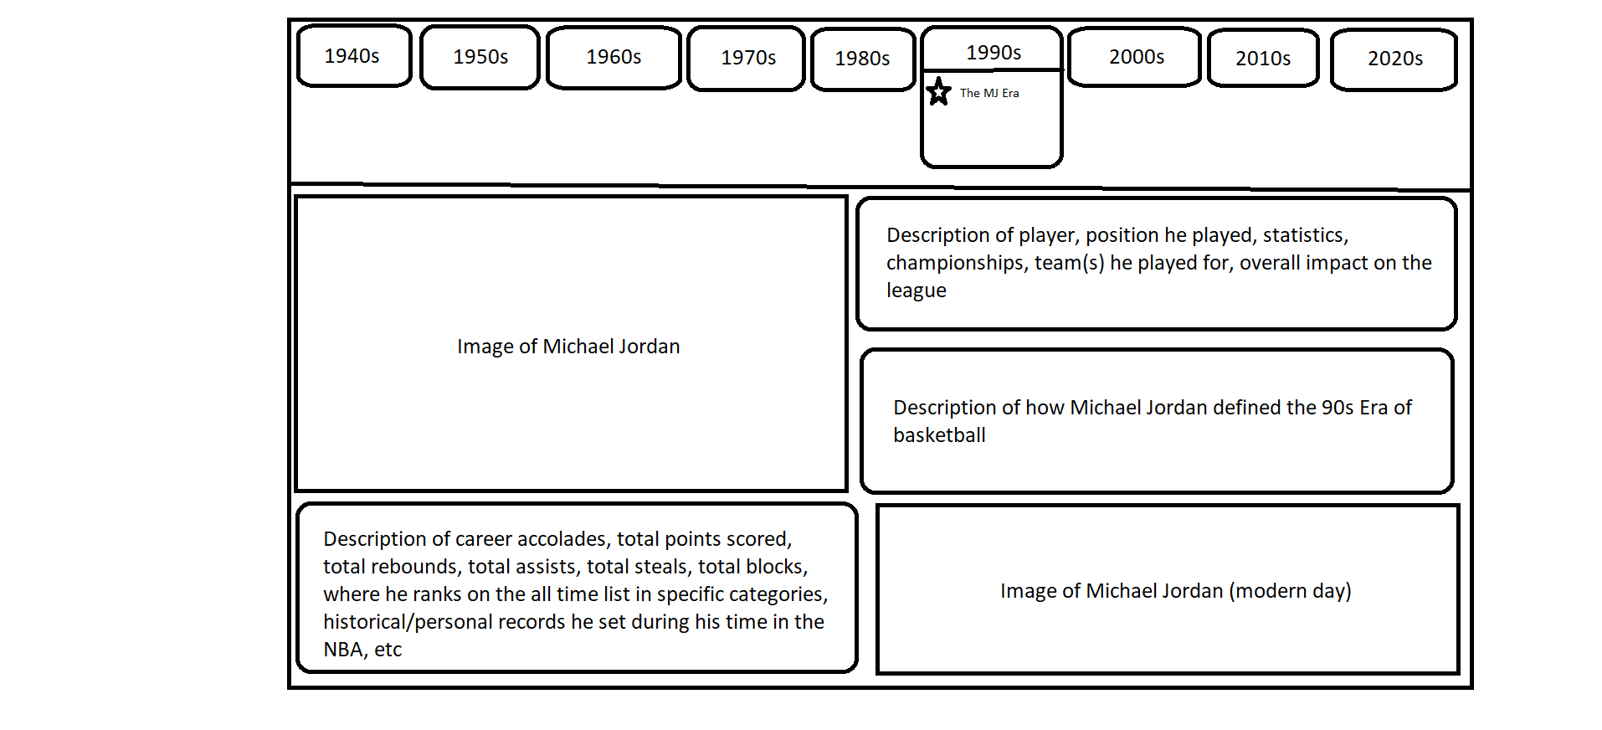

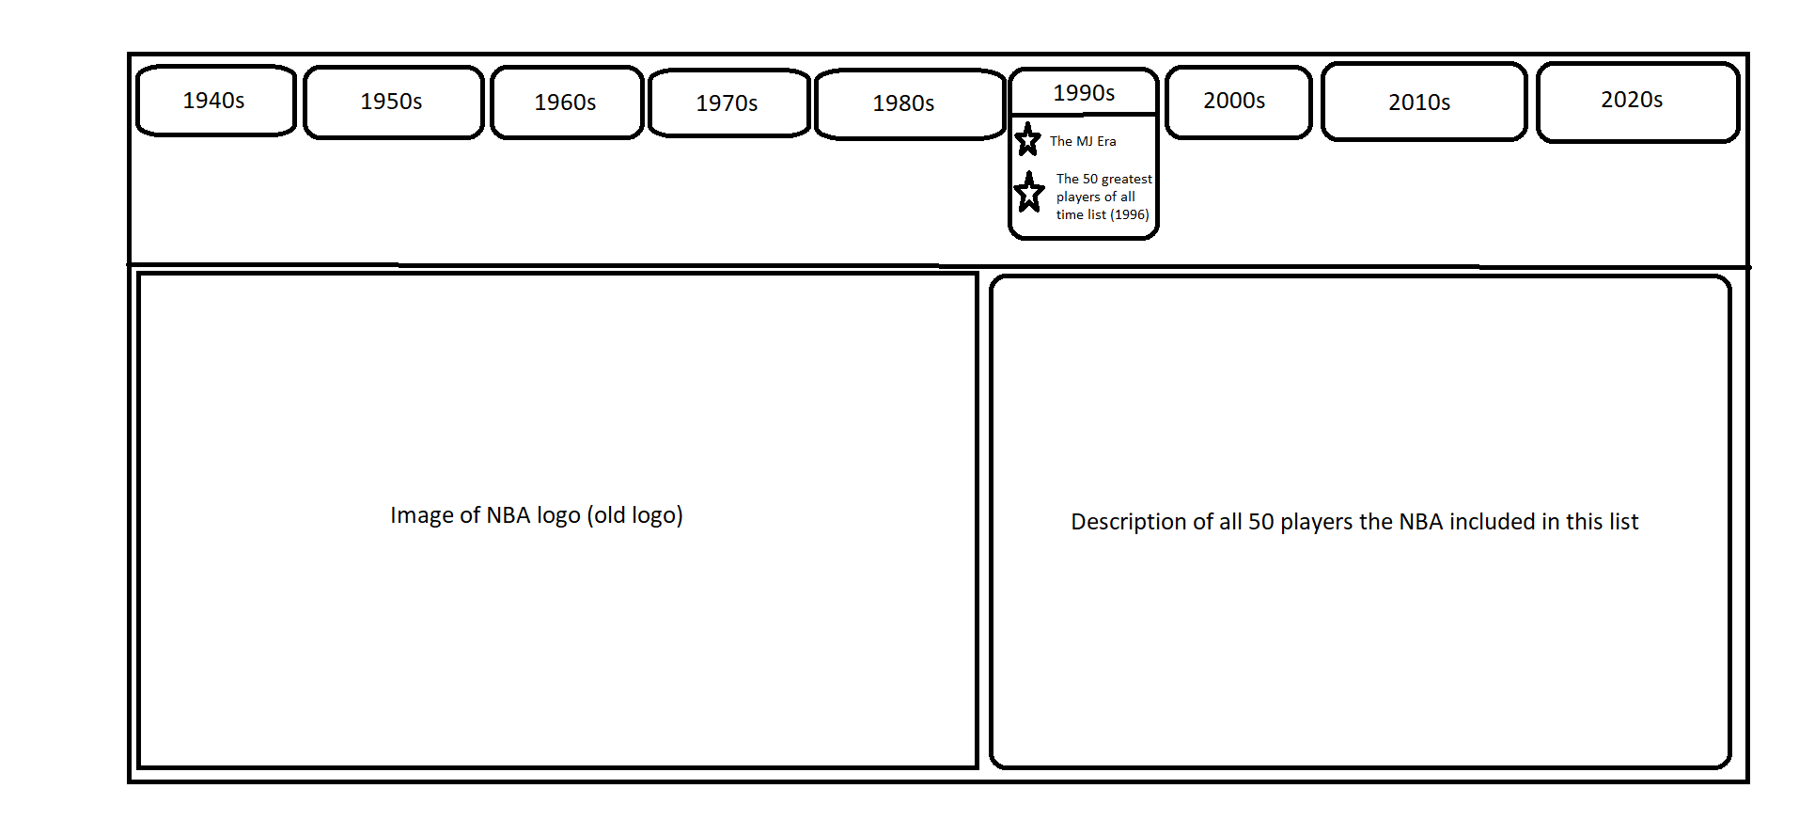

* 1. Enter the 2000s decade portion and there will be a key point labeled “The 2000s”. When users hover their cursor over the 2000s decade, a dropdown menu with this key point will be displayed and once users click on the key point, it will take them to the page that will inform the user of that decade of the sport and how it will translate into the 2010s decade.

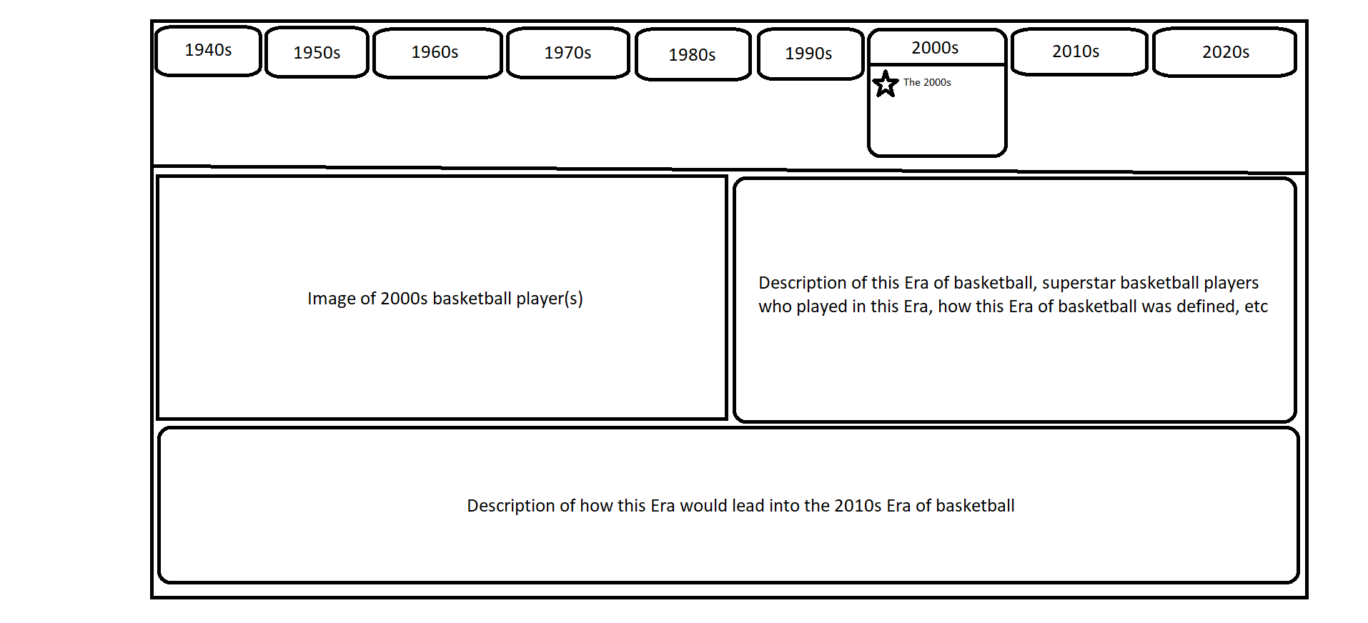

* 1. The 2010s decade portion will consist of a key point labeled “The Era of the Three Pointer Begins”. When users hover over the 2010s decade, a dropdown menu with this key point will be displayed and once users click on it, it will take them to a page that will go over how the three-point shot began to define the future of the league.

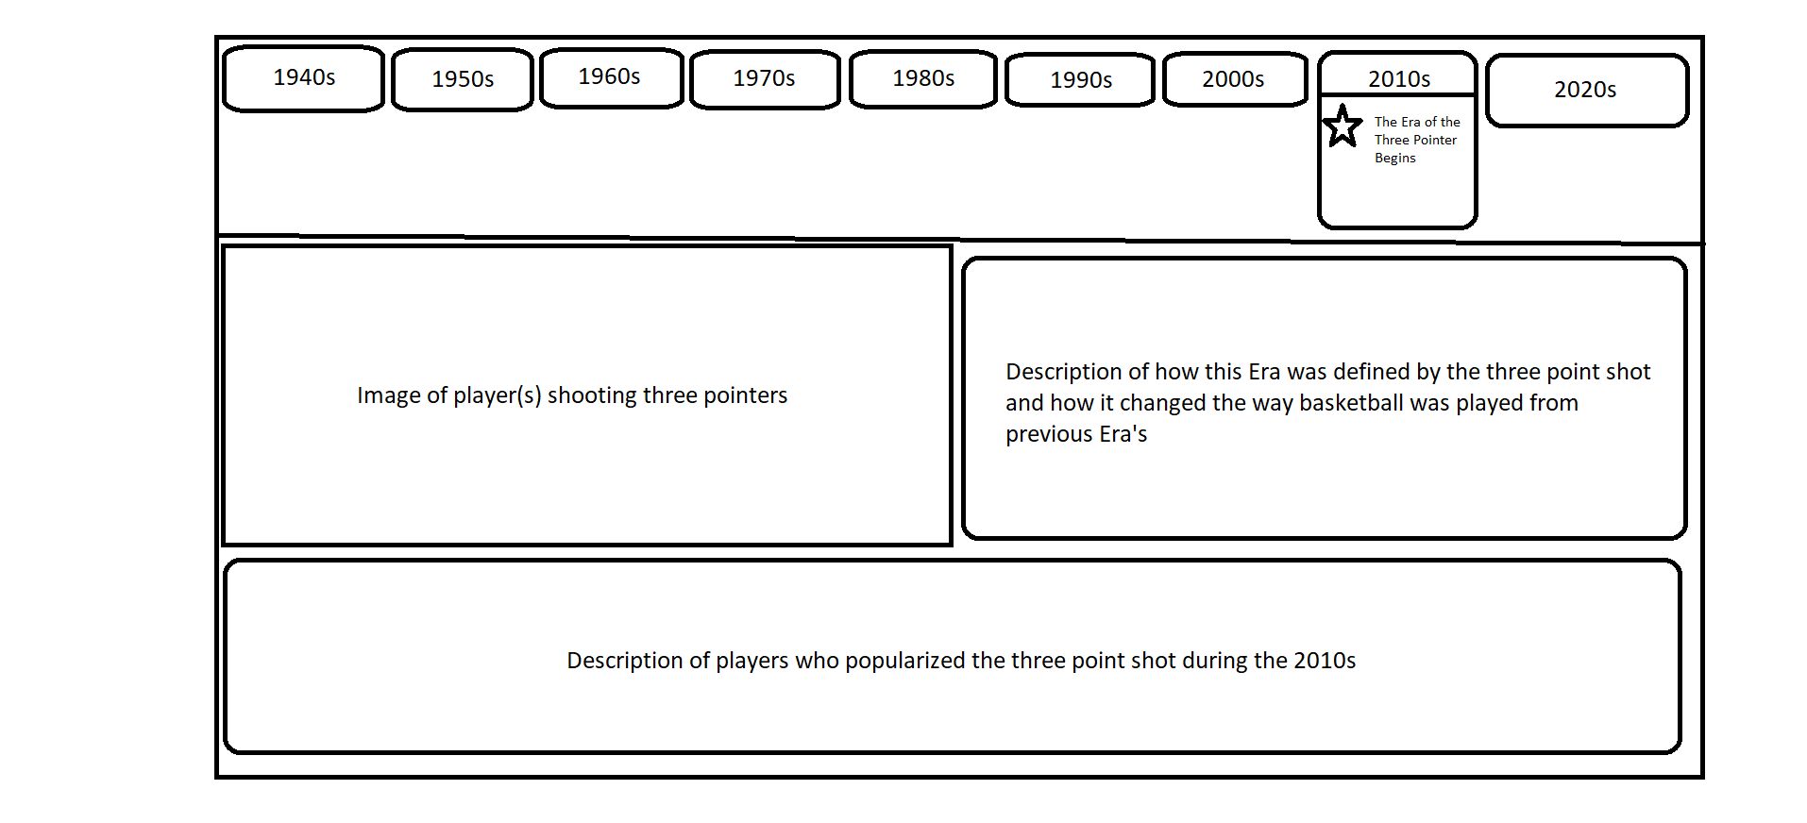

* 1. Now entering the 2020s portion, there will be a key point labeled “Modern Era”. When users hover over the 2020s decade, a dropdown menu with this key point will be displayed. Once users click on this key point, it will take them to a page that goes over how the sport is in today’s day and age. There will also be another key point displayed within the dropdown menu of this decade titled “The 75th Anniversary Team (2021)”. Once users click on this key point, it will take them to a page that will display all of the players that made the 75th Anniversary Team and background information on their career and what they accomplished. This will follow the same format as the 50 greatest players of all-time list.

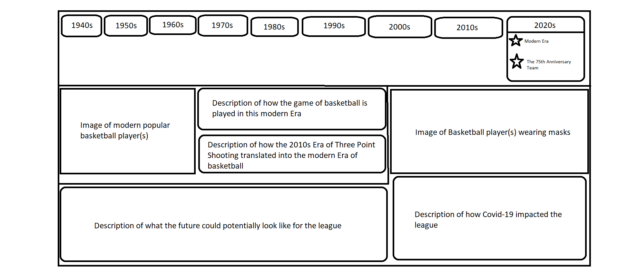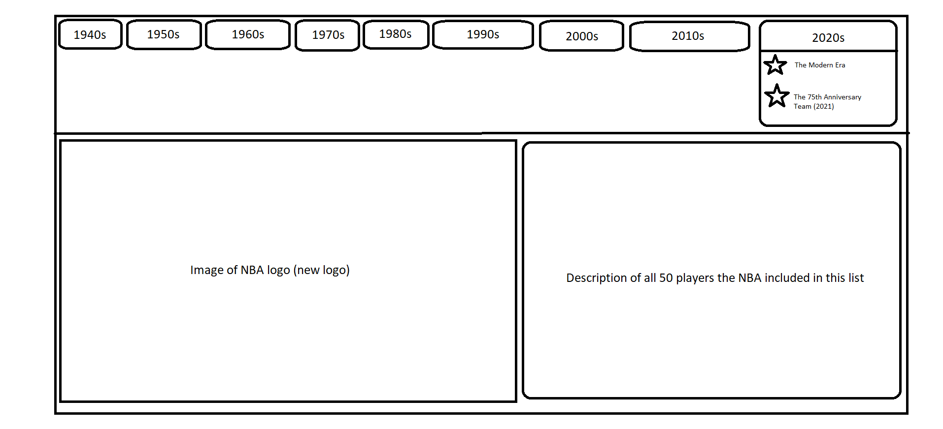

1. Franchise History
   1. When users hover their cursor over the franchise history portion of the site, a dropdown menu will be displayed and will consist of 30 individual key points (1 key point for each individual NBA franchise). Once a user clicks on any of the key points displayed, it will take the user to a page that goes over the history of the franchise and what players are associated with that specific franchise (both past and present) they selected within the dropdown menu. It is also important to note that there are several NBA players (both past and present) who have played for multiple franchises throughout their career. For these players, they will be displayed in the pages of the franchises that they had the most impact on.

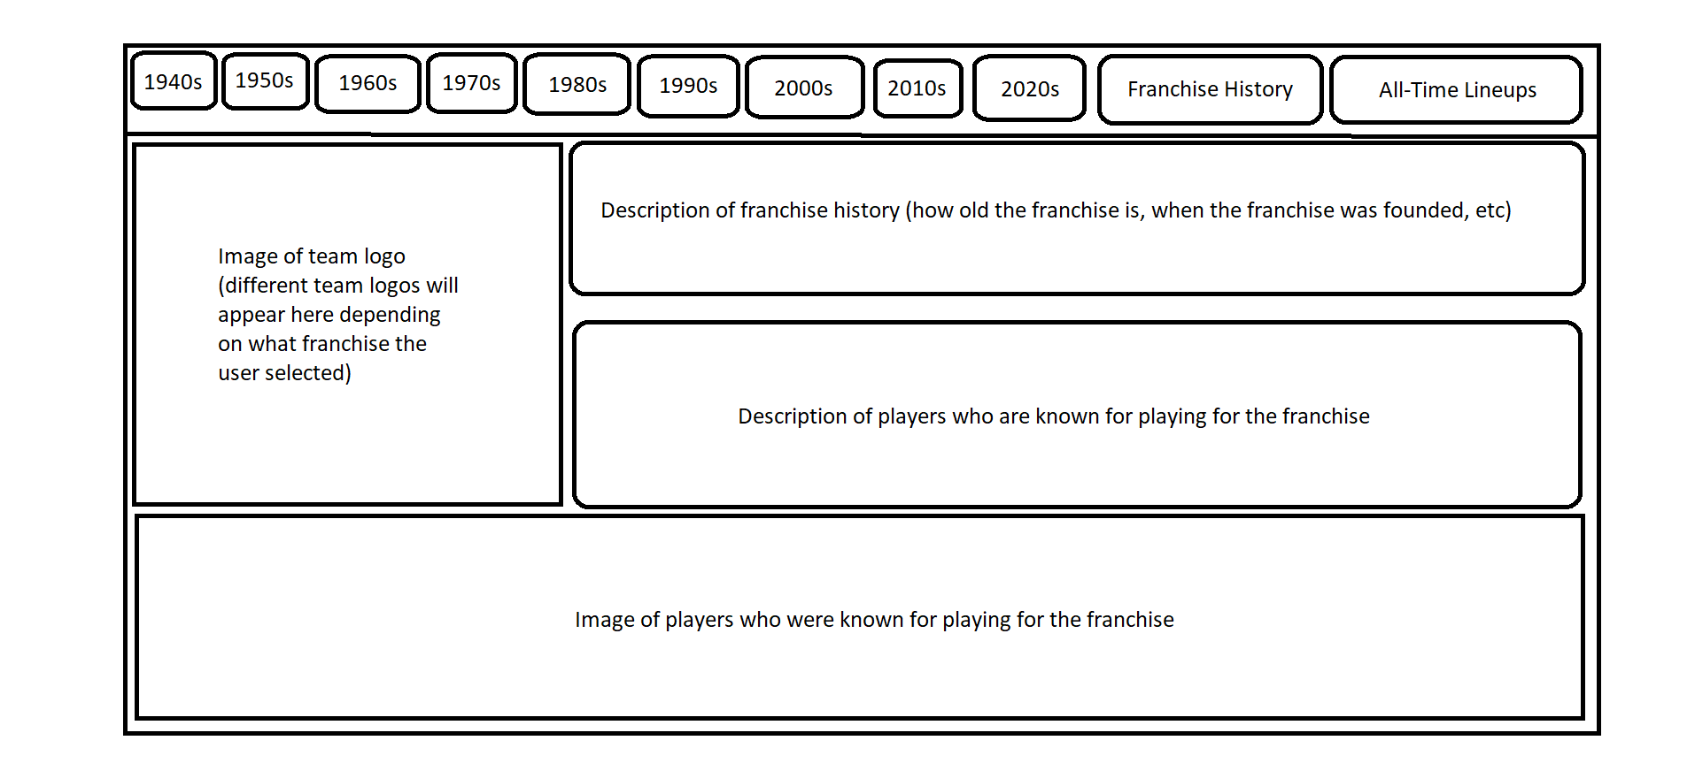

1. All-time lineups
   1. When users hover their cursor over the all-time lineups portion of the site, a dropdown menu will be displayed and will consist of 30 individual key points (1 for each individual franchise). Once a user clicks on any of the 30 key points displayed within that dropdown menu, it will take them to a page that includes that team’s all-time lineup. All-time lineups will consist of a variety of players from all different eras of the sport and putting them into one lineup together. For the most part, all-time lineups will consist of past players, however there will be exceptions for some current players as certain franchises have current players who played for them when they were at their best. Therefore, current players who follow this stigma will be included in the all-time lineups of whatever team they performed their best on.

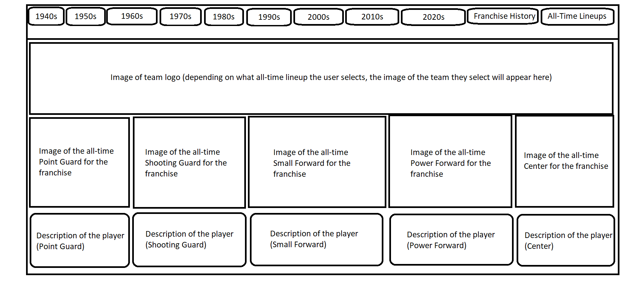

1. Homepage Structure



## 2.3 Non-functional Design

How the most important non-functional requirements for the system ***(your system)*** shall be implemented:

1. Visual Studio Code will be implemented with this project in order to provide an up-to-date software to construct the website in.
2. Windows 10 is implemented to provide the most recent version of windows OS so that the website can register on users machines properly.

## 2.4 User Interface Design

How the user interface requirements for the system ***(your system)*** shall be implemented:

1. Light theme or dark theme shall be implemented within the homepage of the website. Users will be able to change the theme if they so desire. Light theme will be selected as default but can be changed in the settings of the website. Option buttons will be displayed at the top of the homepage and users can select 1 option at a time to change the theme.
2. Videos and Articles shall be implemented within certain parts of pages that might require video(s) or article(s) information (these will be strategically placed within the layout of a certain page in order for information from the page to flow smoothly without the video or article getting in the way). Videos will be embedded into the page with the capability of providing the option of turning on/off captions if a user desires.

# References

A list of all references used for your system requirements should be here.

<https://www.basketball-reference.com/> - Accessed 9/13/22

<https://probasketballencyclopedia.com/players-index/> - Accessed 9/27/22

[Bill_Russell_Blocks_and_Steals_Statsheet.jpg](http://bill_russell_blocks_and_steals_statsheet.jpg) – Accessed 9/27/22

[Wilt_Chamberlain_Blocks_and_Steals_Statsheet.jpg](http://wilt_chamberlain_blocks_and_steals_statsheet.jpg) – Accessed 9/27/22

<https://naismithbasketballfoundation.com/about-basketball/history-of-basketball/> - Accessed 9/27/22

<https://hooptactics.net/premium/basketballbasics/bb8rulesevolution.php> - Accessed 9/27/22

<https://americasbesthistory.com/abhtimeline1892m.html> - Accessed 9/27/22

<https://sportshistorynetwork.com/basketball/first-ever-basketball-game/> - Accessed 9/27/22

<https://www.statmuse.com/> - Accessed 10/13/22