Alex Simons
CS487
Wainer
Lab1
9/12/2014

I have included in my submission my rough prototype gui sketch, project brainstorming notes, and 2D model concept as scanned images, as well as my Pencil design.

To start off, the biggest re-factor was changing the number of nodes that the NimModel would have, thus changing the Node class. This will allow the user to dynamically change the number selection moves they can do. However due to the algorithms poor efficiency, I narrowed it down to up to six.

I accomplished this dynamic change by adding an ArrayList of the class node. So that one node can reference as many child nodes as needed before buffer overflow. The ArrayList class is a linked list data-structure, and was very handy for what this project needed.

After changing the node class, the provided NimModel functions that used the old Node data-structure became obsolete. I first had to re-factor the buildGameTree method. After I had a working game tree that worked with provided Controller and View, I had to fix the Nim AI's methods. I had done my testing as a two layered game, easy change (changing the number of players, that is).

I took a bit of thinking, but I got computeMinimax of the NimModel class to work recursivly with a linked list of nodes. It took a couple of trys, but it works now like it did previously with the static number of nodes. Once I got the computeMinimax method working, I moved off to the takeBestMove method of the NimModel Class. After I had figured out what the provided method was originally did, I was able to re-factor it to my dynamic noded class. Due to time constraints, and the algorithm's difficulty, I saved working on this for last. So I did not have too much time to mess with AI difficulty settings too much. Its either really easy or really hard (the AI).

This brings me to the meat of this project, the controller or NimPanel. The change to the Node class also had me redue the reorder method. Thats about the only change that I can think of right now that was affected by changing the Node Class.

Still on the topic of the NimPanel class, there were a few refactorings as well. To start off, I added a isInDropZone method to determine whether the Nimja is within the specified drop zone when dragging. It makes the code easier to read. The controller handles the current player, so I created a setPlayer method to call to set the player during the appropriate action. Again, added for the sake of readability. After that I created a runNimAI method that runs the computers turn for this Nimja game. It still has the remnants of code that I was trying to get working. What it was trying to do is show the Nimjas being selected, while being drawn at the same time, didn't have enough time to get it to work though.

After that I crated a moveNimja method which, well, moves Nimjas off the board. This was created to use for buttons calling the controller to move the nimjas, I assume that I could have used it in the mouse events, but given time constraints I could not. I also created a setNimjas method, that puts all of the Nimjas on the board, with variables to control where they are and how they are placed. This was to aid anybody wanting to move the coded nimjas around and improve some readability.

I also addeda get setNewGame method to the NimPanel class to eliminate some duplicated code appearances. After those methods, the are created for the view to know what state the model is in.

I also spent some time making a nice swing interface for this Lab, due to time, I was unable to change the model state to the view via drag events of the mouse. As for the view, I created an ActionListener class so all of the buttons/menu items were directed to that, aiding readablity.

I did not have anytime to add comments, as I was having too much fun creating this and was busy up until the end. I also did not have the time to change the word 'Matches' to the word 'Nimja' as I have done with everything else in this project.

Anyways this is what my final gui looks like starting up.

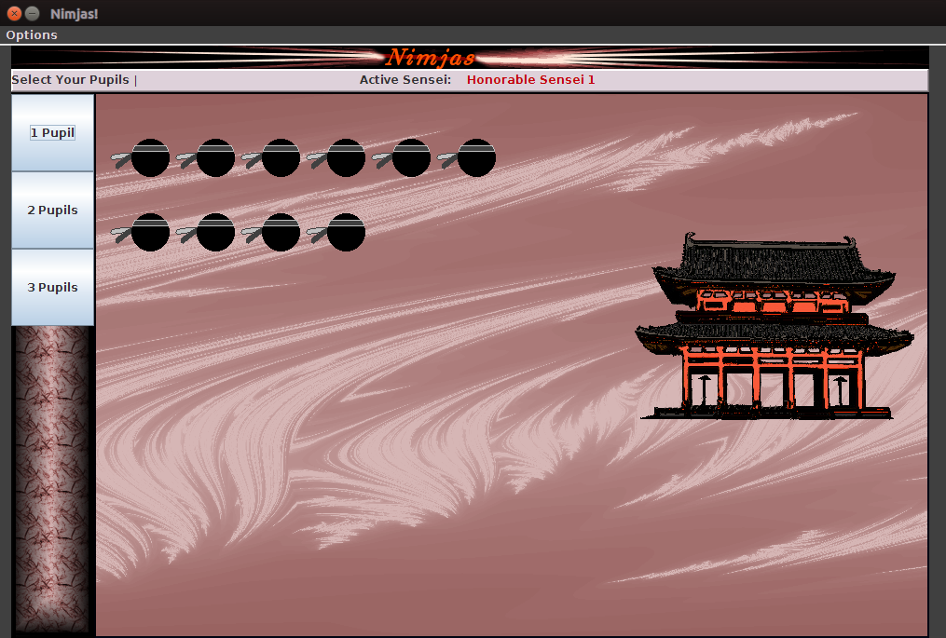

Here is it after I changed the number of Nimjas to play with via the Options Menu

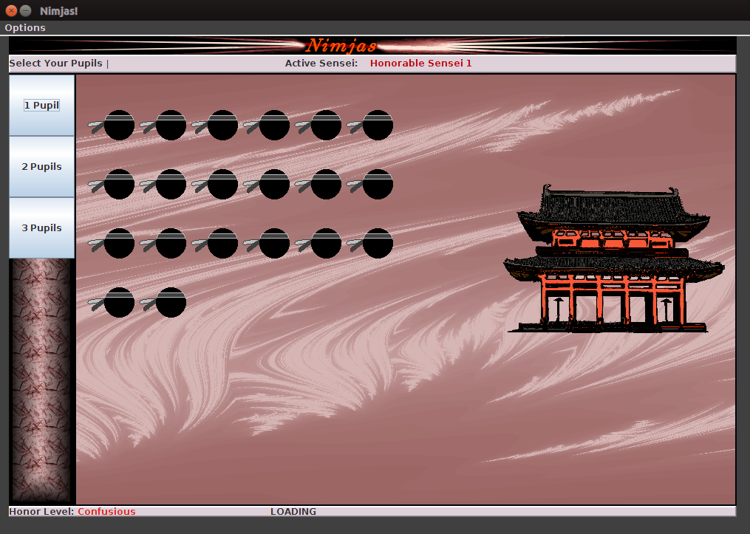

Here I changed the number of Nimjas I could select, and selected some as well

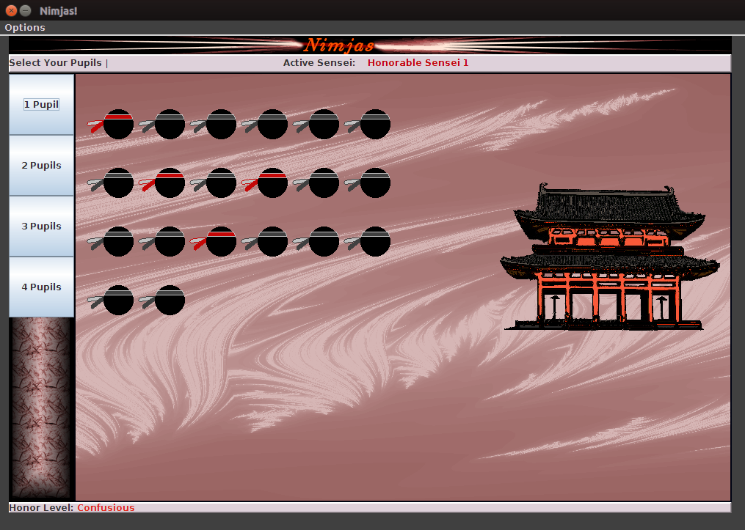

Here I am about to loose, notice the buttons have disappeared for the number of inappropriate moves
