THE AI COMPUTE
CAPITAL STACK
Capacity, signed pipeline, data-center atlas, cost curves and equity implications
____________________________________________________________________________________
  - Research-grade source-led assessment
Cut-off: 1 September 2026 | Market data: 31 August 2026 close
Core convention. Compute is deliverable IT accelerator power. Accelerator TDP, IT power and facility/utility power are kept separate. Capacity is normalized to H100-equivalent dense 8-bit throughput; memory, networking and software advantages remain outside the scalar. [S01-S11]

Anchor | Finding
Named public-site floor | 13.3 GW IT / 14.6M H100e across 86 tracked campuses [S01]
Full-stack one-GW model | $37.883B upfront / $8.514B annual TCO [S03]
Largest modeled owner | Alphabet / Google: 5.04M H100e at Q4 2025 [S04,S05]
Largest explicit signed increments | Amazon/Anthropic up to 5 GW; Oracle/OpenAI 4.5 GW additional [S24,S33]

Prepared by OpenAI. Analytical research, not investment advice. Estimates are labeled; disclosures retain qualifiers such as “up to,” “more than,” and undisclosed overlap.

Executive summary
Central judgment. AI compute has become a capital-stack problem as much as a silicon problem. The decisive variables are power delivery, construction timing, lease/accounting structure, customer prepayments, contract tenor, utilization and refresh cadence. [S03,S12,S20,S23,S27,S31,S37]

- Google leads the comparable modeled fleet. The Q4 2025 chip-owner model estimates 5.04M H100e and 2.947 GW of accelerator TDP, implying approximately 4.72 GW IT under the central fleet bridge. Microsoft follows at 3.50M H100e, Amazon at 2.46M and Meta at 2.42M. [S04,S05; Model]
- The named-site database is a floor. It covers 86 campuses, 13.3 GW IT and 14.6M H100e, but estimates only 46% coverage of deployed global AI compute at end-June 2026. [S01,S02]
- A complete GB200-class GW is expensive: $37.883B upfront and $8.514B annual TCO. Facility shells are only one layer; powered-shell leases near $1.4B-$2.3B/GW-year are not comparable with full GPU services near $9.7B-$10.9B/GW-year. [S03,S17,S33,S34,S37,S39-S46; Model]
- Signed and contracted demand is larger than recognized assets. Amazon/Anthropic announced more than $100B over ten years and up to 5 GW; Oracle/OpenAI announced 4.5 GW additional; Google described a 5 GW TPU program from 2027; CoreWeave disclosed 3.7 GW contracted. [S21,S22,S24,S33,S38]
- The footnotes are the real capacity map. Microsoft disclosed $329.1B of mostly data-center uncommenced leases, Meta $346.99B post-period, Oracle $260B and CoreWeave $35.5B. These figures are not directly additive with capex or purchase obligations. [S12,S27,S31,S37]
- Equity exposure bifurcates. Google has the best modeled compute-to-valuation combination among hyperscalers; Oracle and CoreWeave offer greater AI-capacity torque but carry much larger obligations relative to market capitalization. [S31,S37,S38,S48; Model]
Ticker | Current IT GW | Current H100e | Future indicator GW | Market cap | P/E | Capex / OCF | Uncommenced / MCap
AMZN | 2.69 | 2.46M | 5.00 | $2,832.3B | 20.9x | 137.8% | 4.8%
MSFT | 3.30 | 3.50M | 0.66 | $3,776.8B | 30.2x | 63.4% | 8.7%
GOOGL | 4.72 | 5.04M | 5.00 | $4,150.3B | 17.0x | 95.0% | 2.1%
META | 2.38 | 2.69M | 5.00 | $1,468.6B | 21.6x | 79.5% | 23.6%
ORCL | 0.49 | 0.59M | 4.50 | $434.2B | 26.8x | 174.1% | 59.9%
CRWV | 1.50 | 1.67M | 2.20 | $46.8B | n/d | 385.0% | 75.9%
TSLA | 0.20 | 0.23M | 0.20 | $1,302.5B | 340.7x | 123.0% | n/d

Sources: current compute [S01,S04,S05,S37,S47; Model]; future [S16-S24,S28,S33,S38,S47]; financials [S12,S20,S23,S27,S31,S37,S47]; market data [S48].
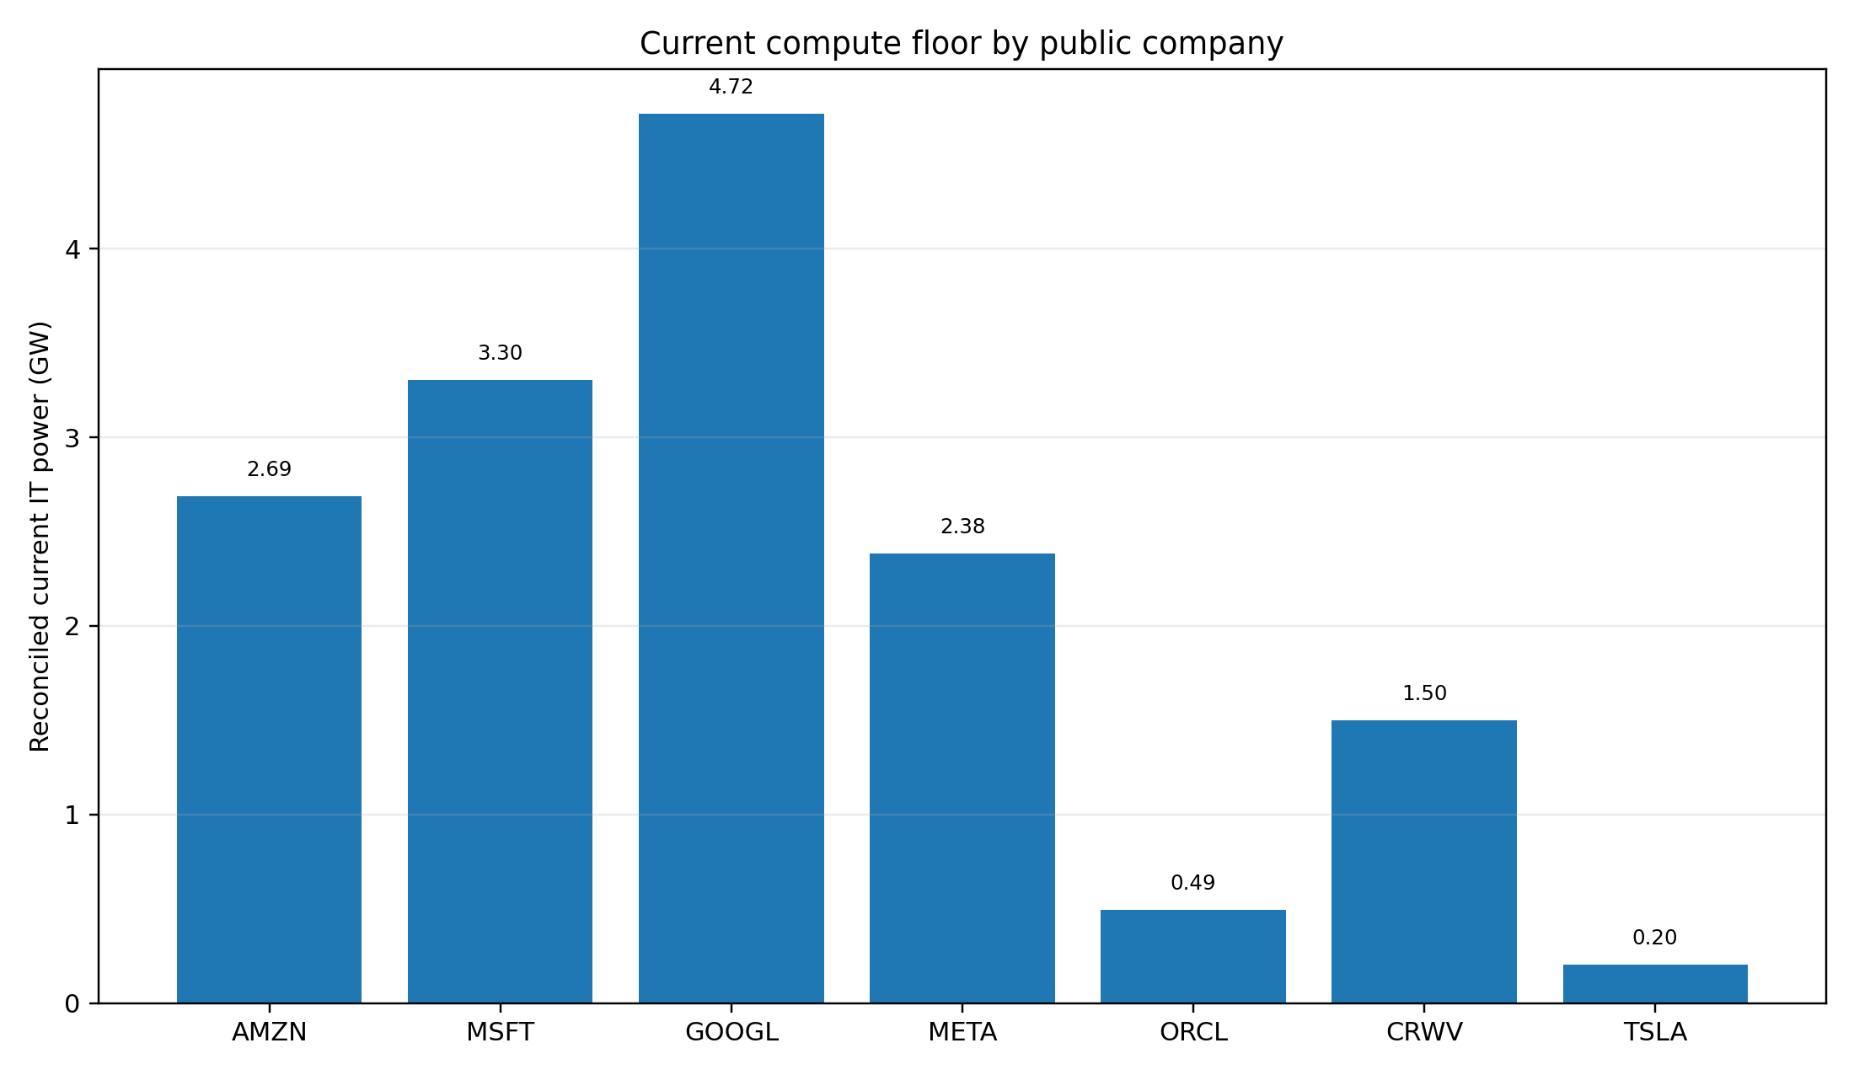
Figure 1. Reconciled current IT-power floor. Sources: [S01,S04,S05,S37,S47; Model].

Contents and source conventions
Section | Subject
1 | Measurement framework
2 | Current compute: comparable fleet view
3 | Data-center atlas: current and target sites
4 | Signed and contracted pipeline
5 | Footnote archaeology and capital commitments
6 | Vendor dossiers
7 | Counterparty chain and market pricing
8 | One-GW cost curves
9 | Equity-market implications
10 | Risks and limitations
Appendix A | Normalization detail
Appendix B | Current site-level table
Appendix C | Planned site-level table
Appendix D | Source register

Citation convention. Every material numerical claim carries a bracketed source ID. Derived values are marked “Model.” Site costs are modeled replacement costs, not company-reported project spend. Contract-value/GW ratios retain disclosed qualifiers and are not tariffs. [S01-S05]

Grade | Evidence | Treatment
A | SEC filing / audited annual report | Recognized assets, liabilities, cash capex and obligations; definitions still differ.
B | Company or named-counterparty announcement | High confidence for stated scope; overlap and timing may remain incomplete.
C | Independent dataset or model | Useful for comparability and site detail; uncertainty is material.
D | Derived normalization or ratio | Transparent arithmetic bounded by input assumptions.

1. Measurement framework

1.1 There is no single meaningful “gigawatt”
Accelerator TDP is the summed design power of chips. IT load includes host CPUs, memory, networking and storage. Facility load adds cooling, pumps, power conversion and redundancy. Utility or campus capacity can include spare blocks and non-AI loads. Treating these as interchangeable can overstate or understate comparable compute by 20%-100%. [S01,S02,S05-S11]
Convention | Includes | Best use | Main trap
Accelerator TDP | Chip design power only | Chip-owner model and silicon efficiency | Not deliverable facility capacity
IT power | Accelerators plus servers/fabric/storage | Preferred comparable data-center unit | Still depends on chip mix and utilization
Facility power | IT load multiplied by PUE | Utility draw and infrastructure burden | MW may be IT or gross
Campus / utility envelope | Interconnect or maximum planned load | Siting and grid context | May include redundancy, phases and general cloud

For fleet estimates based on accelerator TDP, the central bridge is facility power = 2.0x accelerator TDP and IT power = facility power / 1.25 PUE = 1.6x TDP. Sensitivity ranges are 1.7x-2.3x for facility/TDP and 1.18x-1.35x for PUE. [S05; Model]

1.2 H100-equivalent normalization
Platform | H100e / GPU | IT kW / GPU | Physical / IT GW | H100e / IT GW | H100e / facility GW | Source
H100 (DGX H100) | 1.00 | 1.466 | 682,012 | 0.68M | 0.57M | S05,S06
H200 | 1.00 | 1.466 | 682,012 | 0.68M | 0.57M | S05,S06
B100 (modeled air-cooled envelope) | 1.77 | 1.466 | 682,012 | 1.21M | 1.01M | S05,S06,S09
B200 (DGX B200) | 2.27 | 2.056 | 486,470 | 1.11M | 0.92M | S05,S07,S08
GB200 NVL72 | 2.53 | 1.833 | 545,455 | 1.38M | 1.17M | S05,S09,S10,S11

Interpretation. One IT GW can host roughly 682,000 H100s, 486,000 B200s or 545,000 GB200 GPUs under the modeled overhead assumptions. Comparable compute density rises from about 0.68M H100e/GW for H100 to 1.11M for B200 and 1.38M for GB200. [S05-S11; Model]

1.3 Counting and uncertainty rules
- Current named-site capacity is counted once at the attributed vendor roll-up, including dedicated third-party supply where the customer is named. [S01]
- Fleet chip-owner estimates are not added to named sites. Reconciled current compute takes the maximum of the site floor, chip-owner model and later direct disclosure. [S01,S04,S05; Model]
- Target-state sites are separate from signed contracts. A target may lack binding customer demand; a contract may be served across multiple sites. [S16-S34]
- The site database estimates 46% coverage and reports material uncertainty. This report uses floors and ranges rather than false precision. [S01,S02]

2. Current compute: comparable fleet view
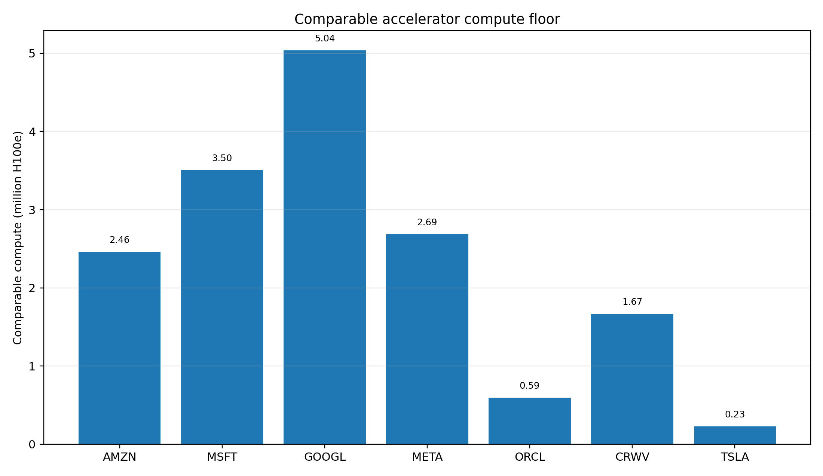
Figure 2. Reconciled current H100-equivalent compute. Sources: [S01,S04,S05,S37,S38,S47; Model].

2.1 Modeled full-fleet leadership
Owner | H100e | Accelerator TDP GW | Modeled IT GW | Modeled facility GW | Modeled mix
Alphabet / Google | 5.04M | 2.947 | 4.72 | 5.89 | NVIDIA 24%, TPU 76%
Microsoft | 3.50M | 2.065 | 3.30 | 4.13 | AMD 9%, NVIDIA 91%
Amazon / AWS | 2.46M | 1.679 | 2.69 | 3.36 | Trainium 41%, NVIDIA 59%
Meta | 2.42M | 1.408 | 2.25 | 2.82 | AMD 24%, NVIDIA 76%

Sources: [S04,S05]. IT/facility power use 1.6x and 2.0x accelerator TDP.
Google is the modeled leader at 5.04M H100e, driven by 3.81M TPU-equivalents plus 1.22M NVIDIA-equivalents. Microsoft follows at 3.50M, mostly NVIDIA. Amazon reaches 2.46M through 1.02M Trainium-equivalents and 1.44M NVIDIA-equivalents. Meta reaches 2.42M through NVIDIA and AMD. [S04,S05]

2.2 Reconciled public-company floor
Ticker | Named sites IT GW | Named sites H100e | Reconciled IT GW | Reconciled H100e | Source
AMZN | 1.74 | 1.35M | 2.69 | 2.46M | S01,S04,S05,S23,S24
MSFT | 1.57 | 1.74M | 3.30 | 3.50M | S01,S04,S05,S12,S16-S19
GOOGL | 3.30 | 4.61M | 4.72 | 5.04M | S01,S04,S05,S20-S22
META | 2.38 | 2.69M | 2.38 | 2.69M | S01,S04,S05,S27-S29
ORCL | 0.49 | 0.59M | 0.49 | 0.59M | S01,S31-S34
CRWV | 0.68 | 0.76M | 1.50 | 1.67M | S01,S37,S38; Model
TSLA | 0.00 | 0.00M | 0.20 | 0.23M | S47; Model

For Google, Microsoft and Amazon, the Q4 2025 fleet model exceeds the named-site floor, consistent with legacy and smaller-region capacity outside the database. Meta is the reverse: its later named-site floor exceeds the older chip-owner model. CoreWeave uses its disclosed 1.5 GW active power, while Tesla uses a direct cluster floor above 205 MW. [S01,S04,S05,S37,S47; Model]

3. Data-center atlas: current and target sites

3.1 Current named-site roll-up
Vendor roll-up | IT GW | H100e | Modeled replacement cost | H100e k / IT MW | Source
Alphabet / Google | 3.30 | 4.61M | $125.0B | 1.40 | S01,S02
Meta | 2.38 | 2.69M | $90.2B | 1.13 | S01,S02
Amazon / AWS | 1.74 | 1.35M | $66.0B | 0.78 | S01,S02
Microsoft | 1.57 | 1.74M | $59.4B | 1.11 | S01,S02
xAI / SpaceXAI | 0.96 | 1.12M | $36.5B | 1.17 | S01,S02
CoreWeave | 0.68 | 0.76M | $25.7B | 1.11 | S01,S02
Oracle | 0.49 | 0.59M | $18.7B | 1.20 | S01,S02
Anthropic | 0.04 | 0.06M | $1.6B | 1.40 | S01,S02

Google has the largest identifiable site floor at approximately 3.30 GW IT and 4.61M H100e. Meta has 2.38 GW and 2.69M. Amazon, including dedicated Anthropic capacity, has 1.74 GW and 1.35M. Microsoft has 1.57 GW and 1.74M including a 50 MW Nebius site attributed to dedicated supply. [S01,S02; Model roll-up]

3.2 Twenty largest current sites
Owner / customer | Site | IT MW | H100e | Modeled cost | Source
xAI / SpaceXAI | Colossus 2 | 946 | 1,112k | $35.84B | S01,S02
Amazon / Anthropic | New Carlisle | 910 | 686k | $34.47B | S01,S02
Microsoft | Fairwater Atlanta | 636 | 769k | $24.09B | S01,S02
Meta | Prometheus | 562 | 680k | $21.29B | S01,S02
Google | New Albany | 453 | 616k | $17.16B | S01,S02
Oracle / OpenAI | Stargate Abilene | 421 | 509k | $15.95B | S01,S02
Microsoft | Fairwater Wisconsin | 369 | 446k | $13.98B | S01,S02
Google | Pryor North | 368 | 763k | $13.94B | S01,S02
Google | Columbus | 303 | 409k | $11.48B | S01,S02
Amazon | Madison | 284 | 214k | $10.76B | S01,S02
CoreWeave | Denton | 262 | 253k | $9.93B | S01,S02
Google | Bristow | 238 | 239k | $9.02B | S01,S02
Google | Council Bluffs East | 237 | 289k | $8.98B | S01,S02
Google | Omaha | 237 | 268k | $8.98B | S01,S02
Google | Papillion | 237 | 80k | $8.98B | S01,S02
Amazon | Ridgeland | 228 | 171k | $8.64B | S01,S02
Amazon | New Albany | 213 | 201k | $8.07B | S01,S02
Microsoft | Goodyear | 202 | 205k | $7.65B | S01,S02
Microsoft | Project Osmium | 190 | 156k | $7.20B | S01,S02
Google | Mesa | 183 | 343k | $6.93B | S01,S02

Concentration. The five largest tracked live sites total approximately 3.51 GW IT, about 26% of the database. They span xAI, Amazon/Anthropic, Microsoft, Meta and Google. [S01; Model]

3.3 Planned and target-state roll-up
Vendor / sponsor | Target-state IT GW | Incremental IT GW | Incremental H100e | Modeled target cost | Source
OpenAI | 9.99 | 9.99 | 20.25M | $269.4B | S01,S02
Meta | 4.33 | 3.31 | 4.96M | $124.5B | S01,S02
Amazon / AWS | 4.75 | 3.01 | 2.15M | $149.8B | S01,S02
Microsoft | 2.84 | 2.47 | 4.32M | $89.2B | S01,S02
Alphabet / Google | 3.20 | 2.28 | 6.83M | $100.1B | S01,S02
QTS | 1.59 | 1.59 | 3.70M | $42.9B | S01,S02
CoreWeave | 2.09 | 1.55 | 1.15M | $55.9B | S01,S02
xAI / SpaceXAI | 2.06 | 1.12 | 0.69M | $58.0B | S01,S02
Crusoe | 0.94 | 0.94 | 1.70M | $25.5B | S01,S02
Oracle | 1.18 | 0.76 | 0.49M | $31.9B | S01,S02
Anthropic | 0.74 | 0.70 | 0.76M | $22.2B | S01,S02

The selected planned-site inventory is dominated by OpenAI/Stargate at approximately 9.99 GW of incremental target capacity, followed by Meta at 3.31 GW, Amazon at 3.01 GW, Microsoft at 2.47 GW and Google at 2.28 GW. These are target estimates and not necessarily signed. [S01,S02; Model matching]

3.4 Largest target-state campuses
Owner / sponsor | Site | Target IT MW | Incremental MW | Target H100e | Modeled cost | Source
Microsoft | Fairwater Wisconsin | 2,715 | 2,346 | 4,500k | $85.73B | S01,S02
OpenAI | Stargate New Mexico | 2,450 | 2,450 | 5,100k | $66.29B | S01,S02
Amazon / Anthropic | New Carlisle | 2,310 | 1,400 | 1,700k | $72.92B | S01,S02
Meta | Hyperion | 2,262 | 2,262 | 4,300k | $63.49B | S01,S02
xAI / SpaceXAI | Colossus 2 | 2,065 | 1,119 | 1,800k | $58.00B | S01,S02
OpenAI | Stargate Shackelford | 1,960 | 1,960 | 4,600k | $53.03B | S01,S02
QTS | Cedar Rapids | 1,587 | 1,587 | 3,700k | $42.92B | S01,S02
OpenAI | Stargate UAE | 1,400 | 1,400 | 2,000k | $37.88B | S01,S02
OpenAI | Stargate Michigan | 1,383 | 1,383 | 2,900k | $37.43B | S01,S02
OpenAI | Stargate Wisconsin | 1,300 | 1,300 | 2,600k | $34.17B | S01,S02
OpenAI | Stargate Milam | 1,200 | 1,200 | 2,500k | $32.46B | S01,S02
Oracle / OpenAI | Stargate Abilene | 1,180 | 759 | 1,000k | $31.93B | S01,S02
Meta | Prometheus | 1,110 | 548 | 1,000k | $32.35B | S01,S02
Google | Fort Wayne | 1,035 | 1,035 | 3,600k | $32.69B | S01,S02
Amazon | Ridgeland | 1,008 | 780 | 788k | $31.82B | S01,S02
Crusoe | Abilene expansion | 941 | 941 | 1,700k | $25.46B | S01,S02
Amazon | Madison | 819 | 535 | 514k | $25.87B | S01,S02
CoreWeave | Helios | 800 | 668 | 638k | $20.00B | S01,S02
CoreWeave | Ellendale | 520 | 452 | 505k | $15.15B | S01,S02
Google | Omaha | 474 | 237 | 1,100k | $14.96B | S01,S02

Targets above 2 GW IT include Microsoft Fairwater Wisconsin, OpenAI Stargate New Mexico, Amazon/Anthropic New Carlisle, Meta Hyperion and xAI Colossus 2. Epoch assigns 80% confidence intervals of roughly 1.4x for site IT power, 1.5x for compute and 1.6x for cost. [S01,S02]

4. Signed and contracted pipeline
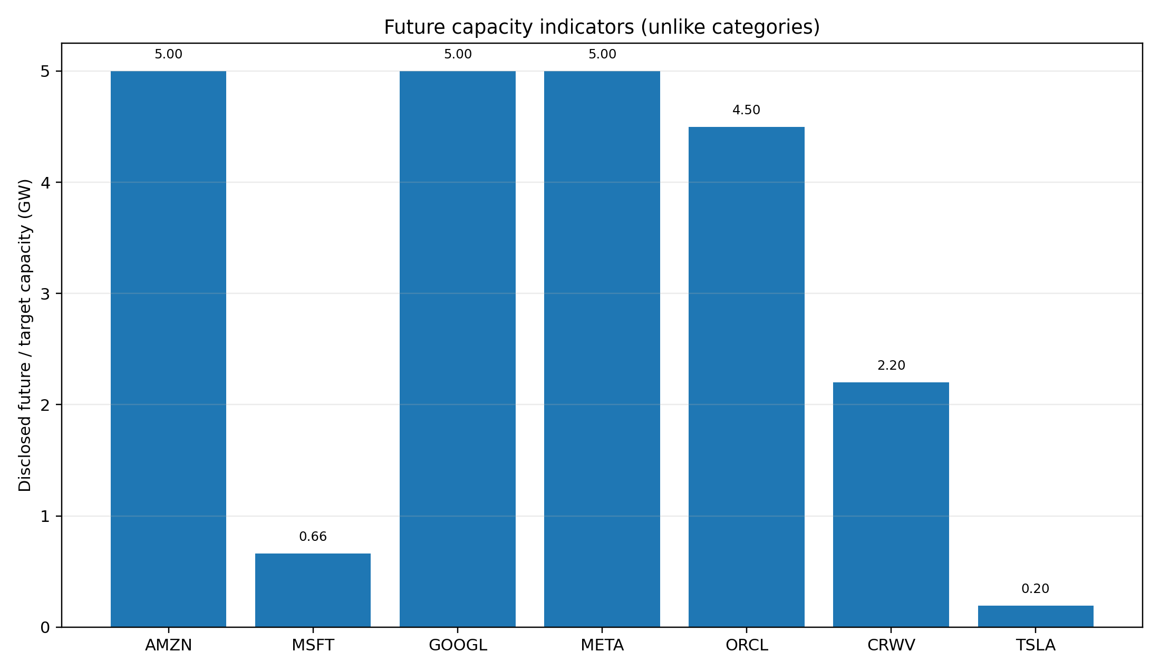
Figure 3. Future capacity indicators. Categories are not additive. Sources: [S16-S24,S28,S33,S38,S47].
Vendor | Counterparty | GW | Category | Value | Value / GW-year | Counting note | Source
Amazon / AWS | Anthropic | 5.00 | Signed / announced | $100.0B | $2.0B | Upper bound; named site targets are not additive without mapping. | S24
Alphabet / Google | Anthropic | 1.00 | Signed / announced | n/d | n/d | May be part of 5 GW program; do not sum. | S21
Alphabet / Google | Anthropic / Broadcom program | 5.00 | Signed / announced | n/d | n/d | Overlap with 2026 milestone undisclosed. | S22
Microsoft | Anthropic | 1.00 | Demand commitment | $30.0B | n/d | May be served by outsourced suppliers below; do not add. | S19
Microsoft | IREN | 0.20 | Firm supply contract | $9.7B | $9.7B | Specific outsourced capacity; $5.8B hardware capex separately. | S17
Microsoft | Nscale | 0.46 | Signed supply; partly modeled | n/d | n/d | Applies Texas MW/GPU ratio; 0.7 GW option excluded. | S16
Microsoft | Nebius | n/d | Firm supply contract | $17.4B | n/d | No defensible GW derivation. | S18
Oracle | OpenAI | 4.50 | Signed / announced | $300.0B | $13.3B | Use 4.5 GW incremental; 5.5 GW only for a rough cross-announcement ratio. | S33,S34
CoreWeave | Multiple customers | 3.70 | Company disclosed | $104.0B | n/d | Backlog duration/service mix vary. | S38
Meta | Internal demand | 5.00 | Project target | $50.0B | n/d | Not a customer contract; capacity/investment scopes may differ. | S28,S29
Tesla | Internal AI | 0.40 | Company roadmap estimate | n/d | n/d | Visual estimate; current direct cluster floor >205 MW. | S47

4.1 Amazon / Anthropic
Anthropic and Amazon announced an expansion above $100B over ten years for up to 5 GW of new AWS capacity. Nearly 1 GW of Trainium2/Trainium3 capacity is expected by end-2026, and Anthropic stated that more than one million Trainium2 chips were already in use. The hybrid ratio is above $2B/GW-year, but it is not a tariff because value is a floor, capacity an upper bound and the ramp undisclosed. [S24; Model]
Project Rainier was fully operational in June 2025 with nearly 500,000 Trainium2 chips and an expected expansion above one million. New Carlisle is the second-largest tracked live AI site at 910 MW IT. [S01,S25]

4.2 Google / Anthropic
Anthropic announced up to one million Google TPUs, tens of billions of dollars of services and well over 1 GW online in 2026. A separate announcement describes a 5 GW Google/Broadcom program beginning in 2027. Because overlap is undisclosed, this report shows 1 GW as a milestone and 5 GW as the program envelope rather than summing them. [S21,S22]

4.3 Microsoft: demand versus supply
Microsoft and Anthropic announced a $30B Azure purchase commitment and up to 1 GW of additional capacity. Separately, Microsoft contracted 200 MW IT from IREN for $9.7B over five years, approximately 200,000 GB300 GPUs from Nscale, and a $17.4B five-year GPU-services agreement with Nebius whose MW is undisclosed. Applying Nscale Texas disclosure of 240 MW for 104,000 GPUs to the total GPU count implies approximately 462 MW IT; a 700 MW option is excluded. [S16-S19; Model]
Do not double count. The 1 GW Anthropic demand commitment may be served by some combination of owned Fairwater assets and outsourced IREN, Nscale or Nebius capacity. Supply and demand rows are therefore separate. [S13-S19]

4.4 Oracle / OpenAI and CoreWeave
OpenAI announced 4.5 GW of additional Oracle capacity, bringing the Oracle-linked program above 5 GW under development and above two million chips. A linked announcement referenced more than $300B and more than 5.5 GW; dividing those values produces a rough $10.9B/GW-year over five years, but it is not a clean tariff. [S33,S34; Model]
CoreWeave disclosed 1.5 GW active and 3.7 GW contracted, so the simple incremental bridge is 2.2 GW. Its $104B backlog divided by contracted capacity is $28.1B/GW, but duration and service mix vary. [S38; Model]

5. Footnote archaeology and capital commitments
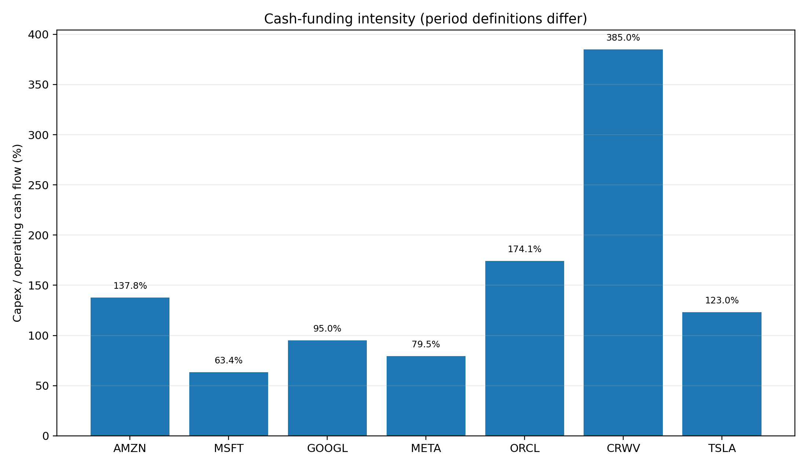
Figure 4. Capex relative to operating cash flow. Period definitions differ. Sources: [S12,S20,S23,S27,S31,S37,S47].
Ticker | Period | Capex | OCF | Capex / OCF | Net PPE | CIP / not in service | Uncommenced leases | RPO / backlog | Source
AMZN | H1 2026 / Q2 BS | $98.41B | $71.42B | 137.8% | $263.75B | n/d | $137.21B | $496.00B | S23
MSFT | FY2026 | $115.95B | $182.94B | 63.4% | $313.08B | n/d | $329.10B | $684.00B | S12
GOOGL | H1 2026 / Q2 BS | $80.60B | $84.86B | 95.0% | $321.21B | $122.81B | $85.20B | $519.50B | S20
META | H1 2026 / Q2 BS | $50.92B | $64.09B | 79.5% | $225.72B | $80.34B | $346.99B | n/d | S27
ORCL | FY2026 | $55.66B | $31.98B | 174.1% | $99.96B | $39.97B | $260.00B | $638.00B | S31,S32
CRWV | H1 2026 / Q2 BS | $14.12B | $3.66B | 385.4% | $46.74B | $11.92B | $35.50B | $104.00B | S37,S38
TSLA | Q2 2026 | $5.79B | $4.70B | 123.2% | n/d | n/d | n/d | n/d | S47

Cash capex understates asset formation when finance leases, OEM financing, prepayments or JVs fund the build. Gross obligations can overstate AI exposure because they may include fulfillment, office, content, energy and general cloud assets. [S12,S20,S23,S27,S31,S37]

5.1 Microsoft
Microsoft reported FY2026 additions to PPE of $115.948B, net PPE of $313.076B and construction commitments of $34.566B. Total disclosed obligations were $743.821B, including $443.506B of leases including interest and $194.060B of purchase commitments. Uncommenced leases, mostly data centers, were $329.1B and begin FY2027-FY2033 with 1-20 year terms. RPO was $684B. [S12]

5.2 Alphabet
Alphabet spent $80.598B of first-half capex against $84.859B of OCF. Net PPE was $321.212B, including $122.814B of assets not yet in service. Uncommenced leases were $85.2B, primarily data centers starting in 2026-2031. Purchase commitments and other obligations were $811.0B; the filing also disclosed $24.1B of estimated data-center/energy backstops and $20B of private-company capital commitments. Cloud RPO was $513.9B. [S20]

5.3 Amazon
Amazon reported $98.411B of first-half cash PPE purchases against $71.419B of OCF. AWS net PPE was $263.750B and first-half AWS net additions were $90.120B. AWS RPO was $496B with a 6.4-year average duration. Amazon disclosed $137.214B of uncommenced leases and $650.034B of total commitments, but these totals include non-data-center categories. [S23]

5.4 Meta
Meta reported first-half capex including finance-lease principal of $50.920B against $64.088B of OCF. Net PPE was $225.724B and construction in progress $80.345B. Uncommenced leases were $278.99B at quarter-end; another $68B of data-center leases signed in July took the post-period figure to $346.99B. Contractual commitments were $349.31B; the totals likely overlap and are not added. [S27]
The Blue Owl Hyperion JV is an 80/20 structure covering approximately $27B of long-lived facility assets. Blue Owl contributed approximately $7B cash, Meta received a $3B distribution and Meta leases the facilities with a 16-year residual-value guarantee. [S29]

5.5 Oracle
Oracle FY2026 capex was $55.663B against $31.977B of OCF. Customer prepayments with a financing component contributed $4.592B to OCF; short-term capex financing added $3.345B and debt issuance was $46.093B. Net PPE was $99.957B and construction in progress $39.973B. [S31]
Oracle disclosed $260B of uncommenced leases, substantially all data centers, beginning FY2027-FY2029 with 15-19 year terms and including a $3.3B lessor guarantee. Other purchase obligations were $13.309B. RPO reached $638B. [S31,S32]

5.6 CoreWeave
CoreWeave reported net PPE of $46.736B and operating-lease ROU assets of $16.595B. First-half cash PPE purchases were $14.117B, while $9.796B of PPE liabilities/OEM financing and $8.359B of ROU additions were noncash. Uncommenced leases were $35.5B; one undelivered 393 MW site carried up to $14.7B of payments over 16 years. Debt principal was $35.551B. [S37]
CoreWeave had $103.7B of unsatisfied RPO in the 10-Q and approximately $104B of reported backlog; 1.5 GW active and 3.7 GW contracted. Its three largest Q2 customers represented 36%, 26% and 10% of revenue. [S37,S38]

6. Vendor dossiers

6.1 Amazon / AWS
Metric | Value | Evidence / interpretation
Reconciled current | 2.69 GW / 2.46M | Q4 2025 model exceeds named-site floor [S01,S04,S05; Model]
Named-site floor | 1.74 GW | Includes New Carlisle 910 MW [S01]
Signed pipeline | Up to 5 GW / >$100B over 10 years | Nearly 1 GW by end-2026 [S24]
Equity | $259.77 / $2,832.3B / 20.9x | 31 Aug. 2026 [S48]

AWS has the strongest vertically integrated named anchor: customer, ten-year minimum value, up-to-5-GW envelope and in-house Trainium roadmap. Trainium is approximately 41% of modeled Amazon H100e. [S04,S05,S24,S25]
The cost is cash intensity. First-half cash PPE exceeded OCF by 38%, and AWS added $90.120B of net PPE in six months. The $15B Indiana / 2.4 GW headline is $6.25B/GW at campus/infrastructure scope, not full stack. [S23,S26; Model]
Stock implication. At 20.9x, Amazon is not the most expensive hyperscaler despite the 5 GW anchor. The key test is whether Trainium lowers delivered cost enough to offset near-term negative free cash flow and whether the Anthropic ramp fills assets before refresh. [S23-S25,S48]

6.2 Microsoft
Metric | Value | Evidence / interpretation
Reconciled current | 3.30 GW / 3.50M | Q4 2025 owner model [S04,S05; Model]
Named-site floor | 1.57 GW | Fairwater and other sites [S01,S13-S15]
Firm supplier capacity | Approximately 0.662 GW plus Nebius undisclosed | IREN 200 MW; Nscale modeled 462 MW [S16-S18]
Equity | $507.29 / $3,776.8B / 30.2x | 31 Aug. 2026 [S48]

Microsoft combines a large owned fleet with a broad outsourced network. IREN, Nscale and Nebius shift some construction, power and hardware financing to suppliers while reserving capacity for Azure. [S13-S18]
The benefit is speed and diversification; the cost is margin sharing and a complex stack. Microsoft had $329.1B of mostly data-center uncommenced leases and $743.821B of obligations, alongside $684B of RPO. [S12]
Stock implication. Microsoft has the best broad cloud demand visibility but trades at 30.2x, the highest P/E among the four hyperscalers. Its premium requires disciplined economics across owned and outsourced capacity. [S12,S16-S19,S48]

6.3 Alphabet / Google
Metric | Value | Evidence / interpretation
Reconciled current | 4.72 GW / 5.04M | Largest modeled fleet [S04,S05; Model]
Named-site floor | 3.30 GW | Largest site roll-up [S01]
Pipeline | 5 GW program from 2027; >1 GW 2026 milestone | Overlap undisclosed [S21,S22]
Equity | $339.35 / $4,150.3B / 17.0x | 31 Aug. 2026 [S48]

Google is the compute leader under both the chip-owner model and the site floor. Approximately 76% of modeled H100e comes from TPUs, creating the strongest custom-silicon position. H100e does not capture TPU workload fit or fungibility. [S01,S04,S05]
Alphabet has $122.814B of assets not in service, versus $247.177B of technical infrastructure in service. Cloud RPO is $513.9B, while the $811B broad commitment total makes the forward envelope less transparent. [S20]
Stock implication. Google combines the largest modeled compute base with the lowest P/E of the four hyperscalers at 17.0x. This is the strongest headline compute-to-valuation setup, subject to sustained TPU utilization. [S04,S05,S20,S48]

6.4 Meta
Metric | Value | Evidence / interpretation
Reconciled current | 2.38 GW / 2.69M | Named-site floor exceeds older model [S01,S04,S05]
Named-site floor | 2.38 GW | Prometheus 562 MW is largest [S01]
Target | Hyperion 5 GW / >$50B regional investment | Internal target [S28]
Equity | $572.34 / $1,468.6B / 21.6x | 31 Aug. 2026 [S48]

Meta monetizes compute through recommendation, advertising and model capability rather than external cloud contracts. There is no independently priced tariff to validate unit economics. [S27,S28]
The balance-sheet strategy mixes direct construction, leases and Blue Owl JV financing. The raw $27B / 5 GW = $5.4B/GW ratio covers long-lived facilities, not servers, and scope/timing are mismatched. [S28,S29; Model]
Stock implication. Meta trades at 21.6x with strong ads cash generation, but post-period uncommenced leases equal 23.6% of market cap. Investors underwrite internal monetization plus long-lived lease and residual commitments. [S27-S29,S48; Model]

6.5 Oracle
Metric | Value | Evidence / interpretation
Current named-site floor | 0.49 GW / 0.59M | Abilene and Batam [S01]
Signed pipeline | 4.5 GW additional Oracle/OpenAI | >5 GW including Abilene under development [S33]
RPO / market cap | 146.9% | $638.0B RPO / $434.2B market cap [S32,S48; Model]
Equity | $149.12 / $434.2B / 26.8x | 31 Aug. 2026 [S48]

Oracle has the most concentrated public AI demand bet. The OpenAI program adds 4.5 GW and a linked >$300B commitment, creating exceptional visibility and exceptional sensitivity to execution and financing. [S31-S34]
FY2026 capex was 174% of OCF. Customer prepayments and debt funded the build, while $260B of uncommenced data-center leases equals approximately 60% of market cap. [S31,S48; Model]
Stock implication. Oracle offers the highest upside torque if capacity comes online on time and RPO converts at attractive margins, and the sharpest downside if power, construction, customer timing or financing moves adversely. [S31-S34,S48]

6.6 CoreWeave
Metric | Value | Evidence / interpretation
Active / contracted | 1.5 GW / 3.7 GW | 2.2 GW simple incremental [S38; Model]
Modeled current | 1.67M H100e | Active power times observed density [S01,S38; Model]
Backlog / market cap | 222.3% | $104.0B / $46.8B [S38,S48; Model]
Equity | $84.89 / $46.8B / P/E n/m | 31 Aug. 2026 [S48]

CoreWeave is the purest public compute exposure; its landlord network reveals powered-shell pricing that hyperscaler filings obscure. [S37-S46]
Debt and uncommenced leases each equal roughly three-quarters of market cap; net PPE approximates market cap; and three customers represented 72% of Q2 revenue. Short hardware life amplifies utilization and renewal risk. [S37,S38,S48; Model]
Stock implication. Backlog can drive rapid revenue growth, but market cap per current IT GW of $31.2B is meaningful only after recognizing debt, leases, refresh capex and customer concentration. [S37,S38,S48; Model]

6.7 Tesla
Metric | Value | Evidence / interpretation
Current cluster floor | >205 MW | Cortex 1 >90 MW; Cortex 2 >115 MW [S47]
Comparable compute | >230k H100e | Company roadmap-equivalent [S47]
Near-term target | Approximately 400 MW by Dec. 2026 | Visual estimate, not a cloud contract [S47; Model]
Equity | $367.95 / $1,302.5B / 340.7x | 31 Aug. 2026 [S48]

Tesla compute supports autonomy, robotics and model development; it is not sold as general-purpose cloud. Q2 company-wide capex of $5.789B exceeded OCF of $4.697B, but compute is only one capital use. [S47]
At $37.883B/GW, 205 MW implies approximately $7.8B of replacement capex, below 1% of market cap. A 400 MW target is approximately $15.2B, around 1.2% of market cap. [S03,S47,S48; Model]
Stock implication. Tesla's market cap per current IT GW exceeds $6.3T, demonstrating the limitation of asset comparisons. Compute is an enabling strategic option rather than primary asset backing. [S47,S48; Model]

7. Counterparty chain and market pricing
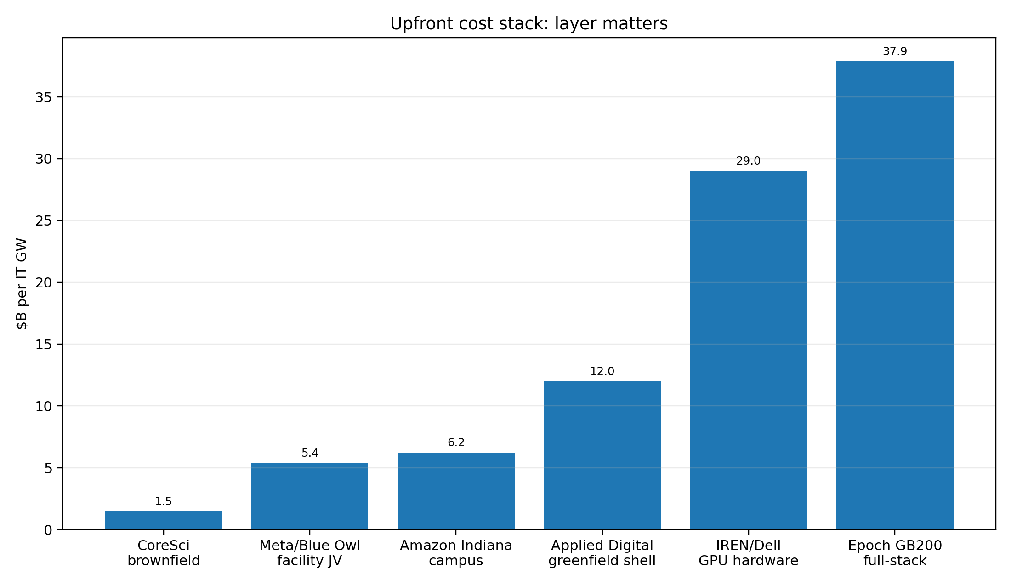
Figure 5. Upfront cost layers per comparable IT GW. Sources: [S03,S17,S26,S28,S29,S40,S46; Model].
Hyperscaler filings aggregate data centers with broader PPE and commitments. Counterparty disclosures provide the missing denominator: critical IT MW, term, contract value, power pass-through and buildout responsibility. [S16-S19,S29,S37,S39-S46]

7.1 Powered-shell lease market
Benchmark | MW | Years | Value | Annual $B/GW | $/kW-month | Power | Source
Core Scientific / CoreWeave | 590 | 12 | $10.20B | $1.44B | $120 | No | S39,S40
Applied Digital / CoreWeave 400 MW | 400 | 15 | $11.00B | $1.83B | $153 | Pass-through | S43,S46
Applied Digital 200 MW AI factory | 200 | 15 | $5.00B | $1.67B | $139 | Pass-through | S44
Galaxy Helios / CoreWeave | 526 | 15 | $15.00B | $1.90B | $158 | No / pass-through | S42
CoreWeave significant undelivered site | 393 | 16 | $14.70B | $2.34B | $195 | Unclear | S37

The disclosed powered-shell range is approximately $120-$195/kW-month, or $1.44B-$2.34B/GW-year, generally excluding tenant GPU hardware and often passing through electricity. [S37,S39-S44; Model]

7.2 Full service and customer commitments
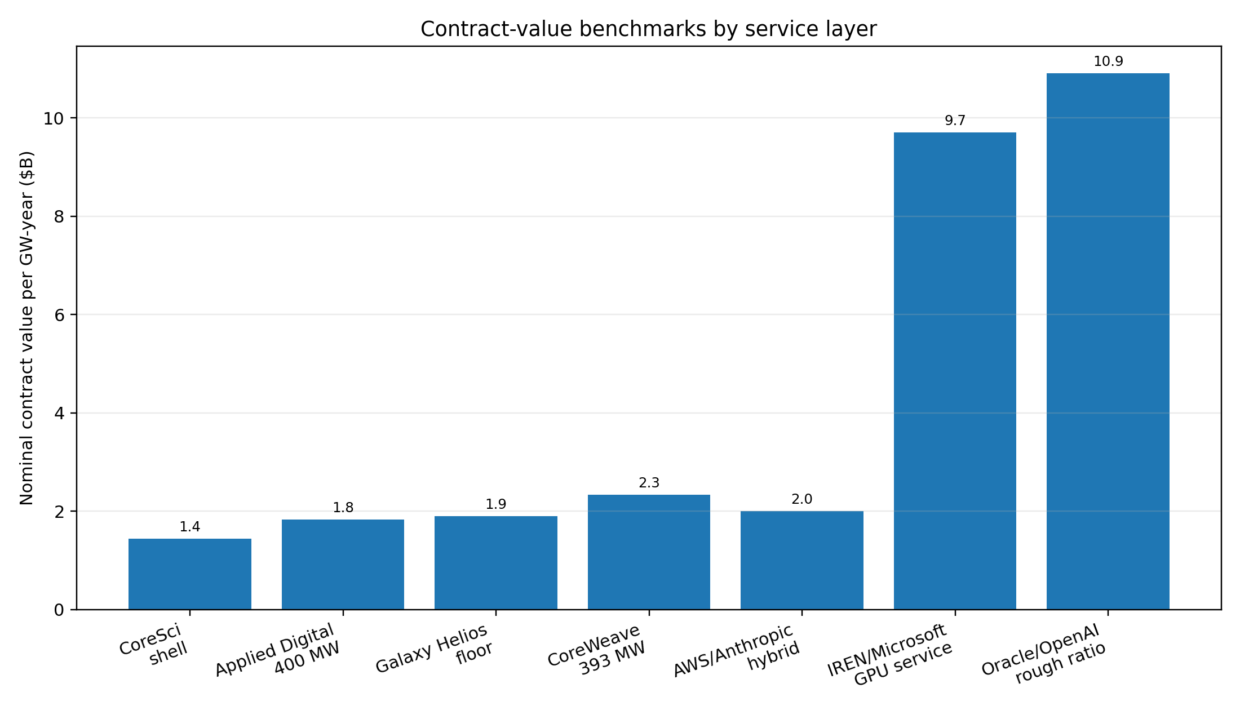
Figure 6. Contract-value benchmarks per GW-year. Sources: [S17,S24,S33,S34,S37,S39-S44; Model].
IREN's 200 MW Microsoft contract is approximately $808/kW-month and $9.7B/GW-year for a full GPU service, versus $29B/GW of separately disclosed Dell hardware capex. The spread over powered-shell pricing reflects accelerators, refresh, operations, financing and service margin. [S17; Model]
A rough Oracle/OpenAI cross-announcement ratio is $10.9B/GW-year, slightly above the $8.514B/GW annual TCO reference. It is illustrative because the numerator and denominator come from linked rather than identical disclosures. [S03,S33,S34; Model]

7.3 Financing migration
Buyer / tenant | Counterparties | Structure | Benefit | Residual risk
Microsoft | IREN / Nscale / Nebius | Supplier funds sites and/or GPUs; Microsoft buys capacity | Speed and optionality | Supplier margin and long commitments [S16-S18]
Meta | Blue Owl JV | JV owns long-lived facility assets; Meta leases all capacity | Shared construction capital | Lease and residual guarantee remain [S29]
CoreWeave | Core Scientific / Galaxy / Applied Digital | Landlords build shells; CoreWeave finances IT | Critical-MW denominators disclosed | Debt/lease and utilization risk at tenant [S37,S39-S46]
Oracle | OpenAI prepayments / debt / lessors | Customer financing and debt support build | RPO and funding visibility | Counterparty concentration and long leases [S31-S34]

8. One-GW cost curves

8.1 Published base case
Component | Upfront | Annualized / opex
Servers | $21.188B | $5.021B
Facility | $11.433B | $1.387B
Network | $4.925B | $1.167B
Land | $0.172B | $0.013B
Utility interconnect | $0.164B | $0.020B
Energy | - | $0.594B
Taxes / maintenance / labor / water / other | - | $0.312B
Total | $37.883B | $8.514B

Epoch AI one-GW GB200-class model [S03]. Five-year IT life and 14-year facility life.
Servers and network are 69% of upfront cost and about 73% of annualized TCO. Extending useful IT life from three to seven years lowers annual TCO from approximately $12B to $7B/GW; hardware refresh dominates land and power. [S03]

8.2 Utilization and refresh
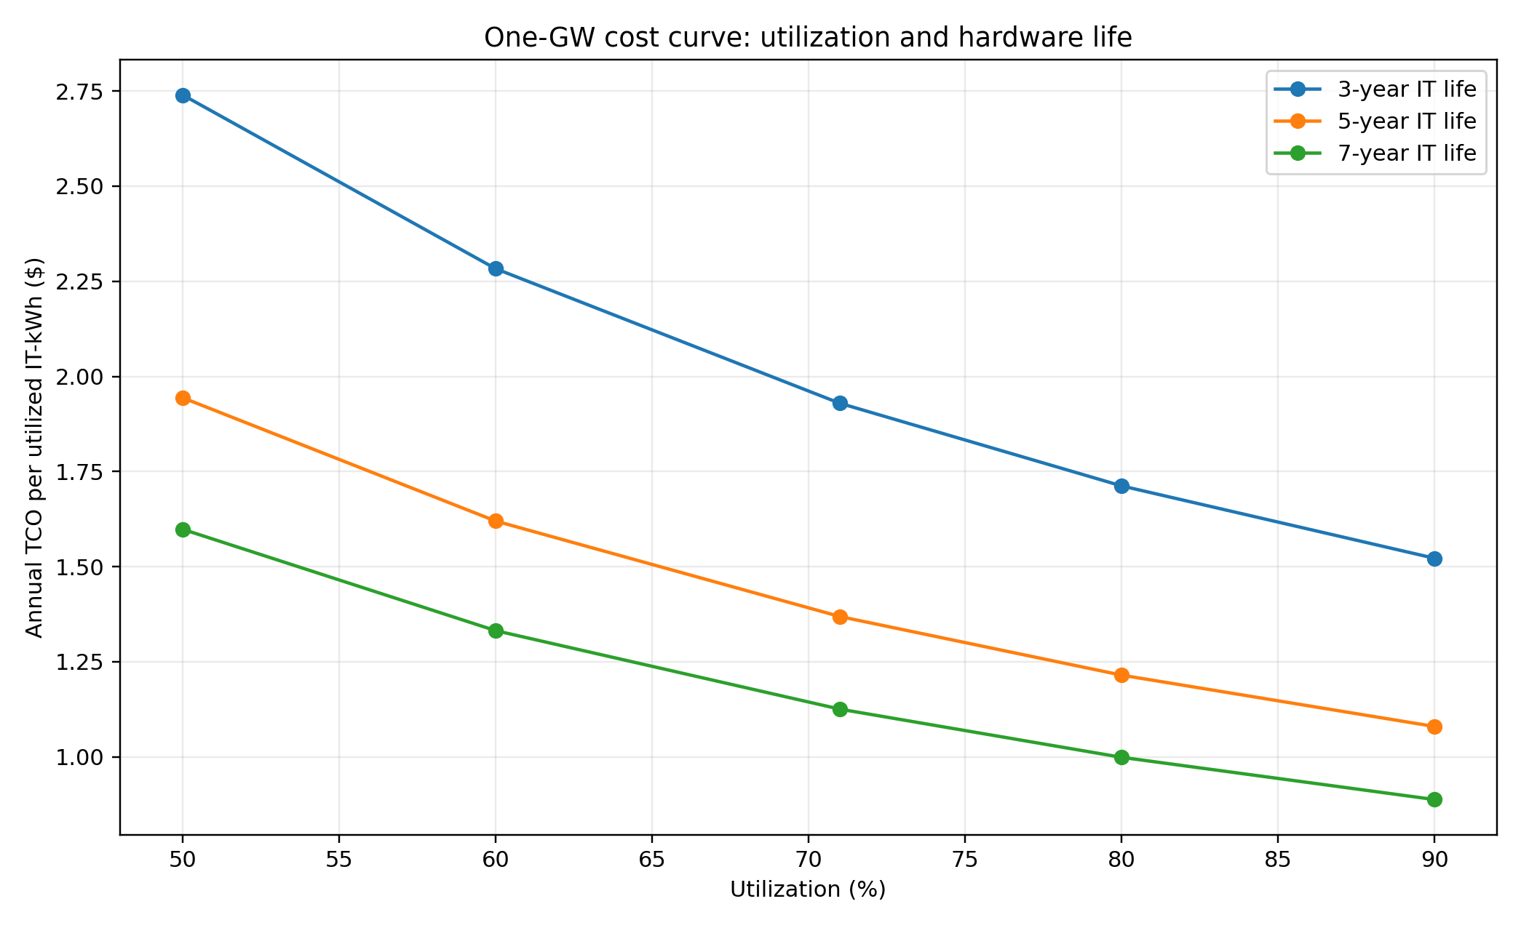
Figure 7. Cost per utilized IT-kWh versus utilization and IT asset life. [S03; Model].
Utilization | 5-year cost / utilized IT-kWh | 5-year cost / H100e-hour | Price for 25% operating margin
50.0% | $1.94 | $1.41 | $1.88
60.0% | $1.62 | $1.18 | $1.57
71.0% | $1.37 | $0.99 | $1.32
80.0% | $1.21 | $0.88 | $1.18
90.0% | $1.08 | $0.78 | $1.04

At 71% utilization, the base model costs approximately $1.37 per utilized IT-kWh and $0.99 per GB200-density H100e-hour. A 25% operating margin requires approximately $1.32/H100e-hour before corporate SG&A, taxes and financing. [S03,S09-S11; Model]

8.3 Power-price sensitivity
Electricity rate | Annual energy | Annual TCO | Cost / utilized IT-kWh
$0.0500 | $0.37B | $8.29B | $1.33
$0.0834 | $0.62B | $8.54B | $1.37
$0.1200 | $0.90B | $8.82B | $1.42
$0.2000 | $1.49B | $9.41B | $1.51

Raising electricity from $0.05 to $0.20/kWh increases annual TCO by approximately $1.12B/GW at 71% utilization and 1.20 PUE. Changing IT asset life from seven to three years changes annual TCO by approximately $5B. [S03; Model]

8.4 Price-to-cost reading
Layer / example | Price | Interpretation
Powered shell | $1.4B-$2.3B/GW-year | Add electricity, IT hardware, operations and financing [S37,S39-S44; Model]
Full GPU service - IREN/Microsoft | $9.7B/GW-year | Approximately 14% above $8.514B base TCO before corporate costs [S03,S17; Model]
Oracle/OpenAI rough ratio | $10.9B/GW-year | Approximately 28% above base TCO; cross-announcement [S03,S33,S34; Model]
Amazon/Anthropic hybrid | >$2.0B/GW-year | Minimum value divided by maximum capacity; not comparable [S24; Model]

9. Equity-market implications
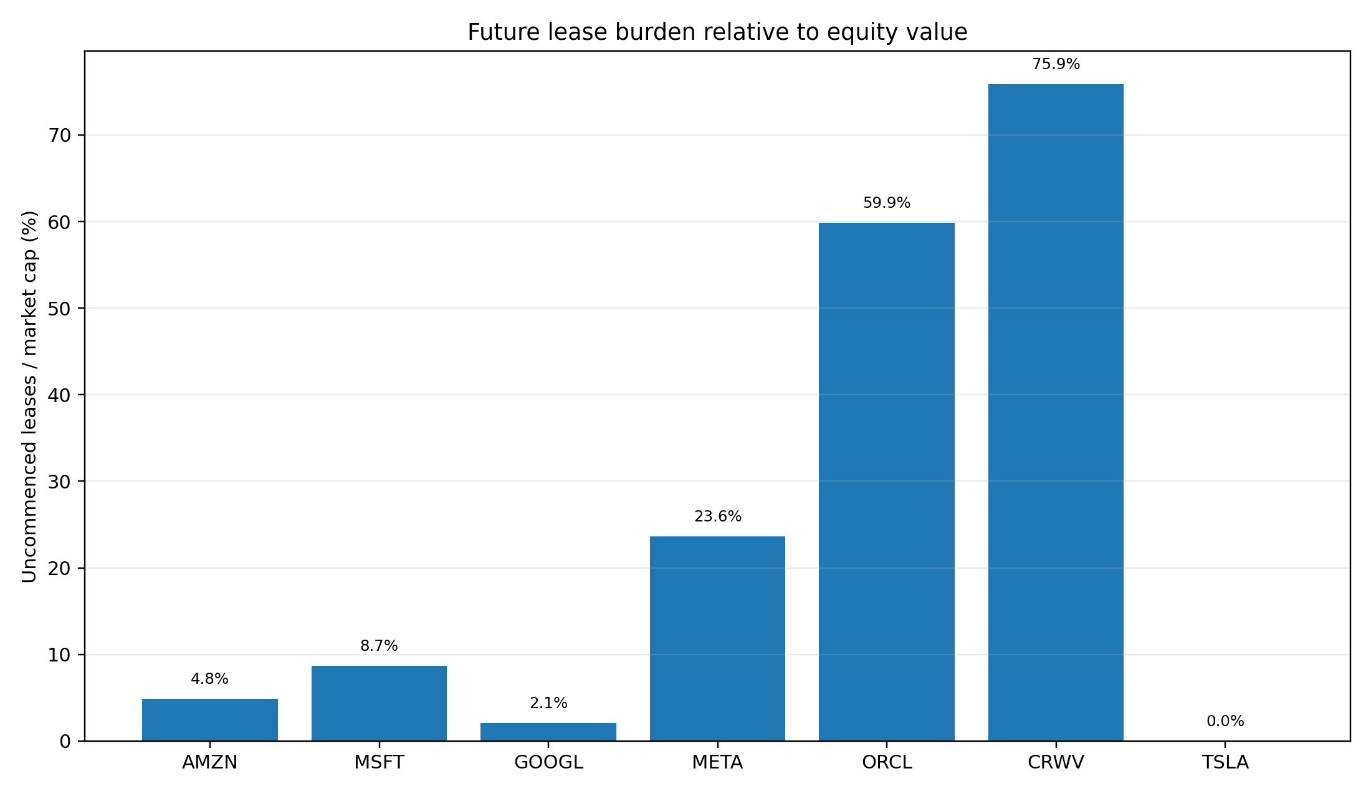
Figure 8. Uncommenced leases relative to market capitalization. [S12,S20,S23,S27,S31,S37,S48; Model].
Ticker | Close | Market cap | P/E | Current IT GW | MCap / IT GW | MCap / H100e | 1 GW capex / MCap | RPO / MCap
AMZN | $259.77 | $2,832.3B | 20.9x | 2.69 | $1,054.3B | $1,151,142 | 1.3% | 17.5%
MSFT | $507.29 | $3,776.8B | 30.2x | 3.30 | $1,143.1B | $1,077,706 | 1.0% | 18.1%
GOOGL | $339.35 | $4,150.3B | 17.0x | 4.72 | $880.2B | $823,819 | 0.9% | 12.5%
META | $572.34 | $1,468.6B | 21.6x | 2.38 | $616.6B | $546,567 | 2.6% | n/d
ORCL | $149.12 | $434.2B | 26.8x | 0.49 | $880.8B | $731,039 | 8.7% | 146.9%
CRWV | $84.89 | $46.8B | n/d | 1.50 | $31.2B | $28,009 | 81.0% | 222.3%
TSLA | $367.95 | $1,302.5B | 340.7x | 0.20 | $6,353.9B | $5,663,230 | 2.9% | n/d

Market data [S48]; compute and RPO [S01,S04,S05,S12,S20,S23,S27,S31,S32,S37,S38,S47; Model].
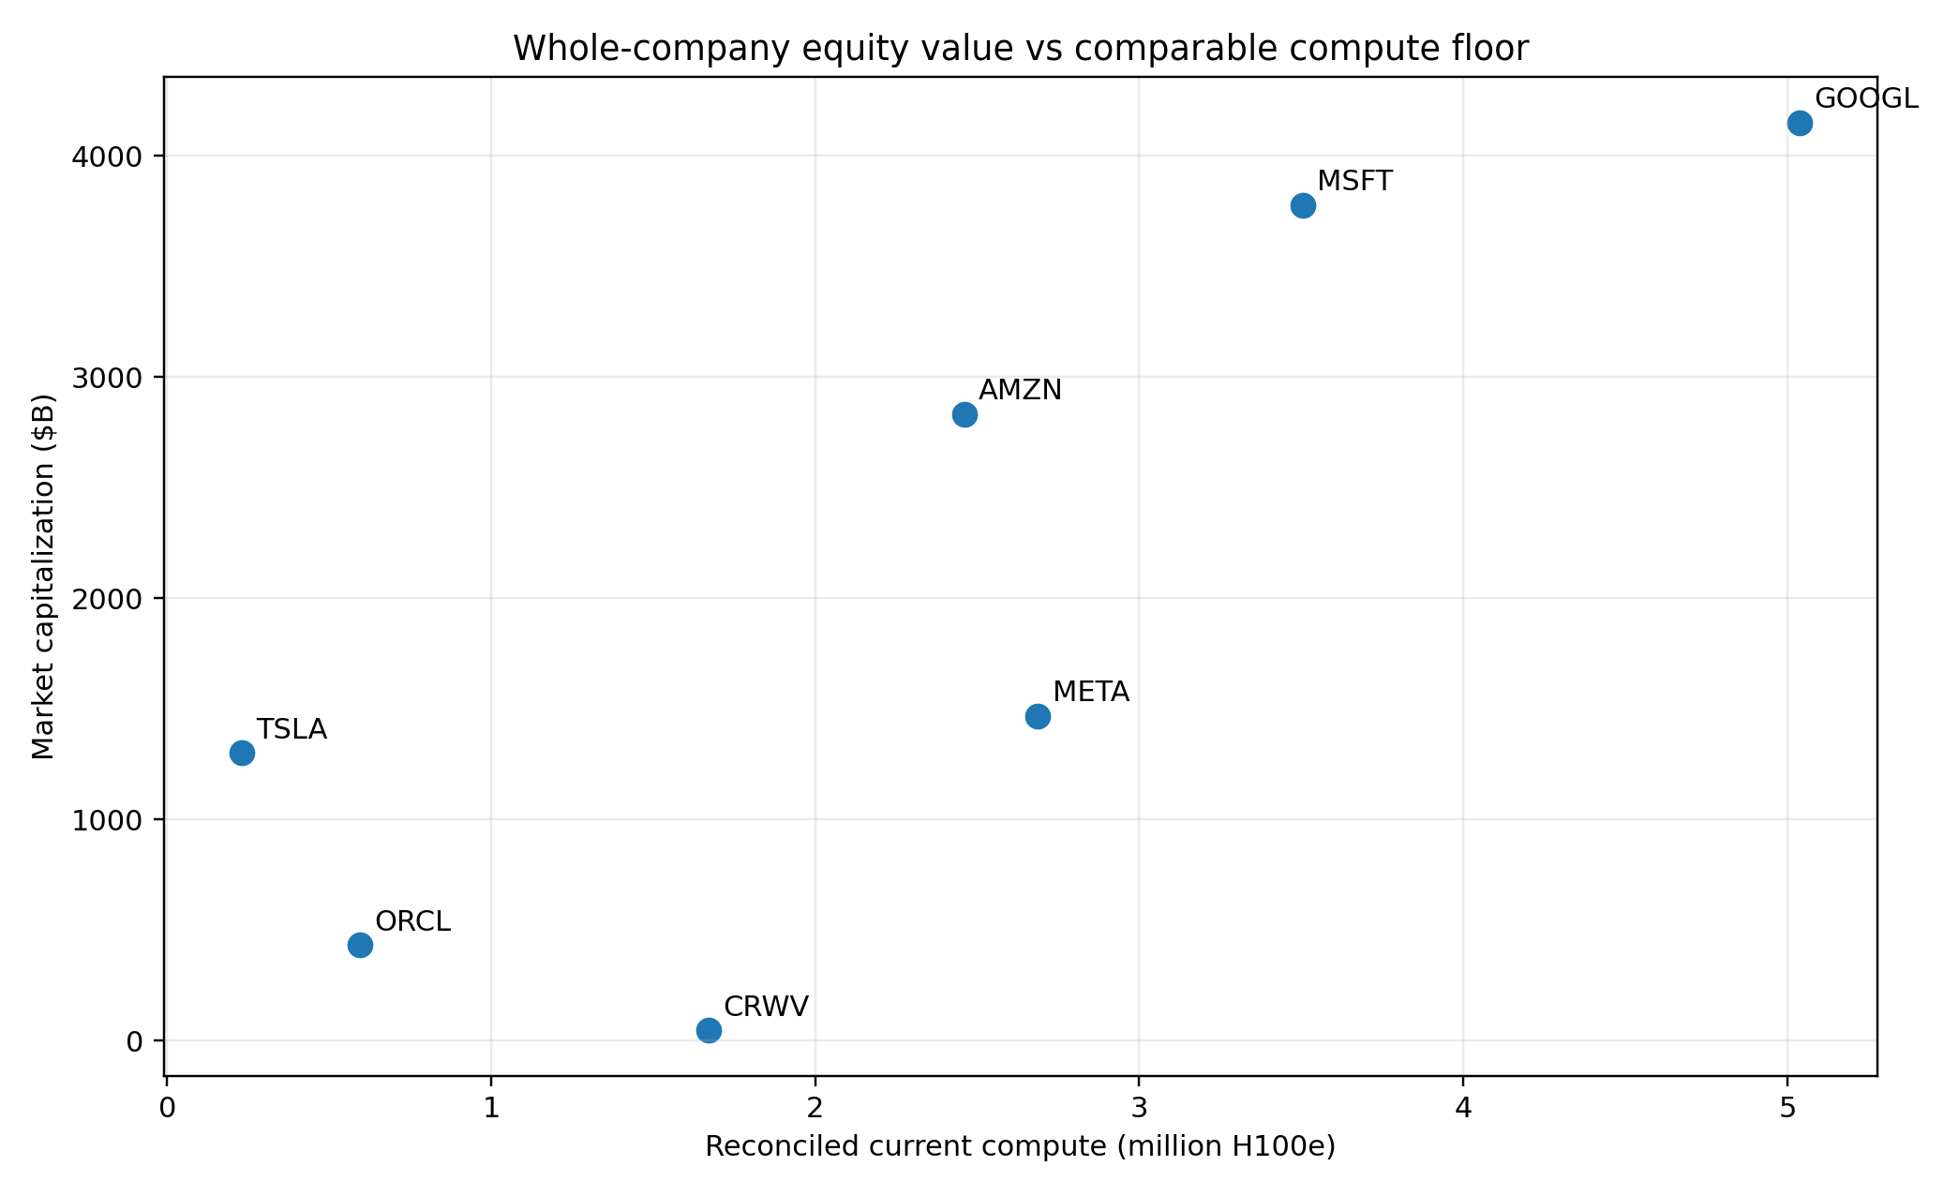
Figure 9. Whole-company equity value versus compute floor; not a data-center appraisal. [S01,S04,S05,S37,S47,S48; Model].

9.1 Hyperscalers
Alphabet has the best headline combination: the largest modeled compute fleet and the lowest P/E among Amazon, Microsoft, Alphabet and Meta. Market cap per H100e is approximately $824,000, versus $1.08M for Microsoft and $1.15M for Amazon. Meta is lower at about $547,000 because its site floor is large relative to market cap, but capacity is internally monetized. [S01,S04,S05,S48; Model]
Microsoft deserves a premium for RPO visibility and enterprise distribution, but its 30.2x P/E and $329.1B uncommenced leases require strong utilization. Amazon has a lower 20.9x P/E and the strongest explicit vertical anchor but weaker near-term cash conversion. Meta's ads cash flows fund the build, while lease and residual commitments make its capital structure less asset-light than headline capex suggests. [S12,S23,S27,S48]

9.2 Oracle and CoreWeave
One modeled installed GW equals 8.7% of Oracle market cap and 81.0% of CoreWeave market cap, versus approximately 0.9%-2.6% for the hyperscalers. Incremental capacity therefore has much greater equity beta at Oracle and CoreWeave. [S03,S31,S37,S48; Model]
Oracle RPO is 147% of market cap and CoreWeave backlog 222%; these are exceptional demand indicators. Oracle uncommenced leases are approximately 60% of market cap, while CoreWeave debt and uncommenced leases are each approximately 76%. [S31,S32,S37,S38,S48; Model]

9.3 Scorecard
Ticker | Primary thesis | Demand / compute support | Funding / execution risk | Key variable
GOOGL | Compute leader / value | High | Moderate | TPU utilization and opaque commitments
MSFT | Demand visibility / premium | High | Moderate-high | Premium multiple and outsourced margin
AMZN | Custom silicon / anchor demand | High | Moderate | Cash conversion and ramp
META | Internal AI monetization | Medium-high | Moderate-high | No external price validation; leases/JV
ORCL | Highest contracted torque | Very high | Very high | Funding, customer and delivery concentration
CRWV | Pure-play compute beta | Very high | Very high | Debt, leases, concentration and refresh
TSLA | Strategic optionality | Low as asset support | High valuation sensitivity | AI outcomes beyond physical capacity

Research conclusion. GOOGL has the strongest current compute-to-valuation profile; MSFT the best broad cloud visibility; AMZN the strongest vertically integrated named anchor; META a strong funding engine without external tariff validation; ORCL the highest upside and financing torque; CRWV the purest and most levered public compute claim; TSLA compute is strategic option value rather than asset support. [S01-S05,S12,S20,S23,S27,S31-S38,S47,S48; Model]

10. Risks, uncertainty and what would change the conclusions
Risk | Why it matters
Coverage risk | The site database estimates 46% global coverage; older, smaller and undisclosed sites are missing. [S01,S02]
Overlap risk | Customer demand, supplier contracts and targets can describe the same capacity. [S16-S24,S33,S38]
Technology risk | H100e omits memory, interconnect, software and workload fit. TPU/Trainium economics may not translate cleanly. [S05-S11]
Power convention risk | A disclosed GW may be TDP, IT load, facility draw or utility interconnect. [S01,S02,S05]
Utilization risk | Cost per useful compute rises rapidly at low utilization. Contract announcements do not disclose steady-state use. [S03; Model]
Asset-life risk | Three-year versus seven-year IT life changes annual one-GW TCO by about $5B. [S03]
Accounting risk | Capex, ROU additions, leases, commitments, prepayments and JVs allocate the same build differently. [S12,S20,S23,S27,S31,S37]
Counterparty risk | OpenAI and Anthropic anchor large pipelines; CoreWeave customers are concentrated. [S19,S21,S24,S33,S37,S38]
Market risk | Share prices and multiples are point-in-time at 31 August 2026. [S48]

The most useful future disclosures would be accelerator and IT MW by generation; active versus reserved capacity; lease starts by site; customer ramp and utilization; power pass-through; refresh responsibility; and cloud gross margin after depreciation and financing. Until then, ranges and layer-specific comparisons are more defensible than single-point fleet values.

Appendix A. Normalization detail
Platform | GPUs/sys | System kW | Ext. OH | PUE | H100e/GPU | IT kW/GPU | Physical/IT GW | H100e/IT GW | Physical/facility GW | H100e/facility GW | Source | Notes
H100 (DGX H100) | 8 | 10.2 | 15.0% | 1.20 | 1.00 | 1.466 | 682,012 | 682,012 | 568,343 | 568,343 | S05,S06 | H100e baseline; 15% external network/storage overhead is modeled.
H200 | 8 | 10.2 | 15.0% | 1.20 | 1.00 | 1.466 | 682,012 | 682,012 | 568,343 | 568,343 | S05,S06 | Compute-only H100e treats H200 near H100; memory advantage is not captured.
B100 (modeled air-cooled envelope) | 8 | 10.2 | 15.0% | 1.20 | 1.77 | 1.466 | 682,012 | 1,206,186 | 568,343 | 1,005,155 | S05,S06,S09 | Uses H100 DGX power envelope as explicit approximation; dense-equivalent FP8 ratio.
B200 (DGX B200) | 8 | 14.3 | 15.0% | 1.20 | 2.27 | 2.056 | 486,470 | 1,106,172 | 405,392 | 921,810 | S05,S07,S08 | Eight-GPU DGX B200; 15% external network/storage overhead modeled.
GB200 NVL72 | 72 | 120.0 | 10.0% | 1.18 | 2.53 | 1.833 | 545,455 | 1,378,106 | 462,250 | 1,167,887 | S05,S09,S10,S11 | 120 kW rack plus 10% external overhead; dense FP8 equivalent.

Formula: IT kW/GPU = system kW / GPUs per system x (1 + external overhead). Facility values divide by PUE. B100 power uses an explicit H100-compatible air-cooled approximation. [S05-S11; Model]

Appendix B. Current site-level table
Vendor roll-up | Owner / customer | Site | IT MW | H100e | Modeled cost | H100e k / IT MW | Cost basis | Source
Alphabet / Google | Google | New Albany | 453 | 616k | $17.16B | 1.36 | Epoch modeled full-stack replacement capex | S01,S02
Alphabet / Google | Google | Pryor North | 368 | 763k | $13.94B | 2.07 | Epoch modeled full-stack replacement capex | S01,S02
Alphabet / Google | Google | Columbus | 303 | 409k | $11.48B | 1.35 | Epoch modeled full-stack replacement capex | S01,S02
Alphabet / Google | Google | Bristow | 238 | 239k | $9.02B | 1.01 | Epoch modeled full-stack replacement capex | S01,S02
Alphabet / Google | Google | Council Bluffs East | 237 | 289k | $8.98B | 1.22 | Epoch modeled full-stack replacement capex | S01,S02
Alphabet / Google | Google | Omaha | 237 | 268k | $8.98B | 1.13 | Epoch modeled full-stack replacement capex | S01,S02
Alphabet / Google | Google | Papillion | 237 | 80k | $8.98B | 0.34 | Epoch modeled full-stack replacement capex | S01,S02
Alphabet / Google | Google | Mesa | 183 | 343k | $6.93B | 1.87 | Epoch modeled full-stack replacement capex | S01,S02
Alphabet / Google | Google | Storey | 161 | 154k | $6.10B | 0.95 | Epoch modeled full-stack replacement capex | S01,S02
Alphabet / Google | Google | The Dalles | 154 | 202k | $5.83B | 1.31 | Epoch modeled full-stack replacement capex | S01,S02
Alphabet / Google | Google | Lincoln | 141 | 288k | $5.34B | 2.04 | Epoch modeled full-stack replacement capex | S01,S02
Alphabet / Google | Google | Lancaster | 137 | 130k | $5.19B | 0.95 | Epoch modeled full-stack replacement capex | S01,S02
Alphabet / Google | Google | Kansas City East | 105 | 245k | $3.98B | 2.33 | Epoch modeled full-stack replacement capex | S01,S02
Alphabet / Google | Google | Midlothian | 103 | 191k | $3.90B | 1.85 | Epoch modeled full-stack replacement capex | S01,S02
Alphabet / Google | Google | Waltham Cross | 88 | 124k | $3.33B | 1.41 | Epoch modeled full-stack replacement capex | S01,S02
Alphabet / Google | Google | Arcola | 77 | 157k | $2.92B | 2.04 | Epoch modeled full-stack replacement capex | S01,S02
Alphabet / Google | Google | Red Oak | 77 | 108k | $2.92B | 1.40 | Epoch modeled full-stack replacement capex | S01,S02
Amazon / AWS | Amazon / Anthropic | New Carlisle | 910 | 686k | $34.47B | 0.75 | Epoch modeled full-stack replacement capex | S01,S02
Amazon / AWS | Amazon | Madison | 284 | 214k | $10.76B | 0.75 | Epoch modeled full-stack replacement capex | S01,S02
Amazon / AWS | Amazon | Ridgeland | 228 | 171k | $8.64B | 0.75 | Epoch modeled full-stack replacement capex | S01,S02
Amazon / AWS | Amazon | New Albany | 213 | 201k | $8.07B | 0.94 | Epoch modeled full-stack replacement capex | S01,S02
Amazon / AWS | Amazon | Berwick | 108 | 81k | $4.09B | 0.75 | Epoch modeled full-stack replacement capex | S01,S02
Anthropic | Anthropic / Fluidstack | Lake Mariner | 42 | 59k | $1.59B | 1.40 | Epoch modeled full-stack replacement capex | S01,S02
CoreWeave | CoreWeave | Denton | 262 | 253k | $9.93B | 0.96 | Epoch modeled full-stack replacement capex | S01,S02
CoreWeave | CoreWeave | Helios | 132 | 160k | $5.00B | 1.21 | Epoch modeled full-stack replacement capex | S01,S02
CoreWeave | CoreWeave | Chester | 82 | 88k | $3.11B | 1.08 | Epoch modeled full-stack replacement capex | S01,S02
CoreWeave | CoreWeave | Ellendale | 68 | 94k | $2.58B | 1.38 | Epoch modeled full-stack replacement capex | S01,S02
CoreWeave | CoreWeave | Marble | 65 | 79k | $2.46B | 1.21 | Epoch modeled full-stack replacement capex | S01,S02
CoreWeave | CoreWeave | Norway | 42 | 51k | $1.59B | 1.21 | Epoch modeled full-stack replacement capex | S01,S02
CoreWeave | CoreWeave | Dalton 1 & 2 | 28 | 32k | $1.06B | 1.15 | Epoch modeled full-stack replacement capex | S01,S02
Meta | Meta | Prometheus | 562 | 680k | $21.29B | 1.21 | Epoch modeled full-stack replacement capex | S01,S02
Meta | Meta / QTS | Hillsboro 2 | 180 | 124k | $6.82B | 0.69 | Epoch modeled full-stack replacement capex | S01,S02
Meta | Meta | Jeffersonville | 178 | 203k | $6.74B | 1.14 | Epoch modeled full-stack replacement capex | S01,S02
Meta | Meta | Rosemount | 178 | 216k | $6.74B | 1.21 | Epoch modeled full-stack replacement capex | S01,S02
Meta | Meta | Montgomery | 153 | 174k | $5.80B | 1.14 | Epoch modeled full-stack replacement capex | S01,S02
Meta | Meta | Cheyenne | 152 | 173k | $5.76B | 1.14 | Epoch modeled full-stack replacement capex | S01,S02
Meta | Meta | Kuna | 152 | 173k | $5.76B | 1.14 | Epoch modeled full-stack replacement capex | S01,S02
Meta | Meta | Temple | 152 | 173k | $5.76B | 1.14 | Epoch modeled full-stack replacement capex | S01,S02
Meta | Meta | Huntsville | 146 | 167k | $5.53B | 1.14 | Epoch modeled full-stack replacement capex | S01,S02
Meta | Meta | Aiken | 142 | 162k | $5.38B | 1.14 | Epoch modeled full-stack replacement capex | S01,S02
Meta | Meta | Eagle Mountain | 133 | 151k | $5.04B | 1.14 | Epoch modeled full-stack replacement capex | S01,S02
Meta | Meta | Gallatin | 87 | 100k | $3.30B | 1.14 | Epoch modeled full-stack replacement capex | S01,S02
Meta | Meta | Los Lunas | 87 | 100k | $3.30B | 1.14 | Epoch modeled full-stack replacement capex | S01,S02
Meta | Meta | Sarpy | 80 | 92k | $3.03B | 1.15 | Epoch modeled full-stack replacement capex | S01,S02
Microsoft | Microsoft | Fairwater Atlanta | 636 | 769k | $24.09B | 1.21 | Epoch modeled full-stack replacement capex | S01,S02
Microsoft | Microsoft | Fairwater Wisconsin | 369 | 446k | $13.98B | 1.21 | Epoch modeled full-stack replacement capex | S01,S02
Microsoft | Microsoft | Goodyear | 202 | 205k | $7.65B | 1.02 | Epoch modeled full-stack replacement capex | S01,S02
Microsoft | Microsoft | Project Osmium | 190 | 156k | $7.20B | 0.82 | Epoch modeled full-stack replacement capex | S01,S02
Microsoft | Microsoft | SAT40 | 75 | 65k | $2.84B | 0.86 | Epoch modeled full-stack replacement capex | S01,S02
Microsoft | Microsoft / Nebius | New Jersey | 50 | 57k | $1.89B | 1.14 | Epoch modeled full-stack replacement capex | S01,S02
Microsoft | Microsoft | SAT14 | 47 | 45k | $1.78B | 0.96 | Epoch modeled full-stack replacement capex | S01,S02
Oracle | Oracle / OpenAI | Stargate Abilene | 421 | 509k | $15.95B | 1.21 | Epoch modeled full-stack replacement capex | S01,S02
Oracle | Oracle | Batam | 72 | 84k | $2.73B | 1.17 | Epoch modeled full-stack replacement capex | S01,S02
xAI / SpaceXAI | xAI / SpaceXAI | Colossus 2 | 946 | 1,112k | $35.84B | 1.18 | Epoch modeled full-stack replacement capex | S01,S02
xAI / SpaceXAI | xAI | QTS Atlanta | 17 | 12k | $0.66B | 0.66 | Epoch modeled full-stack replacement capex | S01,S02

The appendix contains the 55 major-vendor current rows used in the report, not all 86 campuses in the underlying database. Modeled cost is a common replacement-cost estimate. [S01,S02]

Appendix C. Planned / target site-level table
Vendor roll-up | Owner / sponsor | Site | Target IT MW | Matched current MW | Incremental MW | Target H100e | Incremental H100e | Modeled cost | Source
Alphabet / Google | Google | Fort Wayne | 1,035 | 0 | 1,035 | 3,600k | 3,600k | $32.69B | S01,S02
Alphabet / Google | Google | Omaha | 474 | 237 | 237 | 1,100k | 832k | $14.96B | S01,S02
Alphabet / Google | Google | Columbus | 464 | 303 | 161 | 707k | 299k | $14.62B | S01,S02
Alphabet / Google | Google | Storey | 389 | 161 | 228 | 652k | 498k | $11.36B | S01,S02
Alphabet / Google | Google | Lincoln | 339 | 141 | 198 | 869k | 582k | $10.72B | S01,S02
Alphabet / Google | Google | Cedar Rapids | 314 | 0 | 314 | 816k | 816k | $9.89B | S01,S02
Alphabet / Google | Google | Red Oak | 185 | 77 | 108 | 316k | 208k | $5.83B | S01,S02
Amazon / AWS | Amazon / Anthropic | New Carlisle | 2,310 | 910 | 1,400 | 1,700k | 1,014k | $72.92B | S01,S02
Amazon / AWS | Amazon | Ridgeland | 1,008 | 228 | 780 | 788k | 617k | $31.82B | S01,S02
Amazon / AWS | Amazon | Madison | 819 | 284 | 535 | 514k | 300k | $25.87B | S01,S02
Amazon / AWS | Amazon | New Albany | 405 | 213 | 192 | 352k | 151k | $12.80B | S01,S02
Amazon / AWS | Amazon | Berwick | 212 | 108 | 104 | 145k | 64k | $6.40B | S01,S02
Anthropic | Anthropic / Fluidstack | Lake Mariner | 441 | 42 | 399 | 527k | 468k | $14.32B | S01,S02
Anthropic | Anthropic | Barber Lake | 300 | 0 | 300 | 288k | 288k | $7.84B | S01,S02
CoreWeave | CoreWeave | Helios | 800 | 132 | 668 | 638k | 479k | $20.00B | S01,S02
CoreWeave | CoreWeave | Ellendale | 520 | 68 | 452 | 505k | 412k | $15.15B | S01,S02
CoreWeave | CoreWeave | Denton | 395 | 262 | 133 | 272k | 19k | $10.68B | S01,S02
CoreWeave | CoreWeave | Chester | 197 | 82 | 115 | 126k | 37k | $4.28B | S01,S02
CoreWeave | CoreWeave | Muskogee | 181 | 0 | 181 | 198k | 198k | $5.80B | S01,S02
Crusoe | Crusoe | Abilene expansion | 941 | 0 | 941 | 1,700k | 1,700k | $25.46B | S01,S02
Meta | Meta | Hyperion | 2,262 | 0 | 2,262 | 4,300k | 4,300k | $63.49B | S01,S02
Meta | Meta | Prometheus | 1,110 | 562 | 548 | 1,000k | 320k | $32.35B | S01,S02
Meta | Meta | Montgomery | 465 | 153 | 312 | 408k | 233k | $13.56B | S01,S02
Meta | Meta | Cheyenne | 264 | 152 | 112 | 251k | 78k | $8.33B | S01,S02
Meta | Meta | Temple | 231 | 152 | 79 | 202k | 29k | $6.74B | S01,S02
Microsoft | Microsoft | Fairwater Wisconsin | 2,715 | 369 | 2,346 | 4,500k | 4,054k | $85.73B | S01,S02
Microsoft | Microsoft | Narvik | 124 | 0 | 124 | 265k | 265k | $3.49B | S01,S02
OpenAI | OpenAI | Stargate New Mexico | 2,450 | 0 | 2,450 | 5,100k | 5,100k | $66.29B | S01,S02
OpenAI | OpenAI | Stargate Shackelford | 1,960 | 0 | 1,960 | 4,600k | 4,600k | $53.03B | S01,S02
OpenAI | OpenAI | Stargate UAE | 1,400 | 0 | 1,400 | 2,000k | 2,000k | $37.88B | S01,S02
OpenAI | OpenAI | Stargate Michigan | 1,383 | 0 | 1,383 | 2,900k | 2,900k | $37.43B | S01,S02
OpenAI | OpenAI | Stargate Wisconsin | 1,300 | 0 | 1,300 | 2,600k | 2,600k | $34.17B | S01,S02
OpenAI | OpenAI | Stargate Milam | 1,200 | 0 | 1,200 | 2,500k | 2,500k | $32.46B | S01,S02
OpenAI | OpenAI | Lordstown | 300 | 0 | 300 | 546k | 546k | $8.11B | S01,S02
Oracle | Oracle / OpenAI | Stargate Abilene | 1,180 | 421 | 759 | 1,000k | 491k | $31.93B | S01,S02
QTS | QTS | Cedar Rapids | 1,587 | 0 | 1,587 | 3,700k | 3,700k | $42.92B | S01,S02
xAI / SpaceXAI | xAI / SpaceXAI | Colossus 2 | 2,065 | 946 | 1,119 | 1,800k | 688k | $58.00B | S01,S02

Incremental capacity subtracts an exact same-name current site within the same vendor roll-up. It does not prove signing, financing, interconnect completion or final delivery. [S01,S02; Model]

Appendix D. Source register
ID | Category | Issuer | Document / dataset | Date | URL | Use
S01 | Independent dataset | Epoch AI | AI Data Centers dataset | 2026-08-31 | https://epoch.ai/data/ai-data-centers | Named current/planned site IT power, H100e, modeled capex, coverage and uncertainty.
S02 | Methodology | Epoch AI | AI Data Centers methodology | 2026-08-31 | https://epoch.ai/data/data-centers-documentation/methodology | Definitions, estimation methods, common cost convention and uncertainty.
S03 | Cost model | Epoch AI | AI data center cost breakdown | 2025-06-12 | https://epoch.ai/data-insights/ai-datacenter-cost-breakdown | One-GW installed cost and annual TCO component model.
S04 | Independent dataset | Epoch AI | AI Chip Owners dataset | 2026-08-31 | https://epoch.ai/data/ai-chip-owners | Modeled accelerator stocks by owner and chip type.
S05 | Methodology | Epoch AI | AI Chip Owners methodology | 2026-08-31 | https://epoch.ai/data/ai-chip-owners-documentation/methodology | H100e methodology and accelerator-TDP ownership model.
S06 | Technical specification | NVIDIA | DGX H100 user guide - introduction | Current | https://docs.nvidia.com/dgx/dgxh100-user-guide/introduction-to-dgxh100.html | Eight H100 GPUs and 10.2 kW maximum system power.
S07 | Technical specification | NVIDIA | DGX B200 | Current | https://www.nvidia.com/en-us/data-center/dgx-b200/ | Eight B200 GPUs, 14.3 kW maximum power and FP8 throughput.
S08 | Technical specification | NVIDIA | HGX platform | Current | https://www.nvidia.com/en-gb/data-center/hgx/ | B200 eight-GPU platform and FP8 throughput.
S09 | Technical specification | NVIDIA | Blackwell Architecture Technical Overview | Current | https://resources.nvidia.com/en-us-blackwell-architecture | B100 throughput/power and GB200 platform performance.
S10 | Technical specification | NVIDIA | DGX GB200 hardware | Current | https://docs.nvidia.com/dgx/dgxgb200-user-guide/hardware.html | NVL72 configuration: 72 Blackwell GPUs and 36 Grace CPUs.
S11 | Technical specification | NVIDIA | Mission Control FAQ - GB200 rack power | Current | https://docs.nvidia.com/mission-control/docs/systems-administration-guide/2.0.0/prs/faq.html | Approximately 120 kW full-load GB200 NVL72 rack power.
S12 | SEC filing | Microsoft | FY2026 Form 10-K | 2026-07-29 | https://microsoft.gcs-web.com/static-files/8a9beeed-0e9e-48e6-b4fb-593d558e2693 | PPE, leases, purchase/construction commitments, RPO and cash flow.
S13 | Company announcement | Microsoft | Fairwater Wisconsin architecture | 2025-09-18 | https://blogs.microsoft.com/blog/2025/09/18/inside-the-worlds-most-powerful-ai-datacenter/ | Campus acreage, area and hundreds of thousands of GB200 GPUs.
S14 | Company announcement | Microsoft | First Fairwater Wisconsin facility completed | 2026-06-23 | https://news.microsoft.com/source/2026/06/23/microsoft-completes-construction-on-first-datacenter-facility-in-mount-pleasant-wisconsin/ | Operational timing and $4.7B local construction spending estimate.
S15 | Company announcement | Microsoft | Azure AI superfactory - Fairwater Atlanta | 2025-11-12 | https://blogs.microsoft.com/blog/2025/11/12/infinite-scale-the-architecture-behind-the-azure-ai-superfactory/ | Hundreds of thousands of GB200/GB300 and approximately 140 kW rack design.
S16 | Counterparty announcement | Nscale | Nscale and Microsoft capacity agreements | 2025 | https://www.nscale.com/press-releases/nscale-microsoft-2025 | Approximately 200,000 GB300; Texas 104,000/~240 MW; other sites and 700 MW option.
S17 | SEC filing | IREN | 8-K: Microsoft AI cloud contract | 2025-11-03 | https://www.sec.gov/Archives/edgar/data/1878848/000114036125040072/ef20058139_8k.htm | $9.7B/5-year, 200 MW IT, 20% prepayment and $5.8B Dell GPU capex.
S18 | SEC filing | Nebius | 6-K: Microsoft GPU services agreement | 2025-09-08 | https://www.sec.gov/Archives/edgar/data/1513845/000110465925088312/tm2525580d1_6k.htm | $17.4B through 2031, option to $19.4B; capacity undisclosed.
S19 | Company announcement | Microsoft | Microsoft, NVIDIA and Anthropic partnerships | 2025-11-18 | https://blogs.microsoft.com/blog/2025/11/18/microsoft-nvidia-and-anthropic-announce-strategic-partnerships/ | Anthropic $30B Azure commitment and up to 1 GW additional capacity.
S20 | SEC filing | Alphabet | Q2 2026 Form 10-Q | 2026-07-24 | https://www.sec.gov/Archives/edgar/data/1652044/000165204426000071/goog-20260630.htm | Capex, PPE, assets not in service, leases, commitments, guarantees, debt and RPO.
S21 | Customer announcement | Anthropic | Expanding use of Google Cloud TPUs | 2025-10-23 | https://www.anthropic.com/news/expanding-our-use-of-google-cloud-tpus-and-services | Up to 1M TPUs, tens of billions and well over 1 GW online in 2026.
S22 | Customer announcement | Anthropic | Higher usage limits and compute deals | 2026-05-06 | https://www.anthropic.com/news/higher-limits-spacex | Confirms 5 GW Google/Broadcom compute program beginning in 2027; overlap undisclosed.
S23 | SEC filing | Amazon | Q2 2026 Form 10-Q | 2026-07-31 | https://www.sec.gov/Archives/edgar/data/1018724/000101872426000026/amzn-20260630.htm | Cash capex, AWS PPE additions/RPO, leases, purchase obligations and commitments.
S24 | Customer announcement | Anthropic | Anthropic and Amazon expand compute partnership | 2026-04-20 | https://www.anthropic.com/news/anthropic-amazon-compute | >$100B/10 years, up to 5 GW new, nearly 1 GW by end-2026 and >1M Trainium2.
S25 | Company announcement | Amazon | Project Rainier | 2025-06-24 | https://www.aboutamazon.com/news/aws/aws-project-rainier-ai-trainium-chips-compute-cluster | Nearly 500k Trainium2 initially; expected >1M.
S26 | Company announcement | Amazon | $15B Indiana data-center investment | 2026 | https://www.aboutamazon.com/news/company-news/amazon-15-billion-indiana-data-centers | $15B campus investment and 2.4 GW power envelope.
S27 | SEC filing | Meta | Q2 2026 Form 10-Q | 2026-07-30 | https://www.sec.gov/Archives/edgar/data/1326801/000162828026050705/meta-20260630.htm | Capex, OCF, PPE/CIP, leases, commitments, debt, restricted cash and capacity contingencies.
S28 | Company announcement | Meta | Hyperion expansion in Louisiana | 2026-07 | https://about.fb.com/news/2026/07/teachers-local-businesses-win-as-meta-expands-louisiana-data-center/ | 5 GW compute target and >$50B regional investment.
S29 | Company announcement | Meta | Blue Owl joint venture for Hyperion | 2025 | https://investor.atmeta.com/investor-news/press-release-details/2025/Meta-Announces-Joint-Venture-with-Funds-Managed-by-Blue-Owl-Capital-to-Develop-Hyperion-Data-Center/default.aspx | 80/20 JV, approximately $27B assets, Meta lease and residual-value guarantee.
S30 | Company announcement | Meta | Nuclear energy projects | 2026-01 | https://about.fb.com/news/2026/01/meta-nuclear-energy-projects-power-american-ai-leadership/ | Up to 6.6 GW nuclear support by 2035; energy sourcing, not compute.
S31 | SEC filing | Oracle | FY2026 Form 10-K | 2026-06-26 | https://www.sec.gov/Archives/edgar/data/1341439/000119312526277521/orcl-20260531.htm | Capex, OCF, prepayments, PPE/CIP, leases, obligations, guarantees and debt.
S32 | Company results | Oracle | FY2026 results | 2026-06-10 | https://investor.oracle.com/investor-news/news-details/2026/Oracle-Announces-Record-Q4-and-FY-2026-Results-Driven-by-Cloud-Infrastructure--Cloud-Applications/default.aspx | Revenue, cloud revenue, capital funding and $638B RPO.
S33 | Customer announcement | OpenAI | Stargate advances with Oracle | 2025-07-22 | https://openai.com/index/stargate-advances-with-partnership-with-oracle/ | 4.5 GW additional Oracle capacity, >5 GW under development and >2M chips.
S34 | Customer announcement | OpenAI | Five new Stargate sites | 2025-09-23 | https://openai.com/index/five-new-stargate-sites/ | Nearly 7 GW, >$400B/3 years and Oracle partnership >$300B / >5.5 GW.
S35 | Customer announcement | OpenAI | Expanding Stargate to Michigan | 2026 | https://openai.com/index/expanding-stargate-to-michigan/ | >1 GW Michigan; Stargate >8 GW planned and >$450B/3 years.
S36 | Customer announcement | OpenAI | Announcing the Stargate Project | 2025-01-21 | https://openai.com/index/announcing-the-stargate-project/ | Original $500B / 10 GW ambition.
S37 | SEC filing | CoreWeave | Q2 2026 Form 10-Q | 2026-08-12 | https://www.sec.gov/Archives/edgar/data/1769628/000176962826000366/crwv-20260630.htm | PPE, ROU assets, cash/noncash capex, leases, debt, interest and customer concentration.
S38 | Company results | CoreWeave | Q2 2026 results | 2026-08-12 | https://investors.coreweave.com/news/news-details/2026/CoreWeave-Reports-Strong-Second-Quarter-2026-Results/default.aspx | 1.5 GW active, 3.7 GW contracted, approximately $104B backlog and earnings metrics.
S39 | Counterparty announcement | Core Scientific | Core Scientific/CoreWeave 590 MW expansion | 2025 | https://investors.corescientific.com/news-events/press-releases/detail/110/core-scientific-and-coreweave-announce-1-2-billion-expansion-at-denton-tx-site | 590 MW critical IT and $10.2B aggregate 12-year lease value.
S40 | Counterparty filing | Core Scientific | Q1 2025 earnings materials | 2025 | https://investors.corescientific.com/sec-filings/all-sec-filings/content/0001628280-25-023161/exhibit992-q12025earning.htm | Approximately $850M annual lease revenue, tenant-paid power/buildout and approximately $1.5M/MW credit.
S41 | Counterparty filing | Core Scientific | Q4/FY2025 earnings deck | 2026 | https://investors.corescientific.com/sec-filings/all-sec-filings/content/0001628280-26-013214/q4fy25earningsdeckvfinal.htm | Critical-IT MW schedule by site.
S42 | Counterparty announcement | Galaxy | Helios Phase I completion | 2026 | https://www.galaxy.com/newsroom/galaxy-completes-phase-i-of-its-helios-data-center-campus | 526 MW critical/800 MW gross, 15-year lease and >$1B annual revenue.
S43 | Counterparty announcement | Applied Digital | Polaris Forge 1 Phase 1 ready for service | 2026 | https://ir.applieddigital.com/news-events/press-releases/detail/133/applied-digital-achieves-ready-for-service-for-phase-1-at | 400 MW CoreWeave lease, $11B and approximately 15 years.
S44 | Counterparty announcement | Applied Digital | $5B AI factory lease | 2026 | https://ir.applieddigital.com/news-events/press-releases/detail/132/applied-digital-announces-5-billion-ai-factory-lease-with | 200 MW, $5B and 15 years.
S45 | Counterparty results | Applied Digital | FY2026 results | 2026 | https://ir.applieddigital.com/news-events/press-releases/detail/159/applied-digital-reports-fiscal-fourth-quarter-and-full-year | Additional 300 MW/$7.5B and 210 MW/$5.2B leases.
S46 | Counterparty presentation | Applied Digital | Investor presentation | 2026 | https://ir.applieddigital.com/sec-filings/all-sec-filings/content/0001144879-26-000036/apld_invxinvestorpresent.htm | New-build capex $11M-$13M per critical-IT MW; power passed through.
S47 | Company update | Tesla | Q2 2026 shareholder update | 2026-07-22 | https://ir.tesla.com/_flysystem/s3/sec/000162828026049213/tsla-20260722-gen.pdf | Cortex 1 >90 MW, Cortex 2 >115 MW, visual roadmap, capex and cash flow.
S48 | Market data | Market-data feed | US equity snapshot | 2026-08-31 | finance://AMZN,MSFT,GOOGL,META,ORCL,CRWV,TSLA/2026-08-31 | Latest close, market capitalization and trailing P/E.
All sources were retrieved or verified for this report on 1 September 2026. S48 records the finance snapshot by ticker and date.

