Front Cover
NEAPOLIS UNIVERSITY PAFOS
School of Economics, Business and Computer Science
BSc in Applied Computer Science (Artificial Intelligence)
Fair, Reproducible Benchmarking and Visualization of Optimizers when Fine-Tuning Language Models
Maksim Seliuk
2026
Title page
NEAPOLIS UNIVERSITY PAFOS
School of Economics, Business and Computer Science
BSc in Applied Computer Science (Artificial Intelligence)
Bachelor Thesis II — CSAITHE02
Fair, Reproducible Benchmarking and Visualization of Optimizers when Fine-Tuning Language Models
Submitted by: Maksim Seliuk
Student ID: 1220715469
Supervisor: Dr. Dimitris Karampatzakis
Academic year: 2025–2026
Submission date: ____________
Copyright
Copyright © 2026 Maksim Seliuk. All rights reserved.
This dissertation is submitted in partial fulfilment of the requirements for the degree of BSc in Applied Computer Science (Artificial Intelligence) at Neapolis University Pafos. No part of this work may be reproduced without the author's permission, except for short quotations with proper acknowledgement.

Table of Contents
Greek Summary and Abstract 5
1. Introduction 7
1.1 Background and motivation 7
1.2 Problem statement 7
1.3 Aim and research questions 8
1.4 Contributions 8
1.5 Scope and delimitations 9
1.6 Structure of the dissertation 9
2. Theoretical Foundation and Literature Review 10
2.1 Scope of the review 10
2.2 Fine-tuning language models and parameter-efficient adaptation 10
2.3 Optimizers for fine-tuning 11
2.4 The problem of fair optimizer comparison 11
2.5 Loss landscapes, sharpness, and their visualization 12
2.6 Synthesis and research gap 13
3. Research Methodology 14
3.1 Research questions and the logic of the design 14
3.2 The fair-comparison protocol 15
3.3 Experimental setup 15
3.4 Tuning protocol 16
3.5 Final evaluation and statistical treatment 17
3.6 Reported metrics 17
3.7 Second-model robustness check 18
3.8 Second adaptation regime: full fine-tuning 18
3.9 Two-dimensional tunability 19
3.10 Loss-landscape visualization and curvature methods 19
3.11 Reproducibility and honest scoping 20
4. Findings and Results 21

4.1 Overview of the experimental run 21
4.2 RQ1 — final quality and training speed 21
4.3 RQ1 — the cost of a near-tie 23
4.4 RQ1 — statistical comparison 23
4.5 RQ2 — tunability 24
4.6 RQ1 — robustness on a second model 25
4.7 RQ1 — a second adaptation regime: full fine-tuning 27
4.8 RQ2 — two-dimensional tunability 29
4.9 RQ3 — loss-landscape visualization 30
4.10 RQ3 — curvature: a validated proxy, and what it explains 33
4.11 Summary of findings 34
5. Discussion 35
5.1 The near-tie confirms that tuning dominates the update rule 35
5.2 What the second model adds: a firsthand demonstration of AlgoPerf's caution 35
5.3 Tunability and cost as the real axes of comparison 36
5.4 Geometry: misleading visualization, and what curvature explains 37
5.5 Limitations 38
5.6 Implications 39
6. Conclusion 40
7. Epilogue 42
References 43
Appendices 46
Validity page
This dissertation, titled "Fair, Reproducible Benchmarking and Visualization of Optimizers when Fine-Tuning Language Models", was conducted by Maksim Seliuk under the supervision of Dr. Dimitris Karampatzakis and is submitted to the School of Economics, Business and Computer Science of Neapolis University Pafos.
Supervisor: ____________________ Date: __________
Examiner: ______________________ Date: __________

Declaration of originality
I, Maksim Seliuk, declare that this dissertation and the work presented in it are my own. I confirm that:
• This work was carried out wholly while in candidature for the degree at Neapolis University Pafos.
• Where I have consulted the published work of others, this is always clearly attributed, and I have acknowledged all main sources of help.
• Where the dissertation is based on work done jointly with others or on third-party software, I have made clear exactly what was done by others and what I contributed myself; the third-party software components and any reused or adapted code are documented in Appendix A.
• No part of this work has been submitted for any other degree. Signed: ____________________ Date: __________
Acknowledgments (Prologue)
I would like to thank my supervisor, Dr. Dimitris Karampatzakis, for his guidance and feedback throughout this project.
Statement on research ethics
This study involved no human participants, no personal or sensitive data, and no interaction with living subjects. All data used (the WikiText-2 corpus) and all models (GPT-2, SmolLM2-360M) are publicly available research artefacts. In accordance with the Guidance Notes, ethics-committee approval is therefore not required, and confirmation to this effect has been sought from the supervisor.

Greek Summary and Abstract
Περίληψη (Greek Summary)
Η παρούσα πτυχιακή εργασία εξετάζει πώς μπορούμε να συγκρίνουμε δίκαια και αναπαραγώγιμα τους αλγορίθμους βελτιστοποίησης (optimizers) κατά τη λεπτομερή προσαρμογή (fine-tuning) γλωσσικών μοντέλων. Η βιβλιογραφία δείχνει ότι η κατάταξη των optimizers καθορίζεται κυρίως από το πρωτόκολλο ρύθμισης των υπερπαραμέτρων και όχι από τον ίδιο τον αλγόριθμο· επομένως, η συνεισφορά της εργασίας είναι το ίδιο το πρωτόκολλο δίκαιης σύγκρισης και όχι μια ετυμηγορία για το «ποιος optimizer είναι καλύτερος».
Αναπτύχθηκε ένα αναπαραγώγιμο πλαίσιο που επιβάλλει μια αμετάβλητη συνθήκη δικαιοσύνης: όλοι οι optimizers αξιολογούνται με πανομοιότυπο φόρτο εργασίας και προϋπολογισμό υπολογισμού, ενώ μόνο ο χώρος αναζήτησης υπερπαραμέτρων επιτρέπεται να διαφέρει. Συγκρίθηκαν τέσσερις optimizers (SGD με ορμή, AdamW, Lion, Sophia) στη λεπτομερή προσαρμογή με LoRA του GPT-2 στο WikiText-2, με ίσο προϋπολογισμό ρύθμισης του ρυθμού μάθησης, επαναλήψεις πολλαπλών σπόρων (seeds), διαστήματα εμπιστοσύνης και έλεγχο στατιστικής σημαντικότητας. Το ίδιο πρωτόκολλο επαναλήφθηκε και στην πλήρη λεπτομερή προσαρμογή (full fine-tuning) όλων των βαρών του GPT-2 (με έναν πέμπτο optimizer, τον Muon) καθώς και σε μια δισδιάστατη σάρωση ρύθμισης, ώστε να ελεγχθεί αν τα συμπεράσματα εξαρτώνται από το καθεστώς προσαρμογής.
Τα αποτελέσματα δείχνουν ότι, με δίκαιη ρύθμιση, οι τέσσερις optimizers φτάνουν σχεδόν την ίδια τελική ποιότητα (διαφορά μικρότερη από 0,012)· οι πραγματικές διαφορές βρίσκονται στην ευκολία ρύθμισης (tunability) και στο κόστος μνήμης και χρόνου. Ωστόσο, αυτή η σχεδόν ισοπαλία αποδείχθηκε χαρακτηριστικό μόνο του LoRA: στην πλήρη λεπτομερή προσαρμογή οι optimizers διαχωρίστηκαν έξι φορές περισσότερο και η κατάταξη αντιστράφηκε, με τον καλά ρυθμισμένο SGD να είναι πλέον σαφώς ο καλύτερος, γεγονός που δείχνει ότι ο «καλύτερος» optimizer εξαρτάται από το καθεστώς προσαρμογής και όχι μόνο από τον αλγόριθμο. Ο AdamW φτάνει πρώτος στον στόχο ποιότητας και είναι ο ευκολότερος στη ρύθμιση, ενώ ο Sophia αποκλίνει απότομα σε υψηλό ρυθμό μάθησης· ο Lion έχει το χαμηλότερο κόστος μνήμης και χρόνου ανά βήμα. Ένα δεύτερο μοντέλο (SmolLM2-360M) έδειξε ότι το πλεονέκτημα του AdamW και η ευθραυστότητα στη ρύθμιση μεταφέρονται, ενώ ο SGD υστερεί σαφώς, αποδεικνύοντας ότι η κατάταξη είναι μόνο εν μέρει ανεξάρτητη από το μοντέλο. Τέλος, μια έντιμη οπτικοποίηση του τοπίου απώλειας (loss landscape) καταδεικνύει ότι η αφελής οπτικοποίηση παραπλανά, κάτι που η σωστή κανονικοποίηση κατά φίλτρο αποφεύγει· επιπλέον, μια μονοδιάστατη παρεμβολή μεταξύ των λύσεων δύο optimizers αποκαλύπτει ένα φράγμα απώλειας, υποδεικνύοντας ότι καταλήγουν σε διαφορετικές περιοχές του χώρου παραμέτρων.
Λέξεις-κλειδιά: σύγκριση optimizers· δίκαιη αξιολόγηση· ρύθμιση υπερπαραμέτρων· LoRA· γλωσσικά μοντέλα· οπτικοποίηση τοπίου απώλειας.

Abstract
Choosing an optimizer for fine-tuning a language model is harder than it appears: the literature shows that the apparent ranking of optimizers is dominated by how their hyperparameters are tuned rather than by the algorithms themselves. This dissertation therefore reframes the question from "which optimizer is best?" to "how can optimizers be compared and visualised fairly, and what changes once the comparison is made fair?" The contribution is the comparison protocol itself.
A reproducible, configuration-driven harness was built to enforce a fairness invariant: every optimizer is evaluated under an identical workload and compute budget, with only the hyperparameter search space allowed to vary. Four optimizers (SGD with momentum, AdamW, Lion, and Sophia) were compared on LoRA fine-tuning of GPT-2 on WikiText-2, each given an equal, pre-declared learning-rate budget, then re-trained over multiple seeds with bootstrap confidence intervals and significance tests. The same protocol was repeated under full fine-tuning of all of GPT-2's weights (adding a fifth optimizer, Muon) and extended to a two-dimensional tuning sweep, to test whether the conclusions depend on the adaptation regime or on tuning the learning rate alone. A second model, SmolLM2-360M, tested whether the conclusions transfer, and a small model was used to visualise the loss landscape correctly.
Under a fair budget the four optimizers reached almost identical quality (within 0.012 validation loss); the genuine differences lay in tunability and cost. AdamW was the most forgiving to tune and Sophia the most fragile; Lion was the cheapest in memory and step time. This near-tie proved specific to LoRA, however: under full fine-tuning the optimizers separated six times more widely and the ranking inverted, with well-tuned SGD now clearly best and AdamW fourth, so the "best" optimizer is shown to depend on the adaptation regime, not the algorithm alone. A two-dimensional sweep showed that AdamW's forgiving valley is essentially one-dimensional in the learning rate, whereas SGD's learning rate and momentum interact strongly, so whether a single tuning axis suffices is itself optimizer-specific. The AdamW advantage and the tunability fragilities recurred on the second model, while SGD fell clearly behind, showing the ranking to be only partly model-independent. Finally, naive loss-landscape visualization was shown to misrepresent the sharpness of a solution, which correct filter-normalized visualization avoids, and a cheap curvature measure (the top Hessian eigenvalue, validated against the full Hessian to within 0.03% on a small model) explained the tunability differences geometrically.
Keywords: optimizer benchmarking; fair comparison; hyperparameter tuning; LoRA fine-tuning; language models; loss-landscape visualization.

1. Introduction
1.1 Background and motivation
Training a neural network is, in practice, a contest between optimization algorithms. The optimizer determines how the model's parameters are updated from gradients and, in doing so, shapes how quickly training reaches a useful solution, how much memory and compute it consumes, and how sensitive the whole process is to the settings an engineer must choose. For large language models, where a single training run can be expensive, these differences matter a great deal, and the last decade has produced a steady stream of new optimizers, from the now-standard AdamW (Loshchilov & Hutter, 2019) to recent proposals such as Lion (Chen et al., 2023) and Sophia (Liu et al., 2024), each introduced with evidence that it improves on its predecessors.
In parallel, the way language models are adapted to specific tasks has shifted. Rather than fine-tuning every weight, practitioners increasingly use parameter-efficient methods such as Low-Rank Adaptation (LoRA; Hu et al., 2022), which train a small number of additional parameters while freezing the pretrained model. This is now the dominant mode of adapting language models in resource-constrained settings, and it is the setting in which the optimizers above are most often used in practice, yet most published optimizer comparisons are conducted on full training or on image classification, not on parameter-efficient fine-tuning.
1.2 Problem statement
The natural question (which optimizer is best for fine-tuning a language model?) turns out to be remarkably difficult to answer honestly, and the difficulty is methodological rather than computational. A body of work has shown that the apparent ranking of optimizers is dominated by how their hyperparameters are tuned: Choi et al. (2019) demonstrated that the ordering can be inverted simply by changing the search protocol, and Schmidt et al. (2021), after a large benchmark, found no single best optimizer and concluded that the tuning budget is as decisive as the algorithm. Because new optimizers are typically presented with comparisons that do not equalise this tuning effort, much of the reported progress may reflect the experimenter's effort rather than the method's merit. The same unreliability afflicts the visualization of optimizer behaviour: naive loss-landscape plots can be made to show almost any degree of sharpness depending on how the plot's directions are scaled (Dinh et al., 2017; Li et al., 2018), so visual claims about where an optimizer "ends up" are easy to make and hard to trust.
The problem this dissertation addresses, therefore, is not to crown a winner but to establish how to compare and visualise optimizers fairly in the LoRA fine-tuning setting, and to report what changes once the comparison is made fair. This reframes a practical frustration (that optimizer benchmarking seems to lose its meaning) into the contribution of the work: the protocol itself.

1.3 Aim and research questions
The aim of the dissertation is to establish, implement, and demonstrate a fair and reproducible methodology for benchmarking and visualising optimizers when fine-tuning a language model with LoRA, and to use it to characterise four representative optimizers. The aim is pursued through three research questions:
• RQ1 (benchmark). Under an equal tuning budget per optimizer, is there a statistically detectable difference between AdamW, Lion, Sophia, and SGD with momentum, measured by both final validation quality and the number of steps required to reach a target quality?
• RQ2 (tunability). How sensitive is the conclusion to the tuning protocol: what is the curve of best achievable quality against learning rate for each optimizer, and which optimizers forgive a poorly chosen learning rate while which demand a precise one?
• RQ3 (visualization). What does a correct loss-landscape visualization reveal about the solutions different optimizers reach, and how does a naive visualization mislead? RQ1 and RQ2 together form the benchmark; RQ3 supplies the visualization promised in the title, scoped to small models where the method can be demonstrated honestly.
1.4 Contributions
The dissertation makes the following contributions:
1. A reproducible, config-driven benchmarking harness that encodes a fairness invariant in software: every optimizer is compared under an identical workload and compute budget, with only the hyperparameter search space allowed to vary.
2. An equal-budget tuning protocol with pre-declared per-optimizer search ranges, multi-seed final evaluation, bootstrap confidence intervals, and significance testing reported with explicit caveats about small samples.
3. An empirical characterisation of four optimizers on LoRA fine-tuning of GPT-2 (RQ1), together with tunability curves (RQ2) and a robustness check on a second, architecturally different model.
4. A scoped, methodologically honest visualization component (RQ3) that applies filter-normalized loss slices and parameter-space interpolation on small models, and demonstrates concretely how naive visualization misleads.
5. Full reproducibility artefacts (declarative configurations, fixed seeds, captured software and hardware versions, and the complete source code), so that every reported number can be regenerated.

1.5 Scope and delimitations
The study is deliberately bounded so that its claims can be defended precisely. The primary workload is GPT-2 (124M parameters) fine-tuned with LoRA on the WikiText-2 language-modelling corpus; a second model, SmolLM2-360M, is used only to test whether the conclusions transfer. Four optimizers are compared, with the learning rate as the single tuned axis and other hyperparameters fixed at documented defaults. The visualization component is restricted to small "toy" models, where full-data slices are cheap and a ground-truth picture is accessible; no claim is made about the loss geometry of the large model. Full fine-tuning, additional tasks, and a curvature-spectrum validation are identified as future work rather than attempted within the available time and single-GPU budget. These limitations are stated plainly throughout, in keeping with the study's central argument that honest scoping is part of a fair comparison.
1.6 Structure of the dissertation
The remainder of the dissertation is organised as follows. Chapter 2 reviews the theoretical foundations and related work along four strands (parameter-efficient fine-tuning, the optimizers compared, the methodology of fair optimizer comparison, and loss-landscape visualization) and identifies the gap the study fills. Chapter 3 sets out the research methodology: the fairness invariant, the experimental setup, the equal-budget tuning protocol, the multi-seed evaluation and its statistics, and the visualization techniques. Chapter 4 presents the findings for RQ1, RQ2, and RQ3 without reference to prior work. Chapter 5 discusses these findings in the light of the literature, drawing out what they confirm, what they qualify, and their limitations. Chapter 6 concludes by answering the research questions and stating the contribution, and Chapter 7 (Epilogue) reflects on the process and on directions for further work.

2. Theoretical Foundation and Literature Review
2.1 Scope of the review
This chapter establishes the theoretical ground on which the study stands and, more importantly, locates the gap it addresses. The review proceeds along four strands that converge on the research questions. It first situates the workload — fine-tuning a pretrained language model with parameter-efficient methods (Section 2.2). It then surveys the optimizers that are compared and the properties that distinguish them (Section 2.3). The third strand is the methodological core: the literature on why optimizer comparisons are hard to do fairly, which motivates RQ1 and RQ2 (Section 2.4). The fourth concerns loss landscapes, sharpness, and their visualization, which motivates RQ3 and supplies the cautions that shape it (Section 2.5). Section 2.6 synthesises these strands into the specific gap the dissertation fills. Throughout, the emphasis is critical rather than encyclopaedic: the aim is to show what is contested, not merely what exists.
2.2 Fine-tuning language models and parameter-efficient adaptation
Modern language models are built on the Transformer architecture (Vaswani et al., 2017) and are typically used through a pretrain-then-adapt workflow: a model such as GPT-2 (Radford et al., 2019) is pretrained on a large corpus and then fine-tuned on a smaller target task. Full fine-tuning updates every weight, which for contemporary models is expensive in memory and storage, since each downstream task yields a complete copy of the parameters.
Parameter-efficient fine-tuning (PEFT) addresses this cost. Low-Rank Adaptation (LoRA; Hu et al., 2022) freezes the pretrained weights and injects trainable low-rank update matrices into selected layers, reducing the number of trained parameters by orders of magnitude while retaining competitive quality. QLoRA (Dettmers et al., 2023) pushes this further by combining 4-bit quantization of the frozen base with LoRA adapters, enabling fine-tuning of large models on a single GPU. For the present study LoRA is not merely a convenience but a methodological enabler: because it makes each training run cheap, it makes an equal and generous tuning budget across several optimizers affordable, which Section 2.4 will argue is the precondition for a fair comparison. A caveat noted in the PEFT literature is that low-rank adaptation does not always behave identically to full fine-tuning; the present work therefore scopes its claims to the LoRA setting rather than generalising them to full fine-tuning.

2.3 Optimizers for fine-tuning
The optimizers compared in this study span the main families used in deep learning. Stochastic gradient descent with momentum, and its Nesterov variant, remains a strong baseline; Sutskever et al. (2013) showed that well-initialised and well-tuned momentum SGD is competitive with more elaborate methods, a finding that recurs throughout the comparison literature. Adaptive methods followed: Adam (Kingma & Ba, 2015) maintains per-parameter estimates of the first and second gradient moments and has become the default for language-model training. Loshchilov and Hutter (2019) identified a subtle but consequential flaw in how Adam handled L2 regularisation and proposed AdamW, which decouples weight decay from the adaptive update; AdamW is now the standard against which new optimizers are measured.
Two more recent optimizers represent distinct strategies for improving on AdamW. Lion (Chen et al., 2023), discovered through a program-search procedure, replaces the adaptive second moment with the sign of a momentum term; it stores only a single state buffer, halving the optimizer memory of Adam, and reports competitive results across vision and language tasks. Sophia (Liu et al., 2024) takes the opposite direction, introducing a light diagonal estimate of curvature as a preconditioner with element-wise clipping, and reports faster language-model pretraining than Adam. These two methods frame a useful tension for the study: Lion argues that less state can suffice, while Sophia argues that cheap second-order information helps. A parallel line of work, exemplified by Adam-mini (Zhang et al., 2025), attacks the same memory cost as Lion from a different angle by sharing learning rates within parameter blocks. This body of work makes clear that optimizer choice is not only about final quality but about the memory and compute it costs — a dimension this study reports explicitly.
Critically, the very existence of so many competing claims is itself evidence of a problem. Each new optimizer is typically introduced with experiments showing it beating AdamW, yet the field has not converged on a winner. Wilson et al. (2017) gave an early warning that adaptive methods can generalise worse than well-tuned SGD on some problems, suggesting that apparent advantages may be artefacts of tuning effort rather than properties of the algorithms. This sets up the central methodological question.
2.4 The problem of fair optimizer comparison
The most important strand for this dissertation is the literature arguing that optimizer benchmarks are dominated by the hyperparameter-tuning protocol. Choi et al. (2019) demonstrated this directly: the ranking of optimizers can be changed, even inverted, by altering how the hyperparameter search is conducted. They formalised an inclusion hierarchy — for instance, Adam can be configured to approximate SGD or RMSProp — which implies that a more general optimizer should never underperform a special case of it if both are tuned thoroughly. When such an optimizer appears to lose, the cause is usually an under-resourced or asymmetric search rather than the algorithm.
Sivaprasad et al. (2020) reinforced this from the angle of cost, arguing that benchmarking must account for the hyperparameter-tuning budget and introducing the notion of tunability: an optimizer that reaches good performance only within a narrow hyperparameter region is, in practice, worse

than one that is forgiving, even if their best-case numbers match. Schmidt et al. (2021) provided the broadest empirical confirmation, evaluating roughly fifteen optimizers across many tasks and concluding that no single method dominates and that the tuning budget is as influential as the choice of optimizer — the "crowded valley" in which many methods perform comparably once each is tuned. The AlgoPerf benchmark (Dahl et al., 2023) operationalised these lessons into a standardised protocol, fixing the workload and measuring time-to-result — the wall-clock or step count to reach a target quality — rather than only final loss. AlgoPerf is also explicit that a single workload is an inadequate basis for a general ranking, a caution this study takes seriously and addresses with a second-model robustness check.
Two themes emerge from this literature with direct methodological consequences. First, fairness requires holding the workload and compute budget identical across optimizers and giving each an equal, pre-declared tuning budget; otherwise the comparison silently measures the experimenter's effort. Second, the right output of such a study is not a single winner but a multidimensional characterisation — final quality, speed to a target, tuning sensitivity, and resource cost. These two principles are the backbone of the methodology in Chapter 3 and the motivation for RQ1 (equal-budget benchmark) and RQ2 (tunability).
2.5 Loss landscapes, sharpness, and their visualization
The fourth strand concerns how optimizer behaviour is understood and visualised through the loss landscape, and it is as much a source of cautions as of tools. A long-standing intuition links the flatness of a minimum to generalisation: Keskar et al. (2017) reported that large-batch training tends to find sharper minima that generalise worse, and methods such as Sharpness-Aware Minimization (Foret et al., 2021) explicitly optimise for flat regions. However, the notion of flatness is treacherous. Dinh et al. (2017) showed that sharp minima can generalise well and, decisively, that common sharpness measures are not invariant to reparameterisation — by rescaling weights one can make the same function appear arbitrarily sharp or flat. Any visualization that does not control for this can therefore mislead.
This is precisely the problem that Li et al. (2018) addressed with filter normalization. They showed that naive two-dimensional loss-landscape slices, taken along randomly scaled directions, produce apparent sharpness that depends on the weight scale rather than on any meaningful geometry, and that normalising the perturbation directions to the local weight norms restores comparability between solutions. Their work is the methodological basis for RQ3: it provides both the correct visualization technique and the demonstration that the naive alternative is misleading. Related work on the global structure of landscapes adds further nuance. Goodfellow et al. (2015) used one-dimensional interpolation to probe optimization paths, and Garipov et al. (2018) showed that independently trained solutions, though not connected by straight low-loss lines, are often connected by curved paths — so a barrier on a linear interpolation between two solutions indicates they sit in different basins, not that no connection exists.
Finally, the assumption that training "converges" to a basin at all deserves scrutiny. Cohen et al. (2021) documented the edge of stability phenomenon, in which gradient descent on neural networks

operates with curvature hovering at the stability threshold and loss decreasing non-monotonically rather than settling classically. This cautions against over-interpreting a static two-dimensional slice as the "basin the optimizer converged to," and it is why this study frames its landscape work narrowly — as a demonstration of correct versus misleading visualization on small models — rather than as a claim about where large-model training ends up.
2.6 Synthesis and research gap
Read together, these strands point to a clear and addressable gap. The methodological literature (Choi et al., 2019; Sivaprasad et al., 2020; Schmidt et al., 2021; Dahl et al., 2023) has established how a fair optimizer comparison should be run, but this rigour is unevenly applied: new optimizers continue to be introduced with comparisons that do not equalise the tuning budget, and the protocols have been demonstrated mainly on pretraining or classification, not on the parameter-efficient fine-tuning regime that dominates practical language-model adaptation. At the same time, the landscape-visualization literature (Dinh et al., 2017; Li et al., 2018) has shown that naive visual analysis of optimizers is unreliable, yet such visualizations remain common.
This dissertation occupies the intersection of these gaps. It applies the fair-comparison protocol — identical workload and budget, equal pre-declared tuning, multi-seed evaluation with confidence intervals — to the under-examined setting of LoRA fine-tuning of a language model, across four optimizers chosen to span the design space (SGD with momentum, AdamW, Lion, Sophia). It reports not a single winner but the multidimensional characterisation the literature calls for, including the tunability curves that Sivaprasad et al. (2020) argued are essential. And it pairs this benchmark with a deliberately scoped, methodologically honest visualization component that follows Li et al. (2018) and demonstrates, on small models where ground truth is accessible, how naive visualization misleads. The contribution is therefore less a new optimizer or a new number than a faithful, reproducible application of the field's own standards to a setting where they have not yet been applied — and an account of what changes when the comparison is made fair.

3. Research Methodology
3.1 Research questions and the logic of the design
The starting motivation for this work is a practical frustration: when one tries to decide which optimizer is "best" for fine-tuning a language model, the answer keeps shifting depending on how carefully each optimizer was tuned. This is not a personal failing of the experimenter. It is a documented property of optimizer benchmarks. Choi et al. (2019) show that the ranking of optimizers can be inverted simply by changing the hyperparameter-search protocol, and Schmidt et al. (2021), after evaluating fifteen optimizers across many tasks, conclude that the tuning budget matters at least as much as the choice of update rule. Taken seriously, this means that a one-month study cannot honestly answer "which optimizer wins" in general. It can, however, answer a sharper and more useful question: what does a fair comparison actually look like, and what changes once the comparison is made fair?
The study is therefore organised around the comparison protocol itself rather than around a verdict. Three research questions follow from this framing:
• RQ1 (benchmark). Under an equal tuning budget per optimizer, is there a statistically detectable difference between AdamW, Lion, Sophia, and SGD with momentum, measured both by final validation quality and by the number of steps required to reach a target quality? This is examined in two adaptation regimes — LoRA and full fine-tuning (the latter adding Muon, a fifth, matrix-aware optimizer) — so that the comparison's own dependence on the regime can be measured.
• RQ2 (tunability). How sensitive is the conclusion to the tuning protocol — that is, what does the curve of "best achievable quality versus learning rate" look like for each optimizer, and which optimizers forgive a badly chosen learning rate while which demand a precise one?
• RQ3 (geometry). What does the loss geometry reveal about the solutions different optimizers reach? Two parts are asked: how a correct loss-landscape visualization (filter-normalized two-dimensional slices, parameter-space interpolation) differs from a misleading naive one; and whether a cheap curvature estimate — the top Hessian eigenvalue via Hessian–vector products, validated against the full Hessian on a small model — agrees with ground truth and helps explain the tunability differences of RQ2. This chapter describes the methodology for all three research questions: the fair-comparison protocol and equal-budget tuning that answer RQ1 and RQ2 (Sections 3.2–3.6), the second-model robustness check (Section 3.7), the second adaptation regime of full fine-tuning (Section 3.8) and the two-dimensional tunability extension (Section 3.9), and the geometry methods — landscape visualization and curvature — (Section 3.10). The central methodological claim, the contribution of the dissertation, is the fair-comparison protocol set out in Section 3.2; everything else is the apparatus that enforces it.

3.2 The fair-comparison protocol
The protocol rests on a single invariant:
The reasoning is straightforward. If two optimizers are run on the same model, the same data in the same order, from the same initialization, for the same number of steps, and are each given the same number of tuning trials, then any difference in their results must be attributable to the optimizer and to how well it can be tuned — not to luck, not to a longer training run, and not to one optimizer having been hand-tuned more lovingly than the other. Conversely, if any of those conditions is relaxed, the comparison silently stops measuring the optimizer and starts measuring the experimenter's effort. The invariant is encoded directly in the software as a set of configuration objects: a WorkloadConfig (model, data, LoRA configuration, loss, and evaluation metric), a
BudgetConfig (the shared step budget, evaluation schedule, schedule shape, and gradient clipping), and a per-optimizer SearchSpace. Only the last is permitted to vary across optimizers.
A second, related principle is pre-registration of the search space (Choi et al., 2019). Each optimizer's learning-rate range is declared in the experiment configuration before the sweep is run, rather than being widened or shifted after seeing the results. This prevents the subtle unfairness in which the experimenter, having watched one optimizer underperform, quietly extends its search range until it recovers — an adjustment that is rarely applied symmetrically to the optimizer that already looked good.
3.3 Experimental setup
Model. The primary model is GPT-2 (124M parameters; Radford et al., 2019), loaded from the Hugging Face model hub. GPT-2 is chosen because it is a well-understood, fully reproducible causal language model that fits comfortably on a single 16 GB consumer GPU, which leaves headroom for many tuning trials and seed repetitions.
Adaptation method. Fine-tuning is performed with Low-Rank Adaptation (LoRA; Hu et al., 2022), with rank r = 8, scaling alpha = 16, dropout 0.05, applied to the attention projection (c_attn) in every transformer block. This trains roughly 0.3M parameters — about 0.24% of the backbone — while the pretrained weights are frozen. LoRA is the main vehicle of the study precisely because it is cheap: a small trainable footprint is what makes an equal-and-generous tuning budget affordable within a month.
Data and task. The task is causal language modelling on WikiText-2 (raw; Merity et al., 2017), loaded from the Salesforce/wikitext distribution. The corpus is tokenised and packed into contiguous blocks of length 256. Training is capped at 2,500 blocks and evaluation at 128 blocks; this cap is a deliberate speed measure for the sweep and is reported as such rather than treated as the full corpus. The reported metric is validation cross-entropy loss (equivalently, perplexity), a single clean scalar that is cheap and reproducible.
Compute budget (shared by all optimizers). Every run is 800 optimizer steps at a micro-batch of 8 sequences of length 256 (about 1.6M tokens per run), with no gradient accumulation. Validation is evaluated every 100 steps. The learning-rate schedule is a 5% linear warm-up followed by cosine

decay, with gradient clipping at a global norm of 1.0. Following common practice for stability, model weights are kept in fp32 and 16-bit arithmetic is used only through bf16 autocast; optimizer state is maintained in fp32.
Optimizers. Four optimizers spanning the relevant design space are compared. SGD with Nesterov momentum (0.9) is the lower-anchor baseline. AdamW (betas 0.9/0.999, weight decay 0.01; Loshchilov & Hutter, 2019) is the standard to beat. Lion (betas 0.9/0.99, no weight decay; Chen et al., 2023) is a sign-momentum method that stores half the optimizer state of Adam. Sophia (rho 0.04, betas 0.965/0.99; Liu et al., 2024) is a diagonal second-order method whose curvature estimate is refreshed every ten steps. The Sophia implementation used here maintains the diagonal as an exponential moving average of the squared gradient (an empirical-Fisher estimate); this is a documented simplification of the original Gauss–Newton–Bartlett estimator and is flagged as such, because the simplification is itself a potential confound when interpreting Sophia's behaviour.
Declared learning-rate ranges. The learning rate is the single tuned axis; all other hyperparameters are held at the fixed values above so that the tunability curves of Section 3.4 are clean. Each optimizer is swept over 18 learning rates placed on a logarithmic grid between the pre-declared bounds in Table 3.1.
Table 3.1. Pre-registered learning-rate search ranges (18 log-spaced points each).

Optimizer | Learning-rate range | Fixed hyperparameters
SGD + momentum | 1e-3 … 1.0 | momentum 0.9, Nesterov
AdamW | 1e-5 … 1e-2 | betas (0.9, 0.999), weight decay 0.01
Lion | 1e-6 … 1e-3 | betas (0.9, 0.99), weight decay 0.0
Sophia | 1e-5 … 1e-2 | rho 0.04, betas (0.965, 0.99)
The ranges differ between optimizers by design: a fair comparison does not mean an identical learning-rate range, because the well-known good operating point of SGD is two to three orders of magnitude larger than that of the Adam family. Fairness is imposed on the number of trials and on the fact that the ranges are fixed up front, not on the numerical interval itself. Each range is centred, from prior knowledge, on the region where the optimizer is expected to work, and is wide enough to bracket both an under- and an over-shooting regime so that the tunability curve has a visible optimum.
3.4 Tuning protocol
For each optimizer the 18 learning rates are evaluated as an equal-budget sweep. The fairness invariant is enforced at the point of execution: every trial of every optimizer is initialised with the same seed (sweep_seed = 0), which fixes both the LoRA initialization and the order in which data is presented, so that trials differ only in the learning rate. Each trial trains for the shared 800-step budget and records its best validation loss. The best configuration for an optimizer is the trial with the lowest validation loss. The full set of (learning rate, best validation loss) pairs is retained as that optimizer's tunability curve for RQ2.

Each trial is written to disk as soon as it finishes, keyed by its trial index, so that the sweep is idempotent and resumable: re-running the experiment skips trials that already exist. This was a practical necessity given a multi-hour run on a single GPU, and it also means the analysis can be re-derived from cached results without re-training.
3.5 Final evaluation and statistical treatment
A single training run is not a reliable measurement, because GPU training is non-deterministic — in particular the attention backward pass is not bitwise reproducible even with a fixed seed. Rather than attempt to force determinism, the methodology follows Schmidt et al. (2021) and relies on repetition: the best configuration of each optimizer is re-trained from scratch with K = 5 seeds (0–4). The five resulting validation losses are summarised by their mean and standard deviation, and a 95% confidence interval is obtained by bootstrap resampling (5,000 resamples). Pairwise differences against the AdamW reference are tested with the two-sided Mann–Whitney U test. With only five seeds per optimizer the statistical power is limited and the smallest attainable p-value is bounded by the sample size; the tests are therefore reported as supporting evidence with an explicit caveat, not as decisive proof. This conservative posture is itself part of the methodological argument: small-sample optimizer comparisons should report intervals and state their limits rather than over-claim significance.
3.6 Reported metrics
The comparison is multidimensional on purpose, because a near-tie on quality is broken by cost.
• Best validation loss / perplexity at the fixed budget — the primary quality measure.
• Steps-to-target — the number of steps to first reach a target validation loss, a proxy for training speed in the style of the AlgoPerf "time-to-result" metric (Dahl et al., 2023). The target is calibrated, AlgoPerf-style, as a small margin above the converged floor of the slowest optimizer, so that every optimizer's best configuration reaches it under all seeds and the resulting ranking is meaningful; an optimizer that never reaches it is reported honestly as not having reached it rather than being assigned an imputed value.
• Standard deviation across seeds — stability, which is critical for fine-tuning.
• Peak GPU memory, mean step time, and optimizer-state memory — the practical price of each method, which is the deciding factor when quality is statistically close.

3.7 Second-model robustness check
A single workload cannot ground a general ranking (Dahl et al., 2023), so the protocol is repeated on a second, architecturally different model to test whether its conclusions transfer. The second model is SmolLM2-360M, a Llama-style causal language model (rotary position embeddings, SwiGLU feed-forward) about three times the size of GPT-2; LoRA is applied to its attention query, key, and value projections (q_proj, k_proj, v_proj), the structural analogue of GPT-2's fused
c_attn. The workload, metric, fairness invariant, selection rule, and statistics are exactly those of Sections 3.2–3.6; only the budget is lighter, because the question is whether the ranking transfers rather than what new absolute numbers arise. Each optimizer is re-tuned with a coarser seven-point logarithmic learning-rate sweep — each range bracketing that optimizer's GPT-2 optimum — trained for 500 steps, and the selected best configuration is re-run with three seeds. The same AlgoPerf-style recalibration of the steps-to-target threshold is applied from the second model's own evaluation histories.
3.8 Second adaptation regime: full fine-tuning
The benchmark above adapts GPT-2 with LoRA — 0.3M low-rank parameters on the attention projections. Because LoRA constrains the update to a low-rank, well-conditioned subspace, a natural question is whether the optimizer comparison reflects the optimizers or that constrained regime. To separate the two, the identical protocol (workload, data, fairness invariant, selection rule, and statistics of Sections 3.2–3.6) is repeated on the opposite regime: full fine-tuning of GPT-2, in which all 124M parameters are trained and no adapter is inserted. Only the learning-rate ranges are re-declared, because the adaptive methods' optima move to smaller rates when every weight is trained; each optimizer is given a seven-point logarithmic re-tune, five seeds at the selected rate, and a 500-step budget, with the steps-to-target threshold recalibrated from the regime's own histories as before.
This regime also admits a fifth optimizer, Muon (Jordan, 2024), which is deliberately omitted from the LoRA comparison. Muon's update orthogonalizes the gradient of each two-dimensional weight matrix — via a few Newton–Schulz iterations that approximate the nearest orthogonal matrix — an operation defined on full weight matrices and meaningless for the rank-8 adapter factors, so full fine-tuning is its natural setting. As is standard for Muon, parameters to which matrix orthogonalization does not apply (biases, normalization gains, and other one-dimensional tensors) are updated by an AdamW fallback within the same optimizer. Including Muon tests whether a recent matrix-aware method changes the full-fine-tuning picture, and its extra per-step cost from the Newton–Schulz iteration is reported alongside the others.

3.9 Two-dimensional tunability
The tunability curves of Section 3.4 vary a single hyperparameter, the learning rate. Choi et al. (2019) caution that a second hyperparameter can alter optimizer rankings, so to test whether the single-axis sweep omits an important interaction, the tuning protocol is generalised to a grid. The search space is extended from one gridded axis to the Cartesian product of two, each with its own declared point count, so that a sweep over learning rate × a second hyperparameter runs under the same fairness invariant and equal-budget logic as the one-dimensional case. This is applied to AdamW over learning rate × weight decay and to SGD with momentum over learning rate × momentum (a 6 × 4 grid, 24 trials, each on the GPT-2 + LoRA workload). Each result is read as a heatmap of best validation loss, which shows whether the forgiving tunability valley is genuinely one-dimensional or hides a second sensitive direction. The construction stays inside the same harness rather than being a one-off script, so it inherits the protocol's fairness and resumability.
3.10 Loss-landscape visualization and curvature methods
RQ3 is examined on a small char-level Transformer (two layers, model width 64) rather than on the language model, because on a small model full-data loss slices are cheap and a ground-truth picture is accessible; on the language model only the benchmark of RQ1 and RQ2 is run. This gating to toy models is deliberate, as the methodology of curvature and landscape analysis is only trustworthy where it can be checked. Three optimizers (AdamW, SGD with momentum, Lion) are trained from the same initialization and data order — the fairness invariant again — so that their solutions are directly comparable.
The landscape is probed with three techniques. First, a two-dimensional slice evaluates the loss on a grid of the form θ\ + a·d1 + b·d2, where θ\ is a trained solution and d1, d2 are two random directions in parameter space, with a and b ranging over [-0.5, 0.5] at 25 points per axis. Second, the directions are normalized in two ways: filter normalization (Li et al., 2018), which rescales each parameter tensor's direction to that tensor's norm (and zeroes biases and one-dimensional parameters), and a naive global normalization, which scales the whole direction by a single factor to the same total norm. Comparing the two on the same solution and the same total step size isolates the effect of direction scaling, which is the RQ3 result. Third, a one-dimensional interpolation evaluates the loss along the straight line (1-t)·θ_A + t·θ_B between two optimizers' solutions, where a bump indicates a loss barrier between distinct basins. Every slice restores the original parameters afterwards, so the trained solution is never left perturbed.
Curvature is summarised by a single scalar, the top eigenvalue of the loss Hessian (λmax), which measures the sharpness of the minimum along its steepest direction. Forming the full Hessian is infeasible for any but the smallest model, so λmax is estimated by power iteration on Hessian–vector products (Pearlmutter, 1994): each iteration computes Hv by a double backward pass (differentiating the gradient–vector inner product) without ever materialising H, and the Rayleigh quotient of the converged vector gives λmax. This scales to the LLM's LoRA parameters. To check that the cheap estimate is trustworthy, it is validated on the toy MLP — small enough (a few hundred parameters) to build the full Hessian explicitly and diagonalise it — by comparing the

power-iteration estimate against the exact top eigenvalue. The estimate is then computed at each optimizer's best solution in every regime (GPT-2 + LoRA, full fine-tuning, and the second model) and read against the RQ2 tunability curves. Curvature is computed in fp32 with no autocast, gradient checkpointing off, and dropout disabled, because a correct second derivative requires it; on the language model the attention backward is forced onto a double-backward-capable kernel for the estimate only.
3.11 Reproducibility and honest scoping
All runs are driven from a single declarative YAML configuration that records the model, data, LoRA settings, budget, seeds, search ranges, and target. The execution environment (Python, PyTorch and CUDA versions, GPU, library versions) is captured and logged with every run. Per-trial and per-seed results, including the full evaluation history, are stored as JSON, which is what allows the steps-to-target metric to be recomputed at a recalibrated target without re-training.
The scope of the claims is deliberately bounded. The benchmark rests on two language-modelling models — GPT-2 and SmolLM2-360M — adapted with LoRA on WikiText-2; the second model addresses the single-workload caution of AlgoPerf (Dahl et al., 2023), but two points remain a narrow basis for any claim of generality, and both tasks are language modelling. Only the learning rate is tuned, the seed counts are small (five and three), the training-data cap is a speed compromise, and the Sophia curvature estimate is a simplified variant. Adaptation is limited to LoRA and the budget is fixed at a few hundred steps, so the comparison is of fixed-budget behaviour rather than of converged solutions. These limitations are stated here so that the findings of Chapter 4 can be read for what they are: a careful, reproducible measurement under clearly specified conditions.

4. Findings and Results
This chapter reports the results of the equal-budget benchmark (RQ1) and the tunability analysis (RQ2) for the four optimizers on the GPT-2 + LoRA + WikiText-2 workload. Following the structure required of this dissertation, the chapter presents and interprets the data on its own terms; comparison with prior literature is deferred to the Discussion.
4.1 Overview of the experimental run
The primary GPT-2 + LoRA experiment comprised 92 training runs: an 18-point learning-rate sweep for each of the four optimizers (72 runs), plus five seed repetitions of each optimizer's selected best configuration (20 runs). Five further studies extend this core: the second-model robustness check (Section 4.6), the full-fine-tuning regime with a fifth optimizer (Section 4.7), the two-dimensional tunability grids (Section 4.8), the loss-landscape visualization (Section 4.9), and the curvature measurements (Section 4.10) together contribute roughly two hundred additional runs. Every run in the primary experiment used the identical workload and 800-step budget defined in Chapter 3, with the learning rate as the only quantity varied within an optimizer and the search range as the only quantity varied between optimizers. Peak GPU memory stayed near 3.5 GB for the LoRA runs (and below 5 GB even under full fine-tuning, Section 4.7), well within the 16 GB budget, confirming that the equal-and-generous tuning budget was affordable on a single consumer GPU.
4.2 RQ1 — final quality and training speed
Table 4.1 summarises each optimizer at its selected best learning rate, averaged over five seeds. The headline observation is how close together the four optimizers finish. The spread in mean validation loss across all four is 0.012 nats (3.1763 to 3.1881), corresponding to a perplexity spread of roughly 23.96 to 24.24. AdamW attains the lowest validation loss (3.1763), Lion the highest (3.1881), with SGD and Sophia essentially tied between them (3.1813 and 3.1819). After a fair tuning budget, then, the four optimizers occupy a band of the same order as the seed-to-seed noise of a single optimizer (whose standard deviation reaches 0.0032 for SGD).
Table 4.1. Best-configuration results per optimizer (mean over five seeds). Validation loss is cross-entropy; steps-to-target is the first step reaching validation loss 3.20; seconds-to-target is that step count multiplied by the measured step time (all four reach the target under all five seeds).

Optimizer | Best LR | Val loss (mean ± std) | 95% CI | Steps-to-tar get | Seconds-to- target | Opt-state (MB) | Step time (ms)
AdamW | 3.0e-3 | 3.1763 ± 0.0021 | [3.174, 3.178] | 400 | 98 | 2.36 | 241
Sophia | 5.8e-4 | 3.1819 ± 0.0013 | [3.181, 3.183] | 500 | 191 | 2.36 | 383
SGD + momentum | 4.4e-1 | 3.1813 ± 0.0032 | [3.179, 3.184] | 520 | 91 | 1.18 | 176

Optimizer | Best LR | Val loss (mean ± std) | 95% CI | Steps-to-tar get | Seconds-to- target | Opt-state (MB) | Step time (ms)
Lion | 6.7e-4 | 3.1881 ± 0.0019 | [3.187, 3.190] | 540 | 54 | 1.18 | 100
Training speed, measured as steps-to-target, separates the optimizers more clearly than final quality does. All four reach the target validation loss of 3.20 under all five seeds, but at different points in training: AdamW first, at 400 steps, then Sophia at 500, SGD at 520, and Lion last at 540. AdamW therefore reaches a fixed quality bar in about 26% fewer steps than the slowest optimizer, even though the four ultimately converge to within 0.012 of one another. The validation curves in Figure 4.1 show the same story over the whole of training: AdamW (lower curve) descends fastest and stays lowest throughout, while the other three track each other closely and converge toward a shared floor near 3.18–3.19. The shaded bands, which show ±1 standard deviation across the five seeds, are narrow and largely overlapping for the three trailing optimizers, which is why the final-quality differences among them are not individually decisive.
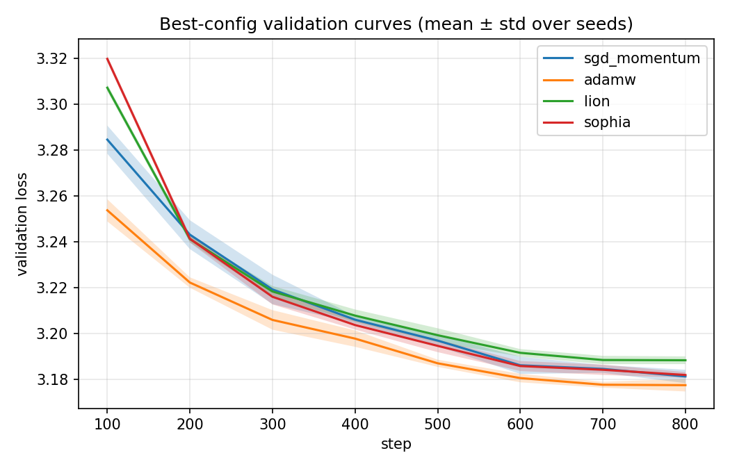
Figure 4.1. Best-configuration validation curves, mean ± standard deviation over five seeds.

4.3 RQ1 — the cost of a near-tie
Because the four optimizers finish so close on quality, their practical cost becomes the discriminating axis, and here the differences are large rather than marginal. Optimizer-state memory divides the field cleanly in two: SGD and Lion store a single momentum buffer (1.18 MB of LoRA-state), whereas AdamW and Sophia store two buffers each (2.36 MB) — exactly double. Per-step wall-clock time spans nearly a factor of four: Lion is the cheapest at about 100 ms per step, SGD next at 176 ms, AdamW at 241 ms, and Sophia the most expensive at 383 ms, the latter reflecting the additional curvature update performed periodically during training. In other words, the optimizer that wins on quality (AdamW) is among the more expensive on both memory and time, while the cheapest optimizer on both axes (Lion) is the one that finishes marginally worst on quality. This trade-off, rather than the quality ranking alone, is the substantive finding of RQ1 in this setting.
The step-time differences also overturn the speed ranking once it is compute-normalized. Steps-to-target counts optimizer steps, which is unfair to a method with a cheaper step; multiplying each optimizer's steps-to-target by its measured step time gives seconds-to-target, the wall-clock analogue of the AlgoPerf time-to-result metric (Dahl et al., 2023). On this measure the ranking inverts: Lion reaches the target fastest in wall-clock time (about 54 s) despite needing the most steps (540), because its step is roughly 2.4× cheaper than AdamW's; AdamW, fastest in steps, is near the back in seconds (about 98 s), and Sophia is slowest by far (about 191 s) on account of its curvature update. So "which optimizer is fastest" has no single answer here (AdamW wins per step, Lion wins per second), which is itself the point: the speed verdict depends on whether the budget is counted in steps or in compute. (The second model's step times are not used for this claim; as noted in Section 4.6 its measured SGD step time is anomalous.)
4.4 RQ1 — statistical comparison
Because only five seeds are available, the Mann–Whitney p-value is a blunt instrument — its smallest attainable value for five-versus-five samples is about 0.008 — so Table 4.2 reports it alongside two effect sizes that are more informative at this sample size: Cliff's delta (the rank-based effect that pairs with Mann–Whitney; +1 means every AdamW seed beats every comparator) and Hedges' g (a standardized mean difference with the small-sample correction). The picture they give is consistent and worth stating carefully. Against Lion and Sophia the separation is total — Cliff's delta = 1.0, with very large g (5.3 and 2.9) — so the ordering is statistically robust, not a fluke of five seeds. Against SGD it is weaker (Cliff's delta = 0.76, g = 1.7, p ≈ 0.056): the SGD seeds, which have the widest spread of any optimizer (±0.0032), overlap AdamW's, so that one comparison is genuinely borderline.
The crucial distinction is between statistical reliability and practical magnitude. The large effect sizes say the ranking is reliable; they do not say it is important, because effect size is measured in units of the (tiny) seed-to-seed spread. In absolute terms the AdamW advantage is 0.012 nats — about 0.3 perplexity — which is practically negligible. The honest reading is therefore that AdamW is reliably but trivially ahead of Lion and Sophia, and not clearly ahead of SGD at all.

Table 4.2. Pairwise comparison versus AdamW (five seeds each): Mann–Whitney U and p, with Cliff's delta and Hedges' g effect sizes (positive = AdamW lower/better).

Comparison | U | p | Cliff's δ | Hedges' g
AdamW vs SGD + momentum | 3.0 | 0.056 | 0.76 | 1.66
AdamW vs Lion | 0.0 | 0.008 | 1.00 | 5.33
AdamW vs Sophia | 0.0 | 0.008 | 1.00 | 2.87
4.5 RQ2 — tunability
The tunability curves in Figure 4.2 plot each optimizer's best validation loss against learning rate across its 18-point sweep. Two features stand out.
First, the optimizers operate at very different learning rates. The optimum sits near 0.44 for SGD but near 6e-4 to 3e-3 for the Adam-family methods — a separation of roughly three orders of magnitude. This is the empirical justification for the per-optimizer learning-rate ranges declared in Chapter 3: a single shared range could not have bracketed the optima of both SGD and Lion without wasting most of its points in regions where one or the other simply diverges.
Second, the shape of the curve (how much an optimizer punishes a mis-set learning rate) differs sharply between methods, and this is the core of RQ2. AdamW has the most forgiving profile: its validation loss stays within about 0.01 of optimal across the entire decade from 1e-3 to 1e-2, a broad flat valley that makes it easy to tune. SGD is tolerant in a different way: it never destabilises anywhere in its range, and its basin is asymmetric — it degrades only mildly on the high side of its optimum (still 3.20 at a learning rate of 1.0) but more steeply on the low side (3.61 at 1e-3, where the rate is simply too small to make progress in 800 steps). Lion has a narrower basin and a slightly higher floor (3.187), so it both demands a more careful learning rate and gives up a little quality at its best. Sophia is the most fragile of the four: it matches the others near its optimum, but above roughly 5e-3 it destabilises catastrophically, with validation loss jumping from about 3.18 at its best to 6.26 at a learning rate of 6.7e-3 and 11.55 at 1e-2. The single red spike in Figure 4.2 makes the point visually — of the four optimizers, Sophia leaves the least margin for an over-set learning rate.

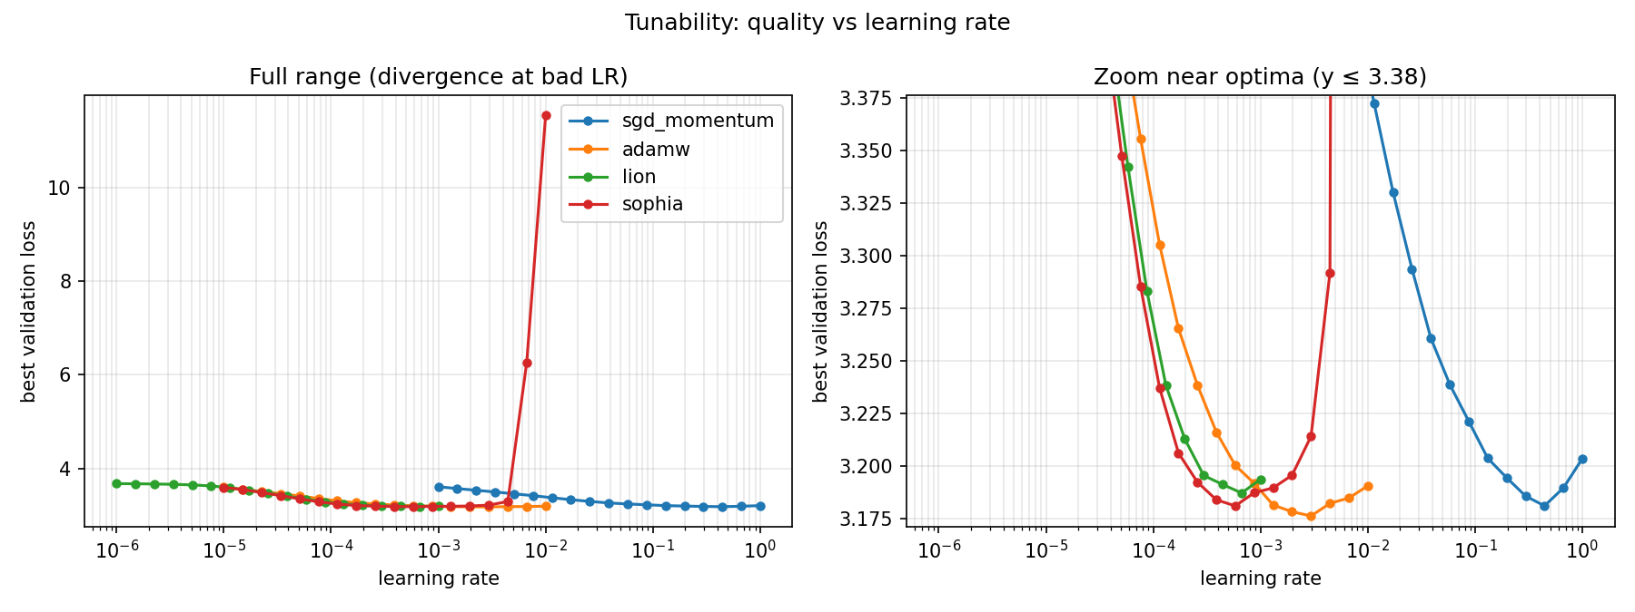
Figure 4.2. Tunability: best validation loss versus learning rate, per optimizer (log x-axis). Left panel: full range, showing Sophia's divergence at high learning rates; right panel: a Y-zoom near the optima, revealing the basin shapes (AdamW's broad flat valley, Lion's narrower basin, Sophia's sharp optimum, SGD's separate high-LR basin).
This tunability result reframes the near-tie of Section 4.2. The four optimizers reach almost the same final quality when each is tuned to its own optimum, but the effort required to find that optimum, and the penalty for missing it, are not equal across optimizers. An experimenter who set a single learning rate for all four without per-optimizer tuning would observe a very different and largely accidental ranking — which is precisely the protocol-sensitivity that RQ2 was designed to expose.
4.6 RQ1 — robustness on a second model
To test whether these conclusions are an artefact of one workload, the protocol was repeated on a second, architecturally different model: SmolLM2-360M, a Llama-style model (rotary embeddings, SwiGLU) roughly three times the size of GPT-2. The budget was lighter (a coarse seven-point learning-rate re-tune per optimizer and three seeds), so the comparison concerns the ranking, not new absolute numbers. Table 4.3 reports the result; the target for steps-to-target was recalibrated to 2.48 by the same rule as before.
Table 4.3. Best-configuration results on SmolLM2-360M (mean over three seeds); steps-to-target at validation loss 2.48.

Optimizer | Best LR | Val loss (mean ± std) | Steps-to-target | Opt-state (MB)
AdamW | 1.0e-3 | 2.4370 ± 0.0005 | 100 | 9.18
Sophia | 4.6e-4 | 2.4421 ± 0.0004 | 200 | 9.18
Lion | 3.0e-4 | 2.4461 ± 0.0011 | 200 | 4.59
SGD + momentum | 2.2e-1 | 2.4767 ± 0.0011 | 400 | 4.59
The conclusions transfer in part, and the parts that do and do not transfer are both informative. What holds: AdamW is again the best optimizer (lowest final loss and fastest to the target on both models) and the three adaptive or preconditioned methods (AdamW, Sophia, Lion) again finish in a tight band, here within 0.009 validation loss. The tunability picture also transfers cleanly (Figure

4.3): Sophia again diverges catastrophically at high learning rates (validation loss reaching 15.5 at 1e-2), SGD again sits in a separate high-learning-rate basin and diverges beyond it, and AdamW again has the broadest, most forgiving valley. What changes: SGD with momentum drops from a near-tie on GPT-2 to clearly last on SmolLM2, trailing the adaptive trio by roughly 0.03–0.04 validation loss — a gap several times larger than the spread within that trio. The optimizer-state memory structure is unchanged — AdamW and Sophia again carry double the buffer of SGD and Lion — but the per-step time ordering does not reproduce that of GPT-2 (here SGD's measured step time was the highest, most plausibly a measurement artefact of GPU contention during that part of the run), so only the memory structure, not the step-time ranking, should be read as transferring. The Mann–Whitney tests put AdamW strictly ahead of all three others (U = 0, perfect rank separation), though with three seeds the p-value floor is 0.1, so these are reported as consistent orderings rather than strong significance.
This partial transfer is itself the point. A single workload would have suggested either that all four optimizers tie (the GPT-2 reading) or that SGD is hopeless (the SmolLM2 reading); seen together, the honest conclusion is that AdamW's edge and the tunability fragilities are robust, while SGD's competitiveness is model-dependent — exactly the kind of distinction a one-workload study cannot make. Table 4.4 places the two models side by side and makes the pattern immediate: AdamW is first on both, the adaptive trio stays bunched, and only SGD moves — from second on GPT-2 to last on SmolLM2.
Table 4.4. Final validation loss and rank on each model (lower is better). AdamW holds rank 1 on both; SGD is the only optimizer whose rank changes.

Optimizer | GPT-2 val (rank) | SmolLM2 val (rank)
AdamW | 3.176 (1) | 2.437 (1)
Sophia | 3.182 (3) | 2.442 (2)
Lion | 3.188 (4) | 2.446 (3)
SGD + momentum | 3.181 (2) | 2.477 (4)
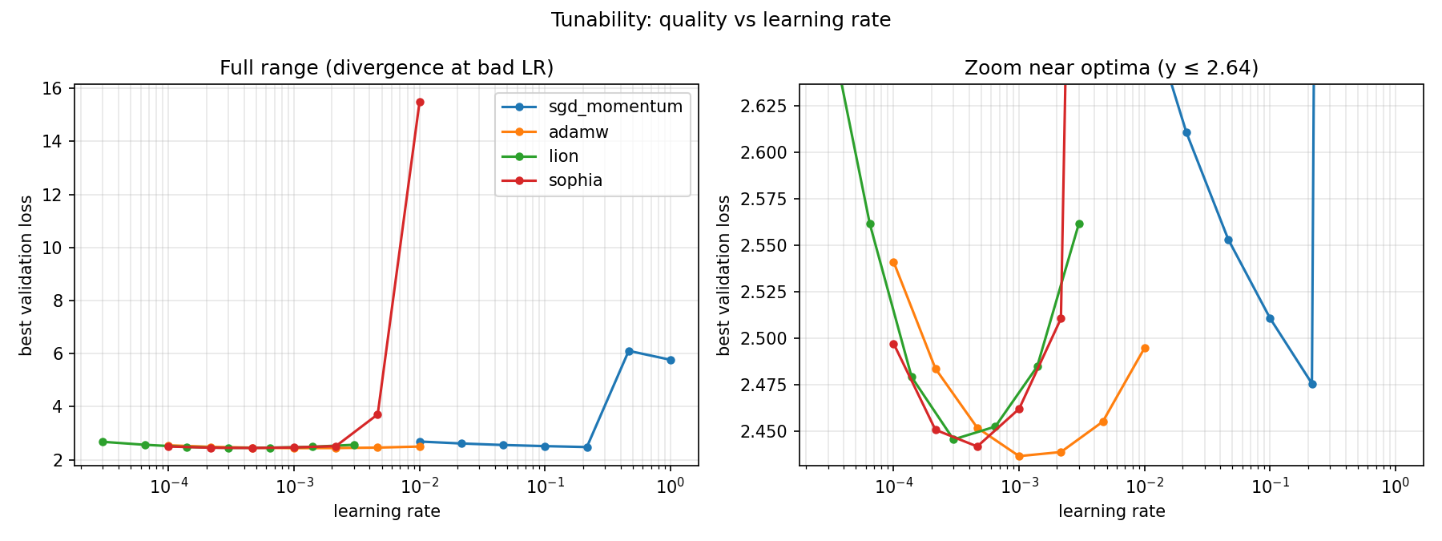
Figure 4.3. Tunability on SmolLM2-360M (results/figures/rq1b_smollm2_lora_rq2_tunability.png), to be read against Figure 4.2: the same fragility pattern (Sophia and SGD diverge at high LR, AdamW is most forgiving) recurs on a different architecture.

4.7 RQ1 — a second adaptation regime: full fine-tuning
The LoRA results above concern one adaptation regime: training 0.3M low-rank adapter weights while the 124M GPT-2 backbone stays frozen. To test whether the near-tie is a property of the optimizers or of that regime, the same fair protocol was applied to full fine-tuning of GPT-2 — every one of the 124M parameters trained, no adapter. A fifth optimizer, Muon, was added here because its update orthogonalizes the gradient of each weight matrix, an operation defined only on full two-dimensional weights and meaningless for the low-rank adapter factors; full fine-tuning is therefore its natural setting. Each optimizer received a seven-point learning-rate re-tune (the adaptive methods' optima move to smaller rates under full fine-tuning, while Muon operates at a larger rate), five seeds at the selected best rate, and a 500-step budget. The steps-to-target threshold was recalibrated to 3.26 — the loss every optimizer reaches within budget; at the tighter LoRA-regime bar of 3.20 only SGD crosses it, which is itself part of the story below.
Table 4.5 reports the result, and the headline is that the LoRA near-tie does not survive. The spread in mean validation loss widens from 0.012 under LoRA to 0.072 under full fine-tuning (a factor of six), and the ranking changes. SGD with momentum, only mid-pack on LoRA, is now clearly best (3.1794), with every one of its seeds below every seed of every other optimizer (Cliff's delta = 1 against each). The adaptive and preconditioned methods follow in a tighter group (Sophia 3.2053, Lion 3.2135, AdamW 3.2202), so the LoRA winner, AdamW, drops to fourth, and Muon finishes last on final quality (3.2535). The picture is the inverse of the LoRA regime: there the adaptive methods led and SGD merely kept pace; here well-tuned SGD wins outright and the adaptive edge disappears.
Muon's profile is worth isolating, because final loss alone does not capture it. It reaches the recalibrated target fastest (100 steps against 200 for every other optimizer), its orthogonalized update making aggressive early progress, but it then plateaus at the highest final loss of the five — and one of its five seeds failed to reach even the moderate 3.26 target, the widest seed spread of any optimizer here (± 0.0074), so its early speed comes with the least reliability. Crucially, this early-speed advantage does not translate into wall-clock time: Muon's Newton–Schulz orthogonalization makes its step about twice as expensive (266 ms against roughly 135 ms), so its 100 steps to the target cost about 27 s — indistinguishable from the others' 200 cheaper steps (also about 27 s). Its optimizer-state memory (0.65 GB) sits between the one-buffer methods (SGD and Lion, 0.50 GB of full-model state) and the two-buffer methods (AdamW and Sophia, 1.0 GB), as expected from its storing momentum plus an Adam fallback for the one-dimensional parameters it does not orthogonalize.
Two honest qualifications bound this result. First, Sophia's full-fine-tuning optimum sits at the low edge of its swept learning-rate range (1e-5), so its 3.2047 may slightly understate its best achievable loss, whereas the other four have clearly interior optima; the order among the three adaptive methods should therefore be read as a tight group rather than a firm ranking. Second, the budget is a modest 500 steps, so these are fixed-budget, not converged, results — the caveat that applies throughout. Neither qualification touches the headline: under full fine-tuning the optimizers separate

six times more widely than under LoRA, and SGD, not an adaptive method, wins.
Table 4.5. Full fine-tuning of GPT-2 (all 124M parameters; mean over five seeds). Steps-to-target is at the recalibrated validation loss of 3.26, reached by every optimizer under all five seeds except Muon (four of five); seconds-to-target is steps-to-target × measured step time. Optimizer state is the full-model buffer size, far larger than the LoRA-only state of Table 4.1.

Optimizer | Best LR | Val loss (mean ± std) | 95% CI | Steps-to-tar get | Seconds-to- target | Opt-state (MB) | Step time (ms)
SGD + momentum | 1.2e-1 | 3.1794 ± 0.0027 | [3.177, 3.182] | 200 | 26 | 498 | 128
Sophia | 1.0e-5 | 3.2053 ± 0.0018 | [3.204, 3.207] | 200 | 28 | 996 | 142
Lion | 6.5e-6 | 3.2135 ± 0.0021 | [3.212, 3.215] | 200 | 27 | 498 | 136
AdamW | 2.2e-5 | 3.2202 ± 0.0036 | [3.218, 3.223] | 200 | 28 | 996 | 141
Muon | 2.2e-3 | 3.2535 ± 0.0074 | [3.248, 3.260] | 100 (4/5) | 27 | 653 | 266
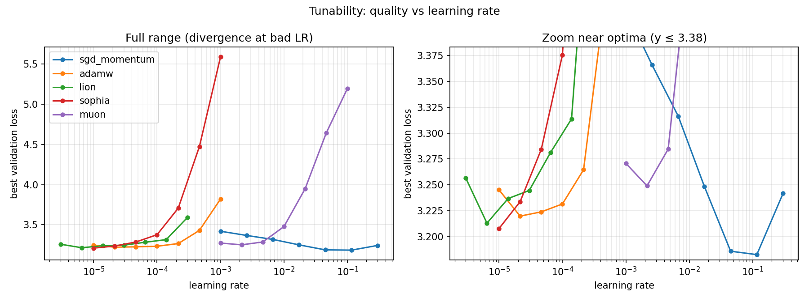
Figure 4.4. Full-fine-tuning tunability: best validation loss versus learning rate per optimizer (log x-axis), showing SGD's low-loss high-rate basin, the adaptive methods' small-rate optima, and Muon's separate basin.
This regime contrast is the cleanest demonstration in the study of its central claim. "Which optimizer is best" has no answer independent of the adaptation regime: the low-rank, well-conditioned LoRA subspace flatters the adaptive methods into a near-tie that AdamW marginally leads, whereas full fine-tuning of all weights rewards well-tuned SGD with momentum and pushes the adaptive methods (and Muon) behind it. A study fixing a single regime would have reported one of these as the ranking; only running both reveals that the ranking is a property of the (optimizer, regime) pair — exactly the protocol-sensitivity the fairness invariant was built to expose.

4.8 RQ2 — two-dimensional tunability
The tunability curves of Section 4.5 vary only the learning rate. Choi et al. (2019) caution that a second hyperparameter can change an optimizer's apparent behaviour, so a natural worry is that the single-axis sweep hides an important interaction — that AdamW's forgiving valley, say, would narrow or shift if weight decay were also varied. To test this directly, AdamW was swept over a full 24-point grid of learning rate (six values) × weight decay (four values, from 1e-4 to 0.3) on the GPT-2 + LoRA workload.
The result (Figure 4.5) is that AdamW's valley is essentially one-dimensional. Averaged over weight decay, the learning rate moves the best validation loss by about 0.065 (from 3.252 at a rate of 3e-4 to a minimum of 3.187 near 2.5e-3); at any fixed learning rate, varying weight decay across more than three orders of magnitude moves it by less than 0.005 near the optimum. The one place weight decay matters is the high-learning-rate edge: at 1e-2, where the rate is slightly too large, the strongest weight decay (0.3) recovers about 0.02 of loss, acting as a mild brake on an over-set step. But the global best cell (3.183) is reached at the optimal learning rate under essentially any weight decay. Within the ranges that matter, then, weight decay does not flip AdamW's tunability — the single-axis learning-rate sweep of Section 4.5 was not concealing a second important axis for AdamW, which validates the simplification there. That conclusion does not, however, generalise to every optimizer, as the SGD grid shows next.
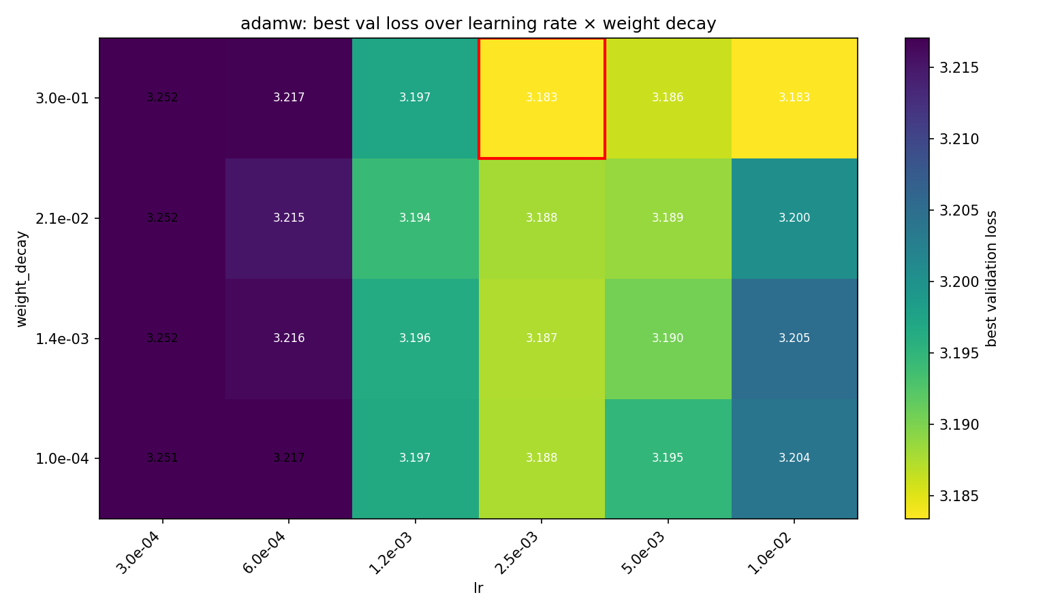
Figure 4.5. Two-dimensional tunability of AdamW: best validation loss over the learning-rate × weight-decay grid (GPT-2 + LoRA, one seed, 600 steps). The valley runs along the learning-rate axis; weight decay barely moves it except at the high-rate edge, where strong decay recovers a little loss. The best cell is outlined.
The same grid applied to SGD with momentum, learning rate × momentum (Figure 4.6), tells the opposite story: here the two axes interact strongly, so SGD's tunability is genuinely two-dimensional. Because momentum amplifies the effective step (roughly learning-rate / (1 −

momentum)), a small learning rate is rescued by a large momentum (at a rate of 0.03 the loss falls from 3.47 at momentum 0.5 to 3.23 at 0.99) while a large learning rate combined with a large momentum diverges (at a rate of 0.5 the loss jumps to 5.61 at momentum 0.99, and at a rate of 1.0 to 10.57). The low-loss region is therefore a diagonal ridge across the grid, not an axis-aligned valley: learning rate and momentum cannot be set independently. This is the case Choi et al. (2019) warn of, realised — for SGD the single-axis sweep at a fixed momentum of 0.9 sits on a good but not self-evidently optimal slice of a genuinely two-dimensional surface. The contrast between the two heatmaps is itself the result: whether a second hyperparameter matters is an optimizer-specific question, inert for AdamW and decisive for SGD, which a single-axis study cannot answer and a two-dimensional one can.
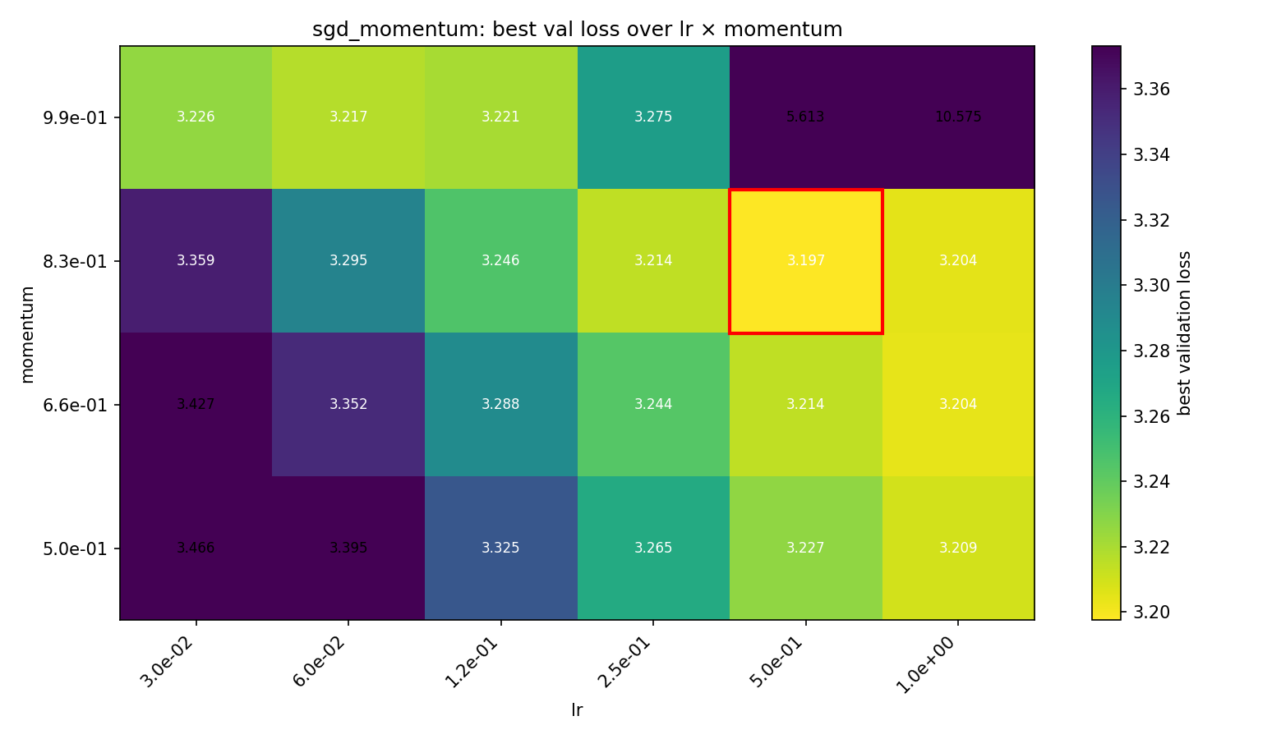
Figure 4.6. Two-dimensional tunability of SGD + momentum: best validation loss over the learning-rate × momentum grid (GPT-2 + LoRA, one seed, 600 steps). Unlike AdamW's, the low-loss region is a diagonal ridge — the two axes trade off and a high learning rate with high momentum diverges — so SGD's tunability is genuinely two-dimensional. The best cell is outlined.
4.9 RQ3 — loss-landscape visualization
The visualization study was conducted on a small char-level Transformer, where full-data loss slices are cheap and a ground-truth picture is accessible. Three findings emerge.
First, under filter normalization the solutions reached by different optimizers can be compared on a common footing (Figure 4.7). All three optimizers settle in a clear basin around their solution, but the basins differ in apparent curvature: the AdamW solution is the flattest (loss rising to about 1.4 at the slice edge), while the Lion solution is the sharpest (rising to about 6.8 over the same range), with SGD in between.

Second, and central to RQ3, this picture is not robust to how the slice directions are normalized (Figure 4.8). Taking the same AdamW solution and the same total step size, but distributing the perturbation with naive global normalization instead of per-tensor filter normalization, makes the identical minimum look markedly sharper — on a shared colour scale the edge loss rises to about 5.3 under naive directions versus about 1.9 under filter-normalized ones. Because nothing about the solution changed, this demonstrates directly that an apparent "sharpness" read off a naive slice is an artefact of direction scaling, not a property of the minimum. A study that compared optimizers by naive slices could therefore reach essentially arbitrary conclusions about which found a flatter solution.
Third, a one-dimensional interpolation between the AdamW and SGD solutions (Figure 4.9) shows a clear loss barrier: both endpoints sit near 0.010–0.012, but the midpoint rises to about 0.027, roughly two and a half times higher. The two optimizers therefore converged to different basins that are not connected by a straight low-loss path, rather than to the same region of parameter space.

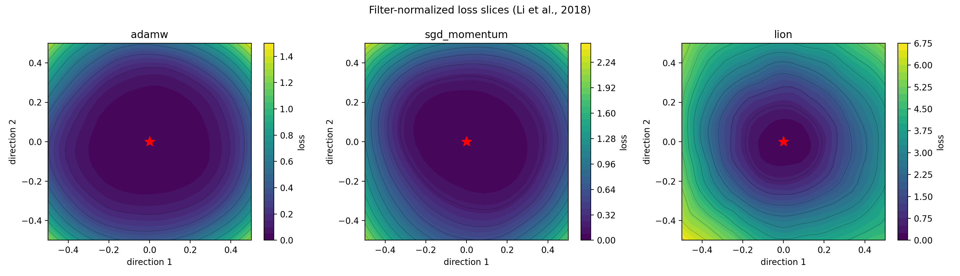
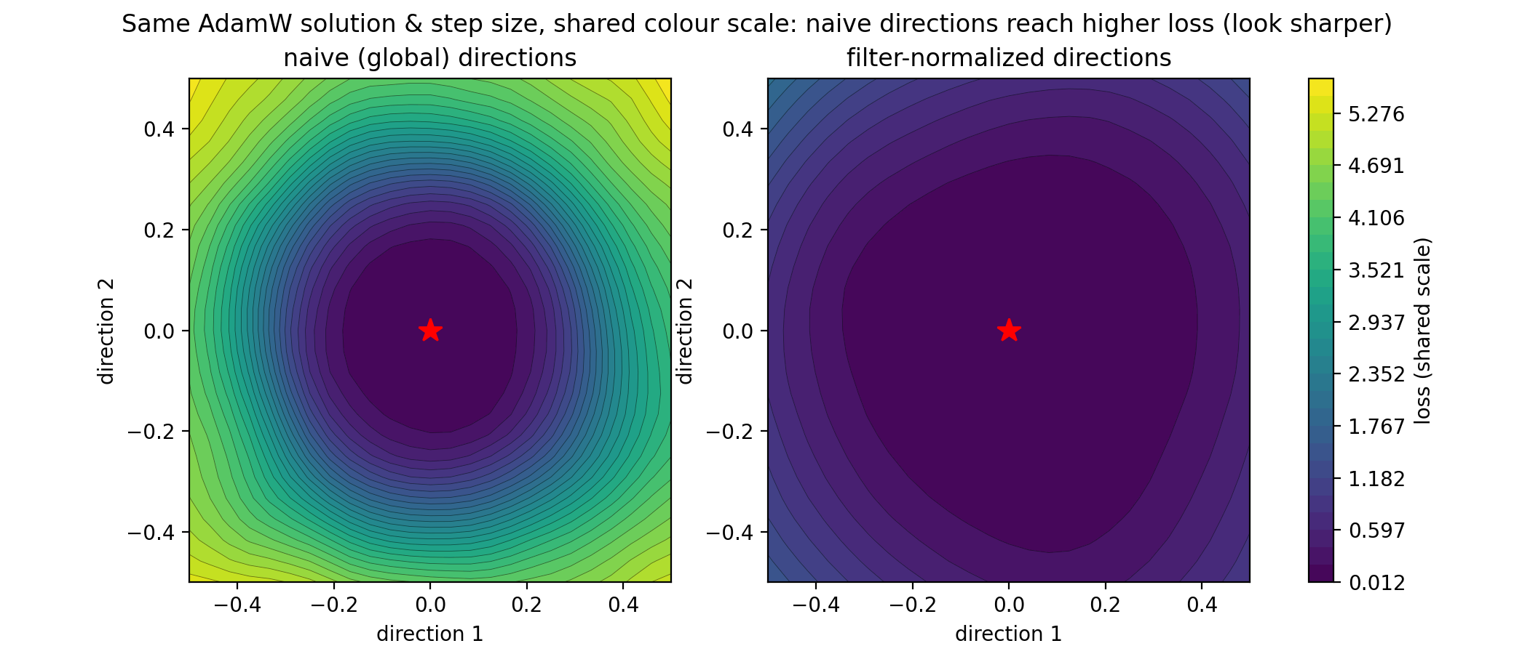
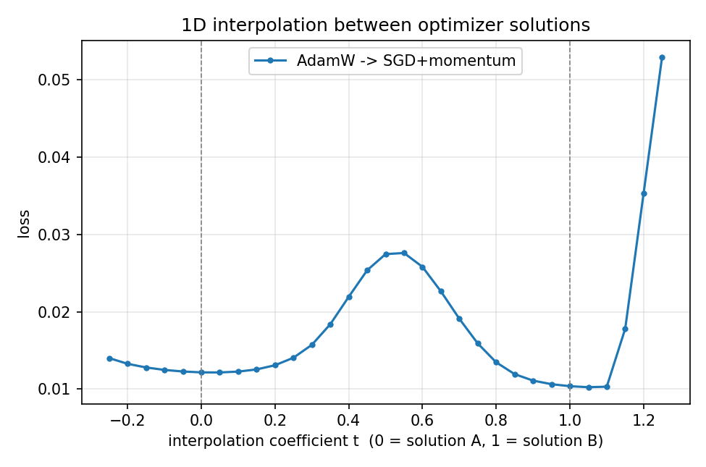
Figures 4.7–4.9. Filter-normalized slices per optimizer; the naive-vs-filter-normalized comparison on the AdamW solution; and the 1D interpolation between the AdamW and SGD solutions.

4.10 RQ3 — curvature: a validated proxy, and what it explains
The second part of RQ3 replaces the qualitative slices with a single quantitative measure of sharpness, the top Hessian eigenvalue λmax. Before using the cheap Hessian–vector-product estimate on the language model, it was validated on the toy MLP, where the full Hessian (433 parameters) can be built and diagonalised exactly: the power-iteration estimate gave 19.046 against an exact top eigenvalue of 19.052 — a relative error of 0.03%. The proxy is therefore trustworthy, which justifies applying it where the full Hessian is out of reach.
Measured at each optimizer's best GPT-2 + LoRA solution (Table 4.6), λmax tells a two-part story that aligns with the RQ2 tunability curves. The flat side: AdamW and SGD settle in the flattest minima (λmax ≈ 1.4–1.5), which matches their forgiving, broad tunability valleys — a shallow minimum is, by construction, insensitive to the exact step that reaches it. Lion is the outlier in the other direction: its solution is roughly four times sharper (λmax ≈ 5.6), and this is exactly consistent with its narrower tunability basin and slightly higher loss floor seen in Section 4.5 — the sign-based update settles into a sharp minimum that demands a more carefully chosen learning rate. So for the basin-width fragility, geometry is a genuine explanation.
What λmax does not explain is Sophia's catastrophic divergence at high learning rates: Sophia's converged minimum is only moderately sharp (λmax ≈ 1.8, in the same low range as AdamW and SGD), yet it is the optimizer that blows up most violently above its threshold. This is the right place to draw a line — Sophia's fragility is a property of its update dynamics (the empirical-Fisher diagonal preconditioning discussed in the next chapter), not of the landscape it converges to. Curvature thus explains one fragility (Lion's narrow basin) and explicitly does not explain another (Sophia's divergence), which is a more honest account than attributing everything to sharpness.
Table 4.6. Top Hessian eigenvalue (λmax) at each optimizer's best GPT-2 + LoRA solution, by power iteration on Hessian–vector products (single seed, one validation batch — indicative). Higher means a sharper minimum.

Optimizer | Best LR | λmax | Tunability (from RQ2)
SGD + momentum | 4.4e-1 | 1.48 | broad, never destabilises
AdamW | 3.0e-3 | 1.41 | broadest, most forgiving
Sophia | 5.8e-4 | 1.81 | diverges at high LR (dynamics)
Lion | 6.7e-4 | 5.58 | narrowest basin
Measured with the same validated estimator across the other regimes, curvature becomes a cross-regime story that tracks the RQ1 ranking. Under full fine-tuning the optimizers split sharply by how far they travel from the pretrained weights. The three adaptive methods, whose full-fine-tuning optima sit at very small learning rates (around 1e-5), barely leave the pretrained initialization and settle at extremely sharp points (λmax ≈ 2800 for AdamW, Lion, and Sophia alike), whereas SGD and Muon, operating at much larger rates, reach far flatter regions (λmax ≈ 32 and ≈ 53), some fifty to ninety times flatter. This is the geometric face of the regime flip of Section 4.7: the full-fine-tuning winner, SGD, is precisely the optimizer that escapes the sharp initialization

basin into a flat, low-loss minimum, consistent with the flat-minima literature (Keskar et al., 2017), while the adaptive methods, pinned to tiny steps, remain in the sharp basin they started from. Muon is the honest complication (flat yet worst on loss), so flatness aligns with, but does not by itself determine, final quality. On the second model the probe again discriminates (λmax ≈ 2.3–3.9 across optimizers), though AdamW's lighter-budget SmolLM2 solution shows a small negative top eigenvalue — a mild saddle rather than a clean minimum, a reminder that these are single-batch, fixed-budget estimates.
4.11 Summary of findings
Under an equal tuning budget: (i) on GPT-2 the four optimizers converge to within 0.012 validation loss of one another, a band of the same order as single-optimizer seed noise; (ii) AdamW is fastest to a fixed quality target and lowest in final loss, with Sophia, SGD, and Lion following closely and SGD's advantage over the rest being statistically borderline; (iii) the near-tie on quality is broken by cost, where Lion is cheapest in both memory and step time and Sophia is the most expensive; (iv) the optimizers differ markedly in tunability, with AdamW the most forgiving of a mis-set learning rate and Sophia the most fragile; (v) on a second, larger, architecturally different model the AdamW advantage and the tunability fragilities recur, but SGD with momentum falls clearly behind, showing the ranking to be only partly model-independent; (vi) the LoRA near-tie does not survive a change of adaptation regime — under full fine-tuning of all 124M GPT-2 weights the optimizers separate six times more widely (0.072 vs 0.012) and the ranking inverts, with well-tuned SGD now clearly best, AdamW dropping to fourth, and the matrix-orthogonalizing Muon fastest to a moderate target but last on final quality, so "best optimizer" is shown to be a property of the (optimizer, regime) pair; (vii) a two-dimensional sweep shows that whether a second hyperparameter matters is optimizer-specific — AdamW's valley is essentially one-dimensional in the learning rate (weight decay does not flip it, validating the single-axis protocol there), whereas SGD's learning rate and momentum interact so strongly that its low-loss region is a diagonal ridge, a genuinely two-dimensional surface; (viii) on a toy model, filter-normalized visualization compares optimizer solutions fairly and exposes a loss barrier between the AdamW and SGD solutions, while naive normalization makes the same minimum look arbitrarily sharper — confirming that naive landscape visualization misleads; and (ix) the cheap Hessian–vector-product estimate of the top eigenvalue matches the full Hessian to within 0.03% on the toy model, and on GPT-2 + LoRA it shows Lion's solution to be about four times sharper than the others, which explains its narrow tunability basin, while Sophia's divergence is not explained by curvature, isolating it as an update-dynamics effect; and across regimes the curvature tracks the RQ1 ranking — under full fine-tuning the winning SGD (and Muon) reach minima fifty to ninety times flatter than the adaptive methods, the geometric face of the regime flip. The interpretation of these findings in the context of prior work is taken up in the Discussion.

5. Discussion
This chapter interprets the findings of Chapter 4 in the light of the literature reviewed in Chapter 2. Where Chapter 4 reported what was observed, this chapter asks what it means: what the results confirm, what they qualify, and where they reach their limits.
5.1 The near-tie confirms that tuning dominates the update rule
The central RQ1 result — that on GPT-2 the four optimizers converge to within 0.012 validation loss once each is tuned under an equal budget — is best read as a direct confirmation, in a new setting, of the "crowded valley" reported by Schmidt et al. (2021). Their broad benchmark found no single best optimizer and concluded that the tuning budget is as influential as the choice of algorithm; the present study reproduces that collapse of the optimizer-choice effect on a workload they did not examine, namely LoRA fine-tuning of a language model. It also operationalises the mechanism that Choi et al. (2019) identified: because every optimizer here was given the same number of pre-declared trials, none could gain the spurious advantage that an asymmetric search confers, and the differences that survived are correspondingly small. In other words, the near-tie is not a failure of the experiment to discriminate but the expected outcome of removing the confound that usually inflates optimizer gaps. This reframes the result the field often reports ("optimizer X beats AdamW") as frequently an artefact of unequal tuning rather than a property of the algorithm.
It is worth being precise about the residual differences. AdamW is statistically lowest on GPT-2, so the four are not literally identical; but the gap to the next methods is around 0.3 perplexity, which is practically negligible and, for SGD, not even statistically distinguishable. The honest summary is not "all optimizers are the same" but "once tuned fairly, the quality differences shrink to the point where they are dominated by other considerations" — which motivates the attention this study gives to cost and tunability.
5.2 What the second model adds: a firsthand demonstration of AlgoPerf's caution
The robustness check sharpens rather than simply repeats the benchmark. AlgoPerf (Dahl et al., 2023) argues explicitly that a single workload cannot ground a general optimizer ranking, and the present results show why in miniature. Read alone, GPT-2 would suggest a four-way tie and SmolLM2 would suggest that SGD is clearly inferior; only together do they yield the defensible conclusion that AdamW's advantage and the tunability fragilities are robust across two architectures, while SGD's competitiveness is model-dependent. That SGD with momentum slips from a near-tie on GPT-2 to last on the larger Llama-style model is a concrete instance of the transferability problem the benchmarking literature warns about.
This finding also speaks to Wilson et al. (2017), who argued that adaptive methods can generalise worse than well-tuned SGD. The present results do not contradict that claim in its original full-training, vision-leaning setting, but they qualify its reach: in LoRA fine-tuning of language models, the adaptive and preconditioned methods (AdamW, Sophia, Lion) were never worse than

SGD and were clearly better on the second model. The marginal value of adaptivity, in other words, appears to depend on the regime — and the parameter-efficient fine-tuning regime that dominates current practice is one where adaptivity looks more, not less, valuable.
The full-fine-tuning experiment (Section 4.7) turns this regime-dependence from inference into direct observation. When the same four optimizers (plus Muon) are run on all of GPT-2's weights rather than a low-rank adapter, the LoRA near-tie collapses: the spread in final loss widens sixfold and well-tuned SGD with momentum, not an adaptive method, finishes first. This is precisely the regime in which Wilson et al. (2017) originally found SGD to match or beat adaptive methods, so the result does not overturn their claim but locates it: adaptivity's advantage is real in the low-rank LoRA subspace and absent under full fine-tuning, with the same model, data, and budget. The contrast is the strongest evidence in this study for its central methodological point — that a verdict on optimizers is conditional on the adaptation regime, and that fixing one regime silently fixes the answer. It also qualifies Section 5.1's reading: the near-tie that motivates judging optimizers on cost and tunability is itself a property of parameter-efficient fine-tuning, not a universal law, and where full fine-tuning is affordable the choice of update rule re-acquires real influence on final quality.
5.3 Tunability and cost as the real axes of comparison
Because the quality differences are small, the study's emphasis on tunability and cost follows the logic Sivaprasad et al. (2020) set out: an optimizer that performs well only in a narrow hyperparameter band is, in practice, worse than one that forgives a poor choice. The RQ2 curves give this argument an empirical face. AdamW's broad, flat valley makes it the easiest of the four to tune, which — more than its slim quality lead — explains its standing as the default. Sophia, by contrast, is the most fragile: beyond a threshold learning rate it diverges catastrophically on both models. This behaviour should be attributed to the specific variant used here, but the attribution is more than a disclaimer — it is mechanistic. The Sophia implemented in this study differs from the paper's in its curvature estimator: it uses an empirical-Fisher diagonal (an exponential moving average of squared gradients) rather than the Gauss–Newton–Bartlett estimator, while retaining the per-coordinate clip that bounds each update at one learning rate, exactly as in canonical Sophia (Liu et al., 2024). The catastrophic divergence above the threshold learning rate is nonetheless predicted by that simplification. In flat, low-gradient directions the empirical-Fisher diagonal badly underestimates the curvature, so the preconditioned ratio saturates and the clip pins the step at its maximum magnitude (one learning rate), turning the update into a sign-of-momentum step in exactly those directions. At a high learning rate such a sign-like step is simply too large, and training diverges. The honest claim is thus narrow and specific — the divergence is a property of empirical-Fisher diagonal preconditioning driven into clip saturation at a large step, a caution about that estimator choice, not evidence against canonical Sophia. The cost dimension reinforces the practical picture. Lion's single state buffer halves the optimizer memory of AdamW and Sophia, consistent with its design motivation (Chen et al., 2023) and with the broader push toward memory-efficient optimizers such as Adam-mini (Zhang et al., 2025). When quality is a near-tie, this halving (and Lion's low per-step time) is exactly the kind of consideration that should decide the choice, which is the practical contribution of reporting these axes alongside loss.

The two-dimensional sweep (Section 4.8) addresses the natural objection that varying only the learning rate understates the tuning problem. Choi et al. (2019) showed that a second hyperparameter can change optimizer rankings, which would make the single-axis curves of Section 4.5 an incomplete picture. The result here is reassuring for the protocol: across a full learning-rate × weight-decay grid, AdamW's valley stays essentially one-dimensional — weight decay moves the best loss by less than 0.005 near the optimum and matters only as a mild brake at an over-set learning rate. Within the ranges that matter, the second axis does not flip the tunability conclusion, so the economy of the single-axis sweep is justified rather than merely assumed for AdamW. The caution is not merely hypothetical for other methods, however: the same grid for SGD with momentum shows the opposite pattern — learning rate and momentum interact so strongly that a high rate with high momentum diverges and the low-loss region becomes a diagonal ridge, a genuinely two-dimensional surface. Whether the single-axis economy is safe is therefore an optimizer-specific question, answered yes for AdamW and no for SGD, which is a sharper reading of Choi et al. (2019) than a blanket caution. Muon, finally, illustrates the cost axis from a new direction: its orthogonalized update reaches a moderate target in half the steps of the others, yet its Newton–Schulz iteration roughly doubles per-step time, so the step advantage cancels in wall-clock — a concrete reminder that a per-step speed claim and a per-second speed claim can disagree, exactly as the compute-normalized analysis of Section 4.3 warned.
5.4 Geometry: misleading visualization, and what curvature explains
The RQ3 results align closely with the cautionary strand of the landscape literature. The demonstration that the same minimum appears markedly sharper under naive global normalization than under filter normalization is a concrete instance of the reparameterisation problem that Dinh et al. (2017) identified analytically: sharpness is not invariant to how parameters (or, here, perturbation directions) are scaled, so a flatness comparison that does not control for scale is meaningless. It is precisely this problem that filter normalization (Li et al., 2018) was designed to solve, and the contrast in Figure 4.8 shows why their correction is not optional. The interpolation result connects to the mode-connectivity literature: the loss barrier on the straight path between the AdamW and SGD solutions indicates they lie in different basins, but Garipov et al. (2018) showed that independently trained solutions are often joined by curved low-loss paths even when the linear path has a barrier. The present study tested only the linear path and so should claim no more than that the two solutions are not linearly connected. Finally, the decision to confine this analysis to a toy model is itself supported by the literature: Cohen et al. (2021) showed that neural-network training operates at the edge of stability and does not "converge" in the classical sense, which cautions against over-reading a static two-dimensional slice of a large model as the basin its optimizer settled into. Scoping the visualization to small models where the picture is honest, rather than producing impressive but unjustified slices of the language model, is the methodologically defensible choice.
The curvature measurement turns this geometric reading from qualitative into quantitative, and it does two things. First, it validates the method: that the Hessian–vector-product estimate of λmax matches the exact full Hessian to within 0.03% on the toy model is a small but genuine instrument-validation result, and it is what licenses using the estimate where the full Hessian cannot

be formed (Pearlmutter, 1994). Second, and more interestingly, it connects geometry to the behaviour measured in RQ2. The finding that Lion converges to a markedly sharper minimum than the others, and that this sharpness tracks its narrower tunability basin, is consistent with the long-standing association between flatness and well-behaved training (Keskar et al., 2017) — though, mindful of Dinh et al. (2017), the claim is comparative under a fixed parameterisation, not an absolute statement about flatness. The more careful point is the negative one: Sophia diverges most violently yet sits at moderate curvature, so its fragility cannot be a landscape property and must instead be an update-rule property — precisely the empirical-Fisher preconditioning instability discussed in Section 5.3. Separating a landscape fragility (Lion) from a dynamics fragility (Sophia) is something neither the benchmark nor the visualization could do alone; it is the curvature measure that makes the distinction, which is the value of adding it. The same measure, applied across regimes, also gives the regime flip of Section 5.2 a geometric reading: under full fine-tuning the winning SGD reaches a minimum tens of times flatter than the adaptive methods, which, tied to tiny learning rates, stay near the sharp pretrained initialization, so the change of ranking is mirrored by a change of geometry.
5.5 Limitations
Several limitations bound these conclusions, and stating them is consistent with the study's own argument that honest scoping is part of a fair comparison. The benchmark rests on two models and one dataset; while the second model addresses the single-workload critique, two points are still a thin basis for any claim of generality, and both are language-modelling tasks. The main sweep tuned only the learning rate, with other hyperparameters fixed at documented defaults; a two-dimensional learning-rate × weight-decay check (Section 4.8) found no ranking flip for AdamW, but a single such check, on one optimizer, does not rule out the interactions Choi et al. (2019) warn of for other methods or wider ranges, so the comparison is fair but not exhaustive. The seed counts are small (five and three), which makes the significance tests coarse and is why effect sizes and intervals, not p-values, carry the argument. The Sophia variant is a simplification, so its specific behaviour should not be transferred to the canonical method. Adaptation was examined in two regimes (LoRA and full fine-tuning), which is enough to show the ranking is regime-dependent, but both share the GPT-2 architecture, so the regime effect is demonstrated for one model rather than established in general. And the training budget was fixed at a few hundred steps, so the comparison is of fixed-budget behaviour rather than of converged solutions. None of these undermines the core finding, but each marks a boundary the conclusions should not cross.

5.6 Implications
Taken together, the findings support a practical and a methodological implication. Practically, for LoRA fine-tuning of small language models, AdamW remains a sound default — not because it is decisively more accurate, but because it is the easiest to tune and its small quality edge is robust across the two models tested; where memory or step-time is the binding constraint, Lion is a well-justified alternative that gives up very little quality. This recommendation is, however, regime-specific: under full fine-tuning the same protocol favours well-tuned SGD with momentum over every adaptive method, so the sensible default tracks the adaptation regime rather than being carried over unexamined from the LoRA setting. Methodologically, and more importantly, the study shows what is gained by holding the comparison to the field's own standards: equalising the tuning budget turns a noisy contest of optimizers into a clear, defensible account in which the genuine differences are not in headline accuracy but in robustness, tunability, and cost — and in which honest visualization replaces misleading pictures. That account, rather than any single winner, is the contribution.

6. Conclusion
This dissertation set out not to crown a best optimizer but to establish and demonstrate a fair, reproducible way of comparing and visualising optimizers when fine-tuning a language model (primarily with LoRA, and in a second regime with full fine-tuning) and to report what changes once the comparison is made fair. The three research questions can now be answered directly.
RQ1 (benchmark). Under an equal, pre-declared tuning budget, the four optimizers (SGD with momentum, AdamW, Lion, and Sophia) reach almost the same final quality on GPT-2, converging to within 0.012 validation loss, a band of the same order as a single optimizer's seed-to-seed noise. AdamW is the lowest in loss and the fastest to a target quality, but its margin over the others is practically negligible and, against SGD, not statistically distinguishable at five seeds. The honest answer to "is there a difference?" is therefore "a small and mostly practical one": the algorithms are close on accuracy and separate on cost and speed. This near-tie is, however, specific to LoRA: repeating the protocol under full fine-tuning of all 124M weights (adding Muon, a fifth optimizer) widens the spread sixfold and inverts the ranking, with well-tuned SGD now clearly first and AdamW fourth. Even the headline "small difference", then, is a property of the adaptation regime rather than of the optimizers alone.
RQ2 (tunability). The optimizers differ far more in how they must be tuned than in their best-case quality. Their optima span three orders of magnitude in learning rate, and the shape of the quality-versus-learning-rate curve varies sharply: AdamW is the most forgiving, with a broad flat valley; Lion has a narrower basin; and Sophia is the most fragile, diverging catastrophically beyond a threshold learning rate. A two-dimensional check confirmed that AdamW's forgiving valley is essentially one-dimensional (weight decay does not flip it), so the single-axis comparison is not hiding a second important variable for AdamW; for SGD, by contrast, learning rate and momentum interact strongly enough to form a diagonal ridge, so whether a single axis suffices is itself optimizer-specific. Tunability, not headline accuracy, is where the optimizers genuinely diverge.
RQ3 (visualization). On a small model where the picture can be checked, filter-normalized slices compare optimizer solutions on a common footing and reveal a loss barrier between the AdamW and SGD solutions, indicating different basins. Crucially, the same minimum looks arbitrarily sharper under naive direction normalization than under filter normalization, demonstrating concretely that naive landscape visualization misleads and that the corrected technique is necessary rather than optional. A cheap curvature estimate (the top Hessian eigenvalue via Hessian–vector products), validated against the full Hessian to within 0.03% on the toy model, adds a quantitative geometric reading: Lion converges to a markedly sharper minimum, which explains its narrow tunability basin, whereas Sophia's divergence is not a curvature effect and is therefore isolated as an update-dynamics property.
A second model, SmolLM2-360M, showed that these conclusions are only partly model-independent: AdamW's advantage and the tunability fragilities recur, while SGD with momentum falls clearly behind on the larger, architecturally different model. This partial transfer is itself a result, illustrating firsthand why a single workload cannot ground a general ranking.

Contribution. The contribution of the work is the protocol and its consequences rather than a new algorithm or a single number: a reproducible, config-driven harness that encodes a fairness invariant (identical workload and budget; only the search space varies), an equal-budget tuning and multi-seed evaluation procedure with intervals and explicit caveats, a multidimensional characterisation of four optimizers (five under full fine-tuning) across two models and two adaptation regimes, and a methodologically honest visualization component. The recurring lesson (that equalising the tuning budget shrinks optimizer differences on accuracy and relocates them to robustness, tunability, and cost) is the substantive finding.
Limitations and future work. The study rests on two language-modelling models, two adaptation regimes on a single architecture, a mostly single-axis search, small seed counts, a fixed step budget, and a simplified Sophia variant; each bounds the claims, as Chapter 5 details. The natural extensions follow directly: testing the regime effect across architectures and on a non-language task; widening the multi-axis search from the single AdamW grid to every optimizer and to the additional hyperparameters Choi et al. (2019) showed can shift rankings; validating the canonical Sophia estimator; and extending the curvature analysis from a single indicative estimate per optimizer to seed-averaged eigenvalue spectra. None of these changes the core message; each would strengthen the generality of an approach whose value lies precisely in being honest about what it does and does not show. Table 6.1 summarises each limitation, why it bounds the claims, and the future work that would address it.
Table 6.1. Limitations, their effect on the claims, and the work that would address each.

Limitation | Why it bounds the claims | Future work
Two models, both language modelling | Generality is supported by a transfer test, but two points and one task family are a narrow base | A non-language task (e.g. classification) and a third model size
Regime effect shown on one architecture | The LoRA→full-FT ranking flip is demonstrated on GPT-2 only | Test the regime effect across architectures and a non-language task
Mostly single-axis search | A 2-D learning-rate × weight-decay grid found no flip for AdamW, but not all optimizers or axes were checked | Multi-axis sweeps for every optimizer and wider ranges
Small seed counts (5 and 3) | The p-value floor is coarse; effect sizes carry the argument | More seeds where a comparison is genuinely borderline
Fixed step budget (not converged) | The comparison is of fixed-budget, not asymptotic, behaviour | A converged-budget or compute-matched comparison
Simplified (empirical-Fisher) Sophia | Conclusions about Sophia apply to the variant's curvature estimator, not the canonical method | The canonical Gauss–Newton–Bartlett curvature estimator
Curvature estimate is indicative | λmax is a single-seed, single-batch estimate per optimizer | Seed-averaged eigenvalue spectra, not just the top eigenvalue

7. Epilogue
This project began from a frustration rather than a hypothesis. Trying to decide which optimizer was "best" for fine-tuning a language model, I kept finding that the answer changed with how carefully I tuned each one, and that the literature had already named this problem. The turning point was to stop treating that instability as an obstacle and to make it the subject of the work: if optimizer rankings are dominated by the tuning protocol, then the honest contribution is a careful protocol, not a verdict. Reframing the question this way made a one-month, single-GPU project both tractable and, I think, more genuinely useful than a larger but less disciplined comparison would have been.
The work also taught me how much of empirical machine learning is engineering for honesty. The fairness invariant only means something because it is enforced in code (the same seed, the same budget, the same data order for every optimizer), and most of the effort went into building a harness that makes unfair comparisons hard to run by accident. The same lesson recurred in the visualization: it would have been easy to produce striking loss-landscape pictures of the language model, and almost as easy for them to be meaningless. Choosing the smaller, checkable experiment over the more impressive but unjustified one was the harder call and, I believe, the right one.
If I were to continue, the immediate next step is the curvature analysis that time did not allow: measuring the top Hessian eigenvalue cheaply on the language model and validating it against the full Hessian on the toy models, which would connect the tunability fragilities observed here (Sophia's divergence in particular) to the geometry that produces them. More broadly, I would like to see the protocol applied beyond LoRA and beyond language modelling, because the most valuable outcome would not be another result about four optimizers but a small, reusable standard for comparing them fairly. That, more than any single number, is what I hope to take from this work.

References
Chen, X., Liang, C., Huang, D., Real, E., Wang, K., Liu, Y., Pham, H., Dong, X., Luong, T., Hsieh, C.-J., Lu, Y., & Le, Q. V. (2023). Symbolic discovery of optimization algorithms. Advances in Neural Information Processing Systems (NeurIPS), 36, 49205–49233. https://arxiv.org/abs/2302.06675
Choi, D., Shallue, C. J., Nado, Z., Lee, J., Maddison, C. J., & Dahl, G. E. (2019). On empirical comparisons of optimizers for deep learning (arXiv:1910.05446). arXiv. https://arxiv.org/abs/1910.05446
Cohen, J. M., Kaur, S., Li, Y., Kolter, J. Z., & Talwalkar, A. (2021). Gradient descent on neural networks typically occurs at the edge of stability. International Conference on Learning Representations (ICLR). https://arxiv.org/abs/2103.00065
Dahl, G. E., Schneider, F., Nado, Z., Agarwal, N., Sastry, C. S., Hennig, P., Medapati, S., Eschenhagen, R., Kasimbeg, P., Suo, D., Bae, J., Gilmer, J., Peirson, A. L., Khan, B., Anil, R., Rabbat, M., Krishnan, S., Snider, D., Amid, E., … Mattson, P. (2023). Benchmarking neural network training algorithms (arXiv:2306.07179). arXiv. https://arxiv.org/abs/2306.07179
Dettmers, T., Pagnoni, A., Holtzman, A., & Zettlemoyer, L. (2023). QLoRA: Efficient finetuning of quantized LLMs. Advances in Neural Information Processing Systems (NeurIPS), 36, 10088–10115. https://arxiv.org/abs/2305.14314
Dinh, L., Pascanu, R., Bengio, S., & Bengio, Y. (2017). Sharp minima can generalize for deep nets. Proceedings of the 34th International Conference on Machine Learning (ICML), 70, 1019–1028. https://arxiv.org/abs/1703.04933
Foret, P., Kleiner, A., Mobahi, H., & Neyshabur, B. (2021). Sharpness-aware minimization for efficiently improving generalization. International Conference on Learning Representations (ICLR). https://arxiv.org/abs/2010.01412
Garipov, T., Izmailov, P., Podoprikhin, D., Vetrov, D., & Wilson, A. G. (2018). Loss surfaces, mode connectivity, and fast ensembling of DNNs. Advances in Neural Information Processing Systems (NeurIPS), 31, 8803–8812. https://arxiv.org/abs/1802.10026
Goodfellow, I. J., Vinyals, O., & Saxe, A. M. (2015). Qualitatively characterizing neural network optimization problems. International Conference on Learning Representations (ICLR). https://arxiv.org/abs/1412.6544
Hu, E. J., Shen, Y., Wallis, P., Allen-Zhu, Z., Li, Y., Wang, S., Wang, L., & Chen, W. (2022). LoRA: Low-rank adaptation of large language models. International Conference on Learning Representations (ICLR). https://arxiv.org/abs/2106.09685
Jordan, K. (2024). Muon: An optimizer for the hidden layers of neural networks [Blog post]. https://kellerjordan.github.io/posts/muon/

Keskar, N. S., Mudigere, D., Nocedal, J., Smelyanskiy, M., & Tang, P. T. P. (2017). On large-batch training for deep learning: Generalization gap and sharp minima. International Conference on Learning Representations (ICLR). https://arxiv.org/abs/1609.04836
Kingma, D. P., & Ba, J. (2015). Adam: A method for stochastic optimization. International Conference on Learning Representations (ICLR). https://arxiv.org/abs/1412.6980
Li, H., Xu, Z., Taylor, G., Studer, C., & Goldstein, T. (2018). Visualizing the loss landscape of neural nets. Advances in Neural Information Processing Systems (NeurIPS), 31, 6391–6401. https://arxiv.org/abs/1712.09913
Liu, H., Li, Z., Hall, D., Liang, P., & Ma, T. (2024). Sophia: A scalable stochastic second-order optimizer for language model pre-training. International Conference on Learning Representations (ICLR). https://arxiv.org/abs/2305.14342
Loshchilov, I., & Hutter, F. (2019). Decoupled weight decay regularization. International Conference on Learning Representations (ICLR). https://arxiv.org/abs/1711.05101
Merity, S., Xiong, C., Bradbury, J., & Socher, R. (2017). Pointer sentinel mixture models. International Conference on Learning Representations (ICLR). https://arxiv.org/abs/1609.07843
Pearlmutter, B. A. (1994). Fast exact multiplication by the Hessian. Neural Computation, 6(1), 147–160. https://doi.org/10.1162/neco.1994.6.1.147
Radford, A., Wu, J., Child, R., Luan, D., Amodei, D., & Sutskever, I. (2019). Language models are unsupervised multitask learners [Technical report]. OpenAI.
Schmidt, R. M., Schneider, F., & Hennig, P. (2021). Descending through a crowded valley — Benchmarking deep learning optimizers. Proceedings of the 38th International Conference on Machine Learning (ICML), 139, 9367–9376. https://arxiv.org/abs/2007.01547
Sivaprasad, P. T., Mai, F., Vogels, T., Jaggi, M., & Fleuret, F. (2020). Optimizer benchmarking needs to account for hyperparameter tuning. Proceedings of the 37th International Conference on Machine Learning (ICML), 119, 9036–9045. https://arxiv.org/abs/1910.11758
Sutskever, I., Martens, J., Dahl, G., & Hinton, G. (2013). On the importance of initialization and momentum in deep learning. Proceedings of the 30th International Conference on Machine Learning (ICML), 28(3), 1139–1147.
Vaswani, A., Shazeer, N., Parmar, N., Uszkoreit, J., Jones, L., Gomez, A. N., Kaiser, Ł., & Polosukhin, I. (2017). Attention is all you need. Advances in Neural Information Processing Systems (NeurIPS), 30, 5998–6008. https://arxiv.org/abs/1706.03762
Wilson, A. C., Roelofs, R., Stern, M., Srebro, N., & Recht, B. (2017). The marginal value of adaptive gradient methods in machine learning. Advances in Neural Information Processing Systems (NeurIPS), 30, 4148–4158. https://arxiv.org/abs/1705.08292
Zhang, Y., Chen, C., Li, Z., Ding, T., Wu, C., Kingma, D. P., Ye, Y., Luo, Z.-Q., & Sun, R. (2025). Adam-mini: Use fewer learning rates to gain more. International Conference on Learning

Representations (ICLR). https://openreview.net/forum?id=iBExhaU3Lc

Appendices
Appendix A: Reused code and third-party components
The Guidance Notes require explicit documentation of reused code. This appendix lists every external component the artefact depends on and states, for each, whether it was used as an installed library (through its public API), re-implemented from a published description, or written originally for this thesis. No source code was copied verbatim from third-party repositories; all third-party functionality is accessed through installed, versioned packages.
A.1 Third-party libraries (used through their public APIs)
Component | Version | Role in this work | License
PyTorch | 2.11.0+cu128 | Tensors, autograd, training loop primitives, SGD and AdamW optimizers | BSD-3-Clause
Hugging Face Transformers | 5.10.2 | Loading the pretrained models and tokenizers (GPT-2, SmolLM2-360M) | Apache-2.0
Hugging Face PEFT | 0.19.1 | LoRA adapter construction and injection | Apache-2.0
Hugging Face Datasets | 5.0.0 | Loading the WikiText-2 corpus (Salesforce/wi kitext) | Apache-2.0
lion-pytorch | 0.2.4 | The Lion optimizer (Chen et al., 2023) | MIT
NumPy / SciPy / matplotlib | 2.2.6 / 1.17.1 / 3.10.9 | Aggregation, bootstrap CIs, Mann–Whitney test, figures | BSD-3-Clause
PyYAML | 6.0.3 | Parsing experiment configuration files | MIT
The two baseline optimizers, SGD with Nesterov momentum and AdamW, are the standard implementations from torch.optim; they are configured (not reimplemented) by this work.

A.2 Methods re-implemented from publications
Component | File | Source method | What was adapted
SophiaG | src/optbench/optimi zers/sophia.py | Sophia (Liu et al., 2024) | Re-implemented in PyTorch as a self-contained Optimizer. The diagonal curvature estimate uses the empirical Fisher (an EMA of the squared gradients already produced by the trainer), refreshed every k steps, instead of the paper's Gauss–Newton–Bartlett estimator that needs an extra sampled backward pass. This simplification is a deliberate, documented deviation (see Section 3.3) and means the optimizer benchmarked here is a Sophia variant.
Filter normalization | src/optbench/landsc ape/directions.py | Visualizing the loss landscape (Li et al., 2018) | Original implementation of the filter-normalization procedure (per-parameter-tensor rescaling of random directions), used for the RQ3 slices.
HVP curvature | src/optbench/curvat ure/hvp.py | Hessian–vector products (Pearlmutter, 1994) | Original implementation of power iteration on Hessian–vector products for the top eigenvalue, with an exact full-Hessian check on the toy model.
A.3 Original work
All remaining code was written specifically for this thesis: the configuration schema and loader (config/), the trainer and scheduler (training/), the experiment unit builders (builders.py), the data modules (data/), the toy models (models/toy_*), the equal-budget sweep, selection and multi-seed runners (tuning/, experiments/), the aggregation, tables and plotting (analysis/), the landscape primitives and surface evaluation (landscape/), the reproducibility utilities (reproducibility/), and all experiment scripts (scripts/). The fairness invariant — the central methodological contribution — is encoded in this original code.

Appendix B: Reproducibility
B.1 Software and hardware environment
Item | Value
Python | 3.12 (project virtual environment)
PyTorch | 2.11.0+cu128
CUDA | 12.8
GPU | NVIDIA GeForce RTX 5060 Ti, 16 GB (Blackwell, compute capability 12.0 / sm 120) _
Key libraries | transformers 5.10.2, peft 0.19.1, datasets 5.0.0, lion-pytorch 0.2.4, numpy 2.2.6, scipy 1.17.1, matplotlib 3.10.9
OS | Windows 11
Exact pins for all packages are in requirements-lock.txt. The Blackwell GPU requires the CUDA 12.8 build of PyTorch; older or cu121 builds will not run on it.
B.2 Determinism and seeds
Global seeds are pinned (reproducibility/seeding.py). The learning-rate sweep uses a single
sweep_seed = 0 so that every trial shares the same initialization and data order; final evaluation re-runs the best configuration with seeds 0–4 (GPT-2) and 0–2 (SmolLM2). The CUDA attention backward pass is not bitwise deterministic; rather than forcing determinism, the study relies on multiple seeds with confidence intervals, as described in Section 3.5.
B.3 Experiment configurations
All experiments are declared in YAML under configs/experiments/:
• rq1_gpt2_lora.yaml — primary benchmark (GPT-2 + LoRA, 4 optimizers × 18 LRs, 5 seeds).
• rq1b_smollm2_lora.yaml — second-model robustness check (SmolLM2-360M, coarse re-tune, 3 seeds).

B.4 Commands to reproduce
# primary benchmark (RQ1 + RQ2): tables -> results/tables, figures -> results/figures
.venv\Scripts\python.exe scripts\run_rq1.py --config configs\experiments\rq1_gpt2_lora.yaml
# second-model robustness check
.venv\Scripts\python.exe scripts\run_rq1.py --config configs\experiments\rq1b_smollm2_lora.yaml
# RQ3 loss-landscape figures (toy models, CPU)
.venv\Scripts\python.exe scripts\run_landscape.py
# RQ3 curvature: HVP lambda_max validation (toy) + per-optimizer lambda_max (GPT-2, GPU)
.venv\Scripts\python.exe scripts\run_curvature.py
# assemble all figures into one PDF
.venv\Scripts\python.exe scripts\make_figures_pdf.py
# unit tests
.venv\Scripts\python.exe -m pytest -q
Runs are idempotent: each trial and seed is cached as JSON under results/runs/, so an interrupted run resumes by re-executing the same command. Because the time-to-target metric is recomputed from each run's saved evaluation history, the target threshold can be recalibrated without re-training.

