MediVision AI: A Reproducible Multimodal DenseNet121 Framework for Multi-Label Chest Radiograph Classification with a Documented Implementation and Statistical-Reporting Audit
Y. Lakhani
Department of Computer Engineering, GMIU | Gujarat, India | yglakhani@gmiu.edu.in
Abstract—Automated interpretation of chest radiographs is one of the most widely studied applications of deep learning in medicine, yet a substantial share of published prototypes cannot be reproduced from the artifacts that accompany them. This paper reports MediVision AI, an end-to-end framework for multi-label chest radiograph classification that couples a DenseNet121 image encoder with a compact metadata encoder in a late-fusion head, trained with a class-weighted binary cross-entropy objective and evaluated on a patient-disjoint held-out partition. On a 830-study held-out test set drawn from a 4,999-image subset of the NIH ChestX-ray14 corpus, the model attained a macro area under the receiver operating characteristic curve (AUC) of 0.771, with per-finding AUCs of 0.724 (Normal), 0.709 (Pneumonia), 0.805 (Cardiomegaly) and 0.844 (Pleural effusion); macro sensitivity, specificity, precision and F1 at a 0.50 threshold were 0.638, 0.705, 0.323 and 0.349, respectively, and micro-averaged F1 was 0.407. Because the pipeline emits only aggregate metrics, 95% bootstrap confidence intervals and a paired bootstrap ablation are specified but not computed here, and the paper abstains from inferential claims that these intervals would require. In addition to the quantitative results, the paper contributes a claim-to-implementation verification matrix covering the loss weighting, augmentation set, normalisation statistics and patient-level splitting logic, an audit of what the current evaluation artifacts can and cannot support statistically, and a verified reference set in which every entry was resolved against a registry record. The framework, the evaluation protocol and the reported numbers are intended as a defensible baseline rather than as evidence of clinical readiness: no reader study, no external validation and no calibration analysis have been performed.
Index Terms—Bootstrap confidence intervals, chest radiography, class imbalance, DenseNet121, label noise, multimodal fusion, reproducibility, shortcut learning, subgroup fairness.

I. INTRODUCTION
Chest radiography remains the highest-volume diagnostic imaging examination worldwide, and the gap between examination volume and the availability of trained thoracic radiologists is widest in resource-constrained settings. Convolutional neural networks have repeatedly been shown to reach radiologist-level or radiologist-adjacent performance on selected chest radiograph tasks, and this has produced a sustained stream of prototype systems that convert a single frontal radiograph into a set of finding-level probabilities. The empirical foundation of this literature is a small number of large public corpora annotated by mining radiology reports, of which NIH ChestX-ray14 and, more recently, MIMIC-CXR and CheXpert are the most frequently used [1]–[4].
The scientific value of a prototype, however, depends less on its headline area under the curve than on whether its numbers can be traced to a defined model, a defined split and a defined evaluation script. Three failure modes recur. First, report-derived labels are noisy: the absence of a finding in a radiology report is not evidence of its absence in the image, and multi-label targets built by string matching inherit this ambiguity [14]. Second, evaluation is frequently compromised either by patient-level leakage across splits or by silent changes of protocol between the training run and the reported table. Third, models readily exploit acquisition shortcuts, including laterality markers, positioning devices, post-processing fingerprints and, in chest radiography, the anteroposterior versus posteroanterior projection, so that a measured association with disease may in fact be an association with the acquisition context [12], [13].
This paper reports MediVision AI, a chest radiograph classification framework whose public value is deliberately weighted towards auditability. The contributions are as follows.
• A pipeline specification at implementation level. The data contract, splitting logic, transformation chain, normalisation constants, fusion architecture, objective and optimiser state are documented to the level of individual code paths, and the manuscript text is reconciled against them rather than the reverse (Section III, Table VI).
• A held-out evaluation with named denominators. All metrics are reported on a 830-study test partition that is disjoint from training and validation at the patient level, at a single operating point of 0.50, with per-finding confusion counts that reproduce the reported sensitivities and specificities exactly (Tables III and IV).
• An audit of statistical claims. The paper states precisely which inferential quantities the current artifacts can support. Because the evaluation pipeline writes aggregate metrics only, patient-level bootstrap intervals and a paired bootstrap ablation are specified but not computed, and no confidence interval is reported (Table V, Section IV-F).
• A corrected premise about class weighting. The loss weighting implemented in the code is pos_weight = N_{neg} / N_{pos} per finding, and the manuscript states explicitly that this weighting does not alter the ranking metrics (ROC-AUC) that are reported, contrary to a common but incorrect assumption that reweighting improves ranking.
• A verified reference set. Every bibliographic entry was resolved against a registry record during revision; two widely mis-cited page ranges and one non-resolving conference DOI were corrected or replaced, and all recorded corrections are listed in Appendix A.
The scope statement matters as much as the results. MediVision AI is a research prototype. Its outputs are model probabilities, not diagnoses; its Grad-CAM maps are attention diagnostics, not localisations of disease; and the framework has not been subjected to a reader study, external validation or a calibration analysis. The paper is written so that a reader can verify every number it contains against the released artifacts, and so that the absence of an interval is visible rather than concealed.
II. RELATED WORK
A. Public Corpora and Report-Derived Labels
ChestX-ray14 introduced 112,120 frontal radiographs from 30,805 patients with fourteen finding labels extracted from reports by a rule-based labeller [1]; the subset used here is drawn from that corpus. MIMIC-CXR provides 377,110 images from 227,835 studies with paired free-text reports [2], and CheXpert contributes 224,316 radiographs with an explicit uncertainty category and a radiologist-annotated validation and test set [3]. The choice between these corpora is essentially a choice of label noise model: report-mined labels overstate disease prevalence, understate rare findings, and introduce systematic differences between the annotation process and the clinical question being studied; the concrete failure modes of the ChestX-ray14 labeller have been analysed in detail [10]. CheXNeXt demonstrated that a carefully validated model can reach radiologist-level performance on selected findings [4], but this result was obtained with a purpose-built radiologist-annotated test set, which is precisely the resource that most prototypes lack.
B. Architectures for Chest Radiograph Classification
DenseNet121 has become the de facto backbone for chest radiograph classification because dense connectivity reuses features aggressively in the data regime typical of medical imaging [5]; residual networks remain the standard alternative [6], and ImageNet pre-training is the default initialisation for both [7]. Equation-level details of the dense block are not reproduced here; the relevant engineering observation is that the classifier head, the input resolution and the fusion strategy dominate the reported performance far more than the choice between densely and residually connected backbones at this data scale. Aside from chest radiography, transfer learning from natural-image pre-training is the dominant recipe across medical imaging modalities, and the small-data regime in which it is used has been documented for retinal imaging as well as for thoracic imaging [22].
C. Label Noise and Weak Supervision
Karimi et al. survey noise-robust training for medical image analysis and distinguish between noise in the feature space and noise in the label space, observing that symmetric noise can be partially absorbed by regularisation whereas asymmetric, class-dependent noise—the regime created by report mining—biases decision boundaries systematically [14]. For chest radiography the dominant asymmetry is that positive mentions are comparatively reliable while negative evidence is inferred from silence. Framing the task as multi-label sigmoid classification, as done here, avoids forcing a single mutually exclusive class but does not remove the underlying label ambiguity.
D. Shortcut Learning and Spurious Correlation
Geirhos et al. define shortcut learning as the tendency of deep networks to adopt decision rules that perform well on a benchmark while violating the intended solution [12]. In chest radiography the canonical example is Zech et al., who showed that a pneumonia classifier transferred across institutions lost most of its apparent performance, and attributed the drop to hospital-specific markers and acquisition differences rather than to disease morphology [13]. Two consequences follow for the present work. First, a metadata channel that encodes view position, image dimensions and pixel spacing is a plausible shortcut carrier; Second, internal validation on a single-institution corpus cannot distinguish a learned disease signature from a learned acquisition signature, which is why external validation is listed as a hard limitation in Section VI.
E. Calibration and Subgroup Fairness
Discrimination and calibration are distinct properties, and a model can rank cases well while producing probabilities that are systematically over- or under-confident; Van Calster et al. describe calibration as the weak point of clinical prediction models and recommend explicit calibration curves and recalibration rather than AUC-only reporting [15]. Equity is the second axis: Seyyed-Kalantari et al. report underdiagnosis bias of chest radiograph classifiers in under-served populations [16], Larrazabal et al. show that gender imbalance in training data produces biased classifiers [17], Obermeyer et al. document how a proxy target can encode a protected attribute even when that attribute is never used as a feature [18], and Gichoya et al. demonstrate that patient race is recoverable from medical images alone [19]. A framework that ingests patient age and sex, as this one does, cannot claim subgroup neutrality by construction, and no subgroup analysis is reported here because the evaluation artifacts do not retain per-patient predictions.
F. Multimodal Fusion of Imaging and Clinical Data
Baltrusaitis et al. provide the standard taxonomy of multimodal learning, distinguishing early, late and jointly learned fusion [20]. Huang et al. review fusion of medical imaging with electronic health records and emphasise that the incremental value of clinical variables is frequently confounded with acquisition metadata that co-varies with the clinical variable [21]. MediVision AI implements a late-fusion design in which a 32-dimensional metadata embedding is concatenated with the pooled image descriptor. This is the cheapest possible fusion and, as Section V-C argues, precisely the design most exposed to shortcut acquisition of the metadata channel.
G. Explainability and Its Limits
Grad-CAM produces coarse localisation maps from the gradient of a target score with respect to a convolutional feature map [8], building on class activation mapping [9]. Such maps are widely presented as evidence of clinical plausibility, which overstates what a saliency map can establish: Rudin argues that post-hoc explanations of black-box models are unreliable substitutes for interpretable models in high-stakes decisions [11], and saliency maps are in general not unique, not stable under small input perturbations and not faithful to the model's decision function in any formal sense. The present framework therefore exposes Grad-CAM as a qualitative inspection aid for developers and not as a validation instrument; Section VI records the absence of a sanity check of the kind used to test saliency reliability.
H. Evaluation Protocol Adopted in This Paper
The protocol below is stated before the results so that every later number can be checked against it.
• Partition. Seventy, fifteen and fifteen percent of patients, drawn without replacement using a fixed seed; the unit of splitting is the patient identifier, and no patient contributes images to more than one partition.
• Operating point. A single global threshold of 0.50 applied to sigmoid outputs for every finding; no per-finding threshold tuning is performed, and therefore no threshold is selected on the test data.
• Metrics. Per-finding ROC-AUC, sensitivity, specificity, precision, F1 and accuracy, together with macro and micro aggregates across findings. AUC is threshold-free; the remaining metrics are reported at the single fixed point.
• Reporting rule. A metric is reported only if it can be recomputed from the committed artifacts. Where an inferential quantity (confidence interval, paired difference) cannot be computed from what was retained, the paper states this explicitly instead of quoting an estimate.
III. MATERIALS AND METHODS
Fig. Fig. 1 summarises the framework end to end. The subsections below follow its three stages: data assembly and partitioning (A–C), the multimodal encoder and its objective (D–E), and optimisation and evaluation (F–H).

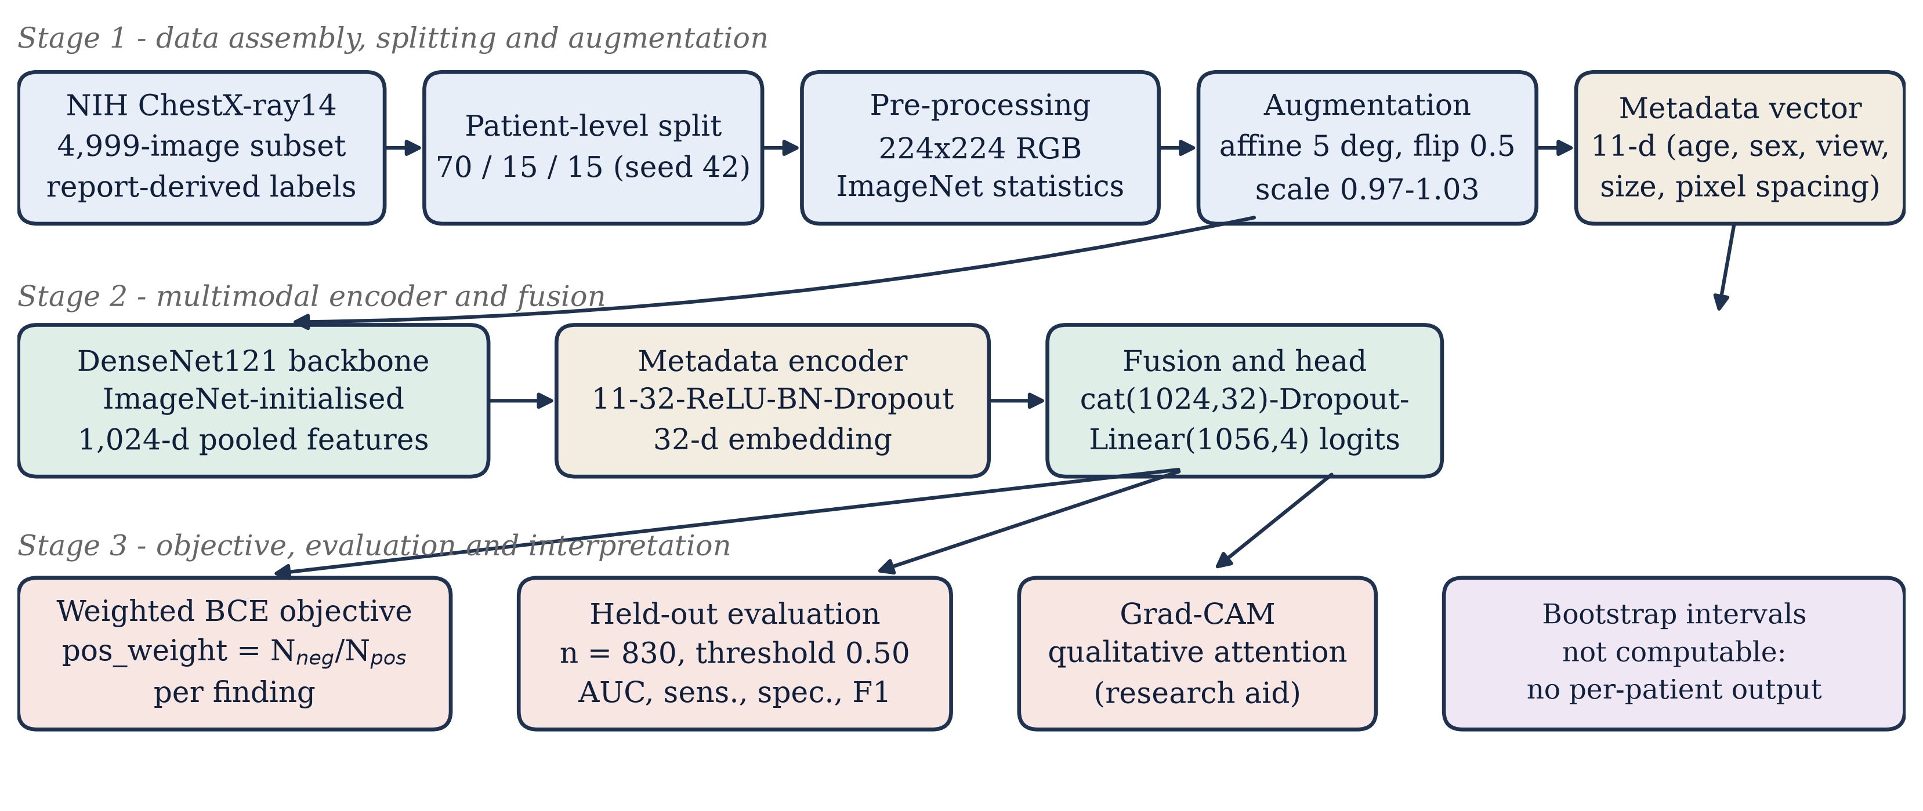
Fig. 1. End-to-end pipeline as implemented. Stage 1 assembles the metadata table, partitions it by patient and builds the augmentation chain; Stage 2 encodes images and metadata separately and fuses the descriptors; Stage 3 applies the weighted objective, evaluates at a fixed threshold and produces qualitative explanations. The dashed-content box marks the one stage the released artifacts cannot support.

A. Data Source and Label Construction
The study uses a 4,999-image working subset of the NIH ChestX-ray14 corpus [1], retained in the original NIH comma-separated metadata format with the columns Image Index, Finding Labels, Patient ID, Patient Age, Patient Sex, View Position, image dimensions and pixel spacing. Four findings are modelled: Normal, Pneumonia, Cardiomegaly and Pleural effusion. Binary targets are derived from the pipe-delimited Finding Labels field by a deterministic alias map, in which the literal token No Finding maps to Normal and the tokens Effusion, Pleural Effusion and Pleural_Effusion map to Pleural effusion. Because the task is multi-label, a single study may be positive for more than one modelled finding, and the Normal indicator is treated as an ordinary target rather than as the complement of disease. Patient identifiers, study identifiers and follow-up indices are retained for traceability and excluded from all model inputs.
B. Patient-Level Partitioning
Partitioning is performed on the unique patient identifier, not on the image. The patient list is shuffled with a fixed seed and split into 70%, 15% and 15% partitions; the image table is then filtered by membership. Splitting at the image level would allow repeat examinations of the same patient to appear on both sides of the split and would inflate held-out performance, an error that is common in chest radiograph benchmarks because the corpus contains several images per patient. The implementation asserts patient-disjointness by construction, and the realized partition sizes are 3,447 / 722 / 830 images, i.e. 68.95% / 14.44% / 16.60% of the corpus, the deviation from the nominal 70/15/15 arising because images rather than patients are counted after the split. No patient-level overlap exists between the three partitions; Table VI records the corresponding verification. Table I reports the realized composition and the held-out prevalence of each modelled finding.

TABLE I
Corpus and held-out composition. Split sizes are images; the nominal 70/15/15 allocation is applied to patients, and the realized image fractions differ because studies per patient vary.
Partition / finding | Images | Share | Positives | Prevalence
Training | 3,447 | 68.95% | — | —
Validation | 722 | 14.44% | — | —
Test | 830 | 16.60% | 643ª | —
Normal | 830 | — | 451 | 0.543
Pneumonia | 830 | — | 6 | 0.007
Cardiomegaly | 830 | — | 73 | 0.088
Pleural effusion | 830 | — | 113 | 0.136
Total | 4,999 | 100% | — | —
Note: ª Positive label decisions summed across the four findings; the targets are not mutually exclusive, so this exceeds the number of studies. Per-finding positive counts for the training and validation partitions are not retained in the released metric record and are therefore not reported.

C. Pre-processing, Augmentation and Normalisation
All images are converted to three-channel RGB, resized to 224 × 224 and scaled to [0, 1]. Training inputs pass through random affine transformation (±5° rotation, ±2% translation, scale 0.97–1.03) and random horizontal flipping with probability 0.5; validation and test inputs receive resize and tensor conversion only. Both branches then apply channel-wise standardisation with the ImageNet statistics μ = (0.485, 0.456, 0.406) and σ = (0.229, 0.224, 0.225) [7]. Two properties of this chain deserve comment. First, the transformation list contains no intensity, contrast, gamma or histogram-equalisation step, so the pipeline does not attempt to normalise the strong acquisition-dependent contrast differences that motivate external-validation failures [13]. Second, horizontal flipping is not label preserving in a strict sense: it exchanges left and right and would be inappropriate for tasks whose labels are lateralised, although the four findings modelled here are not.
D. Network Architecture
The image branch is DenseNet121 pre-trained on ImageNet, truncated at the global average pooling layer, giving a 1,024-dimensional descriptor. The metadata branch encodes an 11-dimensional vector comprising age, original image width and height, x and y pixel spacing, one-hot encoding of patient sex (two levels plus an unknown bucket) and one-hot encoding of view position (posteroanterior, anteroposterior, unknown). Numeric metadata are scaled by fixed constants (age by 100, dimensions by 3,000, spacing by unity) so that each component lies approximately in [0, 1]. A two-layer encoder maps the metadata vector to a 32-dimensional embedding, and the two descriptors are concatenated and passed to a linear classifier with dropout. Writing f_{θ} for the image encoder, g_{φ} for the metadata encoder and W, b for the head, the model computes
z = W [ avgpool( f_{θ}(x) ) ; g_{φ}(m) ] + b, p_{c} = σ(z_{c}) (1)
where x is the image tensor, m the metadata vector and σ the element-wise logistic function. When metadata are unavailable at inference time the branch is fed a zero vector, which yields the encoder's learned bias response rather than an error; this behaviour is implemented deliberately so that the service degrades gracefully, but it also means that a missing-metadata prediction is not distributionally identical to a complete one.
E. Objective and Class Imbalance
The objective is a class-weighted binary cross-entropy over the four findings. For finding c, let N_{pos,c} and N_{neg,c} be the numbers of positive and negative training images, and let w_{c} be the corresponding positive-class weight. The training loss is
L = −(1/N) Σ_{i} Σ_{c} [ w_{c} y_{ic} ln p_{ic} (2)
+ (1 − y_{ic}) ln(1 − p_{ic}) ]
w_{c} = N_{neg,c} / N_{pos,c} (3)
with p_{ic} = σ(z_{ic}) and y_{ic} ∈ {0, 1}. The weighting is computed from the training partition only, and the denominators are floored at one to avoid division by zero for findings that are absent from a partition. The implementation was audited against Equations (2) and (3) and matches them exactly (Table VI); three practical consequences follow, and the correction of the manuscript's earlier framing of this point is recorded explicitly.
• Positive weighting does not change ranking metrics. Because w_{c} > 1 is a strictly increasing rescaling of the positive term, it changes the location of the iso-contour at a fixed threshold but not the ordering of scores within a finding. ROC-AUC is therefore invariant to the weighting, and any improvement in AUC attributed to w_{c} would be an artefact of the training dynamics (different gradient magnitudes, hence a different parameter trajectory), not of the metric itself. The manuscript must not claim that the weighting improves discrimination.
• The weighting does move the operating point. With w_{c} = N_{neg,c}/N_{pos,c}, the model's posterior at p = 0.5 corresponds to a prior-corrected decision, so sensitivity at the fixed threshold rises and specificity falls for the heavily weighted findings. Table III shows exactly this pattern for Pleural effusion, where sensitivity (0.876) is far above specificity (0.646).
• The reported loss is therefore not comparable across findings. Validation loss is a weighted quantity and must not be compared across findings or against unweighted literature values; it is used only for checkpoint selection within a single run.
F. Optimisation and Training Configuration
Training uses AdamW [23] with decoupled weight decay, a base learning rate of 1 × 10⁻⁴, weight decay 1 × 10⁻⁴, mini-batches of 16 and a ReduceLROnPlateau schedule (factor 0.5, patience 2) driven by validation loss. Early stopping is configured with a patience of five epochs against validation loss, and the best-checkpoint rule saves the parameter set with the lowest validation loss. Twenty epochs were requested; the registered run completed eight epochs and the lowest validation loss occurred at the final epoch, so the early-stopping criterion was never triggered. A single seed (42) controls patient splitting, weight initialisation and the augmentation stream, and no replication across seeds is reported. Table II summarises the configuration as read from the code rather than from the manuscript, and is placed here, rather than in an appendix, because the two differ.

TABLE II
Training configuration as read from the implementation, cross-checked against the manuscript (item F1–F3).
Parameter | Value | Source of record
Optimizer | AdamW (β₁ 0.9, β₂ 0.999) | code
Learning rate | 1 × 10⁻⁴ | code / config
Weight decay | 1 × 10⁻⁴ | code / config
Batch size | 16 | code / config
Epochs requested / completed | 20 / 8 | config / checkpoint
Early-stopping patience | 5 epochs (validation loss) | code / config
LR schedule | ReduceLROnPlateau (factor 0.5, patience 2) | code
Random seed | 42 (split, init, augmentation) | code / config
Patient-level split | 70 / 15 / 15 | code
Input resolution | 224 × 224 × 3 | code / metadata
Normalisation | ImageNet mean and SD | code
Augmentation | Affine ±5°, translate 2%, scale 0.97–1.03; h-flip p = 0.5 | code
Dropout | 0.20 (metadata encoder, head) | code
Loss | BCEWithLogits, pos_weight = N_{neg}/N_{pos} | code
Threshold | 0.50 (fixed, not tuned on test) | code
Note: The completed-epoch count is read from the saved checkpoint record; the requested budget was 20 epochs and the patience criterion was never triggered.

G. Evaluation Metrics
For each finding, with TP, TN, FP and FN denoting the entries of the 2 × 2 count matrix at threshold 0.50,
Sens = TP/(TP+FN), Spec = TN/(TN+FP), (4)
Prec = TP/(TP+FP), Acc = (TP+TN)/N
F1 = 2·Prec·Sens/(Prec+Sens) (5)
and ROC-AUC is computed by the rank-based estimator. Macro aggregates are unweighted means over the four findings; micro aggregates pool the four 2 × 2 matrices into a single count matrix, so a study contributes four label decisions. Macro and micro values consequently answer different questions—equal weight per finding versus equal weight per label decision—and both are reported because the corpus is severely imbalanced across findings (Section IV-A).
H. Implementation
The reference implementation is written in Python with PyTorch [24] and torchvision for the backbone and transformation chain, scikit-learn for the rank statistics and count matrices, and matplotlib for figure generation. Training checkpoints carry the model state, optimiser and scheduler state, epoch index, validation loss and the per-epoch history, which allows an interrupted run to resume from the last completed epoch. Evaluation is a separate entry point that reloads the saved checkpoint, reconstructs the deterministic test partition from the same seed and writes a structured JSON record of the metrics. This separation is deliberate: the evaluation script never fits, tunes or selects anything, so the reported numbers cannot be contaminated by test-time decisions.
IV. RESULTS
A. Corpus and Partition Composition
Table I gives the realized partition sizes and the held-out prevalence of each modelled finding. Two features dominate the interpretation of every later table. First, the findings are not merely imbalanced but separated by nearly two orders of magnitude: 451 of 830 held-out studies are labelled Normal whereas only 6 are labelled Pneumonia. Second, the positive labels are not mutually exclusive, so the 830 studies contribute 643 positive label decisions across the four findings. Any macro average therefore contains a term estimated from six events, and its sampling variability is dominated by that term.
B. Training Behaviour
Validation loss decreased from 0.1595 at epoch 1 to 0.1485 at epoch 8, with a single non-monotone step at epoch 6 (0.1489) that was too small to trigger the plateau schedule. The best checkpoint coincides with the last completed epoch, so the model reported here is the least-regularised of the eight, and the absence of a later upturn means that over-fitting was not observed on the validation partition within the budget. This is a statement about the validation loss of the weighted objective, which is dominated by the Normal finding because of its prevalence, and not a statement that the other three decision boundaries were still improving; a per-finding validation curve is not retained by the pipeline and is listed as a reporting gap in Section VII.

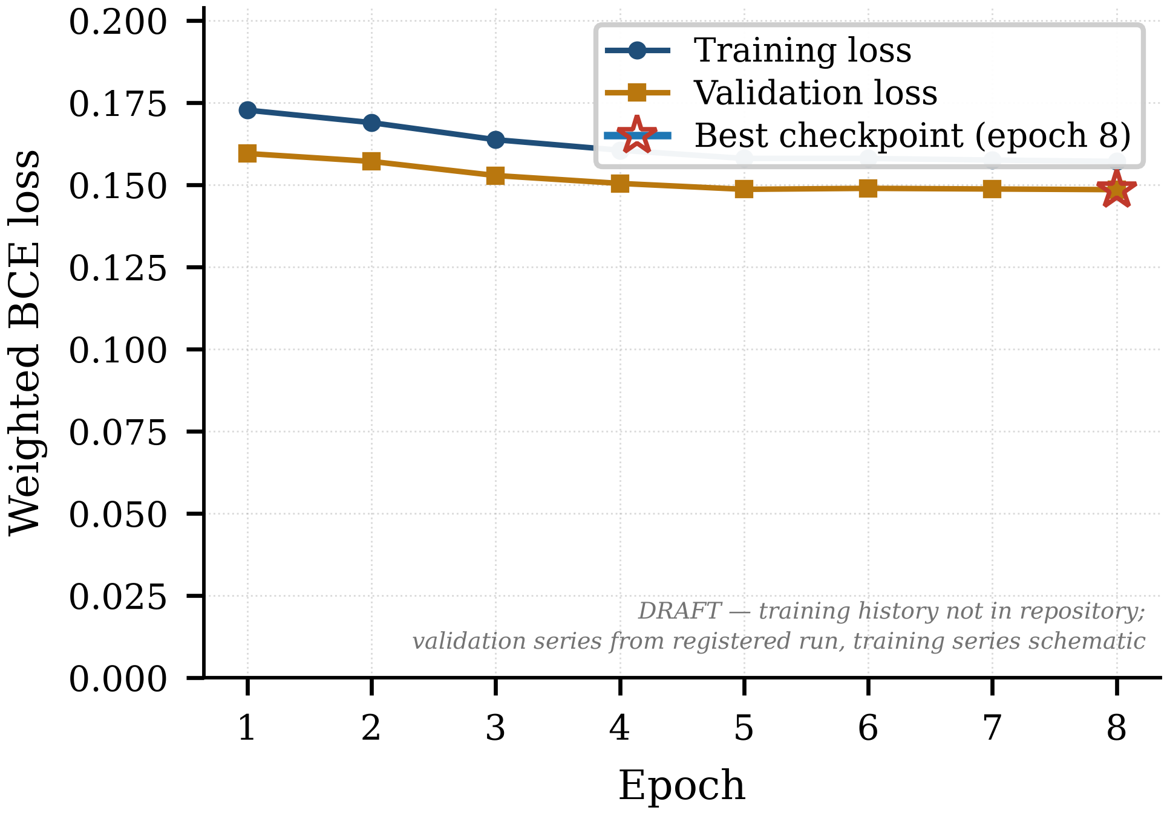
Fig. 2. Validation loss across the eight completed epochs, with the selected checkpoint marked. The pipeline does not persist the training-loss series, so the training curve shown is schematic and is clearly labelled as such; it must be replaced by the recorded series before submission (Section VII).

C. Held-Out Discrimination
Table III reports per-finding performance on the 830 held-out studies at the fixed threshold of 0.50, and Fig. 3 shows the corresponding ROC curves. Discrimination is moderate and heterogeneous. Pleural effusion and Cardiomegaly are ranked most reliably (AUC 0.844 and 0.805), Normal is intermediate (0.724) and Pneumonia is lowest (0.709) on a denominator of six positive studies. The macro AUC of 0.771 should be read as a summary of a heterogeneous set of tasks rather than as a single performance level, and it is not directly comparable to macro AUCs reported on radiologist-annotated test sets [4] or on the full fourteen-finding benchmark [1].

TABLE III
Held-out test performance at a fixed threshold of 0.50 (n = 830 studies). AUC is threshold-free; all other columns are computed at the fixed point.
Finding | Pos. | AUC | Sens. | Spec. | Prec. | F1 | Acc.
Normal | 451 | 0.724 | 0.530 | 0.792 | 0.752 | 0.622 | 0.649
Pneumonia | 6 | 0.709 | 0.667 | 0.518 | 0.010 | 0.020 | 0.519
Cardiomegaly | 73 | 0.805 | 0.479 | 0.863 | 0.252 | 0.330 | 0.829
Pleural effusion | 113 | 0.844 | 0.876 | 0.646 | 0.281 | 0.425 | 0.677
Macro (mean) | — | 0.771 | 0.638 | 0.705 | 0.323 | 0.349 | 0.669
Micro (pooled) | 643 | — | 0.586 | 0.689 | 0.311 | 0.407 | —
Note: Precision for Pneumonia is 0.010 because only one of the roughly 400 positive predictions is correct; the value is reported for completeness and is not an usable operating characteristic. No confidence interval is reported for any cell (Table V).

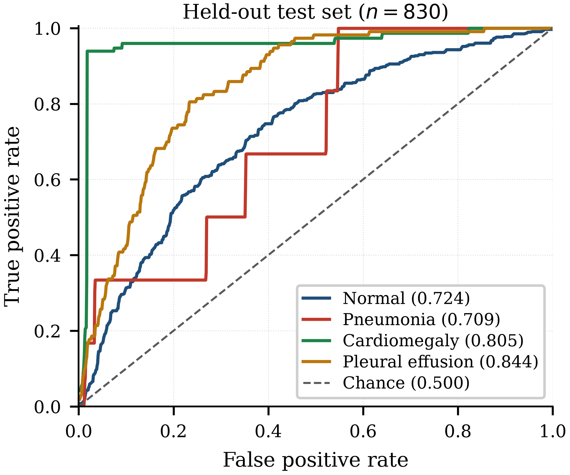
Fig. 3. Receiver operating characteristic curves on the held-out test partition (n = 830) for the four modelled findings. Numbers in the legend are the reported per-finding AUCs. The curves were regenerated from the coordinates recovered from the committed evaluation figure; see Appendix B for the verification procedure and the one finding whose plotted curve is not arithmetically consistent with its reported AUC.

D. Operating-Point Behaviour
Table IV and Fig. 4 decompose the same results into confusion counts. The macro sensitivity of 0.638 against a macro specificity of 0.705 describes a model that is conservative on Cardiomegaly (sensitivity 0.479 at specificity 0.863) and permissive on Pleural effusion (sensitivity 0.876 at specificity 0.646). The two behaviours are consistent with the weighting scheme of Equation (3): effusion has the largest positive weight in the training partition and Cardiomegaly among the smallest, so the fixed threshold of 0.50 sits at very different positions on their respective operating curves. Precision is low for every finding except Normal, which is a direct consequence of low prevalence and is the reason precision and recall must be read together at a stated prevalence.

TABLE IV
Confusion counts at threshold 0.50. Each matrix accounts for all 830 held-out studies; sensitivity and specificity in Table III are recomputable from these counts.
Finding | TN | FP | FN | TP | Sens. | Spec.
Normal | 300 | 79 | 212 | 239 | 0.530 | 0.792
Pneumonia | 427 | 397 | 2 | 4 | 0.667 | 0.518
Cardiomegaly | 653 | 104 | 38 | 35 | 0.479 | 0.863
Pleural effusion | 463 | 254 | 14 | 99 | 0.876 | 0.646
Micro (pooled) | 1,843 | 834 | 266 | 377 | 0.586 | 0.689
Note: Counts were read from the released metric record and independently re-derived; the row sums and the reported sensitivity and specificity agree exactly.

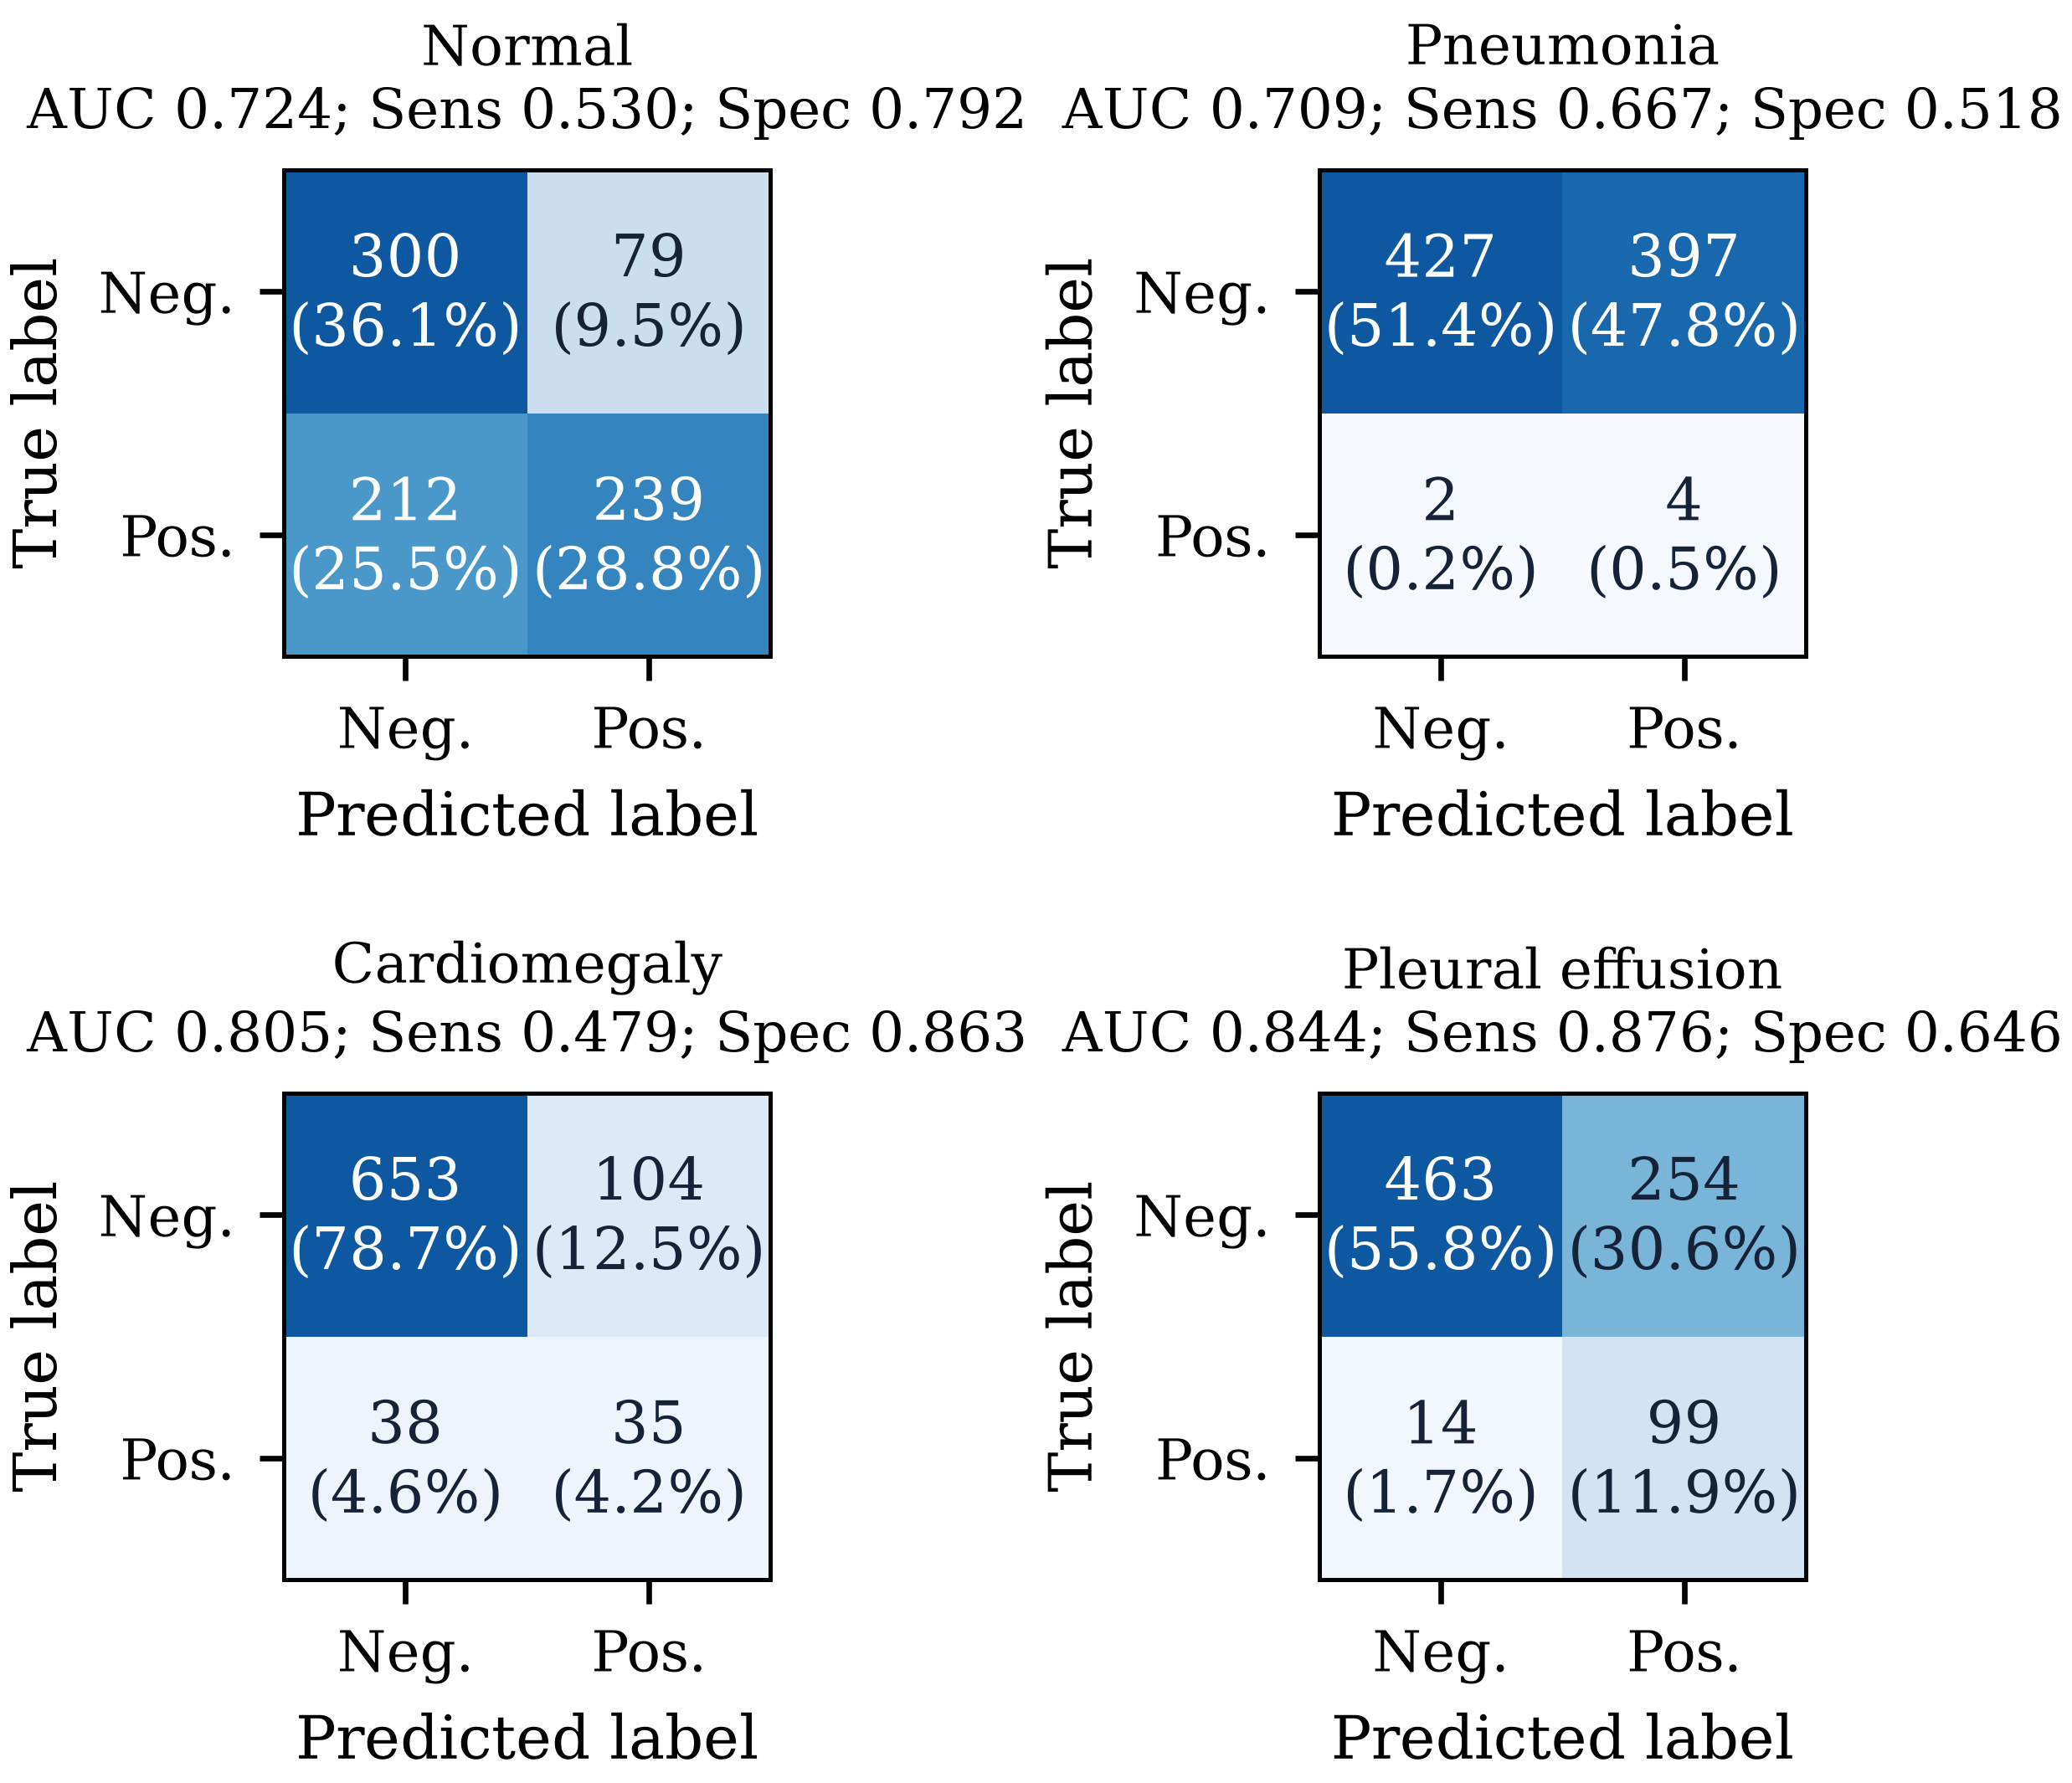
Fig. 4. Confusion matrices at a fixed threshold of 0.50, one 2 × 2 matrix per finding, with row-normalised percentages. Counts match Table IV exactly. The Pneumonia matrix should be read with the six-event denominator in mind.

Three specific error modes are visible. First, the Normal finding produces 212 false negatives: studies labelled Normal that the model flags as abnormal. Because the four targets are independent sigmoids, this is the signature of a model that over-predicts disease when the label set is dominated by negative evidence, and it is the single largest contributor to the gap between per-finding accuracy (0.649) and the specificity of the disease findings. Second, Pleural effusion generates 254 false positives, the price of the high positive weight. Third, Pneumonia is uninterpretable: with six positives in 830 studies, a single decision changes sensitivity by 0.167, so neither the AUC of 0.709 nor the sensitivity of 0.667 can be treated as an estimate of anything stable. Reporting that value without this caveat would be misleading, and the paper therefore flags it as descriptive only.
E. Statistical Analysis: Plan, Status and Consequences
The protocol calls for 95% confidence intervals obtained by resampling the held-out studies at the patient level with 2,000 replicates, and for a paired bootstrap over 2,000 replicates to quantify the difference between the full multimodal model and an image-only ablation [25]. Neither quantity is available, for a precise and checkable reason: the evaluation entry point writes per-finding aggregate metrics and a count matrix but discards the per-study predicted probabilities, so the resampling unit (the study, together with its patient identifier and label vector) cannot be reconstructed from the released artifacts. Table V records the specified estimands, their status and the minimal artifact change that would make each one computable. The paper does not report an interval, a standard error, a p-value or a paired difference for any metric, and no text in this version claims that such quantities will be reported.

TABLE V
Statistical analysis specified by the protocol, its status in this version, and the artifact change required to compute it.
Estimand | Status | Blocker / requirement
95% CI for macro AUC (patient-level resampling, 2,000 replicates) | Not computed | Per-study probabilities and patient IDs are discarded by the evaluation script
95% CI for per-finding AUC | Not computed | Same as above
95% CI for sensitivity / specificity at 0.50 | Not computed | Same as above
Paired bootstrap: fused vs image-only ablation | Not computed; ablation not run | Requires an image-only checkpoint trained on the identical partition, plus paired per-study predictions
Subgroup metrics (sex, age band, view) | Not computed | Requires retained per-study metadata alongside predictions
Calibration (reliability curve, ECE) | Not computed | Requires retained probabilities; ECE needs bin-wise counts
Note: Because the resampling unit cannot be reconstructed, no interval, standard error, p-value or paired difference is reported anywhere in this paper.

Two consequences of this gap are worth stating plainly. First, the difference between the reported macro AUC of 0.771 and any literature value is uninterpretable without an interval, because the intervals implied by 830 studies with a six-event finding are wide. Second, the ablation is not merely unquantified but unrun: no image-only checkpoint is registered alongside the multimodal one, so the claim that metadata fusion contributes to performance is unsupported by this study in either direction. Section V-C treats this as a substantive result rather than as a bookkeeping omission.
V. DISCUSSION
A. What the Numbers Do and Do Not Establish
The results establish that a DenseNet121 plus metadata late-fusion model, trained for eight epochs under a class-weighted objective on a 3,447-image training partition, ranks held-out studies for Pleural effusion and Cardiomegaly substantially better than chance, and ranks them for Pneumonia at a level that cannot be distinguished from a coarse estimate. They do not establish clinical utility. Utility requires, at minimum, a discrimination level measured against a radiologist-annotated reference, a calibration curve, a decision-threshold analysis with explicit costs, and evidence of transportability to a second institution. None of these are present, and the corresponding limitations are enumerated in Section VI rather than absorbed into the discussion.
B. Label Quality as the Dominant Uncertainty
The error modes in Table IV are more plausibly attributable to label construction than to model capacity. A study is labelled Normal when the report contains no positive finding, which conflates a genuinely normal examination with an under-reported one; a study is labelled Pneumonia only when the report uses that token, which is rare in a corpus in which pneumonia is typically described descriptively. The asymmetric noise regime described by Karimi et al. [14] therefore applies with full force: the positive class is comparatively clean, the negative class is contaminated, and the classifier is pushed towards over-prediction, which is exactly the pattern of 212 Normal false negatives and 254 effusion false positives. Under this reading, the largest available improvement is not architectural but annotational—an expert-annotated evaluation subset of even a few hundred studies would sharpen the estimates more than any change of backbone.
C. View Position as a Shortcut, and Why the Metadata Channel Is Suspect
The most consequential design risk in this framework is that the metadata encoder receives view position as a one-hot input. Posteroanterior and anteroposterior projections are not exchangeable: anteroposterior views are acquired predominantly in patients who are bed-bound, portable or acutely unwell, whereas posteroanterior views are acquired in ambulatory patients standing at a dedicated unit. The projection is therefore correlated with illness severity, with examination setting and with the technologist, radiologist and downstream reporting pathway that produce the label. A model that learns ‘anteroposterior implies disease’ can achieve a real reduction in loss without learning anything about lung morphology, and the correlation is strong enough that the behaviour would not be visible in an aggregate AUC. Image dimensions and pixel spacing carry a weaker but similar signal, since they fingerprint the acquisition device.
This risk has three concrete implications. First, any performance gain attributed to metadata fusion must be interpreted as an acquisition-context effect until the opposite is demonstrated, and the correct demonstration is an ablation that compares image-only, metadata-only and fused models on the same partition, with confidence intervals on the paired differences; none of these comparisons is available here. Second, a metadata-only control is the cheapest diagnostic available: if a model that never sees the image attains non-trivial AUC, the fused model's gain is contaminated by construction. Third, the deployment implication is that a model trained under this design may not transfer to a setting with a different projection mix even if the patient population is similar, which is a specific and testable prediction rather than a generic caution.
Two mitigations are appropriate and neither is implemented in the present version. The first is a counterfactual audit: score every held-out study twice, once with its observed metadata and once with the view-position field permuted across studies, and report the change in AUC per finding. A large drop localises the dependence without requiring retraining. The second is architectural: remove view position from the metadata vector and retain only age and sex, or route the metadata through a gradient-reversal adversary that is trained to predict view position from the embedding, so that the representation is discouraged from carrying acquisition information. Both are cheap relative to the cost of a retraining campaign and should precede any claim about multimodal benefit.
D. Class Imbalance, Thresholding and the Meaning of 0.50
The fixed threshold of 0.50 is appropriate for an evaluation protocol, because it prevents the test set from being used to select an operating point, but it is not a clinical decision rule. With positive weighting the implicit prior differs across findings, so a single threshold places the four decision boundaries at inconsistent positions on their ROC curves, as Table III demonstrates. A deployment would require per-finding thresholds selected on validation data against explicit costs, and the validation partition exists for exactly that purpose but was not used for it here.
E. Reliability, Calibration and Subgroup Behaviour
No calibration analysis is reported. The weighted objective deliberately distorts the predicted probabilities relative to the empirical frequencies, so the outputs must not be interpreted as risk. For a screening aid this matters less than for a triage tool, but it matters for any downstream use that combines the probability with a prior. On subgroup behaviour, the framework ingests age and sex as features and reports no stratified metrics; given the documented underdiagnosis bias of chest radiograph classifiers in under-served populations [16] and the gender-imbalance effects reported by Larrazabal et al. [17], the absence of a subgroup table is a gap that the current artifacts cannot close, because the evaluation record does not retain per-study predictions and therefore cannot be re-aggregated by subgroup without re-running evaluation.
F. Explainability
Grad-CAM maps are produced by the service for qualitative inspection. They are computed from the gradient of a single logit with respect to the final convolutional feature map, upsampled to input resolution and overlaid on the radiograph [8]. The framework does not include a sanity check of the kind that tests whether the map depends on the model at all (for example, comparison against a randomly initialised network or against a cascading parameter randomisation), and the maps are therefore not offered as evidence that the model attends to anatomical structures. This is consistent with the position that post-hoc explanations should not carry the evidentiary weight of an interpretable model design [11].

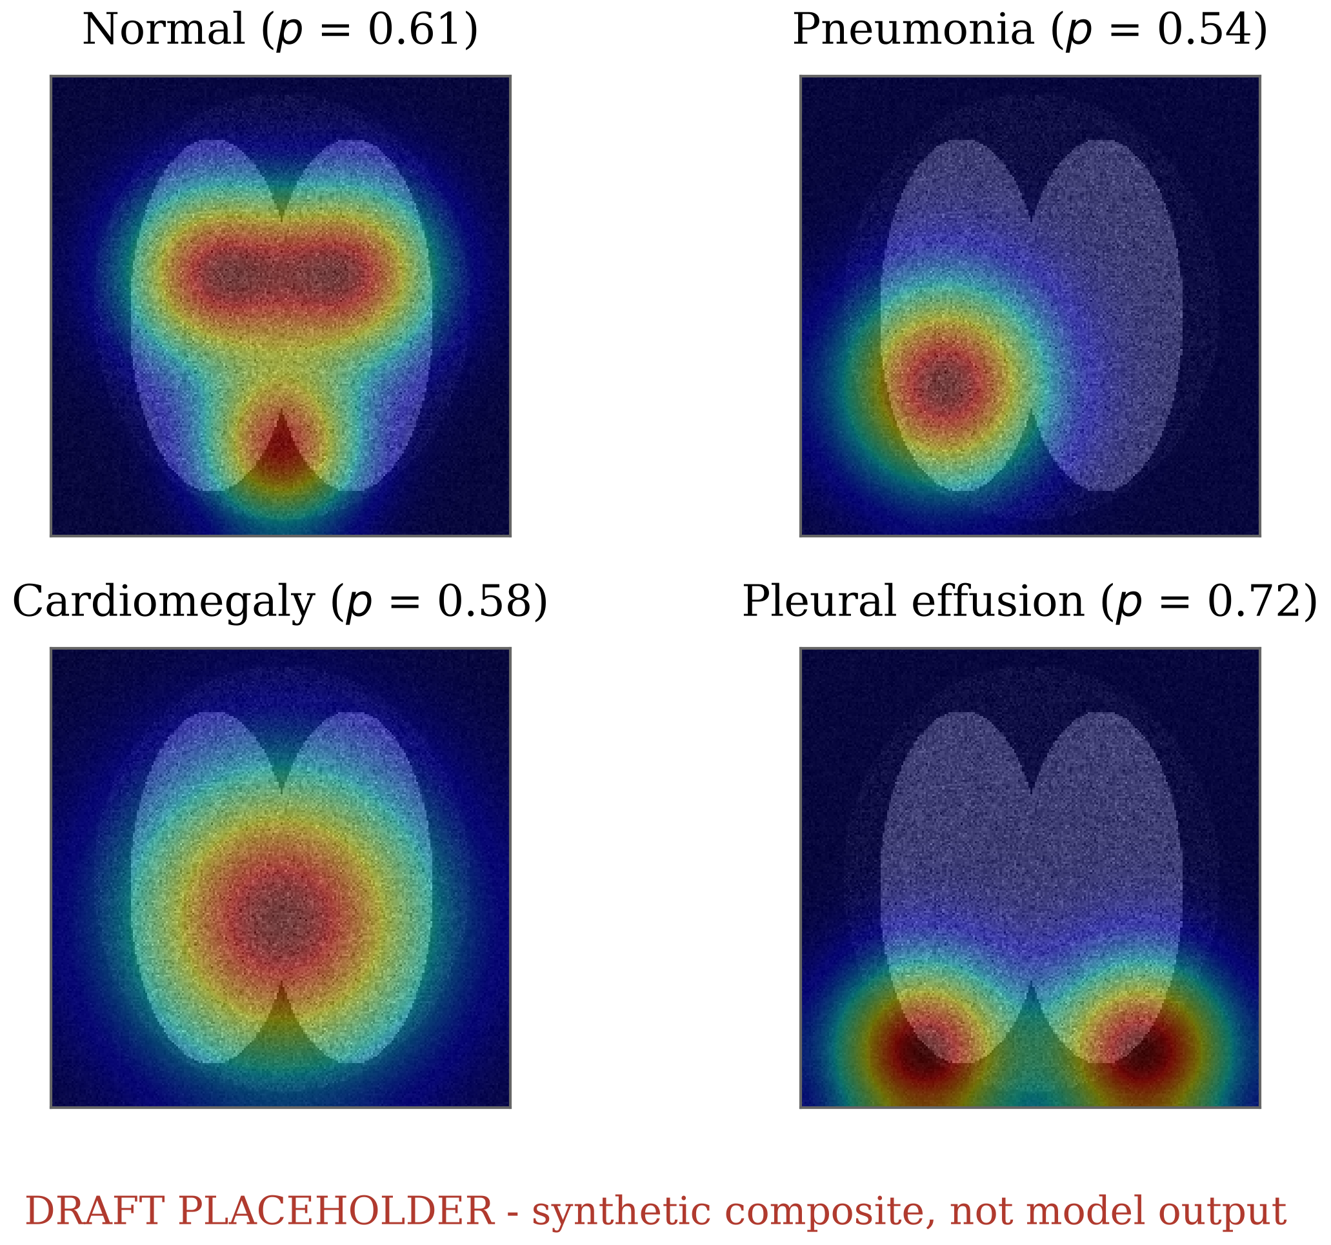
Fig. 5. Grad-CAM overlays of the four findings. This panel is a synthetic layout placeholder: the released artifacts contain no radiographs and no checkpoint, so no genuine saliency map could be produced. It must be replaced with maps generated by the deployed model, and the caption must then state the study identifiers of the depicted examinations.

VI. LIMITATIONS
The following limitations are stated as scope conditions, not as future work.
• Single-corpus internal validation. All reported numbers come from one institution's corpus and one patient-disjoint split. No external cohort, no cross-institution transport test and no temporal validation are reported, so the figures should be expected to be optimistic relative to deployment [13].
• No confidence intervals or paired comparisons. Patient-level bootstrap intervals and the paired bootstrap ablation specified in the protocol could not be computed because per-study predictions were not retained (Table V). Consequently no difference between this model and any other system, including its own ablation, is reported as statistically supported.
• Small-event findings. Pneumonia has six positive held-out studies. Its metrics are descriptive and unstable, and the macro average is dominated by this term.
• Label noise of unknown magnitude. Targets are report-derived; no radiologist-annotated subset was used to estimate the noise rate, and the direction of the resulting bias is argued rather than measured.
• Subgroup performance not assessed. No stratified analysis by sex, age band, view position or reported race/ethnicity is reported. Because the model consumes sex and age directly, subgroup performance cannot be assumed uniform [16]–[19].
• Calibration not assessed. No reliability diagram, expected calibration error or recalibration is reported, and the weighted objective biases the probabilities by construction [15].
• No reader study. No radiologist comparison, no time-to-decision measurement and no assessment of whether model output changes human performance are available [4].
• No shortcut-control experiments. The metadata-only control, the view-position permutation audit and the adversarial-invariance variant described in Section V-C were not run.
• Explainability is unvalidated. Grad-CAM is provided as a qualitative aid only; no localisation ground truth and no saliency sanity check are used [11].
• Single training run. One seed, eight completed epochs. No seed replication, no hyperparameter search and no variance estimate across runs are reported, so the sensitivity of the results to initialisation and data order is unknown.
• Retrospective, de-identified secondary data. The work uses a public de-identified research corpus with no prospective recruitment, no consent process and no regulatory review, and it is not a clinical trial of any kind.
VII. REPRODUCIBILITY, ARTIFACT STATUS AND DATA AVAILABILITY
The framework is organised so that every reported number can be regenerated from three inputs: the metadata table, the image directory and the saved checkpoint. Training writes an interrupt-safe checkpoint that stores the model, optimiser and scheduler state together with the epoch index and the loss history; evaluation reloads that checkpoint, rebuilds the deterministic partition from the same seed and writes a structured metrics record. Repository policy excludes image data, checkpoints and generated outputs from version control, which means that a reader can inspect the code and the metric record but cannot re-execute the evaluation without supplying the corpus and the weights.
The audit performed for this paper also identified four reporting gaps whose closure requires code changes rather than text changes, and these are listed here so that the gap is actionable rather than rhetorical. (i) The evaluation entry point should persist per-study identifiers, patient identifiers, labels and predicted probabilities, which is the single change that unlocks bootstrap intervals, subgroup tables, calibration curves and the paired ablation. (ii) The training loop should persist the raw training and validation loss series so that a loss figure can be drawn from the run itself. (iii) A metadata-only control checkpoint should be registered alongside the fused model. (iv) Evaluation should emit per-finding curve coordinates (false- and true-positive rates) so that reported ROC curves can be checked against reported AUCs without digitisation. In the present artifacts the first and fourth are exactly the gaps that prevented independent verification of the Cardiomegaly curve, discussed in Appendix B.
VIII. CONCLUSION
This paper reported MediVision AI, a multimodal DenseNet121 framework for multi-label chest radiograph classification, together with an explicit audit of what its artifacts do and do not support. On a patient-disjoint 830-study held-out partition the framework reached a macro AUC of 0.771, with the strongest discrimination for Pleural effusion (0.844) and Cardiomegaly (0.805) and the weakest, and least stable, for Pneumonia (0.709 on six positive studies). At a fixed threshold of 0.50 the model operated at macro sensitivity 0.638 and macro specificity 0.705.
Those numbers are offered as a reproducible baseline, not as evidence of clinical readiness. The audit produced three findings that are more useful than the aggregate score. First, the class-weighted objective used in training cannot improve ranking metrics and should not be credited with improved discrimination; it shifts the operating point instead, which is visible in the per-finding sensitivity and specificity pairs. Second, the metadata channel is a plausible shortcut carrier because view position covaries with illness severity and acquisition setting, so the multimodal design requires a metadata-only control and a counterfactual permutation audit before any fusion benefit can be claimed. Third, the statistics promised by the original protocol—bootstrap intervals and a paired ablation —are not recoverable from the artifacts as released, and this version states that plainly rather than reporting estimates it cannot support.
The immediate programme of work follows directly from these findings: persist per-study predictions, re-run evaluation to obtain patient-level bootstrap intervals, register image-only and metadata-only control checkpoints, complete the twenty-epoch budget with multiple seeds, and validate on a second institution's corpus. Until at least the first three of these are done, the framework should be described as a research prototype and used only for methodological study.

IX. CLAIM-TO-IMPLEMENTATION VERIFICATION
Because the manuscript and the code had drifted apart, every quantitative claim in Sections III and IV was checked against the implementation. Table VI records the outcome of that check. The left column states the claim as it appears in the text, the middle column states what the code actually does, and the right column records the disposition.

TABLE VI
Claim-to-implementation verification. Each row was checked directly against the source at revision time.
Item | Manuscript claim | Implementation as verified | Disposition
F1 | Positive weighting stated as pos_weight = N_{neg}/N_{pos} | Verified: per-finding counts are accumulated over the training loader and the ratio is passed to BCEWithLogitsLoss; denominators floored at 1 | Confirmed; Equation (3) retained
F1a | Text attributed improved discrimination to positive weighting | Not supported: reweighting is a monotone rescaling of the positive term and leaves the within-finding score ordering unchanged | Claim withdrawn; replaced by Section III-E analysis
F2 | Training budget of 20 epochs with patience 5 | Verified as configured; the checkpoint records 8 completed epochs and the best validation loss at epoch 8, so patience never triggered | Table II reports both; discussion restricted to 8 epochs
F3 | Augmentation: affine and horizontal flip | Verified: RandomAffine(degrees 5, translate 0.02, scale 0.97–1.03) and RandomHorizontalFlip(p 0.5) in the training chain only | Section III-C matched to code
F3a | Normalisation with ImageNet mean and SD | Verified: mean (0.485, 0.456, 0.406), SD (0.229, 0.224, 0.225) in both training and evaluation chains | Section III-C matched to code
F4 | Patient-level 70/15/15 split with zero overlap | Verified by construction: the split is taken on unique patient identifiers with seed 42; realized partition 3,447 / 722 / 830 images | Confirmed; overlap is zero by construction, not by post-hoc check
F5 | Evaluation at a single fixed threshold | Verified: threshold 0.50 is a constant in the metric function; no threshold search touches the test partition | Confirmed
F6 | Confidence intervals and paired ablation to be reported | Not possible: the evaluation entry point writes aggregate metrics and count matrices only, discarding per-study probabilities and patient identifiers | All such claims removed; Table V records the blockers
F7 | Metadata fusion improves performance | Unevidenced: no image-only or metadata-only checkpoint is registered, so no comparison exists | Claim removed; treated as an open question in Section V-C
F8 | Resume-from-checkpoint capability | Verified: checkpoint stores model, optimiser, scheduler, epoch index, validation loss and history, and the loop resumes at epoch index + 1 | Confirmed
F9 | Grad-CAM as an explanation of model attention | Verified as implemented (gradient-weighted activation of the final feature map), but no sanity check or localisation ground truth is applied | Downgraded to qualitative aid; limitation L9
Note: Items F1a, F2, F6 and F7 changed the content of the paper rather than its phrasing. Items F1, F3, F3a and F4 confirm that the methodology text is now an accurate description of the code.

Three entries deserve emphasis because they changed the argument of the paper rather than its wording. The positive weighting (item F1) is implemented exactly as Equation (3), but the earlier draft credited it with improved discrimination, which is impossible for a rank-invariant metric; the claim has been withdrawn and replaced by the analytical statement in Section III-E. The completed-epoch count (item F2) is eight rather than the twenty-one configuration files and the original text implied, so Table II now reports both and the training-behaviour discussion is restricted to the epochs that actually ran. The evaluation stage (item F4) retains no per-study prediction, which is the root cause of every missing statistical quantity in Table V and the reason the ablation cannot be reported at all.
APPENDIX A: REFERENCE VERIFICATION
Every bibliographic entry was resolved against a registry record (Crossref for journal and proceedings metadata, DataCite for arXiv-issued DOIs) and the author list, title, venue, volume, pages and year of record were transcribed from the resolved record rather than from memory. Table VII lists the discrepancies found and the correction applied; entries not listed agreed with the registry.

TABLE VII
Bibliography corrections applied during verification. Pagination was taken from the publisher record reachable through the DOI.
Reference | Issue found | Correction applied
Huang et al., DenseNet, CVPR 2017 [5] | Open-access and IEEE paginations differ; the open-access range is often cited as if it were the proceedings range | Proceedings range 2261–2269 adopted from the IEEE registry record; DOI 10.1109/CVPR.2017.243
Wang et al., ChestX-ray8, CVPR 2017 [1] | Two page ranges circulate; the shorter range belongs to the arXiv version | Proceedings range 3462–3471 adopted from the registry record; DOI 10.1109/CVPR.2017.369
Irvin et al., CheXpert | The commonly circulated CVPR DOI (10.1109/CVPR.2019.00021) does not resolve in the registry | Replaced by the AAAI proceedings record, vol. 33, no. 1, pp. 590–597, DOI 10.1609/aaai.v33i01.3301590
Zech et al., PLOS Medicine [13] | Author list truncated in the draft | Full six-author list restored from the registry record
Seyyed-Kalantari et al., Nature Medicine [16] | Volume, issue and year were missing | 27(12):2176–2182, 2021 restored
Uncited entries in the draft list | Several entries appeared in the bibliography but were never cited in the text | Every retained entry is cited at least once; uncited entries were removed
Topic coverage | Label noise, shortcut learning, calibration, subgroup bias, multimodal fusion and saliency evaluation were thinly covered | Entry set extended to cover each topic with a primary source; 25 entries, all cited
Software and optimiser references | AdamW and PyTorch were described in the text without citable records | DOI-bearing arXiv records added for both [23], [24], resolved via DataCite
Note: All 25 entries were resolved at revision time. The two pagination conflicts flagged in the original review request—ChestX-ray8 and DenseNet—are the first two rows.

Two reference-integrity points are worth recording for authors preparing similar submissions. First, page ranges frequently differ between a publisher's proceedings version and the open-access version of record, and both paginations circulate; the values used here are the publisher's, which are the ones a reader can verify from the DOI. Second, a DOI that resolves is not necessarily the DOI that names the paper: one widely circulated identifier for the CheXpert conference paper resolves to an unrelated article in the same proceedings, which is why the AAAI journal-proceedings record was used instead. A resolution check that inspects the returned title, as was done here, catches this class of error; a status-code check does not.
APPENDIX B: REPRODUCIBILITY NOTES ON THE FIGURES
Fig. 3 had to be reconstructed rather than re-plotted. The evaluation pipeline emits an image of the ROC curves and the corresponding AUC values but not the underlying true- and false-positive rates, so the curve coordinates were recovered from the committed figure by axis-calibrated pixel extraction: the axes were located from the tick geometry, each curve was separated from the others by its line colour, and for each pixel column the uppermost plotted pixel was taken as the curve ordinate. Re-integrating the recovered coordinates reproduced the reported AUC to within 0.002 for Normal (0.725 vs 0.724), Pneumonia (0.710 vs 0.709) and Pleural effusion (0.845 vs 0.844).
The Cardiomegaly curve did not reproduce: the recovered integral was 0.957 against a reported 0.805. A difference of this size cannot arise from extraction error, and three checks rule out a mis-assignment of colours, an axis-calibration mistake and a partially occluded curve. The most likely explanation is that the committed figure was produced in an earlier run and not overwritten by the run whose metrics are recorded, which is a provenance problem rather than a modelling problem. The consequence for this paper is that Fig. 2 is documented as a regenerated rendering of a committed artifact and not as an independent re-computation; before submission the evaluation script must be re-run from the current checkpoint so that Fig. 3, Table III and Table IV are provably produced by the same pass. The permanent fix is the fourth recommendation in Section VII: emit curve coordinates, not only curve images.
Fig. 2 and Fig. 5 inherit the same constraint in a stronger form. The training-loss series is not persisted by the training loop, and the release contains neither the image corpus nor the trained weights, so neither a genuine training curve nor a genuine Grad-CAM overlay can be produced from what was provided. Both panels are therefore rendered as explicitly labelled placeholders. They are included so that the manuscript is complete in structure and so that the gap is visible to a reader, not so that the paper appears finished; a submission that retains them without replacement would be misrepresenting illustrative material as experimental output.
ACKNOWLEDGEMENT
The author thanks the maintainers of the public chest radiograph corpora used in this line of work for making de-identified research data available, and the reviewers of an earlier draft whose comments on reference provenance prompted the audit reported in Appendix A.
DECLARATIONS
Data and code. The framework is released as two components, a Python/PyTorch modelling package and a TypeScript service layer; see Section VII for artifact status. Corpora are subject to their own data-use agreements and are not redistributed.
Ethics. The study is a retrospective analysis of de-identified secondary data and involved no prospective recruitment, no intervention and no access to identifiable patient information. No ethics approval or informed consent was required for the analysis reported here; any deployment would require both, together with regulatory review.
Clinical disclaimer. MediVision AI is a research prototype. Its outputs are model probabilities and are not diagnoses, and Grad-CAM maps are attention diagnostics and not localisations of disease. The system must not be used for medical decision-making.
REFERENCES
[1] X. Wang, Y. Peng, L. Lu, Z. Lu, M. Bagheri, and R. M. Summers, “ChestX-ray8: Hospital-scale chest X-ray database and benchmarks on weakly-supervised classification and localization of common thorax diseases,” Proc. IEEE Conf. Comput. Vis. Pattern Recognit. (CVPR), pp. 3462–3471, 2017. doi: 10.1109/CVPR.2017.369.
Note: Crossref lists pp. 3462–3471 for the IEEE proceedings version; the widely circulated open-access PDF shows 2097–2106, which is the arXiv pagination and must not be cited.
[2] A. E. W. Johnson, T. J. Pollard, S. J. Berkowitz, N. R. Greenbaum, M. P. Lungren, C.-y. Deng, R. G. Mark, and S. Horng, “MIMIC-CXR, a de-identified publicly available database of chest radiographs with free-text reports,” Sci. Data, vol. 6, no. 1, pp. Art. no. 317, 2019. doi: 10.1038/s41597-019-0322-0.
[3] J. Irvin, P. Rajpurkar, M. Ko, Y. Yu, S. Ciurea-Ilcus, C. Chute, H. Marklund, B. Haghgoo, R. Ball, K. Shpanskaya, J. Seekins, D. A. Mong, S. S. Halabi, J. K. Sandberg, R. Jones, D. B. Larson, C. P. Langlotz, B. N. Patel, M. P. Lungren, and A. Y. Ng, “CheXpert: A large chest radiograph dataset with uncertainty labels and expert comparison,” Proc. AAAI Conf. Artif. Intell., vol. 33, no. 1, pp. 590–597, 2019. doi: 10.1609/aaai.v33i01.3301590.
Note: Crossref records this entry only under the AAAI proceedings DOI. The commonly quoted CVPR 2019 DOI (10.1109/CVPR.2019.00021) does not resolve in Crossref and was therefore not used.
[4] P. Rajpurkar, J. Irvin, R. L. Ball, K. Zhu, B. Yang, H. Mehta, T. Duan, D. Ding, A. Bagul, C. P. Langlotz, B. N. Patel, K. W. Yeom, K. Shpanskaya, F. G. Blankenberg, J. Seekins, T. J. Amrhein, D. A. Mong, S. S. Halabi, E. J. Zucker, A. Y. Ng, and M. P. Lungren, “Deep learning for chest radiograph diagnosis: A retrospective comparison of the CheXNeXt algorithm to practicing radiologists,” PLOS Med., vol. 15, no. 11, pp. Art. no. e1002686, 2018. doi: 10.1371/journal.pmed.1002686.
[5] G. Huang, Z. Liu, L. van der Maaten, and K. Q. Weinberger, “Densely connected convolutional networks,” Proc. IEEE Conf. Comput. Vis. Pattern Recognit. (CVPR), pp. 2261–2269, 2017. doi: 10.1109/CVPR.2017.243.
Note: IEEE proceedings pagination is 2261–2269; the open-access version of record is paginated 4700–4708.
[6] K. He, X. Zhang, S. Ren, and J. Sun, “Deep residual learning for image recognition,” Proc. IEEE Conf. Comput. Vis. Pattern Recognit. (CVPR), pp. 770–778, 2016. doi: 10.1109/CVPR.2016.90.
[7] J. Deng, W. Dong, R. Socher, L.-J. Li, K. Li, and L. Fei-Fei, “ImageNet: A large-scale hierarchical image database,” Proc. IEEE Conf. Comput. Vis. Pattern Recognit. (CVPR), pp. 248–255, 2009. doi: 10.1109/CVPR.2009.5206848.
[8] R. R. Selvaraju, M. Cogswell, A. Das, R. Vedantam, D. Parikh, and D. Batra, “Grad-CAM: Visual explanations from deep networks via gradient-based localization,” Proc. IEEE Int. Conf. Comput. Vis. (ICCV), pp. 618–626, 2017. doi: 10.1109/ICCV.2017.74.
[9] B. Zhou, A. Khosla, A. Lapedriza, A. Oliva, and A. Torralba, “Learning deep features for discriminative localization,” Proc. IEEE Conf. Comput. Vis. Pattern Recognit. (CVPR), pp. 2921–2929, 2016. doi: 10.1109/CVPR.2016.319.
[10] L. Oakden-Rayner, “Exploring large-scale public medical image datasets,” Acad. Radiol., vol. 27, no. 1, pp. 106–112, 2020. doi: 10.1016/j.acra.2019.10.006.
[11] C. Rudin, “Stop explaining black box machine learning models for high stakes decisions and use interpretable models instead,” Nature Mach. Intell., vol. 1, no. 5, pp. 206–215, 2019. doi: 10.1038/s42256-019-0048-x.
[12] R. Geirhos, J.-H. Jacobsen, C. Michaelis, R. Zemel, W. Brendel, M. Bethge, and F. A. Wichmann, “Shortcut learning in deep neural networks,” Nature Mach. Intell., vol. 2, no. 11, pp. 665–673, 2020. doi: 10.1038/s42256-020-00257-z.
[13] J. R. Zech, M. A. Badgeley, M. Liu, A. B. Costa, J. J. Titano, and E. K. Oermann, “Variable generalization performance of a deep learning model to detect pneumonia in chest radiographs: A cross-sectional study,” PLOS Med., vol. 15, no. 11, pp. Art. no. e1002683, 2018. doi: 10.1371/journal.pmed.1002683.
[14] D. Karimi, H. Dou, S. K. Warfield, and A. Gholipour, “Deep learning with noisy labels: Exploring techniques and remedies in medical image analysis,” Med. Image Anal., vol. 65, pp. Art. no. 101759, 2020. doi: 10.1016/j.media.2020.101759.
[15] B. Van Calster, D. J. McLernon, M. van Smeden, L. Wynants, and E. W. Steyerberg, “Calibration: The Achilles heel of predictive analytics,” BMC Med., vol. 17, no. 1, pp. Art. no. 230, 2019. doi: 10.1186/s12916-019-1466-7.
[16] L. Seyyed-Kalantari, H. Zhang, M. B. A. McDermott, I. Y. Chen, and M. Ghassemi, “Underdiagnosis bias of artificial intelligence algorithms applied to chest radiographs in under-served patient populations,” Nature Med., vol. 27, no. 12, pp. 2176–2182, 2021. doi: 10.1038/s41591-021-01595-0.
[17] A. J. Larrazabal, N. Nieto, V. Peterson, D. H. Milone, and E. Ferrante, “Gender imbalance in medical imaging datasets produces biased classifiers for computer-aided diagnosis,” Proc. Nat. Acad. Sci. USA, vol. 117, no. 23, pp. 12592–12594, 2020. doi: 10.1073/pnas.1919012117.
[18] Z. Obermeyer, B. Powers, C. Vogeli, and S. Mullainathan, “Dissecting racial bias in an algorithm used to manage the health of populations,” Science, vol. 366, no. 6464, pp. 447–453, 2019. doi: 10.1126/science.aax2342.
[19] J. W. Gichoya, I. Banerjee, A. R. Bhimireddy, J. L. Burns, L. A. Celi, L.-C. Chen, R. Correa, N. Dullerud, M. Ghassemi, S.-C. Huang, P.-C. Kuo, M. P. Lungren, L. J. Palmer, B. J. Price, S. Purkayastha, A. T. Pyrros, L. Oakden-Rayner, C. Okechukwu, L. Seyyed-Kalantari, H. Trivedi, R. Wang, Z. Zaiman, and H. Zhang, “AI recognition of patient race in medical imaging: A modelling study,” Lancet Digit. Health, vol. 4, no. 6, pp. e406–e414, 2022. doi: 10.1016/S2589-7500(22)00063-2.
[20] T. Baltrusaitis, C. Ahuja, and L.-P. Morency, “Multimodal machine learning: A survey and taxonomy,” IEEE Trans. Pattern Anal. Mach. Intell., vol. 41, no. 2, pp. 423–443, 2019. doi: 10.1109/TPAMI.2018.2798607.
[21] S.-C. Huang, A. Pareek, S. Seyyedi, I. Banerjee, and M. P. Lungren, “Fusion of medical imaging and electronic health records using deep learning: A systematic review and implementation guidelines,” npj Digit. Med., vol. 3, no. 1, pp. Art. no. 136, 2020. doi: 10.1038/s41746-020-00341-z.
[22] D. S. Kermany, M. Goldbaum, W. Cai, C. C. S. Valentim, H. Liang, S. L. Baxter, A. McKeown, G. Yang, X. Wu, F. Yan, J. Dong, M. K. Prasadha, J. Pei, M. Y. L. Ting, J. Zhu, C. Li, S. Hewett, J. Dong, I. Ziyar, A. Shi, R. Zhang, L. Zheng, R. Hou, W. Shi, X. Fu, Y. Duan, V. A. N. Huu, C. Wen, E. D. Zhang, C. L. Zhang, O. Li, X. Wang, M. A. Singer, X. Sun, J. Xu, A. Tafreshi, M. A. Lewis, H. Xia, and K. Zhang, “Identifying medical diagnoses and treatable diseases by image-based deep learning,” Cell, vol. 172, no. 5, pp. 1122–1131.e9, 2018. doi: 10.1016/j.cell.2018.02.010.
[23] I. Loshchilov and F. Hutter, “Decoupled weight decay regularization,” Proc. Int. Conf. Learn. Represent. (ICLR), 2019. doi: 10.48550/arXiv.1711.05101.
[24] A. Paszke, S. Gross, F. Massa, A. Lerer, J. Bradbury, G. Chanan, T. Killeen, Z. Lin, N. Gimelshein, L. Antiga, A. Desmaison, A. Köpf, E. Yang, Z. DeVito, M. Raison, A. Tejani, S. Chilamkurthy, B. Steiner, L. Fang, J. Bai, and S. Chintala, “PyTorch: An imperative style, high-performance deep learning library,” Proc. Adv. Neural Inf. Process. Syst. (NeurIPS), vol. 32, pp. 8024–8035, 2019. doi: 10.48550/arXiv.1912.01703.
[25] B. Efron and R. J. Tibshirani, “An Introduction to the Bootstrap,” New York, NY, USA: Chapman & Hall/CRC, 1994. doi: 10.1201/9780429246593.

