

Capstone Project Report
Report 3 – Software Requirement Specification
Battery-Aware Mission Planner (BAMP)
A Decision-Support System for Energy Consumption Prediction in Surveillance Drones

Class: IS1904 Supervisor: Assoc.Prof. Ngô Đăng Hà An

Group: Trương Quốc Tuấn (Leader); Lê Vương Định; Nguyễn Trường Huy; Võ Minh Thuận; Nguyễn Ngọc Phương Anh

– Ho Chi Minh City, September 2026 –
Table of Contents
Right-click here and choose "Update Field" (or press Ctrl+A then F9) to generate the Table of Contents.

I. Record of Changes
Date | A*  M, D | In charge | Change Description
03-Sep-2026 | A | Whole team | Initial draft of Report 3 - SRS, derived from the approved Capstone Project Register (BAMP).
*A - Added M - Modified D - Deleted

II. Software Requirement Specification

1. Product Overview
Battery-Aware Mission Planner (BAMP) is a standalone, offline decision-support application that predicts the energy consumption of a planned surveillance-drone mission before it is flown. Surveillance UAV operations (traffic monitoring, infrastructure inspection) are constrained by battery capacity, and operators currently lack an accessible tool to estimate whether a planned mission is achievable on a given drone before committing to it, or to compare how different drone platforms would perform under the same mission profile.
BAMP addresses this gap by combining real-world UAV flight telemetry (CMU KiltHub dataset, 209 flights) with four candidate regression models (Linear Regression, Random Forest, XGBoost, Gradient Boosting), validated through 5-fold cross-validation and paired statistical significance testing (extended from the team's prior DTA301 research), to estimate the energy a mission will consume and to compare that estimate against the selected drone's battery capacity. The context diagram below shows the two external entities the system exchanges data with: the Operator, and an optional external AI Explanation Service.
The application runs entirely offline and does not require physical drone hardware, live telemetry, or an internet connection for its core functionality (Drone Management, Mission Configuration, Prediction, Simulation, Feasibility Assessment). Only the optional AI-generated natural-language explanation of the model recommendation (Tier 2 extension) requires connectivity, and it degrades gracefully to a template-based explanation when the external API is unavailable.
Figure 1. Context Diagram – Battery-Aware Mission Planner (BAMP)
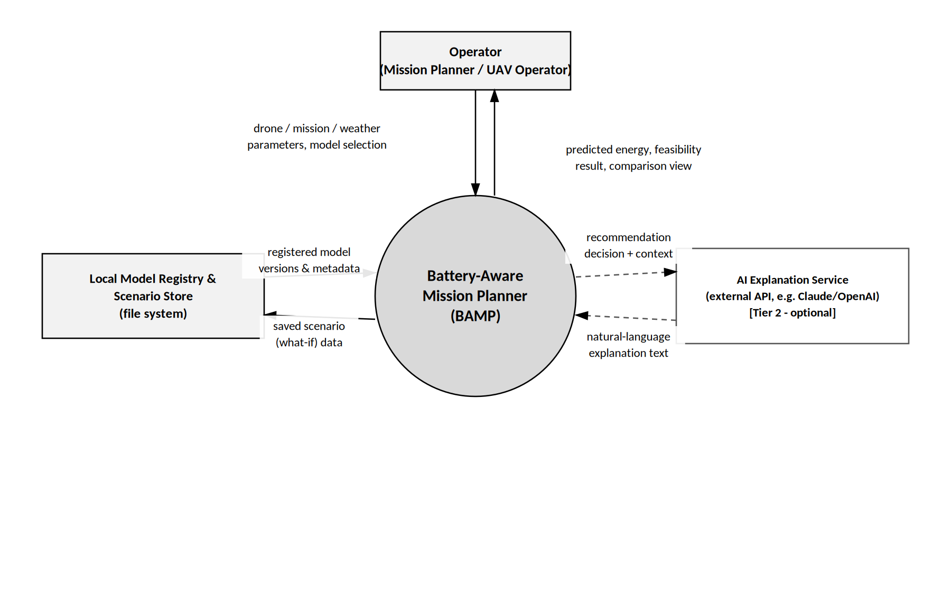

2. User Requirements

2.1 Actors
The application is used by a single human role. It also integrates with one optional external system actor, invoked by the application itself rather than directly by the human actor.
# | Actor | Description
1 | Operator | The primary and only end user of the standalone application: a mission planner / UAV operator who configures drones, missions, and weather conditions; selects a prediction model and version; and reviews simulation and feasibility results. The MVP has no login or role differentiation.
2 | AI Explanation Service (external) | A third-party generative-AI API (e.g., OpenAI or Claude) invoked by the system - not directly by the Operator - to phrase the rule-based Model Recommendation decision as natural language. Optional Tier 2 extension; the system falls back to a template-based explanation when this actor is unavailable.

2.2 Use Cases
A use case (UC) describes a sequence of interactions between the Operator (or, for UC-06, the external AI Explanation Service) and BAMP that results in value for the Operator. The diagram and table below cover the Tier 1 (MVP) and Tier 2 (extension) use cases defined in the project register.

2.2.1 Diagram(s)

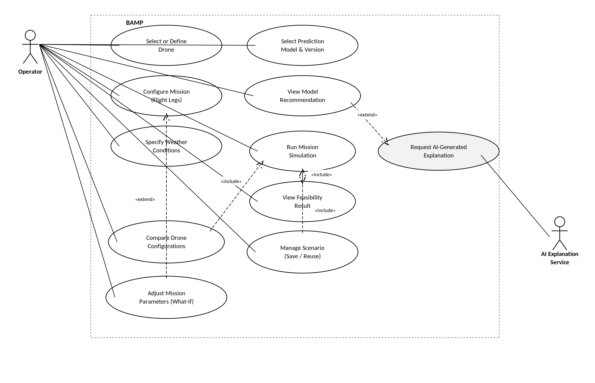
Figure 2. Use Case Diagram – BAMP

2.2.2 Descriptions

ID | Use Case | Actors | Use Case Description
UC-01 | Select or Define Drone | Operator | Operator selects one of the predefined drone models, or defines a custom drone by entering its technical specifications (weight, battery capacity, payload capacity).
UC-02 | Configure Mission | Operator | Operator defines a mission composed of one or more flight legs, each specifying duration, altitude, distance, and payload.
UC-03 | Specify Weather Conditions | Operator | Operator manually enters the wind speed applicable to the mission.
UC-04 | Select Prediction Model & Version | Operator | Operator selects a prediction model (Linear Regression / Random Forest / XGBoost / Gradient Boosting) and a specific registered model version before running a simulation.
UC-05 | View Model Recommendation | Operator | System presents a rule-based recommended model/version for the current scenario; Operator may accept it or select a different one.
UC-06 | Request AI-Generated Explanation | Operator, AI Explanation Service | «extend» of UC-05: the recommendation decision is phrased as a natural-language explanation via an external AI API, with a local template-based fallback if the API is unavailable.
UC-07 | Run Mission Simulation | Operator | Operator executes the simulation, producing a per-leg and total predicted energy estimate. «include» UC-08.
UC-08 | View Feasibility Result | Operator | System compares total predicted energy against the selected drone's battery capacity and reports a Feasible / Not Feasible status with a safety margin.
UC-09 | Compare Drone Configurations | Operator | Operator runs the same mission scenario across multiple drone configurations and views the resulting energy estimates side by side. «include» UC-07 (once per drone).
UC-10 | Manage Scenario (Save / Reuse) | Operator | Operator saves the current combination of drone + mission + weather + model version as a named scenario, and reuses or modifies it later.
UC-11 | Adjust Mission Parameters (What-if) | Operator | «extend» of UC-02: Operator interactively changes payload, altitude, or wind speed and observes the recalculated prediction without re-entering the whole mission.

3. Functional Requirements

3.1 System Functional Overview
This section describes BAMP's screens, non-screen (service-layer) functions, and data model. As noted in 2.1, the application has a single Operator role and no server-side authentication/authorization subsystem in the MVP, which shapes 3.1.3 below.

3.1.1 Screens Flow

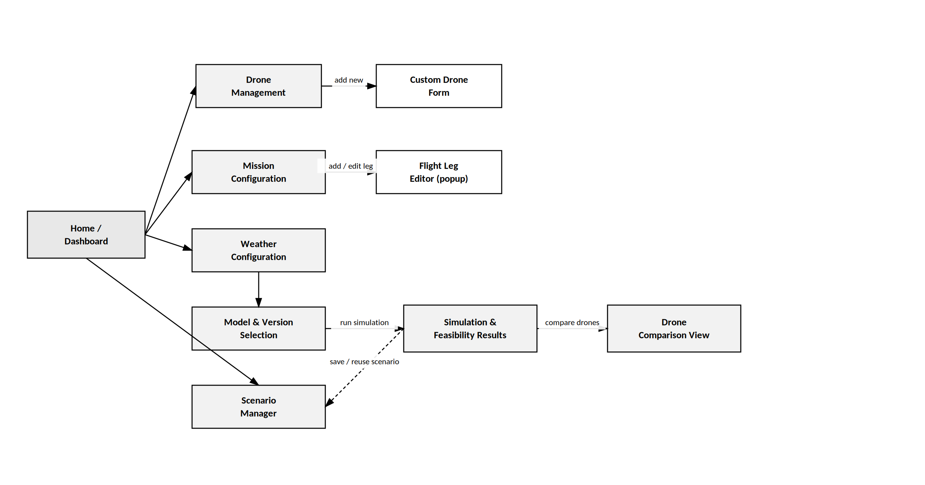
Figure 3. Screens Flow Diagram – BAMP

3.1.2 Screen Descriptions

# | Feature | Screen | Description
1 | Drone Management | Drone List / Selection | Lists predefined drone models (name, battery capacity, payload capacity); entry point to define a custom drone.
2 | Drone Management | Custom Drone Form | Form to enter a custom drone's technical specifications (see Figure 5).
3 | Mission Configuration | Mission Builder | Add, edit, and remove the flight legs that make up a mission (see Figure 6).
4 | Mission Configuration | Flight Leg Editor | Popup/modal to enter or edit a single leg's duration, altitude, distance, and payload.
5 | Weather Configuration | Weather Form | Manual entry of wind speed for the mission (embedded in the Mission Builder screen, Figure 6).
6 | Prediction | Model & Version Selection | Select the prediction model and a registered version; view the rule-based recommendation.
7 | Simulation | Simulation & Feasibility Results | Per-leg and total predicted energy, feasibility status and margin, what-if controls (see Figure 7).
8 | Comparison | Drone Comparison View | Side-by-side comparison of the same mission simulated across multiple drones (see Figure 8).
9 | Scenario Management | Scenario Manager | Lists saved scenarios; load, rename, or delete a scenario.

3.1.3 Screen Authorization
BAMP is a standalone, single-user application: the MVP has no login and no multi-role authorization subsystem (see 2.1), so the role-authorization matrix required by this template section is simplified to one Operator role with full access to every screen. If a future extension introduces additional roles (e.g., a read-only supervisor review mode), this matrix should be expanded with the additional role columns.
Screen | Operator
Drone List / Selection | X
Custom Drone Form | X
Mission Builder | X
Flight Leg Editor | X
Weather Form | X
Model & Version Selection | X
Simulation & Feasibility Results | X
Drone Comparison View | X
Scenario Manager | X

3.1.4 Non-Screen Functions

# | Feature | System Function | Description
1 | Prediction | Prediction Engine | Loads the selected pre-trained model artifact (version-locked) and computes the predicted energy consumption for a flight leg from its parameters.
2 | Prediction | Feasibility Calculator | Sums per-leg predictions into a total mission energy estimate and compares it against the drone's battery capacity with a safety margin (BR-04, BR-05).
3 | Prediction | Model Recommendation Rule Engine | Deterministic rule, grounded in the team's Report 3/4 cross-validation and statistical-test results, that selects the recommended model/version for a scenario (WP1-confirmed 'Option A').
4 | Prediction | AI Explanation Client (Tier 2) | Calls the external AI Explanation Service to phrase the Model Recommendation decision in natural language; falls back to a local template if the API is unavailable (BR-06, BR-07).
5 | Data Validation | Out-of-Range Validator | Checks user-entered drone/mission/weather parameters against the range represented in the training dataset and raises a warning when exceeded (BR-03).
6 | Data Persistence | Scenario Persistence Service | Saves and loads scenario definitions (drone + mission + weather + model version) to/from local storage.
7 | Data Persistence | Model Registry Service | Maintains registered, immutable model versions and their metadata (dataset, feature set, hyperparameters, evaluation metrics) (BR-02).

3.1.5 Entity Relationship Diagram

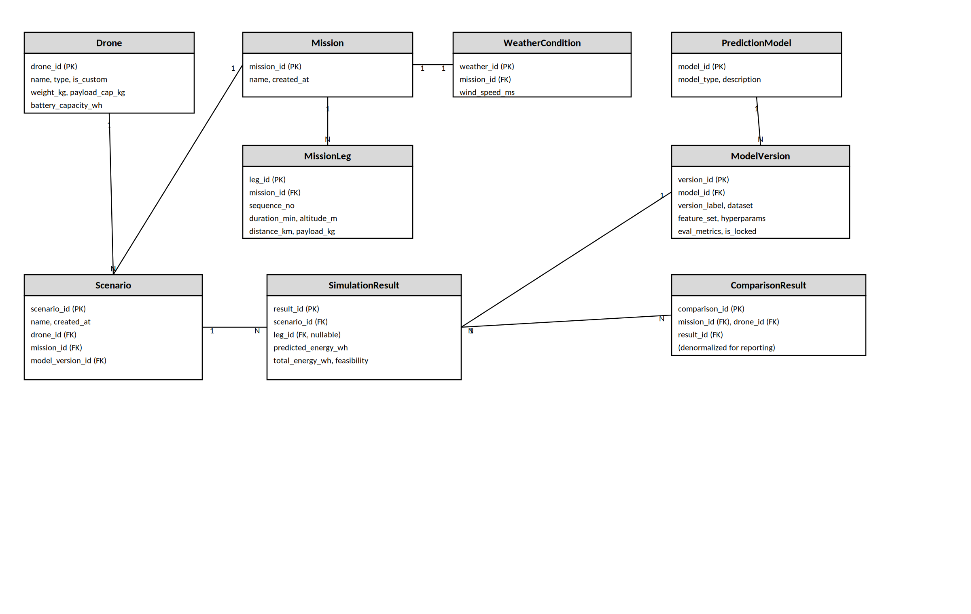
Figure 4. Entity Relationship Diagram – BAMP
Entities Description
# | Entity | Description
1 | Drone | A predefined or custom drone configuration (weight, battery capacity, payload capacity).
2 | Mission | A named mission composed of one or more flight legs.
3 | MissionLeg | A single leg of a mission (duration, altitude, distance, payload).
4 | WeatherCondition | Wind speed applicable to a mission (one set of conditions per mission in the MVP - see 3.3.2).
5 | PredictionModel | A candidate model type: Linear Regression, Random Forest (Tier 1); XGBoost, Gradient Boosting (Tier 2).
6 | ModelVersion | An immutable, registered, trained artifact of a PredictionModel, with its training dataset, feature set, hyperparameters, and evaluation metrics (BR-02).
7 | Scenario | A saved combination of drone + mission + weather + model version, reusable for what-if analysis (UC-10, UC-11).
8 | SimulationResult | The predicted energy (per-leg and total) and feasibility status produced by running a Scenario.
9 | ComparisonResult | A denormalized record linking a SimulationResult to the mission and drone it was produced for, to support the side-by-side comparison view (UC-09).

3.2 Drone Management

3.2.1 Select Predefined Drone
- Function trigger: Operator opens Drone Management from the Home/Dashboard and selects a drone from the predefined list.
- Function description: Only actor: Operator. Purpose is to start a scenario quickly using an existing, already-characterized drone configuration without re-entering specifications. The list shows drone name, type, battery capacity, and payload capacity (UC-01).
- Screen layout: Reuses the Drone List / Selection screen described in 3.1.2 (a simple read-only list with a 'Define Custom Drone' action); no separate mock-up is required for this function.
- Function Details: Predefined entries are read-only reference data shipped with the application; they cannot be edited or deleted from within the application. If the Operator needs a configuration outside this list, they proceed to 3.2.2 Define Custom Drone.

3.2.2 Define Custom Drone
- Function trigger: Operator selects 'Define Custom Drone' from the Drone Management screen (UC-01).
- Function description: Only actor: Operator. Lets the Operator register a drone that is not in the predefined list, so it can be used in any Mission Configuration (3.3) or Drone Comparison (3.6).
- Screen layout: See Figure 5.
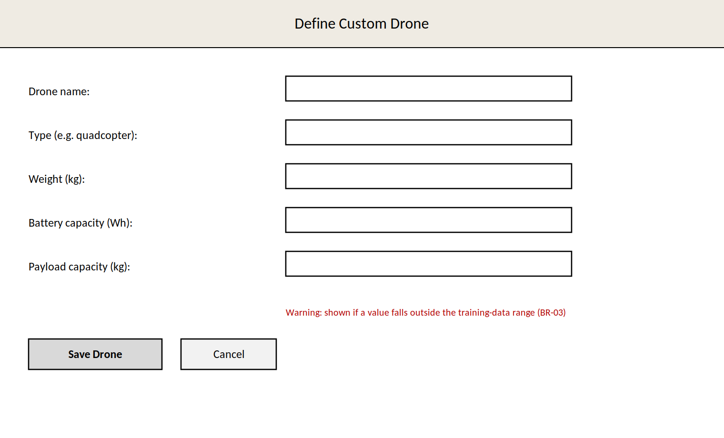
Figure 5. Define Custom Drone – screen mock-up
- Function Details: Fields: drone name, type, weight (kg), battery capacity (Wh), payload capacity (kg). Validation: all numeric fields must be greater than 0; values are checked against the range represented in the training dataset, and an out-of-range warning is shown when exceeded, though the drone can still be saved (BR-03). Custom drones are stored locally and can be reused and edited in later scenarios.

3.3 Mission Configuration

3.3.1 Configure Mission (Flight Legs)
- Function trigger: Operator opens Mission Configuration from the Home/Dashboard, or a saved scenario is loaded from the Scenario Manager and pre-fills this screen (UC-02, UC-10).
- Function description: Only actor: Operator. Purpose is to build a mission from one or more flight legs that will be simulated together as a patrol session.
- Screen layout: Figure 6 shows the combined Mission Configuration screen, which also hosts Weather Configuration (3.3.2) and Prediction Model Selection (3.4.1), consistent with the Screens Flow in Figure 3.
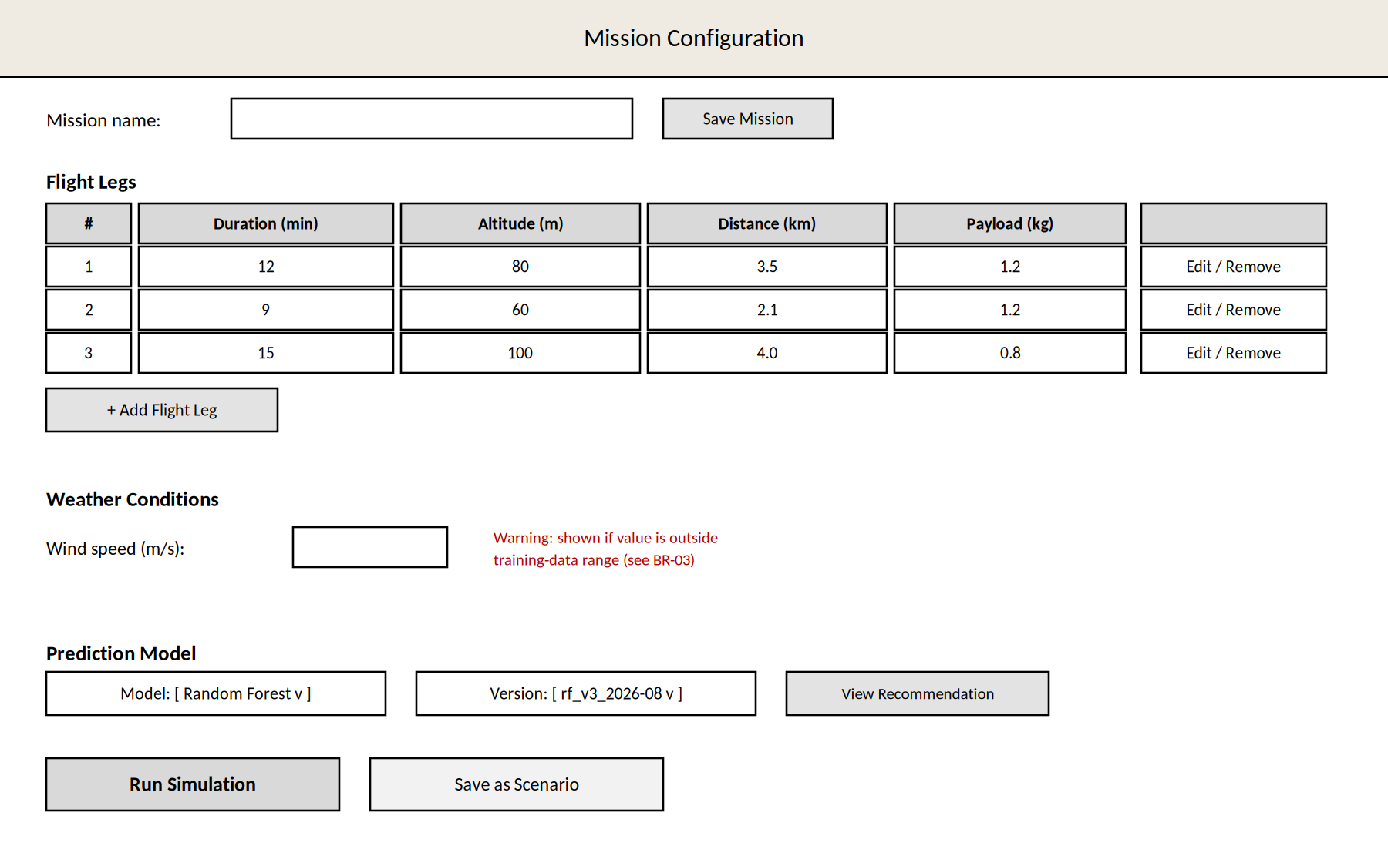
Figure 6. Mission Configuration – screen mock-up (also covers 3.3.2 and 3.4.1)
- Function Details: A mission shall consist of at least one flight leg (BR-01). Each leg requires duration (min), altitude (m), distance (km), and payload (kg), all validated as greater than 0 and checked against the training-data range (BR-03). Legs are added, edited, or removed through the Flight Leg Editor popup (screen #4 in 3.1.2). The mission name is optional while editing but required to save the mission as a Scenario (3.7.1).

3.3.2 Specify Weather Conditions
- Function trigger: Embedded in the Mission Configuration screen (Figure 6); no separate navigation is required.
- Function description: Only actor: Operator. Captures the wind speed applicable to the mission (UC-03).
- Screen layout: See the 'Weather Conditions' section of Figure 6.
- Function Details: The current MVP models one wind-speed value per mission rather than per flight leg (see WeatherCondition in 3.1.5). ASSUMPTION – TO CONFIRM WITH THE SUPERVISOR: whether wind should instead be captured per leg for missions whose legs span a long duration or different times of day; the data model would need a WeatherCondition-per-leg relationship if so. Wind speed is validated against the training-data range (BR-03).

3.4 Prediction & Model Selection

3.4.1 Select Prediction Model & Version
- Function trigger: Operator interacts with the 'Prediction Model' section of the Mission Configuration screen (Figure 6) before running a simulation (UC-04).
- Function description: Only actor: Operator. Lets the Operator choose which candidate model, and which specific registered version of it, will be used for the simulation.
- Screen layout: See the 'Prediction Model' section of Figure 6.
- Function Details: Model choices are Linear Regression and Random Forest for the committed Tier 1 MVP; XGBoost and Gradient Boosting are added as Tier 2 extensions if the schedule allows (BR-09). The Version dropdown lists only immutable, registered versions of the selected model, each carrying its training dataset, feature set, hyperparameters, and evaluation metrics; the selected model and version are recorded with every simulation result for traceability (BR-02).

3.4.2 View Model Recommendation
- Function trigger: Operator clicks 'View Recommendation' on the Mission Configuration screen (UC-05).
- Function description: Primary actor: Operator. System-invoked actor: AI Explanation Service (UC-06). Presents a recommended model/version for the current scenario.
- Screen layout: See the 'View Recommendation' control in Figure 6; the recommendation is shown as a short text panel, not a separate screen.
- Function Details: The recommendation itself is produced by the deterministic Model Recommendation Rule Engine (3.1.4), grounded in the team's Report 3/4 cross-validation and statistical-significance results, so it remains reliable and reproducible without external dependency; WP1 confirmed the simple rule-based approach ('Option A') with the supervisor. The AI Explanation Service (UC-06) is only used to phrase this decision as natural language and never changes the decision itself (BR-06); if the API is unavailable, a local template-based sentence is shown instead (BR-07).

3.5 Simulation & Results

3.5.1 Run Mission Simulation
- Function trigger: Operator clicks 'Run Simulation' after configuring the drone, mission, weather, and model/version (UC-07).
- Function description: Only actor: Operator. Produces the predicted energy consumption for the configured mission.
- Screen layout: Figure 7.
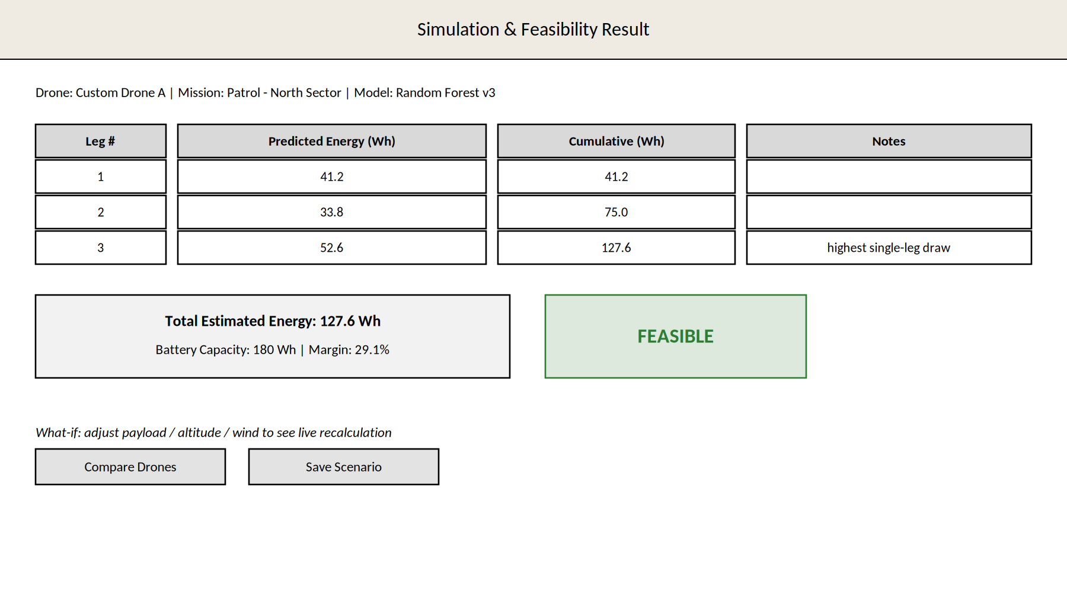
Figure 7. Simulation & Feasibility Result – screen mock-up
- Function Details: For each leg, the Prediction Engine (3.1.4) computes a predicted energy value from the selected model version; per-leg values are summed into a total mission energy estimate (BR-04). The result should return within an acceptable interactive delay to support real-time what-if exploration (see 4.2.3).

3.5.2 View Feasibility Result
- Function trigger: Automatic: immediately follows 3.5.1 (UC-07 includes UC-08).
- Function description: Only actor: Operator. Compares the total predicted energy against the selected drone's battery capacity.
- Screen layout: See the feasibility panel in Figure 7 ('FEASIBLE' indicator).
- Function Details: A mission is Feasible if total predicted energy does not exceed the drone's battery capacity minus an agreed safety margin (BR-05); the margin is a configurable constant, provisionally 10-15%, to be confirmed with the supervisor. The panel also shows the numeric margin so the Operator can judge borderline cases, and offers 'Compare Drones' (3.6.1) and 'Save Scenario' (3.7.1) as next actions.

3.6 Drone Comparison

3.6.1 Compare Drone Configurations
- Function trigger: Operator clicks 'Compare Drones' from the Simulation & Feasibility Results screen (UC-09).
- Function description: Only actor: Operator. Runs the same mission scenario across multiple drone configurations.
- Screen layout: Figure 8.
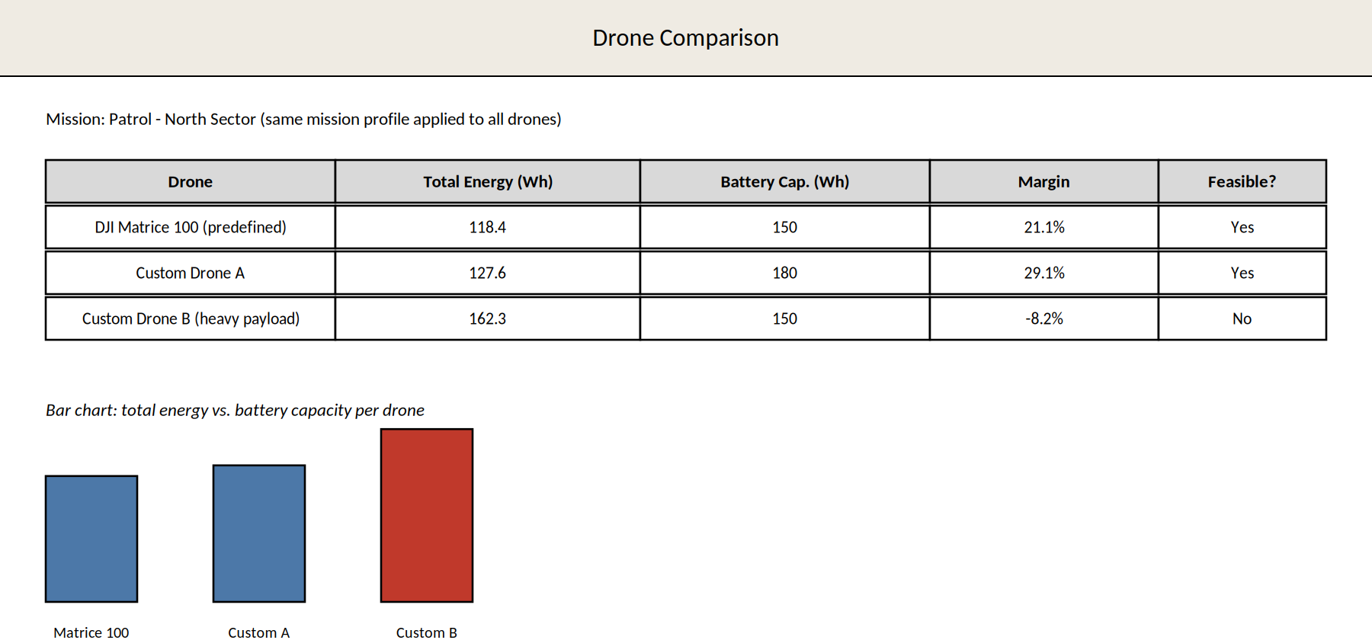
Figure 8. Drone Comparison – screen mock-up
- Function Details: Operator selects two or more drones (predefined and/or custom, 3.2). The same mission, weather, and model version are applied to each (UC-09 includes UC-07 once per drone); results are shown side by side with a Feasible / Not Feasible indicator per drone, consistent with 3.5.2.

3.7 Scenario Management

3.7.1 Save / Reuse Scenario (What-if Analysis)
- Function trigger: Operator clicks 'Save as Scenario' on the Results screen (Figure 7), or opens Scenario Manager from the Home/Dashboard (UC-10).
- Function description: Only actor: Operator. Persists the current drone + mission + weather + model version combination so it can be reopened, modified, and re-run.
- Screen layout: Scenario Manager screen (#9 in 3.1.2): a list of saved scenarios (name, created date) with load/rename/delete actions.
- Function Details: Opening a saved scenario pre-fills Mission Configuration (3.3.1) with its data. For what-if analysis (UC-11), the Operator then edits payload, altitude, or wind speed and re-runs the simulation without rebuilding the whole mission. Scenarios are persisted locally by the Scenario Persistence Service (3.1.4).

4. Non-Functional Requirements

4.1 External Interfaces
BAMP has a single external interface: a REST call to a third-party generative-AI API (e.g., OpenAI or Claude) used only by the AI Explanation Client (3.1.4) to phrase the Model Recommendation decision (UC-06). No other external system, hardware, or live-telemetry interface exists in the committed MVP scope; the core prediction/simulation pipeline reads only locally stored model artifacts and local scenario data (see the context diagram, Figure 1).

4.2 Quality Attributes

4.2.1 Usability
Target, to be validated by the WP5 usability testing defined in the project register: a first-time Operator should be able to configure a single-leg mission, select a prediction model, and obtain a feasibility result without external help. A concrete task-time target will be set after the first usability test session rather than assumed here. The interface shall clearly flag out-of-range inputs (BR-03) rather than fail silently, and shall label every prediction with the model/version that produced it (BR-02).

4.2.2 Reliability
BAMP is a standalone desktop/web application with no server component in the MVP, so availability, MTBF, and MTTR in the traditional client-server sense do not apply. Reliability is instead expressed as:
(a) the application shall not lose or corrupt a saved Scenario if it is closed unexpectedly after a successful save;
(b) a prediction result shall always be traceable to the exact model version used, even after the application is restarted (BR-02);
(c) if the AI Explanation Service is unreachable, the application shall degrade to the template-based explanation rather than fail the Model Recommendation feature (BR-07).

4.2.3 Performance
The prediction/simulation pipeline shall return a result within an acceptable interactive delay to support real-time what-if exploration, per the project register. A concrete target is proposed here for the team and supervisor to confirm once the WP3 models are integrated into the WP4 application:
Single-leg prediction (used for interactive what-if recalculation): proposed target ≤ 2 seconds.
Full mission simulation (all legs) and feasibility result: proposed target ≤ 5 seconds for a typical patrol mission (≤ 10 legs).
Loading the Model Registry and listing available versions shall not noticeably delay screen navigation.

4.2.4 Portability
The application shall be usable on standard desktop/web-browser environments without specialized installation requirements, per the project register. No physical drone hardware or live telemetry connection is required for core functionality (BR-08); the AI Explanation feature (Tier 2) is the only functionality that requires internet connectivity.

5. Requirement Appendix

5.1 Business Rules

ID | Rule Definition
BR-01 | A mission shall consist of at least one flight leg.
BR-02 | A registered model version is immutable once created; every prediction/simulation result shall record the exact model type and version used, together with its evaluation metrics, for traceability and reproducibility.
BR-03 | If a user-provided drone, mission, or weather parameter falls outside the range represented in the training dataset, the system shall display an out-of-range warning; the prediction is still produced but shall be flagged as reduced-confidence.
BR-04 | Total mission energy consumption is the sum of the predicted energy consumption of each flight leg in the mission.
BR-05 | A mission is Feasible if the total predicted mission energy does not exceed the selected drone's battery capacity minus an agreed safety margin; the margin value is to be confirmed with the supervisor.
BR-06 | The AI-generated explanation (Tier 2) shall only phrase the Model Recommendation decision; it shall never alter the underlying rule-based recommendation itself.
BR-07 | If the external AI Explanation Service is unavailable, the system shall fall back to a local template-based explanation so the Model Recommendation feature remains usable offline.
BR-08 | The core functionality (Drone Management, Mission Configuration, Prediction, Simulation, Feasibility Assessment) shall operate entirely offline, without requiring an internet connection or physical drone hardware.
BR-09 | Linear Regression and Random Forest are the two prediction models committed for the Tier 1 MVP; XGBoost and Gradient Boosting are Tier 2 extensions, added only if the schedule allows.

5.2 Common Requirements
All numeric inputs use metric units (kg, m, km, m/s, Wh), consistent with the data dictionary to be produced in WP2. All dates/timestamps are recorded in ISO 8601. UI-level common requirements (field-length limits, default values, keyboard shortcuts, etc.) are to be added by the team once the WP4 screen designs are finalized.
The set below is representative and derived from the business rules in 5.1; it should be extended with the final message copy once the WP4 UI is implemented.

5.3 Application Messages List
# | Message code | Message Type | Context | Content
1 | MSG01 | In red, under the field | Numeric field left empty or ≤ 0 | The {field} field is required and must be greater than 0.
2 | MSG02 | Inline warning (amber) | Parameter outside training-data range (BR-03) | This value is outside the range seen in the training data; the prediction may be less reliable.
3 | MSG03 | Toast message | Simulation completed successfully | Simulation complete – see the Feasibility Result below.
4 | MSG04 | Toast message | Scenario saved successfully | Scenario "{name}" saved successfully.
5 | MSG05 | Inline banner | AI Explanation Service unavailable (BR-07) | AI explanation unavailable – showing a standard explanation instead.
6 | MSG06 | In red, under the field | Mission has zero flight legs (BR-01) | Add at least one flight leg before running a simulation.
7 | MSG07 | Inline, result panel | Mission not feasible (BR-05) | Estimated energy exceeds the drone's battery capacity by {x} Wh.

5.4 Other Requirements
None identified at this stage; to be completed during WP4/WP5 as the UI and test plan are finalized.

