CAPSTONE PROJECT REPORT
IntelliScope
AI-Driven Business Insight & Decision Optimization Dashboard

Student Name | Sanchayan Garai
Roll Number | 2306136
Batch / Program | 2023–2027 | B.Tech – Information Technology
College | Kalinga Institute of Industrial Technology (KIIT)
Project Title | IntelliScope: AI-Driven Business Insight & Decision Optimization Dashboard
Tool Used | Microsoft Power BI
Submission Date | April 21, 2026

Kalinga Institute of Industrial Technology (KIIT)
Department of Information Technology | B.Tech 2023–2027

1. Problem Statement
Modern businesses generate vast amounts of transactional data across sales, customers, products, and regions. However, the absence of a unified, interactive analytical platform makes it difficult for decision-makers to extract timely insights, identify performance trends, or act on data-driven strategies. Traditional static reports fail to capture dynamic patterns, segment-level variances, or profitability classifications in real time.

The core challenges addressed by this project are:
- Lack of a centralized view of business performance across products, regions, and time periods
- Difficulty in tracking month-over-month and year-to-date sales growth trends
- Inability to classify and compare profit performance across categories (High, Medium, Low)
- No structured customer segmentation analysis across Consumer, Corporate, and Home Office segments
- Absence of interactive filtering for regional and category-level drill-down

2. Solution & Features
IntelliScope is a four-page interactive Power BI dashboard that consolidates business data into actionable intelligence. Built on a real-world retail dataset (train.csv), it enables stakeholders to monitor, analyze, and optimize decisions across sales, customer behavior, and operational performance.

2.1 Executive Overview
The first page provides a high-level snapshot of the entire business for quick executive consumption.
- KPI Cards: Total Sales (619.17K), Total Orders (3K), Total Customers (665), Average Sales (231.38)
- MoM Growth % displayed with conditional formatting — currently at 0.66%
- YTD Sales metric showing 196.14K cumulative sales
- Monthly Sales Trend line chart for temporal performance tracking
- Sales by Region interactive map (Bing Maps) with region-level color coding (Central, East, South, West)
- Smart Narrative visual automatically summarizing key data observations
- Slicers for Order Date range, Region, and Category filtering

2.2 Sales Analytics
The second page provides deep-dive analysis of product and regional sales performance.
- Total Sales by Sub-Category displayed as a color-coded Treemap — Chairs (88.66K) and Phones (83.28K) are top performers
- Product Rank table listing top-performing products (Canon imageCLASS 2200 Advanced Copier ranked #1)
- Category Sales Distribution bar chart: Technology leads, followed by Furniture and Office Supplies
- Regional Sales Performance bar chart: West region contributes the highest revenue
- Smart Narrative summarizing sub-category totals and spread (range: 776.98 to 88,659.37)
- Region and Category slicers for cross-filtering

2.3 Customer Insights
The third page focuses on customer segmentation, top buyers, and regional behavior.
- Segment Contribution Donut Chart: Consumer (46.94% | 290.62K), Corporate (32.13% | 198.92K), Home Office (20.94% | 129.63K)
- Sales by Segment horizontal bar chart for direct segment comparison
- Top Customers Table ranked by sales — Tamara Chand leads at 17,499.95 in Technology
- Total Sales by Region and Segment stacked bar chart for cross-dimensional analysis
- Top Customer Sales KPI card showing 18.44K
- Region and Segment slicers for dynamic filtering

2.4 Performance Analysis (Category-Based)
The fourth page evaluates business performance using categorical profit classification (High / Medium / Low).
- KPI Cards: Total Sales (619.17K), High Sales (393.28K), Medium Sales (172.24K), Low Sales (53.65K), Top Category (Technology)
- Sales by Profit Category clustered column chart — High category dominates at ~0.4M
- Top 10 Products by Sales horizontal bar chart — Canon imageCLASS 2200 Advanced Copier (17K) ranks first
- Category Performance by Profit Class stacked column chart — Technology, Furniture, Office Supplies broken down by profit class
- Sales Contribution by Profit Category waterfall chart showing cumulative contribution: High (0.39M) → Medium (0.17M) → Low (0.05M) → Total (0.62M)
- Key Performance Insights text block with five auto-generated observations

3. Dashboard Screenshots

3.1 Page 1 – Executive Overview
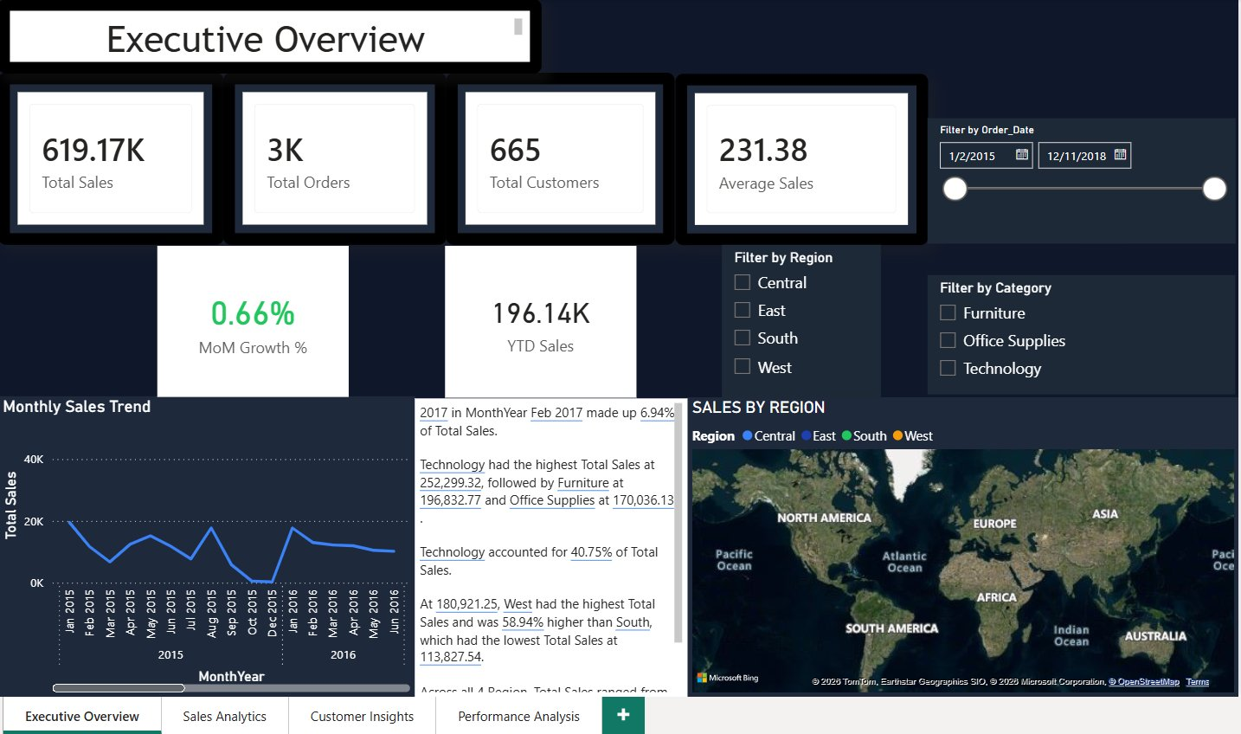
Figure 1: Executive Overview — KPIs, Monthly Trend, Sales by Region Map, Smart Narrative

3.2 Page 2 – Sales Analytics
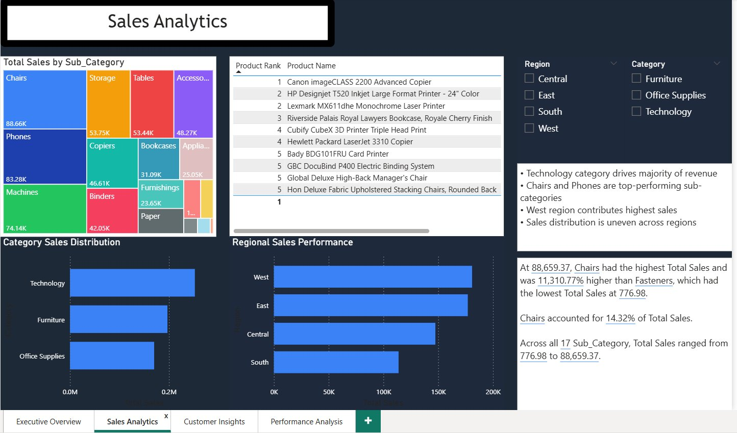
Figure 2: Sales Analytics — Sub-Category Treemap, Product Ranking Table, Regional Performance

3.3 Page 3 – Customer Insights
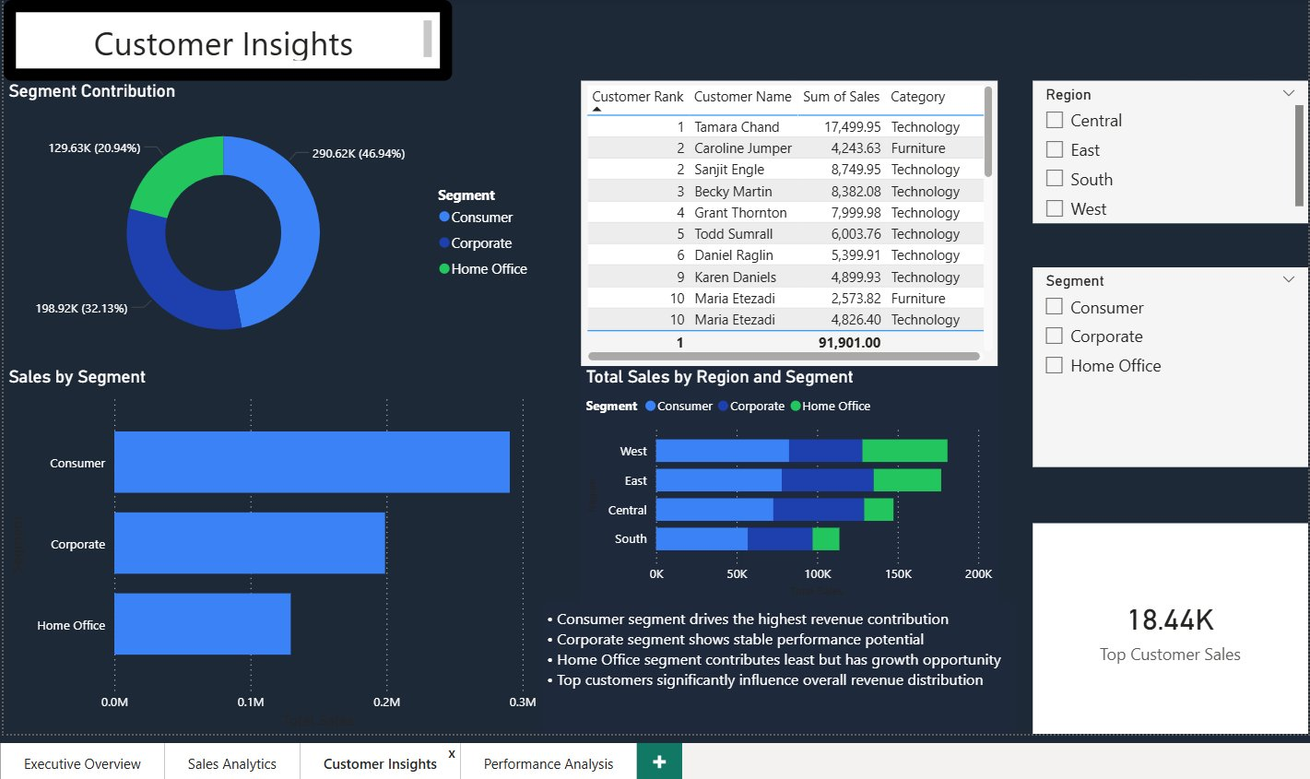
Figure 3: Customer Insights — Segment Donut, Top Customers Table, Region-Segment Analysis

3.4 Page 4 – Performance Analysis
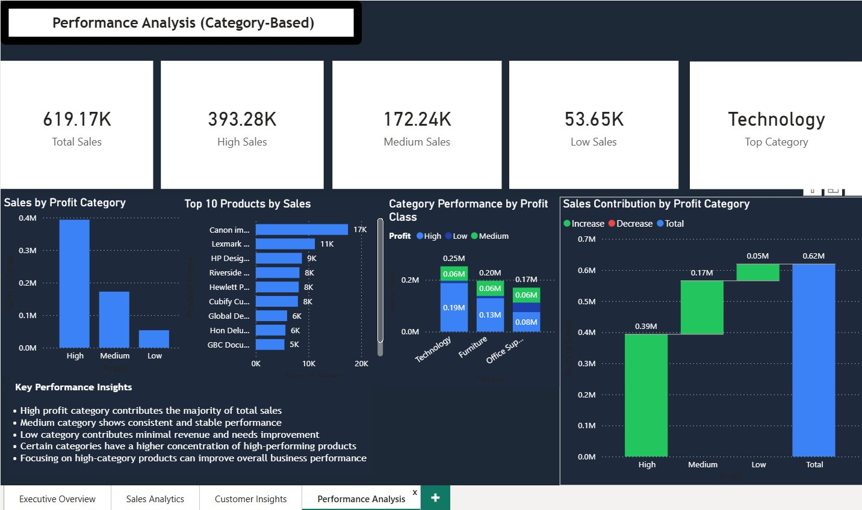
Figure 4: Performance Analysis — Profit Category KPIs, Waterfall Chart, Product Rankings

4. Technology Stack

Component | Technology / Tool
BI Tool | Microsoft Power BI Desktop
Data Source | CSV file (train.csv — retail transactional dataset)
Query Language | Power Query (M Language) — data transformation
Measure Language | DAX (Data Analysis Expressions) — calculated measures
Date Intelligence | Custom Date Table for YTD & MoM calculations
Map Visual | Bing Maps (built-in Power BI geographic visual)
AI Feature | Smart Narrative (Power BI AI visual for auto-insights)
Visualization Types | Line, Bar, Donut, Treemap, Map, Waterfall, KPI Cards, Table
File Format | Power BI (.pbix)
Operating System | Windows 10/11

5. Key DAX Measures
The following DAX measures form the analytical backbone of the IntelliScope dashboard:

Total Sales
Total Sales = SUM(train[Sales])
High Category Sales
High Sales = CALCULATE(SUM(train[Sales]), train[Profit] = "High")
Medium Category Sales
Medium Sales = CALCULATE(SUM(train[Sales]), train[Profit] = "Medium")
Low Category Sales
Low Sales = CALCULATE(SUM(train[Sales]), train[Profit] = "Low")
YTD Sales
YTD Sales = TOTALYTD([Total Sales], 'Date Table'[Date])
MoM Growth %
MoM Growth % = DIVIDE([Total Sales] - [Prior Month Sales], [Prior Month Sales])

Note: Profit in this dataset is categorical (High / Medium / Low), not a numeric field. All profit-based measures use CALCULATE with text filters rather than SUM or AVERAGE aggregations.

6. Unique & Distinguishing Points
IntelliScope differentiates itself from a standard reporting dashboard through the following design and analytical choices:

Categorical Profit Classification System
Rather than relying on raw numeric profit, the project uses a three-tier classification (High / Medium / Low) that mirrors real-world business performance bucketing, enabling cleaner visual comparison.

AI-Powered Smart Narratives
The Smart Narrative visuals on the Executive Overview and Sales Analytics pages automatically generate natural-language summaries of the data, making the dashboard accessible to non-technical stakeholders without requiring manual annotation.

Multi-Dimensional Cross-Filtering
All four pages are fully cross-filtered. Selecting a region on the map in Page 1 dynamically updates all other visuals. Similarly, clicking a segment in the Customer Insights page updates the ranking table and regional breakdown simultaneously.

Waterfall Chart for Cumulative Contribution Analysis
The Sales Contribution by Profit Category waterfall chart in Page 4 visually illustrates how each profit class incrementally builds the total revenue, giving stakeholders immediate insight into contribution hierarchy.

Consistent Dark Professional Theme
The dashboard uses a uniform dark navy theme with blue accent colors across all four pages, ensuring brand consistency and reducing cognitive load during extended analysis sessions.

Hierarchical KPI Layering
Each page is structured from macro to micro: top KPI cards provide the summary, mid-level charts provide category and segment breakdowns, and detail tables enable granular product/customer-level investigation.

7. Future Improvements
The following enhancements are identified as high-priority extensions for IntelliScope in subsequent development cycles:

- Integration of live/real-time data sources via DirectQuery or Power BI Dataflows to replace static CSV import
- Machine learning forecasting visual using Power BI's built-in analytics pane to project next-quarter sales trends
- Row-Level Security (RLS) implementation to enable role-based access for regional managers vs. executives
- Addition of a Returns & Discount Impact analysis page to measure the effect of discounting on profit classification
- Embedding the dashboard into a web portal using Power BI Embedded API for broader stakeholder access
- Automated email subscription alerts triggered when MoM Growth drops below a defined threshold
- Natural Language Q&A integration so users can type queries like "top products in West region" directly in the dashboard

8. Conclusion
IntelliScope successfully demonstrates how a well-structured Power BI dashboard can transform raw transactional data into a comprehensive business intelligence platform. Through four analytically distinct pages — Executive Overview, Sales Analytics, Customer Insights, and Performance Analysis — the dashboard addresses critical business questions around sales trends, customer behavior, regional performance, and profit classification.

The integration of DAX-based calculated measures, AI-powered Smart Narratives, interactive slicers, and a visually consistent design makes IntelliScope a production-grade analytical tool. The project validates core competencies in data modeling, visualization design, DAX programming, and business storytelling using Power BI.

This capstone project reflects the end-to-end application of skills developed throughout the B.Tech program and provides a strong foundation for professional roles in data analytics and business intelligence.

