Lab Mid Examination
DevOps for Cloud Computing (CSC418)
Docker, Docker Compose, AWS Load Balancer, Auto Scaling and Selenium
Student Name | Unzela Fareed
Roll Number | FA23-BSE-189
Course Instructor | Dr. M. Hasanain Ch
GitHub Repository | https://github.com/UnzelaFareed/Devops_MidLab
Load Balancer URL | http://notes-alb-1297509342.ap-southeast-1.elb.amazonaws.com

EC2 Instance Setup
An Ubuntu Linux EC2 instance (mid-lab, t3.micro) was launched in ap-southeast-1 and used for all Docker work. Its security group allows HTTP (80) and SSH (22).
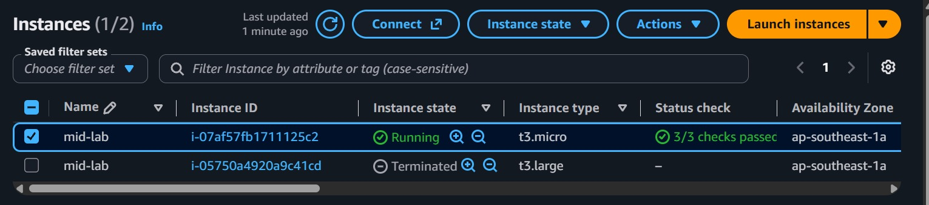
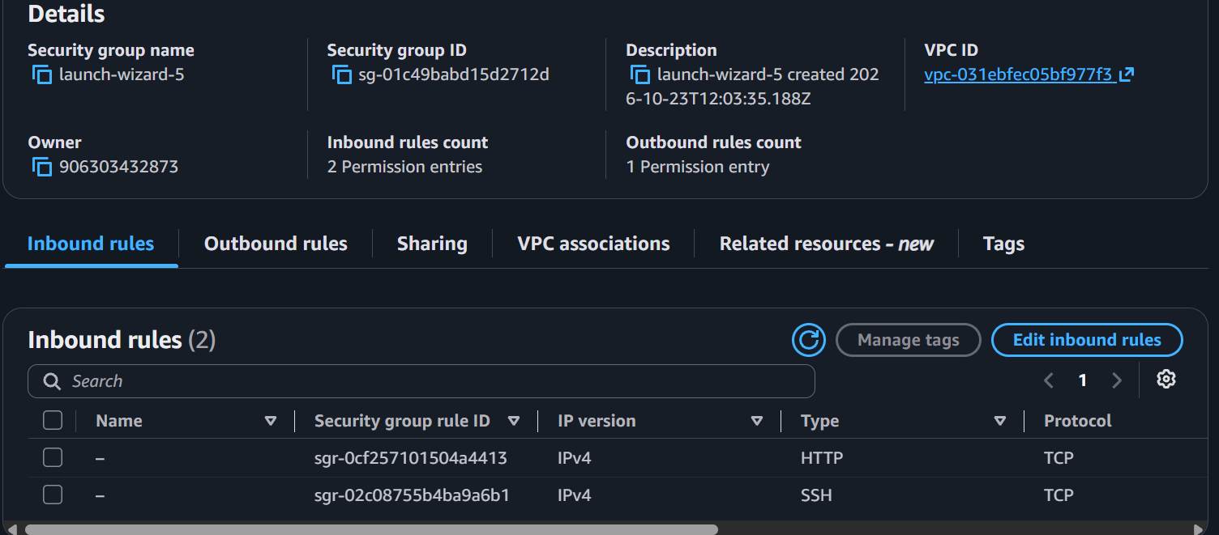
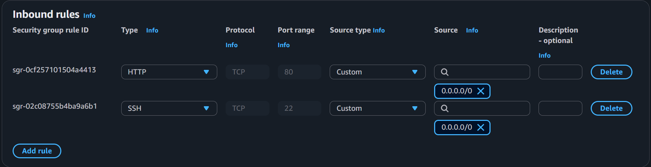

Task 1: AWS Load Balancer and Auto Scaling
Two EC2 instances run the application behind an Application Load Balancer and are managed by an Auto Scaling Group (Desired 2, Min 2, Max 3).

A. Security groups
alb-sg allows HTTP from anywhere. ec2-sg allows HTTP only from alb-sg, and SSH only from my IP, so the app is reachable only through the load balancer.
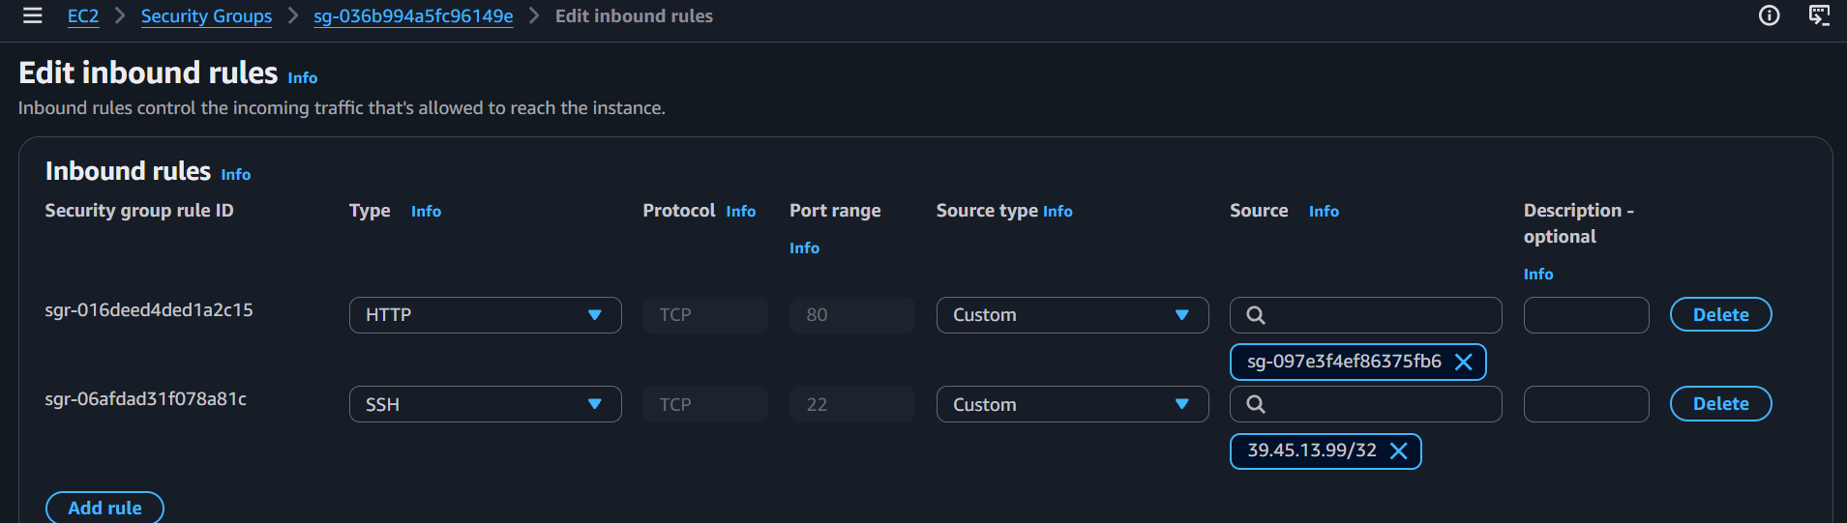
ec2-sg inbound rules: HTTP source is alb-sg, SSH source is my IP
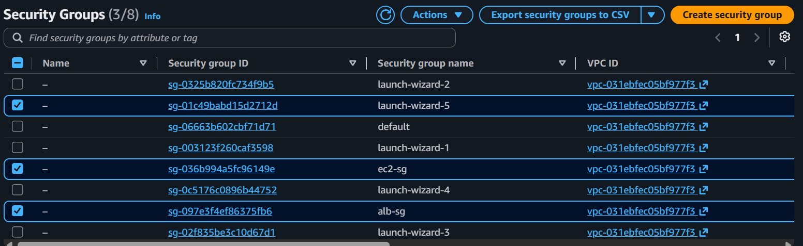
Security groups list showing launch-wizard-5, ec2-sg and alb-sg

B. Launch template
Launch template notes-lt (Ubuntu 24.04, t3.micro, key lab-key, ec2-sg) installs Docker and runs the app from GitHub using user data.
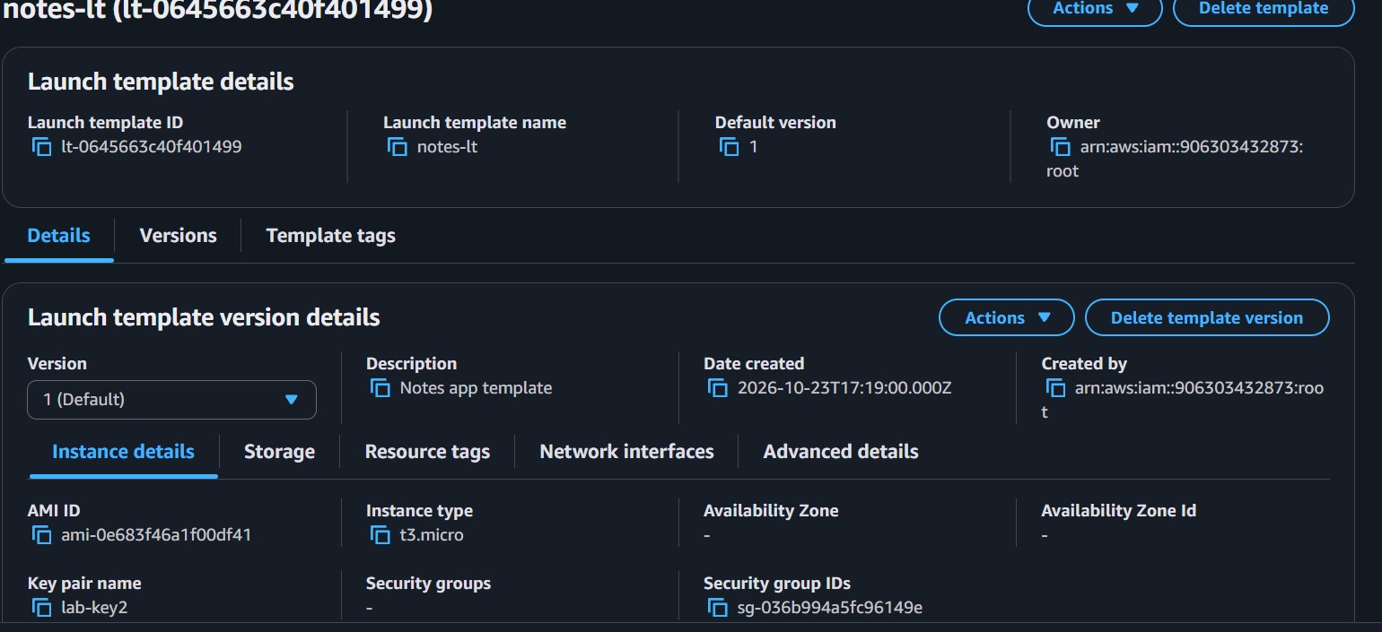
Launch template notes-lt with user data (SS 15)

C. Application Load Balancer
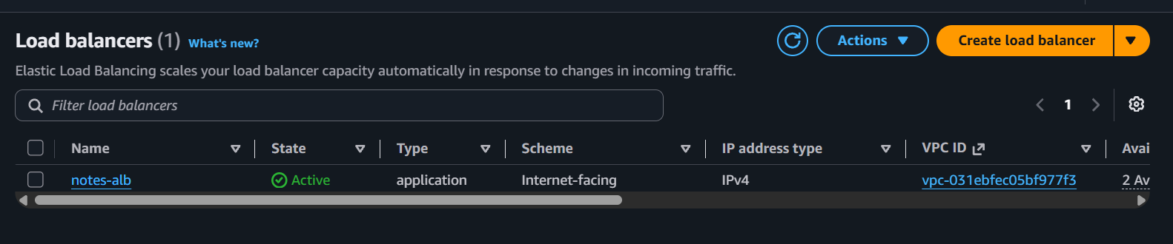
Application Load Balancer notes-alb, State: Active, Internet-facing
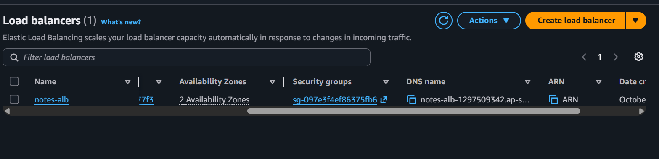
notes-alb security group (alb-sg) and DNS name

D. Auto Scaling Group

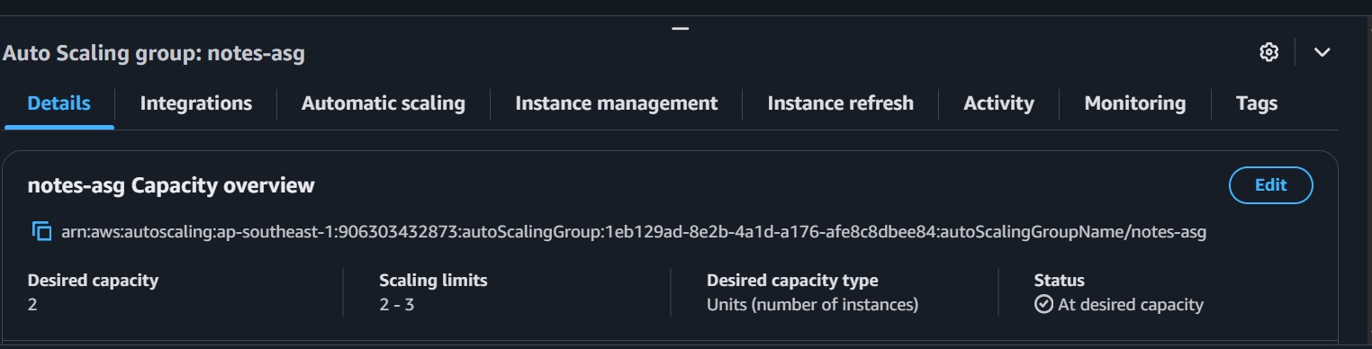
Auto Scaling Group notes-asg: Desired 2, Min 2, Max 3, Instances 2 (SS 18)
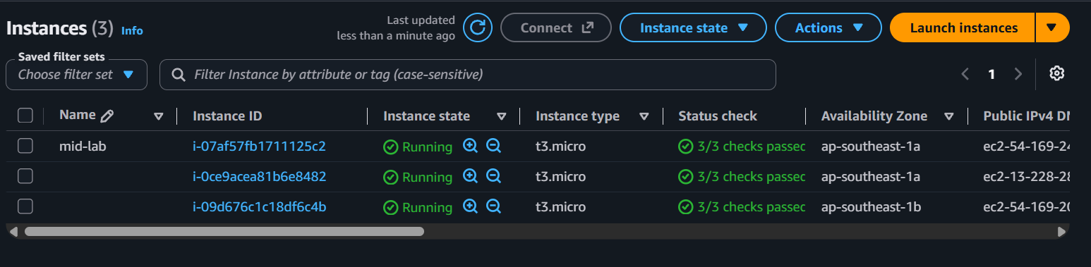
EC2 instances list: mid-lab and the two new ASG instances in different availability zones (1a and 1b)

E. Healthy targets and load balancing demo
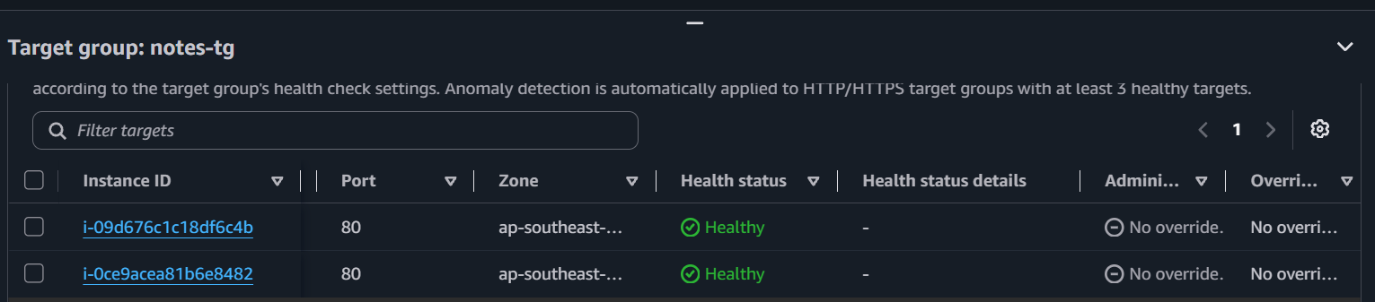
Target group notes-tg: both targets Healthy on port 80 (health check path /health)
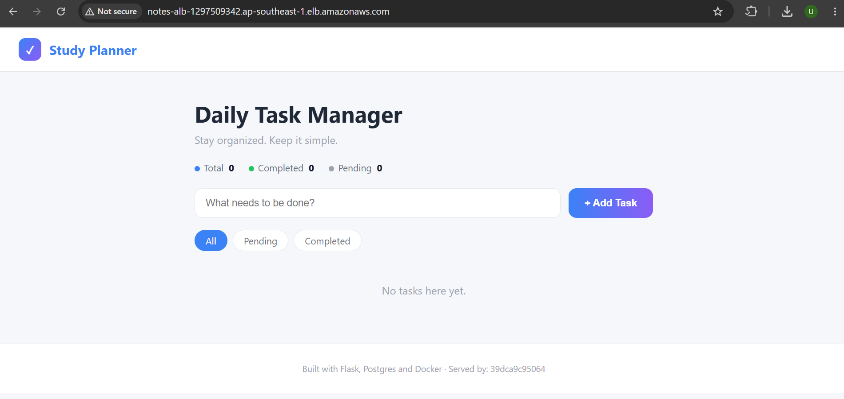
Application opened through the ALB DNS name, Served by: 39dca9c95064
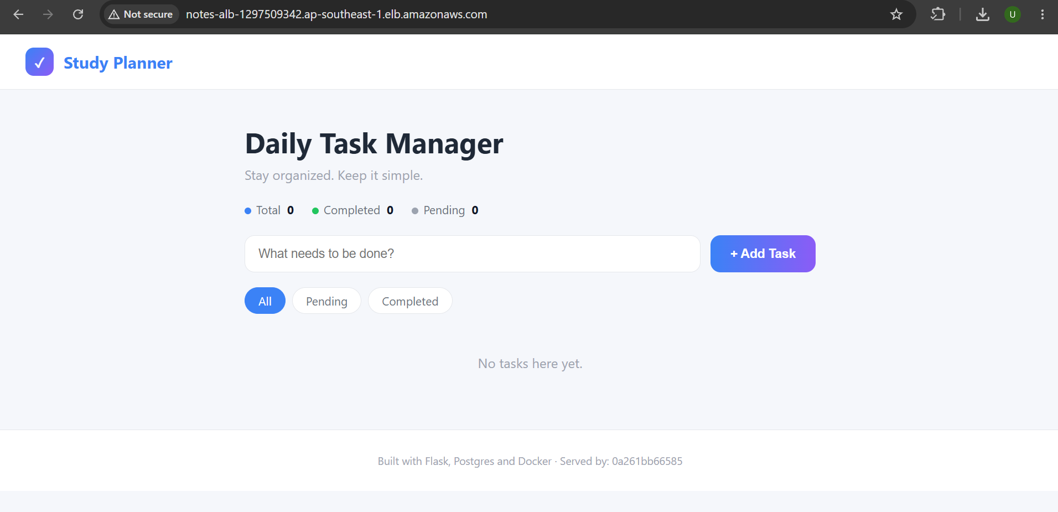
Same ALB URL after refresh, Served by: 0a261bb66585 (different instance)

Task 2: Linux Administration
Basic Linux commands were executed, a directory was created and file permissions were configured with chmod.
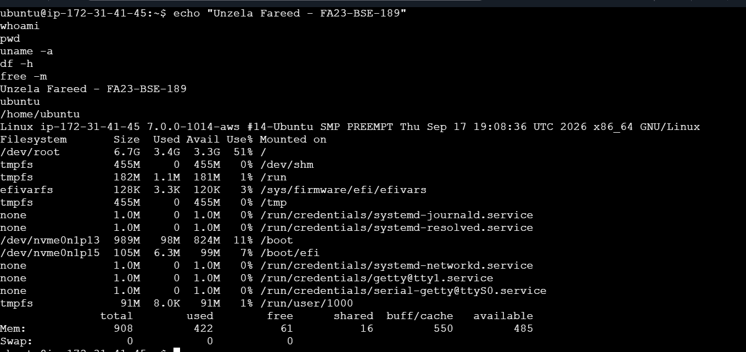
Basic commands: whoami, pwd, uname -a, df -h, free -m
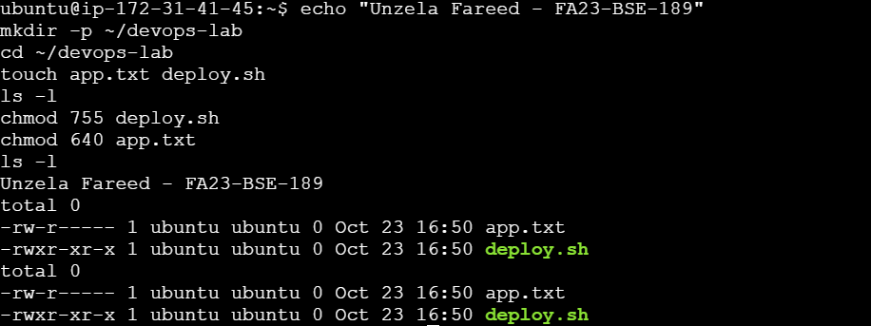
mkdir devops-lab, touch files, chmod 755 deploy.sh and chmod 640 app.txt (permissions before and after)

Task 3: Docker Installation and Images

Docker installed
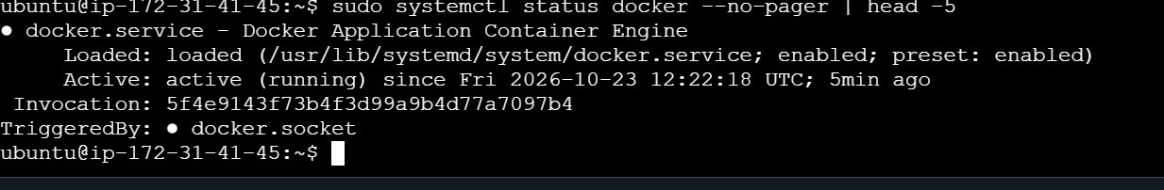
Docker service active (running)
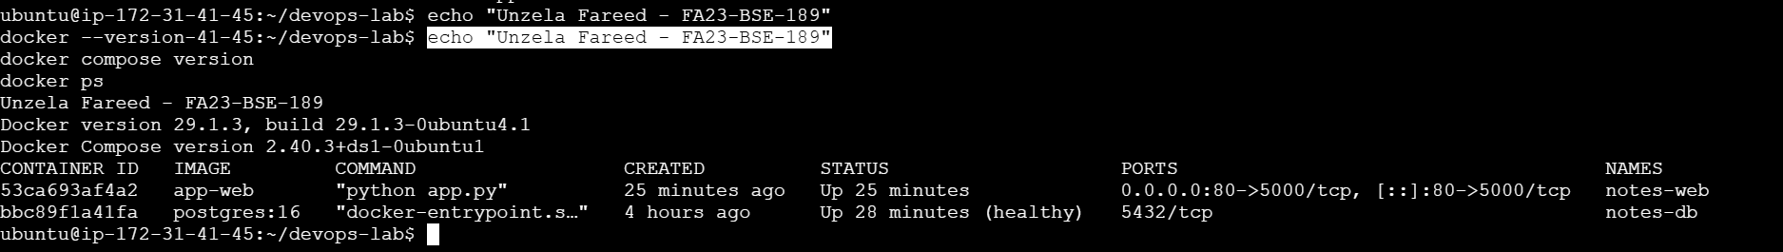
docker --version, docker compose version and running containers

Dockerfile
The application code was cloned from GitHub and the Dockerfile builds a Python 3.12 image that runs the Flask app.
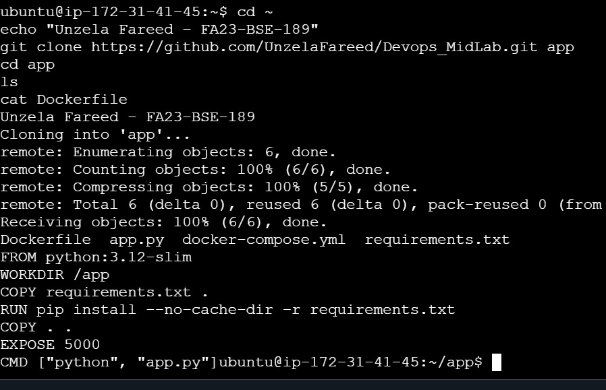
Repository cloned and Dockerfile displayed

Custom image build and container run
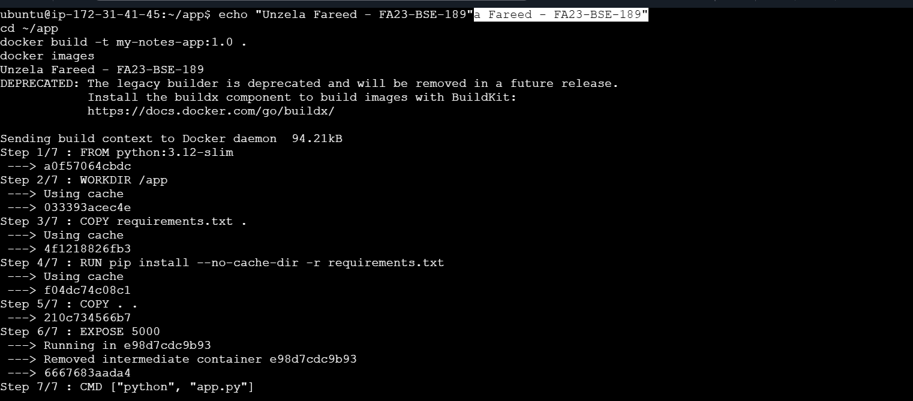
docker build -t my-notes-app:1.0 .
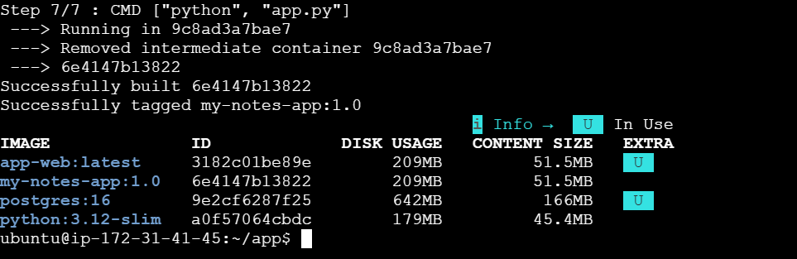
Image my-notes-app:1.0 built successfully (docker images)
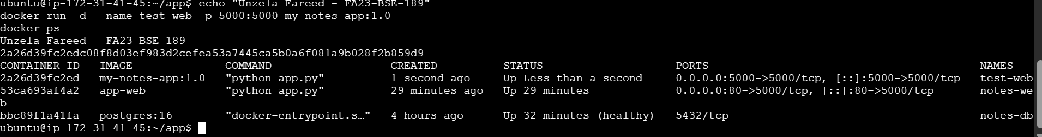
Container test-web running from the custom image on port 5000

Task 4: Docker Volumes
The PostgreSQL container stores its data in the named volume app_pgdata. Containers were removed and recreated to show that the data persists.
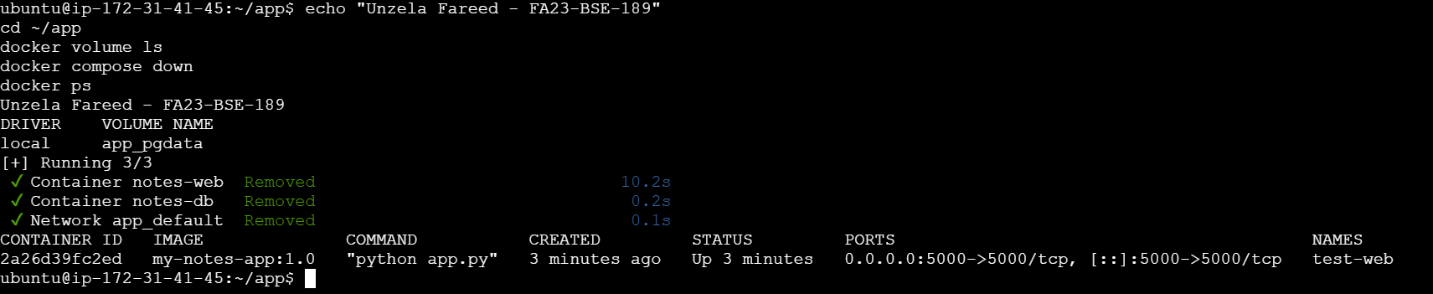
docker volume ls shows app_pgdata, then docker compose down removes the containers
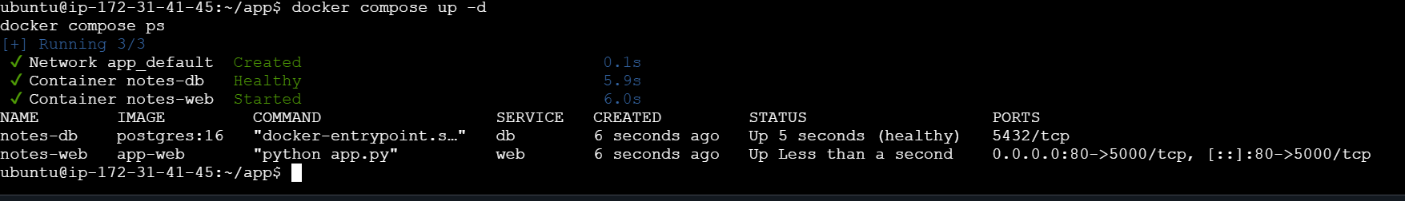
docker compose up -d recreates the containers
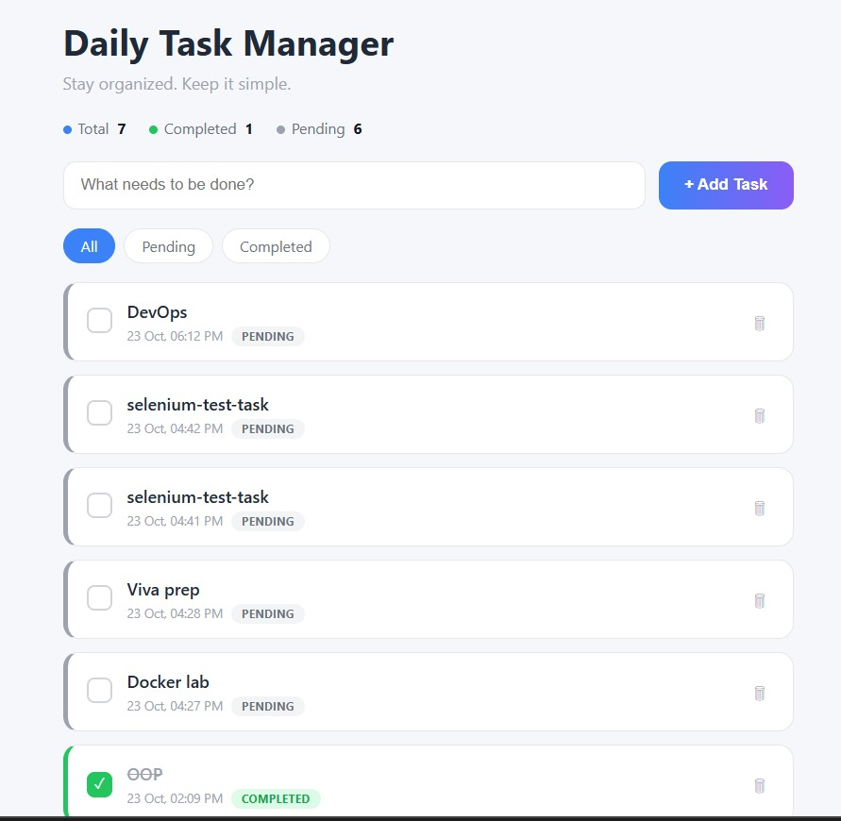
Application with a task added, BEFORE docker compose down
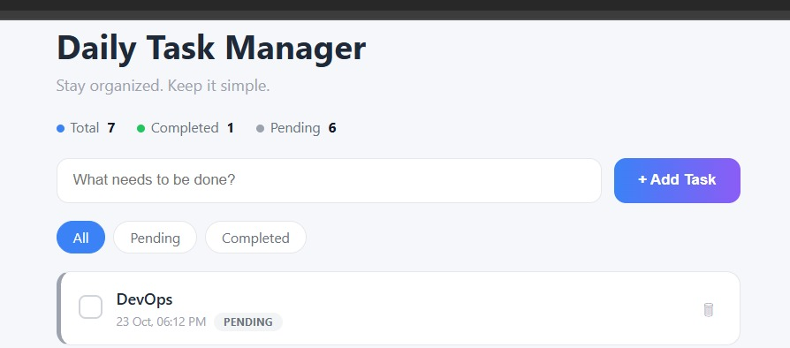
Same task still present AFTER docker compose down and up -d (data persisted)

Task 5: Docker Compose
docker-compose.yml defines two services: web (Flask app) and db (postgres:16) with a healthcheck, plus the named volume pgdata.
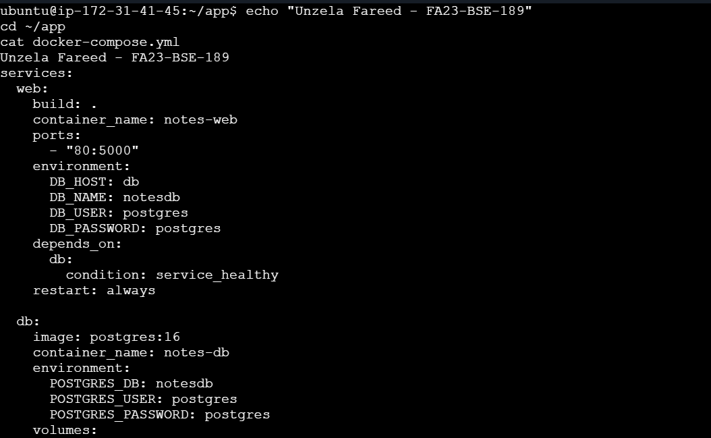
docker-compose.yml: web service and the start of the db service
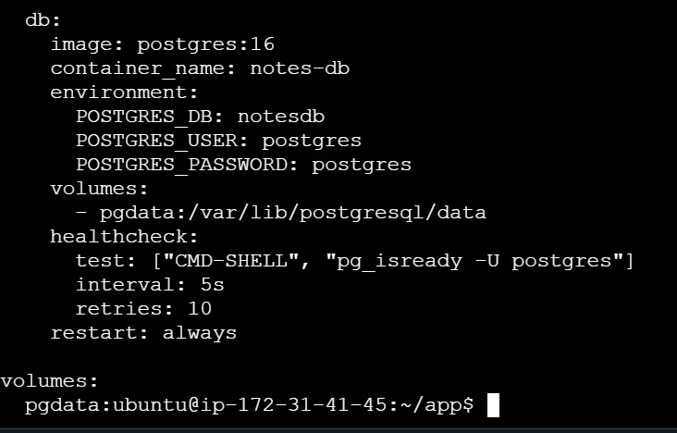
docker-compose.yml: db environment, volume mapping, healthcheck and volumes section
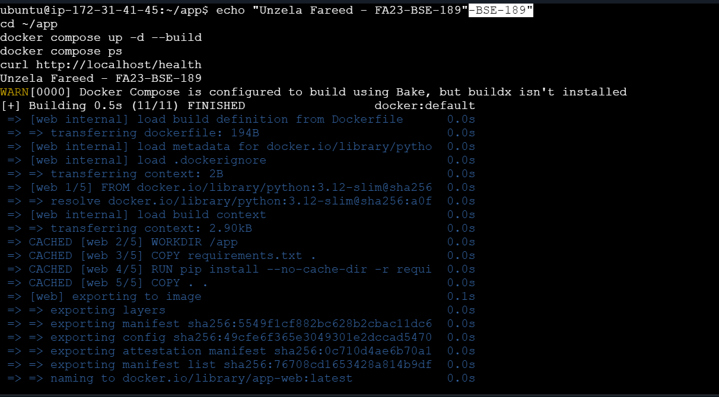
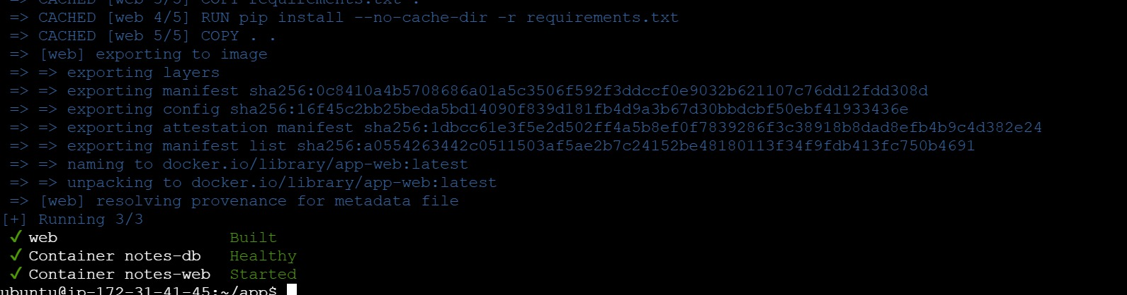
docker compose up -d --build
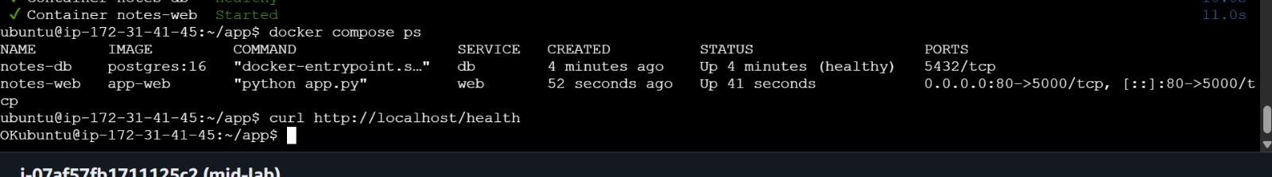
docker compose ps: notes-web and notes-db (healthy), curl /health returns OK
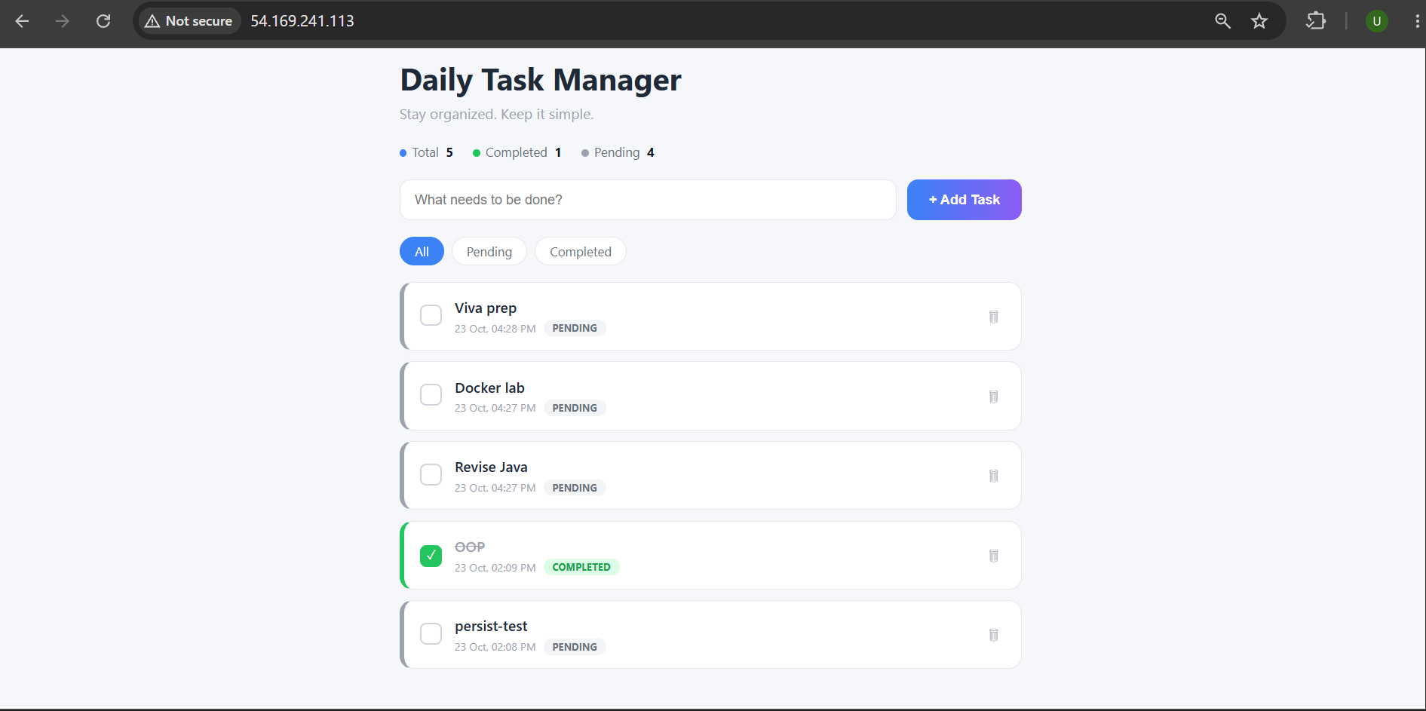
Daily Task Manager running with tasks stored in the database

Task 6: Selenium Testing
test_selenium.py opens the application, verifies the page heading, adds a task and verifies it, and checks that the /health endpoint returns OK.
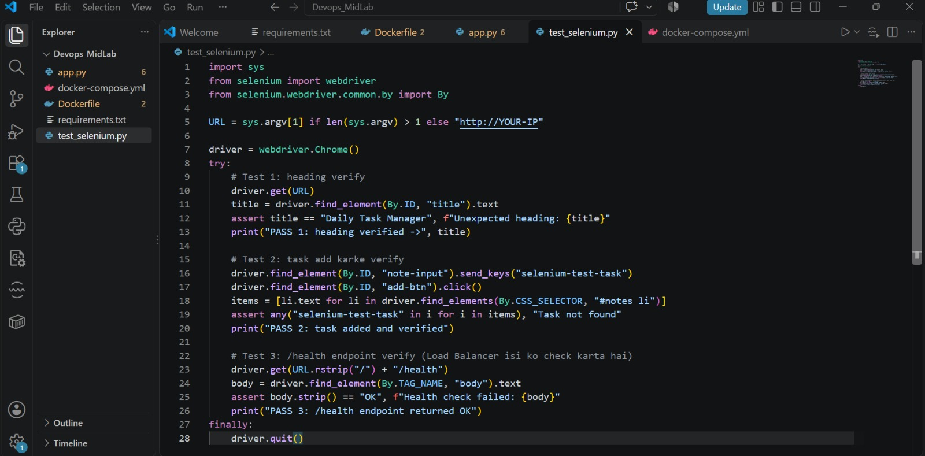
test_selenium.py script code in VS Code (SS 13)
