**Calligraphy art**

Calligraphy is the art of beautiful handwriting or lettering. It involves the correct formation of characters, the ordering of the various parts, and the harmony of proportions.

[[https://encrypted-tbn2.gstatic.com/favicon-tbn?q=tbn:ANd9GcRb8wLPse_clbygtbR06NeRAELLDZapBsNx8UjzZ5Ot-zK5-cA8cJKbOn_-P1peuNO-VCQo7hNz1SkLecS7LYAlI6XDhoe9peb55t_E](https://www.baytalfann.com/post/arabic-calligraphy-heritage-shazia-daud)](https://www.baytalfann.com/post/arabic-calligraphy-heritage-shazia-daud)

Arabic calligraphy art

* Calligraphy has been practiced for centuries in many different cultures around the world.
* Western calligraphy is the most common type of calligraphy in the West. It is characterized by its use of Roman letters and its emphasis on clean, simple lines.

[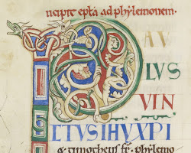](https://en.wikipedia.org/wiki/Western_calligraphy)

Western calligraphy art

* Eastern calligraphy is a more diverse category, encompassing a wide range of styles from different cultures. Some of the most well-known types of Eastern calligraphy include Chinese calligraphy, Japanese calligraphy, and Arabic calligraphy

.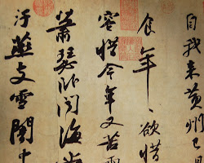

Chinese calligraphy art

* Calligraphy is often used in religious and decorative contexts. It can be found in illuminated manuscripts, religious texts, and works of art.
* Calligraphy can also be used for practical purposes, such as writing letters or signs.

Here are some of the most famous calligraphers:

* Petrus Arlati (1452-1527) was an Italian calligrapher who is considered to be one of the greatest masters of Western calligraphy.

[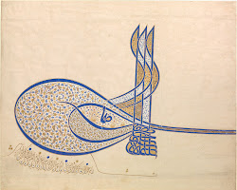](https://www.metmuseum.org/toah/hd/suly/hd_suly.htm)

Petrus Arlati calligraphy art

* Wang Xizhi (303-361) was a Chinese calligrapher who is considered to be one of the greatest masters of Eastern calligraphy.

[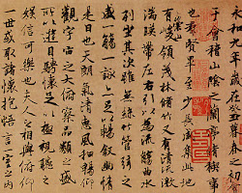](https://depts.washington.edu/chinaciv/callig/7calsixd.htm)

Wang Xizhi calligraphy art

Calligraphy is a beautiful and expressive art form that has been practiced for centuries. It is a skill that can be learned by anyone, and it can be a great way to express your creativity.

Here are some tips for creating calligraphy art:

* Start with the basics. Learn the correct formation of the letters in the style of calligraphy that you want to learn.
* Practice regularly. The more you practice, the better you will become at calligraphy.
* Use the right tools. A good pen or brush is essential for creating beautiful calligraphy.
* Experiment with different styles. There are many different styles of calligraphy, so experiment until you find one that you like.
* Don't be afraid to make mistakes. Everyone makes mistakes when they're learning calligraphy. The important thing is to learn from your mistakes and keep practicing.

I hope these tips help you create beautiful calligraphy art!