**Landscape painting**

Landscape painting is the depiction of natural scenery in art. Landscape paintings may capture mountains, valleys, bodies of water, fields, forests, and coasts and may or may not include man-made structures as well as people.

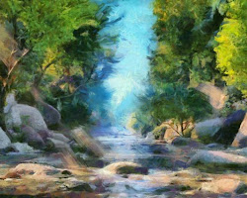

Landscape painting of a forest

Landscape painting has a long and rich history, dating back to the ancient Egyptians and Greeks. However, it was not until the Renaissance that landscape painting began to be seen as a legitimate art form. During the Renaissance, landscape painters began to focus on capturing the beauty of nature in a realistic and naturalistic way.

Some of the most famous landscape painters from the Renaissance include Leonardo da Vinci, Albrecht Dürer, and Claude Lorrain. These artists helped to establish the conventions of landscape painting that are still used today.

In the 19th century, landscape painting took on a new direction with the rise of Impressionism. Impressionist painters were interested in capturing the fleeting effects of light and atmosphere in their paintings. They often used loose brushwork and bright colors to create a sense of movement and vibrancy.

Some of the most famous Impressionist landscape painters include Claude Monet, Pierre-Auguste Renoir, and Vincent van Gogh. These artists helped to revolutionize landscape painting and paved the way for future generations of landscape artists.

Today, landscape painting is still a popular art form. Landscape painters continue to experiment with new techniques and styles, and they are constantly finding new ways to capture the beauty of nature in their art.

Here are some tips for painting landscapes:

* Start by observing nature. Take some time to go outside and study the landscape that you want to paint. Pay attention to the colors, shapes, and textures of the natural world.

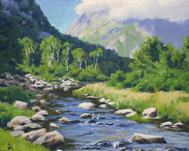

Landscape painting of a river

* Choose a focal point. Once you have a good understanding of the landscape, choose a focal point for your painting. This could be a tree, a mountain, or a building.
* Use light and shadow to create depth. Landscape paintings should have a sense of depth. You can create depth by using light and shadow.
* Experiment with different colors. Don't be afraid to experiment with different colors when painting landscapes. The colors you choose will help to create a mood or atmosphere in your painting.
* Use different brushstrokes. The way you apply paint to the canvas can also affect the mood or atmosphere of your painting. Try using different brushstrokes to see what effect they have.
* Don't be afraid to make mistakes. Everyone makes mistakes when they're painting. The important thing is to learn from your mistakes and keep practicing.

With a little practice, you'll be able to create beautiful landscape paintings that capture the beauty of nature.