**OHP sheet**

OHP sheets, also known as transparency sheets, are transparent sheets that are used for overhead projectors. They are typically made of plastic or acetate and are available in a variety of sizes and thicknesses.

[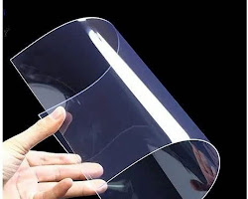](https://www.indiamart.com/proddetail/ohp-sheet-175-micron-26408181655.html)

OHP sheet

* OHP sheets are used to project images, text, and diagrams onto a screen. They are often used in presentations, classrooms, and training sessions.
* OHP sheets can be written on with a variety of markers, including dry erase markers, wet erase markers, and permanent markers.
* OHP sheets can be erased with a damp cloth or a dry erase eraser.

Here are some of the advantages of OHP sheets:

* Portability: OHP sheets are lightweight and easy to transport, making them a good choice for presentations that are given in different locations.
* Durability: OHP sheets are durable and can withstand repeated use.
* Visibility: OHP sheets are highly visible, even in bright light.
* Reusability: OHP sheets can be reused multiple times, making them a cost-effective option.

Here are some of the disadvantages of OHP sheets:

* Limited resolution: OHP sheets have a limited resolution, which means that they are not as sharp as other types of projection media.
* Brightness: OHP sheets can be difficult to see in low light conditions.
* Environmental impact: OHP sheets are made from plastic, which is a non-renewable resource.

Overall, OHP sheets are a versatile and affordable option for projection media. They are easy to use and can be reused multiple times. However, they have some limitations, such as limited resolution and brightness.

I hope this documentation helps you get started with OHP sheets!