**Religious painting**

Religious painting is a type of painting that depicts religious figures, events, or stories. Religious paintings have been created for centuries, and they can be found in a variety of cultures and religions.

* Religious paintings can be used to teach religious doctrine, to inspire devotion, or to simply depict religious stories in a beautiful way.
* Religious paintings can be done in any medium, but some popular mediums include oil paint, acrylic paint, watercolor, and mosaic.
* Religious paintings can be realistic or abstract, and they can be done in a variety of styles.

Here are some of the most famous religious paintings:

* Giotto's *The Scrovegni Chapel Frescoes* (1303–1305)

[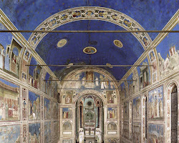Opens in a new window[https://encrypted-tbn3.gstatic.com/favicon-tbn?q=tbn:ANd9GcQenZK924-dUfOlopaEPe3vGck9wfKm5UP6QgdglIPz6ihXBC5YrYn3eaihqPp2qBAgeruPWM9Pjb-nWkXVjojWr6NfR9qIXx3LVYXKhhs6Rc16-g](http://www.travelingintuscany.com/art/giotto/scrovegni.htm)www.travelingintuscany.com](http://www.travelingintuscany.com/art/giotto/scrovegni.htm)

Giotto's The Scrovegni Chapel Frescoes

* Leonardo da Vinci's *The Last Supper* (1495–1498)

[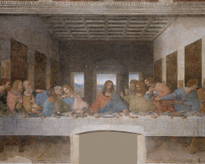Opens in a new window[https://encrypted-tbn2.gstatic.com/favicon-tbn?q=tbn:ANd9GcTGo2ldWXblVJVy9av_nsZSibxa_2qWNauc-_aN3Z88QWRlrBwOirgky4S2BQx4HAP717l1X6fwOGXal25Xka-QwL048XUpux7h5g](https://en.wikipedia.org/wiki/The_Last_Supper_(Leonardo))en.wikipedia.org](https://en.wikipedia.org/wiki/The_Last_Supper_(Leonardo))

Leonardo da Vinci's The Last Supper

* Michelangelo's *The Sistine Chapel Ceiling* (1508–1512)

[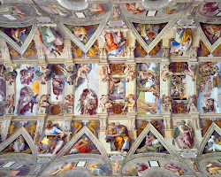Opens in a new window[https://encrypted-tbn2.gstatic.com/favicon-tbn?q=tbn:ANd9GcSuae5vGgg5AYdqH5ECWtPrwq861sBIdQuSyFbo8hb-GTeb3AhA5EKcwbtDRTm30GaITC1JxQRDinBlvKNSlylWtIkJJopWgvL4Dg](https://smarthistory.org/michelangelo-ceiling-of-the-sistine-chapel/)smarthistory.org](https://smarthistory.org/michelangelo-ceiling-of-the-sistine-chapel/)

Michelangelo's The Sistine Chapel Ceiling

* Rembrandt's *The Night Watch* (1642)

[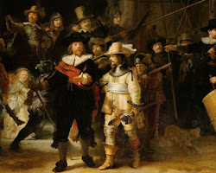Opens in a new window[https://encrypted-tbn1.gstatic.com/favicon-tbn?q=tbn:ANd9GcRjJvcyvIYHdQbnCWnq1vAKqKwhihnbaJAApPSxjI5UMTLAWg_LNrvi7O53-Dx5GVaZ5cnugzPYgG9N2Bvy8ifMT4UpEc0](https://www.bbc.com/culture/article/20190214-does-rembrandts-the-night-watch-reveal-a-murder-plot)www.bbc.com](https://www.bbc.com/culture/article/20190214-does-rembrandts-the-night-watch-reveal-a-murder-plot)

Rembrandt's The Night Watch

* Vincent van Gogh's *The Potato Eaters* (1885)

[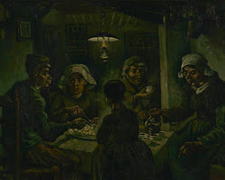Opens in a new window[https://encrypted-tbn3.gstatic.com/favicon-tbn?q=tbn:ANd9GcRPAj2tfANf606DCq1nzCT7fHkZc5Ijzix-azytIHegAg26CtTmvG34XFklK-G5uPGH5SB7niHuOsZ3BJ0pPvw2HM31IO_E3te4D4s39fI](https://www.vangoghmuseum.nl/en/collection/s0005V1962)www.vangoghmuseum.nl](https://www.vangoghmuseum.nl/en/collection/s0005V1962)

Vincent van Gogh's The Potato Eaters

Religious paintings have played an important role in the history of art, and they continue to be a popular subject for artists today.

Here are some tips for creating religious paintings:

* Do your research. Before you start painting, it's important to do your research and learn as much as you can about the religious figure, event, or story that you're depicting. This will help you to create a painting that is both accurate and meaningful.
* Be respectful. When you're painting a religious subject, it's important to be respectful of the religious beliefs of others. This means avoiding images or symbols that could be offensive to some people.
* Use your imagination. Religious paintings don't have to be strictly realistic. You can use your imagination to create a painting that is both beautiful and evocative.
* Don't be afraid to experiment. There are no rules when it comes to religious painting, so feel free to experiment with different techniques and styles. This is the best way to find your own unique style.

I hope these tips help you create beautiful religious paintings!