
BAHRIA UNIVERSITY ISLAMABAD
Department of Computer Science

Digital Lost and Found System

Submitted To: | Ms. Aima Zahoor
Course: | Software Engineering (SEN 220)
Submission Date: | May 10, 2026
Project Type: | Documentation — Reverse Engineering

GROUP MEMBERS

Aaima Binte Basit — 01-134242-001 Humna Sajid — 01-134242-052 Unzish Maira — 01-134242-133 Yusra Yasin — 01-134242-138

Table of Contents
MILESTONE 1: REQUIREMENTS 4
◆ 1.1 Problem Statement 4
◆ 1.2 Project Scope 4
Included in Scope 4
Excluded from Scope 4
◆ 1.3 Functional Requirements 5
◆ 1.4 Non-Functional Requirements 5
Performance 5
Security 6
Usability 6
Reliability 6
Maintainability 6
◆ 1.5 Actors 6
◆ 1.6 Use Case Diagram 6
◆ 1.7 Use Case Descriptions 8
UC-01: Report Lost Item 8
UC-02: Report Found Item 8
UC-03: Search and Filter Items 9
UC-04: Submit a Claim 9
UC-05: Admin Review and Approve Claim 9
MILESTONE 2: MODELING 11
◆ 2.1 Context Diagram 11
◆ 2.2 Data Flow Diagram — Level 1 11
◆ 2.3 Class Diagram 12
◆ 2.5 Activity Diagram — Claim Submission and Review Workflow 14
◆ 2.6 State Diagram — Item Lifecycle 14
MILESTONE 3: DESIGN & ARCHITECTURE 16
◆ 3.1 Refined UML Explanations 16
Class Diagram Refinements 16
Sequence Diagram Refinements 16
State Diagram Refinements 16
◆ 3.2 System Architecture — MVC with Service Layer 16
◆ 3.3 System Components 18
◆ 3.4 Database Design 18
Table: users 18
Table: reports 19
Table: matches 19
Table: claims 20
Entity-Relationship Diagram 20
MILESTONE 4: TESTING & MANAGEMENT 21
◆ 4.1 Test Plan 21
Testing Objectives 21
Testing Levels 21
Entry and Exit Criteria 21
◆ 4.2 Test Cases 21
TC-01: Successful Lost Item Report Submission 21
TC-02: Report Submission with Missing Mandatory Fields 22
TC-03: Automated Match Detection 22
TC-04: Claim Approval Workflow 23
TC-05: Unauthorised Access to Admin Dashboard 23
TC-06: Image Upload — Oversized File Rejection 23
◆ 4.3 Version Control — GitHub Strategy 24
Repository Structure 24
Branching Strategy 24
Commit Convention 24
Pull Request Policy 24
◆ 4.4 Project Planning 24
GanG Chart — Task Timeline (Weeks 1–8) 24
PERT Chart — Task Network 25
Risk Analysis 25
◆ 4.5 Team Roles and Responsibilities 26
REFERENCES 28

MILESTONE 1: REQUIREMENTS

1.1 Problem Statement
In university campuses and public spaces such as libraries, transport hubs, and shopping centers, misplaced personal belongings represent a persistent and costly problem. Currently, most institutions rely on manual, paper-based lost-and-found systems that are a physical box or reception desk where found items are deposited and a handwritten log is maintained. These systems suffer from three fundamental flaws:
  - Discoverability gap: A person who loses an item has no reliable way to know whether it has been found and handed in, because there is no searchable record.
  - Coordination failure: The person who found an item and the person who lost it have no structured channel to connect, leading to abandoned or unclaimed items.
  - Administrative burden: Staff must manually log, store, tag, and dispose of items, diverting effort from their core responsibilities.

The Digital Lost and Found System (DLFS) address these problems by providing a web-based platform where community members can report lost or found items, search a live database, receive automated match notifications, and coordinate claim handovers, all without manual administrative intervention. The system is designed for Bahria University, Islamabad Campus, but its architecture is general enough for any large institution.

1.2 Project Scope

Included in Scope
  - User registration and authentication (students, staff, guests).
  - Reporting a lost item with description, category, date/time, and location.
  - Reporting a found item with photo upload, description, and drop-off location.
  - Keyword and category-based search of all active reports.
  - Automated matching engine comparing lost and found reports and generating alerts.
  - In-app and email notifications when a potential match is detected.
  - Secure claim workflow: owner submits claim, admin verifies and approves.
  - Admin dashboard for item lifecycle management and statistics.
  - Item expiry and archival after a configurable retention period (30 days).
  - Audit log of all actions for accountability.

Excluded from Scope
  - Physical item storage or courier/delivery logistics.
  - Payment or reward processing.
  - Integration with external government or police lost-property databases.
  - Native mobile applications (iOS/Android), responsive web only.
  - AI-based image recognition for automated item identification.

1.3 Functional Requirements
ID | Requirement Name | Description
FR-01 | User Registration | Any community member shall be able to create an account by providing name, email, university ID, and password. Email verification required before activation.
FR-02 | User Login / Logout | Registered users shall log in using email and password. Sessions expire after 30 minutes of inactivity.
FR-03 | Report Lost Item | Authenticated user submits item name, category, date/time last seen, campus location, description, and contact preference.
FR-04 | Report Found Item | Authenticated user submits item name, category, date/time found, drop-off location, description, and at least one photograph.
FR-05 | Photo Upload | System accepts JPEG and PNG images up to 5 MB. Thumbnail previews are generated automatically.
FR-06 | Search and filter | Any visitor can search active reports by keyword, category, date range, and campus location. Results paginated and sorted by most recent.
FR-07 | View Item Detail | Any user can view full report details. Contact info hidden unless viewer is authenticated.
FR-08 | Automated Matching | Upon new report creation, system compares it against all open opposite-type reports using keyword overlap, category match, and date/location proximity.
FR-09 | Match Notification | When a match is detected, both reporters receive an in-platform notification and email with match summary and link.
FR-10 | Submit a Claim | Authenticated user submits a claim describing proof of ownership. Only one active claim per item is allowed at a time.
FR-11 | Admin Claim Review | Administrator views pending claims, reviews submitted proof, and marks claim as Approved or Rejected.
FR-12 | Item Status Management | Each item has a status: Open, Matched, Claimed, or Expired. System auto-expires items after 30 days.
FR-13 | Admin Dashboard | Dashboard shows active lost/found reports, pending claims, unmatched items, and a monthly trend chart.
FR-14 | User Profile Management | Users can edit profile (name, contact, notification preferences) and view their own report/claim history.
FR-15 | Audit Log | Tamper-proof log records every Create, Update, Status-change, and Deletion action with actor identity and timestamp. Admin-only access.

1.4 Non-Functional Requirements

Performance
  - Search queries return results within 2 seconds for up to 10,000 active reports.
  - Matching engine completes within 5 seconds of new report submission.
  - System supports at least 200 concurrent users without degradation.

Security
  - All data in transit encrypted using TLS 1.2 or higher (HTTPS).
  - Passwords hashed using bcrypt with minimum cost factor of 10.
  - Role-based access control (RBAC) with roles: Guest, Registered User, Administrator.
  - All file uploads scanned and validated for type and size before storage.

Usability
  - A first-time user can submit a lost-item report within 3 minutes without training.
  - Interface is fully responsive for screens from 360px to 1920px wide.
  - Form validation errors displayed inline within 500 ms.

Reliability
  - System targets 99.5% uptime excluding scheduled maintenance.
  - Database backups taken daily and retained for 30 days.

Maintainability
  - MVC architectural separation allows UI, business logic, and data layers to be modified independently.

1.5 Actors
Actor | Type | Description
Guest / Visitor | External, unauthenticated | Can browse and search listings. Cannot report items or submit claims.
Registered User | Primary, authenticated | Student or staff with account. Can report items, view details, submit claims, and receive notifications.
Item Finder | Subset of Registered User | Reports a found item and designates a drop-off location.
Item Owner / Claimer | Subset of Registered User | Reports a lost item or submits a claim on a found item.
Administrator | Internal, privileged | University staff who manage claims, item status, dashboard, and audit log.
System (Automated) | Non-human | Runs matching engine, sends scheduled notifications, expires old records.

1.6 Use Case Diagram
The following diagram shows all major interactions between actors and the system. Actors: Guest and Registered User (left), Administrator (right), System Automated (bottom). Use cases are ovals inside the system boundary. <<include>> relationships shown for Upload Photo and Send Notifications. Registered User inherits Guest capabilities via generalization arrow.

Use Case Diagram
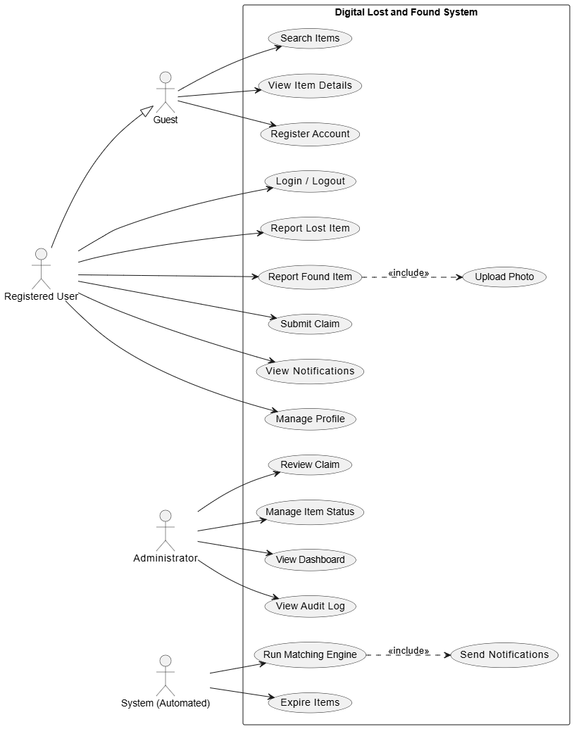
Figure 1: Use Case Diagram

1.7 Use Case Descriptions

UC-01: Report Lost Item

Field | Detail
Use Case ID | UC-01
Use Case Name | Report Lost Item
Actor(s) | Registered User (Item Owner)
Preconditions | 1. The user is authenticated (logged in). 2. The item has not already been reported by this user.
Main Flow | 1. User navigates to 'Report Lost Item'. 2. System displays the lost-item form. 3. User enters: item name, category, date last seen, time, campus location, description, notification preference. 4. User clicks 'Submit Report'. 5. System validates all mandatory fields. 6. System saves the report with status 'Open' and generates a unique Report ID. 7. System triggers the matching engine in the background. 8. System displays confirmation page with Report ID.
Alternate Flow | AF-1 (Validation failure): System highlights invalid fields with inline errors. User corrects and resubmits. AF-2 (Duplicate detection): If identical report exists, system warns user to confirm or cancel.
Post conditions | 1. New lost-item record exists with status 'Open'. 2. Matching engine has run; match alerts sent if match found. 3. Report appears in public search results.

UC-02: Report Found Item

Field | Detail
Use Case ID | UC-02
Use Case Name | Report Found Item
Actor(s) | Registered User (Item Finder)
Preconditions | 1. User is authenticated. 2. User has the physical item or has deposited it at a campus drop-off point.
Main Flow | 1. User navigates to 'Report Found Item'. 2. System displays the found-item form. 3. User enters: item name, category, date/time found, location found, drop-off location, description. 4. User uploads at least one photograph (JPEG/PNG, max 5 MB). 5. User clicks 'Submit Report'. 6. System validates fields and verifies image format and size. 7. System stores the image, generates a thumbnail, saves the report with status 'Open'. 8. Matching engine triggered in background. 9. Confirmation page shown.
Alternate Flow | AF-1 (Image too large): System displays error: 'Image exceeds 5 MB. Please compress and re-upload.' AF-2 (Unsupported format): System rejects file and instructs user to upload JPEG or PNG only.
Post conditions | 1. Found-item record saved with status 'Open'. 2. Uploaded image stored with thumbnail. 3. Matching engine executed; matched lost-item reporters notified.

UC-03: Search and Filter Items

Field | Detail
Use Case ID | UC-03
Use Case Name | Search and Filter Items
Actor(s) | Guest, Registered User
Preconditions | 1. System has at least one active report. 2. Search page accessible without authentication.
Main Flow | 1. User navigates to 'Search' page. 2. System displays search bar and filters: Category, Date Range, Type (Lost/Found/Both), Campus Location. 3. User enters keyword and optionally applies filters. 4. User clicks 'Search'. 5. System returns paginated list of matching reports (10 per page), sorted by most recent. 6. Each result card shows: item name, category, date, location, report type. 7. User clicks a card to view full details.
Alternate Flow | AF-1 (No results): System displays 'No items match your search. Try broadening your filters.' AF-2 (No keyword): System returns all active reports filtered by selected options.
Post conditions | 1. User views list of relevant reports. 2. No database records modified.

UC-04: Submit a Claim

Field | Detail
Use Case ID | UC-04
Use Case Name | Submitting a Claim
Actor(s) | Registered User (Item Owner / Claimer)
Preconditions | 1. User is authenticated. 2. Target found-item report has status 'Open' or 'Matched'. 3. User does not already have an active claim on this item.
Main Flow | 1. User views detail page of a found-item report. 2. User clicks 'Submit Claim'. 3. System displays claim form requesting: proof of ownership (serial number, unique feature, purchase date), and preferred contact time. 4. User fills form and clicks 'Submit'. 5. System validates and saves claim with status 'Pending'. 6. Item report status updated to 'Claim Pending'. 7. Administrator receives notification. 8. User receives confirmation email with Claim ID.
Alternate Flow | AF-1 (Item already claimed): System displays 'This item already has an active claim under review.' AF-2 (User is finder): System prevents a user from claiming an item they themselves reported.
Post conditions | 1. Claim record exists with status 'Pending'. 2. Found-item report status is 'Claim Pending'. 3. Administrator has been notified.

UC-05: Admin Review and Approve Claim

Field | Detail
Use Case ID | UC-05

Field | Detail
Use Case Name | Admin Review and Approve Claim
Actor(s) | Administrator
Preconditions | 1. Administrator is authenticated. 2. At least one claim with ‘Pending’ status exists.
Main Flow | 1. Administrator logs into Admin Dashboard. 2. Dashboard shows count of pending claims; admin navigates to 'Claims Management'. 3. System lists all pending claims with Claim ID, claimant name, item name, date, and proof summary. 4. Admin selects a claim and views: the found-item report (with photo), the lost-item report (if linked), and ownership proof. 5. Admin clicks 'Approve' or 'Reject' and optionally adds a note. 6a. (Approve) System marks claim as 'Approved', item status becomes 'Claimed', approval notification sent to claimant. 6b. (Reject) System marks claim as 'Rejected', item reverts to 'Open', rejection notification sent. 7. Action recorded in Audit Log.
Alternate Flow | AF-1 (Admin requests info): Admin sends message to claimant; claim placed in 'Info Requested' status. AF-2 (Claimant withdraws): Claim changes to 'Withdrawn'; item reverts to 'Open'.
Post conditions | 1. Claim status is 'Approved' or 'Rejected'. 2. Item status reflects outcome. 3. Both parties are notified. 4. Audit log entry created.

MILESTONE 2: MODELING

2.1 Context Diagram
The Context Diagram (Level 0 DFD / Black-Box view) represents the DLFS as a single process and shows all external entities that interact with it. External entities: Registered User, Administrator, Guest, Email Service SMTP, and File Storage Cloud. Data flows show inputs to the system (reports, claims, queries, login credentials) and outputs (search results, match notifications, claim status, dashboard data).

Context Diagram
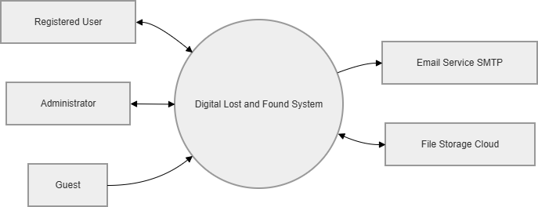
Figure 2: Context Diagram

2.2 Data Flow Diagram: Level 1
The Level 1 DFD decomposes the DLFS into 7 major sub-processes (P1–P7) and 5 data stores (DS1–DS5). It shows how data flows between external entities, processes, and storage components. Key processes include User Management (P1), Report Management (P2), Search (P3), Matching Engine (P4), Notifications (P5), Claim Management (P6), and Admin Management (P7).

Data Flow Diagram: Level 1

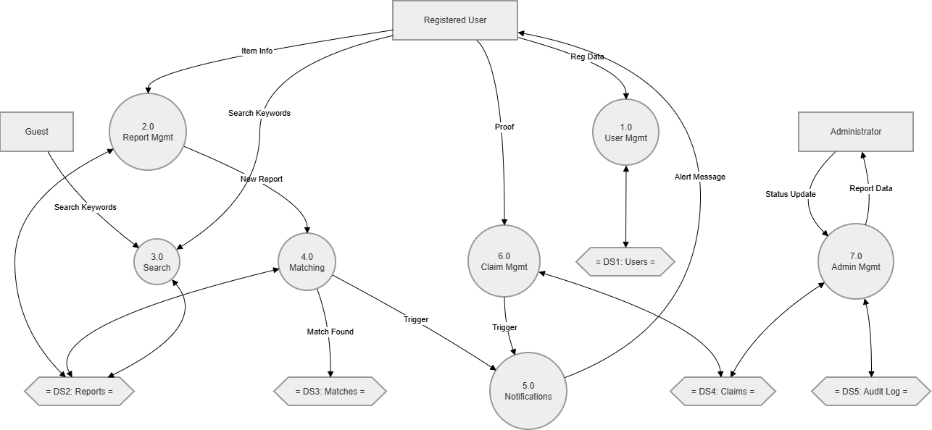
Figure 3: DFD Level 1

2.3 Class Diagram
The Class Diagram defines the object-oriented structure of the DLFS domain model. It contains 8 classes: User, Report (abstract), LostReport, FoundReport, Match, Claim, Notification, and AuditLog. LostReport and FoundReport inherit from the abstract Report class. The Match class links lost and found reports via a match score. The Claim class connects a User (claimant) to a FoundReport.
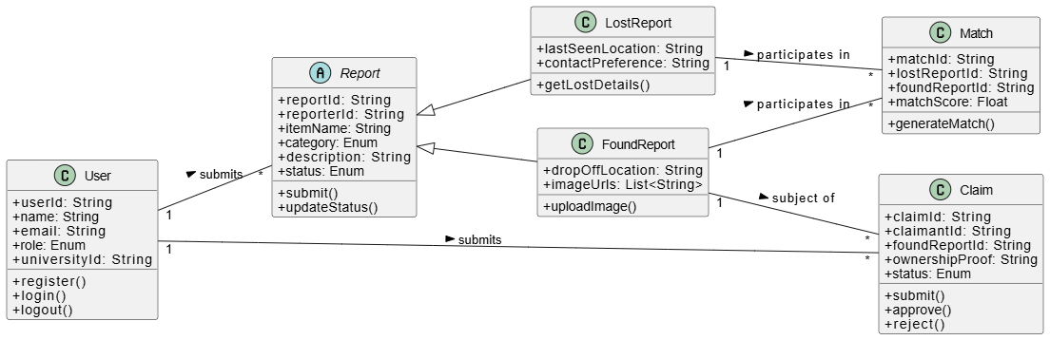
Figure 4: Class Diagram

Key class relationships:
- User 1 ──< * Report: submits
- User 1 ──< * Claim: submits
- Report (abstract) <|── LostReport (inheritance)
- Report (abstract) <|── FoundReport (inheritance)
- LostReport 1 ──< * Match: participates in
- FoundReport 1 ──< * Match: participates in
- FoundReport 1 ──< * Claim: subject of

- 2.4 Sequence Diagram: Report Lost Item and Trigger Matching This sequence diagram illustrates the interaction between objects when a user reports a lost item. Lifelines: User, System UI/Controller, Report Service, Database, and Matching Engine. The flow shows form submission, data persistence, asynchronous match triggering, and success confirmation returned to the user.

Sequence Diagram
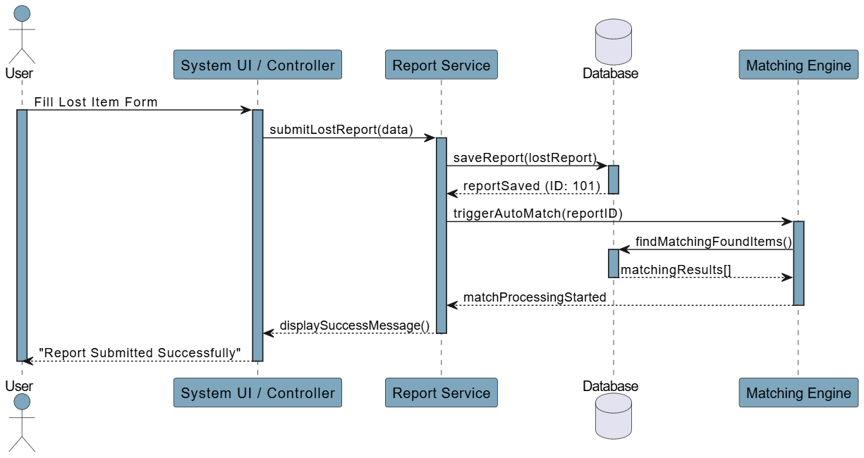
Figure 5: Sequence Diagram, Report Lost Item and Trigger Auto-Match

2.5 Activity Diagram: Claim Submission and Review Workflow
This activity diagram models the complete workflow from a user discovering a found-item report through to the final handover decision. It uses 3 swim lanes: Registered User, System, and Administrator. Key decision points: form validation, proof sufficiency review, and approve/reject decision.

Activities in order across swim lanes:
  - [User] Search → Find matching found-item report → Click 'Submit Claim' → Fill claim form → Submit.
  - [System] Validate inputs → Save claim (PENDING) → Update item status → Notify Admin → Confirm to User.
  - [Admin] Receive notification → Review claim and photo evidence → Decision: Approve or Reject.
  - [System — Approve path] Set claim = APPROVED, item = CLAIMED → Notify claimant with handover details → Log action.
  - [System — Reject path] Set claim = REJECTED, item = OPEN → Notify claimant with reason → Log action.

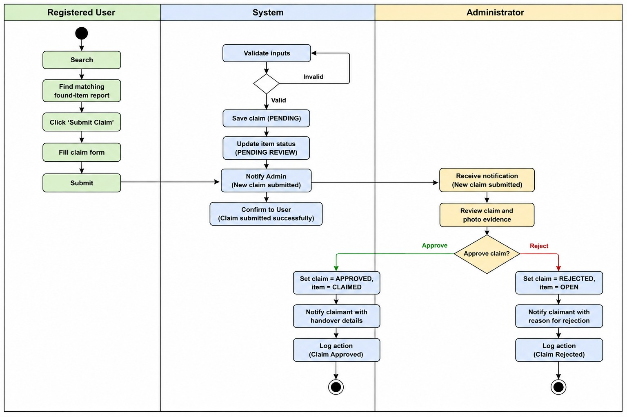

2.6 State Diagram: Item Lifecycle
This state diagram models all states an item report can be in, from initial submission to final resolution. 7 states: OPEN, MATCHED, CLAIM_PENDING, INFO_REQUESTED, CLAIMED, EXPIRED, CLOSED. Transitions are triggered by user actions, admin decisions, and automated system events (matching engine, 30-day timer).

State Diagram: Item Lifecycle

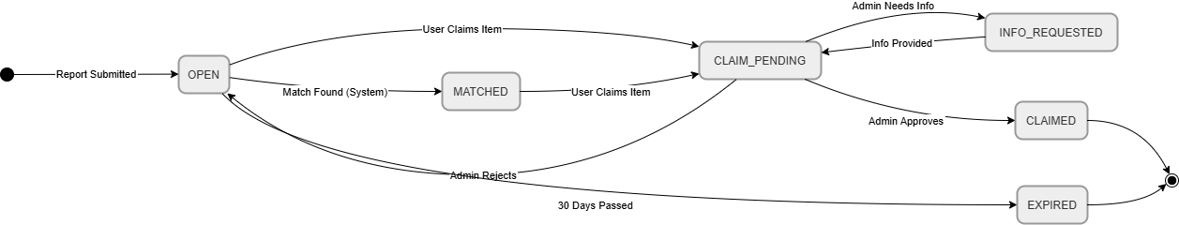
Figure 6: State Diagram Item Report Lifecycle

MILESTONE 3: DESIGN & ARCHITECTURE

3.1 Refined UML Explanations

Class Diagram Refinements
  - The Report class is abstract, only LostReport or FoundReport instances can be created, enforcing the business rule that every report must be typed.
  - The Match class includes a matchScore (Float 0.0–1.0) calculated as a weighted average: category match (40%), keyword overlap via Jaccard similarity (35%), location proximity (15%), date proximity (10%).
  - An ItemCategory enumeration is shared by both LostReport and FoundReport, ensuring consistent category values across the system.

Sequence Diagram Refinements
  - The call from ReportService to MatchingEngine is explicitly asynchronous, report submission returns immediately to the user without waiting for matching to be completed.
  - The Matching Engine queries the Database for candidate found reports and returns matchingResults[] asynchronously.

State Diagram Refinements
  - The INFO_REQUESTED state was added to reflect the real-world admin workflow step where additional ownership proof is requested before a decision.
  - Guard conditions added to transitions, e.g. [match score > 0.65] on OPEN → MATCHED, making the diagram implementation- ready.

3.2 System Architecture: MVC with Service Layer
The recommended architecture for the DLFS is MVC (Model-View-Controller) augmented with a dedicated Service Layer between the Controller and Model layers.

Justification:
  - Separation of concerns: UI (View), business logic (Service), and data (Model) are independently modifiable.
  - Testability: Service classes can be unit-tested in isolation without a browser or database.
  - Standard for web applications: Frameworks like Laravel, Django, and Spring MVC implement this natively.
  - Scalability: Thin controllers allow adding new API endpoints without changing service or model layers.

- System Architecture Diagram: MVC + Service Layer
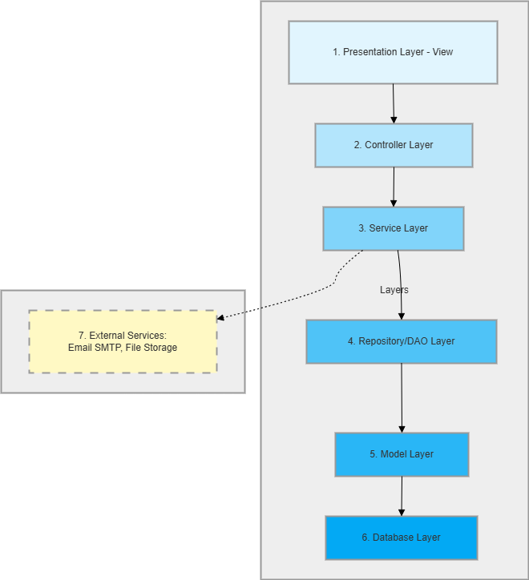
Figure 7: System Architecture — MVC + Service Layer

Architecture layers (top to bottom):
  - 1. Presentation Layer (View): HTML templates, CSS/JS assets. Displays data and captures user input only.
  - 2. Controller Layer: Routes HTTP requests, validates input format, calls the appropriate service.

3. Service Layer: All business logic, report creation, matching algorithm, claim validation, notification orchestration.
  - 4. Repository/DAO Layer: Abstracts all database queries. No raw SQL in controllers or services.
  - 5. Model Layer: Data structures (entities) mapped to database tables using an ORM.
  - 6. Database Layer: Relational database (MySQL/PostgreSQL) storing all persistent data.
  - 7. External Services: Email SMTP provider and Cloud File Storage, connected via dashed arrow from Service Layer.

3.3 System Components
Component | Technology (Suggested) | Responsibility
Frontend (View) | HTML5, CSS3, JavaScript (Bootstrap 5) | Renders UI pages: report forms, search page, dashboard, notifications.
Web Server / Controller | Node.js + Express.js (or Laravel/PHP) | Routes HTTP requests. Manages sessions and authentication middleware.
Service Layer | JavaScript modules / PHP classes | Business logic: matching algorithm, claim validation, notification orchestration, expiry scheduler.
ORM / Repository | Sequelize (Node.js) or Eloquent (Laravel) | Abstracts SQL queries into typed method calls; handles migrations.
Relational Database | MySQL 8.0 or PostgreSQL 14 | All data persists: users, reports, matches, claims, notifications, audit logs.
File Storage | Local disk (dev) / AWS S3 (prod) | Stores uploaded item photographs; returns publicly accessible URLs.
Email Service | Nodemailer + SMTP (dev) / SendGrid (prod) | Delivers transactional emails: verification, match alerts, claim outcomes.
Scheduler / Cron | node-cron or system cron | Run periodic jobs: item expiry check (daily), notification cleanup (weekly).
Authentication | JWT or express session | Manages user sessions; enforces RBAC on protected routes.

3.4 Database Design
The following relational tables form the complete database schema. Each table is shown with column names, data types, constraints, and descriptions.

Table: users

Column | Data Type | Constraints | Description
user_id | VARCHAR(36) | PK, NOT NULL | UUID primary key
name | VARCHAR(100) | NOT NULL | Full name
email | VARCHAR(150) | UNIQUE, NOT NULL | Login email

Column | Data Type | Constraints | Description
password hash | VARCHAR(255) | NOT NULL | bcrypt hash
role | ENUM | DEFAULT 'USER' | GUEST, USER, ADMIN
university_id | VARCHAR(50) | NULLABLE | Student/staff ID
is_verified | BOOLEAN | DEFAULT FALSE | Email verified?
created_at | DATETIME | NOT NULL | Account creation time

Table: reports

Column | Data Type | Constraints | Description
report_id | VARCHAR(36) | PK, NOT NULL | UUID
reporter_id | VARCHAR(36) | FK → users | Who filed the report
report_type | ENUM | NOT NULL | 'LOST' or 'FOUND'
item_name | VARCHAR(150) | NOT NULL | Item name
category | ENUM | NOT NULL | Electronics, Clothing, Keys, etc.
description | TEXT | NOT NULL | Full description
date_occurred | DATE | NOT NULL | Date of loss/finding
location | VARCHAR(200) | NOT NULL | Campus location
drop_off_location | VARCHAR(200) | NULLABLE | Found items only
status | ENUM | DEFAULT 'OPEN' | OPEN, MATCHED, CLAIM_PENDING, CLAIMED, EXPIRED
expires_at | DATETIME | NOT NULL | Auto: created_at + 30 days

Table: matches

Column | Data Type | Constraints | Description
match_id | VARCHAR(36) | PK | UUID
lost_report_id | VARCHAR(36) | FK → reports | Lost report reference
found_report_id | VARCHAR(36) | FK → reports | Found report reference
match_score | DECIMAL(4,3) | NOT NULL | Score 0.000–1.000
status | ENUM | DEFAULT 'PENDING_REVIEW ' | PENDING_REVIEW, CONFIRMED, DISMISSED
matched_at | DATETIME | NOT NULL | When match was generated

Table: claims

Column | Data Type | Constraints | Description
claim_id | VARCHAR(36) | PK | UUID
claimant_id | VARCHAR(36) | FK → users | Who is claiming
found_report_id | VARCHAR(36) | FK → reports | Found item being claimed
ownership_proof | TEXT | NOT NULL | Claimant's proof description
status | ENUM | DEFAULT 'PENDING' | PENDING, APPROVED, REJECTED, WITHDRAWN, INFO_REQUESTED
admin_note | TEXT | NULLABLE | Reviewer's note
submitted_at | DATETIME | NOT NULL | Claim submission time
reviewed_at | DATETIME | NULLABLE | Admin review timestamp

Entity-Relationship Diagram
The ER diagram below shows the full database schema with all 7 tables, primary keys, foreign keys, and cardinality relationships using crow's-foot notation.

Entity-Relationship (ER) Diagram
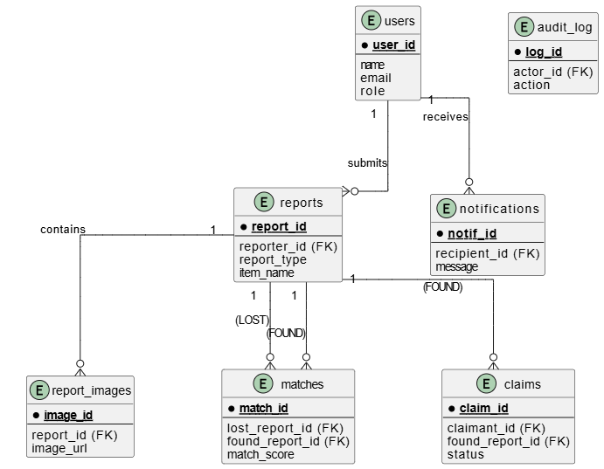
Figure 8: ER Diagram

MILESTONE 4: TESTING & MANAGEMENT

4.1 Test Plan

Testing Objectives
  - Verify that all functional requirements FR-01 through FR-15 are correctly implemented.
  - Ensure system is secure against SQL injection, XSS, CSRF, and broken authentication.
  - Validate performance under concurrent load (200+ users).
  - Confirm correct inter-module integration across controller, service, and repository layers.

Testing Levels

Level | Scope | Tools / Method | Responsibility
Unit Testing | Individual service methods and utility functions in isolation. | Jest (Node.js) with mock repositories. | Member 1 & 2
Integration Testing | Controller ↔ Service ↔ Repository interaction; HTTP request-response cycles. | Super test + Jest; test database instance. | Member 3
System Testing | End-to-end user workflows against a fully deployed test environment. | Manual test cases; Postman for API flows. | Member 4
Security Testing | Input validation, authentication bypass, role-access violations. | Manual penetration testing; OWASP checklist. | Member 4
Performance Testing | Search and match response times under 200 concurrent users. | Apache JMeter load test. | Member 4

Entry and Exit Criteria
Entry: Development environment fully set up with seeded test database. All unit tests for targeted module pass. Test plan reviewed.
Exit: All critical and high-priority test cases pass. No open critical/high severity defects. Service layer code coverage ≥ 80%.

4.2 Test Cases

TC-01: Successful Lost Item Report Submission

Field | Detail
Test Case ID | TC-01

Field | Detail
Related Requirement | FR-03
Preconditions | User is logged in as a registered user. Report form is open.
Test Input | Item Name: 'Blue Backpack'; Category: Accessories; Date: 2026-04-20; Time: 09:30; Location: Main Library, Ground Floor; Description: Blue Adidas backpack with yellow keychain.
Test Steps | 1. Navigate to 'Report Lost Item'. 2. Fill all fields with test input. 3. Click 'Submit Report'.
Expected Result | Confirmation page shown with generated Report ID. Report appears in search with status 'Open'. Success notification displayed.
Pass / Fail | (To be filled during testing)

TC-02: Report Submission with Missing Mandatory Fields

Field | Detail
Test Case ID | TC-02
Related Requirement | FR-03
Preconditions | User is logged in. Report form is open.
Test Input | Item Name: '' (empty); Date: (blank); Category: Electronics; Location: Block C.
Test Steps | 1. Leave Item Name and Date blank. 2. Fill remaining fields. 3. Click 'Submit Report'.
Expected Result | System does NOT submit. Inline errors appear below Item Name ('Item name is required') and Date ('Date is required'). Form remains populated.
Pass / Fail | (To be filled during testing)

TC-03: Automated Match Detection

Field | Detail
Test Case ID | TC-03
Related Requirement | FR-08, FR-09
Preconditions | A found-item report for 'Black Samsung phone', category Electronics, at Cafeteria, date 2026-04-19 already exists with status 'Open'.
Test Input | New lost-item: 'Samsung Galaxy phone'; Category: Electronics; Date: 2026-04-19; Location: Cafeteria; Description: Black Samsung Galaxy S23 with cracked screen protector.
Test Steps | 1. Submit the lost-item report. 2. Wait up to 10 seconds. 3. Check notifications panel of both reporters.
Expected Result | Both users receive match notification within 5 seconds. Match record created with score  > 0.65. Both report statuses update to 'Matched'.
Pass / Fail | (To be filled during testing)

TC-04: Claim Approval Workflow

Field | Detail
Test Case ID | TC-04
Related Requirement | FR-10, FR-11, FR-12
Preconditions | A found-item report (status: Open) exists. Registered user submits a claim with proof: IMEI 357849105678234.
Test Input | Admin selects the pending claim and clicks 'Approve'.
Test Steps | 1. User submits claim. 2. Admin navigates to Claims Management. 3. Admin selects claim and clicks 'Approve'. Leaves note blank. Confirms.
Expected Result | Claim status = 'Approved'. Item status = 'Claimed'. Claimant receives approval email. Audit log records CLAIM_APPROVED. Item removed from public search.
Pass / Fail | (To be filled during testing)

TC-05: Unauthorized Access to Admin Dashboard

Field | Detail
Test Case ID | TC-05
Related Requirement | NFR Security, FR-01 (RBAC)
Preconditions | A regular registered user (role: USER) is logged in.
Test Input | User manually types: https://dlfs.bahria.edu.pk/admin/dashboard in the browser.
Test Steps | 1. Log in as regular user. 2. Directly navigate to admin dashboard URL.
Expected Result | System returns HTTP 403 Forbidden. User redirected to 'Access Denied' page. No admin data exposed.
Pass / Fail | (To be filled during testing)

TC-06: Image Upload: Oversized File Rejection

Field | Detail
Test Case ID | TC-06
Related Requirement | FR-05
Preconditions | User is logged in. Found-item report form is open.
Test Input | An image file of size 7.2 MB in JPEG format.
Test Steps | 1. Fill out the found-item form. 2. Attempt to upload the 7.2 MB image. 3. Click 'Submit'.
Expected Result | System rejects files before upload. Inline error: 'File size exceeds 5 MB.' Form not submitted. No file stored on server.

Field | Detail
Pass / Fail | (To be filled during testing)

4.3 Version Control: GitHub Strategy

Repository Structure
  - Milestone 1-requirements: Problem statement, FR/NFR tables, use case diagrams and descriptions.
  - Milestone 2-modeling: DFD, class diagram, sequence, activity, and state diagram files (.drawio / .png).
  - Milestone 3-architecture: Architecture description, DB schema SQL scripts, component diagram.
  - Milestone 4-testing: Test plan, test cases, Gantt chart, risk register.
  - Docs: Final compiled report (PDF/DOCX), references, meeting minutes.
  - README.md: Project overview, team members, submission details.

Branching Strategy
  - Main: Protected branch. Represents latest approved version of all documents.
  - Dev: Integration branch. All feature branches merged here first.
  - Feature/ milestone1 ... feature/milestone 4, Per-milestone branches, one per team member.
  - Hotfix: for correcting critical errors post-merge.

Commit Convention
Format: [MILESTONE-X] <type> : <short description>
  - Example: [MILESTONE-1] docs: add use case UC-04 description table
  - Example: [MILESTONE-3] schema: add claims table with FK constraints

Pull Request Policy
  - Every merge from a feature branch to dev requires at least one peer review approval.
  - Merge conflicts resolved by branch author before PR approval.
  - Each PR must reference relevant milestones and requirement IDs in its description.

4.4 Project Planning

Gantt Chart: Task Timeline (Weeks 1–8)
Filled (dark) cells indicate the weeks during which each task is actively being worked on. The critical path runs through M1 requirements → M2 modeling → M3 design → M4 testing.
Task | Week 1 | Week 2 | Week 3 | Week 4 | Week 5 | Week 6 | Week 7 | Week 8
Project kick-off & tool setup | ⬛ | ⬛
M1: Problem statement & scope | ⬛ | ⬛
M1: FR/NFR requirements |  | ⬛ | ⬛
M1: Actors, use cases & descriptions |  |  | ⬛ | ⬛

Task | Week 1 | Week 2 | Week 3 | Week 4 | Week 5 | Week 6 | Week 7 | Week 8
M2: Context diagram & DFDs |  |  |  | ⬛ | ⬛
M2: Class, sequence, state diagrams |  |  |  |  | ⬛ | ⬛
M3: Architecture & component design |  |  |  |  |  | ⬛ | ⬛
M3: Database schema & ER diagram |  |  |  |  |  |  | ⬛
M4: Test plan & test cases |  |  |  |  |  |  | ⬛ | ⬛
M4: GitHub setup & VCS demo | ⬛ |  |  |  |  |  |  | ⬛
M4: Risk analysis & team roles |  |  |  |  |  |  |  | ⬛
Final report compilation & review |  |  |  |  |  |  |  | ⬛

PERT Chart: Task Network
The table below represents the PERT network. Nodes highlighted in amber indicate the critical path: A → B → C → D → F → G → H. Any delay on this path delays the final submission. Task E (Architecture Design) runs in parallel with D and is not on the critical path.

Node | Task | Duration | Depends On | Critical? | Notes
A | Project Setup | 0.5 weeks | — | YES | Start node
B | Requirements (FR/NFR) | 2 weeks | A | YES | Milestone 1 core
C | Use Cases & Actors | 1 week | B | YES | Milestone 1 complete
D | Modeling Diagrams | 2 weeks | C | YES | Milestone 2 — critical path
E | Architecture Design | 1.5 weeks | B | NO | Milestone 3 — parallel with D
F | DB Schema & ER Diagram | 1 week | D, E | YES | Milestone 3 complete
G | Test Plan & Test Cases | 1 week | D, F | YES | Milestone 4
H | Final Report & Review | 0.5 week | G | YES | End node — submission

Risk Analysis

 | Risk | Likelihood | Impact | Priority | Mitigation Strategy
 | Team member unavailability (illness or exam clash) | Medium | High | High | Divide tasks into daily sub-tasks. Maintain a shared progress tracker updated daily so any member can pick up another's work.
 | Scope creep -adding features beyond defined scope | High | Medium | High | Strictly follow the scope defined in M1. All scope changes require team consensus and must be documented.

 | Risk | Likelihood | Impact | Priority | Mitigation Strategy
 | Poorly defined requirements leading to rework in later milestones | Medium | High | High | Conduct requirements review at end of M1 where all members validate each FR/NFR against the case study.
 | Technical difficulty drawing accurate UML diagrams | Medium | Medium | Medium | Use draw.io or PlantUML. Allocate 2-day buffer in modelling milestone for corrections.
 | Data loss due to no version control early in project | Low | High | High | Set up GitHub repository in Week 1, Day 1. All documents committed at end of every work session.
 | Submission deadline misunderstanding or platform issues | Low | High | Medium | Set internal deadline 3 days before official deadline (May 7) to allow review and resubmission if needed.
 | Poor task coordination causing duplicate or conflicting document sections | Medium | Medium | Medium | Hold 15-minute stand-up daily (online) and use a shared Trello board to track each section's status.

4.5 Team Roles and Responsibilities
Member | Role Title | Primary Responsibilities | Milestone Owned
Aaima Binte Basit  (01-134242-001) | Requirements Engineer | Writes problem statement, project scope, and all FR/NFR requirements.  Identify actors. Leads use case diagram and write UC-01, UC-02, UC-03 tables. | Milestone 1
Yusra Yasin  (01-134242-138) | Systems Modeler | Draws Context Diagram and DFD. Creates Class Diagram. Draws State Diagram. Write UC-04, UC-05 description tables. | Milestone 2
Unzish Maira  (01-134242-133) | Architect & DB Designer | Defines MVC + Service Layer architecture with justification. Lists all system components. Designs full database schema (7 tables). Refines UML from M2. | Milestone 3
Humna Sajid  (01-134242-052) | QA Lead & Project Manager | Writes test plan and all 6 test cases. Sets up GitHub repository, branching | Milestone 4

Member | Role Title | Primary Responsibilities | Milestone Owned
 |  | Strategy, commit conventions. Creates Gantt/PERT, risk analysis. Coordinates team meetings.

REFERENCES
- (Sommerville, 2016)
- (Pressman & Maxim, 2020)
- (Object Management Group, 2017)
- (OWASP Foundation, 2023)
- (Github Inc., 2024)
- (IEEE, 2008)
- (Fawler, 2002)

