Benchmarks for Hybrid Automata

I/ Water tanker

**Source** : *An Introduction to Hybrid Automata*

Jean-François Raskin

Computer Science Department, University of Brussels, Belgium

* **Description** : This system is composed of three devices:
  + A tank that contains water and that can be heated using a gas burner
  + A gas burner that can be turned on or turned off
  + A thermometer that monitors the temperature of the water inside the tank and periodically issues signals when the temperature of the water in the tank is above or below certain thresholds.
  + A controller that will observe the signals issued by the thermometer and will issue orders to the gas burner in order to maintain the temperature of the water within a given range.
* **Abstraction** of the system into an Hybrid Automaton

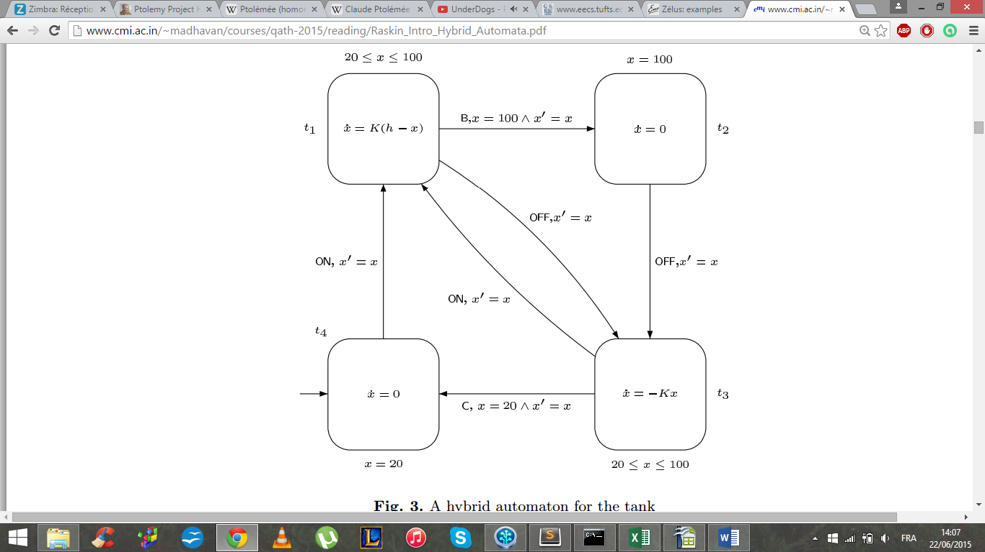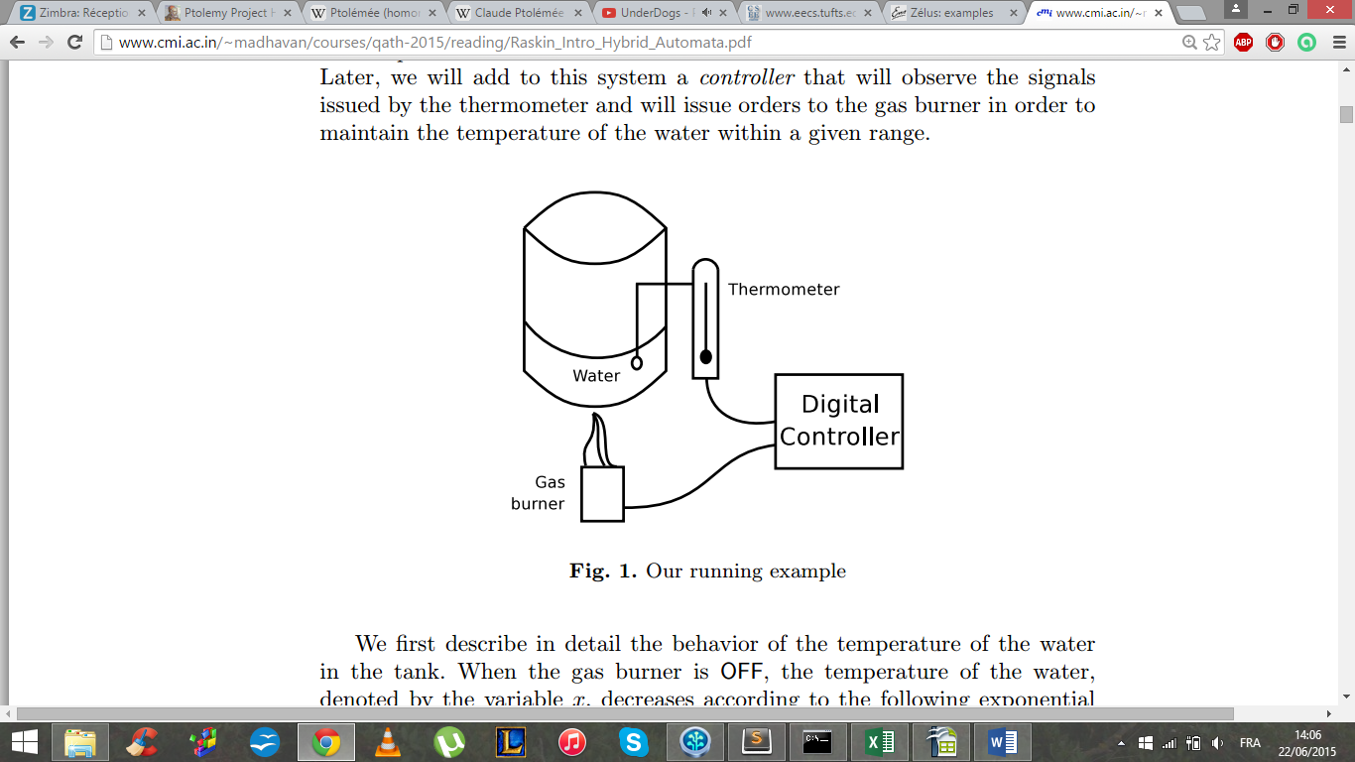

Figure 1 : Physical system

* **Expected behaviour**

Figure 2 : Hybrid Automaton

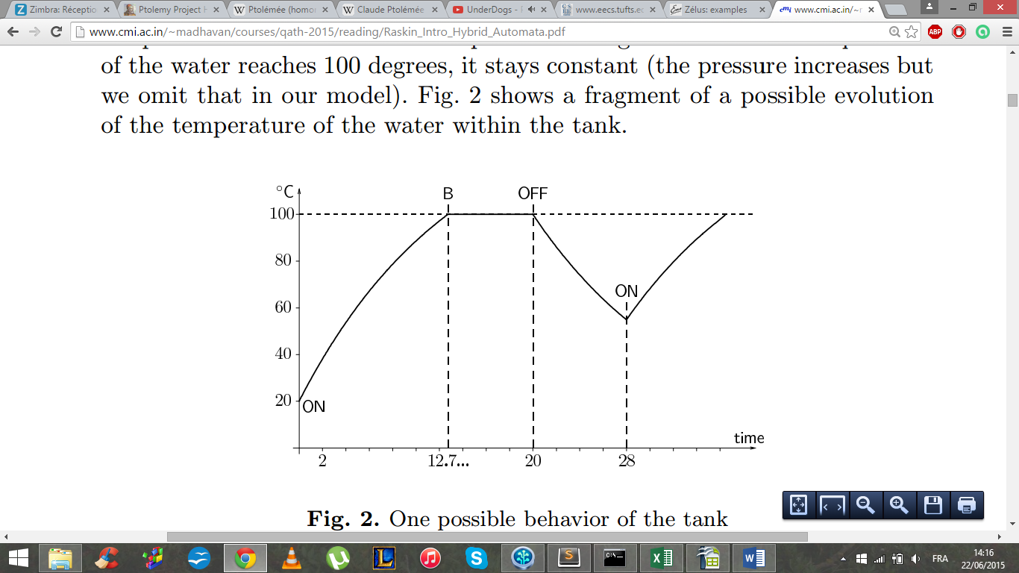

* + *Location t1 :* Burner ON, the temperature of the water increases according to x(t) = Ie−Kt + h(1 − e −Kt)
  + *Location t2 :* The temperature of the water reaches 100°C and stays constant
  + *Location t3 :* Burner OFF, the temperature of the water decreases according to x(t) = Ie−Kt
  + *Location t4 :* The temperature of the water reaches 20°C and stays constant

Figure 3 : possible evolution of the temperature

(not shown in the figure)

II/ Single Heart Cell

**Source** : *Quantitative verification of implantable cardiac pacemakers over hybrid heart models*

Taolue Chen, Marco Diciolla, Marta Kwiatkowska, Alexandru Mereacre

Department of Computer Science, University of Oxford, UK

* **Description** : The sinoatrial (SA) node (a special tissue in the heart) spontaneously produces an electrical signal, which is the natural pacemaker of the heart. On each heart beat, it generates the control electrical signal which is conducted through prescribed internodal pathways into the atrium causing its contraction. Here is displayed one single cell of this network, which is artificially paced by a pacemaker.
* **Abstraction** of the system into an Hybrid Automaton

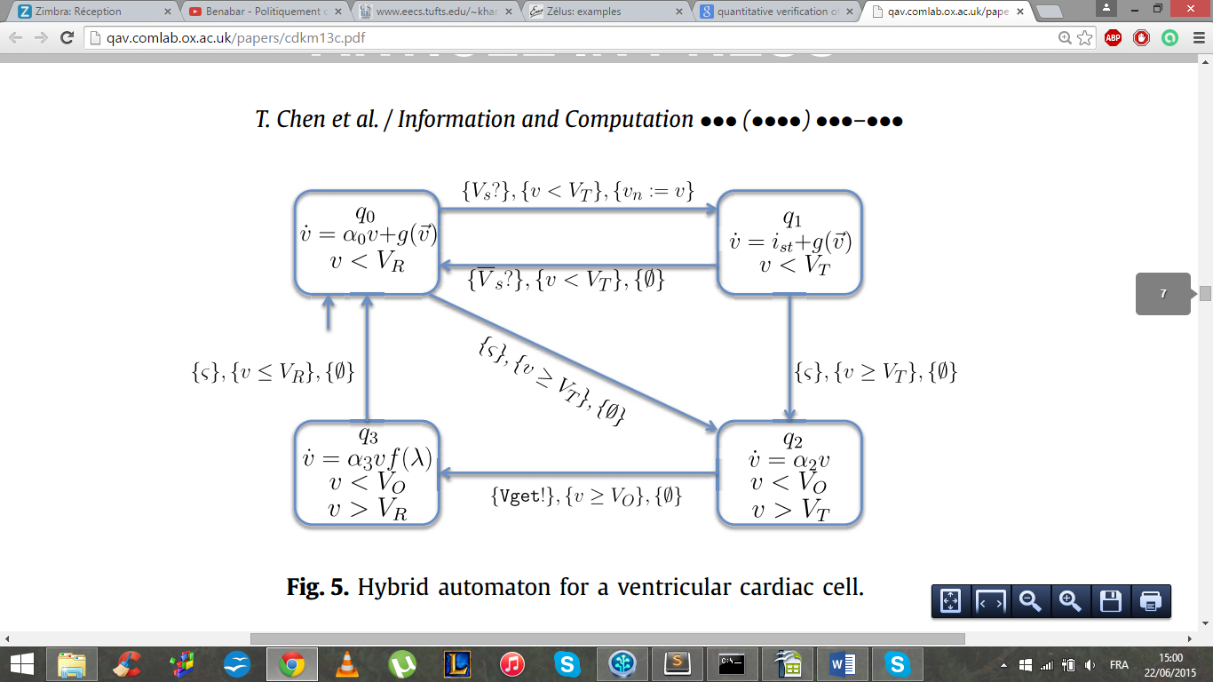The g function is describing the neighbor contribution ; as only one cell is considered, g equals zero.

Figure 4 : Cell Hybrid Automaton

* **Expected behavior**

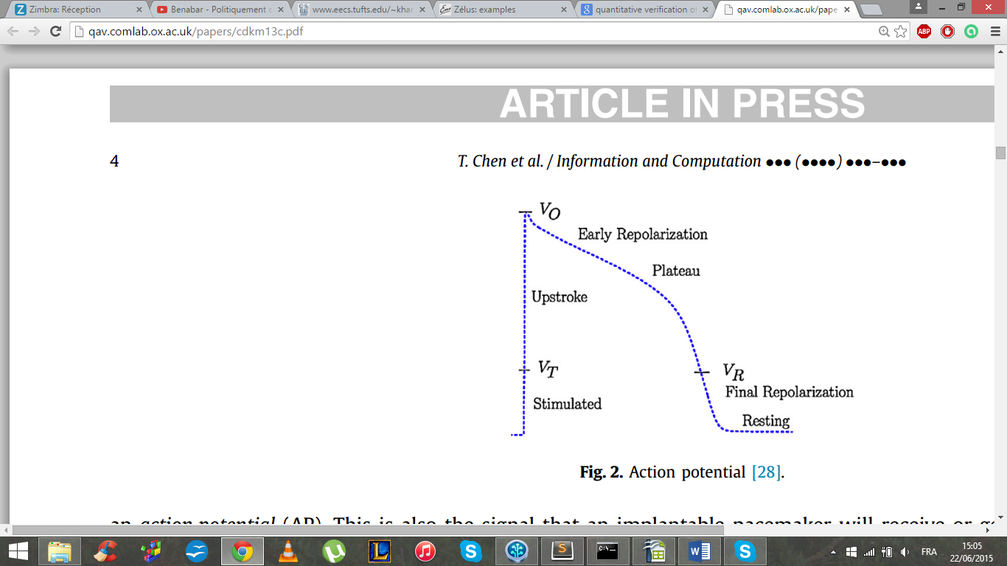

* + *Stimulated :* This is the phase where the cell is triggered by a voltage spike from the AP of its neighbouring tissue or from an artificial pacing signal (pacemaker signal). However, if the current does not reach the threshold, then the cell cannot get stimulated, and consequently it goes to the resting phase.
  + *Rapid upstroke :* If the received voltage spike is high enough, the upstroke indicates the depolarisation of the cell and the time when the muscle contracts.

Figure 5 : Cell Voltage

* + *Plateau and ER (early repolarisation) :* This is a plateau phase during which calcium influx facilitates the muscle contraction.
  + *Resting and FR (final repolarisation) :* This is the last phase which features faster repolarisation that brings the potential back to the resting phase.

III/ Nuclear Reactor

**Source** : *Principles of Cyber-Physical Systems*

Rajeev Alur

Department of Computer and Information Science, University of Pennsylvania

* **Description** : We consider a toy model of a nuclear reactor with two control rods. Initially, the temperature is 510 degrees, and no rods are in the reactor. When the event add1 is issued, the plant switches to the mode Rod1. The rod has a dampening effect, which slow down the rate of increase in temperature.
* **Abstraction** of the system into an Hybrid Automaton

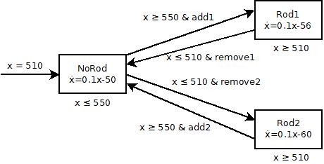

Figure 6 : Power Plant Hybrid Automaton

* **Expected behavior**

The system is supposed to follow the command, and the temperature should increase and decrease within the 510-550 degrees bound.

IV/Train Control

**Source** : *Logical Analysis of Hybrid Systems[1]*

André Platzer

Carnegie Mellon University, Pittsburgh, PA

* **Description :** This examples shows a very simplistic train control in two states.

The train is accelerating until it reaches a given speed, then brakes until it reaches another

given speed.

* **Abstraction** of the system into an Hybrid Automaton

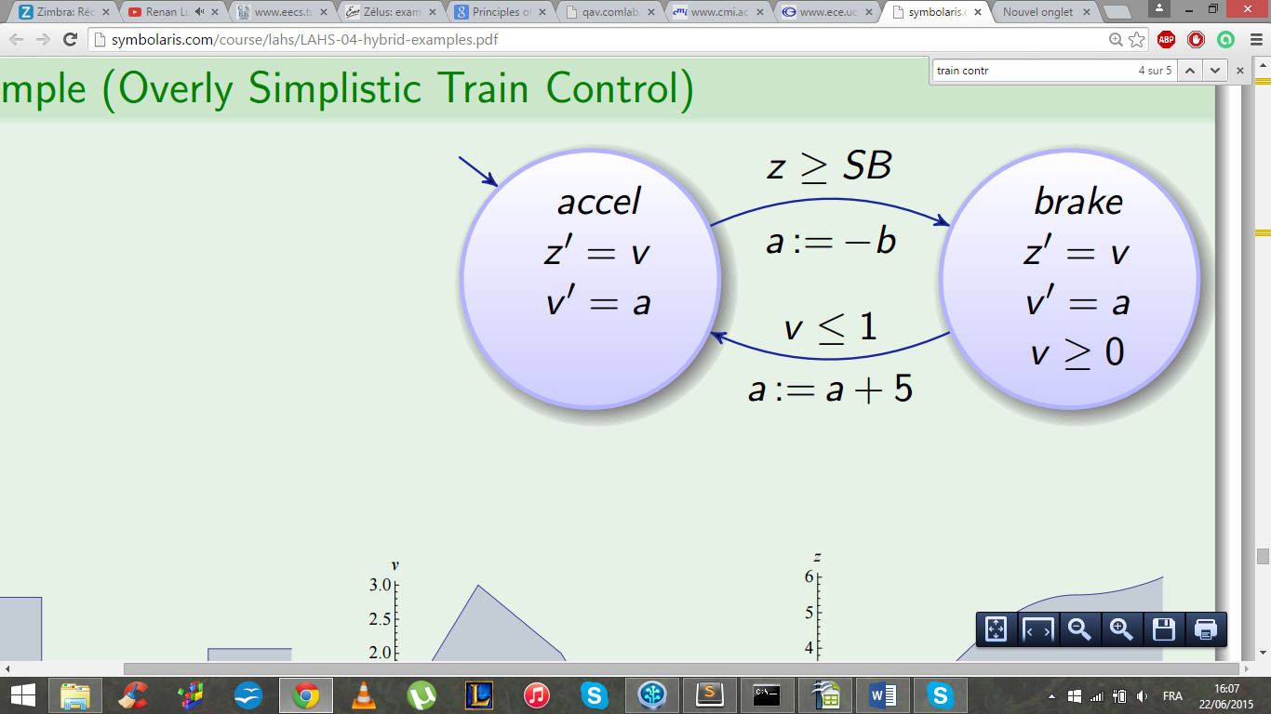

The z ≥ SB condition had been replaced by a condition on the speed

Figure 7 : Train Control Hybrid Automaton

* **Expected behavior**

The acceleration is constant in each location ; then the speed should oscillate between the two bounds.

The position graph should have the shape of stairs.

V/ Thermostat

**Source** : *How to describe a hybrid system? Formal models for hybrid system[2]*

João P. Hespanha

University of California at Santa Barbara

* **Description :** This example display a simple model for a thermostat. The thermostat heat the room to keep the temperature warm.
* **Abstraction** of the system into an Hybrid Automaton

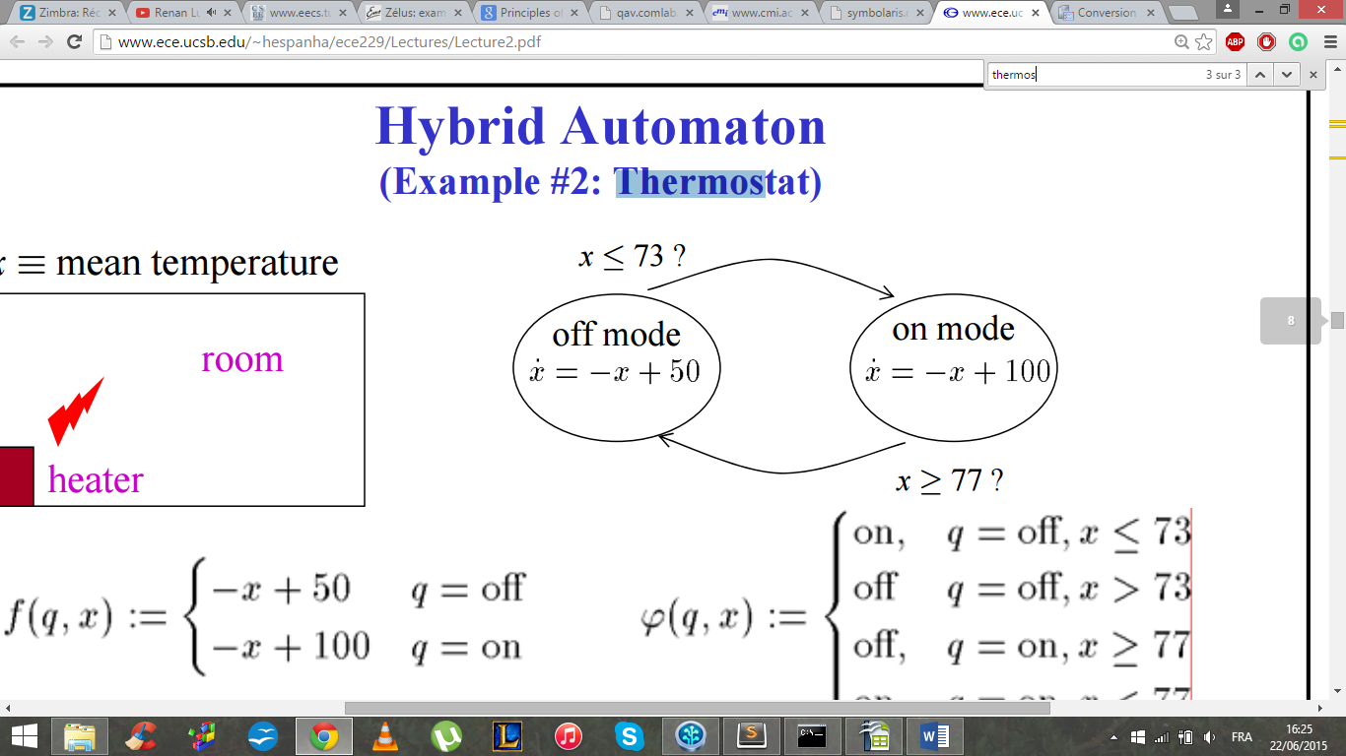

Figure 8 : Thermostat model, temperature in °F

* **Expected behavior**
  + *Off mode* : Room cooling down, until temperature reaches 22.78 °C
  + *On mode* : Room warming up, until temperature reaches 25 °C

The temperature should grow until it reaches 25°C then oscillates between 22.78°C and 25 °C

VI/ Train and Gate

**Source** : *Hybrid system[3]*

Brennon Costello & Joshua Elliott

Tufts University

* **Description :** A train travels around a circle track of circumference 25m, and its position is described by y. A road crosses over the tracks. A gate blocks traffic when there is an oncoming train. There are sensors in the tracks 10m before the intersection and 5m after the intersection. The height of the gate is described by x. A controller sends a signal to raise or lower the gate based on the sensors.
* **Abstraction** of the system into an Hybrid Automaton

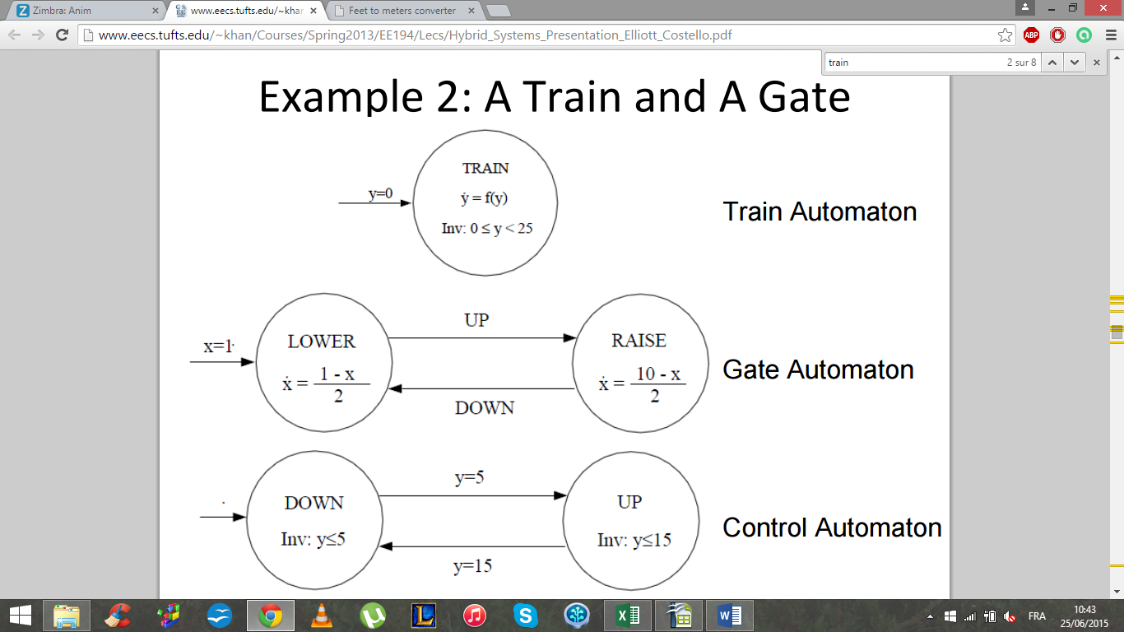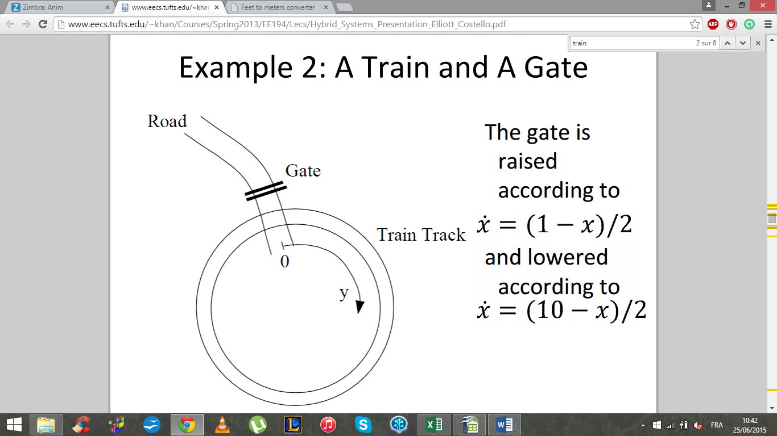

Figure 9 : Schematic for the train & gate example

Figure 10 : The train & gate automata

We made the choice, in our implementation, to merge the train automaton and the control automaton to simplify the problem.

* **Expected behavior**

Following the train position, the gate is expected to oscillate between its high and its low position.

1. http://symbolaris.com/course/lahs/LAHS-04-hybrid-examples.pdf
2. http://www.ece.ucsb.edu/~hespanha/ece229/Lectures/Lecture2.pdf
3. http://www.eecs.tufts.edu/~khan/Courses/Spring2013/EE194/Lecs/Hybrid_Systems_Presentation_Elliott_Costello.pdf