Starting from a new project

Design data collection instruments
Designer
- Rename Form 1 = ‘Subjects’. Open it.
  - Add field. Variable name = ‘dob’. Label = ‘Date of birth’.
Text box with validation Date (Y-M-D).
- Create new instrument ‘Regular events’. Open it.
  - Add field. Variable name = ‘assess_date’. Label = ‘Date of assessment’.
Text box with validation Date (Y-M-D).
  - Add field. Variable name = ‘test’. Label = “Test result’
Text box with validation Integer. Min = 0. Max = 100.
- Create new instrument ‘Irregular events’. Open it.
  - Add field. Variable name = ‘ae_date’. Label = ‘Date of adverse event’.
Text box with validation Date (Y-M-D).
  - Add field. Variable name = ‘ae’. Label = ‘Adverse event’.
Multiple choice – Radio buttons (Single Answer).
1 = Mild | 2 = Moderate | 3 = Severe
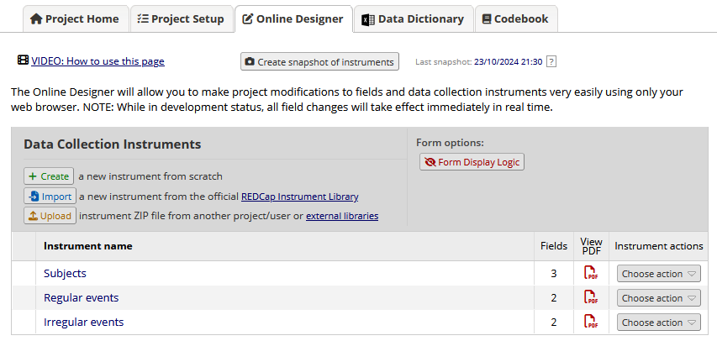

Define events and designate instruments for them
Project setup
- Convert to project to longitudinal project Main Project Settings
  - Enable ‘Use longitudinal data collection with defined events’.
- Define my events.
  - Event #1. Label = week_00. Custom label = ‘Baseline’
  - Event #2. Label = week_04. Custom label = ‘Week 4’
  - Event #3. Label = week_12. Custom label = ‘Week 12’
- Designate instruments for my events.
  - All for week_00.
  - Regular for week_04 and week_12.
- Enable optional modules and customizations
  - Repeated instruments and events.
  - We want to enable out adverse events to be a repeat instrument
Event week_00 = Repeat Instruments. ‘Irregular’. Custom = [ae_date]
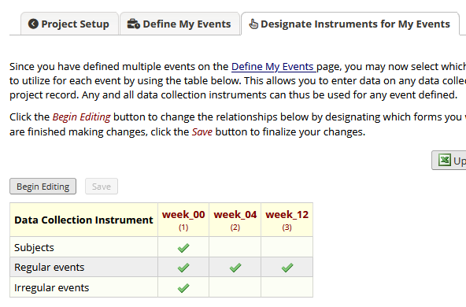
Go to record status dashboard
No records but can see the project set up

Enter cases
Add / Edit Records
- Add new record
  - Subjects. DOB = 1975-03-20
  - Regular.
Week_00: Date of assessment = 2024-01-18. Test result = 66.
Week_04: Date of assessment = 2024-02-14. Test result = 78.
Week_12: Date of assessment = 2024-04-13. Test result = 82.
  - Irregular
Date of adverse event = 2024-03-07. Adverse event = ‘Mild’.
Explain what pops up when you add adverse events, acknowledge custom label. Multiple repetitions under a single event
- Data import tool to speed up the rest of the data
  - Browse BiostatsExample… file, and ‘Upload File’.
- Record status dashboard.
  - View record 3.
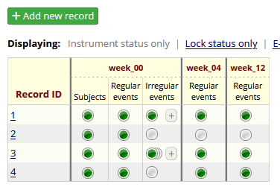

Extract information for analysis
Data Exports, Records, and Stats
- All data. View report.
  - Order by record_id.
  - Highlight record_id, event_name, repeart_instance.
  - Discuss how difficult this would be to analyse as is.
- Selected instruments and/or events
  - Instruments = Subjects. Events = week_00. Create report. Remove ‘repeat’.
  - Instruments = Regular. Events = ‘All events’. Create report. Remove ‘repeat’.
  - Instruments = Irregular. Events = week_00. Create report. Filter. Deselect ‘Show data for all events or repeating instruments…’. Add ‘[current-instance] <> ""’ as advanced filter. Only want to return instance that is on a repeating form.
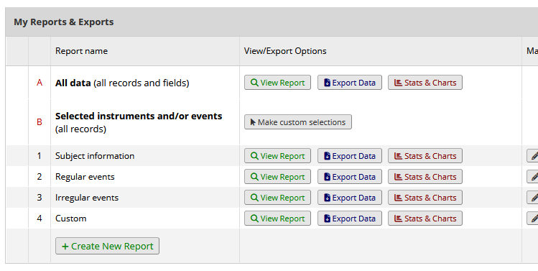

OPTIONAL: Schedule cases for follow-up
Project setup
- Enable optional modules and customizations
  - Scheduling module (longitudinal only)
  - Define my events. Set ‘Days offset’ to 0, 28, 84.
  - Scheduling. Generate schedule. Record_id = 1. Start date = 2024-01-18.
  - Show calendar and Project Home (upcoming calendar events)

