Visual Abstracts workshop
- Summarise written abstract in words, using guidelines on template
- Use PowerPoint to create visual abstract, with words and icons from 1.
- Evaluate visual abstract created in 2. with peer
-------------------------------------------------------------------------------------------------------------

Summarise written abstract
Guidelines | Text of your visual abstract | Icon / image / visual metaphor in words
Title
15 words max
Point 1
<15 words
Point 2
<15 words
Point 3
<15 words
Conclusion or takeaway point
<15 words
Your name and date | Created by
Reference with DOI hyperlink
Use your own article or one you are reading.

Create visual abstract with icons
Template will be provided in chat to download
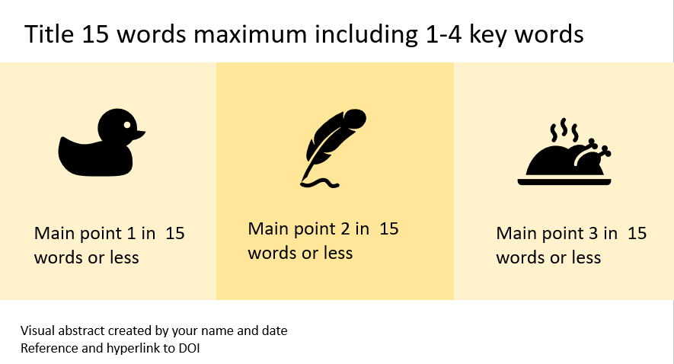
Swap out words and icons with your content.
To insert icons
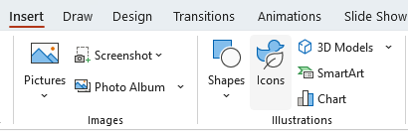

Evaluate your visual abstract with a peer
Breakout rooms
- Information elements

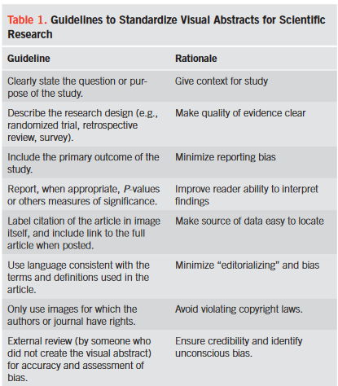
Ibrahim, Andrew M. ‘Seeing Is Believing: Using Visual Abstracts to Disseminate Scientific Research’. American Journal of Gastroenterology 113, no. 4 (April 2018): 459–61. https://doi.org/10.1038/ajg.2017.268.

3. Evaluate your visual abstract with a peer

b) Design elements
Guideline | Rationale
Body text <45 words | Text is sufficiently brief
Key message is clear | Emphasise the important
Icons consistent style | All solid/open/monochrome or coloured
Contrasting colours for icons/text | For readability
Words/numbers/graphics aligned with each other | For readability

Adapted from Guidolin, et al ‘Evaluating the Accuracy and Design of Visual Abstracts in Academic Surgical Journals’. Annals of Surgery 276, no. 5 (November 2022): e275. https://doi.org/10.1097/SLA.0000000000005521.

