ART DRAWING Pages:
- Begin
- Victory
- Failure(game over)
- Loading
- Background story(maybe a lot)
- Explain
- Ranking
- Map
- Option setting

HUD:
- Alarm bar
- Weapon amount showing bar(advanced)
- Time
- Key bar (optional)

Interactive elements:
- Option button
- Weapon useable button(advanced)
- Exit
- Door
- Box(weapon box(advanced) / key box)
- Key
- Light button
- Portal

Other elements:
- Floor block
- Wall block
- Window
- Shelf
- Table
- Neon light
- NPC
- Main actor

Dynamic effect:
- open the door
- open the box
- get key
- get weapon(advanced)
- alarm bar

Tables
ART DRAWING Pages:
English | 中文 | Priority | note
Map | 地图页 | 1
Begin | 开始页 | 3
Victory | 胜利页 | 3
Failure(game over) | 失败页（游戏结束） | 3
Loading | 加载页 | 3
Background story(maybe a lot) | 背景故事页（篇幅可能较长） | 3
Explain | 说明页 | 3
Ranking | 排行榜页 | 3
Option setting | 选项设置页 | 3

HUD:
英文 | 中文 | Priority | Note
Alarm bar | 警戒条 | 1
Weapon amount showing bar(advanced) | 武器数量显示条（进阶版） | 2
Time | 时间显示 | 2
Key bar (optional) | 钥匙条（可选） | 2

Interactive elements:
English | 中文 | Priority | Note
Door | 门 | 1
Key | 钥匙 | 1 | 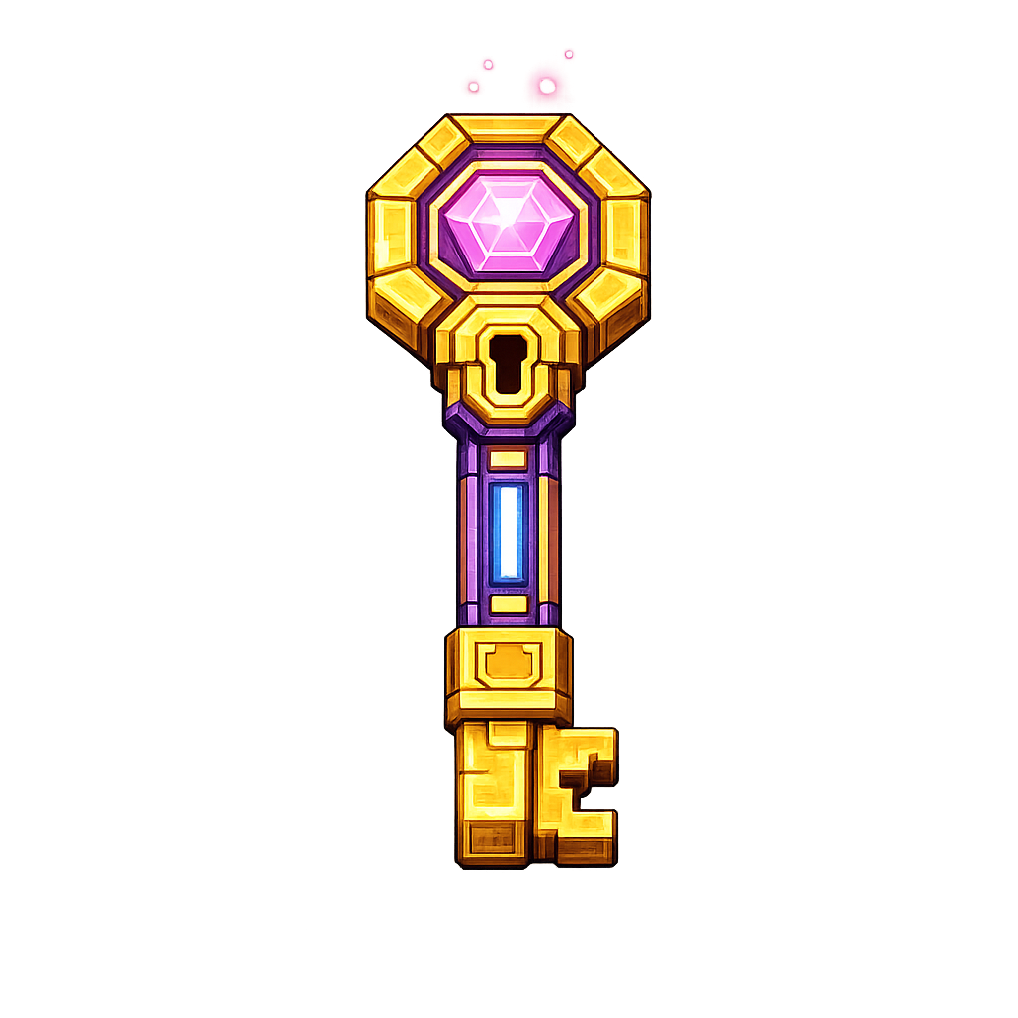
Light button | 灯光按钮 | 1
Portal | 传送门 | 2
Weapon useable button(advanced) | 武器可使用按钮（进阶版） | 2
Box(weapon box(advanced) / key box) | 箱子（武器箱（进阶版）/ 钥匙箱） | 2 | 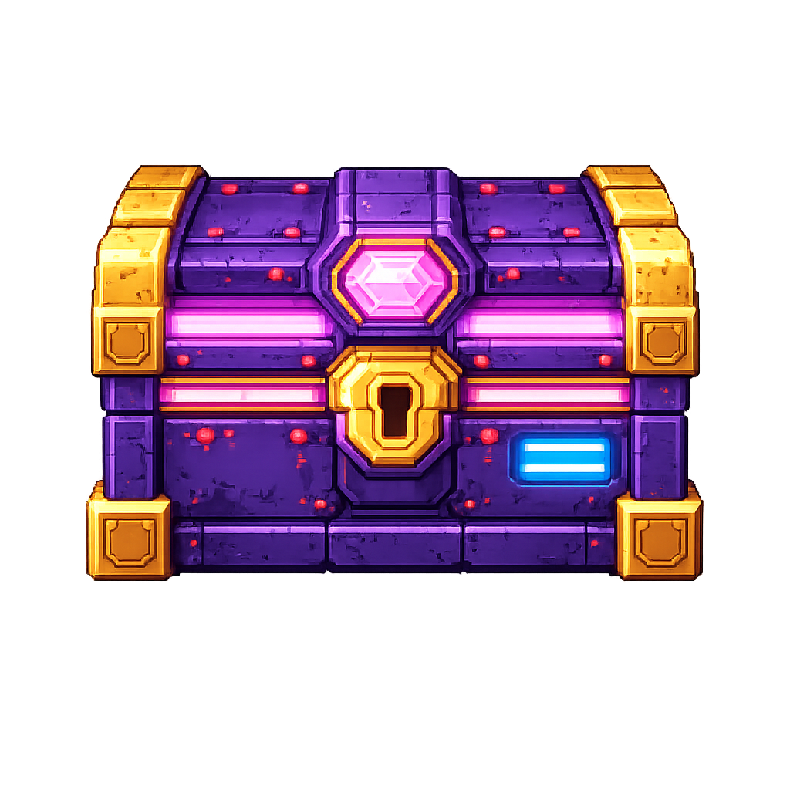
Option button | 选项按钮 | 2
Exit | 退出按钮 | 2

Other elements:
English | 中文 | Priority | Note
Floor block | 地面方块 | 1
Wall block | 墙体方块 | 1
Window | 窗户 | 1
Shelf | 置物架 | 1
Table | 桌子 | 1
Neon light | 霓虹灯 | 1
NPC | 非玩家角色 | 1
Main actor | 主角 | 1

Dynamic effect
English | 中文 | Priority | Note
open the door | 开门 | 2
open the box | 开箱子 | 2
get key | 拾取钥匙 | 2
get weapon(advanced) | 拾取武器（进阶版） | 2
alarm bar | 警戒条动态效果 | 2

