Firstly, all the shops in the dataset were grouped into seven categories and the annual incomes of the shops were calculated as shown in the figure. Among them bar has the highest incomes.

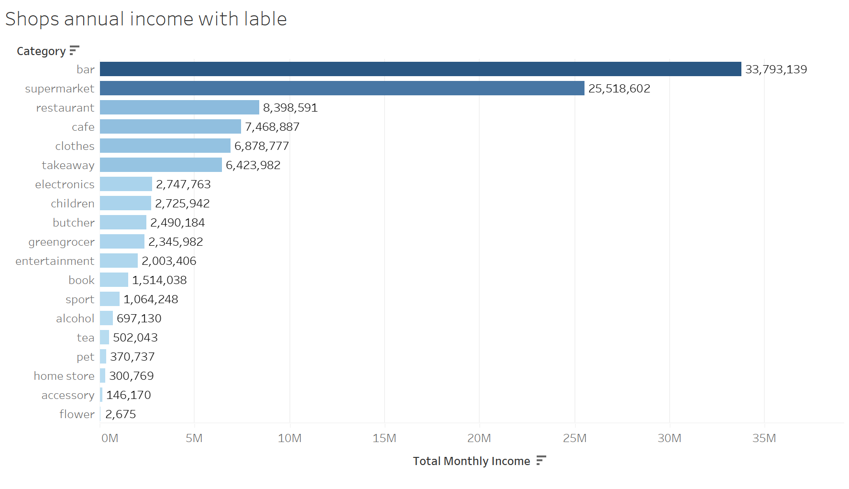

This graph represents the annual incomes of all the shops in the bar category. It can be clearly seen that PUB has the most income.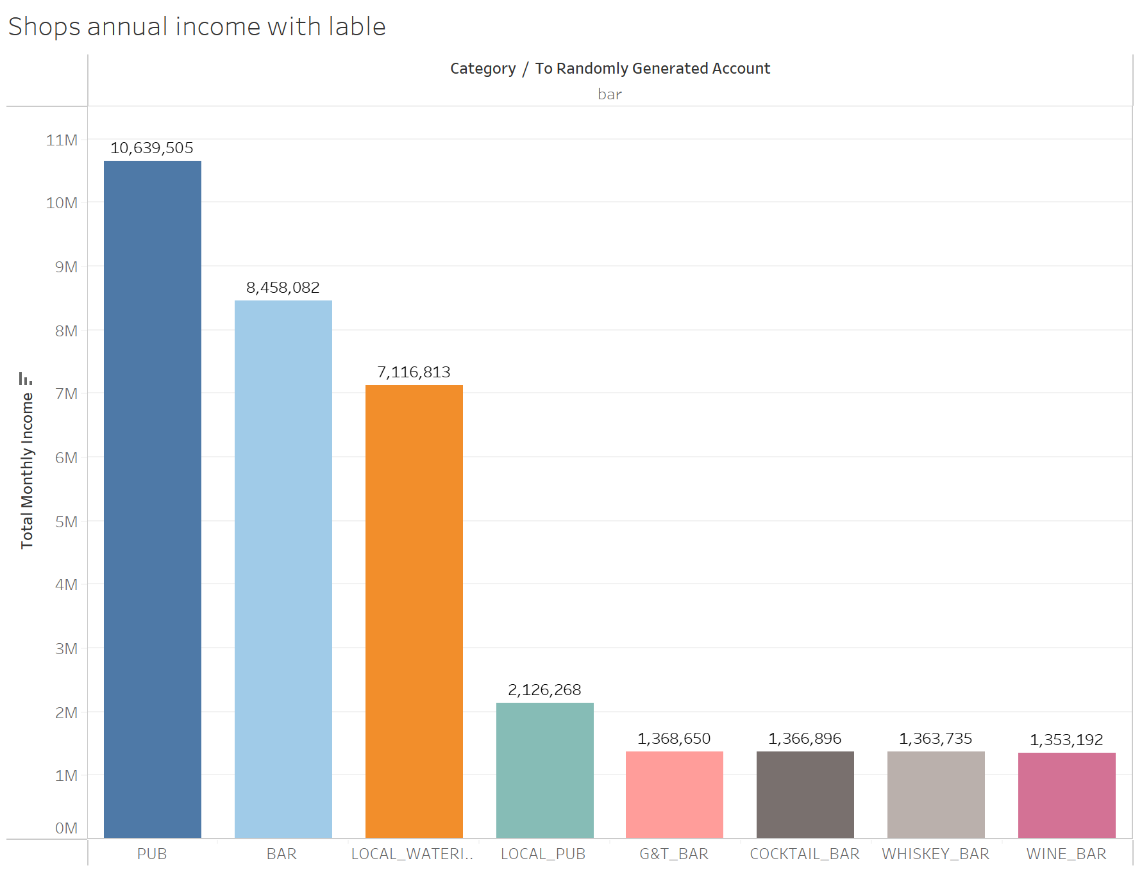

The next step is to analyse the top three RFMs in terms of income.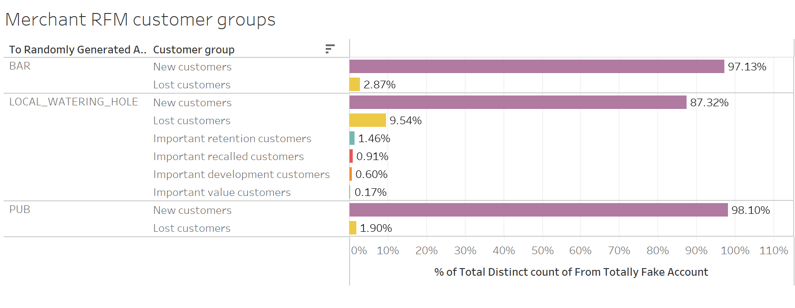

It can be seen that the percentage of New customers is higher.