Webcam Video Stream Analysis Exercise

Overview
The focus of this exercise is the construction of a simple computer vision application that will be used to analyse a webcam video stream. Our aim is to write some code that is able to detect different types of vehicle driving through a particular road junction. We have provided you with a template project to help get you started:

https://github.com/UoB-SummerSchool/CameraAnalysisAndComms

Task 1: Run the template project
The first activity in this exercise is very simple – to make sure that you can actually run the template code linked to above. First download and then unzip the project to a suitable location (e.g. “My Documents”), then open the VehicleAnalysisTemplate file in Processing. In order to run the code, you will need to install two different libraries. From the menu, select “Sketch > Import Library > Manage Libraries”. Then use the “Filter” box to search for and install the “MQTT” library and then the “Video 4” library, as shown below:

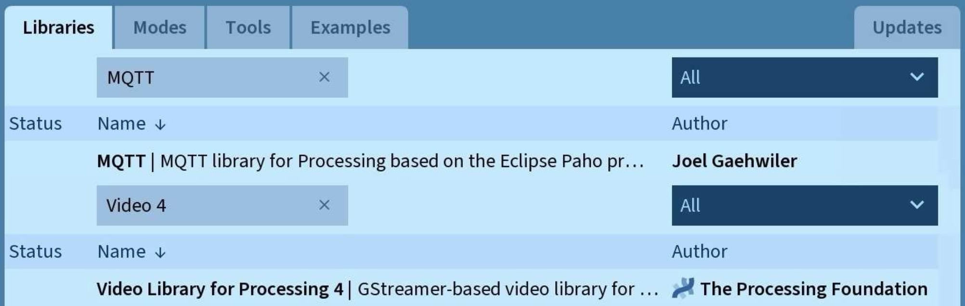



Once you have installed these two libraries, you should then be able to run the code. If everything is working correctly, you should see a video stream of the camera as shown below (note that the grass will be shown grey !):

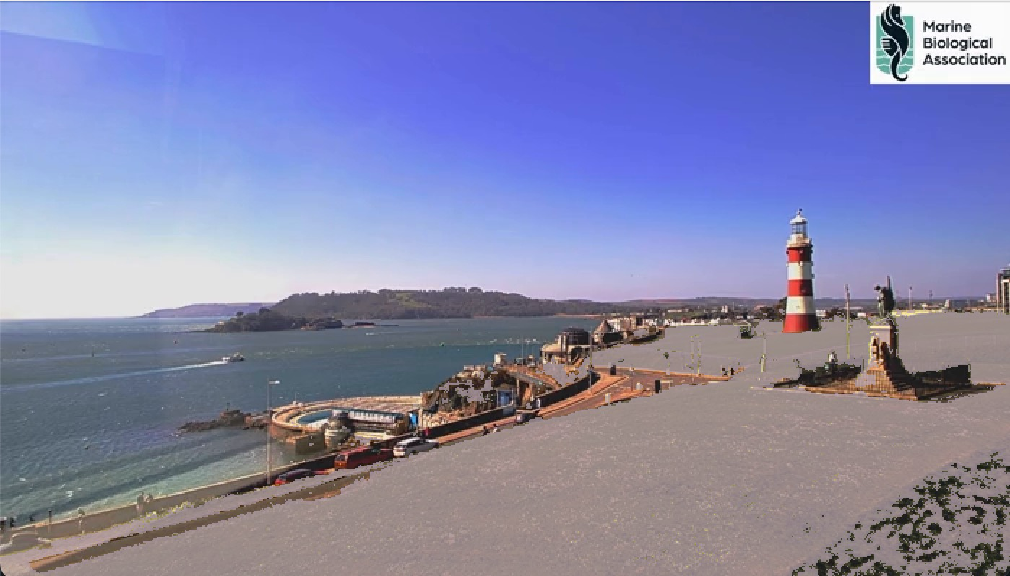

Task 2: Detect movement
You first real challenge is to be able to detect when there is movement in the webcam video stream. When your code first starts to run, you will need to grab a background (baseline) frame and store this for later comparison. First declare a new PGraphics variable to store the baseline image, then initialise this variable with a call to the createGraphics function (in the same way that the currentFrame variable was initialised in the code template). In order to store a frame in your initialised baseline image varable, call the drawMovieOntoFrame to draw a frame onto it.

Each time a new frame is loaded, you should compare the new frame with the original baseline image in order to detect any changes within the scene. For each pixel in the current frame, determine if there has been a change in brightness (compared with the original baseline image). Note that there will always be a slight variation in pixel brightness from frame to frame (even if there is no real change in the content of the image). For this reason, you will need to identify a suitable threshold, above which a pixel is deemed to have changed. Any minor change in brightness (below the threshold) should be considered to be just normal variation in pixel colour and therefore ignored. Note that brightness values can decrease as well as increase between frames, so you should use the absolute change in value for each pixel (i.e. convert any negative values into positive ones).

In order to help you identify a suitable threshold value for the pixel brightness change, it is useful to re-colour “changed” pixels in a special colour to highlight them on the screen. In the image below, bright green has been used to re-colour pixels that have changed in the current frame (compared with the original baseline frame).

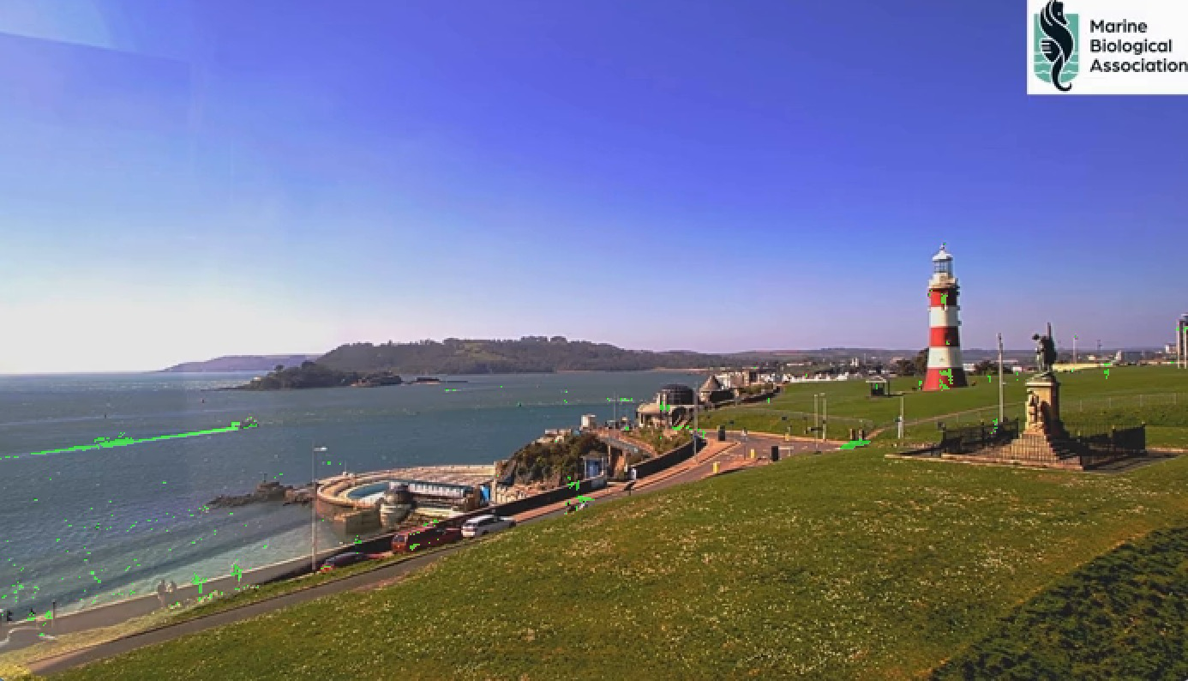

Re-colour changed pixels in this way makes it a lot easier to experiment with the brightness change threshold value. It is possible to see if the threshold is set too low (too many pixels are being drawn green) or if the threshold level is set too high (not enough pixels are being drawn green).

Important note: the very first frame that comes from the video stream might be blank – this is because the video is being displayed before the underlying video frame has fully loaded. In this situation, you might need to use the 2nd frame from the video to initialise the baseline image. The following code in your draw function will ensure that the second frame of the video is drawn onto your baseline image frame (note that frameCount is a built-in variable that you can just use without initialising):

if((frameCount==1)||(frameCount==2)) drawMovieOntoFrame(baselineFrame);

Task 3: Mask-off unwanted areas
As you will have seen in the previous task, there is a lot of movement and activity in a variety of different areas across the entire camera frame. In this exercise, we wish to focus analysis on one particular area - namely the road junction shown near the centre of the image (see the area circled in red on the left-hand image below). For irregular shaped areas such as this (areas that are not rectangular), it is easier to “mask off” unwanted pixels with black, rather than trying to constrain the analysis loop. For this reason, you should draw a number of black filled shapes to mask off everything except the road junction. A zoomed-in illustration of what you should be attempting is shown in the right-hand image below.

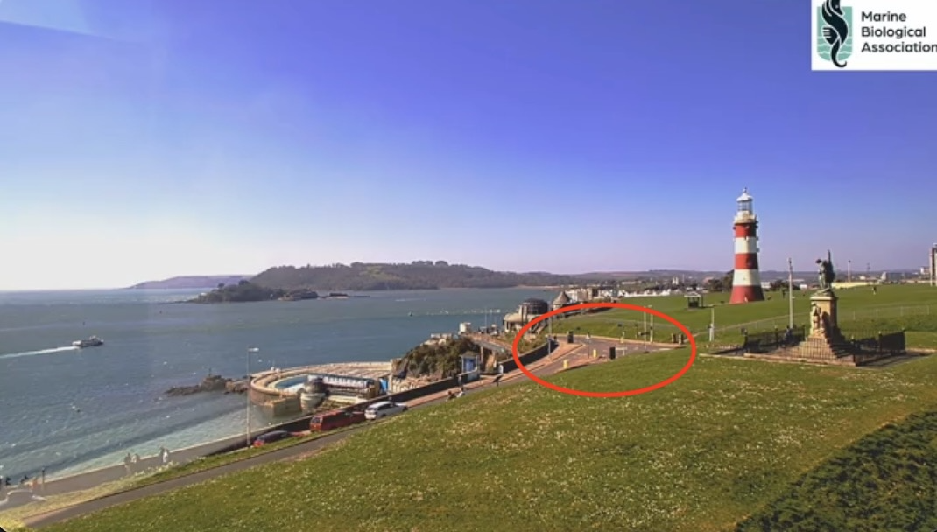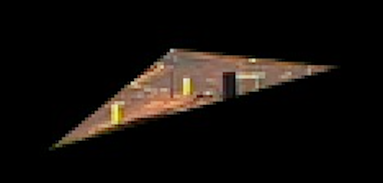

In order to achieve this “masking off”, there are two drawing functions that you might find useful:
- triangle: takes 6 parameters – 3 pairs of [x,y] coordinates for each of the 3 triangle corners
- rect: takes 4 parameters – [x,y] coordinates of the top-left corner and the width and height
To illustrate the use of these functions, an example of each is included in the project template. You will need to experiment with the coordinate positions in order to mask off the required areas. Note that clicking on the video display window with the mouse will print out the [x,y] coordinates of that position – this could be useful !

Task 4: Detect presence of vehicles
In this next task, you will apply your pixel change detection code to the masked-off image frame. The aim of this activity is to detect when a vehicle is passing through the road junction. For each frame that is shown on the screen, count the number of pixels that have changed in brightness (the number of pixels that have been re-coloured green). When the number of changed pixels is above a suitable threshold, print out a simple message on the screen (for example “vehicle at junction !”). The aim of this new pixel count threshold is to allow your code to distinguish between small changes (e.g. a person walking past the junction) and larger changes (indicating a vehicle being present). Test your code by running the webcam video and checking that a message is printed out every time a vehicle passes through the junction.

Task 5: Detect a red vehicle
Now that you have a mechanism in place to detect the presence of a vehicle (any vehicle), you should refine your code in order to identify a particular type of vehicle. In this task, we are interested only in red vehicles. Alter your vehicle detection code so that it prints out a message only when a red vehicle is passing through the junction (not just any vehicle). Note that you will need to turn-off the pixel re-colouring code that you wrote in a previous task – obviously if all changing pixels have been re-draw green, your code will not be able to detect any red vehicles !

When attempting to detect red vehicles, you will need to consider the “hue” values of each pixel to identify those pixels that are red. You will also need to take into account the brightness and saturation of pixel colours. Consider the pixels in the colour spectrum shown below – all pixels have the same hue value, but only some of them would be perceived as “red” by a human viewer. Low saturation values appear light pink or grey and low brightness values appear black. You should check the saturation and brightness values and only consider pixels that are very red (i.e. pixels found near the top right-hand corner of the colour spectrum).



To help you experiment to identify correct hue, saturation and brightness values, it is useful to over-write the colour of pixels within the frame when they have met your current criteria for “red”. This is shown in the images below, where the detected red pixels have been “enhanced” by painting them fully red (with an RGB value of [255,0,0]). Repainting pixels in this way makes it a lot easier to see which pixels meet the threshold requirements and which have fallen below.

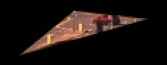 | 
Before repainting enhancement | After repainting enhancement

Once you have identified suitable hue, saturation and brightness thresholds, use these values to identify the presence of red vehicles. When you think you have detected a red vehicle, print out a suitable message to the screen. In order to help test your code, you might like to press the 3 key on the keyboard – this will jump to a segment of video containing a red car (you might need to mouse click inside the video window first, so that the keypress is sent to the playback handler).

Task 6: Determine direction of travel
It is useful to know that a red car has passed through the junction, however it would be even more useful to know in which direction it was travelling in. Update your code so that it is able to determine the direction in which the car was travelling. Note that the camera we are using if facing approximately west, so you should therefore use the below compass directions to classify the direction of travel:

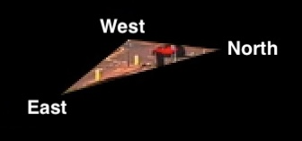

Your aim is to be able to print out a message of the form:

A red car was seen travelling from North to West

In order to be able to do this, you will need to determine the position of the car when it first appears at the junction, as well as the position of the car as it leaves the junction. You will need to compare the position of the vehicle with the locations of the three points of the triangle shown in the image above. To do this, you will need to identify the position of the triangle corners (to help you, remember that clicking anywhere in the display window will print out the coordinates of the pixel that was clicked). To help you store pixel locations, a “Position” class has been provided for you (which can be used to represent the [x,y] location of a point on the screen).

Hint: A good way to simplify the problem of identifying the location of a vehicle is to calculate the average position of all the red pixels currently inside the triangular area. This will give you the approximate centre point of the vehicle (so that you don’t have to deal with many pixel positions). As you may already have realised, problems could occur if there is more than one red vehicle travelling through the junction at a particular time (especially if they are travelling in different directions). There are more sophisticated approaches that could be used (such as “blob detection”) however this simple approach of calculating an average red pixel position will be good enough for this exercise.

Task 7: Differentiate between different types of vehicle
There are a wide variety of vehicles that may use the road junction that we are analysing. It would be useful to be able to determine which type of vehicle is passing through at a particular time. One property that we can use to differentiate between vehicles is their size. By counting the number of red pixels inside the junction triangle at a particular point in time, it is possible to infer if the vehicle is small (for example a car) or large (for example a bus). Implement additional features in your code so that it attempts to differentiate between cars and busses (printing out a suitable message when it encounters each type of vehicle).

Note that we have provided a video recording that contains a bus in order for you to test your code. Replace the video.mp4 filename in your code with bus.mp4 in order to load in the new video file. Note that a bus arrives at the road junction at time 00:19 in this new video. You might like to update the key press event handler in order to jump the video to the correct time (when a key is pressed).

Task 8: Send an alert to the central computer
There is little point performing analysis of the road junction if no one is actually alerted to the movement of traffic. In this task we will send a notification of detected vehicles to a central computer (the computer connected to the projector). In order to send these notifications, we will be using a protocol called MQTT. This is a light-weight protocol, based on a “publish/subscribe” architecture, that is popular for use in real-time data communication. The MQTT architecture is illustrated in the diagram below. Consumers who are interested in a particular type of data subscribe to specific “topic” channels on a server called a “Message Broker”. Producers (that generate data) publish messages to these “topic” channels via the broker. When a message is published to a topic, the broker forwards a notification to any consumers who have previously subscribed to receive data on that topic.

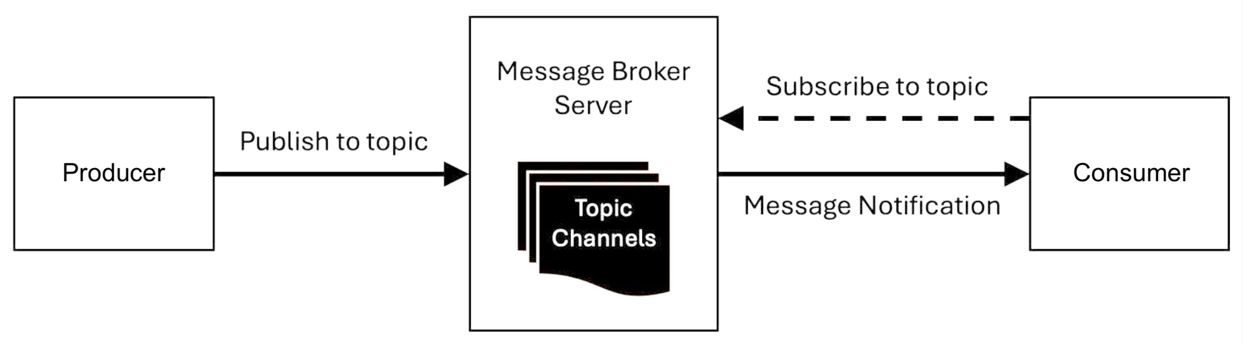

Your application should take on the role of the “Producer” and publish suitable messages to the junction/vehicles topic via the broker. These messages will then be automatically forwarded by the broker to the central computer (which has previously subscribed to receive vehicle alerts). When the central computer receives a message, it will be shown on the main projection screen. To ensure that the messages you send are successfully received by central computer, the topics you publish to should be of the form:

junction/vehicles/car/red
junction/vehicles/bus/red

To connect to the message broker in the first place, you should add the following to your setup method:

mqtt = new MQTTClient(this);
mqtt.connect("mqtt://broker.hivemq.com:1883");

Later on in your code (where to detect the movement of vehicles) you should publish a suitable message to the broker. In addition to the type and colour of the vehicle, your message should also include details of the direction of travel. For example, to publish information regarding the red car, we might use:

mqtt.publish("junction/vehicles/car/red", "North to West");

You might event like to put some kind of unique ID at the end of the “topic” string (e.g. after the red colour element). This is so you can see which are your messages when they appear on the projector screen.

Each time you send a message to the broker, you should sleep your application for 3 seconds (in order to avoid flooding the broker with a sequence of many messages). To do this, you should call the delay function from your code – do this just after you have sent an alert message to the broker. The delay function takes a single parameter – the number of milliseconds to sleep for. In order to sleep for 3 seconds, you should therefore pass in 3000.

For this activity we will be using a free public broker (broker.hivemq.com). Since this broker has been provided for free, there are no guarantees of its availability - sometimes the server may not be operational :o(
This is fine - there are various other alternatives available that we can use instead:

mqtt://broker.emqx.io:1883
mqtt://test.mosquitto.org:1883
mqtt://public-mqtt-broker.bevywise.com:1883

If the hivemq broker doesn’t seem to be working for you (your get an error message when your try to run your code), try using one of the other brokers instead (we will be monitoring ALL of them on the central computer).

Task 9: Analyse the LIVE video stream
Until this point, your code has been analysing a pre-recorded video of the webcam stream. There are a number of reasons why we have been doing this – perhaps the most important is that we can be sure we will see red vehicles in the stream ! Now that you have tested your code with the pre-recorded videos, you should see if your code works on the LIVE video stream. In order to do this, you will need to change the call to the drawMovieOntoFrame function to be drawLiveStreamOntoFrame.

Note that you may have to be patient and wait a while for a red vehicle to pass through the junction !
You might also like to update your code so that it sends a live tag in the message sent to the broker (so that everyone will be able to see that your code is performing real-time analysis):

junction/live/vehicles/car/red
junction/live/vehicles/bus/red

[Optional] Task 10: Detect three white vans
Well done if you have gotten this far in the exercise ! You might now like to challenge yourself with some additional extensions ! Let’s make the video analysis a little bit more sophisticated. In the first video that we used, there are three white vans following each other through the road junction (at time 02:56). Update your code so that it is able to detect these and publish the message van+van+van to the junction/vehicles/ topic. This will require some careful thought to implement a suitable detection algorithm – you will need to be able to distinguish between a single white vehicle (which we are not interested in) and 3 white vehicles in a row (which we are interested in). Clearly you are going to need to implement some kind of historical memory in your code.

[Optional] Task 11: Monitor other published topics
You might be interested to see what other messages are being published through the broker. In order to find out how to subscribe to a particular topics, take a look at the example code that can be found in:

File > Examples > Contributed Libraries > MQTT > PublishSubscribe

Use these examples to help you create a new project and subscribe to a “wildcard” topic. For example, to see ALL vehicle messages use:

client.subscribe("junction/#");

To see ALL messages about ANY topic (from any part of the world) you can use:

client.subscribe("#");

If you try this “global” wildcard subscription, is it interesting to take a look through the range and variety of messages that are being published – can you tell what the messages are being used for ?

