EART29200 · ENSO AND CLOUD COVER PROJECT
Student Guide
The science, the data, the methods and how your report is marked
HOW TO USE THIS GUIDE
This is the reference for the project: keep it open while you work. The Writing Workbook has the activities and the tasks between tutorials; the tutorial slides have the explanations from each session.
§1 is the project on one page. §2–4 give the science, data and methods you need for your Introduction and Methods. §5–6 cover the report itself. §7 is the marking scheme.

1. The project at a glance
You will use ERA5 reanalysis data and the Oceanic Niño Index (ONI) to investigate how cloud cover is related to the El Niño–Southern Oscillation (ENSO). After exploring with a guided Jupyter notebook, you choose one focused question and answer it in a short scientific report.
The report | Individual; at most 2,000 words; about 3–5 figures; 100% of the course mark
Your question | One focused question: a cloud type, region, season or timing, not ‘ENSO and all clouds everywhere’
The notebook | A toolbox, not a checklist: use only the analyses that answer your question
Use of AI | AI Minimal: “AI may be used only for limited presentation-related support, such as grammar, fluency, spelling, or formatting. Students' ideas, arguments, and conclusions must remain their own.”
Draft | Complete first draft by Thu 3 Dec 2026; draft submitted Fri 5 Feb 2027 (formative, no marks, no DASS extensions)
Final report | Fri 12 Mar 2027, 12:00 (DASS extensions apply)

Why it matters
ENSO is the largest source of year-to-year climate variability on Earth. It shifts the odds of drought, flood and tropical storms across much of the planet, and an ENSO forecast is one of the few skilful seasonal forecasts we have. The patterns you will find in ERA5 are the ones national weather services watch. ENSO shifts the odds; it doesn't guarantee any single outcome, and that nuance belongs in your report too.

2. The science you need

2.1 ERA5: a reconstruction of the atmosphere
ERA5 is ECMWF's fifth-generation reanalysis. A weather model is repeatedly corrected towards all available observations (data assimilation), giving a complete, gridded, physically consistent record. We use monthly means on a 0.75° grid for January 2005 – August 2025.
Cloud in ERA5 is a model product. Cloud cover is calculated by the model's cloud scheme from its humidity, temperature and vertical motion; observations shape it only indirectly. Trust the sign of a change more than its exact size, and say so in your Discussion.
- TCC, LCC, MCC, HCC: total, low, medium and high cloud cover, each the fraction (0–1, plotted as %) of a grid box covered at that level.
- TCC ≠ LCC + MCC + HCC. Layers overlap, so seen from above the total is less than the sum.
- Changes in cloud cover are in percentage points (pp): 40% → 44% is +4 pp (a 10% relative increase).

2.2 ENSO and the ONI
ENSO is coupled ocean–atmosphere variability in the tropical Pacific. In El Niño the central and eastern Pacific is anomalously warm; in La Niña it is anomalously cool. The ONI is the 3-month running-mean sea-surface temperature anomaly in the Niño 3.4 region (5°N–5°S, 170°W–120°W), from the NOAA Climate Prediction Center. ENSO is phase-locked to the seasons: events usually peak around November–January.

2.3 Why clouds change: the Walker circulation
Air rises over the warm western Pacific (deep convection, high cloud), flows east aloft, sinks over the cool eastern Pacific, and returns west as the trade winds. The Maritime Continent always stays the rising branch: El Niño weakens the circulation, La Niña strengthens it. During El Niño, convection and high cloud shift towards the central Pacific and are suppressed over the Maritime Continent. Any extra cloud further east is usually thin. Low cloud responds through different physics (stability, subsidence), so don't assume it follows the high cloud.
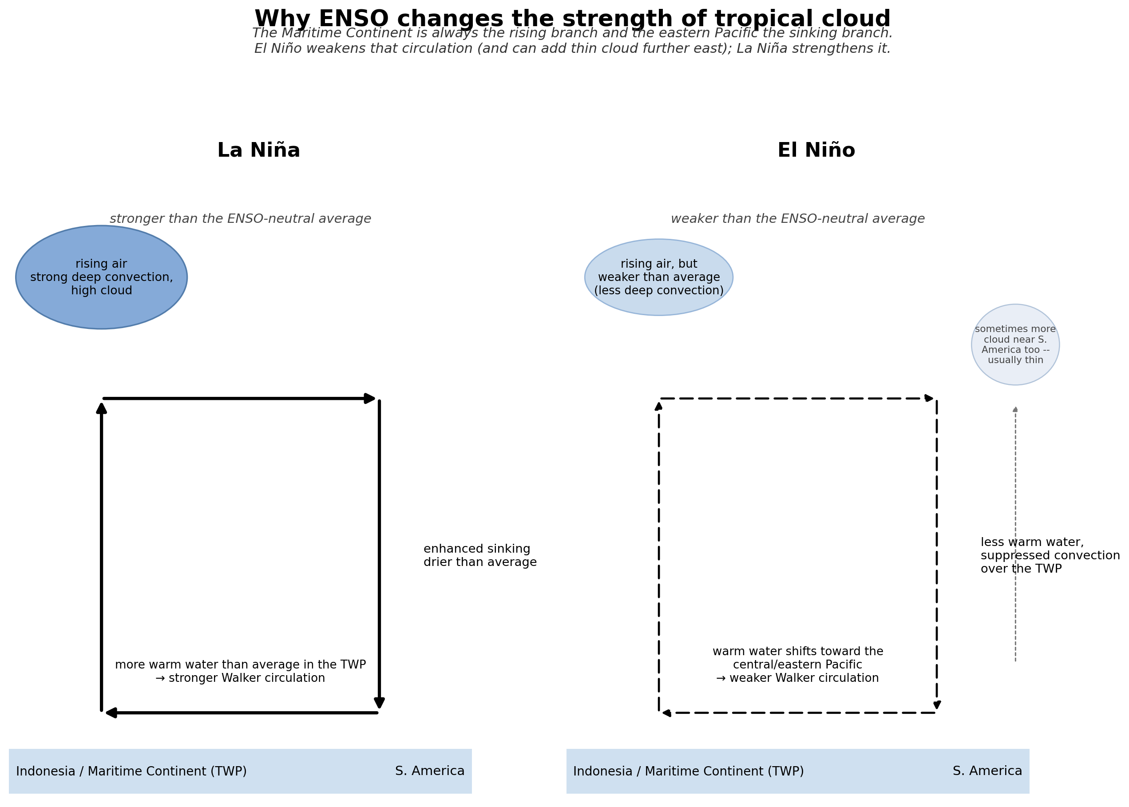
Figure 1. How ENSO changes the strength of the Walker circulation and tropical cloud. Schematic: course team.
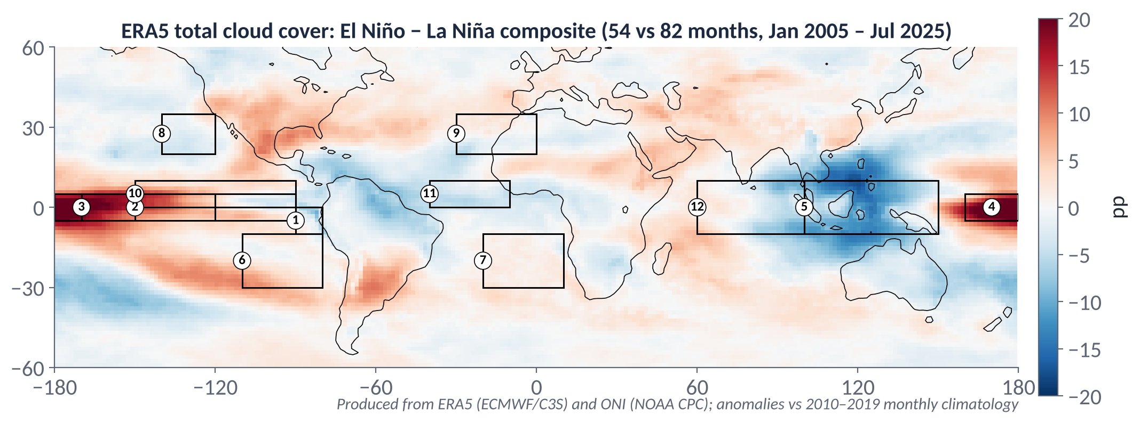
Figure 2. El Niño minus La Niña total cloud cover from the project's ERA5 data (54 El Niño vs 82 La Niña months, January 2005 – July 2025; anomalies relative to the 2010–2019 monthly climatology). Numbered boxes are the notebook's regions. Produced for this course from ERA5 (ECMWF/C3S) and ONI (NOAA CPC).

3. The data and the notebook
Launch student_project.ipynb on Binder (link on Canvas) and run it from the top, in order. Binder sessions are temporary: download your figures, results and notebook before closing.
Section | What it does
0 · 0b | Settings (variable, years, baseline, threshold) and loading the data (run once)
1 | Global seasonal cycle
2 | Global maps: El Niño − La Niña composite and correlation with the ONI
3 (3b) | Global-mean anomalies by ENSO phase (3b, optional: is one year different from another?)
4 | Regional anomalies for 12 numbered regions
5 | ONI vs regional anomaly: scatter plots with r, R² and n
6 | Optional: correlation table with n, n_eff, 95% range and adjusted p; lag and seasonal correlations

Settings you can change (section 0)
Setting | Default | Meaning
VARIABLE | "tcc" | Variable for maps and regional analysis: tcc, lcc, mcc, hcc, tcwv, tclw, tciw, skt, …
ANALYSIS_START/END | 2005, 2025 | Years analysed
CLIM_START/END | 2010, 2019 | Baseline period for the monthly climatology
ENSO_THRESH | 0.5 | |ONI| ≥ this (°C) classes a month as El Niño or La Niña

The 12 regions (latitude °S/°N; longitude °W negative, °E positive)
# | Region | Bounds (latS, latN, lonW, lonE)
1 | Niño 1+2 | −10, 0, −90, −80
2 | Niño 3 | −5, 5, −150, −90
3 | Niño 3.4 | −5, 5, −170, −120
4 | Niño 4 (central Pacific) | −5, 5, 160, −150 (crosses the dateline)
5 | Maritime Continent | −10, 10, 100, 150
6 | SE Pacific stratocumulus | −30, −10, −110, −80
7 | SE Atlantic stratocumulus | −30, −10, −20, 10
8 | NE Pacific stratocumulus | 20, 35, −140, −120
9 | NE Atlantic stratocumulus | 20, 35, −30, 0
10 | ITCZ Pacific | 0, 10, −150, −90
11 | ITCZ Atlantic | 0, 10, −40, −10
12 | Equatorial Indian Ocean | −10, 10, 60, 100
You can add your own region in the REGIONS setting. Give the bounds in your Methods.

4. The methods in brief
Method | What it is | Watch out for
Area weighting | Grid boxes shrink towards the poles (area ∝ cos latitude), so means are weighted: X̄ = Σ cos(φᵢ)Xᵢ / Σ cos(φᵢ) | Matters hugely for global means, little for narrow tropical boxes; say you did it
Climatology and anomaly | Climatology = mean for each calendar month over the baseline (2010–2019). Anomaly = value − climatology for that month | Positive means ‘cloudier than usual for that place and month’, not ‘cloudy’; state the baseline
Thresholds | Months with ONI ≥ +0.5 °C are El Niño, ≤ −0.5 °C La Niña (54 and 82 months, 2005–2025) | NOAA's official episodes also need ≥ 5 overlapping seasons; one event (2015–16) supplies 14 El Niño months
Composite | Mean anomaly in El Niño months minus mean anomaly in La Niña months (units: pp) | A difference between two states, not a correlation; compare each phase with neutral to spot asymmetry
Correlation r | How consistently cloud follows the ONI along a straight line (−1 to +1, no units). R² = r² is the fraction of variance explained | Not the size of the effect; misses one-sided or curved responses; always plot the scatter
Regression slope | Change in cloud per °C of ONI (pp per °C) | Pulled by extreme months; straight line only
Significance | p = chance of a correlation at least this strong if there were no real relationship: t = r√(n−2)/√(1−r²), n−2 degrees of freedom | Needs n; monthly ENSO data are autocorrelated, so use n_eff = n(1 − r₁ₓr₁ᵧ)/(1 + r₁ₓr₁ᵧ) (notebook §6)
Lag | Correlation with the ONI shifted in time (notebook §6: lag +L pairs the ONI from L months earlier with cloud now, i.e. ONI leads) | Peaks are broad; a lag is consistent with cause but doesn't prove it

TWO TRAPS WORTH KNOWING
Many tests, some false positives. On a map with thousands of grid points, about 5% pass a 5% test by chance, and more when data are autocorrelated. Choose your region for a physical reason, then test it.
Trends. Global cloud in this ERA5 record falls by about 0.4 pp per decade. Years far apart can differ because of the trend, not ENSO; notebook §3b can remove it.
The methods_demos.ipynb notebook (optional, on Canvas) lets you try each of these ideas in a few seconds.

5. Writing the report
Your report is one argument, organised around your question, not a diary of the notebook. Every section and figure should help answer the question.
Section | ≈ Words | Its job
Title |  | Informative and accurate: it should not promise more than you show
Introduction | 350 | Context the reader accepts → the problem (‘however…’) → “The purpose of this report is to…” (+ hypothesis if useful)
Methods | 300 | Data, period, region bounds, ONI and threshold, baseline, weighting, statistics actually used, with n. Science, not code; enough for a classmate to repeat it
Results | 650 | One paragraph per finding: the finding first, then quantified evidence citing the figure, e.g. “(Fig. 2)”
Discussion | 450 | Physical mechanism; comparison with published work; exceptions; limitations that matter; back to the question. Flag speculation
Conclusion | 150 | Answer the question in the first sentence; 2–3 findings with key numbers; nothing new
References |  | One consistent author–year style; include ERA5 and the ONI
Word counts are a guide. Your tutor will confirm whether captions and references count towards the 2,000 words.

The paragraph pattern
Claim → Evidence → Interpretation → Qualification. State the finding, give the numbers and the figure, explain it physically, then say where it doesn't hold.
SAME RESULT, TWO PARAGRAPHS (ILLUSTRATIVE NUMBERS)
✗ “Figure 3 shows that cloud cover changes during El Niño. There is a difference between the two phases. This could be due to ENSO affecting the atmosphere.”
✓ “High-cloud cover over the central Pacific (Niño 4 region) averages about 14 percentage points above normal in El Niño months and 12 below in La Niña months (Fig. 3), and is strongly correlated with the ONI (r = 0.8, n = 247 months). This is consistent with the weakening of the Walker circulation during El Niño, when deep convection shifts eastward from the Maritime Continent. The response is not uniform, however: [n] of the [N] El Niño events show a much weaker signal, suggesting that event strength matters as well as ONI alone.”

Citing data and literature
- ERA5: Hersbach, H. et al. (2020) The ERA5 global reanalysis. Q. J. R. Meteorol. Soc., 146, 1999–2049.
- ONI: NOAA Climate Prediction Center (give the page and the date you accessed it).
- Find literature with Google Scholar and Web of Science; manage it with Zotero or EndNote (see the workbook's literature toolkit). Synthesise sources around ideas; don't list them one by one.

6. Figures, numbers and captions

Figures
- Include a figure because it is evidence for your answer, not because the notebook produced it. A typical set: one context figure, one or two that test the question, one that qualifies or compares.
- Label axes with variable and units. For anomalies, differences and correlations, use a diverging colour scale centred on zero with symmetric limits; panels you compare share the same limits.
- Cite every figure in the text, in numerical order, describing the science, not the plot: “Cloud cover over the Maritime Continent is lower in El Niño months (Fig. 2)”, not “Figure 2 shows…”.

Captions: the five-point check
A caption tells the reader how to read the figure without the main text. Begin with a phrase that captures its essence, then give:
- What is plotted (raw field, anomaly, difference, composite, correlation)
- Units
- Period and region
- Any threshold or definition (e.g. how El Niño months were chosen)
- The data source(s), with the attribution line
EXAMPLE
✗ “Figure 2. Correlation map.”
✓ “Figure 2. Correlation between monthly high-cloud-cover anomaly and the ONI at each grid point, January 2005 – July 2025 (n = 247 months). Boxes mark the regions analysed in Figs 3–4. Figure produced by the author using ERA5 (ECMWF / Copernicus Climate Change Service) and ONI (NOAA Climate Prediction Center) data.”

Reporting numbers
- Give the number, not just the direction: “8 percentage points lower”, not “lower”.
- Match precision to the data (two decimal places for r is plenty), and state units, the baseline and the sample size (n, and n_eff if you test significance).
- Only use ‘significant’ if you ran a test, and say which. Keep correlation and causation apart: ‘is associated with’ unless you argue the mechanism.
- Sanity-check numbers copied from the notebook (an r outside −1 to +1 means something has gone wrong).

7. How your report is marked
The report is marked on a UK percentage scale. A report that does everything asked of it, correctly, sits at roughly 65%, with real room above that for independent thinking.
Band | What it looks like
40–49%: Pass / Third | A question is present but vague or broad, or not clearly answered. Some figures, but they may be poorly chosen, mislabelled or largely descriptive. The report tends to follow the notebook's narrative rather than build an argument. Basic concepts are used, sometimes with misunderstandings. Sources are at least partly acknowledged.
50–59%: 2:2 | One reasonably specific question is answered, though the reasoning from evidence to conclusion may be thin. Figures are mostly relevant and well presented, but one or two may not serve the question. Some quantification, perhaps imprecise. The standard structure is followed, though sections may overlap. Attribution is present and mostly correct.
60–69%: 2:1 (solid, competent; roughly 65%) | A genuinely focused question, clearly stated and directly answered in the Conclusion. Three to five well-designed figures, each earning its place as evidence. Claims consistently backed by quantified evidence (sign, magnitude, r/R², n) and physically interpreted. Some awareness of limitations. Clean structure: a funnel Introduction, Methods that explain what was done and why (not a Python how-to), Results and Discussion kept separate, and a Conclusion with no new analysis.
70–79%: First | A well-chosen, specific, physically motivated question. Excellent figures, with physical insight discussed rather than just described. Claim → Evidence → Interpretation → Qualification used consistently, with thoughtful qualifications. Independent scientific thinking in the Discussion: comparing regions or methods, relating results to the Walker circulation, SST, subsidence and convection, noting what was surprising or expected. Concise writing; complete, precise attribution.
80%+: Exceptional | All of the above, plus something beyond what was directly taught: an original angle, an insightful comparison, or a careful and correct treatment of a subtlety (e.g. effective sample size, a sensitivity test). Writing and figures of near-publishable short-communication standard. Rare.

WHAT PULLS A MARK DOWN, WHATEVER THE BAND
No single clear question · including every notebook output rather than choosing evidence · treating correlation as proof of causation · unattributed data or images · code in the report · new analysis in the Conclusion.

8. Common pitfalls
- A question so broad it becomes ‘ENSO and all clouds everywhere’.
- Writing Results in the order you ran the notebook, rather than around the question.
- Describing colours on a map without giving the sign, size and location of the signal.
- A correlation with no n, period or test; ‘significant’ without a test.
- Percent when you mean percentage points.
- Physical interpretation in the Methods (it belongs in the Discussion); Python in the Methods (describe the science).
- A region box that straddles opposite signals, so the average shows nothing.
- Forgetting that one big event (2015–16) can dominate a composite.
- Forgetting to cite ERA5 and the ONI.

Key dates and resources
When | What
Thursdays 1 Oct – 3 Dec | Tutorials 1–8 (no tutorials on 22 Oct or 5 Nov)
Thu 3 Dec 2026 | Complete first draft brought to Tutorial 8
Fri 5 Feb 2027 | Draft submitted (formative; no DASS extensions; your tutor confirms how)
w/c 8 or 15 Feb 2027 | Peer feedback on drafts
w/c 1 Mar 2027 | Group presentation
Fri 12 Mar 2027, 12:00 | Final report submitted (DASS extensions apply)
Wed 7 Apr 2027 | Marks and feedback released
On Canvas: this guide, the Writing Workbook, the tutorial slides (W1–W8), Binder links for both notebooks, and the submission link.
Data: ERA5, ECMWF / Copernicus Climate Change Service; ONI, NOAA Climate Prediction Center. Schematics: course team.

