**Training Catalogue Guide for University of Manchester Faculty of Science and Engineering School Safety Advisors**

Contents

Introduction 1

The Training Catalogue 1

Training Catalogue Structure 2

Finding Courses on the Training Catalogue 2

Getting Academics Enrolled onto Training Courses 2

Enrolment Errors 2

Editing Course Information 4

Hiding the Course 4

Changing the Course Code and/or Title 5

Changing the Course Overview Text 5

Changing the Auto Email Sender 6

Changing the Auto Email Text 6

Add a Course Leader 7

Remove a Course Leader 8

Annual Maintenance 9

Support 9

Appendix 10

Creating Courses in the Training Catalogue 10

Recreating the Event Space After Course Creation 11

IntroductionThis document provides step by step details on using the Training Catalogue to enrol academics onto the Faculty Health & Safety courses. Once enrolled academics should have access to the Blackboard space within 24 hours. Every academic year a new event will need to be added to each course in the Training Catalogue. This process is also documented here. To perform the actions described in this document you will need to have administrative access to the Training Catalogue which is located at: <https://app.manchester.ac.uk/training/default.aspx> . If you can see a link titled “Manage Training Courses” on the left-had menu list, then you have administrative access. If you do not have administrative access and require it to perform actions detailed in this guide, please contact your Faculty Health & Safety Manager to request access.

The Training CatalogueThe Training Catalogue lists all skills training courses available across the University. Many staff training courses, both face-to-face and online, are listed in the Training Catalogue. The Training Catalogue can be setup to integrate with Blackboard, so that when an event is added to a course in the Training Catalogue an associated space is created in Blackboard. Then, when a person applies for a course event they receive access to the related Blackboard course space within 24 hours.

# Training Catalogue Structure

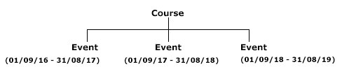

Each course can have multiple ‘events’. Events are presentations of a course that occur within a specified date range. For the Faculty Health & Safety Courses, a new course event should be added to the course every year, dated to correspond with the current academic year (1st September – 31st August).

Finding Courses on the Training CatalogueThe initial courses have already been added to the Training Catalogue. To find these, go to the Training Catalogue <https://app.manchester.ac.uk/training/default.aspx> and in the **Search term** field enter FSEHS – this will return a list of all of the Faculty Health and Safety Courses. Click on the course code to get the course overview page.

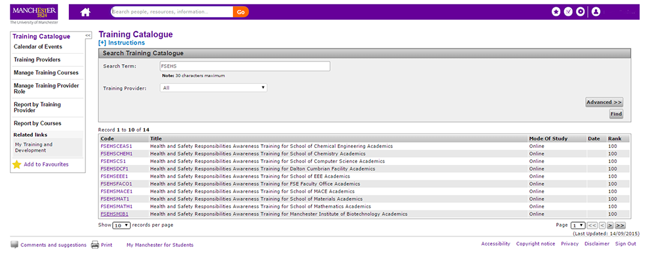

There is a section on adding new courses in Appendix I.

Getting Academics Enrolled onto Training Courses  
To get academics enrolled on your courses, send them an email asking them to apply for the course. You can send them the link to the course overview in the Training Catalogue. To get this link, follow the process described in the **Finding Courses on the Training Catalogue** section above and then copy the link from the browser toolbar and paste into your email. If you would like to use a shorter link, you can use the university link shortening service at <https://shorturl.manchester.ac.uk/app/>

Enrolment Errors  
When applying for the course the applicants need to select **the dated option** and NOT the option entitled “I wish to apply for general access to the online course”.



This is detailed on the course overview page for applicants to read. It’s not possible to change the text on the bottom option. However, selecting the date is counter-intuitive and you will find there are a few who will select the incorrect option. If an applicant selects the incorrect option, their Blackboard course will not appear automatically and manual intervention is required. It is suggested that you monitor the courses for this on a regular basis and correct where necessary.

To monitor for this, click on the **participants** tab in the course and look at the status of the applicants. The page shows 10 records by default. Expand the list to show all applicants (using the dropdown at the bottom left) and then click the **status** column of the table in order to sort by status. Look for any status of pending.

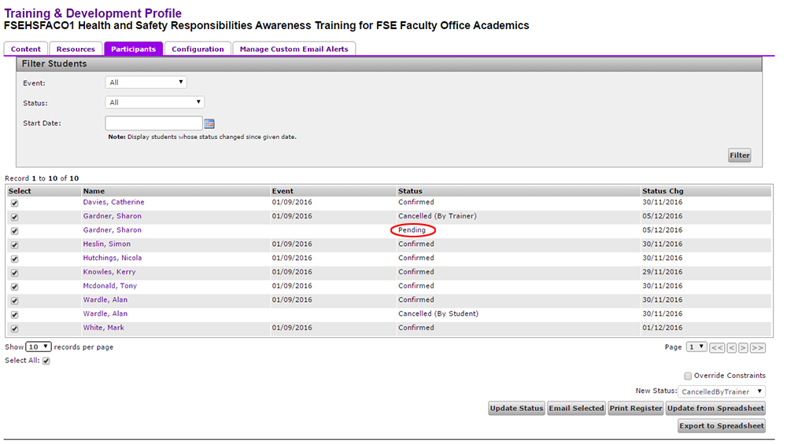

If you have any of these, follow the steps below to change the status to ‘Confirmed’.

1. In your course, click on the **Participants** tab.
2. Select only the applicant with the status of ‘pending’. To do this, uncheck the **Select All** checkbox (below the participant list) and wait for the screen to update. Then, click the checkbox next to the participant with the pending status.
3. Select the **Override Constraints** checkbox (bottom right).
4. Select ‘confirmed’ from the **New Status** dropdown.
5. Click **Update Status** button.
6. Select the event date.
7. Click **Continue.**
8. Do **NOT** check suppress email.
9. Click **Update** button.

The applicant should now have the status of ‘Confirmed’. They will receive the auto-email confirming their place and the Blackboard course will appear on their course list within 24 hours.

# Editing Course Information

Hiding the Course  
This hides the course in the Training Catalogue listings and in the Blackboard Course list. Applicants cannot see the course in the Training Catalogue. Neither Applicants nor Course Leaders can see the course in Blackboard. To hide the course:  
  
(1) In your course, click on the **Configuration** tab.  
(2) Check the box labelled **Is Course Hidden**.  
(3) Click **Update** button.

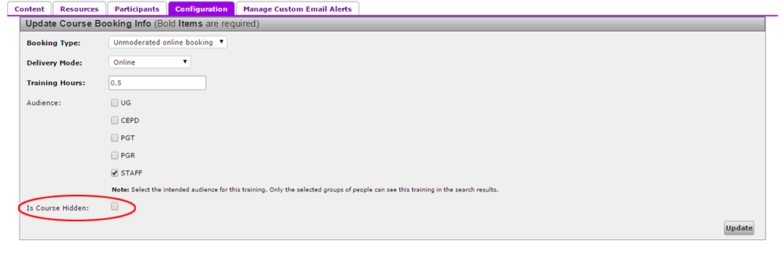

After you have hidden a course it will no longer appear in the Training Catalogue Search. To access this course you must go through the **Manage Training Courses** link on the left-hand menu and search there.

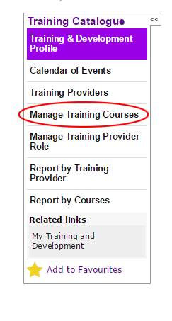

Changing the Course Code and/or Title  
Changing the course title or code, will also alter the name of the course in all associated Blackboard courses. To edit the course title or code:  
  
(1) Select **Manage Training Courses** link in the Training Catalogue left-hand menu (see image above).   
(2) Search for the course you want to change.  
(3) Click the **Edit** link next to the course.   
(4) Alter the information as required.  
(5) Click **Save**.

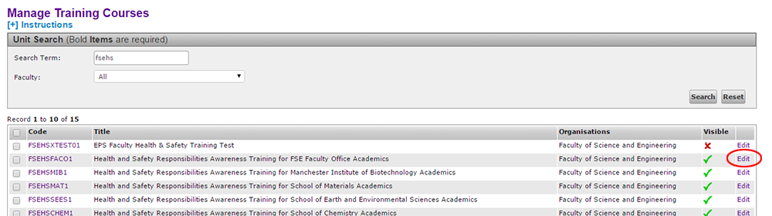

Changing the Course Overview Text(1) In your course, click on the **Content** tab.  
(2) Click the **Edit** button to the bottom right of the overview text.   
(3) Alter the text as required.  
(4) **DO NOT** check the box labelled hidden (see important note below).  
(5) Click **Update**.

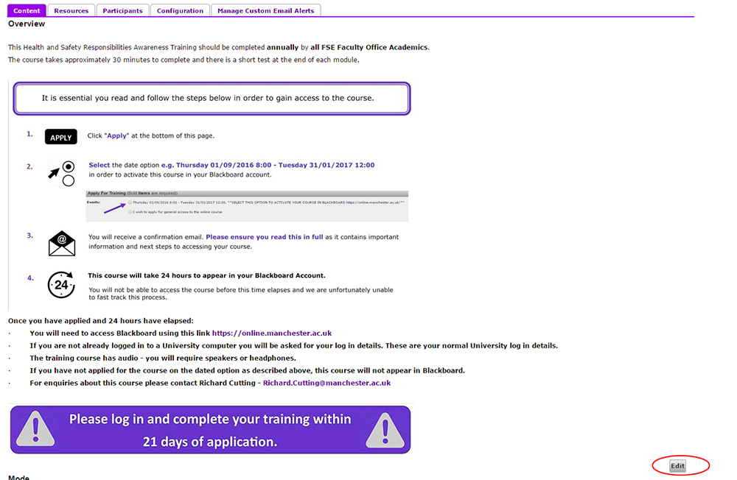

**IMPORTANT NOTE:** When editing content - there is a checkbox labelled **hidden** in this section. You should **NOT** check this box. After checking this box the overview information is not retrievable. This is a known system bug.

Changing the Auto Email Sender  
(1) In your course, click on the **Manage Custom Email Alerts** tab.  
(2) Change the email address.   
(3) Click the **Save Settings** button.

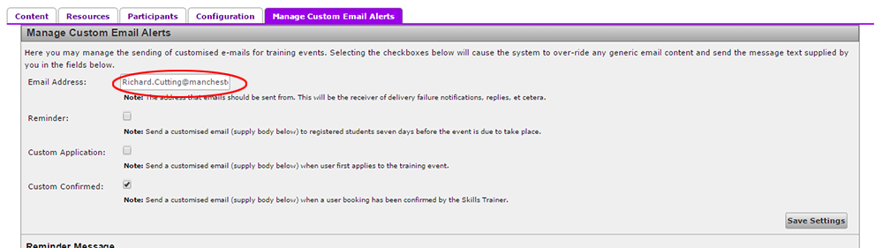

Changing the Auto Email Text(1) In your course, click on the **Manage Custom Email Alerts** tab.  
(2) Click the **Edit Confirmed Message** button.   
(3) Click and drag the  icon in the bottom right of the message box to expand it.  
(4) Edit the message text as required.   
(5) Click the **Update** button.  
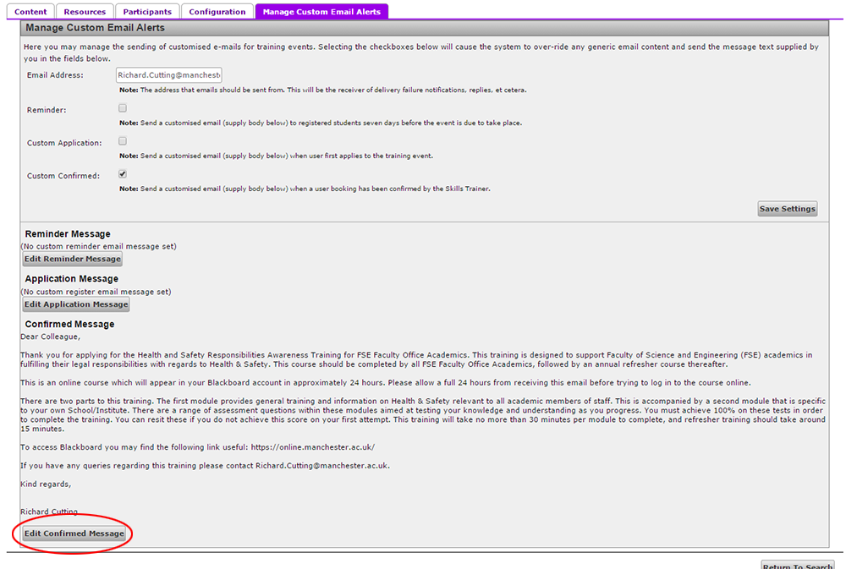

Add a Course Leader  
Course Leaders have administrative access to the course spaces on Blackboard. To add a course Leader:  
  
(1) In your course, click on the **Configuration** tab.  
(2) At the bottom of the page select the book icon and enter the name of the person you wish to add.   
(3) Highlight the person in the list returned and click **OK**.  
(4) Click the **Add Course Leader** button.  
  
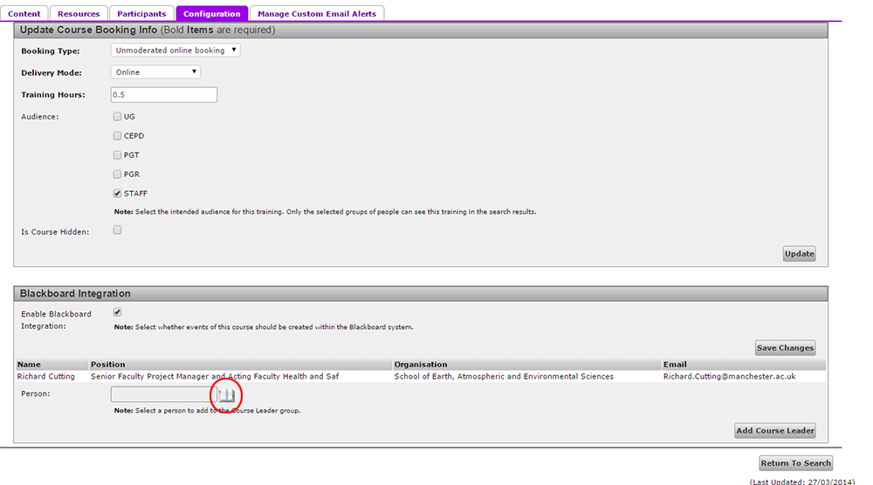

Remove a Course Leader  
Follow steps 1-4 above then select the **Remove** link next to the Course Leader you would like to remove. Note that there must be more than one Course Leader before the **Remove** link will appear, so if you are adding and remove you will need to add first. NOTE: This occasionally produces an error message, although if you click on another tab and click back you should find the course leader has been removed.

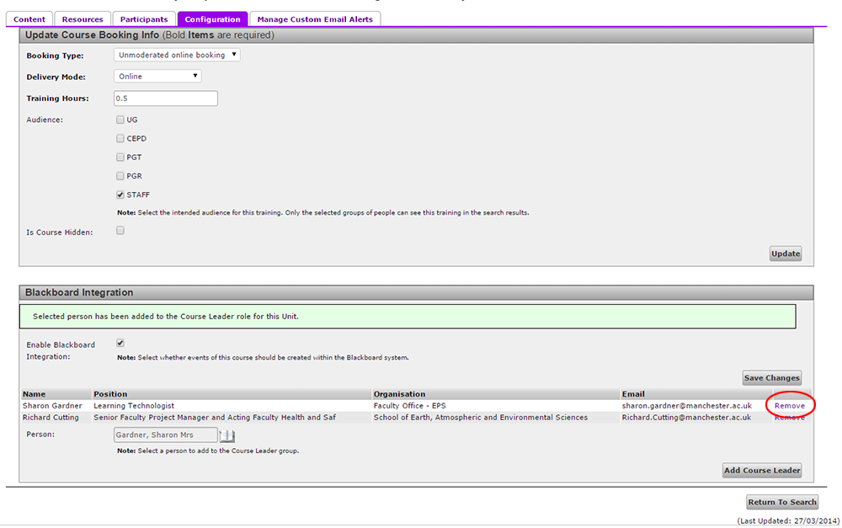

Annual MaintenanceAn event is a presentation of a course that occurs within a specified date range. A course can have multiple events. Each event has an associated Blackboard space. In this instance, an event should be setup for each academic year. These have already been added for the 2016-17 academic year. On its end date the Blackboard space will no longer be accessible by participants (although it will still be available to administrators). At the end of August a new event should be added to the course for the following academic year. This will create a new Blackboard space into which course materials should be copied. Creating a new event for each academic year ensures compliance with the University’s course archiving policy and also prevents Blackboard performance issues arising from too many users being enrolled on one Blackboard space.After the event end date the course will no longer display to applicants in the Training Catalogue and the participants will no longer have access to the course on Blackboard.  
  
Course Leaders will still be able to access the space on Blackboard until it is archived on the 1st of December of the year following its presentation. You should download any participant data that you require from the course units in Blackboard before they become unavailable to you on the archive date.

Support  
Any queries relating to the Training Catalogue should be submitted using the **Comments and Suggestions** link at the bottom right of each Training Catalogue page.

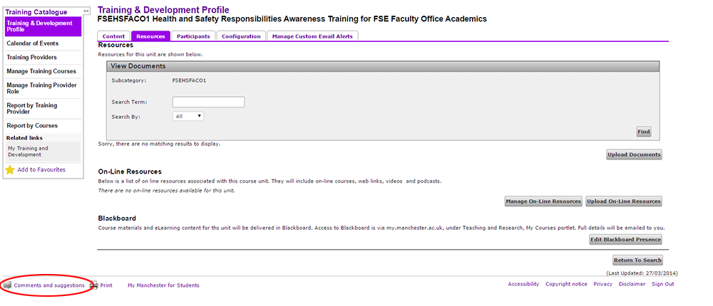

For Blackboard queries or training requests, please contact the eLearning team at[elearning@manchester.ac.uk](mailto:elearning@manchester.ac.uk)For Blackboard training, you can also book a time on the Faculty eLearning web pages at:<http://www.elearning.eps.manchester.ac.uk/bookings/>

Appendix

Creating Courses in the Training Catalogue  
The initial courses have been added to the Training Catalogue. Should the need arise for a further course to be added, you can follow the process below.

**Note:** After a course is created in the Training catalogue, it cannot be deleted, so add with care!

1. Go to Training Catalogue: <https://app.manchester.ac.uk/training/default.aspx>   
   Click **Manage training courses** link (left).
2. Click **Add Unit** (bottom right).
3. Enter the course code and title.
4. Click the **hidden** checkbox.
5. Enter organisation (Faculty of Science and Engineering).
6. Click **Add.** You should see a green bar at the top of the screen indicating that the unit has been added successfully.
7. Search for the course you have just created.
8. Click on the course code to go into the course record.
9. Click on **Add Content**, select content type “Overview**”** from the dropdownand add course overview text.  
   **DO NOT CHECK THE HIDDEN CHECKBOX IN THIS SECTION, there is a bug and you can’t get the text back after you do!**If you want to copy the text from another course:
   1. Open the Training Catalogue in a new tab.
   2. Navigate to the course record you want to copy.
   3. In the **Content** tab click **Edit.**
   4. Click the **Source** button on the text editor toolbar.
   5. Use CTRL + A to highlight all text and CTRL + C to copy to the clipboard.
   6. Click the **Return to Profile** button.
   7. Paste this text into your new course.
10. After you have added the text, click **Update** and check it looks ok. Edit if necessary.
11. Click on the **Configuration** tab.
12. Change Booking Type to **Unmoderated online booking**.
13. Set Delivery Mode to **Online.**
14. Set Training Hours to 0.5 (or as required).
15. Uncheck all audience checkboxes except **STAFF.**
16. Click **Update.**
17. At the bottom of the page, select the book icon, enter the Course Leader’s name in the course picker, highlight the correct entry and click **OK**.
18. Click the **Add Course Leader** button. (You can add multiple Course Leaders if required).
19. Check **Enable Blackboard** and click **Save Changes.**
20. Select **Content** tab.
21. Click the second **Edit** button (at bottom, next to the **Apply** button).
22. Enter start and end date and time (01/09/2016 08:00 – 31/08/2017 20:00) - **NOTE:** you need to type in the end date, the calendar seems to have a bug and will stick at 02/01/2017)  
    In Venue field enter the following text: **SELECT THIS OPTION TO ACTIVATE YOUR COURSE IN BLACKBOARD [https://online.manchester.ac.uk/**](https://online.manchester.ac.uk/**)
23. Enter 1000 as capacity.
24. Click **Add.**
25. Click on the **Manage Custom Email Alerts** Tab.
26. Enter the Course Leader’s email address in the **Email Address** field.
27. Check the **Custom Confirmed** checkbox.
28. Click **Save Settings.**
29. Click the **Edit Confirmed Message** button
30. Add the confirmation email text
31. Click **update**

The course is now displaying on the Training Catalogue and a new Blackboard space will show on the Course Leader’s Blackboard course list at <https://online.manchester.ac.uk> within 24 hours.

**NOTE:** When setting up the initial courses a bug was observed whereby the template space is created on Blackboard, but an event space is not. You can identify the event-related Blackboard space as it will contain a date – e.g. “FSEHSMIB1 Health and Safety Responsibilities Awareness Training for Manchester Institute of Biotechnology Academics 25/08/2016”. (The template space does not appear to fulfil any function and can be safely ignored.) This bug appears to only affect the initial Blackboard space creation on newly created courses.

If your dated event space does not appear in Blackboard within 24 hours, you will need to create another event in the training catalogue, the same as the last one and then delete the original event – it is important to so this in this order. Step by step details are provided below.

## Recreating the Event Space after Course Creation

If the event space is not created in Blackboard after waiting 24 hours (due to the system bug detailed above), follow these steps.

1. In your course, in the training catalogue, click on the **Edit** button at the bottom of the **Contents** tab (next to the **Apply** button).
2. Add the event details again – start date e.g. 01/09/2016, start time 08:00, end date e.g. 31/08/17, end time 20:00. In the venue box add this text “**SELECT THIS OPTION TO ACTIVATE YOUR COURSE IN BLACKBOARD [https://online.manchester.ac.uk/**](https://online.manchester.ac.uk/**)”, in the Capacity section add 999 – **NOTE: this is different to the 1000 entered in the original event, this is how you will tell the two events apart so that you can delete the original event.**
3. Click **Add**.
4. You should now have the two events listed in the table in the centre of the page. Click **Delete** next to the original event (if you have followed these instructions, you can delete the one with 1000 capacity).
5. Click **Confirm**.

The event-related Blackboard space should display on the Course Leader’s Blackboard Course List at <https://online.manchester.ac.uk> within 24 hours.