**Installation of VSCode**

**What is VS code?**

Visual Studio Code (VS Code) is a versatile, free and open-source code editor developed by Microsoft. It is lightweight, supports numerous programming languages, offers a large number of extensions for enhanced productivity and is an excellent tool for wrangling data in Python for all your Chemistry studies.

In the context of chemistry, where data analysis, simulation, and computational modelling are increasingly important, VSCode serves as a single environment where you can write, debug, and run your Python code. It simplifies the development process, allowing you to focus on what matters most: learning Python and applying it to solve complex chemical problems.

Furthermore, VSCode supports collaborative coding with the "Live Share" feature, allowing multiple people to work on the same codebase in real-time—a feature that can greatly enhance group projects or collaborative research.

**Installation guide**

Installing VSCode is relatively straightforward. Installation guides for different operating systems can be found here: <https://code.visualstudio.com/docs/setup/setup-overview>. Please make sure to choose the correct operating system (mac, windows, linux etc) for your computer.

Alternatively, you can follow our step-by-step guide with screenshots below.

**Step by step guide**

* Search VS code in your favorite internet browser
* Click the link to download

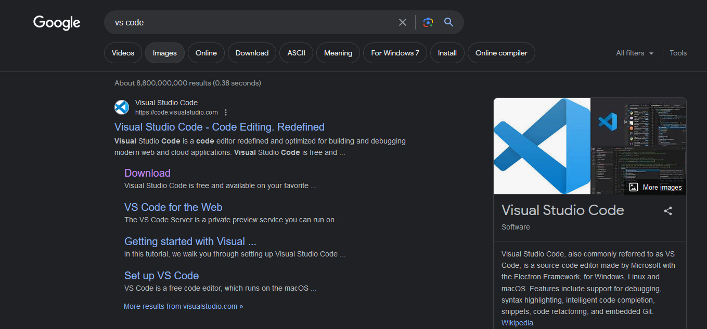

* You should now be on the Download Visual Studio Code page - <https://code.visualstudio.com/download> , and select your operating system

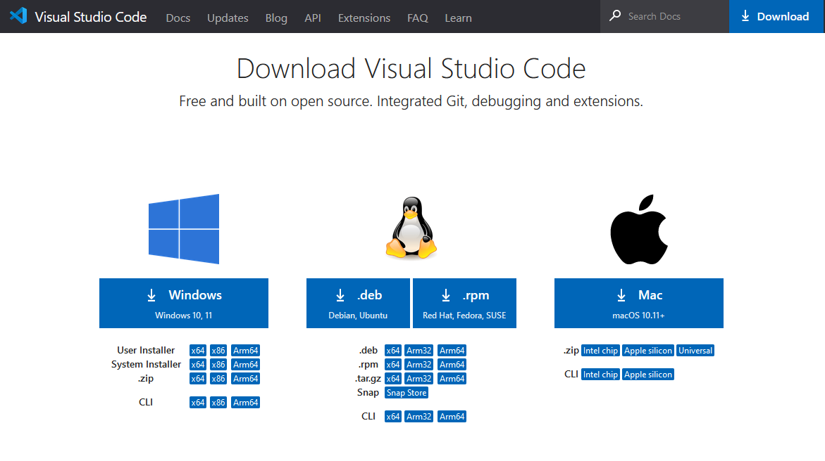

PLEASE LEAVE ALL DEFAULT SETTINGS WHEN GOING THROUGH THE INSTALLATION

Windows

Open the executable from your downloads folder

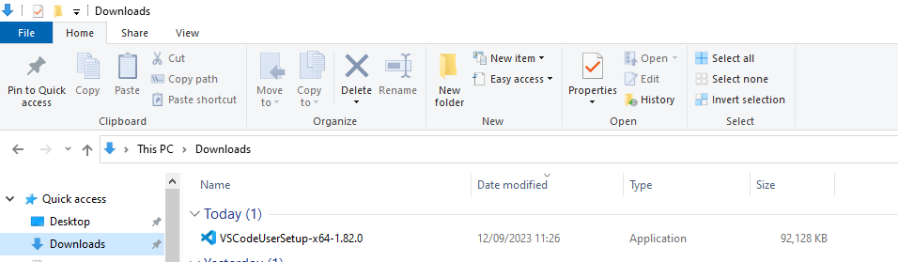

Accept the user agreement

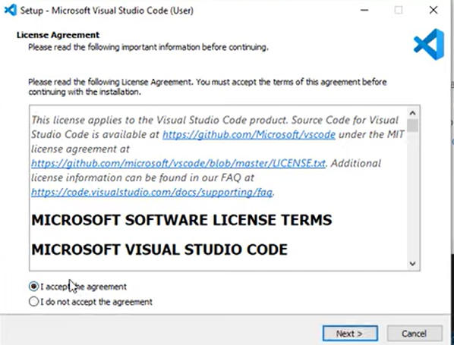

Use default file destination

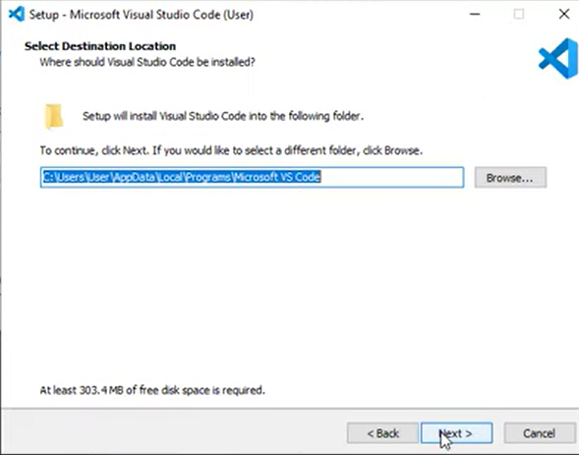

Create start menu link

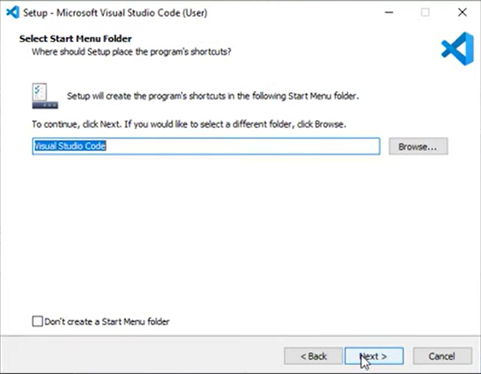

Leave additional tasks as default

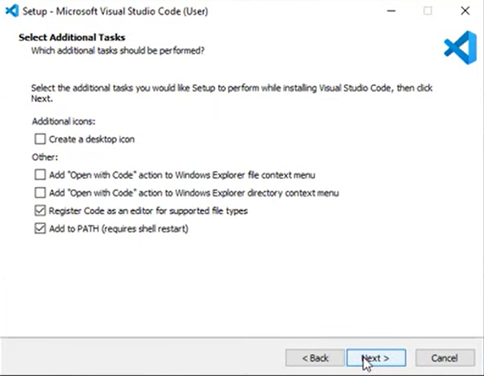

Now install

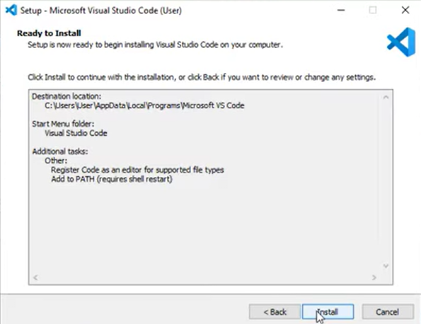

All done :)

Mac

Once you have clicked on the download button you should see the darwin zip file appear in your own downloads folder. Double click this.

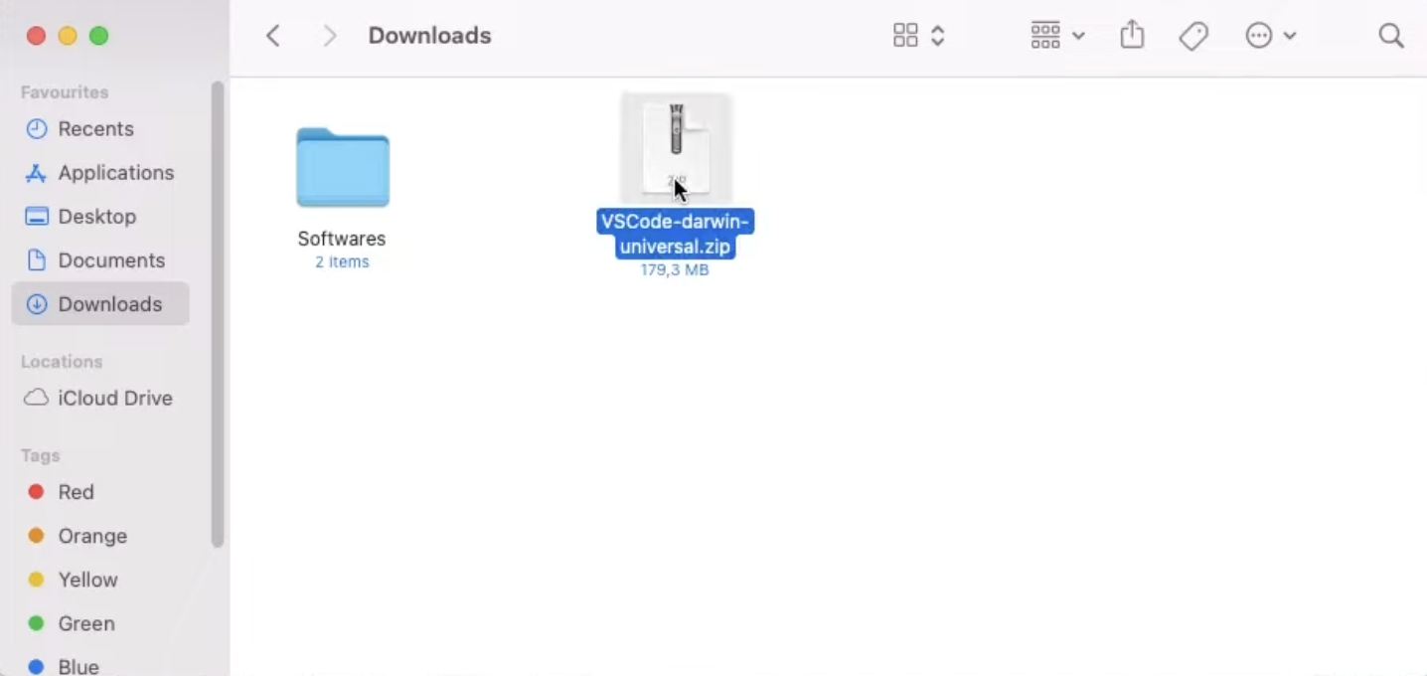

You’ll then see a file called ‘Visual Studio Code’ appear.

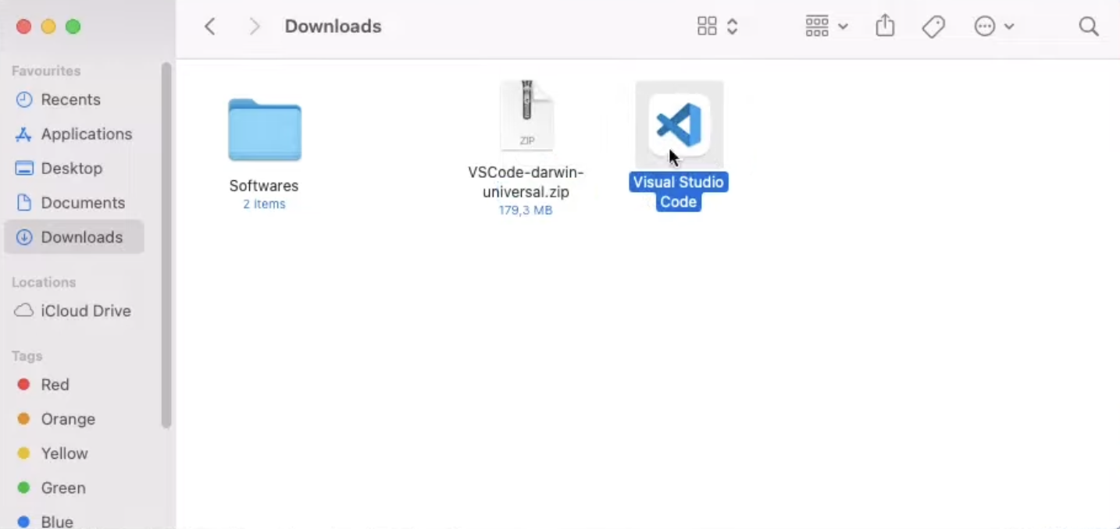

Move this to your applications folder.

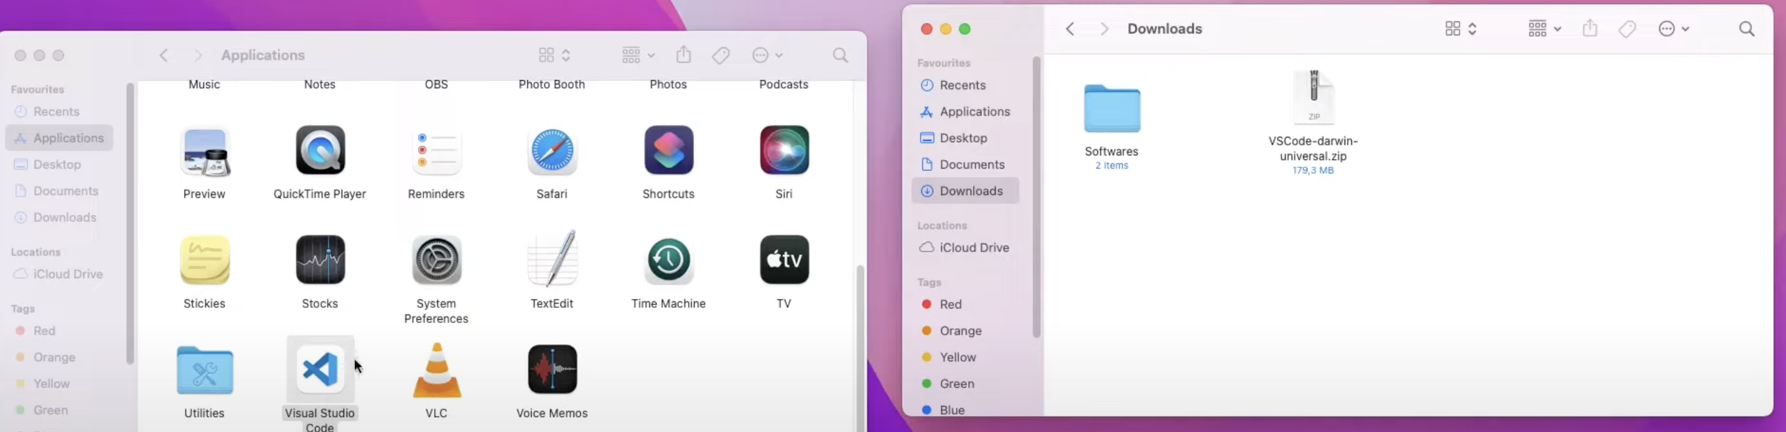

Once in your applications folder, launch the app. You may see this message come up. Press open.

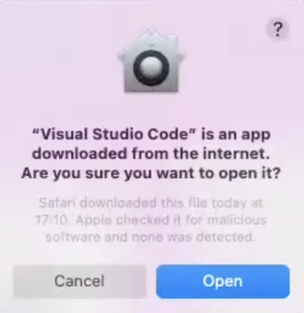

This should take you to the VSCode opening window.

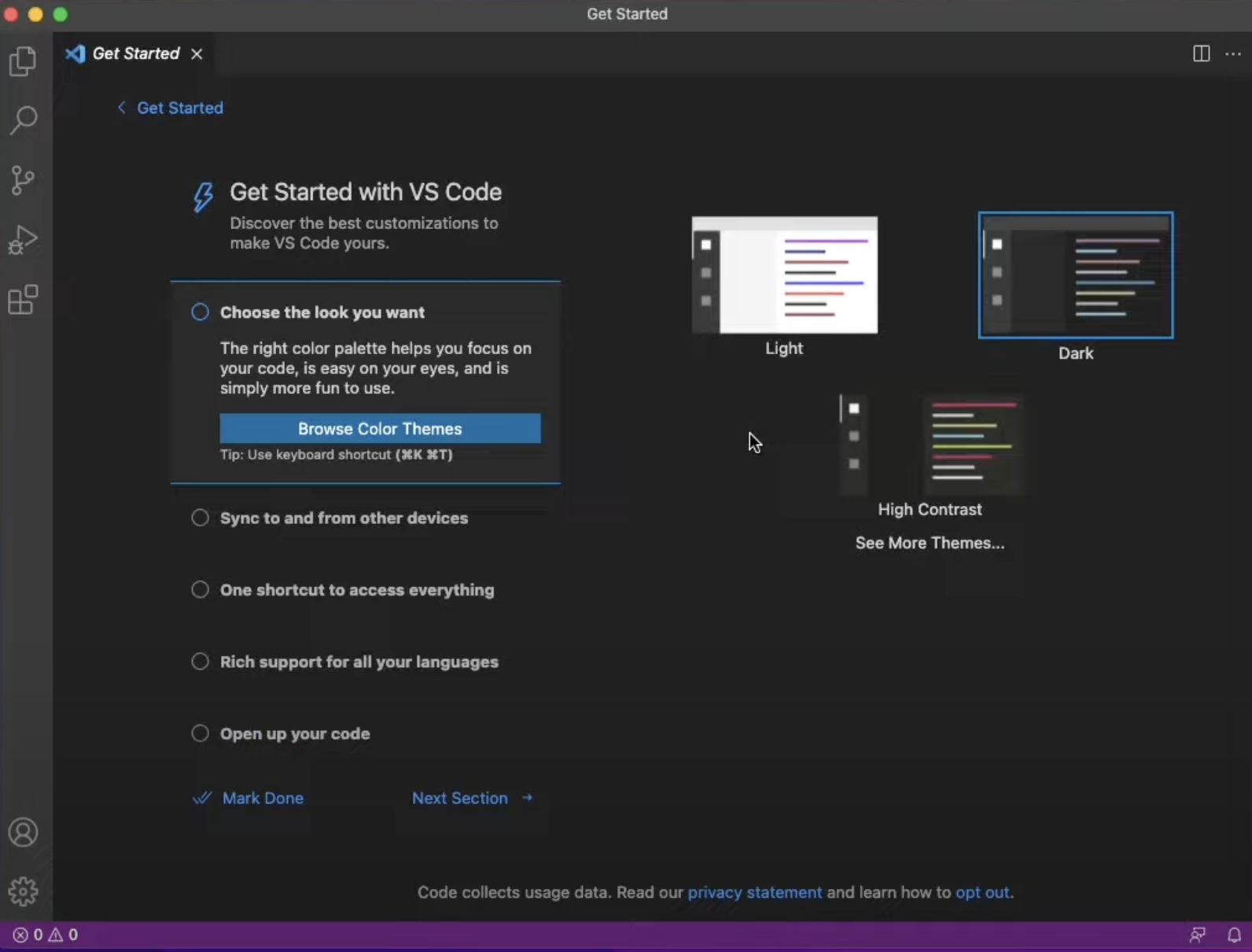

Congratulations – you are now all set up to use VSCode!