Puzzles based around pulling/pushing levers/buttons in the correct order to operate machinery (may involve manipulating enemies). Will heavily depend on level design and is best to balance through testing.

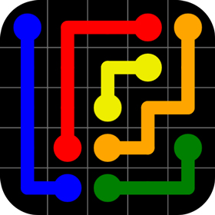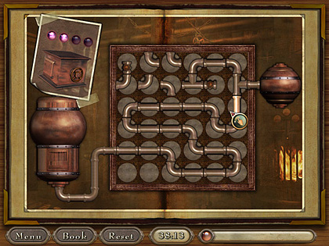

Repairing circuitry to restore power to sections of the base allowing the player to progress (either by allowing doors to be opened, allowing machinery to be operated (see above) or stopping electrical hazards). May become harder by becoming more complex (smaller, more pieces to connect, less pieces available, obstacles (where wires cannot be placed) etc.).

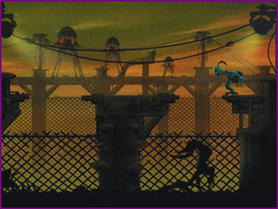

Some enemies can be avoided by stealth.