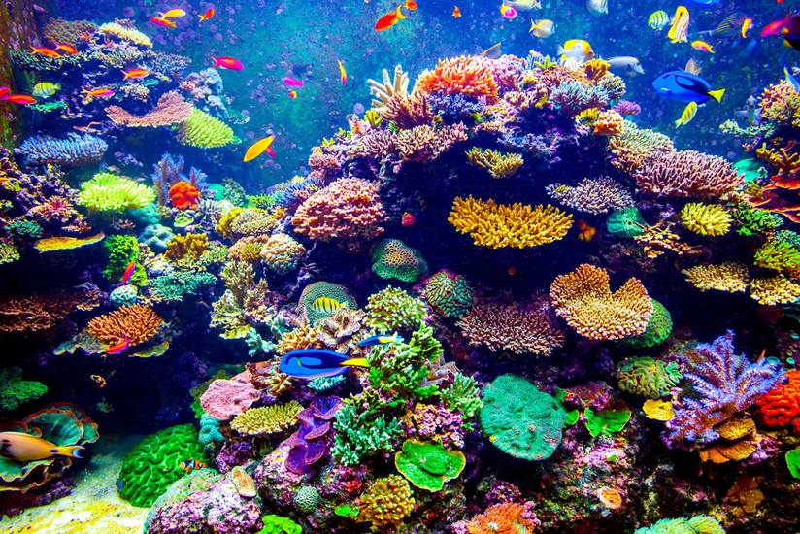

I chose this picture for the bright colours and variety of corals.

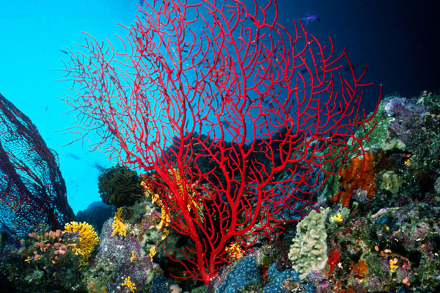

I would like to use these in the corners of the game or at least the bottom corners.

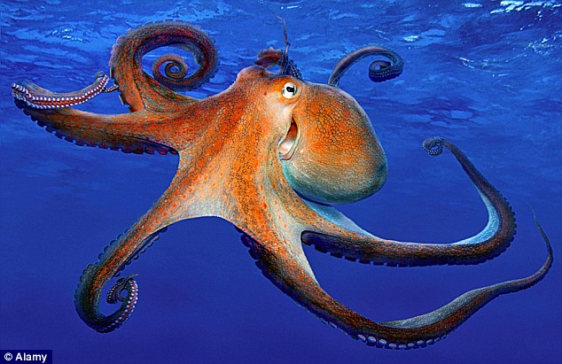

Other creatures surrounding the board with appeal and create a peaceful environment. (Maybe a baby version)

