**Monachopsis Research**

Monachopsis by definition -

*The subtle but persistent feeling of being out of place, as maladapted to your surroundings as a seal on a beach. Lumbering, clumsy, easily distracted, huddled in the company of other misfits, unable to recognize the ambient roar of your intended habitat, in which you’d be fluidly, brilliantly, effortlessly at home.*

To dissect this definition, I found it best to break down into sections and look at it piece by piece. “*The subtle but persistent feeling of being out of place”* Indicates that the emotion is felt by someone that is trying to fit in somewhere, and willing to belong there, but always knowing in the back of their mind that it might not be the place for them. By reading it, I would suggest that the apparentness of this should be kept low, but constant.

“*as maladapted to your surroundings as a seal on a beach. Lumbering, clumsy, easily distracted, huddled in the company of other misfits”* This piece brings on a sense that to others, it is easy to detect that you do not belong, although the person themselves may not always realise. To those in the group and that belong, this person is not able to be themselves or act naturally and fluidly in situations. I would take this from the adjectives used such as clumsy and lumbering. Finally in this section, it may suggest that those feeling Monachopsis naturally come together in groups?

“*unable to recognize the ambient roar of your intended habitat, in which you’d be fluidly, brilliantly, effortlessly at home.”* In this last section the definition brings about this sense that although the ideal place for the person can be so close, they are too oblivious with where they are trying to fit in. Little would they know that If they were as intended by their very nature, all that they did would be so much more, fluid and genuine. They themselves, as a person would be able to effortlessly shine. This is what I would take from the list of adjectives given at the end of the piece.

Monachopsis through media -



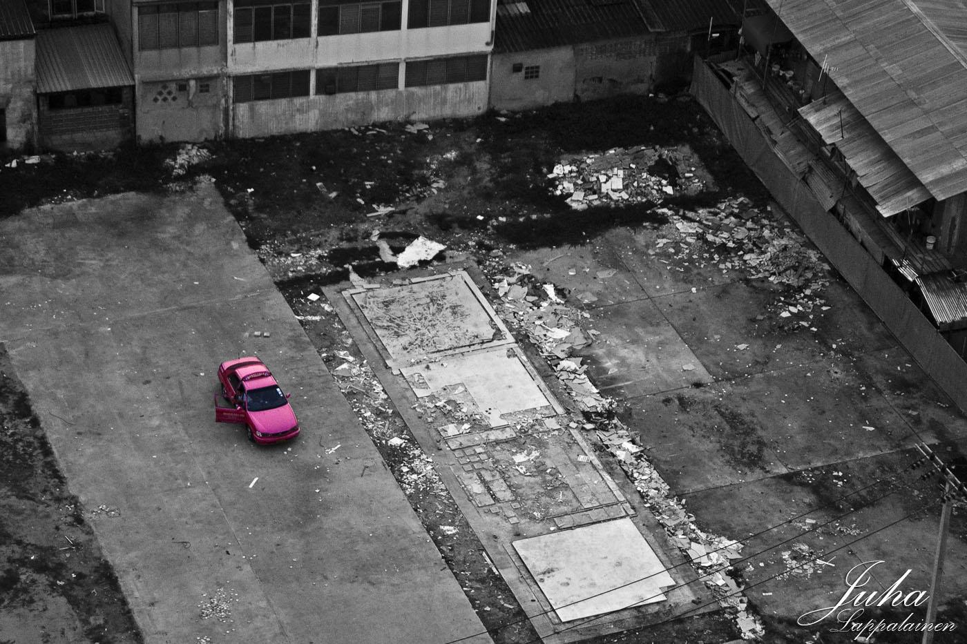

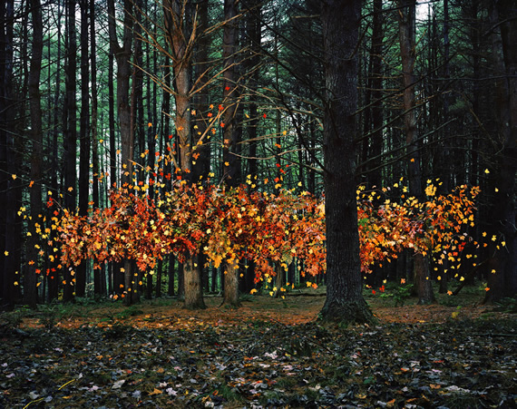

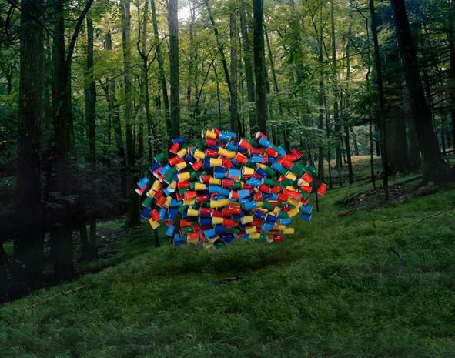

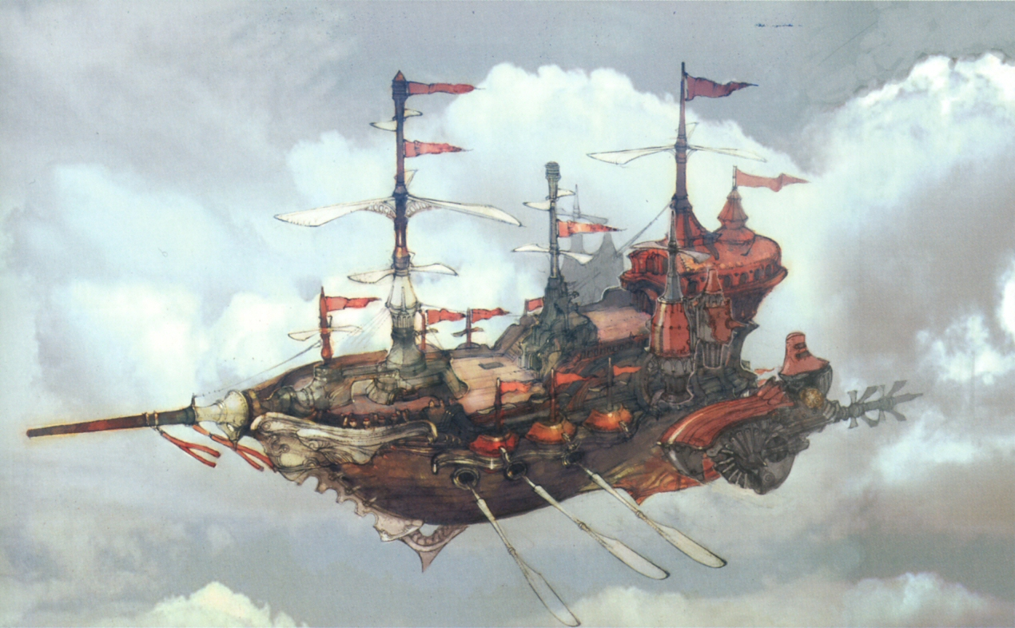

Tokyo Ghoul: TV series -

In this show, set in an alternate reality, there are two sets of humans. Those best described as regular and those that are known as ‘ghouls’. Ghouls are the same as humans in appearance unless their abilities activate, in which they show their true form - a predator, designed by nature, to prey on humans.

The story sets a teenage boy, Kaneki, in Tokyo into the middle of conflict between ghouls and humans, at this point he is human and firmly belongs to one group, he knows that he is human and belongs with them. Later on, after an incident, his organs are transplanted with those from a ghoul. This causes an extremely rare change and transforms him into a hybrid ghoul/human.

For the next arc of story, we see Kaneki picked up and accepted by a group of ghouls. He spends the majority of his time here trying to fit in it the group, although it is apparent that he is undeniably different from the ghouls. This is because he doesn’t share the same upbringing, hasn’t lived the same life or possesses a disdain for humans that ghouls have harboured after being hunted for years. After certain events in the story this culminates into a breakdown of Kaneki’s mind when he comes to the realisation that due to his unique hybrid nature, there isn't a clear place of which he belongs.

This is an incredible piece to use as a basis of inspiration and research. A huge part of the story is focused on Kaneki’s struggle to fit in or belong somewhere, which for the most part is kept subtly within his mind. It’s a perfect representation of Monachopsis and the way that it relays this onto the viewer to ignite the same emotions felt as the character, is something of great achievement.