**Occhiolism Research**

**Occhiolism by Definition -**

*“The awareness of the smallness of your perspective, by which you couldn’t possibly draw any meaningful conclusions at all, about the world or the past or the complexities of culture, because although your life is an epic and unrepeatable anecdote, it still only has a sample size of one, and may end up being the control for a much wilder experiment happening in the next room.”*

To better understand occhiolism I’ll break the definition into sections once more. *“The awareness of the smallness of your perspective”* This part of the definition is pretty self explanatory. The person feeling this emotion is aware of it and their opinions are small, or biased to their own experiences. *“by which you couldn’t possibly draw any meaningful conclusions at all, about the world or the past or the complexities of culture”* This part of the definition reaffirms the first. Due to the assumed, small size of their perspective, they don’t feel like their opinions or thoughts bear a greater meaning or impact on the wider issues of life. They would feel alien to other cultures of people, made insecure by what they don’t know of them.

*“because although your life is an epic and unrepeatable anecdote, it still only has a sample size of one”* This section is a reminder that whilst one's perspective may feel small and insignificant, if they thought about it a little differently, it’s a huge epic, monument to itself, totally unique and beautiful. Despite this, it seems to imply that those that feel instead view themselves as just one take, or instance, out of billions of others. *“and may end up being the control for a much wilder experiment happening in the next room”* Finally, the closing statement really embeds the emotions feeling. That despite however amazing or great what they’re doing is, there might be something worth more, possibly in a sense to wider group or humanity, that is considered better.

**Occhiolism Through Media -**









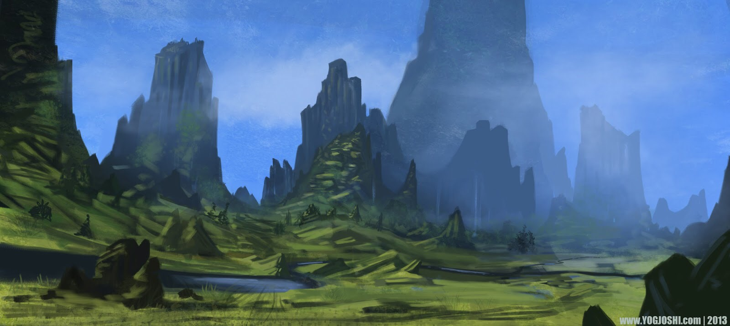



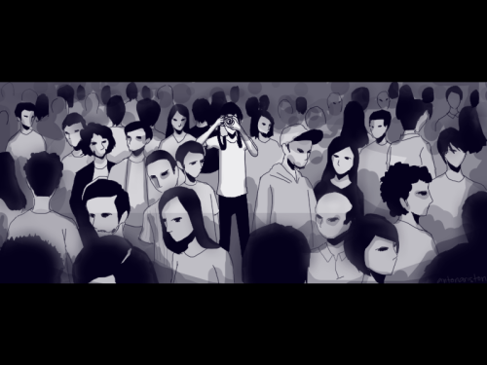

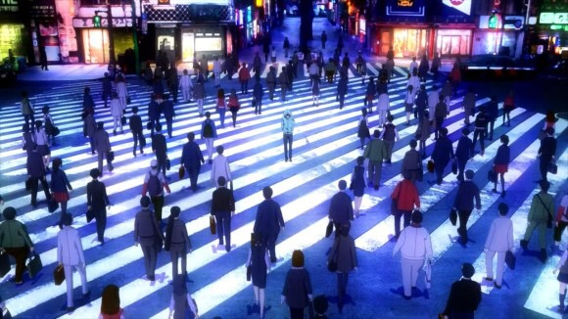



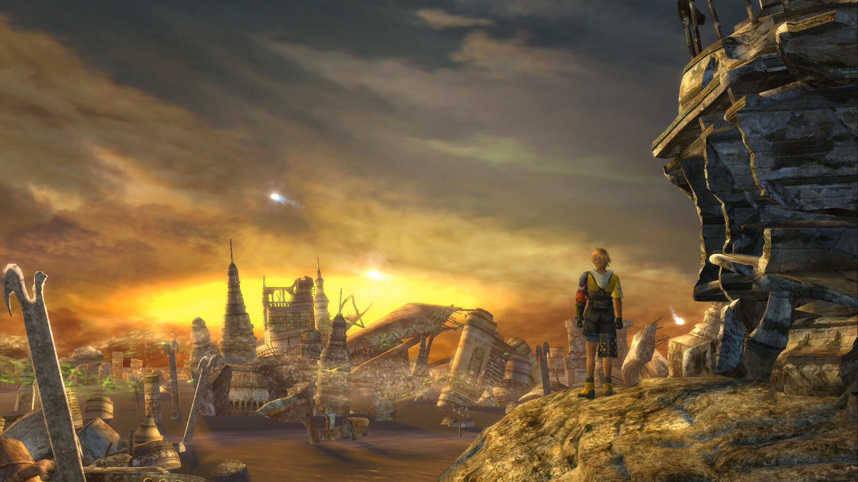





**Final Fantasy X - Game**

In this game, the main character Tidus is made aware of his occhiolism. For the introduction he is fine, and at home in his city, going through his daily life as a sports star. After a cataclysmic set of events, he is sent forward in time. This takes him to a new place, where there is no cities and humans are banding together to fend off a foe looking to end humanity.

Tidus for most of the opening hours, is solely preoccupied to getting back to his reality and his way of life, as that is what he sees as most important to him. Eventually he gets tied up escorting another of the game's protagonist, on her journey to defeat the great evil. Once he embarks on this journey, his eyes are slowly opened and he begins to realise how small his own perspective was. That all he wanted to do was return to his normality, when he could be helping to save an entire future.

Whilst not a major component of the story, being the player controlling Tidus, you become frustrated that he isn’t fully committed to this cause, and openly find yourself asking why his view is so small. I think this is a great way to effectively use occhiolism, and make the player feel it on behalf of who they’re controlling.