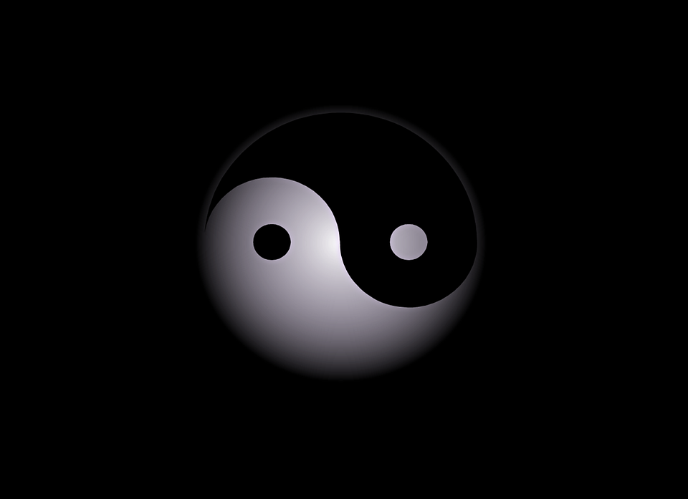I chose this because of the way it’s faded around the outsides and thought something like this would suite our game nicely considering we have “light” – “dark” being portrayed in our game.

The player would stand on this and it would begin to light up as the player exits the level.