*Bugs/Glitches (Main Game)*

1. Player Animation is always set up to face to the left. (I’m sure this will get changed when working on the art work of the player?)
2. If you touch the side of a platform (playing card) then you can jump again as classed as grounded. This allows you to reach areas you shouldn’t and helps to avoid dangers, such as spikes.
3. Changed camera size to 8 as I find that 5 is too close to the game. Personal preference.
4. 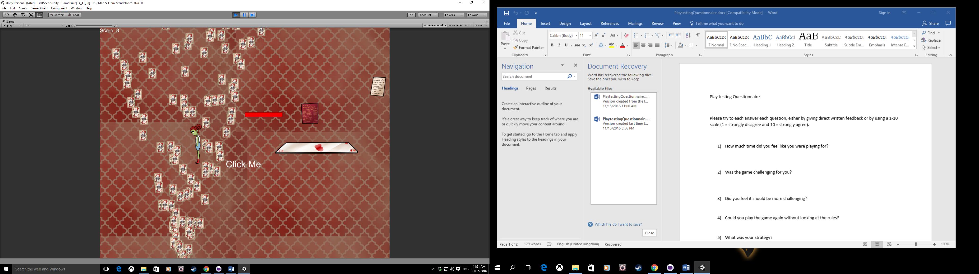When this book is picked up it automatically picks up about 5 pages from in front of the player.
5. 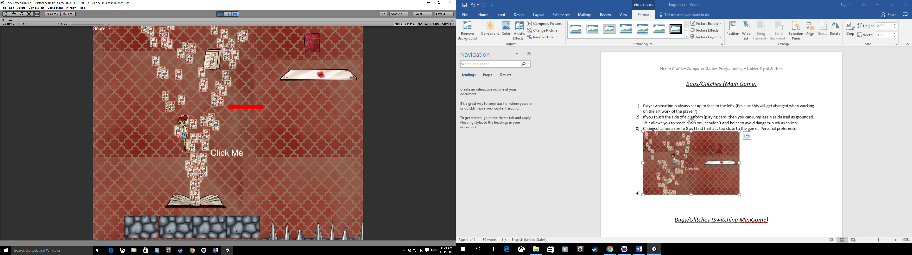When going up the elevation if you hit this page from the bottom then you collide with it and pick it up but you must come off the lift and back on again as it stops you in your tracks.

*Bugs/Glitches (Switching MiniGame)*

1. When moving the axis lock until you hit a block. If you move to the third block and then go back right when you pass over the second block “moving” becomes false and allows the player to free roam the map.

b) If changed to OnCollisionStay then the player can move freely after the first block if they lightly press a movement key as the collision repeats each frame.