8/10/16 – 50 mins

# Adronitis

### Online Definition:

Frustration with how long it takes to get to know someone spending the first few weeks chatting in their psychological entryway

### What does it actually mean?

An example of this, would be, the feeling when talking to somebody new and having to make small talk with them, before leading into more diverse and detailed topics. Learning somebodies like’s and dislikes before you share your own, the unknown of knowing if they will agree with you or share the same views as you.

### Physical Emotional Feeling?

The possibility of saying something that could upset a person you a newly meeting or talking to, can give a heart retching feeling, Maybe Anxiety of wanting to impress or not disappoint. Anger if they do not feel the same way, or do not try to help with making small talk. Anger, Frustration, Empathy, Gritting Teeth

### Example in Game Design:

Within a game you have many bonus parts, For example: Having “an alien species” that talks a different language, to understand this you need to do side “quests” to find the knowledge of the language so then you can understand it, But only bits at a time so it is sometimes still unknown on what they are trying to tell you. – I’m Referencing “No mans Sky” for this.

### Game design idea:

To have clues within the game, to help get to the end goal, Little notes/messages, But the user cannot yet understand them. Later on in the game they find multiple “markings” on a wall, which gives them the knowledge of a couple of words and now they can understand part of the clue, they may be able to figure it out with just a few or have to find more. Gives a small sense of achievement with a hint structure if they get stuck on the main goal, they can look for secondary goals to help with progression.

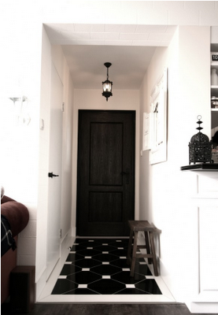Black and white – Simulating the Empty small talk between two people that have no idea about each other and are trying to learn.

Uncluttered –Simple – Nothing Complicated

Detailed in small ways – Not complicated but yet the small things have lots of complexity.

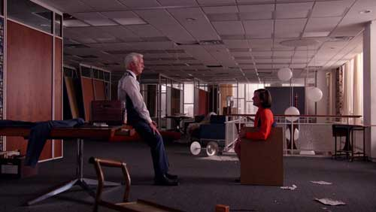

09/10/16 – 1 hour

Liberosis

Online Definition:

 The desire to care less about things or to loosen your grip on your life

### What does it actually mean?

To remove the feeling of worrying about the past, to be able to look forward without looking back. To not worry for what is to come. In a sense the word can mean liberated from yourself, or from others, Rather than fighting life or a feeling, Just flow with it. Holding onto loose ends that are not needed

### Physical Emotional feelings?

Relief, Stress free, Freedom, Weightlessness , relax, momentum, progress

### Example in games design:

Minecraft – When you have been holding on to way to my inventory and you finally go on a mass chest and inventory clean and you realise how little you needed and how much of it there was, now you have loads of space for important items.

### Design idea:

Maybe have a small inventory and items that really make a difference, But make it so replacing one item is important in the sense that they all have such important factors against them that you don’t miss the old item as you are excited for the uses of the new one.

Mood Board:

10/10/16 -

Anecdoche

### Online Definition:

a conversation in which everyone is talking but nobody is listening, simply overlaying disconnected words like a game of Scrabble, with each player borrowing bits of other anecdotes as a way to increase their own score, until we all run out of things to say.

### What does it actually mean?

Empty conversation that is not directed at anybody but everybody. For example muttering Answers while doing working out, other people around you could be listening or not. It may be helpful at some point. It can cause frustration if people were expected to listen but did not

### Physical emotional Feelings:

Boredom, random, Letting steam out, Concentration,

### Example in Games design:

During Team Gameplay, during mic communication, mumbling things to yourself not expecting anybody to listen for then the stuff you mumble helps your team mate inadvertently save their life in the game. Example Mumbling about a hole in the ceiling, For the Team mate to then shoot down at an enemy through said hole. - tom Clancy's rainbow six siege.

### Game design idea:

to maybe have the character the user is playing to be rambling along, saying stuff that seems to mean no value, But later on in the game, if you remember some of the stuff the character was talking about maybe give you access to a secret item or Easter egg.